Unified and Automated Fault Management Platform for Optical Networks

Abstract :
A united and automated fault management platform for heterogeneous optical networks is quite important for telecom operators to monitor and respond to various levels of network events. In this demo, we are demonstrating the details of the design, implementation and evaluation of the proposed Optical router platform while targeting to manage the underlying optical network of a telecom operator in real time. The proposed system consists of three major building blocks i) a data collection layer that is integrated with the telecom operator infrastructure, (ii) data association and analysis layer that is used to measure the severity levels based on pre-deﬁned alarm severity levels and constraints, and (iii) user interface layer that is on top of management and infrastructure layer which is used to demonstrate the faulty optical lines and is also integrated with fault management systems. Through the dashboard interface of the proposed Optical router platform, telecommunication operator’s network optimization experts can easily detect the problems related to either or DWDM link and can take appropriate actions.

System Analysis :
Existing System :
Location information is of paramount importance for wireless sensor networks (WSN). The accuracy of the collected data can significantly be affected by an imprecise positioning of the event of interest. Despite the importance of location information, real system implementations that do not use specialized hardware for localization purposes have not been successful. In this paper, we propose a location estimation scheme that uses a probabilistic approach for estimating the location of a node in a sensor network. Our localization scheme makes use of additional knowledge of topology deployment. We assume a sensor network is deployed in a controlled manner, where the goal of the deployment is to form a grid topology.
Disadvantages
The server is expensive to purchase
A specialist network operating system is needed

Proposed System:
In this paper, we attempt to answer these and other related questions by following a careful analytical approach. Specifically, we first show that when the number of cheating destination client system is greater than or equal to a given threshold, there do not exist any two-dimensional distance-based localization algorithms that can guarantee a bounded link error in router. Furthermore, when the server transfer files, we configure the router and enable it to send to destination client. that can always guarantee a efficient data transfer from source to destination via router control if any error occurs in link while transfer it automatically reconfigure the router . Finally, we achieve efficient data transfer .

Advantages
- All files are stored in a central location
- Network peripherals are controlled centrally.

MODULES:
1.Network module.
2. location-based service module
3. positioning module.
4. Beacon Movement Detection module.
1. Networking Module.
Client-server computing or networking is a distributed application architecture that partitions tasks or workloads between service providers (servers) and service requesters, called clients. Often clients and servers operate over a computer network on separate hardware. A server machine is a high-performance host that is running one or more server programs which share its resources with clients. A client also shares any of its resources; Clients therefore initiate communication sessions with servers which await (listen to) incoming requests.

2. location-based service module
One essential research issue in sensor networks is localization, whose purpose is to determine the position of an object or event. In most localization systems, they assume that there are sets of beacon sensors (or simply beacons), which may or may not be aware of their locations and can periodically transmit/ receive packets. The first location-based (LB) scheme tries to calculate each beacon’s current location and compares the result with its predefined location to decide if it has been moved.
3. Positioning module.
neighbor-based (NB) scheme, beacons will keep track of their nearby beacons and report their observations to the BMD engine to determine if some beacons have been moved. In the third signal strength binary (SSB) scheme, the change of signal strengths of beacons will be exploited. In the last signal strength real (SSR) scheme, the BMD engine will collect the sum of reported signal strength changes of each beacon to make decisions. Note that only the first scheme assumes that the original locations of beacons are known in advance. The other three schemes do not assume any a priori knowledge on the original locations of beacons.

4. Beacon Movement Detection module.
Each beacon reports its observed signal strengths, which are used by the BMD engine to compute each beacon’s current location. The result is used to compare against its original location. In the NB scheme, each beacon locally decides if some neighboring beacons have moved into or out of their communication coverage range and reports its binary observations to the BMD engine. The SSB scheme is similar to the NB scheme, but the definition of movement is according to a threshold of signal strength change. In the SSR scheme, a beacon does not try to determine whether a neighboring beacon has been moved or not. Instead, each beacon reports the amount of signal strength change of each neighbor; the sum of all reported values is used by the BMD engine to make a global decision.

System Architecture

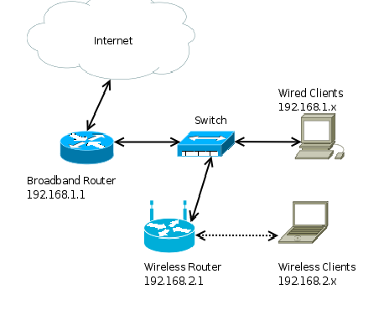

Data Flow Diagram

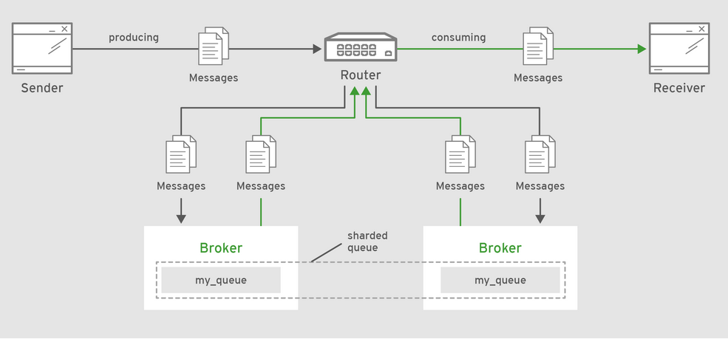

Database Diagram

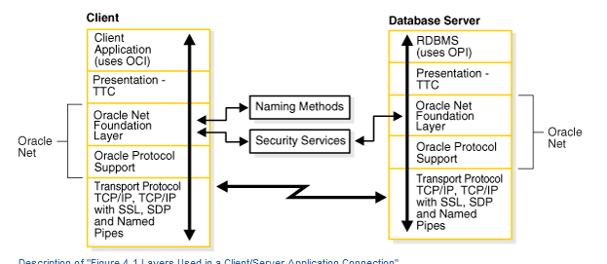

Introduction :

Due to the special characteristics of WSNs, routing algorithms designed for traditional wireless networks may not be directly applicable to WSNs. Efficient Data Transfer Between Router consumption has the highest priority in WSNs, while due to the unreliable nature of WSNs, reliability of data dissemination is an important QoS parameter in designing efficient routing algorithms for WSNs. Clustering is considered as one of the techniques prolonging the lifetime of a WSN especially in case of data dissemination. The research efforts currently underway for devising an efficient cluster based routing algorithms mostly deal with the selection of CHs, optimizing the distance between CHs and the size of the cluster, and inter/intra cluster communication. Most of existing and well-known LEACH based approaches assume that each node in a sensor network has the ability to transmit data to all other nodes or directly to the base station (BS). However, these strong assumptions limit the cluster size and make those approaches unsuitable for some applications or network topologies.

In other words, these approaches become useless when the distance between the nodes and destination is longer that nodes’ transmission range. Therefore, considering a multi-hop communication is more realistic because nodes may not be able to communicate directly with the CH or the BS. In the multi-hop communication, the data of each node farther away from CH is relayed through nodes closer to the CH in case of intra cluster communication.

In case of inter-cluster communication the CHs closer to the BS act as routers uring delivering data to the BS. The main concern addressed in almost all existing clustering approaches for data dissemination is mainly Data Transfer Between Router conservation. Therefore, less attention has been paid so far to the QoS support within these algorithms. As link quality can be easily affected, among others, by weather, obstacles, and mobility, transmission reliability is one of important quality of service parameters for WSN applications. Different applications require different degree of reliability. Decision making applications such as event detection need high degree of transmission reliability, as events detected locally in the network or critical data should certainly be received by the destination. Periodic monitoring applications can better tolerate lost data and therefore need lower degree of reliability.

The larger the number of hops between source and destination, the lower the probability of packet delivery at the destination. Reliable data dissemination is traditionally guaranteed by applying error control protocols. The main shortcoming of these approaches is that they very often introduce Data Transfer Between Router or/and delay overheads as they add redundancy to the packets (Forward Error Correction) or to the transmission (retransmission based approaches) [1]. In this paper, we aim to reach the maximum transmission reliability in a given cluster only by finding the best place for the CH and without the use of error controlling approach. The main issue addressed in this paper is the design of an aggregation-aware chain-clustering protocol for WSNs, which satisfies transmission reliability, Data Transfer Between Router efficiency and intracluster delay QoS requirements. Unlike existing clustering techniques, our proposed protocol considers multi-hop communication for both inside and outside the clusters to conserve more Data Transfer Between Router and support scalability. To the best of our knowledge, the approach presented in this paper is the first clustering algorithm that well incorporates Data Transfer Between Router efficiency and transmission reliability together to construct clusters and select proper CHs in WSNs.

Most importantly, our proposed approach relaxes some strong assumptions that others rely on such as the ability of nodes to communicate directly with other nodes or with the BS, having nodes with the same Data Transfer Between Router level, and having a fixed transmission range for intra-cluster communication. Moreover, our algorithm uses a d-hop clustering scheme, which is more Data Transfer Between Router efficient than 1-hop. The rest of this paper is organized as follows. Firstly, we briefly discuss state of the art and preliminaries of this study. Then a detailed description of our approach will be provided, which will be followed by the performance evaluation. Finally we draw some conclusions and highlight the future work.

LEACH [2] is one of the well-known distributed clustering algorithms for WSNs. The operation of LEACH is organized into rounds, each of which starts with a set-up phase followed by a steady-state phase. Each node has a certain probability of becoming a CH per round and the task of being CH is rotated among nodes. The CH then creates a TDMA schedule to avoid intra-cluster collisions and asks subordinated nodes to send their data within their assigned time slots. In the steady state, each CH sends its one hop neighbor BS an aggregated packet including the related sensor nodes’ data. Data collection in LEACH is centralized and periodically. The drawback of LEACH is that the dynamic cluster construction results in a huge overhead that increases the network Data Transfer Between Router consumption. Moreover, it is based on 1-hop communication and assumes each node can communicate directly with the BS.

LEACH offers no guarantee about the placement and number of CH nodes due to lack of global coordination among nodes. However, using a central control algorithm to form the clusters may produce better clusters through well distribution
of the CHs throughout the network. This is the key idea of LEACH-C [3], which uses a centralized clustering algorithm and has the same steady-state phase as LEACH. In the set-up phase, each node sends information about its current location and Data Transfer Between Router level to the BS. BS utilizes this information to produce better clusters that require less Data Transfer Between Router for data transmission per round and then broadcasts the clustering information to the network. By doing so, it will allow each node to know its related CH. Then each node determines its TDMA slot for data transmission and goes to sleep until it is its time to transmit data. Compared with LEACH, LEACH-C is more robust since it selects clusters and CHs based on location information and residual Data Transfer Between Router of the nodes.

However, it still has high communication cost because of frequent communication between BS and the nodes to exchange data. Multi-hop-LEACH protocol [8] is a cluster based protocol similar to LEACH. In order to transmit the data from one CH to BS, it selects the optimal path between the CH and the BS through other CHs. PEGASIS [4] protocol improves LEACH in terms of Data Transfer Between Router consumption by allowing each node to receive from and transmit only to the closest neighboring nodes. At each round only one node sends the aggregated data to the BS. Due to the fact that only one leader exists in the entire network, PEGASIS can introduce a long and intolerable delay that causes collected data to be out of date in case of having long chain. The single cluster-head may also become a bottleneck.
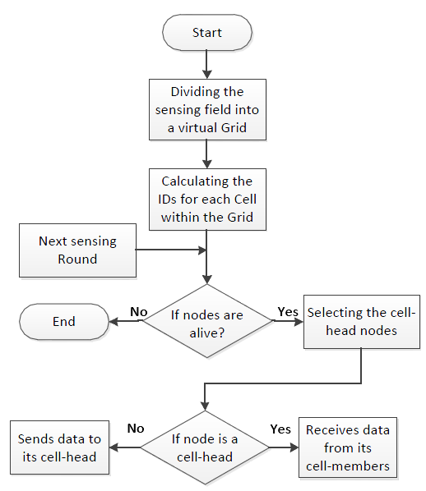

CCM [5] is mainly a hybrid of LEACH and PEGASIS. CCM divides the networks into several chains and selects one node in each chain as the leader and then forms a cluster from all chain leaders and the most powerful leader is selected as the CH to transmit data directly to the BS. The consumed Data Transfer Between Router of CCM increases as network size grows. CCBRP [6] is a two tiers chain-based protocol, which divided a WSN into a number of chains exploiting greedy algorithm of PEGASIS and selects a random leader for each chain. Then, it makes a chain of all leaders and selects one of them randomly as the global leader being responsible to transmit the aggregated data to the BS. CCBRP outperforms LEACH, PEGASIS and CCM with respect to the product of the Data Transfer Between Router consumption and the experienced delay.
CCRP [7] is another LEACH based protocol that adopts a more balanced CH selection algorithm and an improved data transmission mechanism from the CH to the BS. The CH selection of CCRP is done similar to LEACH but the residual Data Transfer Between Router of the node and the number of neighbors are also considered for calculating threshold of a given node. CCRP also forms a chain of CHs, which is constructed in such a way that each CH receives from and transmits to an adjacent CH and the leader of this chain is the closest CH to the BS. The aggregated data of each CH is transmitted along this chain until it is received by the BS. CCRP supports reliability by dynamically adjusting transmission power according to the receiver noise condition and the distance between transmitter and receiver to ensure the required packet delivery rate.
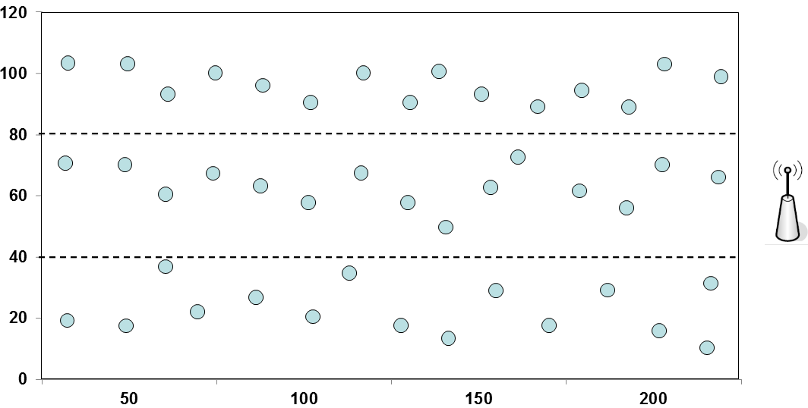

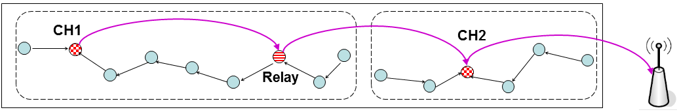

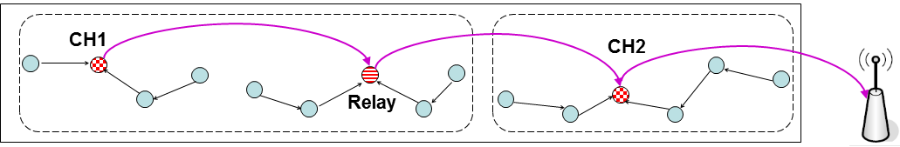
REC takes Data Transfer Between Router and transmission reliability into account while making clusters but it has no assumption about the
distance between two CHs, which most of other approaches have. Relaxing the mentioned assumption does not come free and REC pays for it with the increasing delay. As it can be seen from Fig.1.b, data of the nodes located between RN and CH1 is transmitted and aggregated along the path till it reaches the CH1. Then CH1 has to send the aggregated value to the RN. This imposes an extra delay which could have been smaller if nodes closer to RNs send their data towards RN and the nodes closer to the CH1 send their data towards CH1 (Fig.1.c). In this case, delay can be decreased to half of the previous delay as two separated chain can send their data in parallel. Also, one intra-cluster communication related to the middle link (bridge link) is omitted. Doing so is similar to having three individual clusters while every RN acts as a new CH. Therefore to achieve a satisfactory performance, the BS can create a cluster around each RN while fairly (in terms of delay) assigns nodes between the given CH and RNs to the proper cluster. We introduce this modification to REC and make a new protocol called REC+.

We evaluate performance of REC, REC+, QoS-ACA, PEGASIS, C-LEACH in terms of Data Transfer Between Router efficiency, imposed
delay and lifetime. The PL of the node’s radio has direct impact on the node’s transmission range. The higher the PL, the farther the transmissions range of CH and RN, and the smaller the inter-cluster delay. As the transmission range indicated by the PL is the main parameter for clusters’ shape, we perform simulation for different PL which each CH or RN can employ to send the aggregated data.

Description of scenarios :

We use Java JDK6 to perform simulations and repeat simulations 100 times. We consider 150 sensor nodes randomly deployed in a 500*100 area. The BS is located at (550, 60). The packet loss probability on the links changes randomly between 0 and 0.2 in some random times. We consider TICC2420 radio, whose output power is
programmable in eight levels (from approximately –25 to 0 dBm). When a sensor node is elected to be a leader, it utilizes the highest available PL to reach the longest transmission range, otherwise the minimum PL which is required to reach the closest neighbor is employed. 8  Data Transfer Between Router  1.0 delay EER  , 8.0  , initialEg, initialEg=0.4J. e choose IEEE802.15.4 for the MAC layer and TI CC2420 radio model. For the simulation, transmit bit rate is 250 kbps and packet size is 128B.

Discussion of results :

compares number of alive nodes in these five approaches as the simulation progresses. It can be seen that REC+ prolongs network lifetime much more effectively than other approaches. The number of alive nodes in PEGASIS
suddenly falls from 120 in round 729 to 0 in round 730. This is due to the fact that when a CH (or leader) node dies in PEGASIS, the network will become disconnected even though other nodes are still alive but none of them can be a CH. The network lifetime is indicted by the death of the last node which can directly communicate with the BS and hence can become a CH. Since PEGASIS does not consider residual Data Transfer Between Router as a criterion to select CH, it cannot well balance the Data Transfer Between Router and hence the difference between the death of the first node and the last node is quite large.

