FABRICATION OF PNEUMATIC MULTI PURPOSE CUTTER

ABSTRACT
Multi tool turret head is used to make more operations like drilling, facing, turning; chamfering, grooving etc… are done sequentially. It has proved to be the most versatile method to machining works on the work piece. This machine includes a first functional portion known as the work holder which helps to hold the work piece. This system is provided with a set of heads in which machining tools are placed. This tools are arranged in sequential manner according to the operations need to be carried out on the work piece. It includes a great number of pinions and gears meshing together in order to be able to index all such movable tools and so as to furnish them with the necessary mechanical torque whilst, for the rest, enabling their relative displacement, whether this be in translation or in rotation. It can be noted that the high number of tools in such first functional portion leads, in known lathes, to a very substantial space requirement and weight. The cutting tools are generally moved about one direction called machining direction. This direction may be single axis sliding or rotational motion. The machining portion, in which are concentrated the tools and more generally the change the tool head in our job requirement.

TABLE OF CONTENTS

CHAPTER NO. TITTLE PAGE NO.

1. INTRODUCTION 2
1.1CLASSIFICATION OF MILLING MACHINE 4
1.2 PURPOSE OF MACHINING 5
1.3 TYPES OF MILLING CUTTERS 5
2. LITERATURE REVIEW 9
3. WORKING METHODOLOGY 13
4. COMPONENTS DESCRIPTION 16
4.1PNEUMATIC CYLINDER 16
4.2 MOTOR 26
4.3 WORKPIECE HOLDER 30
4.4 PULLEY 31
5. WORKING PRINCIPLE 37
6. ADVANTAGES & APPLICATION 40
7. CONCLUSION 42
8. REFERENCES 44
CHAPTER
INTRODUCTION
The project work subject is one, in which actually we are leaning the theoretical concepts in practical way. Also the practical experience is one of the aims of this subject. For a developing industry these operating performed and the parts or components produced should have its minimum possible production cost, then only the industry runs profitably. There are a number of units having used in industries for various purposes.

For our thought the various project name are given below.
- Pedaling sheet meal cutter.
- Pneumatic multi purpose device.
- Versa mill.
- Paint mixer
- Mechanical Jack.

From the above we selected ‘PNEUMATIC MULTI PURPOSE DEVICE’. In small scale Industries and automobile maintenance shops, there are frequent needs of tightening and loosening of screws, Drilling, Boring, Grinding, etc. Huge and complicate designed parts can not be machined in ordinary machines. Further for every operation separate machine is required. This increases the initial cost required, large area requirements and a large number of machines are required.

They are as follows:-Grinding, Drilling, Losing and tightening of nut and bolt, Cutting, Screw driving. This device is mainly operated by compressed air. It consists of the following main parts: • Air compressor with cylinder • Pneumatic gun • Grinding wheel • Drilling tool • Air pipe • Wrench for nut and bolt tightening • Cutting tool • Screw driving tool
The word ‘pneuma’ comes from Greek and means breather wind. The word pneumatics is the study of air movement and its phenomena is derived from the word pneuma.Today pneumatics is mainly understood to mean s the application of air as a working medium inindustry especially in driving and controlling of machines and equipment. Pneumatics has been considered to be used to carry out simple mechanical tasks. But, in today’s world it is playing an important role by becoming one of the major sources for automation, and the recent developments in this field has made it a useful technology in the field of complex automated application. Pneumatic systems operate on a supply of compressed air which must be available insufficient quantity and at a pressure to suit the capacity of the system. When the pneumatic system is being adopted for the first time, however it will indeed be necessary to deal with the section of compressed air supply. The key part of any pneumatic machine is supply of compressed air is by means reciprocating compressor. A compressor is a machine that takes in air, gas at a certain pressure and delivers the air at a high pressure. Compressor capacity is the actual quantity of air compressed and delivered. And
the volume expressed is that of the air at intake conditions The compressibility of the air was first investigated by Robert Boyle in 1962 and found that the product of pressure and volume of a particular quantity of gas is constant. This is usually written as: PV = C (or) = In this equation the pressure is the absolute pressure which is about 14.7 Psi. Any gas can be used in pneumatic system but air is the mostly used system now a days.

CHAPTER
COMPONENTS USED
The components used in this project are:
- Pneumatic System
- Spring
- Bearing
- Turbine

Pneumatic Systems:
The word ‘pneuma’ comes from Greek and means breather wind. The word pneumatics is the study of air movement and its phenomena is derived from the word pneuma.Today pneumatics is mainly understood to mean s the application of air as a working medium inindustry especially in driving and controlling of machines and equipment. Pneumatics has been considered to be used to carry out simple mechanical tasks. But, in today’s world it is playing an important role by becoming one of the major sources for automation, and the recent developments in this field has made it a useful technology in the field of complex automated application. Pneumatic systems operate on a supply of compressed air which must be available insufficient quantity and at a pressure to suit the capacity of the system. When the pneumatic system is being adopted for the first time, however it will indeed be necessary to deal with the section of compressed air supply. The key part of any pneumatic machine is supply of compressed air is by means reciprocating compressor. A compressor is a machine that takes in air, gas at a certain pressure and delivers the air at a high pressure.
Compressor capacity is the actual quantity of air compressed and delivered. And the volume expressed is that of the air at intake conditions The compressibility of the air was first investigated by Robert Boyle in 1962 and found that the product of pressure and volume of a particular quantity of gas is constant. This is usually written as: PV = C (or) = In this equation the pressure is the absolute pressure which is about 14.7 Psi. Any gas can be used in pneumatic system but air is the mostly used system now a days.
Selection of Pneumatics Mechanization is broadly defined as the replacement of manual effort by mechanical power. Pneumatic is an attractive medium for low cost mechanizations particularly for sequential(or) repetitive operations. Many factories and plants already have a compressed air system, which is capable of providing the power (or) energy requirements and the control system (although equally pneumatic control systems may be economic and can be advantageously applied to other forms of power). The main advantage of a pneumatic system is it is economically cheap and simple in design, also reducing maintenance costs. It can also have an outstanding advantage in terms of safety.[16] 2.3 Pneumatic power Pneumatic systems use pressurised gas to transmit and control power. Pneumatic systems typically use air as the fluid medium because air is safe, free and readily available The advantages of pneumatics
• Air used in pneumatic systems can be directly exhausted in to the surrounding environment and hence the need of special reservoirs and no-leak system designs are eliminated.
• Pneumatic systems are simple in design and economical.
• Control of pneumatic systems is easier
The disadvantages
• Pneumatic systems exhibit spongy characteristics due to compressibility of air
• Pneumatic pressures are quite low due to compressor design limitations (less that 250 psi)
Production of Compressed Air
Pneumatic systems operate on a supply of compressed air, which must be made available in sufficient quantity and at a pressure to suit the capacity of the system. [9] The key part of any pneumatic system for supply of compressed air is by means using reciprocating compressor. A compressor is a machine that takes in air, gas at a certain pressure and delivers it at a higher pressure. Compressor capacity is the actual quantity of air compressed and delivered. And the volume expressed is that of the air at intake conditions namely at atmosphere pressure and normal ambient temperature. Clean condition of the suction air is one of the factors, which decides the life of compressor. Warm and moist suction air will result in increased precipitation of condense from the compressed air.
Pneumatic technology deals with the study of behavior and applications of
compressed air in our daily life in general and manufacturing automation in particular.
Pneumatic systems use air as the medium which is abundantly available and can be
exhausted into the atmosphere after completion of the assigned task.
- Basic Components of Pneumatic System:
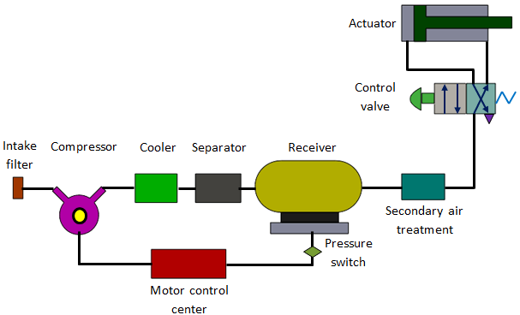
Components of a pneumatic system
a) Air filters: These are used to filter out the contaminants from the air.
b) Compressor: Compressed air is generated by using air compressors. Air
compressors are either diesel or electrically operated. Based on the
requirement of compressed air, suitable capacity compressors may be used.
c) Air cooler: During compression operation, air temperature increases.
Therefore coolers are used to reduce the temperature of the compressed air.
d) Dryer: The water vapor or moisture in the air is separated from the air by
using a dryer.
e) Control Valves: Control valves are used to regulate, control and monitor for
control of direction flow, pressure etc.
f) Air Actuator: Air cylinders and motors are used to obtain the required
movements of mechanical elements of pneumatic system.
g) Electric Motor: Transforms electrical energy into mechanical energy. It is
used to drive the compressor.
h) Receiver tank: The compressed air coming from the compressor is stored in
the air receiver.

Actuators are output devices which convert energy from pressurized hydraulic oil or
compressed air into the required type of action or motion. In general, hydraulic or
pneumatic systems are used for gripping and/or moving operations in industry. These
operations are carried out by using actuators.
Actuators can be classified into three types.
1. Linear actuators: These devices convert hydraulic/pneumatic energy into
linear motion.
2. Rotary actuators: These devices convert hydraulic/pneumatic energy into
rotary motion.
3. Actuators to operate flow control valves: these are used to control the flow and
pressure of fluids such as gases, steam or liquid.
The construction of hydraulic and pneumatic linear actuators is similar. However they
differ at their operating pressure ranges. Typical pressure of hydraulic cylinders is
about 100 bar and of pneumatic system is around 10 bar.
Single acting cylinder
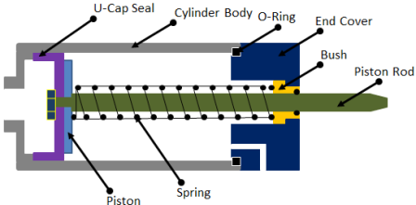
Single acting cylinder
These cylinders produce work in one direction of motion hence they are named as
single acting cylinders. Figure 6.4.1 shows the construction of a single acting
cylinder. The compressed air pushes the piston located in the cylindrical barrel
causing the desired motion. The return stroke takes place by the action of a spring.
Generally the spring is provided on the rod side of the cylinder.
Double acting cylinder
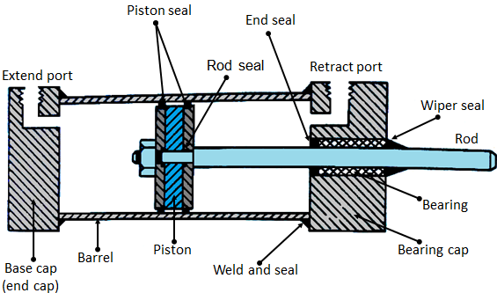
Double acting cylinder
The main parts of a hydraulic double acting cylinder are: piston, piston rod, cylinder
tube, and end caps. These are shown in Figure 6.4.2. The piston rod is connected to
piston head and the other end extends out of the cylinder. The piston divides the
cylinder into two chambers namely the rod end side and piston end side. The seals
prevent the leakage of oil between these two chambers. The cylindrical tube is fitted
with end caps. The pressurized oil, air enters the cylinder chamber through the ports
provided. In the rod end cover plate, a wiper seal is provided to prevent the leakage of
oil and entry of the contaminants into the cylinder. The combination of wiper seal,
bearing and sealing ring is called as cartridge assembly. The end caps may be attached
to the tube by threaded connection, welded connection or tie rod connection. The
piston seal prevents metal to metal contact and wear of piston head and the tube.
These seals are replaceable. End cushioning is also provided to prevent the impact
with end caps.
Pneumatic controllers
In automated industrial processes, it is always essential to keep the process variables
such as temperature, flow rate, system pressure, fluid level, etc. at the desired value
for safety and economical operation. Consider an example where the flow of water
through a pipe has to be kept constant at some predetermined value (Fig. 6.5.1). Let
the value of flow to be measured is ‘V’ (process variable PV). This flow rate is
compared with the required flow value say ‘V1’ (set point SP). The difference
between these two values is the error which is sent to the controller. If any error
exists, the controller adjusts the drive signal to the actuator, informing it to move the
valve to give the required flow (zero error). This type of control system is called
closed loop control system. It mainly includes a controller, actuator and a measuring
device.
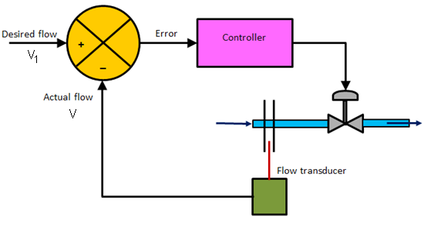
Closed loop control system
The control can be achieved by using control electronics or by pneumatic process
control. The pneumatic systems are quite popular because they are safe. In the process
industries like refinery and chemical plants, the atmosphere is explosive. Application
of electronics based systems may be dangerous in such cases. Since the pneumatic
systems use air, there are very scant chances of any fire hazards. Even though
electrical actuators are available, but most of the valves employed are driven by
pneumatic signals.
The pneumatic components which can be used to implement the mentioned task are as
follows:
• double acting cylinder
• 3/2 push button valve
• 3/2 roller valve
• shuttle valve
• 3/2 foot pedal actuated valve
• 5/3 pneumatic actuated direction control valve
• compressed air source and connecting piping

Bearings:
A bearing is a machine element that constrains relative motion to only the desired motion, and reduces friction between moving parts. The design of the bearing may, for example, provide for free linear movement of the moving part or for free rotation around a fixed axis; or, it may prevent a motion by controlling the vectors of normal forces that bear on the moving parts. Most bearings facilitate the desired motion by minimizing friction. Bearings are classified broadly according to the type of operation, the motions allowed, or to the directions of the loads (forces) applied to the parts.
Rotary bearings hold rotating components such as shafts or axles within mechanical systems, and transfer axial and radial loads from the source of the load to the structure supporting it. The simplest form of bearing, the plain bearing, consists of a shaft rotating in a hole. Lubrication is used to reduce friction. In the ball bearing and roller bearing, to reduce sliding friction, rolling elements such as rollers or balls with a circular cross-section are located between the races or journals of the bearing assembly. A wide variety of bearing designs exists to allow the demands of the application to be correctly met for maximum efficiency, reliability, durability and performance.

CHAPTER
CONCLUSION

After completing this mini project on “MULTIPURPOSE PNEUMATIC PORTABLE MACHINE “we are much happy and would like to thank our professors , guide and the lecture of the concerned department who have guide us. While making this project we have been able to learn lot and understand the various aspects of “MULTIPURPOSE PNEUMATIC PORTABLE MACHINE” we can use our knowledge, which we get during our study

