FABRICATION OF PNEUMATIC MOBILE CRANE

ABSTRACT

This project deals with the fabrication of pneumatic mobile crane. The aim of this project work is to acquire practical knowledge in the field of material handling equipment. The project work is concerned with the fabrication of the portable jib crane. This machine is very useful for lifting and transporting heavy jobs up to two tons for all types of jobs such as automobile repairs and service shops of central workshops, production industries, material handling units etc.

TABLE OF CONTENTS

CHAPTER NO. TITTLE PAGE NO.

1. INTRODUCTION 2
1.1CLASSIFICATION OF MILLING MACHINE 4
1.2 PURPOSE OF MACHINING 5
1.3 TYPES OF MILLING CUTTERS 5
2. LITERATURE REVIEW 9
3. WORKING METHODOLOGY 13
4. COMPONENTS DESCRIPTION 16
4.1PNEUMATIC CYLINDER 16
4.2 MOTOR 26
4.3 WORKPIECE HOLDER 30
4.4 PULLEY 31
5. WORKING PRINCIPLE 37
6. ADVANTAGES & APPLICATION 40
7. CONCLUSION 42
8. REFERENCES 44

CHAPTER
INTRODUCTION
The development of lift machine or crane has reached through different time starting the first crane for lifting heavy load was invented by ancient Greeks in the late 6th century BC. The heydays of crane in ancient times come during Roman Empire when construction activity soared and buildings reached enormous dimensions. The Romans adapted the Greeks cranes and developed it further. The simplest Romans crane is the trespasses, which consists of a single beam jib, a winch, a rope, and a block containing three pulleys. Having this mechanical advantage of 3:1, it has been calculated that a single man working the winch could raise 150kg [3pulles*50kg=150kg], assuming that 50kg represent the maximum effort of a man can exert. Over a long time period heavier crane type featured five pulleys (pentaspastos) or in case of the largest one a set of three by five pulleys (polyspestos) and came with two, three, or four masts depending on the maximum loads. The polyspestos when operated by four men at both side of the winch could readily lifts 3000kg[3 ropes*5 pulleys*4 men*50kg=3000kg] If the winch was replaced by a trade wheel, the maximum load could be doubled to 6000kgs, because the trade wheel have much bigger mechanical advantages due to its higher diameters. This means comparing with the construction of Egyptian
pyramid where in 50 men are needed to move 2.5 tons of stone up the ramp (50kg per persons). The lifting capability of the Roman polyspastos is proved to be 60 times higher than the Egyptian system of lifting stones. During the high middle age the trade wheel was introduced on large scale after the technology had fallen in the Western Europe with dismiss of Western Roman Empire.
The earliest reference to the trade wheel reappears in the archival literature in France about 1225. Generally vertical transport could be done more safely and inexpensively by crane than customary method. Typical areas of application were harbors, mines, and in particular building sites where the trade wheel crane played a pivoted role in the construction of lofty Gothic cathedrals. In contrast to the modern cranes, middle age cranes and hoists –much like to their counter parts in Greece and Rome were primarily capable of a vertical lift, not used to move loads for considerable distance horizontally as well. It is not worthy that middle age cranes rarely featured ratchets or brakes to forestall the loads from running backwards. This curious absence is explained by a high friction force
exercised by middle age trade wheels, which normally prevented the wheel from accelerating beyond control. With the onset of the industrial revolution, the first modern cranes were installed at harbors for loading cargo.

CHAPTER
COMPONENTS USED
The components used in this project are:
- Pneumatic Systems
- Wheel
- Bearings
- Links

Bearings:
A bearing is a machine element that constrains relative motion to only the desired motion, and reduces friction between moving parts. The design of the bearing may, for example, provide for free linear movement of the moving part or for free rotation around a fixed axis; or, it may prevent a motion by controlling the vectors of normal forces that bear on the moving parts. Most bearings facilitate the desired motion by minimizing friction. Bearings are classified broadly according to the type of operation, the motions allowed, or to the directions of the loads (forces) applied to the parts.
TYPES OF BEARINGS AND THEIR APPLICATIONS
1. BALL BEARINGS:
A ball bearing is a type of rolling-element bearing which uses balls to maintain the separation between the moving parts of the bearing.
The purpose of a ball bearing is to reduce rotational friction and support radial and axial loads. It achieves this by using at least two races to contain the balls and transmit the loads through the balls. Usually one of the races is held fixed. As one of the bearing races rotates it causes the balls to rotate as well. Because the balls are rolling they have a much lower coefficient of friction than if two flat surfaces were rotating on each other.
Ball bearings tend to have lower load capacity for their size than other kinds of rolling-element bearings due to the smaller contact area between the balls and races. However, they can tolerate some misalignment of the inner and outer races.
Compared to other rolling-element bearings, the ball bearing is the least expensive, primarily because of the low cost of producing the balls used in the bearing. There are several common designs of ball bearing, each offering various trade-offs. They can be made from many different materials, including: stainless steel, chrome steel, and ceramic. A hybrid ball bearing is a bearing with ceramic balls and races of metal.
1.1. Single-row ball bearing:
a) General:
The rigid bearing with a row of balls is a bearing presenting a very good performance/price ratio; it is relatively universal.
b) Aptitudes:
It has a good capacity to support the radial loads and also the axial loads in the two directions. It presents a swivelling and exists in an instrumented version making it possible in particular to determine the rotational speed of the shaft.
c) Uses:
This type of bearing is used in all the fields of mechanical engineering in general (flaps, bearings of jet engines, transmissions of helicopters, on-board equipment...). It is available with a segment which allows an axial immobilization without any retaining wall in the housing.
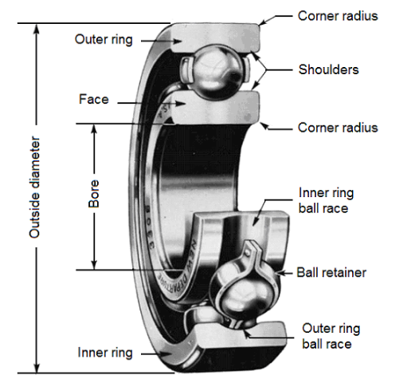
1.2. Double-row ball bearing:
a) General:
These bearings require a good coaxiality between the shaft and the housing.
b) Aptitudes:
This type of bearing allows strong radial and axial loads in the two directions.
A preferential way is sometimes noticed, in case of filling notches. This bearing can be installed alone or together with another bearing (where alignment is necessary).
c) Uses
This type of bearing is used in pumps, reducers (wheel and screw), equipment...
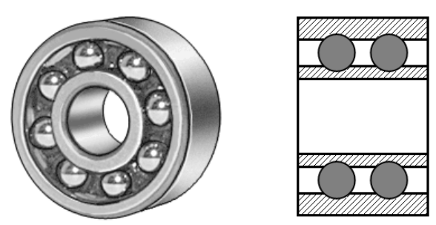

1.3. Double-row self-aligning ball bearing:
a) General:
The self-aligning ball bearing has two rows of balls and a common concave sphered raceway in the outer ring. The bearing is consequently self-aligning and insensitive to angular misalignments of the shaft relative to the housing.
b) Aptitudes:
Self-aligning ball bearings with extended inner ring are designed for less demanding applications using commercial grade shafting. The special bore tolerance allows easy mounting and dismounting.
c) Uses
It is particularly suitable for applications where considerable shaft deflections or misalignment are to be expected.
Additionally, the self-aligning ball bearing has the lowest friction of all rolling bearings, which allows it to run cooler even at high speeds.
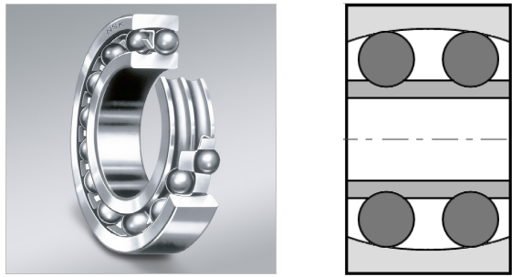
Self-aligning ball bearings with extended inner ring are axially located on the shaft by means of a pin or shouldered screw, which engages in a slot at one side of the inner ring and also prevents the inner ring from turning on the shaft.
When two self-aligning ball bearings with extended inner ring are used to support a shaft, they should be positioned so that the inner ring slots either face each other, or are at the outboard positions of the bearings.
If this is not the case, the shaft is axially located in one direction only.
1.4. Single and double -row angular contact bearing:
a) General:
Angular contact ball bearings have raceways in the inner and outer rings that are displaced with respect to each other in the direction of the bearing axis. This means that they are designed to accommodate combined loads, i.e. simultaneously acting radial and axial loads.
b) Aptitudes:
The axial load carrying capacity of angular contact ball bearings increases with increasing contact angle.
The contact angle is defined as the angle between the line joining the points of contact of the ball and the raceways in the radial plane, along which the load is transmitted from one raceway to another, and a line perpendicular to the bearing axis.
The contact angle varies from 15° to 40° and is measured relative to a line running perpendicular to the bearing axis. Angular contact bearings are unidirectional thrust bearings that can withstand heavy thrust loads and moderate radial loads.
See below: Single angular contact bearing.
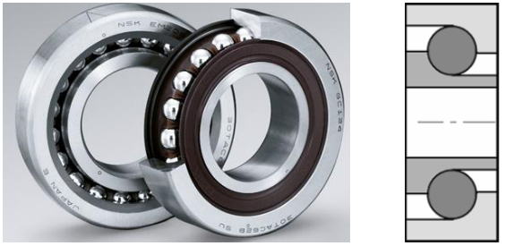

c) Uses:
Angular contact bearings can have a number of different styles of seals or shielding. Seals and shields provide protection from contamination and as a retainer for lubricant.
Seals provide better protection and lubricant containment than shields, but have lower maximum speed capabilities.
Bearings with ball screw support are specially designed for use in ball screw or lead screw applications.
Some bearings may also be flanged. Angular contact bearings may have a variety of lubrication options.
See below: Double-row angular contact bearing.
CHAPTER
CONCLUSION
For many years cranes have been designed for lifting heavy objects with different capacity in different work sites. Portable cranes are of one type of cranes designed for lifting objects which are beyond the capacity of human being. Of this lifting operation by using portable and moveable crane which is not being use before, we have identified that there is the need for using portable crane to lift up objects these are beyond the capacity and difficult of human power. Thus this paper provides the design of each part of portable crane. And the design analysis for each part is checked that it is safe accordingly the size of each parts of the crane.

