FABRICATION OF PNEUMATIC BREAKING SYSTEM

ABSTRACT

The aim is to design and develop a control system based on breaking system of an AIR controlled safely automotive wheel braking system. The control valve which directs the air to the double acting cylinder for breaking control. This braking actions is implemented In our project, we have to apply this braking system in one wheel as a model.

TABLE OF CONTENTS

CHAPTER NO. TITTLE PAGE NO.

1. INTRODUCTION 2
1.1CLASSIFICATION OF MILLING MACHINE 4
1.2 PURPOSE OF MACHINING 5
1.3 TYPES OF MILLING CUTTERS 5
2. LITERATURE REVIEW 9
3. WORKING METHODOLOGY 13
4. COMPONENTS DESCRIPTION 16
4.1PNEUMATIC CYLINDER 16
4.2 MOTOR 26
4.3 WORKPIECE HOLDER 30
4.4 PULLEY 31
5. WORKING PRINCIPLE 37
6. ADVANTAGES & APPLICATION 40
7. CONCLUSION 42
8. REFERENCES

INTRODUCTION
In the present study a model was designed to automatically forecast upcoming collision and take appropriate action and avoid collision by automatic braking and thus reduce the damage by automatic bumper circuit and to decrease response time by using high frequency waves. A safety system was designed to reduce property damage and passenger injury. All the conventional vehicles are equipped with brakes that are operated manually. The consequence of collision depends on driver‟s reflex to vary the driving environment. Vehicle accidents might be a consequence of rash driving, driving under influence, fatigue etc. Most of these can be mapped down to a single cause, driver‟s inability to hit the brakes at right time. If this work is replaced by automatic means, most of the collision can be controlled.
Automated collision avoidance system is one among such system to avoid the severity of accidents. It is an electrically controlled pneumatic circuitry, which aims to avoid forward collision of the vehicle and improve crashing safety. This is achieved by means of automatic pneumatic circuits. The aim is to design and develop a control system based on intelligent electronically controlled automotive bumper activation system is called “automatic pneumatic braking system”. The project consists of IR transmitter and Receiver circuit, Control Unit, Pneumatic bumper system. The IR sensor senses the obstacle. There is any obstacle closer to the vehicle (within 1feet), the control signal is given to the bumper and break activation system. This bumper activation system is activated when the vehicle speed above 40-50 km per hour. The speed is sensed by the proximity sensor and this signal is transfer to the control unit and pneumatic bumper activation system. In collision mitigation system, the sensors detect the possibility of collision but will not take immediate action. A warning will be sent to the driver in the form of a signal or a voice message. There is a threshold safe distance calculated by the system and if the driver fails to respond even when the vehicle crosses that region, then only brakes will be applied automatically.

COMPONENTS USED
The components used in this project are:
- Wheel
- Braking system
- IR Sensor
- Microcontroller
- Electronic Circuit
- Pneumatic systems
- Bearings

Bearings:
A bearing is a machine element that constrains relative motion to only the desired motion, and reduces friction between moving parts. The design of the bearing may, for example, provide for free linear movement of the moving part or for free rotation around a fixed axis; or, it may prevent a motion by controlling the vectors of normal forces that bear on the moving parts. Most bearings facilitate the desired motion by minimizing friction. Bearings are classified broadly according to the type of operation, the motions allowed, or to the directions of the loads (forces) applied to the parts.
Rotary bearings hold rotating components such as shafts or axles within mechanical systems, and transfer axial and radial loads from the source of the load to the structure supporting it. The simplest form of bearing, the plain bearing, consists of a shaft rotating in a hole. Lubrication is used to reduce friction. In the ball bearing and roller bearing, to reduce sliding friction, rolling elements such as rollers or balls with a circular cross-section are located between the races or journals of the bearing assembly. A wide variety of bearing designs exists to allow the demands of the application to be correctly met for maximum efficiency, reliability, durability and performance.
The term "bearing" is derived from the verb "to bear";a bearing being a machine element that allows one part to bear (i.e., to support) another. The simplest bearings are bearing surfaces, cut or formed into a part, with varying degrees of control over the form, size, roughness and location of the surface. Other bearings are separate devices installed into a machine or machine part. The most sophisticated bearings for the most demanding applications are very precise devices; their manufacture requires some of the highest standards of current technology.

TYPES OF BEARINGS AND THEIR APPLICATIONS
1. BALL BEARINGS:
A ball bearing is a type of rolling-element bearing which uses balls to maintain the separation between the moving parts of the bearing.
The purpose of a ball bearing is to reduce rotational friction and support radial and axial loads. It achieves this by using at least two races to contain the balls and transmit the loads through the balls. Usually one of the races is held fixed. As one of the bearing races rotates it causes the balls to rotate as well. Because the balls are rolling they have a much lower coefficient of friction than if two flat surfaces were rotating on each other.
Ball bearings tend to have lower load capacity for their size than other kinds of rolling-element bearings due to the smaller contact area between the balls and races. However, they can tolerate some misalignment of the inner and outer races.
Compared to other rolling-element bearings, the ball bearing is the least expensive, primarily because of the low cost of producing the balls used in the bearing. There are several common designs of ball bearing, each offering various trade-offs. They can be made from many different materials, including: stainless steel, chrome steel, and ceramic. A hybrid ball bearing is a bearing with ceramic balls and races of metal.
1.1. Single-row ball bearing:
a) General:
The rigid bearing with a row of balls is a bearing presenting a very good performance/price ratio; it is relatively universal.
b) Aptitudes:
It has a good capacity to support the radial loads and also the axial loads in the two directions. It presents a swivelling and exists in an instrumented version making it possible in particular to determine the rotational speed of the shaft.
c) Uses:
This type of bearing is used in all the fields of mechanical engineering in general (flaps, bearings of jet engines, transmissions of helicopters, on-board equipment...). It is available with a segment which allows an axial immobilization without any retaining wall in the housing.
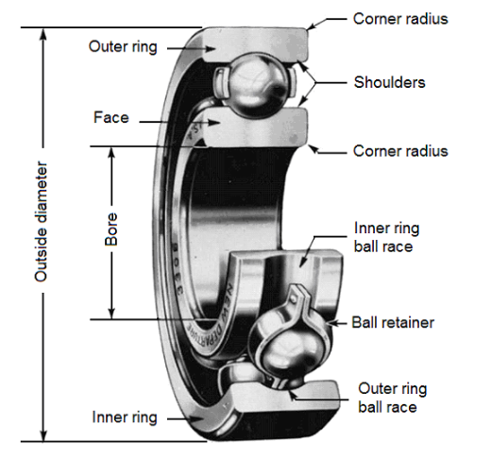
1.2. Double-row ball bearing:
a) General:
These bearings require a good coaxiality between the shaft and the housing.
b) Aptitudes:
This type of bearing allows strong radial and axial loads in the two directions.
A preferential way is sometimes noticed, in case of filling notches. This bearing can be installed alone or together with another bearing (where alignment is necessary).
c) Uses
This type of bearing is used in pumps, reducers (wheel and screw), equipment...
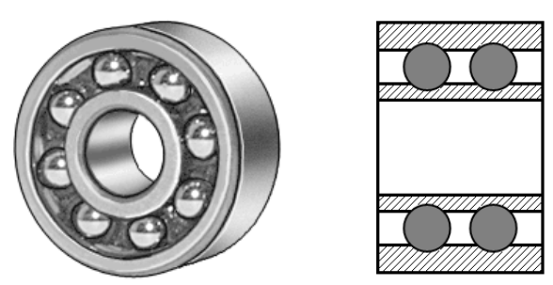

1.3. Double-row self-aligning ball bearing:
a) General:
The self-aligning ball bearing has two rows of balls and a common concave sphered raceway in the outer ring. The bearing is consequently self-aligning and insensitive to angular misalignments of the shaft relative to the housing.
b) Aptitudes:
Self-aligning ball bearings with extended inner ring are designed for less demanding applications using commercial grade shafting. The special bore tolerance allows easy mounting and dismounting.
c) Uses
It is particularly suitable for applications where considerable shaft deflections or misalignment are to be expected.
Additionally, the self-aligning ball bearing has the lowest friction of all rolling bearings, which allows it to run cooler even at high speeds.
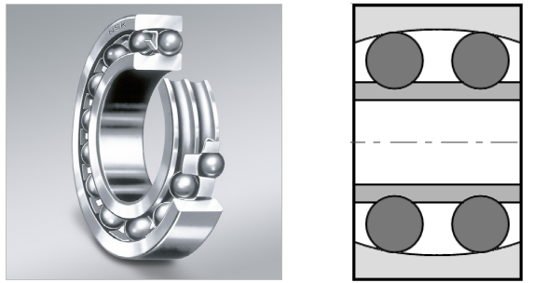
Self-aligning ball bearings with extended inner ring are axially located on the shaft by means of a pin or shouldered screw, which engages in a slot at one side of the inner ring and also prevents the inner ring from turning on the shaft.
When two self-aligning ball bearings with extended inner ring are used to support a shaft, they should be positioned so that the inner ring slots either face each other, or are at the outboard positions of the bearings.
If this is not the case, the shaft is axially located in one direction only.
1.4. Single and double -row angular contact bearing:
a) General:
Angular contact ball bearings have raceways in the inner and outer rings that are displaced with respect to each other in the direction of the bearing axis. This means that they are designed to accommodate combined loads, i.e. simultaneously acting radial and axial loads.
b) Aptitudes:
The axial load carrying capacity of angular contact ball bearings increases with increasing contact angle.
The contact angle is defined as the angle between the line joining the points of contact of the ball and the raceways in the radial plane, along which the load is transmitted from one raceway to another, and a line perpendicular to the bearing axis.
The contact angle varies from 15° to 40° and is measured relative to a line running perpendicular to the bearing axis. Angular contact bearings are unidirectional thrust bearings that can withstand heavy thrust loads and moderate radial loads.
See below: Single angular contact bearing.
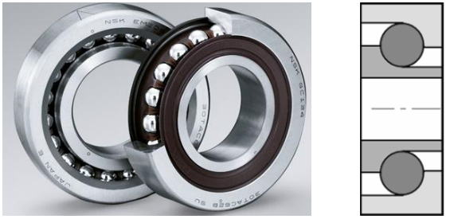

c) Uses:
Angular contact bearings can have a number of different styles of seals or shielding. Seals and shields provide protection from contamination and as a retainer for lubricant.
Seals provide better protection and lubricant containment than shields, but have lower maximum speed capabilities.
Bearings with ball screw support are specially designed for use in ball screw or lead screw applications.
Some bearings may also be flanged. Angular contact bearings may have a variety of lubrication options.
See below: Double-row angular contact bearing.
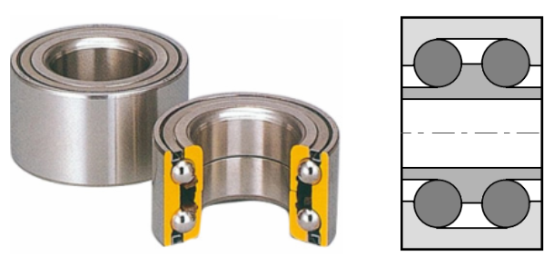
2. ROLLER BEARINGS:
Roller bearings are one of the most widely used industrial bearings. They are called as roller bearings because they are able to carry a load by placing round elements between the two pieces. With the movement of the two pieces, these round elements roll, thereby helping to carry the load.
Most roller bearings use cylinder whose length is slightly greater than its diameter. Roller bearings have higher radial load capacity compared to ball bearings but higher friction and a low axial capacity under axial loads.
2.1. Applications of roller bearings:
Roller bearings are used in rotary applications to replace sliding movement with low friction, rolling.
Automated roller bearing setting techniques offer many advantages like reduced setting time, assembly cost, and and reliable setting. To select the right roller bearing, one must determine the desired bearing life and a sufficient basic dynamic load rating to meet that life requirement.
Roller bearings are used in power generation, wind turbines, gear drives, rolling mills, machine tool spindles, gear reduction units etc.
Roller bearings are the earliest known type of rolling-element-bearing.
2.2. One row, two row cylindrical bearings:
a) General:
This type of bearing supports axial loads only in one direction. They are thus generally used in pairs, opposing each other. Their play must be regulated in order to obtain a good rigidity for the connection. They can also be installed side by side.
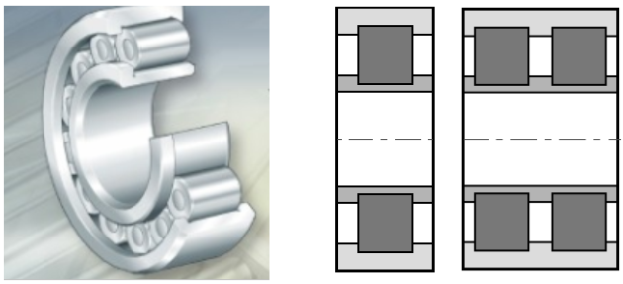
Conical tapered roller bearings:
a) General:
These bearings consist of an internal ring (the cone), conical rollers spaced by a cage and an external ring (the basin) separated from the rest. They support the axial loads only in one direction and are generally installed in pairs, opposing each other. Their play must be adjusted.
b) Aptitudes:
They are bearings adapted to the high axial and radial loads, but they do not support high rotational speeds. For high axial loads, a bearing with a significant contact angle, which can vary from 10° to 30°, is used.
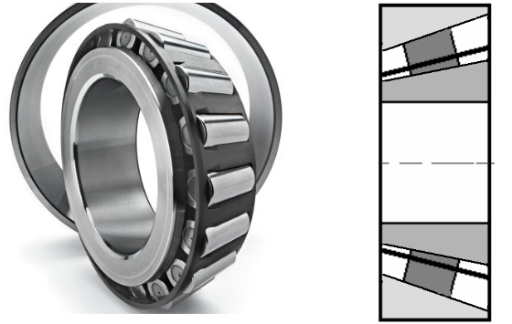
c) Uses:
They are installed in reducers, wheels of the landing gear, etc

CONCLUSION

This project work has provided us an excellent opportunity and experience, to use our limited knowledge. We are feeling that we have completed the work within time successfully. The is working with satisfactory conditions. Thus we have prepared an “Automatic Pneumatic Braking System” which helps to know the how to achieve low cost product.

