FABRICATION OF PEDAL OPERATED MIXI

ABSTRACT
The main aim of the project is to save the electrical power in house, hotels and fast food stalls. Pedal operated mixi is operated by chain and sprocket. The manual power is utilized to run the mixi. This project consists of a pedal, bevel gear arrangement, cutting blades, bearing blocks, arrangement for jar removing.
The following working principle is about pedal operated mixi. In this project the chain and sprocket plays a vital role. A pedal is attached with the chain and sprocket arrangement. Normally the gears are used to transmit power. Driven sprocket is attached with bevel gear arrangement. Here we have used 4 sprockets in two different sizes and 2 chains. When the pedal which is attached with the larger sprocket is rotated, then the smaller sprocket which is connected with another larger one. hence the smaller sprocket attached to the gear shaft will rotated in high speed . This leads to speed up the rotation of the mixie jar. In the above project to transmit the power in 90° we use a bevel gear arrangement. The shaft from the bevel gear is attached to the mixie jar. Here the jar is of removable type. Since the jar is attached with the bevel gear shaft the blades in the jar also rotates in a very high speed.

TABLE OF CONTENTS

CHAPTER NO. TITTLE PAGE NO.

1. INTRODUCTION 2
1.1CLASSIFICATION OF MILLING MACHINE 4
1.2 PURPOSE OF MACHINING 5
1.3 TYPES OF MILLING CUTTERS 5
2. LITERATURE REVIEW 9
3. WORKING METHODOLOGY 13
4. COMPONENTS DESCRIPTION 16
4.1PNEUMATIC CYLINDER 16
4.2 MOTOR 26
4.3 WORKPIECE HOLDER 30
4.4 PULLEY 31
5. WORKING PRINCIPLE 37
6. ADVANTAGES & APPLICATION 40
7. CONCLUSION 42
8. REFERENCES

INTRODUCTION
The multipurpose machine that is ‘exercise bicycle’ which was basically used for exercising purpose has been modified for grinding, water lifting, washing machine and generation of electricity. The consideration for designing was to grind and used as blender, lift water to the height of 10 meter and to generate 14 volts, 4 ampere of electricity in most efficient way. Source of power utilized for above purpose is pedal power. Selecting ‘exercise bicycle’ for this application is due to its low cost, availability and design simplicity. The technical problem addressed by the utility model: the prior art, the process is relatively simple, small parts of the object is small grinder, using electric drive is not conducive to energy saving. according to the above technical solution, the operator holds the part to be machined, sit on the seat cushion, two feet on the foot pedal handle and rotate the handle, the handle foot drive shaft rotates, the first drive shaft on which two sprocket rotation, the second sprocket by driving the first drive chain sprocket rotation, the first drive sprocket is rotated in the first rotation of the spindle sleeve, the first rotary drive sleeve is fixed on the disc rotation. Thus, the operator can be in the hands of grinding parts on the disc. This utility model the human-driven small grinder, the disc drive, the part to be processed feed, are entirely done by hand, not only to save processing costs, and energy saving. Previous devices and systems have been developed to analyze forces applied by a cyclist on a pedal. Such previous devices and systems have used strain gauges or piezo resistors mounted on a pedal, on other parts of a cycle, or on the shoes or cleats of the cyclist. The previous devices and systems, however, have required extensive calibration and complicated equipment, and therefore have been limited to use in the laboratory.

COMPONENTS USED
The components used in this project are:
- Pedal system
- Chain drive
- Shaft
- Bearings

Bearings:
A bearing is a machine element that constrains relative motion to only the desired motion, and reduces friction between moving parts. The design of the bearing may, for example, provide for free linear movement of the moving part or for free rotation around a fixed axis; or, it may prevent a motion by controlling the vectors of normal forces that bear on the moving parts. Most bearings facilitate the desired motion by minimizing friction. Bearings are classified broadly according to the type of operation, the motions allowed, or to the directions of the loads (forces) applied to the parts.
Rotary bearings hold rotating components such as shafts or axles within mechanical systems, and transfer axial and radial loads from the source of the load to the structure supporting it. The simplest form of bearing, the plain bearing, consists of a shaft rotating in a hole. Lubrication is used to reduce friction. In the ball bearing and roller bearing, to reduce sliding friction, rolling elements such as rollers or balls with a circular cross-section are located between the races or journals of the bearing assembly. A wide variety of bearing designs exists to allow the demands of the application to be correctly met for maximum efficiency, reliability, durability and performance.
The term "bearing" is derived from the verb "to bear";a bearing being a machine element that allows one part to bear (i.e., to support) another. The simplest bearings are bearing surfaces, cut or formed into a part, with varying degrees of control over the form, size, roughness and location of the surface. Other bearings are separate devices installed into a machine or machine part. The most sophisticated bearings for the most demanding applications are very precise devices; their manufacture requires some of the highest standards of current technology.

TYPES OF BEARINGS AND THEIR APPLICATIONS
1. BALL BEARINGS:
A ball bearing is a type of rolling-element bearing which uses balls to maintain the separation between the moving parts of the bearing.
The purpose of a ball bearing is to reduce rotational friction and support radial and axial loads. It achieves this by using at least two races to contain the balls and transmit the loads through the balls. Usually one of the races is held fixed. As one of the bearing races rotates it causes the balls to rotate as well. Because the balls are rolling they have a much lower coefficient of friction than if two flat surfaces were rotating on each other.
Ball bearings tend to have lower load capacity for their size than other kinds of rolling-element bearings due to the smaller contact area between the balls and races. However, they can tolerate some misalignment of the inner and outer races.
Compared to other rolling-element bearings, the ball bearing is the least expensive, primarily because of the low cost of producing the balls used in the bearing. There are several common designs of ball bearing, each offering various trade-offs. They can be made from many different materials, including: stainless steel, chrome steel, and ceramic. A hybrid ball bearing is a bearing with ceramic balls and races of metal.
1.1. Single-row ball bearing:
a) General:
The rigid bearing with a row of balls is a bearing presenting a very good performance/price ratio; it is relatively universal.
b) Aptitudes:
It has a good capacity to support the radial loads and also the axial loads in the two directions. It presents a swivelling and exists in an instrumented version making it possible in particular to determine the rotational speed of the shaft.
c) Uses:
This type of bearing is used in all the fields of mechanical engineering in general (flaps, bearings of jet engines, transmissions of helicopters, on-board equipment...). It is available with a segment which allows an axial immobilization without any retaining wall in the housing.
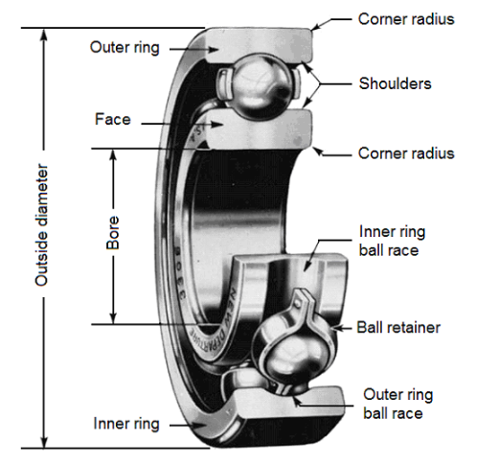
1.2. Double-row ball bearing:
a) General:
These bearings require a good coaxiality between the shaft and the housing.
b) Aptitudes:
This type of bearing allows strong radial and axial loads in the two directions.
A preferential way is sometimes noticed, in case of filling notches. This bearing can be installed alone or together with another bearing (where alignment is necessary).
c) Uses
This type of bearing is used in pumps, reducers (wheel and screw), equipment...
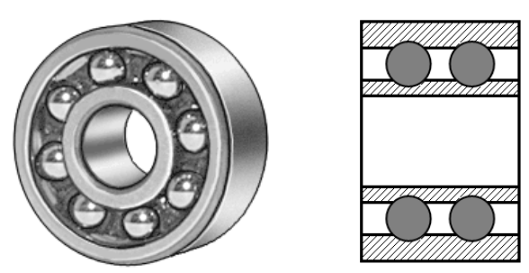

1.3. Double-row self-aligning ball bearing:
a) General:
The self-aligning ball bearing has two rows of balls and a common concave sphered raceway in the outer ring. The bearing is consequently self-aligning and insensitive to angular misalignments of the shaft relative to the housing.
b) Aptitudes:
Self-aligning ball bearings with extended inner ring are designed for less demanding applications using commercial grade shafting. The special bore tolerance allows easy mounting and dismounting.
c) Uses
It is particularly suitable for applications where considerable shaft deflections or misalignment are to be expected.
Additionally, the self-aligning ball bearing has the lowest friction of all rolling bearings, which allows it to run cooler even at high speeds.
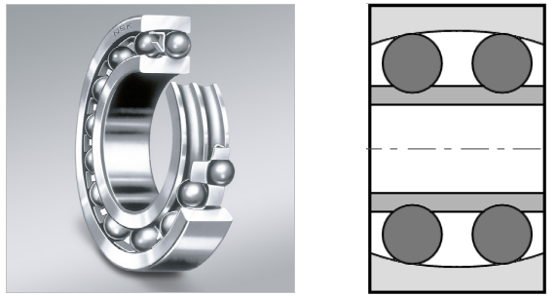
Self-aligning ball bearings with extended inner ring are axially located on the shaft by means of a pin or shouldered screw, which engages in a slot at one side of the inner ring and also prevents the inner ring from turning on the shaft.
When two self-aligning ball bearings with extended inner ring are used to support a shaft, they should be positioned so that the inner ring slots either face each other, or are at the outboard positions of the bearings.
If this is not the case, the shaft is axially located in one direction only.
1.4. Single and double -row angular contact bearing:
a) General:
Angular contact ball bearings have raceways in the inner and outer rings that are displaced with respect to each other in the direction of the bearing axis. This means that they are designed to accommodate combined loads, i.e. simultaneously acting radial and axial loads.
b) Aptitudes:
The axial load carrying capacity of angular contact ball bearings increases with increasing contact angle.
The contact angle is defined as the angle between the line joining the points of contact of the ball and the raceways in the radial plane, along which the load is transmitted from one raceway to another, and a line perpendicular to the bearing axis.
The contact angle varies from 15° to 40° and is measured relative to a line running perpendicular to the bearing axis. Angular contact bearings are unidirectional thrust bearings that can withstand heavy thrust loads and moderate radial loads.
See below: Single angular contact bearing.
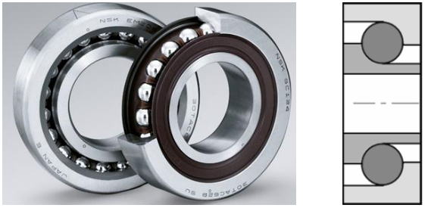

c) Uses:
Angular contact bearings can have a number of different styles of seals or shielding. Seals and shields provide protection from contamination and as a retainer for lubricant.
Seals provide better protection and lubricant containment than shields, but have lower maximum speed capabilities.
Bearings with ball screw support are specially designed for use in ball screw or lead screw applications.
Some bearings may also be flanged. Angular contact bearings may have a variety of lubrication options.
See below: Double-row angular contact bearing.
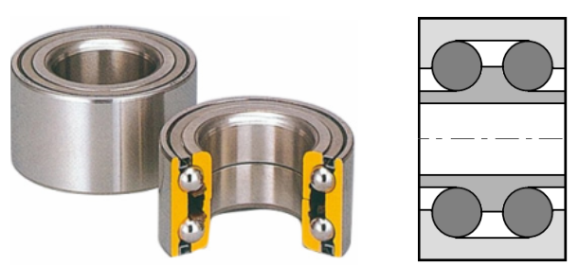
2. ROLLER BEARINGS:
Roller bearings are one of the most widely used industrial bearings. They are called as roller bearings because they are able to carry a load by placing round elements between the two pieces. With the movement of the two pieces, these round elements roll, thereby helping to carry the load.
Most roller bearings use cylinder whose length is slightly greater than its diameter. Roller bearings have higher radial load capacity compared to ball bearings but higher friction and a low axial capacity under axial loads.
2.1. Applications of roller bearings:
Roller bearings are used in rotary applications to replace sliding movement with low friction, rolling.
Automated roller bearing setting techniques offer many advantages like reduced setting time, assembly cost, and and reliable setting. To select the right roller bearing, one must determine the desired bearing life and a sufficient basic dynamic load rating to meet that life requirement.
Roller bearings are used in power generation, wind turbines, gear drives, rolling mills, machine tool spindles, gear reduction units etc.
Roller bearings are the earliest known type of rolling-element-bearing.
2.2. One row, two row cylindrical bearings:
a) General:
This type of bearing supports axial loads only in one direction. They are thus generally used in pairs, opposing each other. Their play must be regulated in order to obtain a good rigidity for the connection. They can also be installed side by side.
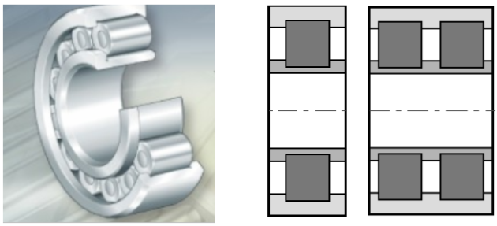
Conical tapered roller bearings:
a) General:
These bearings consist of an internal ring (the cone), conical rollers spaced by a cage and an external ring (the basin) separated from the rest. They support the axial loads only in one direction and are generally installed in pairs, opposing each other. Their play must be adjusted.
b) Aptitudes:
They are bearings adapted to the high axial and radial loads, but they do not support high rotational speeds. For high axial loads, a bearing with a significant contact angle, which can vary from 10° to 30°, is used.
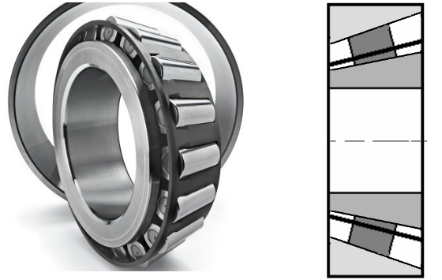
c) Uses:
They are installed in reducers, wheels of the landing gear, etc

Transfer cases
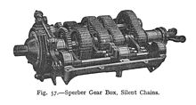
'Silent chain' drives inside a 1912 gearbox
Today, inverted tooth drive chains are commonly used in passenger car and light truck transfer cases.

Motorcycles
Chain drive versus belt drive or use of a driveshaft is a fundamental design decision in motorcycle design; nearly all motorcycles use one of these three designs. See Motorcycle construction § Final drive for more details.

CONCLUSION
The main objective behind development of pedal operated flour mill was on producing cheap, easy to operate system which can be easily fabricated by readily available material and thus we proposed simplistic design that can deliver efficient, productive and reliable flour mill which can be used in rural as well as urban areas. This equipment can be easily operated by semi rather low skilled operator. Further this equipment can easily find its place where there is no or limited power supply.

