AUTOMATIC DRILLING AND TAPPING MACHINE

ABSTRACT

A device, usually motor-driven, fitted with an end cutting tool that is rotated with sufficient power either to create a hole or to enlarge an existing hole in a solid material and also known as driller. Tapping is the process of making thread inside the drilled hole. This operation requires less force to operate.
In this project the drilling machine uses pneumatic power in stead of motor power. The drilling operation is carried with the help of pneumatic cylinder which provide the up down motion to the drill tool. This project is very useful in industrial companies in order to save the time and manpower. This type of drilling machine consumes less time for operation and also no man power is required. After completion of drilling operation, the tapping process is carried out with the help of pneumatic power. In this arrangement the tapping tool is inserted in the machine tool head in stead of drilling tool. So that making the thread on the plate becomes very simple by implementing the tapping operation in the drilling machine. Time control unit is used to control the drilling operation time in the machine. This automatic is only applicable for continuous operation of drilling. Tapping operation requires less working force so that this force is provided by gearing arrangement. So this makes less revolution during the tapping operation.

TABLE OF CONTENTS

CHAPTER NO. TITTLE PAGE NO.

1. INTRODUCTION 2
1.1CLASSIFICATION OF MILLING MACHINE 4
1.2 PURPOSE OF MACHINING 5
1.3 TYPES OF MILLING CUTTERS 5
2. LITERATURE REVIEW 9
3. WORKING METHODOLOGY 13
4. COMPONENTS DESCRIPTION 16
4.1PNEUMATIC CYLINDER 16
4.2 MOTOR 26
4.3 WORKPIECE HOLDER 30
4.4 PULLEY 31
5. WORKING PRINCIPLE 37
6. ADVANTAGES & APPLICATION 40
7. CONCLUSION 42
8. REFERENCES 44

CHAPTER
INTRODUCTION
The main objective of our project is to perform various machining operations using “Auto feed mechanism” in grinding machine with the help of pneumatic sources. For a developing industry the operation performed and the parts (or) components produced should have it minimum possible production cost, then only industry runs profitability. In small-scale industry and automobile maintenance shops, there are frequent needs of tightening and loosening of screws, grinding, boring, grinding. Further for every operation separate machine is required. This increases the initial cost required, large area requirements and large number of machines is required. In our project the above complicated are rectified.
Selection Of Pneumatics
Mechanization is broadly defined as the replacement of manual effort by mechanical power. Pneumatic is an attractive medium for low cost mechanization particularly for sequential (or) repetitive operations.
Many factories and plants already have a compressed air system, which is capable of providing the power (or) energy requirements and the control system (although equally pneumatic control systems may be economic and can be advantageously applied to other forms of power).
The main advantage of an all pneumatic system are usually economic and simplicity the latter reducing maintenance to a low level. It can also have out standing advantages in terms of safety.

CHAPTER
COMPONENTS USED
The components used in this project are:
- Bearings
- Pneumatic system
- Turbine
- Spring

Bearings:
A bearing is a machine element that constrains relative motion to only the desired motion, and reduces friction between moving parts. The design of the bearing may, for example, provide for free linear movement of the moving part or for free rotation around a fixed axis; or, it may prevent a motion by controlling the vectors of normal forces that bear on the moving parts. Most bearings facilitate the desired motion by minimizing friction. Bearings are classified broadly according to the type of operation, the motions allowed, or to the directions of the loads (forces) applied to the parts.
Rotary bearings hold rotating components such as shafts or axles within mechanical systems, and transfer axial and radial loads from the source of the load to the structure supporting it. The simplest form of bearing, the plain bearing, consists of a shaft rotating in a hole. Lubrication is used to reduce friction. In the ball bearing and roller bearing, to reduce sliding friction, rolling elements such as rollers or balls with a circular cross-section are located between the races or journals of the bearing assembly. A wide variety of bearing designs exists to allow the demands of the application to be correctly met for maximum efficiency, reliability, durability and performance.
The term "bearing" is derived from the verb "to bear";a bearing being a machine element that allows one part to bear (i.e., to support) another. The simplest bearings are bearing surfaces, cut or formed into a part, with varying degrees of control over the form, size, roughness and location of the surface. Other bearings are separate devices installed into a machine or machine part. The most sophisticated bearings for the most demanding applications are very precise devices; their manufacture requires some of the highest standards of current technology.

TYPES OF BEARINGS AND THEIR APPLICATIONS
1. BALL BEARINGS:
A ball bearing is a type of rolling-element bearing which uses balls to maintain the separation between the moving parts of the bearing.
The purpose of a ball bearing is to reduce rotational friction and support radial and axial loads. It achieves this by using at least two races to contain the balls and transmit the loads through the balls. Usually one of the races is held fixed. As one of the bearing races rotates it causes the balls to rotate as well. Because the balls are rolling they have a much lower coefficient of friction than if two flat surfaces were rotating on each other.
Ball bearings tend to have lower load capacity for their size than other kinds of rolling-element bearings due to the smaller contact area between the balls and races. However, they can tolerate some misalignment of the inner and outer races.
Compared to other rolling-element bearings, the ball bearing is the least expensive, primarily because of the low cost of producing the balls used in the bearing. There are several common designs of ball bearing, each offering various trade-offs. They can be made from many different materials, including: stainless steel, chrome steel, and ceramic. A hybrid ball bearing is a bearing with ceramic balls and races of metal.
1.1. Single-row ball bearing:
a) General:
The rigid bearing with a row of balls is a bearing presenting a very good performance/price ratio; it is relatively universal.
b) Aptitudes:
It has a good capacity to support the radial loads and also the axial loads in the two directions. It presents a swivelling and exists in an instrumented version making it possible in particular to determine the rotational speed of the shaft.

c) Uses:
This type of bearing is used in all the fields of mechanical engineering in general (flaps, bearings of jet engines, transmissions of helicopters, on-board equipment...). It is available with a segment which allows an axial immobilization without any retaining wall in the housing.
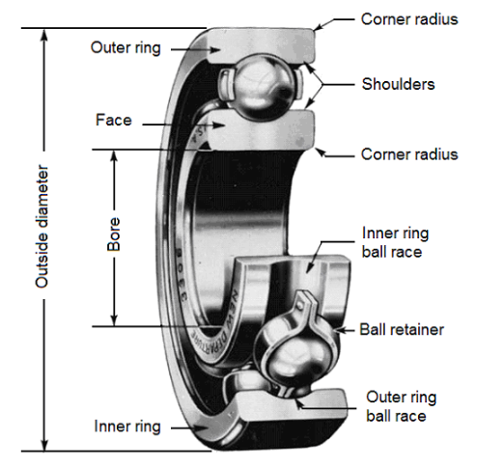
1.2. Double-row ball bearing:
a) General:
These bearings require a good coaxiality between the shaft and the housing.
b) Aptitudes:
This type of bearing allows strong radial and axial loads in the two directions.
A preferential way is sometimes noticed, in case of filling notches. This bearing can be installed alone or together with another bearing (where alignment is necessary).
c) Uses
This type of bearing is used in pumps, reducers (wheel and screw), equipment...
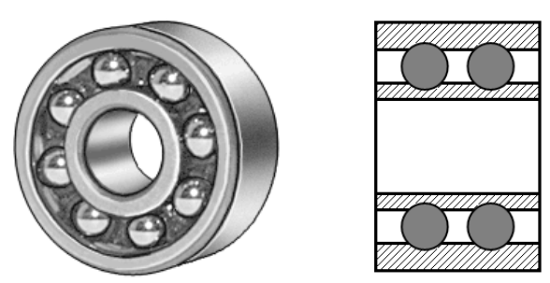

1.3. Double-row self-aligning ball bearing:
a) General:
The self-aligning ball bearing has two rows of balls and a common concave sphered raceway in the outer ring. The bearing is consequently self-aligning and insensitive to angular misalignments of the shaft relative to the housing.
b) Aptitudes:
Self-aligning ball bearings with extended inner ring are designed for less demanding applications using commercial grade shafting. The special bore tolerance allows easy mounting and dismounting.
c) Uses
It is particularly suitable for applications where considerable shaft deflections or misalignment are to be expected.
Additionally, the self-aligning ball bearing has the lowest friction of all rolling bearings, which allows it to run cooler even at high speeds.
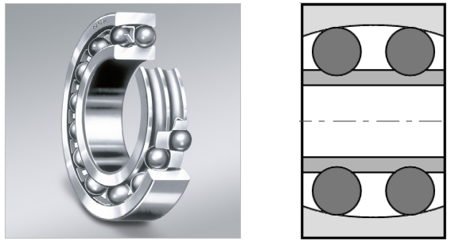
Self-aligning ball bearings with extended inner ring are axially located on the shaft by means of a pin or shouldered screw, which engages in a slot at one side of the inner ring and also prevents the inner ring from turning on the shaft.
When two self-aligning ball bearings with extended inner ring are used to support a shaft, they should be positioned so that the inner ring slots either face each other, or are at the outboard positions of the bearings.
If this is not the case, the shaft is axially located in one direction only.
1.4. Single and double -row angular contact bearing:
a) General:
Angular contact ball bearings have raceways in the inner and outer rings that are displaced with respect to each other in the direction of the bearing axis. This means that they are designed to accommodate combined loads, i.e. simultaneously acting radial and axial loads.
b) Aptitudes:
The axial load carrying capacity of angular contact ball bearings increases with increasing contact angle.
The contact angle is defined as the angle between the line joining the points of contact of the ball and the raceways in the radial plane, along which the load is transmitted from one raceway to another, and a line perpendicular to the bearing axis.
The contact angle varies from 15° to 40° and is measured relative to a line running perpendicular to the bearing axis. Angular contact bearings are unidirectional thrust bearings that can withstand heavy thrust loads and moderate radial loads.
See below: Single angular contact bearing.
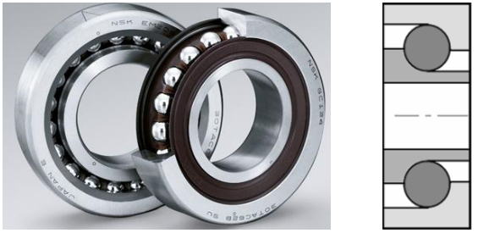

c) Uses:
Angular contact bearings can have a number of different styles of seals or shielding. Seals and shields provide protection from contamination and as a retainer for lubricant.
Seals provide better protection and lubricant containment than shields, but have lower maximum speed capabilities.
Bearings with ball screw support are specially designed for use in ball screw or lead screw applications.
Some bearings may also be flanged. Angular contact bearings may have a variety of lubrication options
CHAPTER
BLOCK DIAGRAM
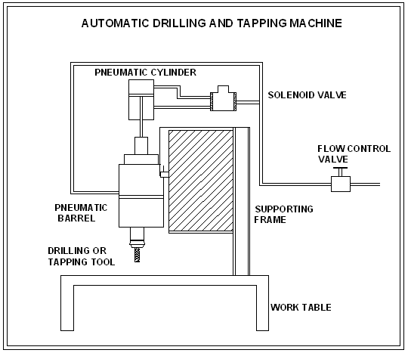
CHAPTER
WORKING PRINCIPLE
The compressed air from the compressor is used as the force medium for this operation. The pneumatic double acting cylinder used .The air from the compressor enters to the four way junction. From four way junctions one way of air enters to the barrel unit. In side the barrel having vane arrangement is welled. The other way of air enters to the solenoid valve.
The function of solenoid valves all of air correct time interval. From solenoid valve air enters to the pneumatic double acting cylinder through flow control valve.
The solenoid valve ON condition, the grinding head is automatically downwards and grinding operation occurs. After some time, the solenoid valve is OFF; the grinding head is automatically released.

MERITS

- It reduces the manual work.
- Quick operation
- Accuracy is more
- Low cost machine
- Its used multipurpose device like Grinding, screw driving.

DEMIRITS

- Noise produced

APPLICATIONS

- Used automobile workshops like carburetor holes
- Used small scale industries
- In welding shop for grinding
- For performing the operations in huge part which cannot be done in ordinary machines. Since it’s portable.
- In such places where frequent change in operation are required.

CHAPTER

CONCLUSION
The concept of automated part transfer line fabricated as an experimental setup can be extended to an industrial application with further modification in the manufacturing and assembly process to achieve quality in the machine as per the test charts provided by leading machine tool manufacturer. On a whole, it is concluded that the automation is an inevitable process though the rate at which it should be introduced will have to be carefully planned in order to bring social justice and to accrue economic benefits.

