AUTOMATIC CLUTCH SYSTEM BASED ON PNEUMATIC

ABSTRACT

The object sensor senses the object and gives corresponding signals. These electrical signals are very small mill voltage signal, so it is given to amplifier circuit. The amplifier circuit is constructed with operational amplifier which acts as power amplifier. Then the amplifier signal is given to signal conditioning unit which also constructed with operational amplifier. In this circuit operational amplifier act as comparator and generate the square pulse given to microcontroller. The microcontroller may be ATMEL/PIC/RENESAS/ARM microcontroller. It will work according to our object already we have programmed.
Air compressor is used for ON/OFF the pneumatic, when the compressed air is passed to the pressure control valve; the required pressure is obtained by adjusting its knob. When the air is passed to the flow control valve, the speed of movement of piston (pneumatic) is controlled by adjusting the knob.

According to the object sensor value, the microcontroller activates the driver circuit as per mentioned in the program. The driver circuit is constructed with transistor which acts as switch to control the relay. The relay output is directly connected to the Solenoid valve this is act as the ON/OFF tap and then solenoid valve output is connected to the Pneumatic cylinder which is attached in the Clutch assembly. Whenever relay gets on the Pneumatic cylinder air piston is force to the clutch assembly.

TABLE OF CONTENTS

CHAPTER NO. TITTLE PAGE NO.

1. INTRODUCTION 2
1.1CLASSIFICATION OF MILLING MACHINE 4
1.2 PURPOSE OF MACHINING 5
1.3 TYPES OF MILLING CUTTERS 5
2. LITERATURE REVIEW 9
3. WORKING METHODOLOGY 13
4. COMPONENTS DESCRIPTION 16
4.1PNEUMATIC CYLINDER 16
4.2 MOTOR 26
4.3 WORKPIECE HOLDER 30
4.4 PULLEY 31
5. WORKING PRINCIPLE 37
6. ADVANTAGES & APPLICATION 40
7. CONCLUSION 42
8. REFERENCES 44

INTRODUCTION
To reduce the speed of the vehicle or to stop brake is a common device. This mechanical tool reducing the speed or stopping the movement of an object. By using friction between two contacting surfaces by pressing together, then convert the kinetic to static condition with elevation of some heat. Here one method of energy conversion is employed in this project is Eddy current Eddy current brake is a break used in magnetic fields to change dynamic energy into electric current in the brake unit, which is applied with better efficiency and low power consumption. Break applying in a very high speed vehicle such as race car or jet aero plane or parachute with gravitational force, Breaks are mainly applied to rotating parts, but it may also be in other forms as the surface of a moving fluid (water or air). In this project eddy current is used to make effective action of break in rotating wheel.
BRAKING SYSTEM
Actually, vehicle can be regard as energy conversion device, which
transfers the momentum into heat, in other words, which transfers the
kinetic energy into thermal energy. The brakes are used to reduce the
speed of the vehicle, and the speed of conversion determines the rate
of the vehicle slows down.
2.2 The basic physics principle used in brake system
As we know when we step the brake pedals or handbrakes, the carstransmit the force from our feet or hands to the brakes. Actually the carcommands a stopping force ten times as Powerful the force that putsthe cat in motion. Because the brakes need a much greater force thandrivers could apply with legs, the car must multiply the force of thefoot.
How could it be achieves? These two physics principles could beused: Leverage and Hydraulic system.And how do the brakes transmit the force to the tires? How do the tirestransmit the force to the road? Both answers are using friction.
Therefore, this part will introducce these three physics principle by first:
Leverage, Hydraulics, Friction.
2.2.1Leverage
As the picture below shows, there is a force applied on the left end of
the lever. The length of the left end is twice (2X) as long as the right
end (X). Therefore, there is a force 2F on the right end. And it acts via
the distance (Y), while the left end moves twice (2Y) as long as the
3right end. Consequently, with the change of the relative lengths of the
left and right ends of the lever, the multipliers are also changing.
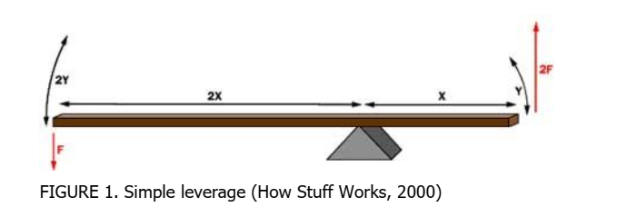
2.2.2Hydraulics system
In addition, a hydraulic system is applied the brakes. The hydraulicsystem connects the brake pedal to the brake parts at each wheel.The basic hydraulic system principle is simple. We can regard it as aprocess that force applied at one point is transmitted to another point
by using an impressible fluid, which almost always is an oil of somesort.
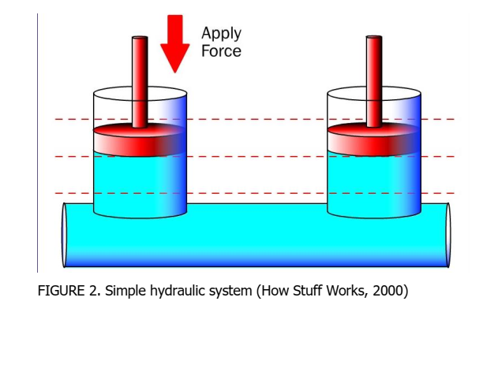
As the picture above shows, 2 pistons (shown in red) are fitted into two
oil-filled glass cylinders (shown in light blue) and connected to another
one with a pipe filled with oil. When a downward force is applied to a
piston, then the force is transferred to another piston via the oil in the
pipe. The oil is almost incompressible, so that the transfer efficiency is
high.
And one advantage of the hydraulic system is that the pipe can be any
length and shape, therefore it could snake through all sorts of
components separating the two pistons. The pipe can also fork, so that
one master cylinder can drive many slave cylinders if need.
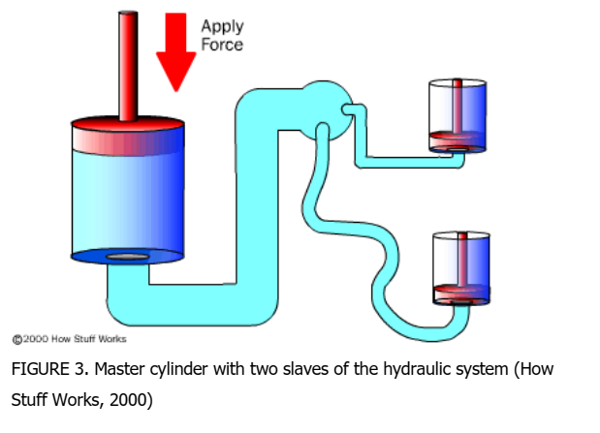
In the figure above, the master cylinder drives two slave cylinder.
One of the advantages of the hydraulic system is that it is easy to
achieve force multiplication or fore division. In a hydraulic system, you
just need to change the size of one piston and cylinder relatively. As
shown here:
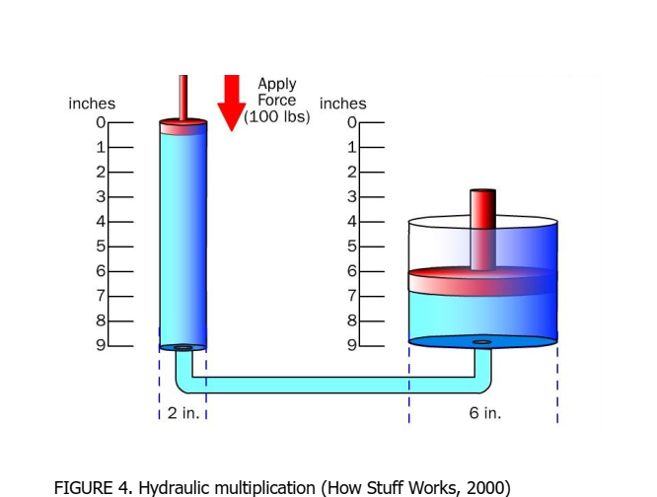
In order to make sure the multiplication factor in the figure above, start
by knowing the size of the pistons. It could be assumed that the piston
on the left is 2 inches (5.08 cm) in diameter (1-inch / 2.54 cm radius),
while the piston on the right is 6 inches (15.24 cm) in diameter (3-inch
/ 7.62 cm radius). The area of the two pistons is Pi * r2. Therefore, the
area of the left piston is 3.14, the right one is 28.26. The piston on the
right is nine times larger than the piston on the left. It means that any
force applied to the left hand piston will come out nine times greater on
the right-hand piston. When applying a 100 pound downward force to
the left piston, a 900pound upward force will appear on the right. The
only thing changed is that the left piston needs to be depressed by 9
inches (22.86 cm), in order to raise the right piston by 1 inch (2.54 cm)
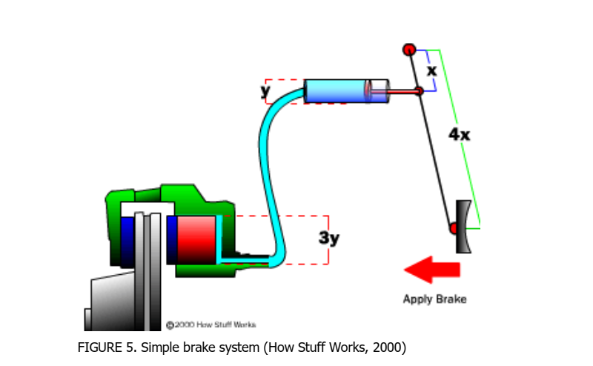
Then it is easy to understand a simple brake system as shown above. It
can be seen that the distance from the pedal to the pivot is 4 times the
distance from the cylinder to the pivot, so that the force at the pedal
will be increased by a factor of 4 before it is transmitted to the cylinder.
And the diameter of the brake cylinder is 3 times the diameter of the
pedal cylinder. It means the fore is further multiplied by 9. In total, the
system increases the force from your foot by a factor of 36.
Specifically, when you put 1 ponds force on the pedal, 36 pounds
(about 16.2 kg) will be generated at the wheel squeezing the brake
pads.
2.2.3Friction
Friction is measured on how hard it is to slide one object over another.
In the figure blow, both of the blocks are made from the same material,
but one is heavier. Image which one will be harder for the bulldozer to push? The idea is the heavier one.

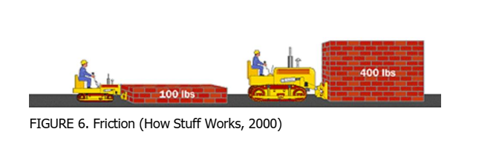
To understand why this is, let's take a close look at one of the blocks
and the table.The blocks look smooth to the naked eye, but actually they are quite
rough at the microscopic level. When the block is set down on thetable, the little peaks and valleys get squished together, and some ofthem may actually weld together. The weight of the heavier blockcauses it to squish together more, so it is even harder to slide.
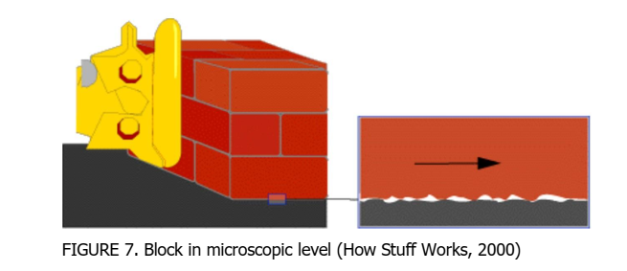
So the amount of force it takes to move the given block is proportional
to that block's weight. The more weight, the more force is required.
This concept applies for devices like brakes and clutches, where a pad
is pressed against a spinning disc. The more force that presses on the
pad, the greater the stopping force.
2.3 Basic components of the brake system
The brake system is composed of the following basic components: theenergy-supplying device, the control device, the transmission device,the brake and additional retarder device, rake line (connectingdifferent devices), and ABS (Anti-lock Braking System)

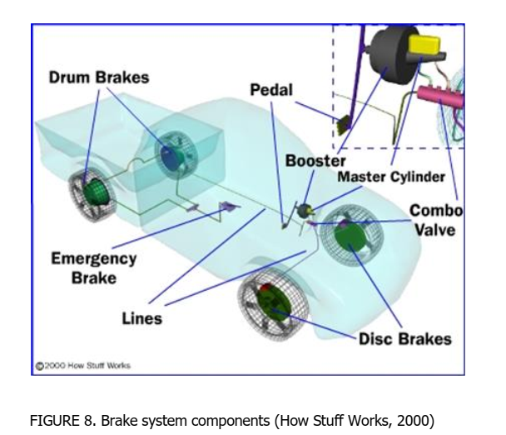
2.3.1The energy-supplying device
The energy-supplying device means supplying and adjusting thenecessary energy of braking. According to the types of energysupplying, there are three types used in automobile braking system:muscular energy braking system (non-power braking system)
When we step the brake pedals or the handbrakes, the cars transmitthe force from our feet or hands to the brakes. The force from driversupplies the basic energy to brakes. This is non-power braking; it justuses the force from human. For example, the bicycle is only using the
no-power braking system to supply energy.energy assisted braking system (power assisted braking system)
.
7 REFERENCE
Asbestos brake dust still a hazard, 24th, May, 2016,www.aa1car.com/library/trtu796.htm
Automobile brake system, 24th, May, 2016,www.baidu.com/view/2235434.htm
Automobile Brake System, 24th, May, 2016,http://wenku.baidu.com/link?url=Eoo1hnYtbfEPo8 91KVBZ_dD51qQiRmcW5fhY1yBUHl8m51XKUPDUzsOpqb1DanyGvXR8gyfZ90_EkQH4OHi1JVTk0X4-6-8NndE3WC Boulter 2006; Chan and Stachowiak 2004; Kukutschová et al.2011;Thorpe and Harrison 2008; Wahlström 2009; Wahlström 2011C.Michael Hogan, Analysis of highway noise, Journal of Water, Air, &
Soil Pollution, Volume 2, Number 3, Biomedical and Life Sciences and
Earth and Environmental Science Issue, Pages 387-392, September,
1973, Springer Verlag, Netherlands ISSN 0049-6979Environment Science and Pollution Research, February 2015, Volume
22, issue 4, pp 2491-2504
What are the best brake pads, 24th, May, 2016,
http://www.autoanything.com/brakes/the-best-brake-pads-ceramic-ormetallic.aspx
Values in brackets refer to PM10 brake wear (Hildemann et al. 1991;
Garg et al. 2000; Kennedy et al. 2002; Westerlund and Johansson
2002; Kennedy and Gadd 2003; Sanders et al. 2003; Von Uexküll et al.
2005; Schauer et al. 2006; Iijima et al. 2008

CONCLUSION
The project presented has involved the development and implementation of automatic clutches for cars. The motivation of this work is to implement this idea in clutch featured cars with a suitable clutch control. The automatic transmission can be also used in 5 and 6 speed versions by altering few changes in the program. Therefore from the above working it is evident that the forces exerted by the cylinders are optimum to move the clutch levers (pedals). According to the achieved results, the suggested mechanism is realizable and workable.

