Architectural Design of Cloud Applications: a Performance-aware Cost Minimization Approach

ABSTRACT
Cloud Computing has assumed a relevant role in the ICT, profoundly influencing the life-cycle of modern applications in the manner they are designed, developed, deployed and operated. In this paper, we tackle the problem of supporting the design-time analysis of Cloud applications to identify a cost-optimized strategy for allocating components onto Cloud Virtual Machine infrastructural services, taking performance requirements into account. We present an approach and a tool, SPACE4Cloud, that supports users in modeling the architecture of an application, in defining performance requirements as well as deployment constraints, and then in mapping each architecture component into a corresponding VM service, minimizing total costs. An optimization algorithm supports the mapping and determines the Cloud configuration that minimizes the execution costs of the application over a daily time horizon. The benefits of this approach are demonstrated in the context of an industrial case study. Furthermore, we show that SPACE4Cloud leads to a cost reduction up to 60%, when compared to a first-principle technique based on utilization thresholds, like the ones typically used in practice, and that our solution is able to solve large problem instances within a time frame compatible with a fast-paced design process (less than half an hour in the worst case). Finally, we show that SPACE4Cloud is suitable to model even micro service-based applications and to compute the corresponding optimized deployment configuration which is compared with a state-of-the art meta-heuristic alternative method, achieving savings between 21% and 85%.

CHAPTER-1
INTRODUCTION

Computing resources have been increasingly powerful, cheaper, more flexible and available on-demand due to the drastic advancement of utility oriented service model. This technological shift has enabled the pay-per-use model and on demand resource allocation abilities, which is known as “Cloud Computing”. A cloud offers a large pool of resources such as hardware, development platforms, and services which can be dynamically configured with regard to variable demand providing features such as elasticity, load balancing, and ease of accessibility. According to the National Institute of Standards and Technology (NIST),[71]cloud computing can be defined as “a model for enabling ubiquitous, convenient, on-demand network access to a shared pool of configurable computing resources (e.g., networks, servers, storage, applications, and services)that can be rapidly provisioned and released with minimal management effort or service provider interaction.”

In general, a cloud environment involves three major stakeholders.CloudService Providersown or administrates the cloud infrastructure. Examples are Amazon EC2[4]or Azure[13]. The second stakeholder is the Cloud Clients who own and operate the cloud services that are hosted on the cloud infra-structures. Examples of cloud clients are Drop box[9], Netflix[3]. Thirdly, theEnd Users use the services offered by the cloud clients. From the high-level perspective while considering both cloud clients and end users, cloud computing provides three features: flexibility to use and release computational resources based on their demands; performance reliability(in terms of service level agreements (SLA)) for the hosted applications; and cost efficiency as theunder lying infrastructure is shared among multiple end users. Given these benefits offered by cloud computing, more and more individuals and enterprises are moving their applications from traditional infrastructures to cloud infrastructures. This in turn makes cloud providers increase the underlying capacity of their infrastructures to accommodate the increasing demands. For example, Amazon owns now at least 30 cloud infrastructures where each one has between 5000 and 8000 physical machines (PMs)[72].

Despite the prevalence of cloud infrastructures, cloud providers today face significant challenges regarding resource management. Depending on the focus of the cloud providers, the resource management follows different objectives. For example, the energy efficiency objective aims to minimize the power consumption for the cloud provider. On the other hand the balanced resource utilization objective aims that all the active PMs in a cloud infrastructure should experience a similar amount of load. Figure 1 illustrates the cloud resource management problem while considering two sample objectives for one dimension of resources e.g. CPU. On the left side, three applications’ CPU demands are presented in the form of virtual machines (VMs). It is assumed that VM1, VM2and VM3 need to be hosted in a cloud infrastructure, which has several Posthaste are equipped with a certain resource capacity. On the right side, the VMs are allocated to PMs depending on the management objective. For instance, when the goal is to minimize the total energy consumption, then VMs are packed tightly into a PM and all other PMs are powered down, but when the goal is to balance the load, then workloads are distributed equally over the two powered on PMs.

Over time, cloud Datacenters (DCs) have gone through several generations. For example, in Generation 1 enterprise consumers restore their server(hardware) images into virtualized DCs to reduce their expenditure. Generation 1 DCs provided custom scripts to control, orchestrate, and manage the virtualized platform, but did not support auto scaling, multi tenancy, load balancing or other cloud services. In Generation 2, public cloud providers and open source cloud platforms such as Open Stack[83]offer advanced cloud management solutions but still lack of efficient integration between system software on the PMs and the cloud management software, particularly their operating utilization level is still prohibitively low[20]. Even on production level infrastructures during peak levels the utilization is rarely over 20%-30%[20,35,2]and during other times most of them are running even at lower utilization. This inefficient use of resources can lead to significant operational cost for the cloud providers. Recently, in Generation 2.5, cloud providers push containers into the mainstream and introduced cloud services around that technology. However, still additional research is required to make development and deployment easier and infrastructure management better. In particular, infrastructure resource management schemes need to assign diverse applications(e.g. e-commerce, Intelligent Transport Systems (ITS) applications, social networking) to appropriate execution units (e.g. VMs, containers or micro service architecture) and schedule it effectively for a multi located environment to embrace the heterogeneity of workloads and operating costs.

The focus of this thesis is on two fundamental problems associated with the resource management in virtualized cloud infrastructures. They are centered around 1) energy-efficient dynamic resource allocation, 2) resource management decisions using application-awareness. Specifically, we address several aspects of how to select PMs in a cloud infrastructure for hosting VMs such that the allocation satisfies, at the same time, the management objective of the provider and the resource demand of all the applications. This problem is referred to as multi objective VM placement/consolidation problem.

The first problem addressed in this thesis is of the major concern for today’s cloud datacenters i.e. how to reduce their energy consumption. In spite of continuous work for green equipments, energy consumption of the cloud in restructures all over the world is growing non-linearly (an increase of 110%from 2010 to 2015 and a predicted increase of 82% from 2015 to 2020) and similar trend is expected for the upcoming years [73]. Further, cloud infra-structures have significant impact on carbon dioxide (CO2) emissions which are estimated to be 2% of global emissions [27]. One of the most important reasons of energy waste in cloud infrastructures is the poor utilization of thumps [27,2]. Under-utilized PMs contribute significantly to energy waste due to their narrow dynamic power range. For example, a powered on but com Cost and Performance-Aware Resource Management in Cloud Infrastructures politely idle PM may consume 70% of its maximum power consumption[37].Therefore, an energy-efficient VM consolidation approach should consider both non-proportional power consumption and under-utilized PMs’ power wastage.

With the fast development of the internet the resources have become more powerful, cheaper and more available. This development produced a new computing model called CLOUD COMPUTING. In this resources are provided by On-Demand approach .It is the on-demand information technology service. It is based on dynamically virtualized sources. Example:-Network Server, Storage Application. Cloud Computing is classified into three different parts as follows:
- Public Computing-The resources are available over internet to all the users.
- Private Computing-The resources are provided to an organization via intranet.
- Hybrid Computing-It is the combination of public and private computing that is depending on requirement to provide resources.
These infrastructure enable companies to reduce overhead (cost, time) by eliminating the requirement for physical hardware by permit the companies to extract data On-Demand. It has been adopted by most popular internet application services with millions of users. Example websites like Google, Yahoo and Facebook[4]. And also by industrial organization such as IBM, Microsoft and many other. Cloud Computing has made a strong impact on the information technology (IT) industry[5]. These IT industries have aim to provide more reliable, powerful and cost effective cloud platform. Cloud Computing provide various types of services such as Infrastructure as a Service (IaaS),Platform as a Service(PaaS) and Software as a Service(SaaS)[6]. This paper describes the overview of cloud computing, architecture of cloud computing and then explain the main challenges of cloud computing. At the end, paper concludes with conclusion.
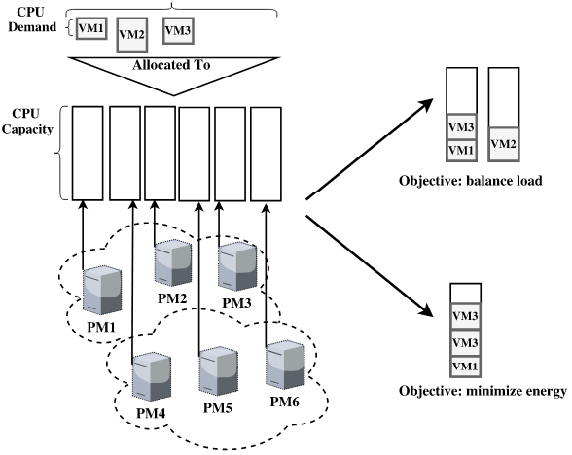

Cloud Infrastructure

Grid to Cloud Evolution

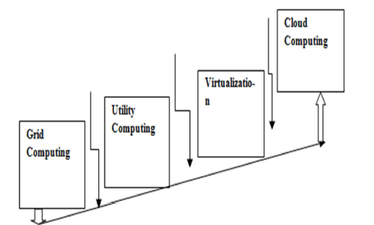

Cloud computing contains virtual cloud in which user information and application are stored. User does not have to depend on computer infrastructure. A complete package of grid computing and utility computing is termed under a buzzword known as cloud computing.

CLOUD COMPUTING ARCHITECTURE
In cloud computing resources are retrieved from the internet through web based tools and applications. This allows the users to work remotely because the cloud can be used as “Internet”. Therefore it is not processed as traditional outsourcing. It is also called Massive Computing. In this the allocation of application must be dynamic. There is no need to install any type of hardware and software. The target of cloud computing is to permit the users to access the data from all the technologies, applications without any deep knowledge about them [11]. In cloud computing architecture, there is no need of high power computer to run web based
Applications. In cloud computing architecture, the applications, data and services all are stored in cloud via internet and run the applications and stored data by delivering the software resources as on-demand services. Now we are describing different modes of cloud computing as follows:

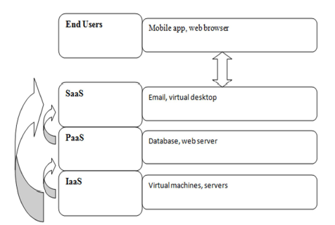
Cloud service computing models

CHAPTER 2
2. SYSTEM ANALYSIS
2.1 EXISTING SYSTEM

Existing solutions do not fully address all of the pre-ceding challenges. For example, Ernest [37] trains a performance model for machine learning applications with a small number of samples but since its performance model is tightly bound to the particular structure of ma-chine learning jobs, it does not work well for applications such as SQL queries (poor adaptively). Further, Ernest can only select VM sizes within a given instance family, and performance models need to be retrained for each instance family.

2.1.1 DRAWBACKS OF EXISTING SYSTEM ARE

In addition, trying each cloud configuration multiple times to get around the dynamics in the cloud (due to resource multiplexing and stragglers)would exacerbate the problem even further.

While such data is available to data center operators, it is out of reach for normal users. Cherry Pick works with a restricted amount of data to get around this problem.

2.2. PROPOSED SYSTEM

In this paper, we present Cherry Pick a system that unearths the optimal or near-optimal cloud configurations that minimize cloud usage cost, guarantee application performance and limit the search overhead for recurring big data analytic jobs. Each configuration is rep-resented as the number of VMs, CPU count, CPU speeder core, RAM per core, disk count, disk speed, and net-work capacity of the VM.

2.2.1. ADVANTAGES OF PROPOSED SYSTEM

- A good cloud configuration can reduce the cost of analytic jobs by a large amount.
- The arithmetic mean and maximum running cost of configurations com-pared to the configuration with minimum running cost for four applications across 66 candidate configurations.

CONCLUSION
CONCLUSION

When you design your architecture in the AWS Cloud, it is important to consider the important principles and design patterns available in AWS including how to select the right database for your application, and how to architect applications that can scale horizontally and with high availability. Because each implementations unique, you must evaluate how to apply this guidance to your implementation. The topic of cloud computing architectures is broad and continuously evolving. You can stay up-to-date with the latest changes and additions to the AWS cloud offerings with the material available on the AWS website58and the AWS training and certification offerings.

CHAPTER-6
REFERENCE
[1] O. Alipourfard, H. H. Liu, J. Chen, S. Venkataraman, M. Yu, and
M. Zhang, “CherryPick: Adaptively Unearthing the Best Cloud Configurations for Big Data Analytics.” in NSDI, 2017.

[2] G. Casale and M. Tribastone, “Modelling exogenous variability in cloud
deployments,” SIGMETRICS Performance. Evaluation Review, vol. 40,
no. 4, pp. 73–82, 2013.

[3] S. Becker, H. Koziolek, and R. Reussner, “The Palladio component
model for model-driven performance prediction,” Journal of Systems and
Software, vol. 82, no. 1, pp. 3–22, 2009.

[4] A. Koziolek, H. Koziolek, and R. Reussner, “PerOpteryx: Automated
Application of Tactics in Multi-objective Software Architecture Optimization,” in Proc. of QoSA 2011, 2011, pp. 33–42.

[5] M. Tribastone, S. Gilmore, and J. Hillston, “Scalable differential analysis
of process algebra models,” IEEE Trans. on Software Engineering,
vol. 38, no. 1, pp. 205–219, 2012.

[6] S. Gilmore and J. Hillston, “The pepa workbench: A tool to support a
process algebra-based approach to performance modelling,” in Computer
performance evaluation modelling techniques and tools. Springer, 1994,
pp. 353–368.

[7] A. Aleti, S. Bj¨ornander, L. Grunske, and I. Meedeniya, “Archeopterix:
An extendable tool for architecture optimization of aadl models,” in Proc.
of MOMPES’09, 2009, pp. 61–71.

[8] A. Koziolek, D. Ardagna, and R. Mirandola, “Hybrid multi-attribute qos
optimization in component based software systems,” Journal of Systems
and Software, vol. 86, no. 10, pp. 2542 – 2558, 2013.

[9] S. Frey, F. Fittkau, and W. Hasselbring, “Search-based genetic optimization for deployment and reconfiguration of software in the cloud,” in Proc. of ICSE ’13, 2013, pp. 512–521.

[10] M. Ciavotta, D. Ardagna, and A. Koziolek, “Palladio optimization
suite: Qos optimization for component-based cloud applications,” EAI
Endorsed Trans. Cloud Systems, vol. 2, no. 6, 2016.

[11] A. Wolke and G. Meixner, “Twospot: A cloud platform for scaling out
web applications dynamically,” in ServiceWave, 2010.

[12] X. Zhu, D. Young, B. Watson, Z. Wang, J. Rolia, S. Singhal, B. McKee,
C. Hyser, D.Gmach, R. Gardner, T. Christian, and L. Cherkasova:, “1000 islands: An integrated approach to resource management for virtualized data centers,” J. of Cluster Computing, vol. 12, no. 1, pp. 45–57, 2009.

