INTELLIGENT CACHE POLLUTION ATTACKS DETECTION FOR EDGE COMPUTING ENABLED MOBILE SOCIAL NETWORKS

CHAPTER 1
INTRODUCTION
With the rapid advances of wireless technologies and popularization of smart mobile devices, edge-enabled mobile social networks (MSNs) have emerged as a promising network paradigm for mobile users to deliver, share, and exchange contents with each other. By leveraging edge caching technology, various content services can be provided to mobile users for improving their quality of experience (QoE). However, edge caching is vulnerable to cache pollution attacks (CPAttacks) with the result of disruptive content delivery. To tackle this problem, we propose a hidden Markov model (HMM) based CPAttack detection scheme in edge-enabled MSNs. Specifically, we first present the CPAttack model based on observations of attacking behaviors. According to the CPAttack model, the caching state of the edge device is characterized by two parameters-content request rate and cache missing rate.Then, with observation sequence constructed by caching states, we develop an HMM-based detection algorithm to distinguish the CPAttack in the approximately time-invariant content request process. To deal with the lack of training data and dynamic of caching states, an adaptive HMM (AHMM) based algorithm is designed to detect the CPAttack in the time-varying content request process. The simulation results demonstrate that the proposed scheme can efficiently improve edge devices’ abilities to sense the CPAttack.

SYSTEM OVERVIEW
The developments of wireless communication technologies and smart mobile devices enable mobile users to easily generate, share, and exchange contents with each other in mobile social networks (MSNs) . Accordingly, the number of mobile users and traffic increase extremely fast, reaching vbillion and 49.0 exabytes per month by 2021, respectivelyvThe huge amount of mobile users and traffic make large burdenson the backbone network, becoming hard to satisfy mobile users diverse demands . Edge computing, as a key enabling technology for the next generation wireless networks, can solve the above problems with several advantages . On one hand, by caching contents at the edge of the network, the redundant content transmissions over the backbone network can be significantly reduced. On the other hand, as cached contents are located closely to mobile users, mobile users can directly fetch desired contents from edge devices with short latencies instead of remote content providers.

SCOPE OF THE PROJECT
Many studies have been carried out to detect explicit attacks with observations on the change of content request rate. However, smart attackers may bypass these detections andlaunch the hidden CPAttack with low unpopular content request rate, where the total content request rate on the edge device is not changed significantly. In addition, although the fixed metric (e.g., static content request rate or cache replacement rate) has been used to detect the attacks with the assumption that the content request process during a time period is stable, the request rate and the popularity of contents may be dynamic over time. The fixed detection metric and the sources of attackers with the limited number of malicious contents in the existing works need to be further studied. Therefore, it is still an open problem to design an efficient detection scheme against both explicit and hidden CPAttacks during the dynamic content request process.

CHAPTER 2
LITERATURE SURVEY

1] A Game Theoretical Incentive Scheme for Relay Selection Services in Mobile Social Networks
Rapid developments in mobile services and wireless technologies have prompted users to form mobile social networks (MSNs), where bundles can be delivered via opportunistic peer-to-peer links in a store-carry-forward mode. This mode needs all nodes to work in a cooperative way. However, mobile nodes may be selfish and might not be willing to forward data to others due to the limited resources (e.g., buffer and energy), resulting in degraded system performance. To tackle the aforementioned problem, this paper proposes a novel incentive scheme to stimulate selfish nodes to participate in bundle delivery in MSNs. At first, a virtual currency is introduced to pay for the relay service. Then, a bundle carrier selects a relay node from its friends or other strangers based on its status. Next, a bargain game is employed to model the transaction pricing for relay service. In addition, the simulation results show that the proposal can improve the performance of the existing schemes significantly.

2] Secure Content Delivery with Edge Nodes to Save Caching Resources for Mobile Users in Green Cities
To save energy during content delivery in green cities, caching contents on edge nodes that are placed near mobile social users has been advocated recently. However, how to allocate the limited caching resources with secure content delivery becomes a new challenge. Therefore, in this paper, we present a novel theoretical model to deliver secure content with edge nodes in order to save energy for green cities. First, we present a reverse auction game to encourage edge nodes to cooperatively provide caching services with incentives. With the model, mobile users can determine the candidate of edge node to cache content based on the interaction between mobile users and edge nodes. Second, a trust management method is designed to evaluate the reliability of the selected candidate of edge node by considering the direct trust evaluation. Finally, extensive simulations show that the proposal can save energy with a secure content delivery where both the delay to obtain the content and the caching ratio can be improved compared with the conventional methods.

3] A Dynamic Trust Framework for Opportunistic Mobile Social Networks
Opportunistic mobile social network (OMSN) enables users to form an instant social network for information sharing (e.g., people watching the same soccer game can share their instant comments). OMSN is ad hoc in nature, thus relies on the cooperation of members regarding message transmission. However, some uncooperative or malicious behavior from abnormal members may reduce network performance, even damage the entire network. Currently, there does not exist effective mechanisms to detect selfish and malicious nodes. To tackle this problem, we propose a dynamic trust framework to facilitate a node to derive a trust value of another node based on the behavior of the latter. The novelty of our framework includes the following: 1) we design a new metric for a trust value of a node and 2) we propose a “two-hop feedback method” that requires intermediate nodes in a forwarding path to generate ACK messages to verify a node's honesty if they are two hops away. In most existing trust models, final ACK messages are considered as critical factors. In OMSN, nodes are not fully connected and final ACK messages cannot be reliably received. In order to avoid the problem that few final ACK messages can be received, we propose a “two-hop feedback method.” Simulation results show that our approach is able to detect a majority of abnormal nodes including malicious nodes, selfish nodes, and those nodes launching conspiracy attacks. Thus, the entire network efficiency can be improved without negative impact of abnormal nodes. Besides, our trust framework can be easily applied to the current popular routing protocols of opportunistic networks.

4] Exploiting mobile social behaviors for Sybil detection

In this paper, we propose a Social-based Mobile Sybil Detection (SMSD) scheme to detect Sybil attackers from their abnormal contacts and pseudonym changing behaviors. Specifically, we first define four levels of Sybil attackers in mobile environments according to their attacking capabilities. We then exploit mobile users' contacts and their pseudonym changing behaviors to distinguish Sybil attackers from normal users. To alleviate the storage and computation burden of mobile users, the cloud server is introduced to store mobile user's contact information and to perform the Sybil detection. Furthermore, we utilize a ring structure associated with mobile user's contact signatures to resist the contact forgery by mobile users and cloud servers. In addition, investigating mobile user's contact distribution and social proximity, we propose a semi-supervised learning with Hidden Markov Model to detect the colluded mobile users. Security analysis demonstrates that the SMSD can resist the Sybil attackers from the defined four levels, and the extensive trace-driven simulation shows that the SMSD can detect these Sybil attackers with high accuracy.

5] Edge Computing Architecture for Mobile Crowdsensing

Mobile crowdsensing (MCS) is a human-driven Internet of Things service empowering citizens to observe the phenomena of individual, community, or even societal value by sharing sensor data about their environment while on the move. Typical MCS service implementations utilize cloud-based centralized architectures, which consume a lot of computational resources and generate significant network traffic, both in mobile networks and toward cloud-based MCS services. Mobile edge computing (MEC) is a natural choice to distribute MCS solutions by moving computation to network edge, since an MEC-based architecture enables significant performance improvements due to the partitioning of problem space based on location, where real-time data processing and aggregation is performed close to data sources. This in turn reduces the associated traffic in mobile core and will facilitate MCS deployments of massive scale. This paper proposes an edge computing architecture adequate for massive scale MCS services by placing key MCS features within the reference MEC architecture. In addition to improved performance, the proposed architecture decreases privacy threats and permits citizens to control the flow of contributed sensor data. It is adequate for both data analytics and real-time MCS scenarios, in line with the 5G vision to integrate a huge number of devices and enable innovative applications requiring low network latency. Our analysis of service overhead introduced by distributed architecture and service reconfiguration at network edge performed on real user traces shows that this overhead is controllable and small compared with the aforementioned benefits. When enhanced by interoperability concepts, the proposed architecture creates an environment for the establishment of an MCS marketplace for bartering and trading of both raw sensor data and aggregated/processed information.

6] Frameworks for Privacy-Preserving Mobile Crowdsensing Incentive Mechanisms
With the rapid growth of smartphones, mobile crowdsensing emerges as a new paradigm which takes advantage of the pervasive sensor-embedded smartphones to collect data efficiently. Many auction-based incentive mechanisms have been proposed to stimulate smartphone users to participate in the mobile crowdsensing applications and systems. However, none of them has taken into consideration both the bid privacy of smartphone users and the social cost. In this paper, we design two frameworks for privacypreserving auction-based incentive mechanisms that also achieve approximate social cost minimization. In the former, each user submits a bid for a set of tasks it is willing to perform; in the latter, each user submits a bid for each task in its task set. Both frameworks select users based on platform-defined score functions. As examples, we propose two score functions, linear and log functions, to realize the two frameworks. We rigorously prove that both proposed frameworks achieve computational efficiency, individual rationality, truthfulness, differential privacy, and approximate social cost minimization. In addition, with log score function, the two frameworks are asymptotically optimal in terms of the social cost. Extensive simulations evaluate the performance of the two frameworks and demonstrate that our frameworks achieve bid-privacy preservation although sacrificing social cost.

7] Software-Defined Networks with Mobile Edge Computing and Caching for Smart Cities: A Big Data Deep Reinforcement Learning Approach
Recent advances in networking, caching, and computing have significant impacts on the developments of smart cities. Nevertheless, these important enabling technologies have traditionally been studied separately in the existing works on smart cities. In this article, we propose an integrated framework that can enable dynamic orchestration of networking, caching, and computing resources to improve the performance of applications for smart cities. Then we present a novel big data deep reinforcement learning approach. Simulation results with different system parameters are presented to show the effectiveness of the proposed scheme

8] Hybrid Content Caching in 5G Wireless Networks: Cloud Versus Edge Caching
Most existing content caching designs require accurate estimation of content popularity, which can be challenging in the dynamic mobile network environment. Moreover, emerging hierarchical network architecture enables us to enhance the content caching performance by opportunistically exploiting both cloud-centric and edge-centric caching. In this paper, we propose a hybrid content caching design that does not require the knowledge of content popularity. Specifically, our design optimizes the content caching locations, which can be original content servers, central cloud units (CUs) and base stations (BSs) where the design objective is to support as high average requested content data rates as possible subject to the finite service latency. We fulfill this design by employing the Lyapunov optimization approach to tackle an NP-hard caching control problem with the tight coupling between CU caching and BS caching control decisions. Toward this end, we propose algorithms in three specific caching scenarios by exploiting the submodularity property of the sum-weight objective function and the hierarchical caching structure. Moreover, we prove the proposed algorithms can achieve finite content service delay for all arrival rates within the constant fraction of capacity region using Lyapunov optimization technique. Furthermore, we propose practical and heuristic CU/BS caching algorithms to address a general caching scenario by inheriting the design rationale of the aforementioned performance-guaranteed algorithms. Trace-driven simulation demonstrates that our proposed hybrid CU/BS caching algorithms outperform the general popularity based caching algorithm and the independent caching algorithm in terms of average end-to-end service latency and backhaul/fronthaul load reduction ratios.

9] Task Assignment in Mobile Crowdsensing: Present and Future Directions
Mobile crowdsensing has wide application perspectives and tremendous advantages over traditional sensor networks due to its low cost, extensive coverage, and high sensing accuracy properties. Task assignment is a crucial issue in mobile crowdsensing systems which is intended to achieve a good tradeoff between task quality and task cost. The design of efficient task assignment mechanisms has attracted a lot of attention and much work has been carried out. In this article, we present a comprehensive survey of state-of-the-art task assignment mechanisms in mobile crowdsensing systems. We will first introduce several fundamental issues in task assignment and classify existing mechanisms based on different design criteria. Then we introduce how each of the existing mechanisms works and discuss their merits and deficiencies. Finally, we discuss challenging issues and point out some future directions in this area.

10] Learning-Based Content Caching and Sharing for Wireless Networks
Content caching at base stations (BSs) is a promising technique for future wireless networks by reducing network traffic and alleviating server bottleneck. However, in practice, the content popularity distribution may change with spatio-temporal variation but be unknown for BSs, which is an intractable obstacle for efficient caching strategy design. In this paper, considering unknown popularity distribution, we explore the content caching problem by jointly optimizing the content caching in cooperative BSs, content sharing among BSs, and cost of content retrieving. We tackle the problem from a multi-armed bandit learning perspective, where the learning of the popularity distribution is incorporated with the content caching and sharing process. Specifically, we first propose a centralized algorithm by employing a semi definite relaxation approach, and we prove that this centralized algorithm learns efficient caching by deriving a sub-linear learning regret bound. To further reduce computational complexity, we propose a distributed algorithm based on alternating direction method of multipliers, where each BS only solves their own problems by exchanging local information with neighbor BSs. Extensive simulation results show the effectiveness of the proposed algorithms in terms of learning content popularity distributions of individual BSs, offloading traffic from the content server, and reducing cost of content retrieving.

CHAPTER 3
SYSTEM ANALYSIS
EXISTING SYSTEM
Mobile edge caching is a promising technology for the next-generation mobile networks to effectively offer service environment and cloud-storage capabilities at the edge of networks. By exploiting the storage and computing resources at the network edge, mobile edge caching can significantly reduce service latency, decrease network load, and improve user experience. On the other hand, edge caching is subject to a number of threats regarding privacy violation and security breach.

DISADVANTAGE OF EXISTING SYSTEM
- Cache spaces are deployed at both BBU and RRH that form a distributed edge caching architecture. Besides, at wireless network edge, caching can be located at wireless routers for enabling various applications, e.g., smart home and smart office.
- The attacker can make the same request to retrieve the account details. Thus, the private data of the victim will be disclosed.

PROPOSED SYSTEM
In this paper, we first introduce the architecture of mobile edge caching, and address the key problems regarding why, where, what, and how to cache. Then, we examine the potential cyber threats, including cache poisoning attacks, cache pollution attacks, cache side-channel attacks, and cache deception attacks, which result in huge concerns about privacy, security, and trust in content placement, content delivery, and content usage for mobile users, respectively. After that, we propose a service-oriented and location-based efficient key distribution protocol (SOLEK) as an example in response to efficient and secure content delivery in mobile edge caching. Finally, we discuss the potential techniques for privacy-preserving content placement, efficient and secure content delivery, and trustful content usage, which are expected to draw more attention and efforts into secure edge caching.

ADVANTAGE OF PROPOSED SYSTEM
- Service Delay Reduction: By storing content close to mobile users, the service delay can be significantly reduced. This feature is quite attractive for data delivery of latencysensitive applications, such as video streaming that will account for 78% of all mobile traffic by 2021.
- Traffic Burden Releasing: As duplicate contents cause severe traffic burden over hackhaul links, the traffic can be reduced up to 35% by storing the requested contents at the network edge . Caching in 3G and 4G LTE networks can reduce mobile traffic up to two thirds

REQUIREMENTS SPECIFICATION

HARDWARE REQUIREMENTS
- Operating System : Windows 7 64 Bit.
- Platform : NS2
SOFTWARE REQUIREMENTS
- Keyboard
- Mouse
- Hard disk 500GB
- Ram 4 Gb
LANGUAGE SPECIFICATION
NS2

SOFTWARE DESCRIPTION

NS meaning Network Simulation is an open source network simulation tool or software, which was first, developed Steve McCanne in 1995-1997. NS (Version 2) is an object oriented, discrete event driven simulator written in C++ (core) and Otcl (python). NS was mainly developed in order for researchers to simulate various kinds of wired or wireless LAN and WAN thus implementing network protocols such as TCP and UDP. In addition NS enables researchers to study and understand traffic source behavior of FTP, VBR, CBR, Web and Telnet, not only that but also router queue management mechanism such as DropTail, RED and CBQ, routing algorithms such as Dijkstra, and many more. NS2 was written in C++ and Otcl in order to differentiate the control and data path implementations. The simulator supports a class hierarchy in C++ (the compiled hierarchy) and a corresponding hierarchy within the Otcl interpreter (interpreted hierarchy). To understand more about the control and data path, take for instance; basically simulation of protocols requires efficient manipulation of bytes and packet headers thus making run-time speed very essential. On the other hand, in network studies where the aim is to vary some parameters and to quickly examine a number of scenarios the time to change the model and run it again is more important. In NS2 for detailed protocol implementation (new queuing discipline), C++ is the best choice this is because every packet flowing must be processed and C++ is quiet fast. On the other hand Otcl is suitable for configuration and setup. Otcl runs a bit slow compared to C++, but it can be changed very quickly making the construction of simulations easier. Another important aspect is availability of the compiled C++ objects to the Otcl interpreter; this enables the objects to be controlled from the OTcl level. A network simulation performance for a network topology that consist of 3 sources, a gateway and a receiver is analyzed using FTP and CBR applications connected over TCP and UDP agent respectively. The benchmark for the simulation is done using the following queuing mechanisms namely; Droptail, Stochastic Fair Queuing (SFQ) and Random Early Detection (RED) in which the performance of this topology is analyzed. The report is organized as follows; First, an introduction is carried out to give an overview on Network Simulation software (NS2) and the aim of this simulation; this is followed by the methodology which gives an insight on the steps carried out in developing the code script for the simulation, this is then followed by the source code and NAM trace file for TCP Scenario. Afterwards the results of the simulation are analyzed and a conclusion on the overall simulation is performed.

METHODOLOGY
This section will cover detail description on various sections of the code and their functions. The various code sections are organized as follows;
a. Creation of new simulator object
b. Trace file
c. Source creation
d. Color definition for different traffic flow
e. Link Creation between nodes
f. Queuing size definition
g. Topology layout
h. Monitoring of queues for the links
i. Creating TCP and UDP agent and attaching to nodes
j. Creating a TCP sink agents and attach them to node
k. Scheduling events for the FTP and CBR agents

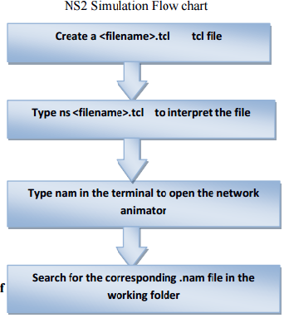

2.1Create a simulator object

A simulator object have functions that allow for the creation of nodes, links and connectingagents used in creating a network topology for the simulation in determining networkperformance . The class Simulator has all the basic functions to perform this task. Functionsbelonging to the simulator class can be used by appending “$ns” at the beginning of thecommand since the simulator object are design to be handled by ns. This is show below.

2.2 Trace file
Trace file is use in collecting data for calculating of simulation results. With the aid of NS2 tracefile, drop or arrival of packet that occurs in queue or in a link are recorded. Below is the code that is use in creating a trace file and the nam trace file for the simulation.
#Open trace files
set f [open droptail-queue-out.tr w]
$ns trace-all $f
#Open the nam trace file
set nf [open droptail-queue-out.nam w]
$ns namtrace-all $nf
2.3 Source creation
The Simulator class has a member called “node” that is use to create five nodes which are assignto be handle s0, s1, s2, G, r. The handles are used when referring to those nodes. Traffic sources(FTP and CBR) are attached to the traffic agents (TCP and UDP) and these traffic agents are attached to the nodes if a node is not a router but an end system. Below is the code for creating nodes using the Simulator class “node”.
#s1, s2 and s3 act as sources.
set s0 [$ns node]
set s1 [$ns node]
set s2 [$ns node]
#G acts as a gateway.
set G [$ns node]
#r acts as a receiver.
set r [$ns node]
2.4 Color definition for different traffic flow
In the simulation, there are two types of traffic used. These traffics can be differentiated fromone another by assigning color to each. The color assigning is done using the calling the colorfunction from the Simulator class using the commands below;
#Define different colors for data flows
$ns color 1 Yallow ; # the color of packets from s0
$ns color 2 SeaGreen ; # the color of packets from s1
$ns color 3 Blue ; # the color of packets from s2
It could be seen that the packet sent from node s0 and s1 have the assigned color red becausethey use the same TCP traffic agent and that of node s2 has green color which uses a UDP trafficagent.

2.5 Link Creation between nodes
In other to complete the network topology, links are required to connect all the different nodes together. When creating a link in NS2, the output queue and the queue type of a node are implemented as part of the link. There are two types of links namely: simplex and duplex but in this simulation all links are design to be duplex. The command for creating a duplex or simplex link between two nodes is shown by the code fragment below; $ns duplex/simplex-link endpoint1 endpoint2 bandwidth delay queue-type The code section below shows a duplex link connection between all the sources (S0, S1 and S2) and the gateway and from the gateway to the receiver using Drop tail queuing mechanism.
#Create links between the nodes
$ns duplex-link $s0 $G 6Mb 5ms DropTail
$ns duplex-link $s1 $G 6Mb 5ms DropTail
$ns duplex-link $s2 $G 6Mb 5ms DropTail
$ns duplex-link $G $r 3Mb 10ms DropTail
From the code section above, it could be seen that the duplex link connection the sources to the gateway have a bandwidth of 6Mb and a delay of 5ms. The duplex link between the gateway and the receiver has a bandwidth of 3Mb and delay of 10ms. There are several queue management algorithms implemented in ns2, but in this exercise only DropTail, RED and SFQ queuing mechanism will be needed.

2.6 Queuing size definition
The Queuing size between the gateway and the receiver need to be define.
$ns queue-limit node1 node2 number: The command above sets the queue limit of the two duplex links that connect node1 and node2 to the number specified. In this report, a queuing size of 5 is used between the gateway and the receiver. This is illustrated as shown in the code fragment below.
#Define the queue size for the link between node G (gateway) and r (receiver)
$ns queue-limit $G $r 5

2.7 Topology layout
For the simulation scenario in ns2 to run successfully, there is need to set up the layout of the network topology. This topology comprises of a collections of links and nodes. The code fragment for creating the topology using 5 nodes is shown below:
#Define the layout of the topology
$ns duplex-link-op $s0 $G orient right-down
$ns duplex-link-op $s1 $G orient right
$ns duplex-link-op $s2 $G orient right-up
$ns duplex-link-op $G $r orient right
2.8 Monitoring of queues for the links
Monitoring of queues for links is essential as it provides means of integrating quantities, which includes number of arrived packets in the queue or number of packets drops, this therefore make it possible to track the statistics of arrivals, departures and drops which can represented either in bytes or packets . Similarly, queue size overtime can be tracked by the queue monitor.
#Monitor the queues for the links
$ns duplex-link-op $s0 $G queuePos 0.5
$ns duplex-link-op $s1 $G queuePos 0.5
$ns duplex-link-op $s2 $G queuePos 0.5
$ns duplex-link-op $G $r queuePos 0.5
The code fragment above shows the queue for monitoring the links.

2.9 Creating TCP and UDP agent and attaching to nodes
UDP and TCP agents are the most commonly used agents in NS2. There are several types of TCP agent some of which are
a. Agent/TCP/Reno – a Reno TCP sender
b. Agent/TCP – a Tahoe TCP sender
c. Agent/TCP/Sack1 – TCP with selective acknowledgement
The command used for setting up a TCP agent that uses Reno and attaching to a node s0 with a window size of 8 byte which is the maximum amount of received data that can be buffered at any given time on the receiving side of the connection.
# setting a TCP agent using Reno
set tcp [new Agent/TCP/Reno]
$ns attach-agent $s0 $tcp
$tcp set window_ 8
$tcp set fid_ 1
There are several traffic sources and applications provided by NS2 and the ones implemented in this simulation are
a. Application/Traffic/CBR – generates packets with a constant bit rate
b. Application/FTP – produces bulk data that TCP will send
The command used to create an FTP application and attaching it to a TCP/Reno agent is shown
below;
#Create FTP applications and attach it to an agents
set ftp [new Application/FTP]
$ftp attach-agent $tcp
$ftp set type_ FTP
Similarly, the command use to create a CBR application and attaching it to a UDP agent is
shown by the code fragment below;
#Setup a UDP agent and attach it to node s2
set udp [new Agent/UDP]
$ns attach-agent $s2 $udp
set null [new Agent/Null]
$ns attach-agent $r $null
$ns connect $udp $null
$udp set fid_ 2
#Setup a CBR over UDP connection
set cbr [new Application/Traffic/CBR]
$cbr attach-agent $udp
$cbr set type_ CBR
$cbr set packet_size_ 1000
$cbr set rate_ 1mb
$cbr set random_ false
The packet size use for the CBR application is 1000byte with a packet rate of 1Mb per second.
2.10 Creating a TCP sink agents and attach them to node
To terminate the flow of information without any processing, a UDP and TCP sources have to be connected with traffic sinks.
Class Agent/TCPSink is used to define a TCP sink as shown below;
#Create TCP sink agents and attach them to node r
set sink0 [new Agent/TCPSink]
set sink1 [new Agent/TCPSink]
set sink2 [new Agent/TCPSink]
$ns attach-agent $r $sink0
$ns attach-agent $r $sink1
#connect the traffic sources with the traffic sinks
$ns connect $tcp0 $sink0
$ns connect $tcp1 $sink1
While Class Agent/Null is use to define a UDP sink also shown below;
set null [new Agent/Null]
$ns attach-agent $r $null
$ns connect $udp $null
2.11 Scheduling events for the FTP and CBR agents
The start and stop of the simulation and other events need to be scheduled after the simulation topology is created and user agents are also configured. Starting and stopping of the simulation can be done using the commands below;
$ns at $time “finish”
$ns run
The first command schedules the procedure finish at the end of the simulation, and the second command starts the simulation. To flush the trace buffer, closing the trace file and terminate the program with an exit routine is defined using the finish procedure. It can also start the NAM (network animator), post process information and plot the information. The code fragment below shows the scheduling of the FTP and CBR agent, starting and stopping of the simulation.
proc finish {} {
global ns nf
$ns flush-trace
#Close the NAM trace file
close $nf
#Execute NAM on the trace file
exec nam droptail-queue-out.nam &
exit 0
}
#Schedule events for the FTP and CBR agents
$ns at 0.0 "$s0 label S0"
$ns at 0.0 "$s1 label S1"
$ns at 0.0 "$s2 label S2"
$ns at 0.0 "$G label GW"
$ns at 0.0 "$r label Rx"
$ns at 0.1 "$ftp0 start"
$ns at 0.2 "$ftp1 start"
$ns at 0.3 "$cbr start"
$ns at 5.5 "$ftp0 stop"
$ns at 6.0 "$ftp1 stop"
$ns at 6.5 "$cbr stop"
$ns at 7.0 "finish"
$ns run
3.0 SOURCE CODE
This section contains the source codes that are used for the simulation. The codes are categorizedbased on the two connection technique TCP and UDP and in each of these connections different queuing mechanism (i.e DropTail, RED, and SFQ) queuing mechanism were implemented. Making a total of six different source codes.
a. Droptail queuing mechanism code
b. SFQ queuing mechanism code
c. RED queuing mechanism code

3.1 TCP Source code
3.2 UDP connection source code
3.3 SFQ queuing mechanism code
The code for the SFQ queuing mechanism is the same as that of the Droptail. They only differ at
link creation between the nodes where the Droptail is replaced with SFQ
#Create links between the nodes
$ns duplex-link $s0 $G 6Mb 5ms SFQ
$ns duplex-link $s1 $G 6Mb 5ms SFQ
$ns duplex-link $s2 $G 6Mb 5ms SFQ
$ns duplex-link $G $r 3Mb 10ms SFQ
3.4 RED queuing mechanism code
#Create links between the nodes
$ns duplex-link $s0 $G 6Mb 5ms RED
$ns duplex-link $s1 $G 6Mb 5ms RED
$ns duplex-link $s2 $G 6Mb 5ms RED
$ns duplex-link $G $r 3Mb 10ms RED

CHAPTER 4
SYSTEM DESIGN
SYSTEM ARCHITECTURE
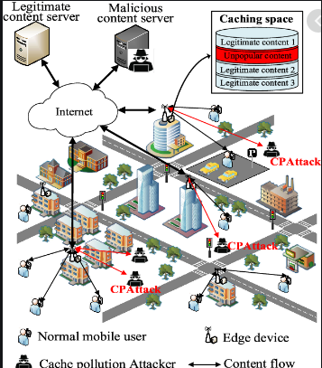

SEQUENCE DIAGRAM
Sensor Nodes
Cluster Head
Cluster Head
Base Station
Processing
Data Packets
Storage
Analysis
WSN

NS2 CODING

# Define options
set val(chan) Channel/WirelessChannel
set val(prop) Propagation/TwoRayGround
set val(netif) Phy/WirelessPhy
set val(mac) Mac/802_11
set val(ifq) Queue/DropTail/PriQueue
set val(ll) LL
set val(ant) Antenna/OmniAntenna
set val(x) 1000 ;# X dimension of the topography
set val(y) 1000 ;# Y dimension of the topography
set val(ifqlen) 50 ;# max packet in ifq
set val(seed) 0.0
set val(MCRP) MCRP
set val(nn) 71 ;# how many nodes are simulated
set val(cp) m1
set val(sc) m2
set val(stop) 4.1 ;# simulation time
set val(traffic) tcp
set val(rp) DSDV ;
proc MCRP {AODV} { return set}
set dist(x) 2.40074e-10
set freq_ 914e+6
Phy/WirelessPhy set CSThresh_ $dist(x)
Phy/WirelessPhy set RXThresh_ $dist(x)
#Phy/WirelessPhy set bandwidth_ 2e6
set ns_ [new Simulator]
# setup topography object
set topo [new Topography]
# create trace object for ns and nam
set tracefd [open mc.tr w]
set namtrace [open mc.nam w]
$ns_ trace-all $tracefd
$ns_ namtrace-all-wireless $namtrace $val(x) $val(y)
# define topology
$topo load_flatgrid $val(x) $val(y)
# Create God
$ns_ color 0 blue
set god_ [create-god $val(nn)]
# define how node should be created
#global node setting
$ns_ node-config -adhocRouting $val(rp) \
-llType $val(ll) \
-macType $val(mac) \
-ifqType $val(ifq) \
-ifqLen $val(ifqlen) \
-antType $val(ant) \
-propType $val(prop) \
-phyType $val(netif) \
-channelType $val(chan) \
-topoInstance $topo \
-agentTrace ON \
-routerTrace ON \
-macTrace OFF

$ns_ node-config -energyModel EnergyModel \
-initialEnergy 25 \
-txPower 0.75 \
-rxPower 0.3
# Create the specified number of nodes [$val(nn)] and "attach" them
set BS_(0) [$ns_ node]
for {set i 1} {$i < $val(nn) } {incr i} {
set sensor_($i) [$ns_ node]
$sensor_($i) random-motion 0 ;# disable random motion
}
puts "Loading connection pattern..."
source $val(cp)
puts "Loading scenario file..."
source $val(sc)
proc MCRP {} {
set novel MCRP}
$val(MCRP)
# Define node initial position in nam
$ns_ initial_node_pos $BS_(0) 10
for {set i 1} {$i < $val(nn)} {incr i} {
$ns_ initial_node_pos $sensor_($i) 7
}
for {set i 1} {$i < $val(nn) } {incr i} {
$ns_ at $val(stop).0 "$sensor_($i) reset";
}

proc finish {} {
global ns_ tracefd namtrace
close $tracefd
close $namtrace

set old_data 0
exec awk {
{
if (($5=="---" && $7=="tcp") || ($5=="---" && $7=="cbr")) {
old_data=old_data + $6
print $2, old_data*42.0/$2/100000
}
}
} mc.tr > MCRP_THROUGHPUT
exec xgraph MCRP_THROUGHPUT TSCP_THROUGHPUT CCBRP_THROUGHPUT -x "Time" -y "Throughput(kbps)" &
exec awk -f graph.awk mc.tr > MCRP_PACKETLOSS
exec xgraph MCRP_PACKETLOSS TSCP_PACKETLOSS CCBRP_PACKETLOSS -x "Time" -y "Packetloss(bytes)" &
exec nam mc.nam &
}
$ns_ at $val(stop).0001 "finish"
$ns_ at $val(stop).0002 "puts \"NS EXITING...\" ; $ns_ halt"
$ns_ at 1 "$ns_ trace-annotate \"...Node 0 is Base sation...\""
$ns_ at 1.5 "$ns_ trace-annotate \"...Node 33 is Cluster Head...\""
$ns_ at 1.6 "$ns_ trace-annotate \"...Node 38 is Cluster Head...\""
$ns_ at 4.8 "$ns_ trace-annotate \"...Eliminate the Malicious node...\""
$ns_ at 4.83 "$ns_ trace-annotate \"...Detect the good neighbor...\""
puts $tracefd "M 0.0 sc $val(sc) cp $val(cp) seed $val(seed)"
puts $tracefd "M 0.0 prop $val(prop) ant $val(ant)"
puts "Starting Simulation..."
$ns_ run

MODULES
- Node Creation
- Data Throughput
- Packet loss
- Energy Consumption

MODULE DESCRIPTION

Node Creation
Creating wireless nodes is also achieved using the ns_ node command: set ns_ [new Simulator] ;# Create a NS simulator object set n1 [ns_ node] ;# Create a WIRELESS node !!! However: BEFORE creating a wireless node you MUST first select (configure) the node configuration parameters to "become" a wireless node.
Data Throughput
network throughput refers to how much data can be transferred from source to destination within a given timeframe. Throughput measures how many packets arrive at their destinations successfully. For the most part, throughput capacity is measured in bits per second, but it can also be measured in data per second.
Packet loss
Packet loss, latency, and jitter are all related to slow throughput speed. Latency is the amount of time it takes for a packet to make it from source to destination, and jitter refers to the difference in packet delay. Minimizing all these factors is critical to increasing throughput speed and data performance.
Energy Consumption
Based on high data through put and less packet loss we have reduce energy demanding and achive energy Consumption

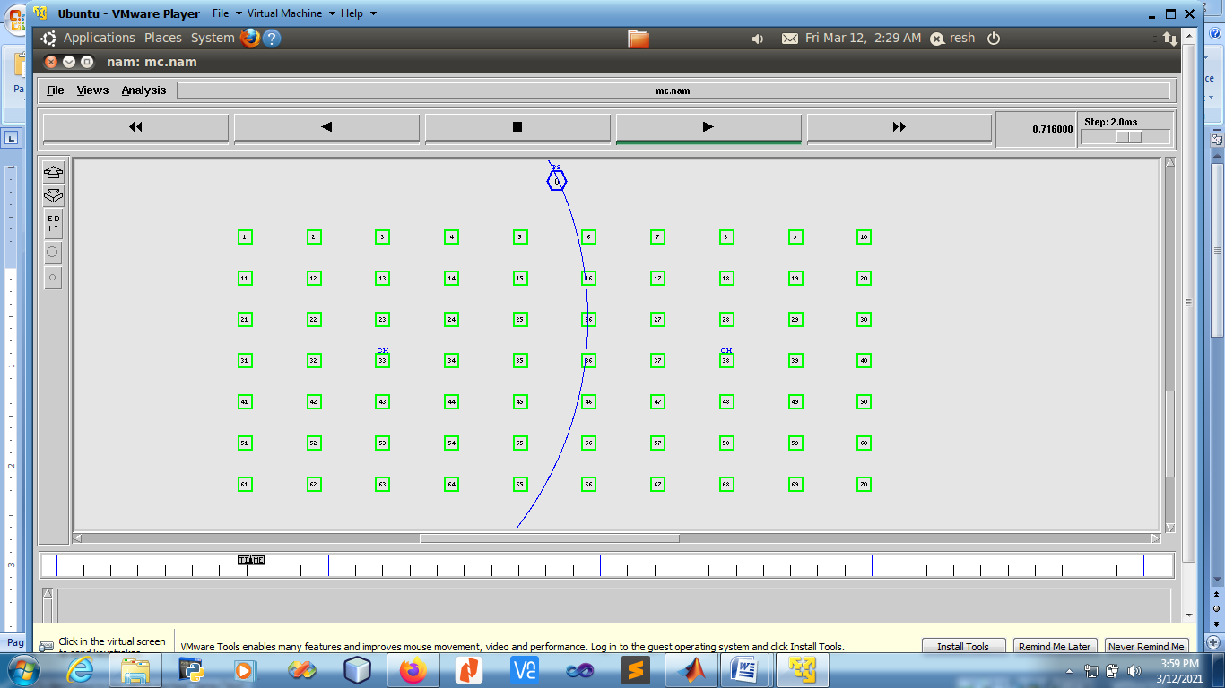
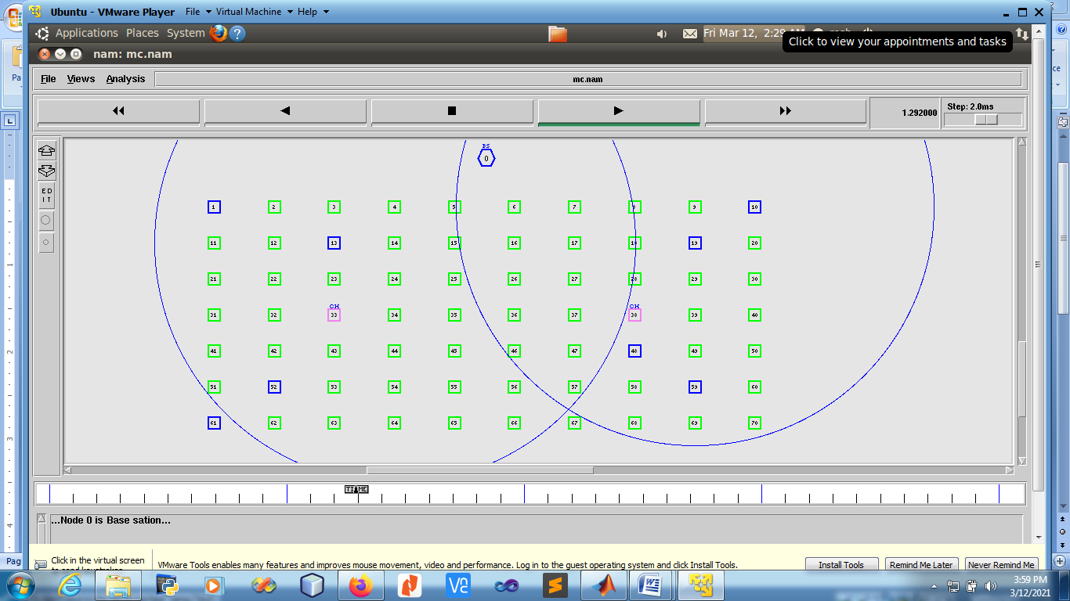
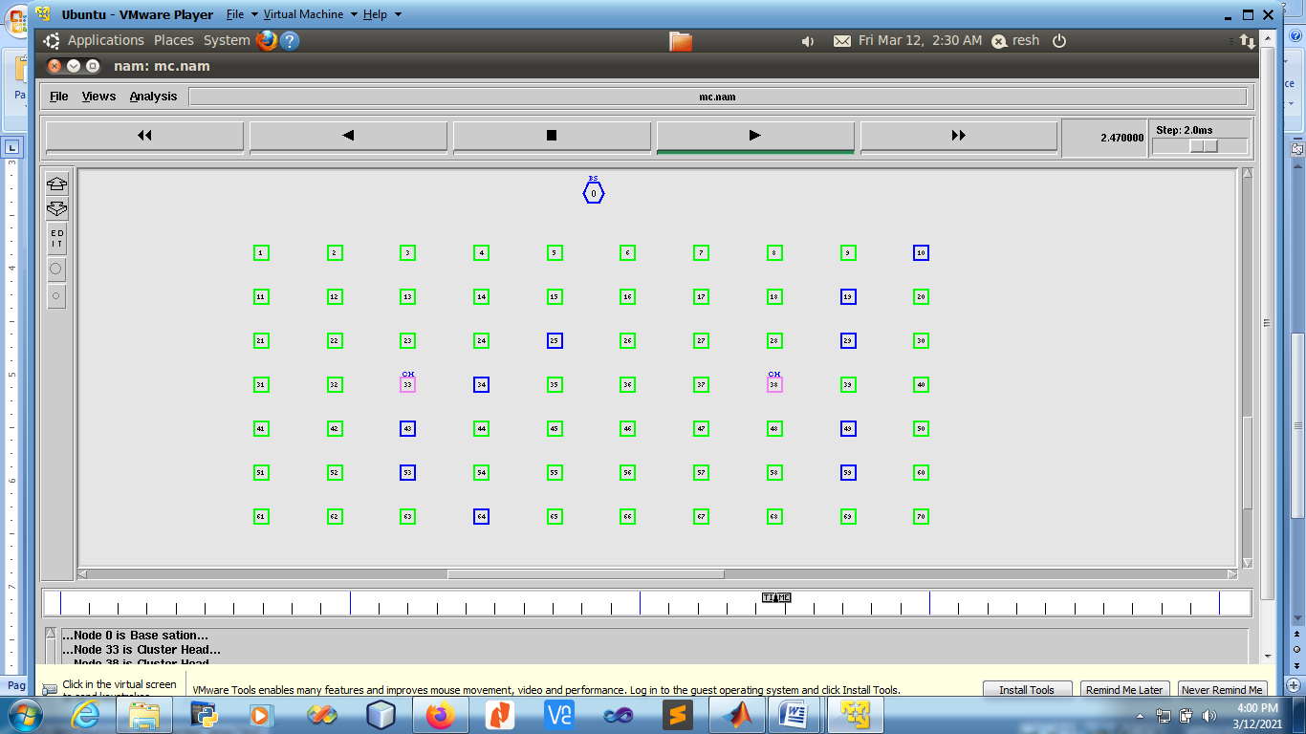
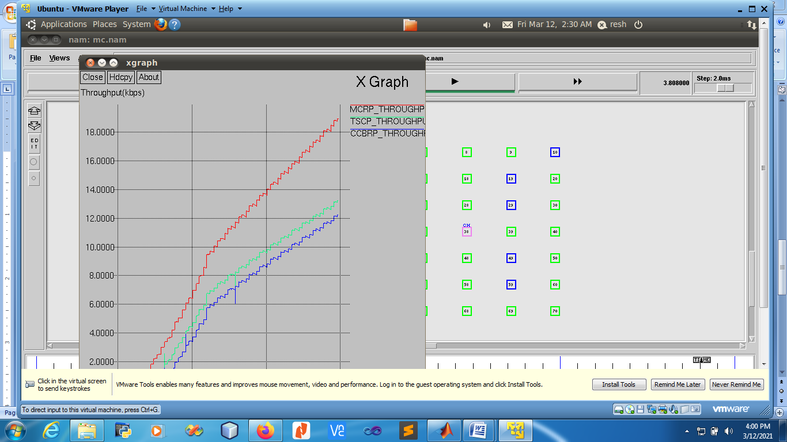
Packet Loss
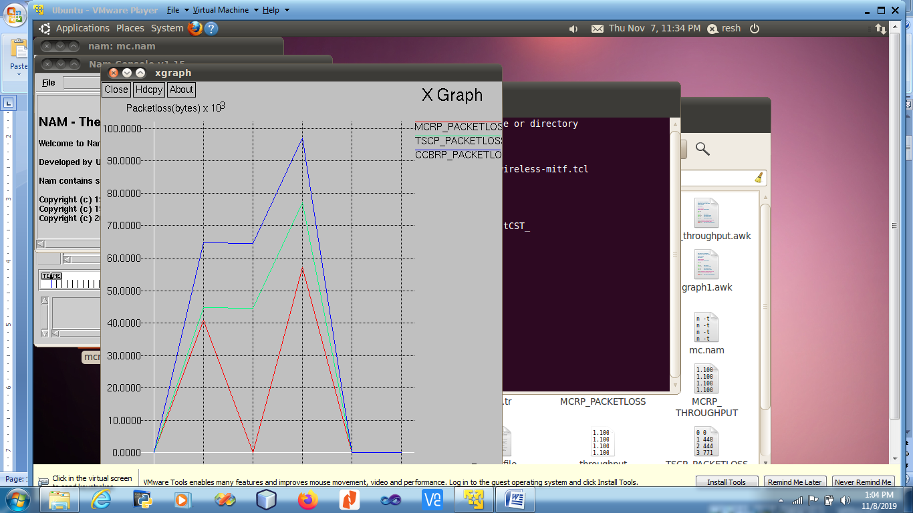

[1] E. Ahmed, I. Yaqoob, A. Gani, M. Imran, and M. Guizani, “Internet-ofthings-based smart environments: state of the art, taxonomy, and open research challenges,” IEEE Wireless Communications, vol. 23, no. 5, pp. 10–16, 2016.
[2] J. Xie, H. Tang, T. Huang, F. R. Yu, R. Xie, J. Liu, and Y. Liu, “A survey of blockchain technology applied to smart cities: Research issues and challenges, in press,” IEEE Communications Surveys Tutorials, 2019.
[3] D. Eckhoff and I. Wagner, “Privacy in the smart city—applications, technologies, challenges, and solutions,” IEEE Communications Surveys Tutorials, vol. 20, no. 1, pp. 489–516, 2018.
[4] N. Ianuale, D. Schiavon, and E. Capobianco, “Smart cities, big data, and communities: Reasoning from the viewpoint of attractors,” IEEE Access, vol. 4, pp. 41–47, 2016.
[5] G. Rostirolla, R. d. R. Righi, J. L. V. Barbosa, and C. A. da Costa, “Elcity: An elastic multilevel energy saving model for smart cities,” IEEE Transactions on Sustainable Computing, vol. 3, no. 1, pp. 30– 43, 2018.
[6] A. Ramaprasad, A. Sanchez-Ortiz, and T. Syn, “A unified definition ´ of a smart city,” in Springer International Conference on Electronic Government, St. Petersburg, Russia, 2017, pp. 13–24.
[7] Y. Mehmood, F. Ahmad, I. Yaqoob, A. Adnane, M. Imran, and S. Guizani, “Internet-of-things-based smart cities: Recent advances and challenges,” IEEE Communications Magazine, vol. 55, no. 9, pp. 16– 24, 2017.
[8] R. Buyya, C. S. Yeo, S. Venugopal, J. Broberg, and I. Brandic, “Cloud computing and emerging it platforms: Vision, hype, and reality for delivering computing as the 5th utility,” Future Generation computer systems, vol. 25, no. 6, pp. 599–616, 2009.
[9] K. Bilal, S. U. R. Malik, S. U. Khan, and A. Y. Zomaya, “Trends and challenges in cloud datacenters,” IEEE Cloud Computing, vol. 1, no. 1, pp. 10–20, 2014.
[10] S. Lehrig, H. Eikerling, and S. Becker, “Scalability, elasticity, and effi- ciency in cloud computing: A systematic literature review of definitions and metrics,” in Proceedings of the 11th ACM International Conference on Quality of Software Architectures, Montreal, QC, Canada, 2015, pp. ´ 83–92.
[11] Y. Al-Dhuraibi, F. Paraiso, N. Djarallah, and P. Merle, “Elasticity in cloud computing: State of the art and research challenges,” IEEE Transactions on Services Computing, vol. 11, no. 2, pp. 430–447, 2018.
[12] V. Delgado, “Exploring the limits of cloud computing,” Master’s thesis, KTH Information andCommunication Technology, Stockholm, Sweden, 2010.

