Fake Currency Detection Using Image Processing

ABSTRACT
- Fake currency is the money produced without the approval of the government, it is considered as a great offence. Most of them are doing it as a profession. Fake currency causes major issues in our economic growth and also it will decrease the value of original money. There are various methods available to fiused to detect these fake notes. We are going to detect the variation in barcode among nd these types of fake currency. Some are water marking, variable ink, etc.
- In this system, image processing is the real and fake one. Matlab is used in this image processing technique.

CHAPTER-1
INTRODUCTION

. Technology is growing very fast these days. Consequently the banking sector is also getting modern day by day. This brings a deep need of automatic fake currency detection in automatic teller machine and automatic goods seller machine. Many researchers have been encouraged to develop robust and efficient automatic currency detection machine [1-5]. Automatic machine which can detect banknotes are now widely used in dispensers of modern products like candies, soft drinks bottle to bus or railway tickets. The technology of currency recognition basically aims for identifying and extracting visible and invisible features of currency notes. Until now, many techniques have been proposed to identify the currency note. But the best way is to use the visible features of the note [1]. For example, color and size. But this way is not helpful if the note is dirty or torn. If a note is dirty, its color characteristic are changed widely. So it is important that how we extract the features of the image of the currency note and apply proper algorithm to improve accuracy to recognize the note. We apply here a simple algorithm which works properly. The image of the currency note is captured through a digital camera. The hidden features of the note are highlighted in the ultraviolet light. Now processing on the image is done on that acquired image using concepts like image segmentation, edgeinformation of image and characteristics feature extraction[2-3]. MATLAB is the perfect tool forcomputational work, and analysis. Feature extraction of images is challenging task in digital image processing. It involves extraction of invisible and visible features of Indian currency notes. This approach consists of different steps like image acquisition, edge detection, gray scale conversion, feature extraction, image segmentation and decision making [4-5]. Acquisition of image is process of creating digital images, from a physical scene. Here, the image is captured by a simple digital camera such that all the features are highlighted. Image is then stored for further processing.
Process of Edge detection
It is a basic tool in image processing. It is widely used in area of feature detection and extraction. This process aim at identifying point in digital image at which image brightness sharply changes.
Process of Image segmentation
This process sub divides image into it sub regions. The level of division depends on the problem. Segmentation algorithm for images which are monochromatic is based on properties of images like discontinuity and similarity.
Commonly Used Methods to Detect Fake Notes
i. See Through Register: The small floral design is printed in the middle of the vertical band and next to watermark. The floral designed on the front is hollow and in back is filled up. The floral design has back to back registration. The design will see as one floral design when seen against the light [1].
ii. Water marking: The mahatma Gandhi watermark is present on the bank notes. The mahatma Gandhi watermark is with a shade effect and multidirectional
lines in watermark [5].
iii. Optically Variable Ink: Optically variable ink is used for security feature; this type of feature is in the Rs.200, 500, and Rs. 2000 bank note. Optically variable ink as security feature for bank note is introduced in Nov.2000. The denomination value is printed with the help of optical variable ink. The color of numerical 2000 or 500 appear green, when note is flat but change the color to blue when is held in an angle [4].
iv. Fluorescence: Fluorescent ink is used to print number panels of the notes. The note also contains optical fiber. The number panel in fluorescent ink and optical
fiber can be seen when exposed to UV light.
v. Security Thread: The security thread is in 2000 and 500 note, which appears on the left of the Mahatma Gandhi’s portrait. In security thread the visible feature of ―RBI‖ and ―BHARAT‖. When note is held against the light, the security thread can be seen as one continuous line [4].

vi. Latent Image: The latent image shows the respective denomination value in numerical. On the observe side of notes, the latent image is present on the right side of Mahatma Gandhi portrait on vertical band. When the note is held horizontally at eye level then the latent image is visible.
vii. Micro Lettering: The micro letter’s appears in between the portrait of Mahatma Gandhi and vertical band. Micro letter’s contains the denomination value of bank note in micro letters. The denomination value can be seen well under magnifying glass.
viii. Identification Mark: Each note has its special identification mark. There are different shapes of identification mark for different denomination (Rs.200-H, Rs.500-circle and Rs.2000- Square). The identification mark is present on the left of water mark.
Detection of fake notes
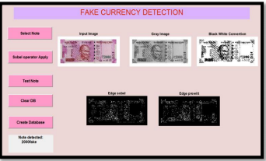

Taking Input Image and Preprocessed Image

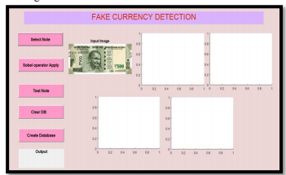

Detection of Original note

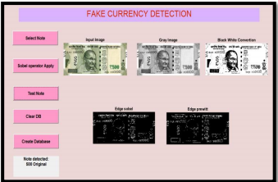

Input as a Fake Note Image

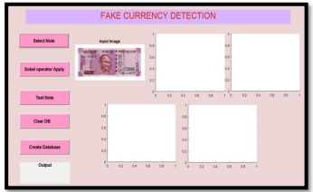

CHAPTER 2
2. SYSTEM ANALYSIS
2.1 EXISTING SYSTEM

The advancement of colour printing technology has increased the rate of fake currency note printing and duplicating the notes on a very large scale. Few years back, the printing could be done in a print house, but now anyone can print a currency note with maximum accuracy using a simple laser printer. As a result the issue of fake notes instead of the genuine ones has been increased very largely. India has been unfortunately cursed with the problems like corruption and black money .And counterfeit of currency notes is also a big problem to it. This leads to design of a system that detects the fake currency note in a less time and in a more efficient manner.

2.1.1 DRAWBACKS OF EXISTING SYSTEM
- There is a need to design a system that will helpful for recognition of paper currency notes with fast speed and in less time.
- Manual testing of notes in transactions is very time consuming and confusing process and also there is a chance of tearing while handling notes.

2.2. PROPOSED SYSTEM
The proposed system gives an approach to verify the Indian currency notes. Verification of currency note is done by the concepts of image processing. This article describes extraction of various features of Indian currency notes. MATLAB software is used to extract the features of the note. The proposed system has got advantages like simplicity and high performance speed. The result will predict whether the currency note is fake or not.
2.2.1. ADVANTAGES OF PROPOSED SYSTEM

- The result will be whether note is real or fake.
- This is the low cost system.

CHAPTER 4
TESTING AND IMPLEMENTATION

  - TESTING
Implementation is the stage of the project when the theoretical design is turned into a working system. This is the final and important phase in the system life cycle It is actually the process of converting the new system into a operational one.

4.1.1Unit Testing
Unit testing comprises the set of tests performed by an individual programmer prior to integration of the unit into a larger system. The module interface is tested to ensure that information properly flows into and out of the program unit. The local data structure is examined to ensure that data stored temporarily maintains its integrity during all steps in an algorithm’s execution. Boundary conditions are tested to ensure that the module operates properly at boundaries established to limit or restrict processing. All independent paths through the control structure are tested. All error-handling paths are tested.

4.1.2 Block Box Testing
Black-box testing is a method of software testing that examines the functionality of an application without peering into its internal structures or workings. This method of test can be applied virtually to every level of software testing: unit, integration, system and acceptance. It is sometimes referred to as specification-based testing.

4.2 SYSTEM IMPLEMENTATION
Implementation is the stage of the project when the theoretical design is turned into a working system. This is the final and important phase in the system life cycle It is actually the process of converting the new system into a operational one.

CHAPTER 5

CONCLUSION

The fake currency detection using image processing was implemented on MATLAB. Features of currency note like serial number, security thread, Identification mark, Mahatma Gandhi portrait were extracted. The process starts from image acquisition to calculation of intensity of each extracted feature. The system is capable of extracting features even if the note has scribbles on it. The algorithm processed here works suitably for the newly introduced 500 and 2000 denomination.. Hardware implementation of the proposed system can also be done using suitable processor so that to increase the speed of detection. An automatic
railway ticket booking system can also be proposed which includes currency detection as one of its part.

CHAPTER-6
REFERENCE
[1] Santhanam K proposed, Polarization Principle and Holographic Technique in Image Processing.

[2] “Indian Currency Denomination Identification Using Image Processing Technique” by Vipin Kumar Jain, Dr. Ritu Vijay.

[3] NM Joshi,RP Bajpai,G.Mitra proposed improved fake currency detector

[4] “Paper Currency verification System Based On Characteristic Extraction Using Image Processing”, by Rubeena Mirza,Vinti Nanda .

[5] E. Muthukumaran, N. Mohanraju proposed Fake currency detection & stenography.

[6] An Automated recognition of Fake or Destroyed Indian currency notes in Machine vision" by Sanjana, Manoj Diwakar, Anand Sharma

[7] C.Yanqing proposed “Counterfeirt money and antisurvelliance measures”

[8] Digital Image Processing by R. C. Gonzalez and R. E. Woods

[9] A Study on Diverse Recognition Techniques for Indian Currency Note” by Ms.Rumi Ghosh, Mr Rakesh Khare

[10] A Novel Method for Counterfeit Banknote Detection”, by R. Bhavani, A. Karthikeyan

