Study of clinical staging and classification of retinal images for retinopathy of prematurity ROP screening

ABSTRACT

Retinopathy of Prematurity (ROP) is a disease which requires immediate precautionary measures to prevent blindness in the infants, and this condition is prevalent in premature babies in all the underdeveloped, developing, and in the developed countries as well. This paper proposes a tool by which the stage and zones of Retinopathy of Prematurity in infants can be diagnosed easily. This tool takes the input from the Retcam and detects the stage, zone, and gives a rating of 1 to 9 for classifying the severity of the disease in the infants. This is achieved by extracting the optic disc, marking the ridge, and the distance of the optic nerve. This tool can be easily used by nurses and paramedics, unlike the existing technologies which require the guidance of a specialist to come to a conclusion.

CHAPTER-1
INTRODUCTION
Retinopathy of prematurity (ROP) formerly known as retrolental fibroplasias is an enigmatic disease of the developing retinal vasculature of the prematurely born infants. Itis a vasoproliferative retinopathy, first described by Terry[1] in 1942 in a premature infant who had grayish white vascular membranes behind the lens in both the eyes. Unlike the vast number of diseases, this was not a disease that was present for decades or centuries just waiting to be discovered. This disease did not exist before the 1930s. It began, as we now know, when infant incubators came intouse and supplemental oxygen was seen to promote the survival of prematurely born infants.Its incidence increases with decreasing gestation andbirthweight [2,3]. Apart from prematurity, the other risk factors of ROP include: hyperoxia, sepsis, blood transfusions, acidosis, antioxidant deficiency, patentductus arteriosus and apnea. In the Indian scenario, screening for ROP should beperformed in all preterm neonates who are born <34 weeks gestation and/or <1750 g birth weight; as well as in babies34-36 weeks gestation or 1750-2000 g birthweight if they have risk factors for ROP. These are India specific NNFguidelines and are different from Western countries due to a number of reasons [4]. Screening should start by one month after birth, and as early as 2-3 weeks of age in infants born <28 wks or <1200g birth weight as per these guidelines [5]. Meticulous coordination between the neonatologist, neonatal nurses and the ophthalmologist is required.

Classification of Retinopathy of Prematurity
The spectrum of the disease may vary from very mild cases that show spontaneous resolution to very severe cases that may cause complete bilateral blindness within the 1st year of life. In 1984, the extent of ROP was described in three zones, five stages, and the presence or absence of plus disease as per the International Classification of ROP.[⁵] The zones are described as three anterior-posterior zones as shown in Figure 1. Zone I is defined as a circle, centered on the disc, whose radius is twice the distance from the disc to the macula; Zone II extends from the edge of Zone I to the nasal ora serrata; and Zone III is the remaining temporal crescent of retina anterior to Zone II. As the disease evolves, five stages of increasing severity have been described. Stage 1 is that of a flat, white demarcation line present within the plane of the retina, separating the anterior avascular retina from the vascularized posterior retina. Stage 2 is that of a ridge which is nothing; but, the demarcation line which now becomes more prominent and increases in height to extend above the plane of the retina. Stage 3 is the presence of extraretinal fibrovascular proliferation in 1–12 clock hours in addition to the presence of the ridge. Contraction of this fibrovascular proliferation at the ridge can result in partial retinal detachment (RD) which is included in Stage 4 with Stage 4a not involving the macula and Stage 4b involving the macula. Stage 5 is when this cicatricial process results in complete RD which is usually tractional; the peripheral avascular retina may, however, remain attached especially if prior laser has been done.

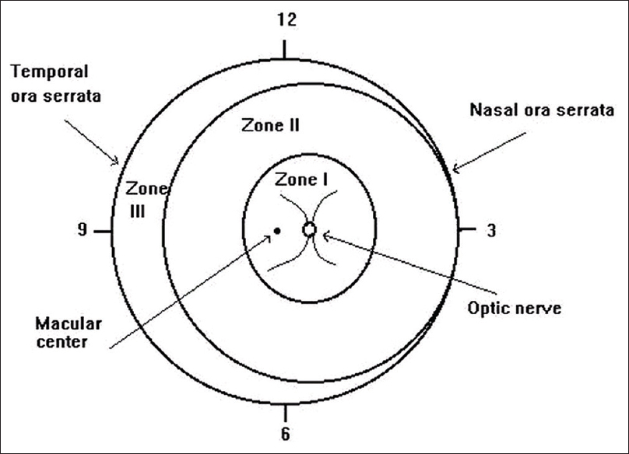

Retinal blood supply is from two sources as follows: the choroidal vessels (outer retinal layers) and the retinal vessels (inner retinal layers). Although the development of choroid is complete by 3 months of gestation, retinal vascular development is incomplete at birth in a premature child. Retinal growth starts at 16th week of gestation, reaching the nasal ora serrata by 32 weeks and temporal by 40 weeks. Hence, more the child is premature, larger is the area of avascularity.
Two retinal vascular development processes have been recognized in the eye. (1) Vasculogenesis wherein the vessels develop de novo from the endothelial cells[²¹] and (2) angiogenesis where the blood vessel formation occurs from preexisting vessels. While vasculogenesis forms the major retinal blood vessels, the angiogenesis forms the capillary plexus in the deeper and peripheral retina.[²²] The process of angiogenesis is vascular endothelial growth factor (VEGF) dependent.[^{23,24}] Both the processes are essential for normal retinal vascular development.
In utero, there is low tissue oxygen, and the developing retina is in a state of physiologic hypoxia. The development of abnormal vasculature in ROP occurs in two phases. The initial phase of vaso-obliteration occurs in response to hyperoxia which occurs on exposure of the premature baby to environmental and supplemental oxygen necessary to treat associated conditions such as respiratory distress syndrome. The second phase occurs as a result of hypoxia due to increased metabolic demands of the maturing retina. This hypoxia results in increased VEGF resulting in vasoproliferation at the edge of the vascular retina.[²⁵] VEGF has been implicated as a major factor in the pathogenesis of ROP.[²⁶] Insulin-like growth factor in addition to VEGF has also been implicated.
If not treated in time, proliferation of immature capillaries along with connective tissue starts at the junction of the avascular and vascular retina. These vasoproliferative cells also grow into the vitreous and contract resulting in traction on the retina.[^{27,28}] The vasoproliferative cells also grow along the collagen fibrils in vitreous toward the posterior capsule of the lens. With increasing traction, [Figure ​[Figure2a2a and ​andb]b] the neurosensory retina detaches from the retinal pigment epithelium (RPE) resulting in tractional detachment with a concave configuration. The effect of this traction on vascular and avascular retina is different. The vascular retina cannot stretch beyond a limit and results in detachment of the retina.[^{29,30}] The peripheral avascular retina on the contrary can stretch significantly without getting detached.[^{29,30}] This results in the presence of a fold between the vascularized and avascular retina which is popularly known as the “peripheral trough,” a unique characteristic of Stage 5 RDs. Further contraction results in narrowing of this funnel-like RD. Varying degree of this contraction gives retinal funnel, the nomenclature of Open-Open (open anteriorly and posteriorly); Open-Close (open anteriorly and closed posteriorly); Close-Open (close anteriorly and open posteriorly); and Close-Close (both anterior- and posterior-closed funnel detachment). As proliferation continues, the fibrous tissue becomes more opaque resulting in white, dense membranes seen posterior to the lens giving Stage 5 ROP the name of retrolental fibroplasia (RLF).
Retinal Imaging
The crux of any telemedicine model depends on the ability to acquire high quality retinal images for review by a medical expert geographically distant from the patient. Early efforts at retinal imaging, such as with the NM-200D camera (NIDEK, Inc, Fremont, CA) that provided a 30° field of view, were limited in clinical effectiveness due to a restricted field of view. Advances in imaging technology have significantly increased the ability to image the pediatric retina. RetCam (Clarity Medical Systems, Inc, Pleasanton, CA) is a mydriatic wide field fund us imaging system that achieves a 130° field of view with a handheld contact camera system. Many ophthalmologists and neonatal intensive care units (NICUs) have adopted RetCam in the clinical management and documentation of ROP. More recently, retinal imaging systems suited to digital wide-field retinal imaging in ROP include the PanoCam LT (Visunex Medical Systems, Fremont, CA) and 3nethra neo (Forus Health, Bangalore, India) systems. The PanoCam LT has a compact wireless, contact-based system that achieves a 130° field of view, while the 3nethra neo is a lightweight compact, contact-based system for high definition imaging that achieves a 120° field of view. Optomap (Optos plc, Dunfermline, Scotland) is a non-contact, non-mydriatic ultra-wide field imaging system that achieves a 200° field of view. Optomap has been used in ROP imaging in infants, but may require a ‘flying baby’ technique of manually holding infants to the imaging device.28 This process can be technically challenging and difficult to integrate into the NICU workflow, and Optomap has not yet been widely adopted for digital retinal imaging in ROP.
The advantages of wide-field retinal imaging and telemedicine for ROP extend beyond its potential for ROP screening. It is an effective modality that enables clinicians to share clinical findings with other physicians, healthcare staff and patient families. Wide-angle photography has been shown to be safe,29 and allows for objective documentation of examination findings, improved detection of disease progression over time by comparison to baseline photographs, and may enable a more precise review of subtle clinical findings that may have been missed from limited bedside binocular indirect ophthalmoscopic examination. There is evidence suggesting that use of digital wide-field retinal imaging in telemedicine may detect moderate to severe ROP earlier than traditional ophthalmoscopy.9 Ophthalmologist time requirement for ROP diagnosis may be less with telemedicine compared to ophthalmoscopy.30Inherent difficulties with ophthalmoscopy such as infant movements, small pupils, and paper-based hand-drawn documentation of retinal findings may also lead to inadequate assessments with traditional ophthalmoscopy.

Changes in ROP phenotype worldwide: The “third epidemic” of ROP
The first epidemic of ROP occurred because of unregulated oxygen use. As smaller infants of younger gestational ages survived, the second epidemic of ROP was recognized. Now, a “third epidemic” has been described in countries with sufficient resources to save premature infants,68 but insufficient resources to provide optimal prenatal and perinatal care and regulate and monitor oxygen.54 Several believe the new “epidemic” reflects a repeat in history and other factors like genetic differences. In developed countries the risk of blindness from ROP is <10%, but can be as high as 40% in developing countries130 where larger infants of older gestational ages have severe ROP.154 This last observation highlights the importance of developing specific ROP screening criteria for individual regions throughout the world. Another consideration regarding differences in ROP phenotypes is that of comparing effects from new treatments in different patient groups. Intravitreal anti-VEGF treatment to growth-restricted infants of younger developmental ages, as seen in the USA, may have adverse effects on organ development and more safety concerns than in infants of larger body weights and older developmental ages (see Section 4).

Studies on oxygen saturation

The level of oxygenation safe for infants and to reduce ROP was readdressed after recognition that stresses besides high oxygen at birth were associated with severe ROP. The Supplemental Therapeutic Oxygen to Prevent ROP study was designed to test the effect of increased oxygenation in an effort to offset later hypoxia from avascular retina. The Supplemental Therapeutic Oxygen to Prevent ROP study found no increase in threshold ROP when premature infants with prethreshold
ROP were maintained at 96e99% oxygen saturation (SaO2) compared to 89e94% SaO2.4 Subsequently, several small-scale studies suggested low oxygen saturation targets reduced ROP risk.179 From these studies, the multicenter Surfactant, Positive Airway Pressure, Pulse Oximetry Randomized Trial (SUPPORT) was performed to compare intubation and surfactant versus continuous positive airway
pressure on a number of outcomes, including ROP. Infants were assigned to target oxygen saturations of 85e89% versus 91e95% SaO2.51 ROP occurred less often in the low oxygen saturation group, but mortality was increased. There was variability in infant survival among the centers of SUPPORT, but the Benefits of Oxygen Saturation Targeting Study II (BOOST-II) in the UK and Australia tested the same oxygen targets and found a greater survival among infants at the higher oxygen saturation range.167 The Canadian Oxygen Trial, however, did not find any differences in ROP or mortality in infants assigned to either oxygen saturation range.152 There are differences in the infants enrolled in COT versus SUPPORT
or BOOST-II. Now many neonatologists are concerned with risking infant survival by lowering oxygen saturation targets as a strategy to manage ROP. Some believe that fluctuations in oxygenation are more important in causing severe ROP than
are absolute targets.76 In keeping to the strict range of target oxygen saturations, inspired oxygen (FiO2) might be adjusted frequently, and this practice may lead to swings in oxygen saturation in infants.

Anti-VEGF studies
Evidence suggests that regulating VEGF signaling through VEGF receptors can restore physiologic homeostasis and permit ordered developmental intraregional angiogenesis, thereby reducing hypoxic peripheral vascular retina, which drives disordered angiogenesis, when the infant is removed from high supplemental oxygen.72,206 Inhibition of VEGF also reduces in travitreal vasoproliferation.89,187 Therefore, inhibiting VEGF signaling is plausible not only to reorder developmental angiogenesis206 to prevent vasoproliferation and
facilitate physiologic retinal vascular development, but also to reduce the need for destructive therapies like laser or cry therapy. Restoring VEGF signaling to physiologic levels locally in the retina would seem an ideal treatment. Preclinical data, however, support the substantial concerns with the use of anti-VEGF treatment in ROP. First, VEGF is important in the development of the retinal vasculature and other tissue beds60,164 and in homeostasis of developed vascular beds and of glia and neurons.
ROPdistribution
Any stage ROP developed in 15% of eyes in Group 1, 46.5% of eyes in Group 2, and 100% of eyes in Group 3 during the entire follow-up period. While only 16 of 128 eyes (12.5%) in Group 1 required treatment, 12 of 72 (16.6%) and 28 of 44 of eyes (63.6%) in Groups 2 and 3, respectively, required treatment during their follow-up. Median (with IQR in brackets) number of visits in Group 1 was 4 (3–4), Group 2 was 4 (4–5), and Group 3 was 10 (8–11). Multivariate logistic regression evaluating the associations between birth weight, gender, PMA, grade of immaturity, and number of visits with the presence of disease and need for treatments represented in [Table 2]. The results show that lower birth weight and lower PMA had greater odds of developing disease and requiring treatment. Lower birth weight was also associated with a greater number of visits. Male children had greater odds of developing disease and requiring treatment and needed more number of visits

Antioxidants

Antioxidant studies, to date, have not been as promising as hoped in preventing or treating ROP. NADPH oxidase inhibitors have been beneficial in experimental OIR models. NADPH oxidase, however, also has important effects on fighting infection in the immune-compromised premature infant. Some antioxidants, such as vitamin E, showed benefit in reducing retinopathy, but the safety profile was not adequate. Other antioxidants may not access intracellular signaling. Lutein/zeaxanthin may reduce oxidative stress and theoretically provide a source of macular pigment in developing photoreceptors. The studies currently have not shown an effect but may require increased sample size and refinement of
studies based on doses needed and timing of intervention. N-acetyl cysteine was tested compared to control, but no effect was found in reducing ROP severity. It is important when assessing outcomes in clinical trials to assess whether infant populations and outcomes, for example, ROP versus
severe ROP, were similar among trials.

Light
The LIGHT-ROP clinical trial tested the hypothesis that increased light to premature infants postnatally would affect severity of ROP. At birth, infants less than 1251 g were either randomized to wear goggles that reduced visible light 97% and ultraviolet light 100% or control until 31-week postgestational age or 4 weeks after birth when the first eye examination would be performed. There was no effect on ROP severity by reducing light. A subsequent Cochrane review also showed no effect on ROP from light exposure during the first 7 postnatal
days. Since the LIGHT-ROP study, other intriguing experimental studies provided evidence that prenatal light limits retinal ganglion cell number, hypoxia, and VEGFA overexpression, thus permitting hyaloidal regression and retinal vascular development to ensue in orderly fashion. The mechanism appeared to be melanopsin dependent. A study in human preterm infants then followed and was conducted in Cincinnati, which is located in a region of the world in which day length varies depending on the time of year. The hypothesis was that infants in gestation during longer daylight would have more normal retinal vascular development and, therefore, less severe ROP. A retrospective multiple logistic
regression analysis of 343 premature infants born smaller than 1251 g found that higher average day length significantly reduced the likelihood of having severe ROP.200 Further study is warranted.
Which infants should be screened for ROP?
Evidence: The American Academy of Pediatrics (AAP) guidelines 6, 7 state that infants with a birth weight of less than 1500 g or gestational age of 30 weeks or less (as defined by the attending neonatologist) and selected infants with a birth weight between 1500 and 2000g or gestational age of more than 30 weeks with an unstable clinical course, including those requiring cardiorespiratory support and who are believed by their attending pediatrician or neonatologist to be at high risk, should have retinal screening examinations. In India, the gestational age of infants is not always known or accurate; in addition, ROP has been reported in larger babies with a birth weight between 1500 and 2000 grams. There have been several anecdotal reports from ophthalmologists of babies between 1750 and 2000 grams being diagnosed with ROP. However, there is a paucity of population based data of ROP in these larger neonates. There is a concern that screening all infants with a birth weight of < 2000 g will considerably increase the number of eligible infants; this is unlikely to be feasible in the current scenario of limited access to trained ophthalmologists. Hence, a birth weight of less than 1750 grams and/or gestational age of less than 34 weeks may be used as a cut-off for performing retinal screening examinations. Babies with a gestational age of 34 to 366/7 weeks gestation or a birth weight between 1750 and 2000 grams should also be screened if risk factors for developing ROP are present.6-10 The traditional risk factors considered are mechanical ventilation, prolonged oxygen therapy and hemodynamic instability. It should be remembered that lack of taking these factors into serious consideration may inadvertently exclude the infants at risk for significant ROP and careful review for risk factors should be undertaken by the pediatrician.

When is treatment of ROP indicated?
Evidence: Prior to December 2003, the CRYO-ROP15 treatment guidelines were followed. Only a more advanced proliferative stage termed as ‘threshold disease’ was treated. This was defined as “at least 5 contiguous or 8 cumulative clock hours of stage 3 ROP in zone I or II in the presence of plus disease.” The Early Treatment for Retinopathy of Prematurity study (ETROP) 16 study showed that early treatment of high-risk prethres holdROP significantly reduced unfavorable outcomes to a clinically important degree. Ablative therapy is indicated for high risk ROP or type 1 ROP, defined as any of the following: a) Zone I, stage 1 to 3 ROP with plus disease, b) Zone I, stage 3 ROPwithout plus disease and c) Zone II, stage 2 or 3 ROP withplus disease.Recommendation: The guidelines from the above study are the currently recommended indications for ablative treatment and are summarized in table 2. AP-ROP also needs early and aggressive laser treatment, often in multiple sessions to prevent retinal detachmen

How should ROP be treated?
Evidence & Recommendation: The aim of the treatment is to ablate the entire avascular retina up to the ora serrata in a near confluent burn pattern getting as close to the edge of the ridge as possible.18, 19 Treatment should be carried out in the NICU or in a setting where monitoring and resuscitation facilities and trained personnel are readily available. Laser photocoagulation delivered by the indirect ophthalmoscopic device is the mainstay of ROP treatment. Laser has supplanted cryotherapy due to better structural and functional outcomes. It is a safer and a more controlled procedure. Laser therapy can be done under topical anesthesia (0.5% proparacaine HCl, 4% xylocaine), general anesthesia or sedation. Laser treatment, using the ETROP guidelines, has a greater than 90% successful outcome. Post-treatment recommendation: The child can be fed after about 30 minutes following completion of the procedure. Vital signs must be monitored. It is preferable that the child be under the supervision of the neonatologist or an anesthesiologist for at least 2-3 hours following the procedure. Post-treatment hypothermia and hypoglycemia are common and must be prevented. Mild conjunctival chemosis and hyperemia following the procedure may last for a few days and the parents must be counseled regarding this. Follow-up visits recommendation: This may be typically scheduled after week 1, 2, 4 and 12 following treatment based on the findings recorded by the treating ophthalmologist. Long-term follow up for development of visual problems is also essential.

CHAPTER 2
2. SYSTEM ANALYSIS
2.1 EXISTING SYSTEM

Retinopathy of Prematurity (ROP) is a disease which requires immediate precautionary measures to prevent blindness in the infants, and this condition is prevalent in premature babies in all the underdeveloped, developing, and in the developed countries as well.

2.1.1 DRAWBACKS OF EXISTING SYSTEM
This has become increasingly prevalent. It may be less affected with no effects to the visual, or very prevalent with neovascularization which is new vessel formation and can move on to become retinal detachment or blindness.

2.2. PROPOSED SYSTEM

ROP plus disease likely exists as a continuous spectrum of retinal vascular abnormality. Thus, the performance of the convolution neural network algorithm in detecting intermediate and less severe pre-plus disease was evaluated. The statistical performance of the classifier was evaluated in an expanded external test set of fungal images, which comprised of the initial external test set of normal retina image and disease images, with an additional preplus disease fungal images. Statistical performance was measured by calculating sensitivity, specificity, accuracy, positive predictive value, and negative predictive value measured.

2.2.1. ADVANTAGES OF PROPOSED SYSTEM

- Our tool is based on image processing which is easy and simple for processing the image using Matlab. We have used Matlab 2015a in which the image processing tool provides us a reference for algorithms which is a standard set, functions which can be used, and a good platform for image processing, image analysis, visualization of image, and algorithm calculation.

Literature Survey
AUTHOR | TITTLE | DESCRIPTION
A. B. Fulton, R. M. Hansen, R. A. Petersen, and D. K. Vanderveen, | “The Rod Photoreceptors in Retinopathy of Prematurity,” Arch. Ophthalmol., vol. 119, no. 4, pp. 499, Apr. 2001. | To test the hypothesis that the more severe the acute phase retinopathy of prematurity (ROP) was in the preterm weeks, the more severely compromised is rod photoreceptor function after the ROP has resolved.
A. Vinekar, M. T. Trese, and A. Capone, | “Evolution of Retinal Detachment in Posterior Retinopathy of Prematurity: Impact on Treatment Approach,” | To provide insight into the course of retinal detachment in eyes with aggressive posterior retinopathy of prematurity (APROP). Prospective, multicenter, masked clinical trial. Multicenter trial based on serial digital photographic imaging detailing five infants (in the Photographic Screening for Retinopathy of Prematurity [PHOTO-ROP] Study) in whom bilateral retinal detachment developed during the course of the study.
M. D. Abràmoff, S. Member, M. K. Garvin, and M. Sonka, | “Retinal Imaging and Image Analysis,” | Automated retinal image analysis has been emerging as an important diagnostic tool for early detection of eye-related diseases such as glaucoma and diabetic retinopathy.
A. Hellström, L. E. H. Smith, and O. Dammann, | “Retinopathy of prematurity,” | The understanding, diagnosis, and treatment of retinopathy of prematurity have changed  in the 70 years since the original description of retrolental fibroplasias associated with high  Oxygenation. It is now recognized that retinopathy of prematurity differs in appearance worldwide and as ever smaller and younger premature infants survive.
Y. Murakami, A. Jain, R. A. Silva, E. M. Lad, J. Gandhi, and D. M. Moshfeghi, | “Stanford University Network for Diagnosis of Retinopathy of Prematurity. | Middle-income countries such as India are suffering from the third epidemic of retinopathy of prematurity (ROP). Improved survival and lower infant mortality rates have resulted in an increased number of preterm survivors in rural areas that unfortunately lack ROP specialists.

2.3 FEASIBILITY STUDY
The feasibility Analysis is an analytical program through project manager determines the project success ratio and through feasibility study project manager able to see either project. The key considerations involved in the feasibility analysis are:
- Economic Feasibility
- Technical Feasibility
- Operational Feasibility
- Environmental Feasibility
2.3.1 ECONOMICAL FEASIBILITY
Hence this project is economically feasible there is no need to involve any cost for this project.
2.3.2 TECHNICAL FEASIBILITY
Software Technologies used are PHP and MySql. In the educational institutions, it is possible to update the system in future. No special hardware is required for the purpose of using this system. Hence it is declared that this project is technically feasible.
2.3.3 OPERATIONAL FEASIBILITY
As the admin work mainly to maintain the Patient and Doctor .Doctor will predict patient cancer disease. Hence it is easy to operate with training. Therefore it is operationally feasible for implementation.

2.3.4 ENVIRONMENTAL FEASIBILITY
This project environment is correct as a admin has developed this system and no expenditure is involved under any head and this process is part of admin document management, this project environment is accessible.
2.4 SYSTEM REQUIREMENTS
- System : Pentium IV 2.4 GHz.
- Hard Disk : 40 GB.
- Monitor : 15 inch VGA Color.
- Mouse : Logitech Mouse.
- Ram : 512 MB
- Keyboard : Standard Keyboard

2.4.1 HARDWARE REQUIREMENTS
The Hardware of the computer consists of physical component such as Input Devices, Storage Devices, Processing & Control units and Output Devices. Computer includes external storage unit to store data in programs.
The Hardware Configuration involved in this project
- System : Pentium IV 2.4 GHz.
- Hard Disk : 40 GB.
- Monitor : 15 inch VGA Color.
- Mouse : Logitech Mouse.
- Ram : 512 MB
- Keyboard : Standard Keyboard

2.4.2 SOFTWARE REQUIREMENTS
Software is a group of programs that computers need to do a particular task. It is an essential requirement of Computer System. The Software used to develop the project is
- Operating System : Windows XP.
- Platform : DOT NET TECHNOLOGY
- Front End : ASP.Net 3.5
- Back End : SQL SERVER 2005

2.5 MODULE DESCRIPTION

CHAPTER 3
SYSTEM DESIGN AND DEVELOPEMENT

3.1 DATA FLOW DIAGRAM

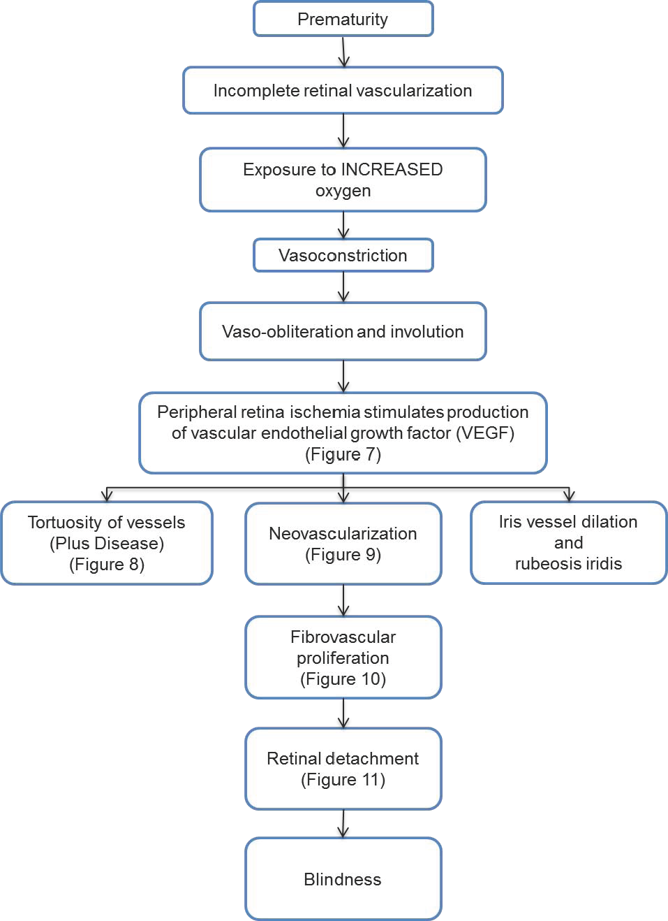

3.2 SYSTEM ARCHICTURE

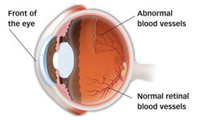

UML DIAGRAM

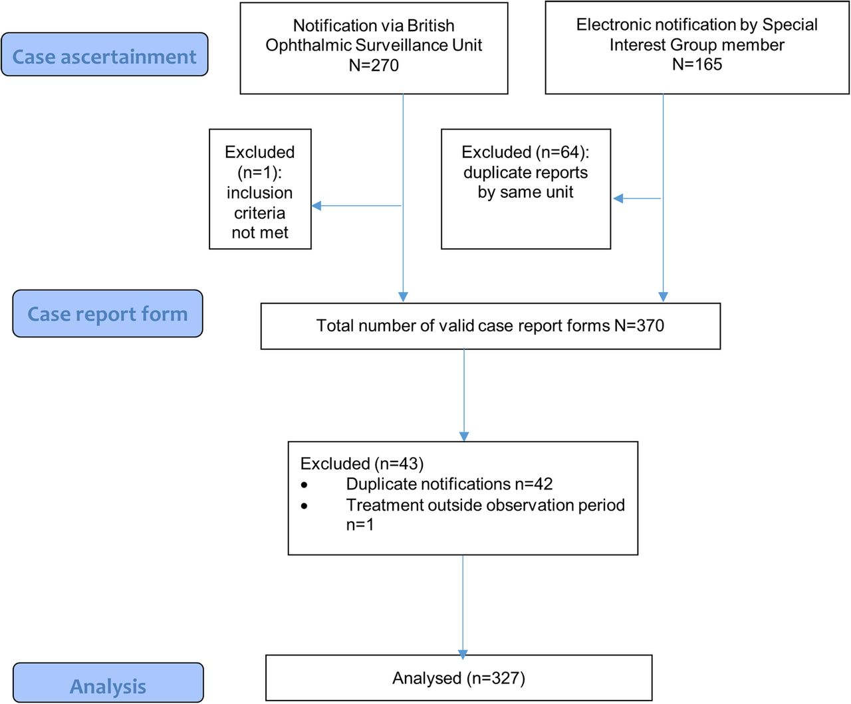

CHAPTER 4
TESTING AND IMPLEMENTATION

  - TESTING
Implementation is the stage of the project when the theoretical design is turned into a working system. This is the final and important phase in the system life cycle It is actually the process of converting the new system into a operational one.

4.1.1Unit Testing
Unit testing comprises the set of tests performed by an individual programmer prior to integration of the unit into a larger system. The module interface is tested to ensure that information properly flows into and out of the program unit. The local data structure is examined to ensure that data stored temporarily maintains its integrity during all steps in an algorithm’s execution. Boundary conditions are tested to ensure that the module operates properly at boundaries established to limit or restrict processing. All independent paths through the control structure are tested. All error-handling paths are tested.

4.1.2 Block Box Testing
Black-box testing is a method of software testing that examines the functionality of an application without peering into its internal structures or workings. This method of test can be applied virtually to every level of software testing: unit, integration, system and acceptance. It is sometimes referred to as specification-based testing.

4.2 SYSTEM IMPLEMENTATION
Implementation is the stage of the project when the theoretical design is turned into a working system. This is the final and important phase in the system life cycle It is actually the process of converting the new system into a operational one.

CHAPTER 5
CONCLUSION
CONCLUSION

Since the original observations of retrolental fibroplasias, many changes in technology, science, and clinical medicine have improved our understanding of the pathogenesis of retinopathy of prematurity. Technical advances in the ability to regulate environmental conditions of the premature infant have improved the survival of extremely premature infants. Scientific techniques to understand the molecular mechanisms involved in path physiology provide insight into the normal and pathologic developmental angiogenesis and are now exploring the role of neurovascular interactions in cognitive function and angiogenesis. Important clinical trials have provided information as to the role of oxygenation, screening and classification, and methods of treatment of severe ROP. It has become increasingly recognized that ROP differs worldwide and that there is a need to consider tailored screening and treatment approaches. Treatment of ROP remains an area of study. Targeted therapies to reduce aberrant vasoproliferation and facilitate physiologic retinal vascular development without harming the developing infant are needed.

CHAPTER-6
REFERENCE

[1] A. B. Fulton, R. M. Hansen, R. A. Petersen, and D. K. Vanderveen, “The Rod Photoreceptors in Retinopathy of Prematurity,” Arch. Ophthalmol., vol. 119, no. 4, pp. 499, Apr. 2001.

[2] “The International Classification of Retinopathy of Prematurity Revisited,” Arch. Ophthalmol., vol. 123, no. 7, pp. 991, 2005.

[3] A. Vinekar, M. T. Trese, and A. Capone, “Evolution of Retinal Detachment in Posterior Retinopathy of Prematurity: Impact on Treatment Approach,” Am. J. Ophthalmol., vol. 145, no. 3, 2008.

[4] M. D. Abràmoff, S. Member, M. K. Garvin, and M. Sonka, “Retinal Imaging and Image Analysis,” IEEE Rev. Biomed. Eng., vol. 3, pp. 169–208, 2010.

[5] A. Hellström, L. E. H. Smith, and O. Dammann, “Retinopathy of prematurity,” Lancet, vol. 382, no. 9902, pp. 1445–1457, 2013.

[6] M. A. W. Hussein, D. K. Coats, and E. A. Paysse, “Use of the RetCam 120 for fundus evaluation in uncooperative children,” Am. J. Ophthalmol., vol. 137, no. 2, pp. 354–355, Feb. 2004.

[7] C. E. Gilbert, L. Anderton, L. Dandona, and A. Foster, “Prevalence of visual impairment in children: a review of available data.,” Ophthalmic Epidemiol., vol. 6, no. 1, pp. 73–82, Mar. 1999.

[8] A. Vinekar, C. Jayadev, S. Mangalesh, B. Shetty, and D. Vidyasagar, “Role of tele-medicine in retinopathy of prematurity screening in rural outreach centers in India - a report of 20,214 imaging sessions in the KIDROP program,” Semin. Fetal Neonatal Med., vol. 20, no. 5, pp. 335–345, 2015.
[9] A. Vinekar, R. Azad, M. R. Dogra, V. Narendran, S. Jalali, and P. Bende, “The Indian retinopathy of prematurity society: a baby step towards tackling the retinopathy of prematurity epidemic in India,” Ann. Eye Sci., vol. 2, pp. 27–27, May 2017.

[10] R. C. Gonzalez, R. E. (Richard E. Woods, and S. L. Eddins, Digital Image processing using MATLAB. McGraw Hill, 2011.

[11] C. Heneghan, J. Flynn, M. O’Keefe, and M. Cahill, “Characterization of changes in blood vessel width and tortuosity in retinopathy of prematurity using image analysis.,” Med. Image Anal., vol. 6, no. 4, pp. 407–29, Dec. 2002.

[12] Y. Murakami, A. Jain, R. A. Silva, E. M. Lad, J. Gandhi, and D. M. Moshfeghi, “Stanford University Network for Diagnosis of Retinopathy of Prematurity (SUNDROP): 12-month experience with telemedicine screening,” Br. J. Ophthalmol., vol. 92, no.

