A Review on Computational Intelligence Techniques in Cloud and Edge Computing

ABSTRACT

Cloud computing (CC) is a centralized computing paradigm that accumulates resources centrally and provides these resources to users through Internet. Although CC holds a large number of resources, it may not be acceptable by real-time mobile applications, as it is usually far away from users geographically. On the other hand, edge computing (EC), which distributes resources to the network edge, enjoys increasing popularity in the applications with low-latency and high-reliability requirements. EC provides resources in a decentralized manner, which can respond to users’ requirements faster than the normal CC, but with limited computing capacities. As both CC and EC are resource-sensitive, several big issues arise, such as how to conduct job scheduling, resource allocation, and task offloading, which significantly influence the performance of the whole system. To tackle these issues, many optimization problems have been formulated. These optimization problems usually have complex properties, such as non-convexity and NP-hardness, which may not be addressed by the traditional convex optimization-based solutions. Computational intelligence (CI), consisting of a set of nature-inspired computational approaches, recently exhibits great potential in addressing these optimization problems in CC and EC. This article provides an overview of research problems in CCand EC and recent progresses in addressing them with the help of CI techniques. Informative discussions and future research trends are also presented, with the aim of offering insights to the readers and motivating new research directions.

CHAPTER-1
INTRODUCTION
Cloud computing (CC) is a paradigm of computing technologies that provides on demand services to its clients. The vision of CC is to offer computing, storage, and network resources centrally in the remote clouds, which is related to data centers, backhaul networks, and core networks [1], [2]. It is architecture for allowing appropriate, pervasive, and on request access to a shared pool of configurable resources [3]. The large number of resources available in the central cloud can then be leveraged to deliver elastic computing capacity and storage to support resource-constrained end devices. It has been driving the rapid growth of many Internet companies [4]. For example, the cloud business has risen to be the most profitable sector for Amazon [5], and Drop box’s success depends highly on the cloud service of Amazon. It can intensify collaboration, scalability, nimbleness, and availability for enterprises as well as users. CC offers services on a payasyou go basis and reduces hardware and software costs, energy, and carbon footprints by providing an optimized and sufficient computing environment [6]. In CC, users first offload tasks to the central cloud, and then the central cloud executes the tasks on behalf of users and sends back results to users [7].
Although CC provides a vast number of resources, easy back and recovery, high accessibility as well as an eco-friendly environment for users (i.e., can be accessed anytime from anywhere on demand), it may not be capable of fulfilling the requirements of real-time applications with low latency and
high reliability as the central cloud is far away from users. On the other hand, edge computing (EC), which deploys the resources, data, and services from the central cloud to the network edge, enjoys increasing popularity recently. It enables analytics and knowledge generation to occur at or close to users’ end. In EC, users first offload tasks to the nearby edge cloud, and then the edge cloud executes their tasks and sends outcomes back to users. Fig. 1 presents a typical architecture of CC and EC, where edge clouds can provide computing and network resources between users and the central cloud. Compared with CC, EC can provide services with low latency, high security, and high mobility but with limited computing capacities. CC and EC facilitate a wide range of applications including virtual reality/augmented reality, online game, online video, etc.
In CC and EC, several metrics are related to the quality of service (QoS), such as security and privacy, latency, resource utilization, cost, energy consumption, throughput, and make span. In order to improve these metrics, we need to consider several issues, such as job scheduling, resource allocation, and task offloading. For example, security and privacy can be improved by designing efficient task offloading schemes [8]. In addition, latency and energy consumption can be optimized by designing proper resource allocation [9] and task offloading schemes [10], [11]. Similarly, other metrics can be improved by considering job scheduling, resource allocation, and task offloading. To this end, many optimization problems have been formulated for tackling these issues. However, compared with optimization problems in other areas, these optimization problems are normally highly complex and NP-hard, which may include mixed/strongly, coupled variables, nonlinear constraints, multiple objectives, and bilevel structures. Therefore, they may not be solved by the traditional convex optimization-based methods. In addition, their optimal solutions should be found within a reasonable amount of time. Computational intelligence (CI) exhibits great potential in addressing complex optimization problems, which has attracted much attention from both academia and industry. CI includes evolutionary algorithms (EAs), swarm intelligence algorithms (SIAs), fuzzy system (FS), learning based system (LBS), and hybrid system (HS). These CI techniques have the capability to process imprecise information and search for approximate yet good enough solutions while ensuring robustness and computational tractability [12]. The aim of this paper is to present a review of CI techniques to address issues in CC and EC. Several survey papers and books have been devoted to CC and EC. For example, Hoang et al. [13] presented a survey on architecture, applications, and approaches in mobile CC (MCC). A short review on task scheduling in CC is carried out in [14]. QoS in CC is surveyed in [15] and [16]. Wu [17] studied multi-objective decision making for offloading decision in MCC. An extensive survey on MCC is given in [18]. A survey on challenges and opportunities in CC is presented in [19]. Zhou et al. [20] published a survey on artificial intelligence (AI) in EC. In [21], visions and challenges of EC are discussed. A survey on EC for Internet of things (IoT) is investigated in [22]. Liu et al. [23] surveyed systems and tools in EC. Peng et al. [24] studied service adaptation and provision in mobile EC (MEC). Mao et al. [4] elaborated on the communication perspective of MEC. Lin et al. presented a survey on computation offloading in EC. Wang et al. [25] focused on offloading algorithms, issues, methods, and perspectives in edge cloud. Moreover, some other surveys devoted to MEC are [26]–[31]. However, none of the aforementioned surveys considers CI techniques. In addition, some survey papers review CI techniques in CC or EC. For example, evolutionary approaches for resource management in CC are reviewed in [32] and [33]. Chopra and Bedi [34] reviewed the applications of fuzzy logic (FL) in CC. Deep learning (DL) in EC is studied in [35]. It is worth noting that the above-mentioned surveys only consider one particular type of CI for CC or EC. This survey attempts to give a detailed review of the stateof the-art CI techniques in CC and EC. Our paper is an ambitious effort to capture the interplay among CI, CC, and EC, instead of delving into one particular CI technique in CC and EC exclusively. The motivation behind this survey is to provide researchers with a glance of mutual relationship between CI and both CC and EC at a higher level. The works introduced in this survey are taken from relevant journals, workshops, conference proceedings, and theses. This survey focuses on reviewing issues in CC and EC tackled by CI techniques, rather than a detailed study of CC/EC/CI techniques. The rest of this paper is organized as follows. Section II presents an overview of the concepts related to CC and EC along with important metrics and critical issues. Section III introduces CI techniques used for addressing critical issues in CC and EC. Section IV reviews the existing applications of CI techniques in CC and EC. Finally, Section V offers a detailed discussion on the use of CI techniques in CC and EC along with future research trends, followed by the conclusion in Section VI. For clarity, the organization of this paper is given in Fig.

Edge Computing vs. Cloud Computing
Edge Computing and Cloud Computing technologies are similar regarding the methods of storing and processing data. However, the differences between these technologies are related to the physical locations of storing and processing, the amount of analyzed data, processing speed and so on, presented on Figure 1. Because of those differences, the challenges of one computing technology represent the opportunities for the other one and vice versa. This section is providing the challenges and opportunities in both, Edge Computing and Cloud Computing technologies compared via several most important dimensions selected based on Data Analytics requirements, namely: amount of storage data; amount of processing data; computing power; processing and response time; security of network and data; costs of analysis transfer; expenses per year; and standardization focused on data analysis and connectivity presented in Table 1.

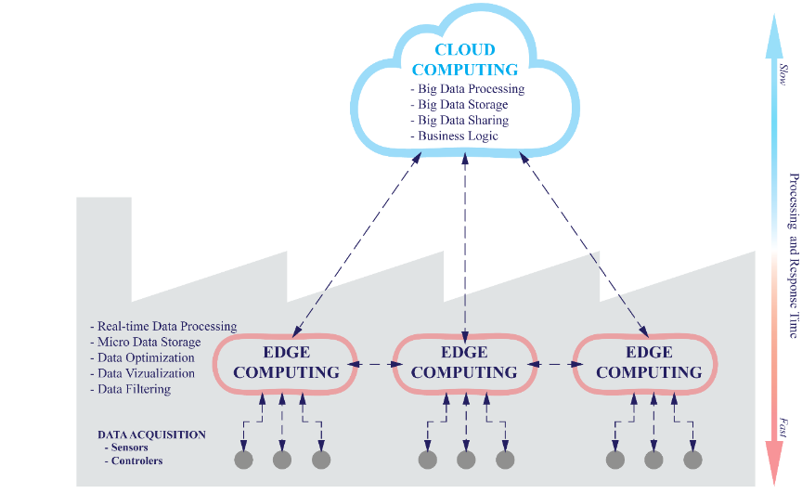

What is Cloud Computing?
Cloud Computing refers to both the applications delivered as services over the Internet and the hardware and systems software in the datacenters that provide those services. The services themselves have long been referred to as Software as a Service (SaaS), so we use that term. The datacenter hardware and software is what we will call a Cloud. When a Cloud is made available in a pay-as-you-go manner to the public, we call it a Public Cloud; the service being sold is Utility Computing. Current examples of public Utility Computing include Amazon Web Services, Google App Engine, and Microsoft Azure. We use the term Private Cloud to refer to internal datacenters of a business or other organization that are not made available to the public. Thus, Cloud Computing is the sum of SaaS and Utility Computing, but does not normally include Private Clouds. We’ll generally use Cloud Computing, replacing it with one of the other terms only when clarity demands it. Figure 1 shows the roles of the people as users or providers of the layers of Cloud Computing, and we’ll use those terms to help make our arguments clear. The advantages of SaaS to both end users and service providers are well understood. Service providers enjoy greatly simplified software installation and maintenance and centralized control over versioning; end users can access the service “anytime, anywhere”, share data and collaborate more easily, and keep their data stored safely in the infrastructure. Cloud Computing does not change these arguments, but it does give more application providers the choice of deploying their product as SaaS without provisioning a datacenter: just as the emergence of semiconductor foundries gave chip companies the opportunity to design and sell chips without owning a fab, Cloud Computing allows deploying SaaS—and scaling on demand—without building or provisioning a datacenter. Analogously to how SaaS allows the user to offload some problems to the SaaS provider, the SaaS provider can now offload some of this problems to the Cloud Computing provider. From now on, we will focus on issues related to the potential SaaS Provider (CloudUser) and to the Cloud Providers, which have received less attention. We will eschew terminology such as “X as a service (XaaS)”; values of Xwe have seen in print include Infrastructure, Hardware, and Platform, but we were unable to agree even among ourselves what the precise differences among them might be.1(We are using Endnotes instead of footnotes. Go to page 20 at the end of paper to read the notes, which have more details.)Instead, we present a simple classification of Utility Computing services in Section 5 that focuses on the tradeoffs among programmer convenience, flexibility, and portability, from both the cloud provider ‘sand the cloud user’s point of view.

1. The illusion of infinite computing resources available on demand, thereby eliminating the need for Cloud Computing users to plan far ahead for provisioning;
2. The elimination of an up-front commitment by Cloud users, thereby allowing companies to start small and increase hardware resources only when there is an increase in their needs; and
3. The ability to pay for use of computing resources on a short-term basis as needed (e.g., processors by the hour and storage by the day) and release them as needed, thereby rewarding conservation by letting machines and storage go when they are no longer useful.

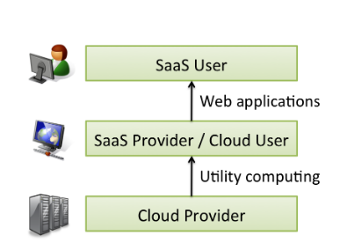

CHAPTER 2
2. SYSTEM ANALYSIS
2.1 EXISTING SYSTEM
Cloud computing (CC) is a centralized computing paradigm that accumulates resources centrally and provides these resources to users through Internet. Although CC holds a large number of resources, it may not be acceptable by realtime mobile applications, as it is usually far away from users geographically. On the other hand, edge computing (EC), which distributes resources to the network edge, enjoys increasing popularity in the applications with low-latency and high-reliability requirements. EC provides resources in a decentralized manner, which can respond to users’ requirements faster than the normal CC, but with limited computing capacities. As both CC and EC are resource-sensitive, several big issues arise, such as how to conduct job scheduling, resource allocation, and task offloading, which signiﬁcantly impudence the performance of the whole system. To tackle these issues, many optimization problems have been formulated. These optimization problems usually have complex properties, such as non-convexity and NP-hardness, which may not be addressed by the traditional convex optimization based solutions. Computational intelligence (CI), consisting of a set of nature-inspired computational approaches, recently exhibits great potential in addressing these optimization problems in CC and EC.

2.1.1 DRAWBACKS OF EXISTING SYSTEM ARE
- Metrics can be improved by considering job scheduling, resource allocation, and task offloading. To this end, many optimization problems have been formulated for tackling these issues.
- Compared with optimization problems in other areas, these optimization problems are normally highly complex and NP-hard, which may include mixed/strongly coupled variables, nonlinear constraints, multiple objectives, and bilevel structures.

2.2. PROPOSED SYSTEM
This paper provides an overview of research problems in CC and EC and recent progresses in addressing them with the help of CI techniques. Informative discussions and future research trends are also presented, with the aim of offering insights to the readers and motivating new research directions.
2.2.1. ADVANTAGES OF PROPOSED SYSTEM

- Like extending battery lifetime.
- Improving storage capacity and processing power, and
- Providing computation intensive applications.

CONCLUSION
This study presents a new scheduling scheme that considers the properties of the cloud in terms of parallel execution of tasks and dependency. The results show improvement in the utilization of cloud resource when dependencies among the tasks were considered. The overall implication is that the proposed approach can boost the resource utilization of cloud computing

CHAPTER-6
REFERENCE
[1] M. Armbrust et al., “Above the clouds: A Berkeley view of cloud
computing,” EECS Department, University of California, Berkeley, CA,
USA, Tech. Rep. UCB/EECS-2009-28, Feb. 2009.

[2] Q. Zhang, L. Cheng, and R. Boutaba, “Cloud computing: State-of-the-art
and research challenges,” J. Internet Serv. Appl., vol. 1, no. 1, pp. 7–18,
May. 2010.

[3] P. Mell and T. Grance, “The NIST definition of cloud computing,”
National Institute of Standards and Technology (NIST), Gaithersburg,
MD, USA, Tech. Rep. 800-145, Sep. 2011.

[4] Y. Mao, C. You, J. Zhang, K. Huang, and K. B. Letaief, “A survey
on mobile edge computing: The communication perspective,” IEEE
Commun. Surv. Tut., vol. 19, no. 4, pp. 2322–2358, Oct.–Dec. 2017.

[5] N. Wingfield, “Amazon’s profits grow more than 800 percent, lifted
by cloud services,” New York Times, New York, NY, USA, Jul. 2016.
[Online]. Available: https://www.nytimes.com/2016/07/29/technology/
amazon-earnings-profit.html?_r=0

[6] I. Bojanova and A. Samba, “Analysis of cloud computing delivery architecture
models,” in Proc. IEEE Workshops Int. Conf. Adv. Inform. Netw.
Appl., 2011, pp. 453–458.

[7] X. Chen, “Decentralized computation offloading game for mobile
cloud computing,” IEEE Trans. Parallel Distrib. Syst., vol. 26, no. 4,
pp. 974–983, Apr. 2015.

[8] Y. Chen, Y. Zhang, S. Maharjan, M. Alam, and T.Wu, “Deep learning for
secure mobile edge computing in cyber-physical transportation systems,”
IEEE Netw., vol. 33, no. 4, pp. 36–41, Jul./Aug. 2019.

[9] Z. Luo, M. LiWang, Z. Lin, L. Huang, X. Du, and M. Guizani, “Energyefficient
caching for mobile edge computing in 5G networks,” Appl. Sci.-
basel J., vol. 7, pp. 1–13, 2017.

[10] Z. Cheng, P. Li, J. Wang, and S. Guo, “Just-in-time code offloading for
wearable computing,” IEEE Trans. Emerg. Topics Comput., vol. 3, no. 1,
pp. 74–83, Mar. 2015.

[11] L. Tang, B. Tang, L. Kang, and L. Zhang, “A novel task caching and
migration strategy in multi-access edge computing based on the genetic
algorithm,” Future Internet, vol. 11, no. 8, pp. 1–14, 2019.

[12] N. Primeau, R. Falcon, R. Abielmona, and E. M. Petriu, “A review of
computational intelligence techniques in wireless sensor and actuator
networks,” IEEE Commun. Surveys Tut., vol. 20, no. 4, pp. 2822–2854,
Oct.–Dec. 2018.

[13] D. T. Hoang, C. Lee, D. Niyato, and P. Wang, “A survey of mobile
cloud computing: architecture, applications, and approaches,” Wireless
Commun. Mobile Comput., vol. 13, pp. 1587–1611, 2013.

[14] R. M. Singh, S. Paul, and A. Kumar, “Task scheduling in cloud
computing: Review,” Int. J. Comput. Sci. Inf Technol., vol. 5, no. 6,
pp. 7940–7944, 2014.

[15] A. A. Helen and B. V. RebeccaJeya, “A survey on quality of service
in cloud computing,” Int. J. Comput. Trends Technol., vol. 27, no. 1,
pp. 58–63, Sep. 2015.

[16] P. Rajeswari and K. Jayashree, “Survey on QoS metrics and ranking in
cloud services,” Int. J. Eng. Technol., vol. 7, no. 1.3, pp. 146–149, 2018.

