Agro Bidding A Smart Dynamic System for Enhancement of Farmers Lifestyle

ABSTRACT

This is an online auction web site aimed at taking the auction to the fingertips of aspiring bidders there by opening up the doors of the "OPEN Auction House' to a wider cross section of Art Lovers and Antique Collectors. This site also acts as an open forum where buyers and sellers can come together and exchange their products. The site makes sure that the sellers get a fair deal and buyers get a genuine product. The work will be done in ASP.Net and my sql.

CHAPTER-1
INTRODUCTION
Agriculture is the backbone of India, saying this, many of the agriculturists face so many problems in the agriculture that includes improper value for the products they produce and there are no proper discussion platforms where they could discuss or clarify their doubts regarding the agriculture. Thus here a new method is tried to find a solution to make the farmers to sell their products and also to discuss the issues. An auction website with all the other kinds of features such as a chat room and discussion forum would satisfy the farmer needs. Unlike the normal website; this auction model website is hosted in the Amazon elastic cloud compute server which could be a reliable environment for this kind of system [1]. The cloud servers are not only reliable but also provide so many advantages such as scalability and cost effectiveness [6].There are many applications developed and hosted in the Amazon web services [2-3]English Auction model is of the forward auction type where a single item is considered for sale [4-5]. Usually here, the bidding moves from low price to progressively high price. The auction is closed when higher bid for the item is made. In this model, the seller sets a margin price. No item is sold below the margin price. The auction is aborted if there is a bid lesser than the margin price. The Dutch Auction is an auction model where the share price of the bidding item lowered to a level where there are enough bids to sell all the shares. Vickery Auction was invented by the Canadian Nobel laureate economist William Vickers. Here the auction is carried out such a way that the buyer or seller pays the second best price for the bidding item. This auction serves the potential buyer to offer a value to the item in his or her own judgment. Next auction type which resembles gambling is the Reserve auction. In is auction type, many sellers offer their items and compete for the bidding. In this model the buyer can accept any bid, by paying for every bid he is placing or can reject all the items. In this model, there is a change for the buyer to lose money or will not get anything back in return. The auctioneer will make money by offering of bids and collecting the amount for the item bided. In First sealed price auction model, the bidder can bid only once and the bidder who bids the highest price will win. This model is different from the English model in such way that, here the bids are closed and this system is open-bidding type.

GENERAL INFORMATION
The Organization of American States (OAS) is a public international organization, with headquarters at 1889 F. St. N.W., Washington, D.C. 20006. The OAS brings together the nations of the Western hemisphere to promote democracy, strengthen human rights, foster peace, security and cooperation and advance common interests. For more information about the OAS, please refer to the OAS’s web site at www.oas.org. The General Secretariat of the OAS (GS/OAS) is the central and permanent organ of the OAS in accordance with Article 107 of the Charter. The Secretariat for Multidimensional Security (SMS) of the General Secretariat of the Organization of the American States (GS/OAS) promotes and coordinates cooperation among the OAS member states and between them, the Inter-American system and other bodies in the international system, in order to access, prevent, confront, and respond effectively to threats to security, with a view of being the leading point of reference in the Hemisphere for developing cooperation and capacity-building in the OAS Member States.The Executive Secretariat for the Inter-American Committee against Terrorism (ES/CICTE) assists member states in the design, implementation, and evaluation of national policies and programs to prevent, combat, and eliminate terrorism and strengthen the antiterrorist capabilities of Member States. This request for proposals is solicited by the CICTE Executive Secretariat (ES/CICTE) in the context of the Implementation ofaCybersecurity Projectin a Member State of the GS/OAS.

OBJECTIVES

To contract the following services, either jointly or separately, to provide cyber security tools and services for operations in a Member State of the OAS:

A)Contract an on cloud based SIEM solution to handle and unify data, collecting different security event sources across multiple logs, sources, endpoints, cloud services, feed service providers, and hosting platforms, in order to analyze the increasing amount of security data processed by a Member State of the GS/OAS. It is necessary to acquire a platform and ecosystem of services totally oriented to evaluate and support the incident handling operations. The service must be offered through a web portal and REST API connection point, and must cover all aspects of data management, including: acquisition, analysis / processing, indexing, application of statistical models and “Machine Learning”, storage, Custom Dashboard Management, and reports. In addition, it is required for the companies to present support to collect, analyze and present non-structure data.

B) Contracta service of non-intrusive scanning of internet-facing critical infrastructure based on request of Internet IP Address to know in real-time the cyber-exposure of a Member State of the GS/OAS’ critical infrastructure. This service will support and strength the Cyber Incident Response Team by managing a cyber-risk model at national level based in accurate and real time information.

C)Contract a Software as a Service (SaaS) with accurate cyber security events information. The aforementioned information should be based on passive scanning of internet traffic through isolated decoy systems with desired fake data (Honeypots) placed in thousands of locations around the world, as well as providequantity and quality information about malicious traffics and activitiesoriginated from the country’s Cyberspace.

D)Contract a Vulnerability Management Solutionable to provide capabilities to identify, categorize and manage vulnerabilities inlimited scope oftechnology assets ofa Member State of the GS/OAS. The solution should provide guides and recommendations to prioritize and mitigate possible risk exposure.

E)Contract a Web App Scanning Softwareable to provide automated vulnerability scanning in limited scope of modern web technologiesof a Member State of the GS/OAS. The solution should provide custom reports and recommendations to prioritize and mitigate possible risk exposure.

F)Contract technological servicesable to provide customizedhands-on training platform and virtual laboratories for Cybersecurity Specialists,Incident responders and Law enforcement agencies of a Member State of the GS/OAS. Platform should beflexible to organize different formatsof training and exercises as a Capture the flag (Jeopardy, attack-Defenseand mixed).

Cyber Security Operation Centre (CSOC)
A cyber security operations centre or CSOC is a subgroup of CERT-O and comprises of a team of expert individuals and the facility in which they dedicate themselves entirely to high-quality IT security operations. A CSOC seeks to prevent cybersecurity threats and detects and responds to any incident on the computers, servers and networks it oversees. What makes a CSOC unique is the ability to monitor all systems on an ongoing basis, as employees work in shifts, rotating and logging activity around the clock. In recent times organizations are shifting their focus more on the human element than the technology element to assess and mitigate threats directly rather than rely on a script. While technology systems such as Firewall, IPS or other security appliances may prevent basic attacks, human analysis is required to put major incidents to rest. As opposed to a traditional IT department, a CSOC staff primarily includes a team of highly experienced cyber security analysts and trained professionals. These individuals use a range of computer programs and specialized security processes that can pinpoint weaknesses in the department’s infrastructure and prevent these vulnerabilities from leading to intrusion or theft. Ensuring these programs comply with company, industry and government regulations is also a significant part of a CSOC’s job. With a variety of tasks to perform, using a variety of tech and methods, SOCs can look different depending on a multitude of factors. Some companies, Govt. Departments, PSU sectors have an in-house CSOC, while others opt to outsource these services. Most importantly, however, they all have the primary goal of preventing breaches and minimizing losses due to online criminal activity.

Bidding Requirements
The Bidding for the Project shall be governed by all the provisions of RA No. 9184 and its 2016 revised IRR, including its Generic Procurement Manuals and associated policies, rules and regulations as the primary source thereof, while the herein clauses shall serve as the secondary source thereof. Any amendments made to the IRR and other GPPB issuances shall be applicable only to the ongoing posting, advertisement, or IBby the BAC through the issuance of a supplemental or bid bulletin. The Bidder, by the act of submitting its Bid, shall be deemed to have verified and accepted the general requirements of this Project, including other factors that may affect the cost, duration and execution or implementation of the contract, project, or work and examine all instructions, forms, terms, and project requirements in the Bidding Documents.

Scope of work for bidder
Cyber Security Operations Centre (CSOC) The bidder shall supply skilled manpower for Cyber Security Operations Centre (CSOC) operations over a period of four years at OCAC location as detailed in this document. Implementation Agency shall ensure uptime & availability of all CSOC devices and tools. Service provider resources are expected to deliver SOC services including but not limited to performance monitoring, performance tuning, optimization, and maintenance of CSOC security tools, SIEM log backup, troubleshooting, security monitoring, security product management, vulnerability assessment and penetration testing and application security testing. The detailed SOC reports formats will be discussed and finalized with bidder. The scope is limited to three stakeholders in the initial phase of the project: 1.Odisha State Data Centre (OSDC). 2.State Wide Area Network (SWAN). 3.State IT Centre. Initially implementation of CSOC is to be carried out for the above three stakeholders. On reaching stability and maturity of CSOC system, additional stakeholders would be added to the project and the scope of work for the bidder would be expanded covering the additional stakeholders also. The bidder should propose cost for the project as per the format / proforma provided in the RFP document.

Objective
Government of Odisha (GoO), Electronics & Information Technology Department and Odisha Computer Application Centre (OCAC) intends to take high priority in securing the organization’s and departmental data and removal of any threat that exist in the current infrastructure of the organization / department. Additionally, its objective is to ensure minimum dwell time of any possible threat in servers, networks and systems. This is possible only if there is a system in place that has constant monitoring. Establishing a Cyber Security Operations Centre (CSOC) has become more important for organizations as security breaches are on the rise and the cost associated with data loss is often high. Hence developed the vision of establishing a Cyber Security Operations Centre to precisely tackle this problem and be better prepared for a worst-case scenario. At present there is no integrated system in place to monitor the infrastructure, network flow, data flow and intrusion for the organization(s). The monitoring currently is done at individual department or project (SDC / SWAN) level and is not integrated into a centralized information and monitoring system. The technology utilized by the individual department / project does not cater to all the infrastructure and are equipped with limited resources.
In brief the objectives can be distinguished as below:-
- •Prevention of cyber security incidents through various measures as establishing security policy, continuous threat analysis, deployment of preventive and detective security devices.
- Monitoring, detection and analysis of potential intrusions/threats in real time from security related data sources.
- Response to the threats in timely manner for mitigates.
- Capacity building and awareness creation for cyber security.
Cyber security operations centre (CSOC) would be a command centre facility for a team of IT professionals with expertise in information security that would be responsible for monitoring, analyzing and protecting the organization from cyber attacks. In the CSOC, internet traffic, local area network, desktops, servers, databases, applications and other systems would be continuously examined for signs of a security incident. The CSOC staff may work with other teams or departments, but would typically be self-contained with employees that have high-level information technology and cybersecurity skills.

Scope of the Project
The vendor has to design course content and develop course material videos/ presentations with voice over, documents and simulations/ramifications etc. The course content will comprise and designed on the basis of the tracks defined later in the RFP. The course content, syllabus and material should be designed in such a way that it can be easily understandable to itstarget audience.The course syllabus itself describes the prerequisitesand the timerequired to complete the course. The course material should comprise:
1.Videos(Bilingual i.e. English and Hindi both)a.Talking Head Videob.Interactive Videoc.Presentations with voice over(with subtitles).
2.Documents/study material(In the form of pdf, word, ppt etc.).(Bilingual i.e. English and Hindi both)
3.Simulation/ Gamificationfor imparting hands on experience.(Bilingual i.e. English and Hindi both)
4.Quizzes(Bilingual i.e. English and Hindi both)a.Multiple choice questions.b.Fill in the blanks.c.Match the Column.d.Sequencing of events in a particular order.e.Solving of crime scene using gamification/Simulation.

METHODOLOGY
a.The idea is to develop an online bidding application that would help the farmersand the customers contact each other directly and do the business.
b.This would include a cloud platform that would store the data of the registered users(farmers and customers)
c.The cloud platform will be a live cloud (Platform as a Service).
d.The application will include membership module for loyal farmers (registered farmers) to participate in it.
e.The online forum will help the customers interact with each other.
f.Farmers get to know the actual demand in the market through the requests that customerspost on the application.
g.This idea comes under Recent trends in IT and hence would require MVC (Model View Controller)design pattern as the core technique to build it.
h.The application would help the farmers bid the price and the highest bidder(customer)will get away with the product.

CHAPTER 2
2. SYSTEM ANALYSIS
2.1 EXISTING SYSTEM

In this project, an online auction system is presented. It has a very large potential market of sellers and buyers. An On Line Transaction Processing(OLTP) database model structure is, therefore, desirable.
2.1.1 DRAWBACKS OF EXISTING SYSTEM

- May be buyers don’t have time to go and waste their time to buy the product in market.

- In manual auction the day of auction, venue and the items for auctions are told to the general public through electronic or print media. The people who wish to take part in the auction should first register himself and then arrive at the venue of the auction on the given date and time.

2.2. PROPOSED SYSTEM

This project involves the design and implementation of an online auction system. The analysis stage is performed first for the case study. Project begins by analyzing and presenting the OLTP database model for the online auction house. Besides, the intention to establish what goes on operationally within the online auction house. It also defines the layout in and web application. In which many number of bidders bids the auction and final the auction won will store the result of the winning bidder details. And finally the shipment process will carried out.

2.2.1. ADVANTAGES OF PROPOSED SYSTEM

- There is a chance of corruption and other factors for not providing transparent bidding.

- Simply we can define auction as a process of buying and selling goods or services by offering up of them for bids, taking bids, and selling items to the highest bidders.

Literature Survey

In case of auction the first thing comes in mind how to sell a product. Simply it means in auction the seller waits for the high number of prices and waits for the bidder who remains active till the last of the auction process. There are various types of bidding a product. To overcome a traditional auction process, this online auction process had been used which is detailed in[1]

Secondly, a various types of auctions had been described suchas English auction(ascending bid auction),the Dutch auction (descending-bid auction), the first-price sealed-bid auction, and the Vickrey auction (second-price sealed-bid auction) as explaineddin [2]. It also described the steps of how auction will be carried out and what information should be carried on.The internet auction is the most simple to use for maintaining the data then the traditional auction which is to be carried on the paper.And most of the auction hasbeen learned by the economists for the understanding purpose to study their properties and how it works

In [3], it describes how the auction is carried out on the internet and what the information is provided before the auction and after the auction process.It also describes auction such as user agents and mobile agents. User agent mostly done on the users PC with the help of the some services or some expert advices while mobile agent deals with the execution of program through remote base server.In addition to this the auction time is provided with the help of auction date and the last date of ending the auction.Earlier auction products were like electrical equipments,etc. But now Agricultural Product can also been auctioned. First product was Tea Auction.

Now-a-days auctioning process has been became a competitive in the market. The auction can be done from anywhere in the world at any time and anyone can auction the products which is detailed in [4].In additional to single item auctioning, it also consists of multi-item auctioning where n number of items are auctioned simultaneously as described in[6]. In multi-item auction it provides more opportunities for online auction market in large market over the world with higher efficiency. This multi-item auction has came into existence because now-a-days very small markets does the auctioning of similar items which results into less efficiency.

Multi-attribute auctions consists of practicalandtheoreticalproblems which has been detailed in[7].In case of practical problems the users should know the product and market characteristics.With help of this term the auction is also referred as the common value based. Sometimes it becomes difficult to arrange the behaviour of the goods which may result in difficult for the analysisof the product. The analysis of the product is also done in case of reverse auction. Because of this the economist’stheory and experimentswhich is used for the developmental testing.Along with traditional auction the internet auction has been more popular. For the internet auction there are various security requirements. Firstly the seller should know whether he/she is going to post a product in large scale or not. Then the user who isinterested should register first and then access the site. The security requirement is used to know whether the site is used by the registered person. Therefore an administrator is used as a trusted third party to keep the records of all the procedures happening which has been explained in[8].Auction application is carried with the help of auction rules which defines the auction schedule, templates for creating the auction and the individual auction rules for the individual auction product.As e-commerce auction is used widely it has featured many security protocols[9]. It has described some security properties such as atomicity of the transaction, weak private keys and weak public keys for the bidders. In case of voting or bidding the product it consists of much work on the verification of the users and the product which is to be handled in the area of privacy.

As auction is defined as mobile agents which deals with the execution of program on the remote server database. The mobile agents in electronic auction is slightly different as described in[10]. The mobile agents in electronic auction first visits the site of auction and then the user may actively participate in auction process. If the user is disconnected for sometime then in behalf of user it can participate for a specific time period.After registering it as server, the mobile agents itself creates its own user profile.

2.3 FEASIBILITY STUDY
The feasibility Analysis is an analytical program through project manager determines the project success ratio and through feasibility study project manager able to see either project. The key considerations involved in the feasibility analysis are:
- Economic Feasibility
- Technical Feasibility
- Operational Feasibility
- Environmental Feasibility
2.3.1 ECONOMICAL FEASIBILITY
Hence this project is economically feasible there is no need to involve any cost for this project.
2.3.2 TECHNICAL FEASIBILITY
Software Technologies used are PHP and MySql. In the educational institutions, it is possible to update the system in future. No special hardware is required for the purpose of using this system. Hence it is declared that this project is technically feasible.
2.3.3 OPERATIONAL FEASIBILITY
As the admin work mainly to maintain the Patient and Doctor .Doctor will predict patient cancer disease. Hence it is easy to operate with training. Therefore it is operationally feasible for implementation.

2.3.4 ENVIRONMENTAL FEASIBILITY
This project environment is correct as a admin has developed this system and no expenditure is involved under any head and this process is part of admin document management, this project environment is accessible.
2.4 SYSTEM REQUIREMENTS
- System : Pentium IV 2.4 GHz.
- Hard Disk : 40 GB.
- Monitor : 15 inch VGA Color.
- Mouse : Logitech Mouse.
- Ram : 512 MB
- Keyboard : Standard Keyboard

2.4.1 HARDWARE REQUIREMENTS
The Hardware of the computer consists of physical component such as Input Devices, Storage Devices, Processing & Control units and Output Devices. Computer includes external storage unit to store data in programs.
The Hardware Configuration involved in this project
- System : Pentium IV 2.4 GHz.
- Hard Disk : 40 GB.
- Monitor : 15 inch VGA Color.
- Mouse : Logitech Mouse.
- Ram : 512 MB
- Keyboard : Standard Keyboard

2.4.2 SOFTWARE REQUIREMENTS
Software is a group of programs that computers need to do a particular task. It is an essential requirement of Computer System. The Software used to develop the project is
- Operating System : Windows XP.
- Platform : DOT NET TECHNOLOGY
- Front End : ASP.Net 3.5
- Back End : SQL SERVER 2005

MODULE DESCRIPTION

Registration Module
In this module any one can register or login for this app. In this the validation for user name and password is of up to minimum five characters. If the user is not login then he/she should register first.
Seller module:
In this module, the seller will post the product information in which he/she wants to sell or auction the product through online. In this module the seller can post the image of the product by using capture image and all the necessary information about the product such as the product name, its description and the auction date and time at what the product is going to be auctioned and finally the stop time of the auction.

Buyer module:
In this module, the bidder will first see which product is been posted on the app which is to be auctioned. The bidder/buyer will see all the information about the product. If the bidder is interested to buy that product then he can register for the auctioning and bid the amount. Atlas, at the end of the auctioning the bidder will get to know the result. Last when the number of auction has been created the bidder will decide the amount which product to be auction. The bidder has to auction within a time which is set by the seller while creating auction that is one hour, twenty-four hours, etc

CHAPTER 3
SYSTEM DESIGN AND DEVELOPEMENT

3.1 DATA FLOW DIAGRAM

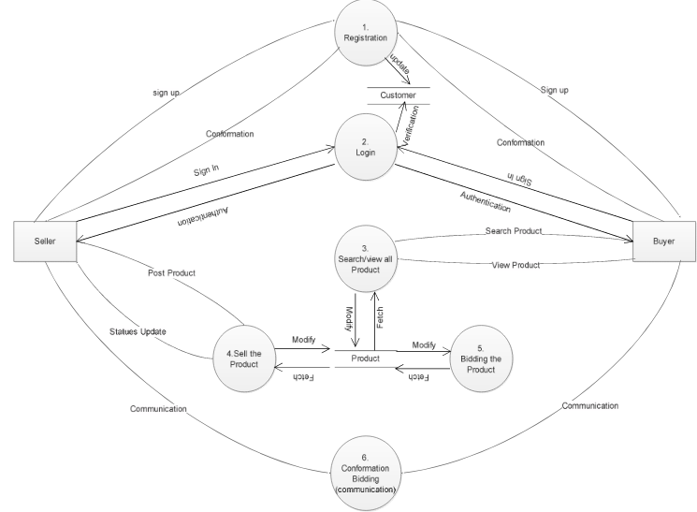

3.2 SYSTEM ARCHICTURE

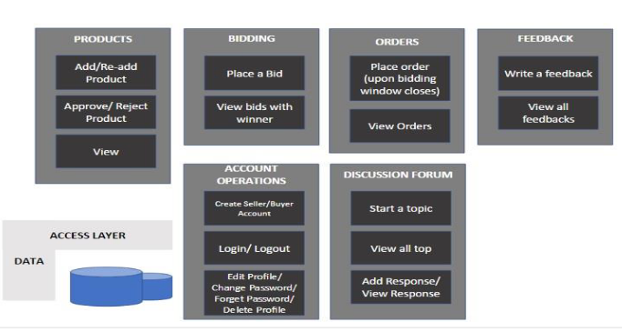

Case Diag

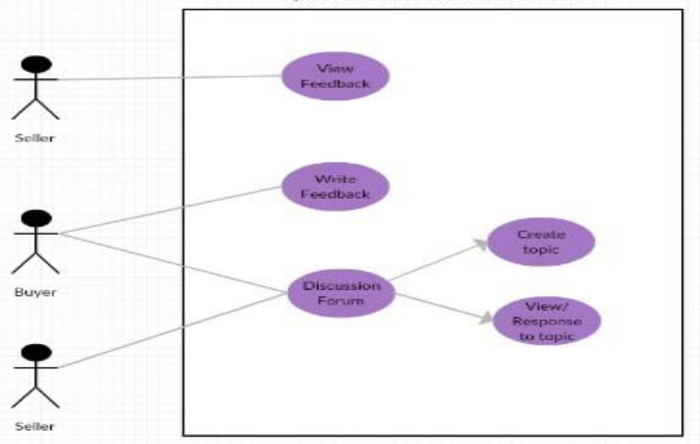
Sequence Diagram

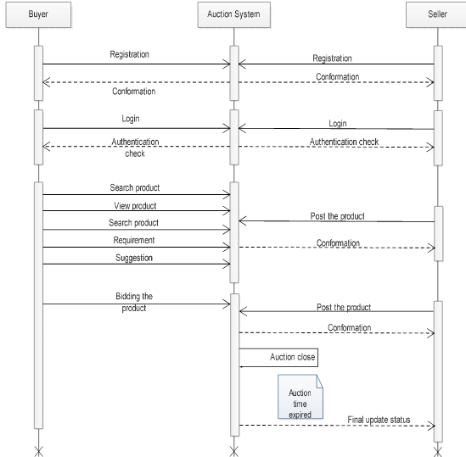

CHAPTER 4
TESTING AND IMPLEMENTATION

  - TESTING
Implementation is the stage of the project when the theoretical design is turned into a working system. This is the final and important phase in the system life cycle It is actually the process of converting the new system into a operational one.

4.1.1Unit Testing
Unit testing comprises the set of tests performed by an individual programmer prior to integration of the unit into a larger system. The module interface is tested to ensure that information properly flows into and out of the program unit. The local data structure is examined to ensure that data stored temporarily maintains its integrity during all steps in an algorithm’s execution. Boundary conditions are tested to ensure that the module operates properly at boundaries established to limit or restrict processing. All independent paths through the control structure are tested. All error-handling paths are tested.

4.1.2 Block Box Testing
Black-box testing is a method of software testing that examines the functionality of an application without peering into its internal structures or workings. This method of test can be applied virtually to every level of software testing: unit, integration, system and acceptance. It is sometimes referred to as specification-based testing.

4.2 SYSTEM IMPLEMENTATION
Implementation is the stage of the project when the theoretical design is turned into a working system. This is the final and important phase in the system life cycle It is actually the process of converting the new system into a operational one.

CHAPTER 5

RESULT AND CONCLUSION

An Online Bidding application deployed on Cloud Platform as aService(PaaS) for sales of agricultural products and deploys end to end live application feature. The project is completely related to the farmers and the customers. It would benefit both of them equally. Farmers will get the complete price of their hard work. Customers need to pay only the price of the product and not the intermediate charges which are applied due to the involvement of the middlemen. This application completely eliminates middlemen hence it’s a direct communication platform between the farmers and the customers.

This web application not only provides the highest price for the farmers but also it possess many additional features which serve the application as the most easy, reliable and user friendly application which would in turn help the users who are new to this computer era. The discussion forum helps the farmers/users post as many questions as they want and get their solution instantaneously.

Online discussion forum is provided for the new users who are unaware of how to use the application and also on how to provide order to the web clients. In addition to all these facilities, cloud technology is used for hosting with which the website runs at the maximum speed without any interruption. Since cloud is used for hosting, there is an option where the website can load multiple users at the same time without any server lag.

FUTURE ENHANCEMENT
Future work of this project includes the integration of Big Data technologies and to scale the product to the maximum extends and also working towards integrating the logistics and payment gateway solutions.

CHAPTER-6
REFERENCE
[1] Matt Traci, “Web Application Hosting in the AWS Cloud Best Practices”, Philip Fitzsimons, 2012.

[2] Octavio Gutierrez-Garcia and KangMongSim, “Agents for CloudResource Allocation: an Amazon EC2 Case Study”.

[3] Kaleesari,NobleMary Juliet “Dynamic Resource Allocation by usingElastic Compute Cloud Service” , International journal of InnovativeResearch in Science Engineering and Technology, vol.3, pp. 1237-12379,2014.

[4] Sandeep Kumar, “Pricing Algorithms in Online Auctions,” ComputerEngineering Department, UIET, M.D.UniversityRohtak, Haryana, India

[5] Hemantha Kumar P., GautamBarua, “Design of Real Time AuctionSystem,” Dept. of Computer Science and Engineering, Guwahati.

[6] LuckingǦReiley, D. “Auctions on the Internet: What’s being auctioned,and how?”, The Journal of Industrial Economics, vol. 48 Issue 3, pp. 227

