Detection of Potato Disease Using Image Segmentation and Machine Learning

ABSTRACT

Potato is one of the prominent food crops all over the world. In Bangladesh, potato cultivation has been getting remarkable popularity over the last decades. Many diseases affect the proper growth of potato plants. Noticeable diseases are seen in the leaf region of this plant. Two common and popular leaf diseases of the potato plants are Early Blight (EB) and Late Blight (LB). However, if these diseases were identified at an early stage it would be very helpful for better production of this crop. To solve this problem by detecting and analyzing these diseases image processing is the best option. This paper proposes an image processing and machine learning-based automatic system that will identify and classify potato leaf diseases. In this paper, image segmentation is done over 450 images of healthy and diseased potato leaf, which is taken from publicly available plant village database and seven classifier algorithms are used for recognition and classification of diseased and healthy leaves. Among them, The Random Forest classifier gives an accuracy of 97%. In this manner, our proposed approach leads to a path of automatic plant leaf disease detection

CHAPTER-1
INTRODUCTION

Potato is one of the most significant food crops. The diseases causing substantial yield loss in potato are Phytophthora infestans(late blight) and Alternaria solani (early blight). Early detection of these diseases can allow to take preventive measures and mitigate economic and production losses. Over the last decades, the most practiced approach for detection and identification of plant diseases is naked eye observation by experts. But in many cases, this approach proves unfeasible due to the excessive processing time and unavailability of experts at farms located in the remote areas [1]. Hence, the introduction of image analysis tools turns out to be an effective method for continuous monitoring of plant health status and early detection of plant diseases. As diseases leave some visible symptoms on the plants, particular on leaves, disease detection can be performed by imaging analysis of those visible patterns on leaves. Thus imaging technique combined with machine learning offers a solution to the issue of agricultural productivity and ensures food security. So the objective of this work is to develop imaging and machine learning based effective and error-free disease detection system for plant. The rest of the paper is organized as follows: Section II describes the previous works of diseases and deficiency detection of different plants and Section III explains the dataset of our work. The proposed approach is illustrated in section IV. The experimental results are projected in section V and finally, section VI concludes the work including the future plans.
In agricultural crops, leaves play a vital role to provide information about the amount and nature of horticultural yield. Several factors affect food production such as climate change, presence of weed, and soil infertility. Apart from that, plant or leaf disease is a global threat to the growthof several agricultural products and a source of economic losses [1]. The failure to diagnose infections/bacteria/virus in plants leads subsequently to insufficient pesticide/fungicide use. Therefore, plant diseases have been largely considered in the scientific community, with a focus on the biological features of diseases. Precision farming uses the most advanced technology for the optimization of decision-making. The visual inspections by experts and biological review are usually carried out through plant diagnosis when required. This method, however, is typically time-consuming and cost ineffective. To address these issues, it is necessary to detect plant diseases by advanced and intelligent techniques.
OVERVIEW
Potato is one of the most highly consumed crops over the entire world. The late blight is the most important disease for potato, which is caused by a fungus-like organism, Phytophthora infestans in humid conditions with temperature within a specific range. This disease can destroy crops of the entire field, causing substantial yield loss, within a few days after the first lesion appears in the farm [1]. Therefore, early detection of this disease attack is essential for prevention of huge economic losses. The early Detection of disease requires continuous monitoring of the disease severity by an expert which is time consuming, tedious and some times not feasible due to a small number of experts and a larger number of farms. So, a fast, reliable, and automatic method is required to accurately quantify the disease severity. In recent literature, the image processing techniques are being widely and efficiently used in agricultural field for disease detection and severity identification [2], [3]. Revathi et al. [4] proposed a Homogeneous Pixel Counting technique for Cotton Diseases Detection (HPCCDD) using leaf spot images captured by farmers through mobile. They used edge features of segmented disease spots extracted with homogenize edge operators like Sobel and Canny filters to classify the target regions and also provided a comparison based study for different classifiers and declared K-mean and Artificial Neural Networks as best classifiers with which they achieved 94% accuracy. Bashish et al. [2] proposed an image processing based framework for detection of plant leaf/stem diseases. They segmented the affected area using K-Means clustering technique and used GCLM features for classification among different cotton leaves diseases and healthy leaf using Back Propagation Neural Network. Revathi et al. [4] and Bashish et al. [2] considered single leaf images to obtain the disease severity which was specific to a particular leaf only. Zulfikli et al. [5] and Sannakki et al. [6] considered images of cluster of leaves with complex background for chili and grape crops. Zulkifli et. al. [5] proposed an effective way for early detection of diseases in chili plants through leaf features inspection. They performed color clustering to extract the leaves from background and used color features to distinguishbetween healthy and diseased chili plant. Sannakki et.al. [6] proposed an image processing technique for grape disease identification and its severity detection from images captured with complex background. They applied anisotropic diffusion for noise removal after masking green pixels and used K-mean clustering for grape leaf disease segmentation from the healthy region of the plant. Although Zulkifli et al. and Sannakki et al. considered images with complex background, for these crops the damaged portion of the leaves have different color features from the background and hence it becomes easy to segregate.

STEPS INVOLVED IN PLANT LEAF DISEASE DETECTION
A. Color Transformation Structure
First, the RGB images of leaves are converted into Hue Saturation Intensity (HSI) color space representation. The purpose of the color space is to facilitate the specification of colors in some standard, generally accepted way. HSI (hue, saturation, intensity) color model is a popular color model because it is based on human perception.
B. Hue Color Attribute
It refers to the dominant color as viewed by a person. Saturation refers to the relative Purity or the amount of white light added to hue and intensity refers to the amplitude of the light. Color spaces can be converted from one space to another easily. After the transformation process, the H component is taken into account for further analysis. S and I are dropped since it does not give extra information.
C. Masking Green Pixels
Here, we identify mainly the green colored pixels. After this, based on specified threshold value computed for these pixels, the mostly green pixels are masked as if the green component of the pixel intensity is less than the pre-computed threshold value, the red, green and blue components of the this pixel is assigned to a zero value.
D. Segmentation
From the above steps, the infected portion of the leaf is extracted. The infected region is then segmented into a number of patches of equal size. The size of the patch is chosen in such a way that the significant information is not lost. In this approach patch size of 32*32 is taken. The next step is to extract the useful segments. Not all segments contains significant amount of that information. So the patches which are having more than fifty percent of the information are taken into account for the further analysis.
E. Color Co-Occurrence Method
The color co-occurrence texture analysis method is developed through the Spatial Gray- level Dependence Matrices (SGDM). The gray level co-occurrence methodology is a statistical way to describe shape by statistically sampling the way certain gray- levels occur in relation to other gray levels. These matrices measure the probability that a pixel at one particular gray level will occur at a distinct distance and orientation from any pixel given that pixel has a second particular gray level.
F.. Texture Features Contrast,
Energy, Local homogeneity, Cluster shade and Cluster prominence are the texture features which are calculated for the Huecontent of the image.
Crop losses
Phytophthora infestans causes late blight diseases in potato and tomato crops worldwide. It is not cause only economic losses of yield but also the quality and quantity of the crop. It is a highly researchable pathogen in plant diseases. The worldwide late blight disease is re-emerging, therefore this disease is constantly observed by the late blight researchers [15]. The late blight disease is considered emerging disease, it is not only having important in global crop production, but also pose severe risks on a local level, especially on small farms in devel-oping countries [16]. The losses caused by late blight disease, it varied countries to countries, as per their adopted plant protections measures and grown cultivars. The yield losses due to late blight of potato were reported up to 50–70% during the 2007 under favorable envi-ronmental condition in Pakistan [17]; however recently Ahmed et al. [18] reported that late blight can induce 100% yield loss under epidemic condition in Pakistan. As far as Indian sce-nario is concerned, reduction in potato production due to late blight ranged between 5 and 90% depending upon climatic conditions, with an average of 15% across the country [19]. However, recently yield loss was reported, overall basis a range of 10–20% due to late blight in the year 2013–2014 major potato growing sites of the India viz., Uttar Pradesh, West Bengal, Punjab, Karnataka and Uttarakhand [20]. Whenever, disease appeared in epiphytotic form at early stage of the crop yield loss would be more. Tuber yield decline was significantly higher in unmanaged crop, which could go as high as 90% of total productivity in hilly regions. The changing climate pattern is being influenced appearance of late blight as it is occurring every Potato - From Incas to All Over the World84
year in plain region with moderate to high disease severity. Variations in disease severity are mainly due to climatic factors i.e. rainfall, relative humidity, temperature and pathogen virulence. In Punjab (main potato growing belt), severe epidemics of late blight disease have appeared during 1985–1986, 1989–1990, 1992–1993 and 2006–2007 [21]. In 2006–07, average crop loss of 22% in productivity resulting in a net loss of around 0.16 mt of potato in the state of Punjab alone. The increase in disease severity could be due to a change in the pathogen population [22]. The varying degree of crop losses was also reported due to late blight from Punjab, Haryana, UP, Maharashtra Karnataka, Bihar and West Bengal [23]. The decline in pro-ductivity and yield of potato was in between 25 and 85% due to late blight, depending mainly on degree of susceptibility of the host plant [24]. The economic costs associated with late blight to be somewhere around US $3–5 billion per year was estimated by several authors [25, 26]. A method had been used to conservative estimate costs of late blight and it was observed that lowest yields mainly in developing countries and previous eastern block countries which suf-fered over €10 billion per annum at least, whereas in developed countries with high yields (7.5% of global potato production) suffered damage of about €1 billion per year.
Disease epidemiology
The late blight infected tubers are the major sources to cause the infection. Moreover, refuse piles and volunteer plants also serve as primary source of disease particularly in the hilly Figure 3.Late blight symptom on potato tubers. Figure 4.Late blight affected potato field. Management of Late Blight of Potatohttp://dx.doi.org/10.5772/intechopen.7247287region. Wherever, both mating type is existed oospore formation take place and oospore also has the potential to cause and initiate the disease. The spores germinate and infect the exposed tubers. Although, some of the infected tubers get completely rotted by the time, crop is har-vested but, still lot of tubers carry incipient infection, and escape in the cold store/country store where they remain dormant but alive. These tubers if used as seed, becomes the source of infection of the disease in the next crop season [28]. Sporangia are formed wide range of temperature (3 to 26°C) and optimum is 18–22°C. The sporangia are germinated by two ways process i.e. indirect and direct germination. It depends mainly on temperature. Indirect ger-mination generally occurs at temperatures of 6 to 15°C (optimum 12°C) by means of sporan-gia produces zoospores. Direct germination takes place under warm temperature and a range of 4 to 30°C (optimum 25°C). High relative humidity (>90%) is required for spore formation, germination and infection; whereas >80% is essential for lesions expansion. Extreme light is harmful for P. infestans and sometimes sporangia may be killed due to extreme light. Cloudy weather is favorable for late blight. The cool (12–15°C) and high humidity (>90%) weather with heavy dews or rains alternating with warm (18–20°C) moist period favor for rapid devel-opment of disease. Infection and disease development is observed a range of 7.2–26.6°C [29]
DATASET DESCRIPTION
Plant Village (www.plantvillage.org), a publicly available image database, contains 54,306 images of diseased and healthy plant leaves of 14 crop species collected under controlled conditions and the ground truths are also provided. We analyze 300 images of potato leaves, which have a spread of the following class labels assigned to them:
- Late blight affected potato leaf.
- Early blight affected potato leaf.
- Healthy or Non-diseased potato leaf.

Annotation of the Training Dataset
The PlantVillage dataset was divided into three sub-datasets: 70% (38017 images) for training, 20%(10858 images) for validation, and 10% (5431 images) for testing [15,17]. Then, the annotation of trainingdataset images was the first step towards the plant disease identification task by DL meta-architectures.In this study, the training images were annotated by LabelImg, which is an open-source graphic imageannotation application. As a result, the bounding box coordinates (Xmin,Ymin,Xmax, andYmax) werecreated. These bounding boxes are the ground truth boxes that evaluate as the intersection of the union(IoU) with the prediction bounding box. To save annotations as XML files, the Pascal VOC formatwas used. An example of an annotated dataset image is given in Figure 3. Table 1 shows the details regarding the classes of the Plant Village dataset.

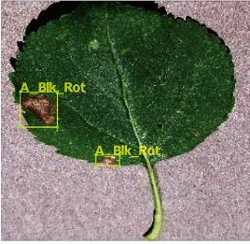

An example of an annotated image using the LabelImg tool.
Selection of affected leaf area from background:
Usingfuzzy-c-mean clustering we get a cluster having both the affected leaf part and background regions [Fig.3(d)]. Hence there is a need to separate the affected vegetation part from background. We observed that, though affected leaf area and background have same color features, they possess different texture characteristics. We proposed to use neural network to discriminate between affected vegetation part and background with same color texture. Here, we take each connected regions (ROIs) of Cs to classify as, whether it belongs to infected vegetation part or background.
Feature extraction:
In this step, texture features are extracted from each connected components. Gray level co occurrence matrix of hue component of the ROIs in HSV color space, is used to extract the texture features. Seven texture features: contrast, uniformity, maximum probability, homogeneity, inverse difference, difference variance, diagonal variance are used for classification using neural network based classifier.

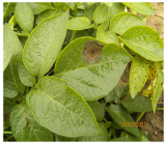
Original image

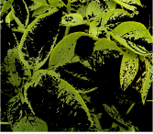

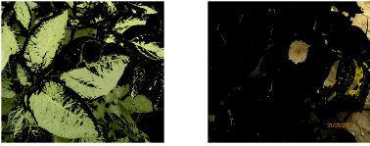

Different clusters

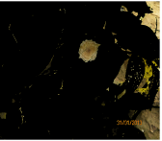
Selected cluster with disease affected area,

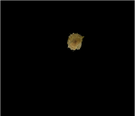

Final cluster classified as affected vegetation part

Classification:
Back propagation neural network with three layers having one input, one hidden and one output layer, is considered in the proposed method to classify the ROIs. Input layer has seven nodes for seven texture features and hidden layer consists of 15 nodes. The separated affected part using neural network approach is shown in Fig.
METHODOLOGY
The methodology is used in this paper are two different segmentation techniques such as thresholding and K-means clustering algorithm and classification technique such as Artificial neural network (feed forward back propagation). First the digital images of plant leaves are acquired form field using camera. Then image pre processing is done. After that two different segmentation processes are done to segment the original image and extract useful features to identify the infected parts of the plant leaf. After that classification technique was done using nf toolbox in MATLAt software. Image processing block diagram is shown in Figure.

Image Gathering Process:
The plant leaf imagesare captured by usingcamera. The capturedimage obtained as aRGB format and this image is further processed in the preprocessing stage for refinement.An image in RGB format means nothing but it has the three primary colors namely: Red,Green and Blue, each color in theirdefinite proportions.

Image Pre-processing:
In the wayto eliminate noise from the image, diversepre-processing techniques can be considered. It will convert RGBcolourmodel into Grayscale model by using theConverter-Weighted method. Theweighted method has a solution to that problem. normallyRed colourhas more wavelength when compared with the Yellow and Green colours,Hence, the resultantequation in that following form: New grayscale image = ((0.4* R) + (0.69 * G) + (0.11 * B)). From theabove equation, we can see that Redcolour has30%of itspart, Green has 69%, whichis greater in all three coloursand Blue has 21%. Next comes an important phase called Image Resizing. Sometimes, the resolution of document images can be very high,typically higher than 2000 *2000, which is large to be setto a CNN with the current availability of resources. Large input dimensions are expensive, but can also lead to over-fitting conditions. To avoid such issues, we will be resizingthe images.after the process of converting RGB image into Gray scale image, itresizes into a standard format.

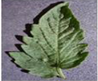
Healthy leaf

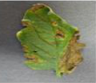
Leaf affected by bacteria

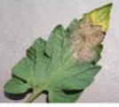

Leaf affected by Late blight

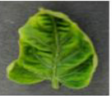

Leaf affected by virus

Image Enhancement:
After removing noise from the image, what we need to do is feature extraction. It is a type of dimension reduction technique that represents the various parts of an image in the form of a feature vector. It has two main algorithms namely Contrast-Limited Adaptive Histogram Equalization(CLAHE) and Gaussian Blur which play a major role in performing feature extraction on the preprocessed image.

Evaluation procedure
The evaluation was performed on the test set. For eachtest image, the decision healthy or blackleg diseased wasdecided through majority voting over the 5 trained modelsof each network. We evaluated the classifier using confu-sion matrices. A confusion matrix shows the breakdown oftrue healthy and true blackleg diseased images, and howmany of them were correctly classified. From the confusionmatrices we calculated the recall and the precision. Therecall is number of true positives divided by the sum oftrue positives and false negatives. The precision is numberof true positives divided by the sum of true positives andfalse positives. The overall accuracy was calculated as thenumber of correct classifications divided by the sum ofcorrect and incorrect classifications.3. RESULTSThe binary classification results for each Resnet architec-ture are presented in the confusion matrices in tables 1and 2. The recall values for each class is presented inparentheses in the right most column and the precisionsare shown in the parentheses in the bottom row. Theaccuracy is indicated in parenthesis in the right-bottomcorner of the matrices.

CHAPTER 2
2. SYSTEM ANALYSIS
2.1 EXISTING SYSTEM

Modern phenotyping and plant disease detection provide promising step towards food security and sustainable agriculture. In particular, imaging and computer vision based phenotyping offers the ability to study quantitative plant physiology. On the contrary, manual interpretation requires tremendous amount of work, expertise in plant diseases, and also requires excessive processing time.

2.1.1 DRAWBACKS OF EXISTING SYSTEM

Over the last decades, the most practiced approach for detection and identification of plant diseases is naked eye observation by experts. But in many cases, this approach proves unfeasible due to the excessive processing time and unavailability of experts at farms located in the remote areas.

2.2. PROPOSED SYSTEM

In this work, we present an approach that integrates image processing and machine learning to allow diagnosing diseases from leaf images. This automated method classifies diseases (or absence thereof) on potato plants from a publicly available plant image database called ‘Plant Village’. Our segmentation approach and utilization of support vector machine demonstrate disease classification over 300 images with an accuracy of 95%. Thus, the proposed approach presents a path toward automated plant diseases diagnosis on a massive scale.

2.2.1. ADVANTAGES OF PROPOSED SYSTEM

- Thus imaging technique combined with machine learning offers a solution to the issue of agricultural productivity and ensures food security.

- So the objective of this work is to develop imaging and machine learning based effective and error-free disease detection system for plant.

Literature Survey
AUTHOR | TITTLE | DESCRIPTION
“AutomaticRecognition of Guava Leaf Diseases using Deep Convolution NeuralNetwork | M. R. Howlader, U. Habiba, R. H. Faisal and M. M. Rahman, ,” | Agriculture is the major part of the Indian economy as it provides key support to social and economic development of the country. Sugarcane isthe leading cash crop in various states of India which has larger share in the net agriculture produce.Recently,researches have highlighted the impact of different disease on various plants.
M. Islam, Anh Dinh, K. Wahid and P. Bhowmik, | Detection of potato diseases using image segmentation and multiclass support vector machine | Modern phenotyping and plant disease detection provide promising step towards food security and sustainable agriculture. In particular, imaging and computer vision based phenotyping offers the ability to study quantitative plant physiology.
“Detection of leaf diseases and classification usingdigital image processing,” | R. M. Prakash, G. P. Saraswathy, G. Ramalakshmi, K. H. Mangaleswariand T. Kaviya, | In this paper, image processing techniques are used to detect the plant leaf diseases. The objective of this work is to implement image analysis & classification techniques for  Detection of leaf diseases and classification.
“Severity identificationof Potato Late Blight disease from crop images captured under uncon-trolled environment,” | S. Biswas, B. Jagyasi, B. P. Singh and M. Lal, | Plant disease management is an important factor  in agriculture as it causes a significant yield loss in crops. Late Blight is the most devastating disease for Potato in most of the potato growing regions in the world. For optimum use of pesticide and to minimize the yield loss, the identification of disease  severity is essential.

2.3 FEASIBILITY STUDY
The feasibility Analysis is an analytical program through project manager determines the project success ratio and through feasibility study project manager able to see either project. The key considerations involved in the feasibility analysis are:
- Economic Feasibility
- Technical Feasibility
- Operational Feasibility
- Environmental Feasibility
2.3.1 ECONOMICAL FEASIBILITY
Hence this project is economically feasible there is no need to involve any cost for this project.
2.3.2 TECHNICAL FEASIBILITY
Software Technologies used are PHP and MySql. In the educational institutions, it is possible to update the system in future. No special hardware is required for the purpose of using this system. Hence it is declared that this project is technically feasible.
2.3.3 OPERATIONAL FEASIBILITY
As the admin work mainly to maintain the Patient and Doctor .Doctor will predict patient cancer disease. Hence it is easy to operate with training. Therefore it is operationally feasible for implementation.

2.3.4 ENVIRONMENTAL FEASIBILITY
This project environment is correct as a admin has developed this system and no expenditure is involved under any head and this process is part of admin document management, this project environment is accessible.
2.4 SYSTEM REQUIREMENTS
- System : Pentium IV 2.4 GHz.
- Hard Disk : 40 GB.
- Monitor : 15 inch VGA Color.
- Mouse : Logitech Mouse.
- Ram : 512 MB
- Keyboard : Standard Keyboard
2.4.1 HARDWARE REQUIREMENTS
The Hardware of the computer consists of physical component such as Input Devices, Storage Devices, Processing & Control units and Output Devices. Computer includes external storage unit to store data in programs.
The Hardware Configuration involved in this project
- System : Pentium IV 2.4 GHz.
- Hard Disk : 40 GB.
- Monitor : 15 inch VGA Color.
- Mouse : Logitech Mouse.
- Ram : 512 MB
- Keyboard : Standard Keyboard

2.4.2 SOFTWARE REQUIREMENTS
Software is a group of programs that computers need to do a particular task. It is an essential requirement of Computer System. The Software used to develop the project is
- Operating System : Windows XP.
- Platform : DOT NET TECHNOLOGY
- Front End : ASP.Net 3.5
- Back End : SQL SERVER 2005

2.5 MODULE DESCRIPTION

CHAPTER 3
SYSTEM DESIGN AND DEVELOPEMENT

3.1 DATA FLOW DIAGRAM

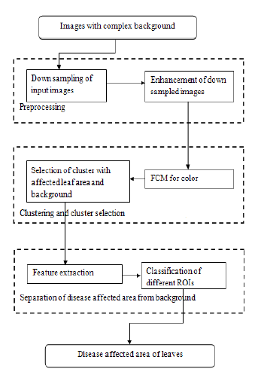

3.2 SYSTEM ARCHICTURE

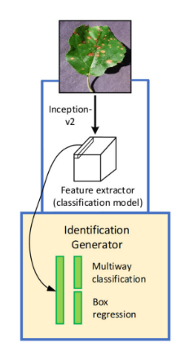

UML DIAGRAM

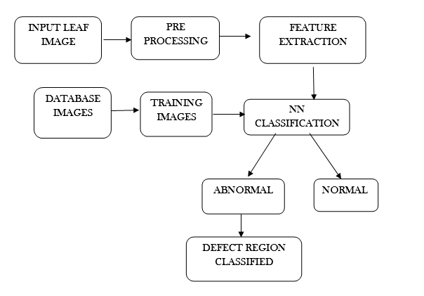

Case Diagram

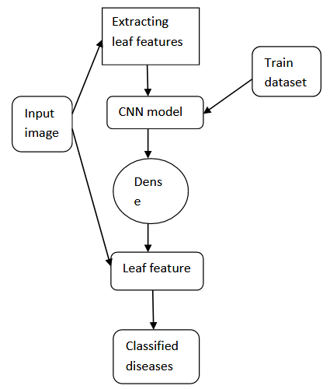

Sequence Diagram

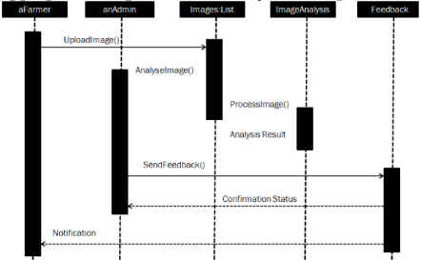

CHAPTER 4
TESTING AND IMPLEMENTATION

  - TESTING
Implementation is the stage of the project when the theoretical design is turned into a working system. This is the final and important phase in the system life cycle It is actually the process of converting the new system into a operational one.

4.1.1Unit Testing
Unit testing comprises the set of tests performed by an individual programmer prior to integration of the unit into a larger system. The module interface is tested to ensure that information properly flows into and out of the program unit. The local data structure is examined to ensure that data stored temporarily maintains its integrity during all steps in an algorithm’s execution. Boundary conditions are tested to ensure that the module operates properly at boundaries established to limit or restrict processing. All independent paths through the control structure are tested. All error-handling paths are tested.
4.1.2 Block Box Testing
Black-box testing is a method of software testing that examines the functionality of an application without peering into its internal structures or workings. This method of test can be applied virtually to every level of software testing: unit, integration, system and acceptance. It is sometimes referred to as specification-based testing.
4.2 SYSTEM IMPLEMENTATION
Implementation is the stage of the project when the theoretical design is turned into a working system. This is the final and important phase in the system life cycle It is actually the process of converting the new system into a operational one.

CHAPTER 5
CONCLUSION
CONCLUSION

In this paper an FCM clustering and neural network classification based approach is proposed to detect and quantify the severity for late blight disease of potato. Images of disease affected leaves are collected under uncontrolled environment to make the algorithm more robust and image background independent. The algorithm consists of mainly two steps: (a) Fuzzy c-mean clustering to separate the disease affected area along with background (b) to extract affected leaf area from background using neural network. The proposed approach achieves a very high accuracy in terms computation of the disease affected area which in turn results in accurate disease severity identification.

CHAPTER-6
REFERENCE
[1] M. Islam, Anh Dinh, K. Wahid and P. Bhowmik, “Detection ofpotato diseases using image segmentation and multiclass support vectormachine,”2017 IEEE 30th Canadian Conference on Electrical andComputer Engineering (CCECE), Windsor, ON, 2017, pp. 1–4.

[2] Malvika Ranjan, Manasi Rajiv Weginwar, NehaJoshi, A.B. Ingole,“Detection and Classification of Leaf Disease Using Artificial NeuralNetwork,”International Journal of Technical Research and Applications,2015, pp. 331–333.

[3] L. Liu and G. Zhou, “Extraction of the Rice Leaf Disease ImageBased on BP Neural Network,”2009 International Conference onComputational Intelligence and Software Engineering, Wuhan, 2009,pp. 1–3.

[4] P. Tm, A. Pranathi, K. SaiAshritha, N. B. Chittaragi and S. G. Koolagudi,“Tomato Leaf Disease Detection Using Convolutional Neural Networks,”2018 Eleventh International Conference on Contemporary Computing(IC3), Noida, 2018, pp. 1–5.

[5] S. Biswas, B. Jagyasi, B. P. Singh and M. Lal, “Severity identificationof Potato Late Blight disease from crop images captured under uncon-trolled environment,”2014 IEEE Canada International HumanitarianTechnology Conference—(IHTC), Montreal, QC, 2014, pp. 1–5.

[6] Aparajita, R. Sharma, A. Singh, M. K. Dutta, K. Riha and P. Kriz,“Image processing based automated identification of late blight diseasefrom leaf images of potato crops,”2017 40th International Conferenceon Telecommunications and Signal Processing (TSP), Barcelona, 2017,pp. 758–762.

[7] H. Waghmare, R. Kokare and Y. Dandawate, “Detection and classifi-cation of diseases of Grape plant using opposite colour Local BinaryPattern feature and machine learning for automated Decision SupportSystem,”2016 3rd International Conference on Signal Processing andIntegrated Networks (SPIN), Noida, 2016, pp. 513–518.

[8] F. T. Pinki, N. Khatun and S. M. M. Islam, “Content based paddyleaf disease recognition and remedy prediction using support vectormachine,”2017 20th International Conference of Computer and Infor-mation Technology (ICCIT), Dhaka, 2017, pp. 1–5.

[9] N. R. Bhimte and V. R. Thool, “Diseases Detection of Cotton Leaf SpotUsing Image Processing and SVM Classifier,”2018 Second InternationalConference on Intelligent Computing and Control Systems (ICICCS),Madurai, India, 2018, pp. 340–344.

[10] S. Hossain, R. M. Mou, M. M. Hasan, S. Chakraborty and M. A. Razzak,“Recognition and detection of tea leaf’s diseases using support vectormachine,”2018 IEEE 14th International Colloquium on Signal Process-ing & Its Applications (CSPA), Batu Feringghi, 2018, pp. 150–154.

[11] R. M. Prakash, G. P. Saraswathy, G. Ramalakshmi, K. H. Mangaleswariand T. Kaviya, “Detection of leaf diseases and classification usingdigital image processing,”2017 International Conference on Innovationsin Information, Embedded and Communication Systems (ICIIECS),Coimbatore, 2017, pp. 1–

[12] M. R. Howlader, U. Habiba, R. H. Faisal and M. M. Rahman, “AutomaticRecognition of Guava Leaf Diseases using Deep Convolution NeuralNetwork,”2019 International Conference on Electrical, Computer andCommunication Engineering (ECCE), Cox’sBazar, Bangladesh, 2019,pp. 1–5

