Advanced Skin Diseases Diagnosis leveraging image Processing

ABSTRACT

Air pollution affects human skin in many ways. Skin diseases are common in densely populated regions. These diseases have a devastating impact on people's lives by creating a huge need for the disease diagnosis. The proposed work on skin disease determination system aims for an accurate diagnosis leveraging image processing. The methodology outlined here aims to identify skin disease by scrutinizing the input image. The method involves filtering of the input provided to remove noise. Conversion of image to a grayscale image, and image segmentation. Feature extraction is used to minimize the amount of data to be processed by the classifier. The SVM (Support Vector Machine) is then used in the image classification to identify the skin disease. The increased use of technology has led to an efficient and accurate way of diagnosis that aids in curing the disease more expeditiously. Using the proposed method skin diseases such as rosacea, melanoma, psoriasis and acne are identified with a high accuracy of 89%.

CHAPTER-1
INTRODUCTION

A skin disease is the pathological state affecting the body surface.Long-timeexposure to ultraviolet radiation or the radiation from high-frequency wire-less equipment may induce the skin canceration. According to the statisticaldata report from American Cancer Society [1], it is estimated that 91,270 newmelanoma cases are diagnosed in the United States in 2018, and meanwhile itis estimated that about 9,320 people will die from melanoma. Melanoma has ahigh cure rate at early detection, with 99% of 5-year relative survival rate. How-ever, since it is easier to spread to other parts of the body than non-melanomaskin cancers, the 5-year relative survival rate at long-term stage drops to 20%.The symptom of skin diseases is a long and constantly changing process.Generally, the health care provider should provide assessment where changeshave occurred in certain area of the skin for over a month or longer. However,due to multiple factors such as poor medical conditions and cumbersome medicalprocess, patients always ignore such changes of their skin, or wrongly identifythem as other skin injuries. Meanwhile, no family physician or supervisionorganization carries out the regular maintenance and treatment since it is not required to report medical records to the cancer registry.The development of body sensor network [2, 3], artificial intelligence, cloudcomputing [4] and wireless network communication [5, 6] has brought opportunities to the cognitive medical service . The remote health monitoring, health guidance and feedback can be realized through multi-sensordata fu-sion with the help of remote medical devices, such as mobile phone ,wearable device [, intelligent robot, autonomous vehicle and unmanned aerial vehicle . And an open-source programming framework to support rapidand flexible prototyping and management of human-centered applications is crit-ical . In the paper , it is pointed out that mobile devices equippedwithdeep neural network can potentially extend the range of dermatologists outside the outpatient service. It is estimated that by 2023, the number of smart phone users will reach 7.2 billion [18]. It is possible to provide general diagnosisservicewith low cost The automatic recognition of patients’ skin conditions may become agoodpromoter for the cognitive medical monitoring framework. On one side, it canreduce the consumption of resources deployed to the medical industry center,and meanwhile automatically feed back the patients’ conditions and service ex-periences evaluation. On the other side, it properly takes into account the consumption of patients’ time and money cost as well as the concerns on pri-vacy. The cloud computing technology deployed on the medical center can solve the problem that the local devices, under the big data environment, have insufficient computing and storage capacities to provide the computation-intensive services . However, the huge amount of data transmission and com-munication will cause a consumption of network communication resources, it isstill unable to meet the delay-sensitive characteristic of cognitive medical ser-vices . The deployment of edge computing technology on the networkedge can solve the pressure caused by the large scale of computation-intensiveand rich-media tasks . Also, the technology is beneficial to facil-itate secure data management and convenient data trading in mobile healthcare . Some existing advanced computation offloading schemes such as [30] and novel routing mechanisms such as can be integrated into the systemto achieve highly reliable cooperative computing and communication betweenlocal terminals and remote clouds .The traditional skin disease detection system complete the classification out-put through characteristics extraction of image data set as the input. The exis ting researches adopt the deep architecture to automate the learning of char-acteristics , and the priori knowledge based on pathological skin dataset is obtained to improve the accuracy of automatic classification.Esteva etal put forward the adoption of Deep Convolution Neural Networks to classify skin diseases, and demonstrate the achievement of expert-level diagnosis. In the literature , it is discussed that the pre-trained deep neural network model has an effect superior to the model trained from the beginning, and the problem of insufficient labeled image data of skin disease can be solved by pre-training the Convolution Neural Network (CNN) with the images from other medical fields. Due to the limited intelligence of current system, a one-time testing result be concluded by inputting the collected users’ skin image data into the system, but the function of monitoring the changes of skin conditions cannot be realized. Meanwhile, current system is a centralized system with a static and centralized database required an active update by expert, which limits the user mobility and cannot realize convenient and high-efficiency self-checking. In addition, the centralized system is unable to provide sufficient resources to support the individualized database for different population groups. Due to the centralization of the database, it is unable to give a good judgment for paroxysmal diseases. We consider that the future skin disease monitoring system will meet following characteristics:
Real-time: The user’s individual database keeps accumulating and storing. The system analyzes user’s skin state based on personal historical data and current data, and monitors skin state changes regularly. The camera on smart terminal capture user’s skin image, and skin analysis reports feedback to terminals. Users record their skin state changes based on reports.

Dynamic: The physical location of users often changes dynamically, but mobile devices are relatively static for skin disease detection. Through mobile terminals, users can easily and efficiently collect individual skin images. With the computing power of terminals, fast analysis results are provided to users.

Sharing mode: User’s skin images can be locally stored for analysis. Multiple users also send their data to the cloud for sharing. The cloud collects data from different users, and conducts more accurate analysis with its powerful storage and computing capacity.
Background and Motivation
Now a day’s people are suffering from skin diseases, More than 125 million people suffering from Psoriasis also skin cancer rate is rapidly increasing over last few decades specially Melanoma is most diversifying skin cancer. Dermatophytosis rate is high specially at rural areas.If skin diseases are not treated at earlier stage, then it may lead to complications in the body including spreading of the infection from one individual to the other. The skin diseases can be prevented by investigating the infected region at an early stage. The characteristic of the skin images are diversified, so that it is challenging job to devise an efficient and robust algorithm for automatic detection of the skin disease and its severity. Skin tone and skin color plays an important role in skin disease detection. Colour and coarseness of skin are visually different. Automatic processing of such images for skinanalysis requires quantitative discriminator to differentiate the diseases.Proposed system is combo model which is used for the prevention and early detection of skin cancer, psoriasis and Dermatophytosis. Basically skin disease diagnosis depends on thedifferent characteristics like color, shape , texture etc. there are no accepted treatment for skin diseases Different physicians will treat differently for same symptoms. Key factor in skin diseases treatment is early detection further treatment reliable on the early detection. In this paper, Proposedsystem is used for thediagnosis multiple skin disease using statistical parameter analysis. Statistical analysis is anxious with analysis of random data. Random data is pattern of skin diseases. Standard database is used this data does not have anymathematical expression,it has some statistical properties. To analysesrandom data we must analyzestatistical properties of it.
In this modern world, there are numerous technological advancements which are most helpful for the betterment of our lives. Various technological advancements are being done in the medical fields. Skin diseases are the most common type of diseases. There are many types of skin diseases. Some are due to allergy while some are due to chronic diseases. Classifying the proper skin disease and treating them is a tedious one. Various diseases have various symptoms. Treating skin disease wrongly may lead to various other diseases like skin cancer. Every disease may have a pattern. So understanding the disease pattern is the only way to understand the type of disease. Usually, for a dermatologist understanding the patternsare a complex task. Using the latest advanced technologies like deep learning &machine learning algorithms skin disease types can be predicted Various type of predictions and analysis are been carried out. The accuracy of the results is improvised.Using Machine Learning algorithms Support Vector Machine, Random Forest, the skin diseasesare predicted. The accuracy of the prediction is biased. The accuracy sometimes may be accurate while sometimes may not.
Different from the traditional open-ended input/output system, we intend to build a user-centered close-loop system, and consider connecting the mobile terminal users’ personal data collection, the communication between mobile terminals and remote data center, and the real-time update of training model. Based on this, a deep skin disease monitoring system based on edge-to-cloud cognitive medical framework is put forward. Specifically, the contributions of this paper are divided into three points as below:
1. A medical AI framework based on data width evolution and self learning is proposed. Under such framework, the process of information interaction between users and terminal devices, and the wide collection of detain the close-loop information flow of user and remote medical data center reconsidered.
2. A data set filter algorithm based on information entropy is given, so as to lighten the load of no-label data sets in terminals and edge cloud in the meantime of improving the data quality of remote cloud data base and the learning ability of analysis model.
3. A load module especially for analysis algorithms is designed. Under such module, it can be compatible with the application requirements accord-ing to the learning model selected. Meanwhile, three learning models are deployed successively in the load module and the training process is completed
Contribution
In this paper, we present Image analysis system to diagnosis multiple skin disease using statistical parameter analysis. Statistical analysis is concerned with analysis of random data. This system is combo-model which is to be used to diagnosis multiple skin diseases at a time. The target skin diseases are skin cancer, psoriasis and dermatophytosis. The disease diagnosis and classification is built on statistical parameter analysis. Statistical parameters includes: Entropy, Texture index, Standard deviation, Correlation fact Depending on standard range of parameters skin disease is going to be diagnosis and classified.
Skin Diagnosis Device
With the development of semiconductor technology and small electronic devices industry, devices for measuring skin using various computerized and electronic technologies have emerged. The global dermatology devices market size was valued at over USD 9.6 billion in 2017 and is expected to showcase lucrative growth over the forecast period, registering a CAGR of 13.5%. Increasing prevalence of skin cancer and other skin diseases has significantly contributed to high demand for various dermatological diagnostic and treatment procedures in recent times, thereby spurring product demand(Market Research Report, 2018).Figure 1shows one of the representative personal skin diagnosis devices(Ahn, 2019).
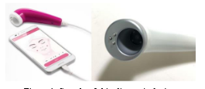
To get a clear image, most of these devices make contact with the skin. Contacting the cylindrical body with the skin enables to get a clear skin image with fixed focal length and stable light source. However, contact with the skin can causepossibleskin contamination due to uncleanness and corrosion of the contact part. To prevent this, the contact part needs to keep clean and sterilized which lead to additional costs and actions.

Skin image identification
Skin image identification has become one of the most demanding and attractive research areas in the past few years. Colour histogram based characteristics are used to analyse and classify the psoriasis infected skin images in sequence to take the diagnostic measures [3]. On one hand, this would be useful for dermatologists to decrease diagnostic faults, while on the other hand it can help as the early test bed for patients in rural areas where there is a dearth of good medical professionals. A support Vector Machine with RBF kernel is used for the classification of images. The experimental results gave the encouraging results in an initial attempt for identification of psoriasis infected skin images. Classification of psoriasis skin diseases and their severity will be carried out.Image processing method is implemented in MATLAB, for skin cancer detection. In this paper, online database of skin cancer images is used for testing the method [4]. Skin images for cancers of different types are obtained from, of these imagesfor BCC (Basal cell carcinoma), SCC (squamous cell carcinoma) and normal or harmless skin lesions are collected and database is created for testing purpose Next step in image processing is de-noising using wavelet tool. To remove low frequency or background noise from image, filtering is used. After de-noising the image, median filtering is applied to remove some hair like material from skin image, if present Thresholding is the simplest and most commonly used method of segmentation. This paper considers use of high-level feature extraction technique by implementing the 2D-DWT as the processing method neural network tool is used for classification of skin images in different skin diseases. Using the features extracted from image, it is classified either in harmful diseased i.e., BCC (Basel cell carcinoma), SCC (Squamous cell carcinoma), or harmless.Buket D. have worked on real time system for the malignant melanoma prevention and early detection [5]. In this system user is able to analyse captured image. System process the image and shows the notification for medical help. This system shows convincing results and accuracy.Ho Tak Lau. Have worked on an automatic skin cancer classification [6]. Available image is given to the system and it goes throughdifferent image processing procedure. Use full information is extracted from the image and then with the help of training and testing system classifies the image. Recognition accuracy of the neural network classifier is 90%

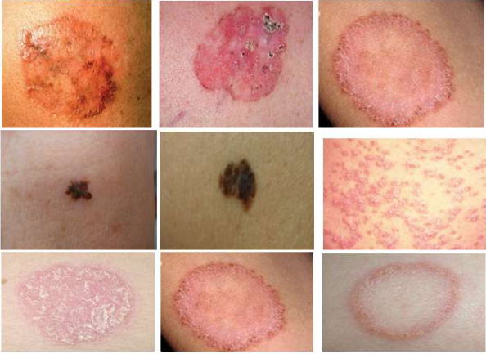
Sample images from database including melanom, psoriasis and dermatophytosis

Skin Analysis Technology
There have been many researches on skin analysis using image processing. Various statistical methods for segmentation and classification of skin lesions in dermoscopic images is developed (Zaqout, 2016). Texture and color features of skin diseases are analyzed(Wei et al., 2018; Yang et al., 2018).Also, applying neural networks including the Artificial Neural Network (ANN) and the Convolution Neural Network (CNN) areconductedfor effective skin recognition (Abbadi et al., 2010; Menaka and Rohini, 2014; Yang et al., 2018).
PREPROCESSING:
Achieving high performance of skin disease detection system requires overcoming some major difficulties. Such as creating a database and unifying image dimensions. In the following section, the technique used in image resizing is explained.

Image Resizing:
To resolve the problem of different image sizes in the database an input image is either increase or decrease in size. Unifying the image size will get the same number of features from all images. Moreover, resizing the image reduces processing time and thus increases system performance. Fig 3 shows the original image of size is 260×325 pixels. Fig 4 shows the resized image with the new size of 227×227 pixels

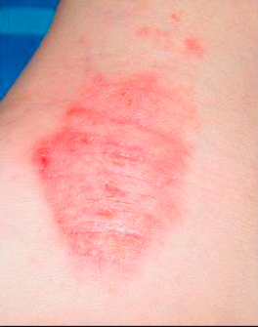

Example of Original image of Eczema database.

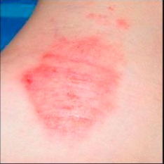

Example of resizing image of Eczema database.

Feature Extraction:
At the beginning, Convolution Neural Network (CNN) is a set of stacked layers involving both nonlinear and linear processes. These layers are learned in a joint manner. The main building blocks of any CNN model are: convolution layer, pooling layer, nonlinear Rectified Linear Units (ReLU) layer connected to a regular multilayer neural network called fully connected layer, and a loss layer at the backend. CNN has known for its significant performance in applications as the visual tasks and natural language processing AlexNet is a deep CNN model, developed by Krizhevsky et al. [8], to model the 2012 ImageNet for the Large Scale Visual Recognition Challenge (ILSVRC-2012). AlexNet consists of five convolutional layers; where a nonlinear ReLU layer is stacked after each convolutional layer. In addition, the first, second, and fifth layers contain max pooling layers, as shown in Figure 5. Moreover, two normalization layers are stacked after the first and the second convolutional layers. Furthermore, two fully connected layers at the top of the model preceded by soft ax layer. Alex Net was trained using more than 1.2 million images belonging to 1000 classes [8]. We proposed feature extraction from a pretrained convolutional neural network. Because it is the easiest and robust approach to use the power of pretrained deep learning networks.

Classification:
Classification is a computer vision method. After extracting features, the role of classification is to classy the image via Support Vector Machine (SVM). A SVM can train classifier using extracted features from the training set.

MACHINELEARNING
A.Motivation for Machine Learning
There are mainly two types of users for this app, naïve users who do not have access to the extremely technical details of histopathological attributes and those users who are aware of this data because they have the access to the medical reports generated by the laboratories. We exploit this fact in order to improve the efficiency of the system. These medically approved attributes are better performers when compared to the features extracted from the image alone.
B.Data Source
The dataset obtained from [18] is used to train the model. There were various models which were tested in order to learn the hypothesis which best suits this training data.
C.Machine Learning Models Used for Prediction
1) kth Nearest Neighbor (kNN) A non-parametric algorithm used for classification. The various test data are considered to be points on a 34 dimensional space, because there are 34 attributes. When the new test data comes in, the k closest points to this are put in a poll and the result gives the label of the disease.

2) Decision Trees (DT) The algorithm which was used to train the decision tree was the ID3 algorithm [10][17].There are two advantages of using the decision tree. The decision tree is the best suited algorithm for training a system with missing values. The ID3 algorithm works on the principle of choosing the attribute with lowest entropy (1)and highest information gain [5]. The attributes which have missing data will have very low information gain. For this data set the attributes with missing data were found not found in the tree as the information gain was too low on these attributes.

3)Artificial Neural Networks (ANN) Any non-linear system can be built with just one hidden layer but must have units in hidden layer; this is known as universal approximator. [19] This is not practical as described by George Cybenko. A feed forward ANN with back propagation was tried for the same features which were extracted. The ANN consisted of one input layer, two hidden layers and an output layer.
A deep learning technique called auto encoder [11] which trains the model using an identity function was used to initialize the parameters of the model, the weight matrices W.
•Input layer: Input from the user (34 neurons)
•Hidden Layer 1: Composed of sigmoid function (16 neurons)
•Hidden Layer 2: Composed of tanh function (8 neurons).
•Output Layer: Softmax as described by (1). One issue with using ANN was the possibility of under fitting. Due to the presence of missing values in the training dataset [18]the artificial neural network does not suit well for this problem as there will be too much under fitting.

CHAPTER 2
2. SYSTEM ANALYSIS
2.1 EXISTING SYSTEM

Skin diseases such as Melanoma and Carcinoma are often quite hard to detect at an early stage and it is even harder to classify them separately. Recently, it is well known that, the most dangerous form of skin cancer among the other types of skin cancer is melanoma because it is much more likely to spread to other parts of the body if not diagnosed and treated early. In order to classify these skin diseases, “Support Vector Machine (SVM)” a Machine Learning Algorithm can be used.

2.1.1 DRAWBACKS OF EXISTING SYSTEM

For a long time, algorithms for finding objects in images have been studied extensively. Numerous researches have been done in object detection, recognition, classification and discrimination.

2.2. PROPOSED SYSTEM

In this paper, we propose a method to identify whether a given sample is affected with Melanoma or not. The steps involved in this study are collecting labeled data of images that are pre-processed, flattening those images and getting the pixel intensities of images into an array, appending all such arrays into a database, training the SVM with labeled data using a suitable kernel, and using the trained data to classify the samples successfully. The results show that the achieved accuracy of classification is about 90%.

2.2.1. ADVANTAGES OF PROPOSED SYSTEM

Experiments show that analyzing the shadow of the skin lesions can effectively detect and classify the lesion of concern.

Literature Survey
AUTHOR | TITTLE | DESCRIPTION
Automatic detection of melanoma skin cancer using texture analysis,” | M. A. Sheha, M. S. Mabrouk, and A. Sharawy, “ | Melanoma is considered the most dangerous type of skin cancer. Early and accurate diagnosis depends mainly on important issues, accuracy of feature extracted and efficiency of classifier method. This paper presents an automated method for melanoma diagnosis applied on a set of dermoscopy images.
R. Yasir, M. A. Rahman, and N. Ahmed, | “Dermatological disease detection using image processing and artificial neural network,” | Skin diseases are among the most common health problems worldwide.In this article we proposed a method that uses computer vision based techniques to detect various kinds of dermatological skin diseases.
Okuboyejo, Damilola A, et al. Automating | ”Skin Disease Diagnosis Using Image Classification”. | The modern leap of machines into smarter  worlds has lead researchers to develop sophisticated systems that have the ability to diagnose human diseases through machine learning tools and techniques.
Vinayshekhar Bannihatti Kumar, S. Selvin Prem Kumar, Varun Saboo | “Dermatological disease detection using image processing and machine learning”. | Diseases much more quickly and accurately. But the cost of such diagnosis is still limited and very expensive. So, image processing techniques help to build automated screening system for dermatology at an initial stage. The extraction of features  plays a key role in helping to classify skin disease.

2.3 FEASIBILITY STUDY
The feasibility Analysis is an analytical program through project manager determines the project success ratio and through feasibility study project manager able to see either project. The key considerations involved in the feasibility analysis are:
- Economic Feasibility
- Technical Feasibility
- Operational Feasibility
- Environmental Feasibility
2.3.1 ECONOMICAL FEASIBILITY
Hence this project is economically feasible there is no need to involve any cost for this project.
2.3.2 TECHNICAL FEASIBILITY
Software Technologies used are PHP and MySql. In the educational institutions, it is possible to update the system in future. No special hardware is required for the purpose of using this system. Hence it is declared that this project is technically feasible.
2.3.3 OPERATIONAL FEASIBILITY
As the admin work mainly to maintain the Patient and Doctor .Doctor will predict patient cancer disease. Hence it is easy to operate with training. Therefore it is operationally feasible for implementation.

2.3.4 ENVIRONMENTAL FEASIBILITY
This project environment is correct as a admin has developed this system and no expenditure is involved under any head and this process is part of admin document management, this project environment is accessible.
2.4 SYSTEM REQUIREMENTS
- System : Pentium IV 2.4 GHz.
- Hard Disk : 40 GB.
- Monitor : 15 inch VGA Color.
- Mouse : Logitech Mouse.
- Ram : 512 MB
- Keyboard : Standard Keyboard
2.4.1 HARDWARE REQUIREMENTS
The Hardware of the computer consists of physical component such as Input Devices, Storage Devices, Processing & Control units and Output Devices. Computer includes external storage unit to store data in programs.
The Hardware Configuration involved in this project
- System : Pentium IV 2.4 GHz.
- Hard Disk : 40 GB.
- Monitor : 15 inch VGA Color.
- Mouse : Logitech Mouse.
- Ram : 512 MB
- Keyboard : Standard Keyboard

2.4.2 SOFTWARE REQUIREMENTS
Software is a group of programs that computers need to do a particular task. It is an essential requirement of Computer System. The Software used to develop the project is
- Operating System : Windows XP.
- Platform : DOT NET TECHNOLOGY
- Front End : ASP.Net 3.5
- Back End : SQL SERVER 2005

2.5 MODULE DESCRIPTION

CHAPTER 3
SYSTEM DESIGN AND DEVELOPEMENT

3.1 DATA FLOW DIAGRAM

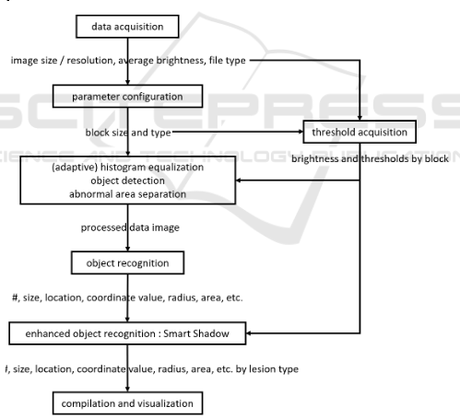

3.2 SYSTEM ARCHICTURE

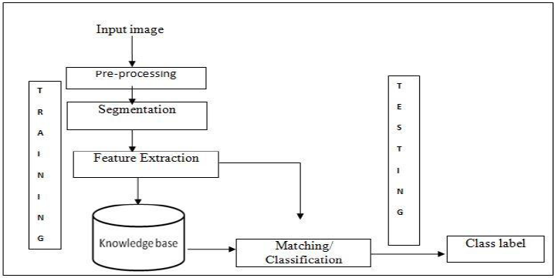

UML DIAGRAM

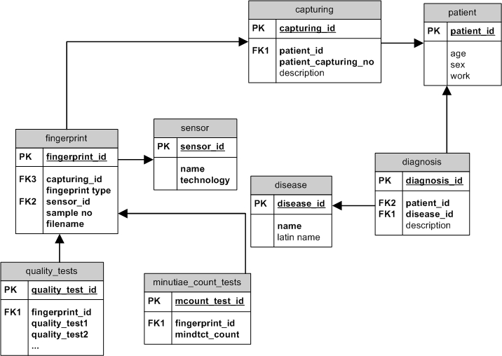

Case Diagram

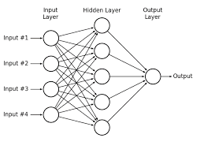

CHAPTER 4
TESTING AND IMPLEMENTATION

  - TESTING
Implementation is the stage of the project when the theoretical design is turned into a working system. This is the final and important phase in the system life cycle It is actually the process of converting the new system into a operational one.

4.1.1Unit Testing
Unit testing comprises the set of tests performed by an individual programmer prior to integration of the unit into a larger system. The module interface is tested to ensure that information properly flows into and out of the program unit. The local data structure is examined to ensure that data stored temporarily maintains its integrity during all steps in an algorithm’s execution. Boundary conditions are tested to ensure that the module operates properly at boundaries established to limit or restrict processing. All independent paths through the control structure are tested. All error-handling paths are tested.
4.1.2 Block Box Testing
Black-box testing is a method of software testing that examines the functionality of an application without peering into its internal structures or workings. This method of test can be applied virtually to every level of software testing: unit, integration, system and acceptance. It is sometimes referred to as specification-based testing.
4.2 SYSTEM IMPLEMENTATION
Implementation is the stage of the project when the theoretical design is turned into a working system. This is the final and important phase in the system life cycle It is actually the process of converting the new system into a operational one.

CHAPTER 5
CONCLUSION
CONCLUSION

An effective image analysis procedure for discriminating and recognizing various skin lesions under contactless skin diagnosis environment is proposed. Issues such as uneven distribution of light are properly addressed, and various skin lesions are effectively discriminated according to their characteristics, using the image processing technique and the shadow analysis. To generalize and objectify the proposed procedure, additional analysis and comparison of detailed skin lesion would be performed under additional light source including the variety of its strength, angle, wavelength, etc. Further researches after this work include detailed lesion discrimination upon appropriate decision-making frameworks such as deep learning, and Bid Data analysis over various kinds of skin image.

CHAPTER-6
REFERENCE
[1] M. A. Sheha, M. S. Mabrouk, and A. Sharawy, “Automatic detection of melanoma skin cancer using texture analysis,” International Journal of Computer Applications, vol. 42, no. 20, pp. 22–26, 2012.

[2] R. Yasir, M. A. Rahman, and N. Ahmed, “Dermatological disease detection using image processing and artificial neural network,” in 8th International Conference on Electrical and Computer Engineering: Advancing Technology for a Better Tomorrow, ICECE. Pan Pacific Sonarga on Dhaka, 2014, pp. 687–690.

[3] S. M. Jadhav, S. Nalbalwar, and A. Ghatol, “Artificial neural network based cardiac arrhythmia classification using ecg signal data,” in Electronics and Information Engineering (ICEIE), 2010 International ConferenceOn, vol. 1. IEEE, 2010, pp. V1–228.

[4] Okuboyejo, Damilola A, et al. ―Automating”Skin Disease Diagnosis Using Image Classification”. Proceedings of WCECS 2013, October 23 -25, 2013, San Francisco, USA, IAENG Open Access Publication, 24 Oct. 2013, www.iaeng.org/publication/WCECS2013/.

[5] Mrs. S.Kalaiarasi1, Harsh Kumar2, Sourav Patra3 “Dermatological Disease Detection using Image Processing and Neural Networks”.

[6] Vinayshekhar Bannihatti Kumar, S. Selvin Prem Kumar, Varun Saboo “Dermatological disease detection using image processing and machine learning”.

[7] Yuslinda Wati Mohamad Yusof, Hadzli Hashim, Khairul Anam Sulaiman, Suhaila Subahir, Noor Ezan Abdullah and Fairul Nazmie Osman “ Plaque Lesion Classification Fuzzy Model Based on Various Color Models”.

[8] Subrat Kumar Rath, Siddharth Swarup Rautaray “Performance Comparison of Min-Max Normalisation on Frontal Face Detection Using Haar Classifiers”.

[9]“Comparison of Machine Learning Algorithms for Skin Disease Classification Using Color and Texture Features”. ParameshwarR. Hegde Department of Dermatology and Yenepoya Research Center Yenepoya, Manjunath M. Shenoy Department of Dermatology Yenepoya, B.H. Shekar Department of Computer Science Mangalore University Mangalore, Karnataka, India.

