Road accident analysis and prediction of accident severity by using machine learning

ABSTRACT

Injuries due to road accidents are one of the most prevalent causes of death apart from health related issues. The World Health Organization states that road traffic injuries caused an estimated 1.35 million deaths worldwide in the year 2016. That is, a person is killed every 25 seconds. This calls for the need to analyse road accidents and the factors affecting them and come up with a method to reduce the probability of their occurrence. The analysis of road accident severity was done by running an accident dataset through several machine learning classification algorithms to see which model performed the best in classifying the accidents into severity classes such as slight, severe and fatal.. It was observed that logistic regression to perform multilevel classification gave the highest accuracy score. It was also observed that factors such as number of vehicles, lighting conditions and road features played a role in determining the severity of the accident.

CHAPTER-1
INTRODUCTION

Statistics of road accident worldwide is alarming. The world health organization’s figure of 12 million peopledying yearly from road accident and over 50 million injured is just a clue to the seriousness of which researchshould be directed towards investigating ways of preventing the occurrence of the global menace. Nigeria, with a total land area of 910,771 square kilometres and human population of about 167 million, is the most populous country in Africa, and the 7th most populousnation in the world. Nigeria ranked as the country with the second largest road network in Africa in 2011. Its population density which varies in rural and urban areas (approximately 51.7% and 48.3% respectively) translates to a population-road ratio of860 persons per square kilometresindicating intense traffic pressure on the available road network. This pressure contributes to the high road traffic accidents in the country (FRSC, 2012).

The frequency of road accident in Nigeria is on the rise daily and the mortality rate recorded is on the increase as compared to deaths registered from deadly diseases. Sumaila (2013) reported that the Nigeria situation has reached such an alarming proportion even to the point of sheer frustration and near helplessness.The study area is Benue state. Located between longitude 6032E and 10oE and latitudes 6o30’N and 8o10’N in the central zone of Nigeria with a population of 4,219,244 (NPC, 2006) and total land area of about 33,955 square kilometres. The state is dividedinto 23 local Government Areas. The state capital is Makurdi.Due to the high rate of accident in Benue state, this paper aim to develop a computer based system for the prediction and hence prevention of road accident UML tools. This will be useful to theFRSC and other agencies in charge of road planning and accident prevention.This paper is set out as follows: Section two gives a review of related literature. Section three is the methodology used in the research. Section four shows the results and discussion. Section five give a brief conclusion of the paper and future work to be done on this research is given in Section six.
Traffic-accident analysis
Many consider car accidents as the 21stcentury epidemic. Researchers from all over the world try to find models which can well define the root cause of this problem, and seek to find creative solutions for it. Reducing the severity of injuries caused bytraffic accident is one of the most effective means to improve highway safety. Hence various models have been employed to analyze the severity of traffic accidents, to gain understanding about it and to identify its factors [50].Regression analyseshave been extensively employed to explore the factors contributing to injury severity[51-55]. Among these regression models, the logistic regression model and the ordered outcome (or choice) model have been the most commonly applied techniques in traffic injury analysis. However, most regression models have their own model assumptions and predefined underlying relationships between dependent and independent features. Violation of this assumptions can result in unreliable models with greater error thandesirable [56]. As mentioned before,ML models havebeen an active analytical technique in many scientific areas for years. Most of them, in particular NNs, are non-parametric models, not assuming predefined assumptions concerning the data.In the field of safety analysis, a number ofstudiesin recent yearsin which ML models were used to predict accident-severityandidentifyits factors have been carried out.The data set used in this type of studies is imbalanced, i.e.,most of the instances describe mild accidents and instances describing the more serious accidents are rare. As was widely explained before, MLmodels learnedby using imbalanced data sets are usually disappointing because of their inability to properly learn the concepts related to the minority class. Moreover, thesemodels may achieve high accuracy scores that seem to reflect the goodness of the model; however these high scoresonly represent the accuracy onthe majority class.To avoid these problems, one should consider implementing techniques for facing with imbalanced data sets. To the best of the author’sknowledge, studies conducted using ML models to analyze accident-severitydid not takeinto consideration the imbalance problem. Hence,one of the main problems in these studies was the inability ofthemodelsfoundto predict and characterize the more serious accidents. The outcome of this problem is a model that,though it achieves high overall accuracy results, its ability to classify correctly and explain severeaccidents was very low. In some of thesestudies,only the overall accuracy was presented,thusthe accuracy oneach class was not probably considered.
MACHINE LEARNING
Machine Learning controls how computers can learn and boost their performance based on data. Main aim of a research aspect since a long time is to make computers such intelligent that they can make independent intelligent decisions in any situation without human intervention. They should implicitly learn to observe, identify complex patterns and make intelligent decisionsbased on the data of their own.
Types of Machine Learning:
- Supervised Learning: based upon the learning from available data and constructs a model, which classifies the new tuples to a particular class. Some examples of supervised learning techniques are SVM, decision tree etc.
- Unsupervised Learning: implies clustering because initially no predefined classes are there in the data set. Clusters are built from the tuples which holds some similarity and after that user can map these clusters to a particular class. Commonly we use clustering to identify the classes within the data. Unsupervised model built cannot tell us about the semantic meaning of the clusters identified, because training data is unlabeled.eg. KNN.

A Survey on Analysis of factors affecting to Road accidents using Data Mining Technique
The paper’s results obtained by data mining can be used by the transportation department to discover the patterns and trends and foresee the future. Existing work mainly concentrates on only analyzing and finding correlation between the parameters influencing road accidents using the dataset for existing roads. Does not consider the newly planned roads and roads under construction. proposes an effective means for analyzing the road accident dataset. Collect the realistic data from the transportation department. Data cleaning is done using the imputation method. Complexity of the dataset is reduced by Data selection. Discretization technique is used of data reduction. Apply data mining techniques such as assoc.rule mining, clustering to obtain the relationwithin the pointsinfluencing road accidents. Use map reduce programming for correlation to reduce the time taken for correlation analysis. Then apply Support vector machines, Naive Bayes Classification and Geospatial predictive modeling machine learning techniques to predict the accident-pronezones for the newly planned roads.
Classification of road accident
Single vehicle crashes are significant over two vehicle crashes and animal-vehicle crashes in increasing the severity of a crash in rural areas. This is provided by having positive parameters for rollover crashes and negative parameter for crashes that occur on the roadway. That is when the crash occurs off the roadway there is a higher risk for having a severe crash. However, in urban areas, both the single vehicle and multi vehicle crashes are significant but crashes related to animals are non-significant towards the severity of the crash. Classification of the road accident is recorded by the Royal Malaysian Police (PDRM). This is determine by the severity of the most seriously injured casualty involved either slight, serious or fatal, using the following criteria :
a) Slight injury – an injury of minor character such as a sprain, bruise, cut or laceration not judged to be severe or slight shock requiring roadside attention.
(b) Serious injury – an injury for which a person is detained in hospital as an “in patient”, or any of the following injuries whether or not detention result, fractures, concussion, internal injuries, crushing, severe cuts and lacerations, severe general shock requiring medical treatment, injuries causing death 30 or more days after the accident.
(c) Fatal – death from injuries sustained, resulting than 30 days after the accident.
(D) Damage only – damage on vehicle. It is not include fatal and injured.
Road Accident Prediction
Accident prediction has been extensively studied in the lastdecades. Historically, variations of the Poisson regression suchas the negative binomial regression were used to predict thenumber of accidents that occurred on a given road segment[18]. During the last decade, machine learning algorithmssuch as decision trees, artificial neural networks and Bayesiannetworks have been used successfully to predict road accidents[6]–[9]. Data features usually include information about theroad such as number of lanes, average daily traffic, and roadcurvature, as well as weather information such as averageprecipitation and temperature.In 2005, Chang [6] compared the performances of a negativebinomial regression with that of an Artificial Neural Network
(ANN) to predict the number of accidents during a year onroad segments of a major freeway in Taiwan. The datasetcontained data from the years 1997 and 1998, which resultedin 1,338 accidents. The ANN achieved slightly better resultsthan negative binomial regression, with an accuracy of61.4%.On the same dataset, Changet al.[7] also used decision treesfor accident prediction, to get more insights on the importantvariables for accident prediction. It appeared that the averagedaily traffic and the number of days with precipitation were themost relevant features. The decision tree reached an accuracyof52.6%.Linet al.[8] compared the performances of FrequentPattern trees [19] with that of Random Forest for feature se-lection. They usedk-nearest-neighbor and Bayesian networksfor real-time accident prediction on a segment of a highway.Using the mean and sometimes the standard deviation ofthe weather condition, the visibility, the traffic volume, thetraffic speed, and the occupancy measured during the last fewminutes their models predict the occurrence of an accident.They obtained the best results using the Frequent Pattern treesfeature selection and achieved an accuracy of61.7%. It shouldbe noted that they used only a small sample of the possiblenegative examples, to deal with data imbalance.Theofilatos [9] also used real-time data on two urban arteri-als of the city of Athens to study road accident likelihood andseverity. Random Forest were used for feature selection and aBayesian logistic regression for accident likelihood prediction.The most important features identified were the coefficients ofvariation of the flow per lane, the speed, and the occupancy.In addition, many studies aim at predicting the severity of anaccident using various information from the accident in orderto understand what causes an accident to be fatal. Chonget al.[20] used decision trees, neural networks and a hybrid modelusing a decision tree and a neural network. They obtainedthe best performances with the hybrid model which reachedan accuracy of90%for the prediction of fatal injuries. Theyidentified that the seat belt usage, the light conditions and thealcohol usage of the driver are the most important features.Abell ́anet al.[21] also studied traffic accident severity bylooking at the decision rules of a decision tree using a datasetof 1,801 highway accidents. They found that the type andcause of the accident, the light condition, the sex of the driverand the weather were the most important features.All of these studies use relatively small datasets using datafrom only a few years or only a few roads. Indeed, it canbe hard to collect all the necessary information to performroad accident prediction on a larger scale, and dealing withbig datasets is more difficult. However, more recent studies[10]–[12] performed accident prediction at a much larger scale,usually using deep learning models. Deep learning models canbe trained online so that the whole dataset does not need tostay in memory. This makes it easier to deal with big datasets.Chenet al.[10] used human mobility information comingfrom mobile phone GPS data and historical accident recordsto build a model for real-time prediction of traffic accidentrisk in areas of 500 by 500 meters. The risk level of anarea is defined as the sum of the severity of accidents thatoccurred in the area during the hour. Their model achievesa Root Mean-Square Error (RMSE) of1.0accident severity.They compared the performance of their deep learning modelwith the performances of a few classical machine learningalgorithms: Decision Tree, Logistic Regression and SupportVector Machine (SVM), which all got worse RMSE valuesof respectively1.41,1.41and1.73. We note that they havenot tried the Random Forest algorithm while it usually hasgood prediction performances. Najjar et al. [11], trained aconvolutional neural network using historical accident data andsatellite images to predict the risk of accidents on an intersec-tion using the satellite image of the intersection. Their bestmodel reaches an accuracy of73%. Yuanet al.[12] used anensemble of Convolutional Long Short-Term Memory (LSTM)neural networks for road accident prediction in the state ofIowa. Each neural network of the ensemble is predicting on adifferent spatial zone so that each neural network learns thepatterns corresponding to its zone, which might be a rural zonewith highways or an urban zone. They used a high-resolutionrainfall dataset, a weather dataset, a road network dataset, asatellite image and the data from traffic cameras. Their modelreaches an RMSE of0.116for the prediction of the numberof accidents during a day in an area of 25 square kilometers.These more recent studies are particularly interesting be-cause they achieve good results for the prediction of roadaccidents in time and space in larger areas than previousstudies which focused on a few roads. But unlike previousstudies, they only provide an estimation of the risk of accidentsfor large areas, i.e., at a coarse spatial resolution. In our study,we decided to focus on urban accidents occurring in the islandof Montreal, a 500-km2urban area, but with a much higherprediction resolution. We used a time resolution of one hourand a spatial resolution defined by the road segments delimitedby road intersections. The road segments used have an averagelength of 124 meters, and82%of the road segments are lessthan 200 meters long.Some of these studies define the road accident predictionproblem as a classification problem, while others define itas a regression problem. Most of the studies performingclassification only report the accuracy metric which is notwell suited for problems with data imbalance such as roadaccident prediction [22]. The studies performing regressionuse different definitions for the risk of accidents, which makes comparisons difficult.
THE EFFECTS OF TRAFFIC ACCIDENTS
Traffic accidents have numerous effects on people, society and nature. Much research has been done on the psychological effects of a traffic accident. Mayou et al (1993) determined the consequences of being a road traffic accident victim. They concluded that psychiatric symptoms and disorder are frequent after major and less severe injuries. The post-traumatic symptoms a traffic accident causes are disabling and common. Next to such effects on your health, traffic accidents also cause physical damage to the victim and the vehicle and involve high costs for aftercare affecting the welfare of society by leaning on scarce medical resources. A study of Bastida (2004), shows by a cost-of-illness method, dividing costs into health services costs, insurance administration costs and the cost of the material damages to vehicles, that the total cost of traffic accidents was more than 6 billion euros in Spain, representing 1,35% of their gross national product. Besides the damage traffic accidents can cause for the welfare of a country, a very recent research of Jou and Chen (2015) examine the external costs that are involved in traffic accidents. These include air pollution and time delay.
Dealing with Data Imbalance
Road accident prediction suffers from a data imbalanceissue. Indeed, a road accident is a very rare event so we havemuch more examples without accident, than examples withaccidents available. Machine learning algorithms usually havedifficulty learning from imbalanced datasets [23]. There aretwo main types of approaches to deal with data imbalance.The sampling approaches consist in re-sampling the datasetto make it balanced either by over sampling the minorityclass, by under-sampling the majority class or by doing
both. Random under-sampling of the majority class usuallyperforms better than more advanced methods like SMOTE orNearMiss [23]. The cost-based approach consists in addingweights on the examples. The negative examples receive alower weight in order to compensate for their higher number.These weights are used differently depending on the machinelearning algorithm.Chen, Liaw, and Breiman [14] proposed two methods to dealwith class imbalance when using Random Forest: WeightedRandom Forest and Balanced Random Forest. Weighted Ran-dom Forest (WRF) belongs to the class of cost-based ap-proaches. It consists in giving more weight to the minorityclass when building a tree: during split selection and duringclass prediction of each terminal node. Balanced RandomForest belongs to the class of sampling approaches. It issimilar to Random Forest, but with a difference during thebootstrapping phase: for each tree of the forest, a randomunder-sampling of the majority class is performed in order toobtain a balanced sample. Intuitively, Balanced Random Forestis an adaptation of random under-sampling of the majorityclass making use of the fact that Random Forest is an ensemblemethod. While none of the methods is clearly better than theother in terms of predictive power, BRF has an advantagein terms of training speed because of the under-sampling.Interestingly, Wallaceet al.[24] present a theoretical analysisof the data imbalance problem and suggest to use methodssimilar to Balanced Random Forest.

Traffic Accident detection using Random Forest Classifier

Constant car crash recognition strategy, that joined vehicle to vehicle correspondence procedures with AI techniques. Utilizations procedures of managed AI calculations, for example, ANN, SVM, and Random Forestsare executed on traffic information to build up a model to recognize mishap cases from ordinary cases. The proposed framework utilizes reenacted information gathered from vehicular specially appointed systems (VANETs) in view of the rates and arranges of the vehicles and afterward, it sends traffic cautions to the drivers. In addition, the proposed strategy can give evaluated topographical area of the conceivable mishap, which could be utilize full for high route organization to reaction quickly or forestall auxiliary mishap.

Mining Road Traffic Accident to Improve Safety: Role of Road Related factors on Accident severity in Ethiopia
Strategies to diminish mishap seriousness are of extraordinary enthusiasm to traffic organizations and the general population on the loose. The work applied information mining advances to connect recorded street qualities to mishap seriousness in Ethiopia, and built up a lot of decides that could be utilized by the Ethiopian Traffic Agency to improve wellbeing. The overall goal of the exploration is to examine the job of street related components in mishap seriousness, utilizing RTA information from Ethiopia and prescient models. Paper gathered and cleaned car crash information, endeavored to build novel traits, and tried various prescient models. information was introduced as rules utilizing the PART calculation of WEKA. The plan was centered around the commitment that different street related components have on the mishap seriousness.
Application of Machine Learning Models in Crash Severity Prediction
Without the assumptions of statistical models, several ML models have been employed for traffic crash severity prediction. ML algorithms can model the non-linear relationship crash severity and related factors. Sameen and Pradhan [38] predicted the injury severity of tra_c crashes using recurrent neural networks (RNN) in Malaysia. It was found that RNN is superior, with an accuracy of 71.77% followed by multilayer perceptron neural network (MLP) and Bayesian logistic regression (BLS) with an accuracy of 65.48% and 58.30%, respectively. Similarly, the performance of the ANN and OP model were compared [39]. Fuzzy adaptive resonance theory (ART) and MLP were used to examine crash severity. The study revealed that MLP performed better, with an accuracy of 73.6%, whereas ART showed a classification accuracy of 70.6%. The results of the OP model were the least accurate, having an accuracy of 61.7%. ANN was used for crash severity prediction using 6 years of crash data for Abu Dhabi. The results of ANN were compared to the OP model and the ANN outperformed the OP model in terms of accuracy [40]. Similarly, ANN was used to predict the crash severity at a signalized intersection in Central Florida, USA. MLP and ART neural networks were compared based on accuracy and MLP performed better than ART [17].
Along with neural networks, many other ML models have been used for crash severity prediction. A study adopted ANN, SVM, decision tree (DT), and LR models to predict severity [41]. SVM showed the most accurate prediction followed by DT, ANN, and LR, respectively. A multi-objective genetic algorithm was compared with ANN, SVM, and DT for predicting crash severity in the capital of Iran. The technique was more accurate compared to ANN, SVM, and DT [42]. Zhang et al. [43] compared ML and statistical techniques for crash severity prediction. The study concluded that the ML techniques, although su_ering from over-fitting issues, outperformed the classical statistical techniques in terms of
prediction accuracy. Similarly, a study was conducted to predict the tra_c crash severity using ANN, genetic algorithm (GA), combined genetic algorithm (CGA), and pattern search (PS) methods, and their performance was compared [44]. The study revealed that ANN outperformed the other three methods having an R-value of 0.87, while an R-value of 0.79 was calculated for GA and PS methods. Li et al. [45] used a combination of GA and ANN to examine the factors a_ecting the crash severity in Washington, USA. The authors combined the GA with ANN architecture to enhance the e_ciency of searching for the significant variables. It was found that driver conduct, vehicle action, roadway surface condition, driver restraint, and age significantly a_ect the crash severity. A deep learning-based convolutional neural network (CNN) was employed for predicting tra_c crash severity. CNN was compared with several statistical techniques like LR and ML techniques like SVM and ANN. The study revealed that the CNN model performed better than all of the other techniques [46]. In the preceding sections (Sections 1.2 and 1.3), we presented the studies related to traffic crash severity prediction. Many statistical techniques have been implemented by researchers followed by modern ML techniques like ANN, SVM, DT, and GA. As a general conclusion, we noticed that ML techniques outperformed conventional crash severity prediction techniques, which was also evident in most studies.

Artificial Neural Networks
First introduced in the 1960s, the ANN can solve many complex analytical problems. It is a biologically-motivated machine learning tool that captures and represents extremely complex non-linear relationships existing in real work data sets. It works by mimicking the neurological functions of the human brain, just as neurons stimulate and react to a situation in the human brain. It can predict the outcome of an observation based on the pattern caught from historical data after carrying put a training procedure [41]. An artificial neuron is the basic unit of a neural network. Input nodes transfer the knowledge to a neuron, which is processed internally to produce a response. ANN is processed in two steps: the first step is the linear combination of input values and then the obtained results are used as an argument for non-linear activation function. Each connection has a weight assigned to it and the activation function is di
erentiable .The network architecture is defined by neurons organization. An example of a neural network is presented in Figure 1. The architecture consists of an input layer, a hidden layer, and an output layer. The input, hidden, and output layers consist of five, three, and one neuron, respectively. The output of one layer is utilized as input to the next layer. The activation function in the neuron combines the inputs by multiplying with the corresponding weights. There is also a bias component in each neuron. Optimization methods are used to estimate the weights of the input (“called the training of network”) by minimizing the loss function. Several training algorithms are available; one of them is backpropagation, which is based on a gradient descent technique for parameter estimation.

CHAPTER 2
2. SYSTEM ANALYSIS
2.1 EXISTING SYSTEM

- The traffic has been transformed into the difficult structure in points of designing and managing by the reason of increasing number of vehicle.
- This situation has discovered road accidents problem, influenced public health and country economy and done the studies on solution of the problem.

2.1.1 DRAWBACKS OF EXISTING SYSTEM

The required precautions against potential accidents may be taken by reckoning the risks for road accidents.

2.2. PROPOSED SYSTEM

Large calibrated data agglomerations have increased by the reasons of the technological improvements and data storage with low cost. Arising the need of accession to information from this large calibrated data obtained the corner stone of the data mining. In this study, assignment of the most compatible machine learning classification techniques for road accidents estimation by data mining has been intended.

2.2.1. ADVANTAGES OF PROPOSED SYSTEM

- Machine learning algorithm, which is much acceptable for road accident assumption by the data mining method attaining from road accident data was studied to be found.
- It is observed that 854.000 road accidents happened in general of the country in 2013 on the study by TRAMER. %34 of these accidents happened in Istanbul.

Literature Survey
AUTHOR | TITTLE | DESCRIPTION
T. Rahman, | "Road Accidents in Bangladesh: An Alarming Issue", | This paper discusses the involvement of Non-Motorized Vehicles(NMVs) in road traffic system and accidents with particular context of Bangladesh. Considering all forms of NMVs, rickshaws are the most popular mode.
M. S. Satu, S. Ahamed, F. Hossain, T. Akter and D. M. Farid | , "Mining traffic accident data  of N5 national highway in Bangladesh employing decision trees," | Mining traffic accident data is necessary for accident free smart cities, as traffic accidents causes harmful injuries, loss of lives and damages properties of people. N5 National Highway in Bangladesh is the largest highway, where a large number of accidents occur in every year.
S. Kumar and D. Toshniwal, | "A data mining approach to characterize road accident locations," | Data mining has been proven as a reliable technique to analyze road accidents and provide productive results. Most of the road accident data analysis use data mining techniques, focusing on identifying factors that affect the severity of an accident.
Beshah, Tibebe, and Shawndra Hill | “Mining Road Traffic Accident Data to Improve Safety: Role of Road-Related Factors on Accident Severity in Ethiopia,” | Road traffic accidents (RTAs) are a major public health concern, resulting in an estimated 1.2 million deaths and 50 million injuries worldwide each year. In the developing world, RTAs are among the leading cause of death and injury; Ethiopia in particular experiences the highest rate of such accidents.

2.3 FEASIBILITY STUDY
The feasibility Analysis is an analytical program through project manager determines the project success ratio and through feasibility study project manager able to see either project. The key considerations involved in the feasibility analysis are:
- Economic Feasibility
- Technical Feasibility
- Operational Feasibility
- Environmental Feasibility
2.3.1 ECONOMICAL FEASIBILITY
Hence this project is economically feasible there is no need to involve any cost for this project.
2.3.2 TECHNICAL FEASIBILITY
Software Technologies used are PHP and MySql. In the educational institutions, it is possible to update the system in future. No special hardware is required for the purpose of using this system. Hence it is declared that this project is technically feasible.
2.3.3 OPERATIONAL FEASIBILITY
As the admin work mainly to maintain the Patient and Doctor .Doctor will predict patient cancer disease. Hence it is easy to operate with training. Therefore it is operationally feasible for implementation.

2.3.4 ENVIRONMENTAL FEASIBILITY
This project environment is correct as a admin has developed this system and no expenditure is involved under any head and this process is part of admin document management, this project environment is accessible.
2.4 SYSTEM REQUIREMENTS
- System : Pentium IV 2.4 GHz.
- Hard Disk : 40 GB.
- Monitor : 15 inch VGA Color.
- Mouse : Logitech Mouse.
- Ram : 512 MB
- Keyboard : Standard Keyboard
2.4.1 HARDWARE REQUIREMENTS
The Hardware of the computer consists of physical component such as Input Devices, Storage Devices, Processing & Control units and Output Devices. Computer includes external storage unit to store data in programs.
The Hardware Configuration involved in this project
- System : Pentium IV 2.4 GHz.
- Hard Disk : 40 GB.
- Monitor : 15 inch VGA Color.
- Mouse : Logitech Mouse.
- Ram : 512 MB
- Keyboard : Standard Keyboard

2.4.2 SOFTWARE REQUIREMENTS
Software is a group of programs that computers need to do a particular task. It is an essential requirement of Computer System. The Software used to develop the project is
- Operating System : Windows XP.
- Platform : DOT NET TECHNOLOGY
- Front End : ASP.Net 3.5
- Back End : SQL SERVER 2005

2.5 MODULE DESCRIPTION
Data Set Selection
Data is the most import part when you work on prediction systems. It plays a very vital role your whole project i.e., you system depends on that data. So selection of data is the first and the critical step which should be performed properly, For our project we got the data from the government website. These datasets were available for all. There are other tons of websites who provide such data. The dataset we choose wad selected based on the various factors and constraints we were going to take under the consideration for our prediction system.
Data Cleaning and Data Transformation
After we have selected the dataset. The next step is to clean the data and transform it into the desired format as it is possible the dataset we use may be of different format. It is also possible that we may use multiple datasets from different sources which may be in different file formats. So to use them we need to convert them into the format we want to or the type that type prediction system supports. The reason behind this step is that it is possible that the data set contains the constraints which are not needed by the prediction system and including them makes the system complicated and may extend the processing time. Another reason behind data cleaning is the dataset may contain null value and garbage values too. So the solution to this issue is when the data is transformed the garbage values are replaced. There are many methods to perform that.

Data Processing and Algorithm Implementation
After the data is been cleaned and transformed it’s ready to process further. After the data has been cleaned and we have taken the required constraints. We divide the whole dataset int o the two parts that can be either 70-30 or 80-20. The larger portion of the data is for the processing. The algorithm is applied on that part of data. Which helps the algorithm to learn on its own and make prediction for the future data or the unknown data. The algorithm is executed in which we take only the required constraints from the cleaned data. The output of the algorithm is in ‘yes’ and ‘no’. It gives the error rate and the success rate.
Output and User Side Experience
After the prediction system is ready to use. The Website is developed for the user. The user just has to fill a form which consists of different options they need to select. They are like the type of climate, the type of vehicle and so on. Once the user submits the form the algorithm is triggered and the input given by the user is passed to the prediction system. The user is given how accident prone the road can be in percentage.

CHAPTER 3
SYSTEM DESIGN AND DEVELOPEMENT

3.1 DATA FLOW DIAGRAM

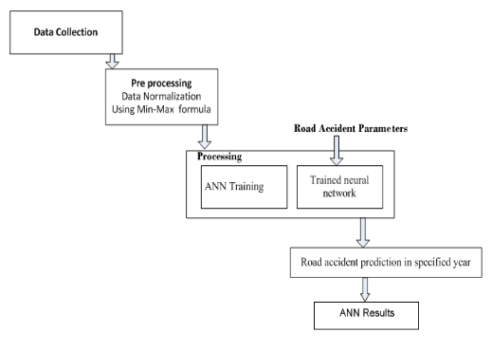

3.2 SYSTEM ARCHICTURE

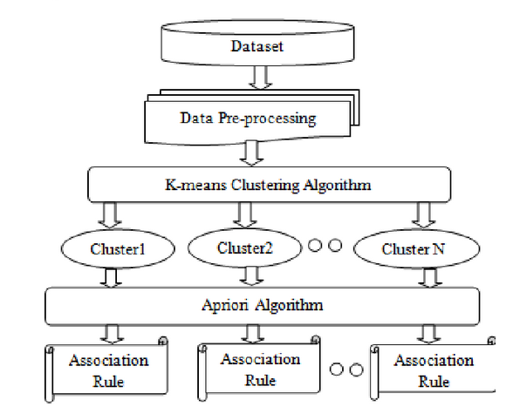

UML DIAGRAM

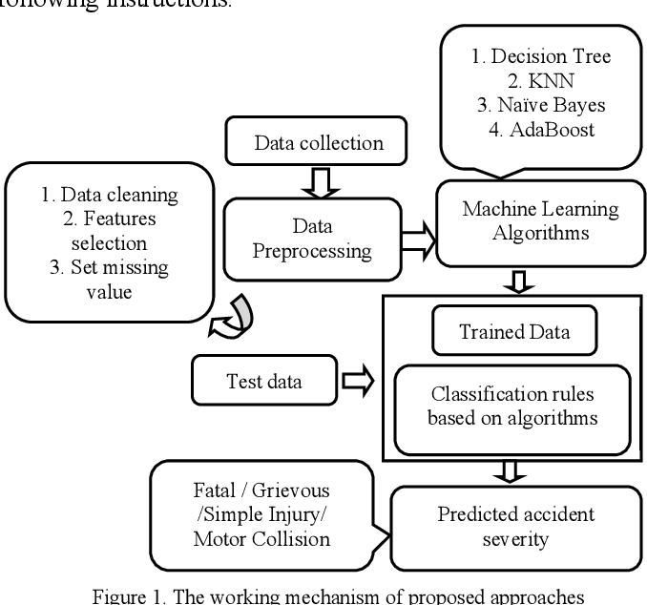

Case Diagram

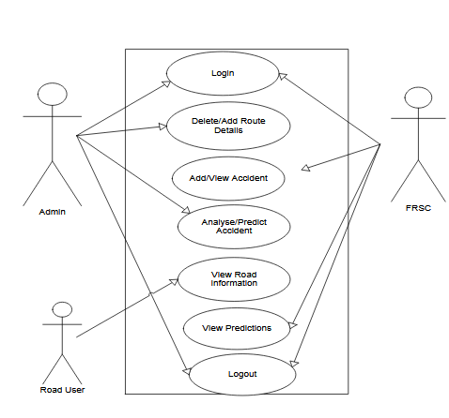

Sequence Diagram

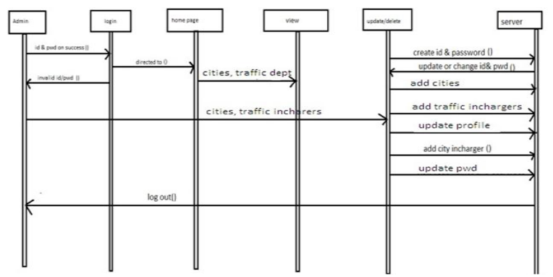

CHAPTER 4
TESTING AND IMPLEMENTATION

  - TESTING
Implementation is the stage of the project when the theoretical design is turned into a working system. This is the final and important phase in the system life cycle It is actually the process of converting the new system into a operational one.

4.1.1Unit Testing
Unit testing comprises the set of tests performed by an individual programmer prior to integration of the unit into a larger system. The module interface is tested to ensure that information properly flows into and out of the program unit. The local data structure is examined to ensure that data stored temporarily maintains its integrity during all steps in an algorithm’s execution. Boundary conditions are tested to ensure that the module operates properly at boundaries established to limit or restrict processing. All independent paths through the control structure are tested. All error-handling paths are tested.
4.1.2 Block Box Testing
Black-box testing is a method of software testing that examines the functionality of an application without peering into its internal structures or workings. This method of test can be applied virtually to every level of software testing: unit, integration, system and acceptance. It is sometimes referred to as specification-based testing.
4.2 SYSTEM IMPLEMENTATION
Implementation is the stage of the project when the theoretical design is turned into a working system. This is the final and important phase in the system life cycle It is actually the process of converting the new system into a operational one.

CHAPTER 5
CONCLUSION
CONCLUSION

For any software to be effective and maintainable, it must be built on good framework and design. The designing aspect is tedious and time consuming and most software developers are likely to either make a mess of it or completely skip it. With the advocacy of rapid prototyping and its many variants, there is less emphasis on software design hence the high rate of software failure and high maintenance cost. This paper presents the design of a road accident predictive system using ANN that can be of help to system developers in building the real software. Road traffic accidents are prevalent on Benueroadshence this design will assist security agents, road users and roadtraffic personnel to be able to predict and prevent the occurrence of accidents. The next phase of this work will be to develop a computer based system for the predictive part using ANN.

CHAPTER-6
REFERENCE
[1] T. Rahman, "Road Accidents in Bangladesh: An Alarming Issue", The World Bank, 2012. [Online]

[2] K. M. Habibullah, A. Alam, S. Saha, A. Amin and A. K. Das, " A Driver-Centric Carpooling: Optimal Route-Finding Model using Heuristic Multi–Objective Search," 2019 4th International Conference on Computer and Communication Systems (ICCCS), Singapore, 2019.

[3] M. M. L. Elahi, R. Yasir, M. A. Syrus, M. S. Q. Z. Nine, I. Hossain and N. Ahmed, "Computer vision based road traffic accident and anomaly detection in the context of Bangladesh," 2014 International Conference on Informatics, Electronics & Vision (ICIEV), Dhaka, 2014, pp. 1-6.

[4] M. S. Satu, S. Ahamed, F. Hossain, T. Akter and D. M. Farid, "Mining traffic accident data
of N5 national highway in Bangladesh employing decision trees," 2017 IEEE Region 10 Humanitarian Technology Conference (R10-HTC), Dhaka, 2017, pp. 722-725.

[5] H. İ. Bülbül, T. Kaya and Y. Tulgar, "Analysis for Status of the Road Accident Occurrence and Determination of the Risk of Accident by Machine Learning in Istanbul," 2016 15th IEEE International Conference on Machine Learning and Applications (ICMLA), Anaheim, CA, 2016, pp. 426-430.

[6] S. Kumar and D. Toshniwal, "A data mining approach to characterize road accident locations," Journal of Modern Transportation(2016), vol. 24, issue no. 1, pp. 62-72.

[7] Beshah, Tibebe, and Shawndra Hill, “Mining Road Traffic Accident Data to Improve Safety: Role of Road-Related Factors on Accident Severity in Ethiopia,” AAAI Spring Symposium: Artificial Intelligence for Development (2010).

[8] A. Esmaeili, M. Khalili and A. Pakgohar, "Determining the road defects impact on accident severity; based on vehicle situation after accident, an approach of logistic regression," 2012 International Conference on Statistics in Science, Business and Engineering (ICSSBE), Langkawi, 2012, pp. 1-4.

[9] M. A. A. Mamun, J. A. Puspo and A. K. Das, “An intelligent smartphone based approach using IoT for ensuring safe driving,” 2017 International Conference on Electrical Engineering and Computer Science (ICECOS), Palembang, 2017, pp. 217-223.

[10] T. Adhikary, A. K. Das, M. A. Razzaque, A. Almogren, M. Alrubaian, and M. M. Hassan, “Quality of Service Aware Reliable Task Scheduling in Vehicular Cloud Computing,” Mobile Networks and Applications, Volume 21, Issue 3, pp 482-493, June 2016

