Detection of leukemia in human blood sample based on microscopic images

ABSTRACT

At the moment, identification of blood disorders is through visual inspection of microscopic images of blood cells. From the identification of blood disorders, it can lead to classification of certain diseases related to blood. This paper describes a preliminary study of developing a detection of leukemia types using microscopic blood sample images. Analyzing through images is very important as from images, diseases can be detected and diagnosed at earlier stage. From there, further actions like controlling, monitoring and prevention of diseases can be done. Images are used as they are cheap and do not require expensive testing and lab equipments. The system will focus on white blood cells disease, leukemia. The system will use features in microscopic images and examine changes on texture, geometry, color and statistical analysis. Changes in these features will be used as a classifier input. A literature review has been done and Reinforcement Learning is proposed to classify types of leukemia. A little discussion about issues involved by researchers also has been prepared.

CHAPTER-1
INTRODUCTION
Medical imaging has become one of the most important visualization and interpretation methods in biology as well as medicine over the past decade. This time has witnessed a tremendous development of new, powerful instruments for detecting, storing, transmitting, analyzing, and displaying medical images. This has led to a huge growth in the application of digital image processing techniques for solving medical problems. The most challenging aspect of medical imaging lies in the development of integrated systems for the use of the clinical sector. Design, implementation, and validation of complex medical systems require a tight interdisciplinary collaboration between physicians and engineers. Main objective of analyzing through images is to gather information, detection of diseases, diagnosis diseases, control and therapy, monitoring and evaluation[1].In blood diseases, the most dangerous disease is blood cancer i.e. leukemia. This study focused on leukemia detection because, it needs fast and accurate detection. Leukemia is a fast growing disease so it require quick detection, regular test & monitoring for control it and to evaluate the treatment properly. Leukemia is detected by hematologist under microscope. This manual examination method has some drawbacks, it is time-consuming and costly. Result may be affected by the factors such as hematologist experience and tiredness. The automation process overcome the above problems, images are cheap and do not require expensive testing and lab equipment. In leukemia, bone marrow produces abnormal white blood cell. Compared with normal cells, abnormal white blood cell do not die when they should. Thus the number of abnormal white blood cell become numerous and interfere normal white blood cells to carry out their duties. This also causes an imbalance of blood system in human body.
Leukemiais a name of a blood disease; it is a cancer of blood cells. Leukemia disease grows very rapidly hence it has to be detected as early as possible. It originates in bone marrow when bone marrow produces large number of white blood cells or abnormal White Blood Cells. Leukemia has four major types: Acute Lymphocytic Leukemia (ALL), Acute Myelogenous Leukemia (AML), Chronic Lymphocytic Leukemia (CLL) and Chronic Myelogenous Leukemia (CML)(3).Leukemia is detected manually by experts under microscope. This manual examination method is costly, time consuming and totally depends on operator’s knowledge and skills. Detection through Digital image processing overcomes the above problems. Digital image processing requires images as the primary input, and do not require expensive lab equipments To automate the process of detection of leukemia many image processing algorithms have been developed. This system takes microscopic blood smear images as their input. Depending on type and quality of the image various image processing techniques are used to get desired output. Various techniques such as image enhancement, segmentation, feature extraction and classification are used to detect and identify the leukemia types. All this study shows that the segmentation of the image is the most important step in leukemia image processing. The accuracy of results of next steps (feature extraction and classification) is based on segmentation output.

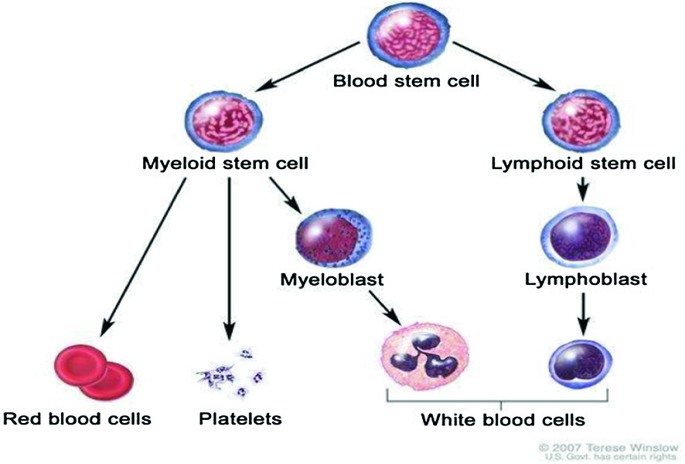

Leukemia is a type of cancer that affects the bone marrow causing increased production of white blood cells which influx the blood stream These are an important, infection-fighting part of your immune system, made in bone marrow. . In orders for myelogenous leukemia to be correctly diagnosed a physician will orders a complete blood count bone mellow biopsy and cytogenetic tests. Leukemia can be identify with the variation in following tests:

AAcute Myeloid Leukemia (AML) : This type of leukemia is common in children under the age of 1 year. It is extremely rare in teenagers. Even so it is mostly in adults aged 40 years.
- Chronic Lymphocytic Leukemia (CLL) : This type of leukemia often happened to older patents. It is extremely rare in patients under the age of 40.
- Chronic Myeloid Leukemia (CML) : This type of leukemia can occur in all but the most common is for adults age after 45 years.

OBJECTIVE
• Goal of segmentation of blood cells is to isolate the region of interest from the complicated background and to segment every cell into its components such as nucleus, cytoplasm and other parts. AWBC countcandetect hidden infections within your body and alert to undiagnosed medical conditions, such as blooddisorders.
• The main objectives of our project is to detect the diseases such as type of leukemia.

CHAPTER 2
2. SYSTEM ANALYSIS
2.1 EXISTING SYSTEM

Leukemia occurs when lot of abnormal white blood cells produced by the bone marrow. Hematologist makes use of microscopic study of human blood, which leads to need of methods, including microscopic color imaging, segmentation, classification and clustering that can allow identification of patients suffering from Leukemia. The microscopic images will be inspected visually by hematologists and the process is time consuming and tiring. The automatic image processing system is urgently needed and can overcome related constraints in visual inspection. The proposed system will be on microscopic images to detect Leukemia. The early and fast identification of Leukemia greatly aids in providing the appropriate treatment. Initial segmentation is done using Statistical parameters such as mean, standard deviation which segregates white blood cells from other blood components i.e. erythrocytes and platelets. Geometrical features such as area, perimeter of the white blood cell nucleusis investigated for diagnostic prediction of Leukemia.

2.1.1 DRAWBACKS OF EXISTING SYSTEM
- The number of counting blood cells will then be used to calculate the ratio of blood cells for leukemia detection.
- Cytogenetic test takes blood or bone marrow to help identify individual chromosomes. It shows abnormalities in chromosomes, which help to diagnosis and identify the type of leukemia. Results are usually available within 3 weeks.

2.2. PROPOSED SYSTEM
The proposed method is successfully applied to a large number of images, showing promising results for varying image quality. Different image processing algorithms such as Image Enhancement, Thresholding, Mathematical morphology and Labeling are implemented using Lab VIEW and MATLAB.
2.2.1. ADVANTAGES OF PROPOSED SYSTEM

- The proposed method and the result showed that the method managed to
Obtain qualitatively good segmentation results.
- Accuracy is high
- High reliability
- There is no chance of error occurrence
- .Speed of output extraction is fast.

CHAPTER 5
CONCLUSION
CONCLUSION

Above explain method use only detection of leukemia in human blood cells. In this method blood cell image processing segmentation, deletion, fill hole operations are used to obtain the edge of the cancerous blood cell. Pathological tests are costly and timely, so this process is not use for every month or short duration. Using this method process of testing is easy cheap, if suspected cells are obtain then go for the diagnosis under the doctors observation. This project can be extended by identifying other different types of leukemia instantly at a very faster rate and that will help us in finding better ways for the diagnosis of disease.

CHAPTER-6
REFERENCE
[1] C.R., Valencio, M.N., Tronco, A.C.B., Domingos, C.R.B., “Knowledge Extraction Using Visualization of Hemoglobin Parameters to Identify Thalassemia”, Proceedings of the 17th IEE Symposium on Computer Based Medical Systems, 2004, pp.1-6.

[2] R., Adollah, M.Y., Mashor, N.F.M, Nasir, H., Rosline, H., Mahsin, H., Adilah, “Blood Cell Image Segmentation: A Review”, Biomed 2008, Proceedings 21, 2008, pp. 141-144.

[3] N., Ritter, J., Cooper, “Segmentation and Border Identification of Cells in Images of Peripheral Blood Smear Slides”, 30th Australasian Computer Science Conference, Conference in Research and Practice in Information Technology, Vol. 62, 2007, pp. 161-169.

[4] D.M.U., Sabino, L.D.F., Costa, L.D.F., E.G., Rizzatti, M.A., Zago, “A Texture Approach to Leukocyte Recognition”, Real Time Imaging, Vol. 10, 2004, pp. 205-206.

[5] M.C., Colunga, O.S., Siordia, S.J., Maybank, “Leukocyte Recognition Using EM- Algorithm”, MICAI 2009, LNAI 5845, Springer Verlag Berlin Heidelberg, 2009, pp. 545-555.

[6] K.S., Srinivisan, D., Lakshmi, H., Ranganathan, N., Gunasekaran, “Non
Invasive Estimation of Hemoglobin in Blood Using Color Analysis”, 1st International Conference on Industrial and Information System, ICIIS 2006, Sri Lanka, 8 – 11 August 2006, pp 547-549.
[7] W., Shitong, W., Min, “A new Detection Algorithm (NDA) Based on Fuzzy Cellular Neural Networks for White Blood Cell Detection”, IEEE Transactions on Information Technology in Biomedicine, Vol. 10, No. 1,
January 2006, pp. 5-10.

[8] H., Shin, M.K., Markey, “A Machine Learning Perspective on the Development of Clinical Decision Support System Utilizing Mass Spectra of Blood Samples”, Journal of Biomedical Informatics 39. 2006, pp. 227-248.

[9] M., Chitsaz, C., S., Woo, “Software Agent with Reinforcement Learning Approach for Medical Image Segmentation”, Journal of Computer Science and Technology, Vol. 26,No. 2, 2011, pp. 247-255.

[10] T., Bergen, D., Steckhan, T., Wittenberg, T., Zerfab, “Segmentation of leukocytes and erythrocytes in Blood Smear Images”, 30th Annual International IEEE EMBS Conference, Vancouver, Canada, August 20 - 24, 2008, pp. 3075-3078.

