Hybride criptography and stenography
ABSTRACT
This paper presents a technique for secret communication using Cryptography and Steganography. In this paper, the secret message of different size is hidden into an image for making the system more secure. The only authorized users can hide and extract the secret message. The secret messages of different size are used to test the system and the system satisfies all requirements of Steganography. The hybrid approach of Steganography and Cryptography makes the communication secured and it is difficult for the attacker to detect the secret message.

INTRODUCTION

INTRODUCTION
CHAPTER 1
Information security has grown as a significant issue in our digital life. The development of new transmission technologies forces a specific strategy of security mechanisms especially in state of the data communication [1]. The significance of network security is increased day by day as the size of data being transferred across the Internet [2]. Cryptography and steganography provide significant techniques for information security [3].The most important motive for the attacker to benefit from intrusion is the value of the confidential data he or she can obtain by attacking the system [2]. Hackers may expose the data, alter it, distort it, or employ it for more difficult attacks[4]. A solution for this issue is using the advantage of cryptography and steganography combined in one system [5, 3]. This paper presents a historical background of the art of cryptography and steganography in Section 2, and shows the differences between these techniques. Section 3 gives a literature survey about methods which combine steganography techniques and cryptography techniques. Section 4 presents a comparative analysis of the surveyed methods. The conclusion is in Section 5 with some useful remarks.

IMAGE BASED STEGANOGRAPHY AND CRYPTOGRAPHY
Steganography is not same as Cryptography. Data hiding techniques have been widely used for covert communication for long time. Ensuring data security is a big challenge for computer users over Internet. Hybrid Steganography and Cryptography approach is a new all in one method which able to perform Steganography with strong encryption technique. This method has been planned either to work with bit streams scattered over multiple images or to work with still images. This approach make possible to use it in real time applications such as mobile video communication [3]. Fig.1 depicts the combination of Cryptography and Steganography At sender side, first the secret message is encrypted which results in cipher message. This cipher message is embedded into cover image which form a stego image as a result. Sender sends this stego image to receiver which contains the confidential message. At receiver side, the intended recipient retrieve the cipher message from the stego image and apply decryption to the cipher message which results in original confidential message.
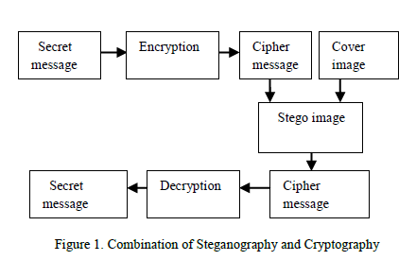

CRYPTOGRAPHY
Cryptography is one of the traditional methods used to guarantee the privacy of communication between parties. This method is the art of secret writing, which is used to encrypt the plaintext with a key into cipher text to be transferred between parties on an insecure channel. Using a valid key, the cipher text can be decrypted to the original plaintext. Without the knowledge of the key, nobody can retrieve the plaintext. Cryptography plays an essential role in many services, like: confidentiality, key exchange, authentication and non-repudiation. Cryptography provides these services for secure communication across insecure channels; Figure 1 shows the cryptography system [10].There are three types of cryptographic schemes for securing the data: public-key cryptography, secret key cryptography, and hash functions. These schemes are used to achieve different objectives. The length and type of the keys used depend on the type of encryption algorithm [10].

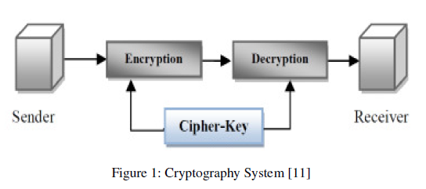

Symmetric-Key Cryptography
The technique of symmetric-key encryption is also known as the symmetric-key, shared key, and single-key encryption. In this technique, the same secret-key is used for both encryption and decryption sides. The original information or plaintext is encrypted with a key by the sender. Then the same key is used by the receiver to decrypt the message and obtain the plaintext. The key is known only by those two parties who are authorized to do the encryption and decryption [12]. The technique provides good security for transmission. However, there is a difficulty in the key distribution. If the key is stolen the whole data security is compromised. Moreover, a secure mechanism is needed for safe key-exchange process. Examples of symmetric-key schemes include DES and AES algorithms [12].

Hash Functions
A hash function is a one-way collision-free function with a fixed-length output. Hash functions are also called message digests. A hash function is an algorithm that does not use any key. However, a fixed-length hash value is calculate based on the input data such that it computationally infeasible to obtain the input data from the hash value, or even any input string that matches the given hash value. Hash functions are usually used to produce digital fingerprints of files and to guarantee the integrity of the files [10].

2.4 SYSTEM REQUIREMENTS
- Operating system : Windows 7.
- Front End : Visual Studio.NET 2010
- Coding Language : Visual C# .NET.

2.4.1 HARDWARE REQUIREMENTS
The Hardware of the computer consists of physical component such as Input Devices, Storage Devices, Processing & Control units and Output Devices. Computer includes external storage unit to store data in programs.
The Hardware Configuration involved in this project
- Keyboard
- Mouse
- Hard disk 500GB
- Ram 4 Gb
2.4.2 SOFTWARE REQUIREMENTS
Software is a group of programs that computers need to do a particular task. It is an essential requirement of Computer System. The Software used to develop the project is
Operating System : Windows XP
Front-End : Visual Basic 6.0 :
Back End : Microsoft Access

2.5 MODULE DESCRIPTION
2.5.1. Hiding the Text
- Crypto Module :

For Crypto Module the following steps are considered for encrypting the data (Refer Figure1)
- Insert text for encryption.
- Apply AES algorithm using 128 bit key (Key 1).
- Generate Cipher Text in hexadecimal form.

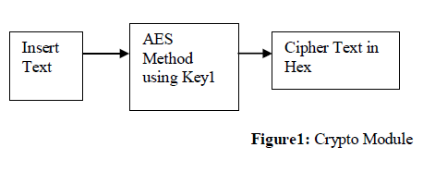

- Security Module

This is an intermediate module which provides an extra security features to our newly developed system. This module is used to modify the cipher text and to generate two extra keys. In the reverse process it regenerates the original cipher text (Refer Figure2) Before the hiding process this module works as follows:

- Separate the alphabets and digits from the cipher text.
- Keep track of the original position of the alphabet and the digits in the form of a secret key (Key 3).
- Separate first seven alphabets retrieved from first step and add the remaining alphabets at the end of the separated digits as in the first step. This generates the second key (Key 4).

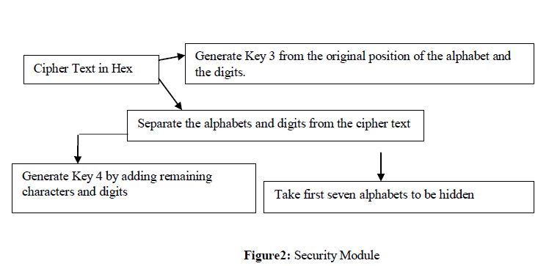

- Steno Module
For Stego Module the following steps are considered for hiding the above generated Cipher text .For more details refer Figure3.
- Take seven alphabets from the above discussed Security Module.
- Scramble the alphabets using a 64 bit key (Key 2).
- Take a Gray Scale Image.
- Find the DCT of the Image.
- Hide the Cipher by altering DCTs.
- Apply Inverse DCT.
- Find the Stego Image

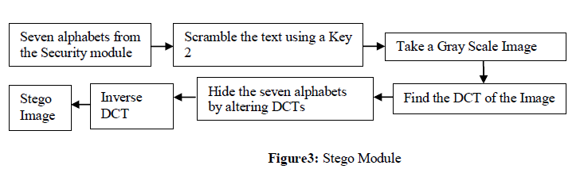
2.5.2. Retrieving Text

- Stego Module (Reverse Process) :
For Stego Module the following steps are considered for retrieving the cipher text (Refer Figure4):
- Take DCT of the Original Image.
- Take DCT of the Stego Image.
- Take difference of DCT coefficients.
- Retrieve bits of the hidden seven alphabets from LSB of the DCT.
- Construct the distorted seven alphabets.
- Unscrambled the distorted seven alphabets using Key 2.
- Retrieve the original seven alphabets.

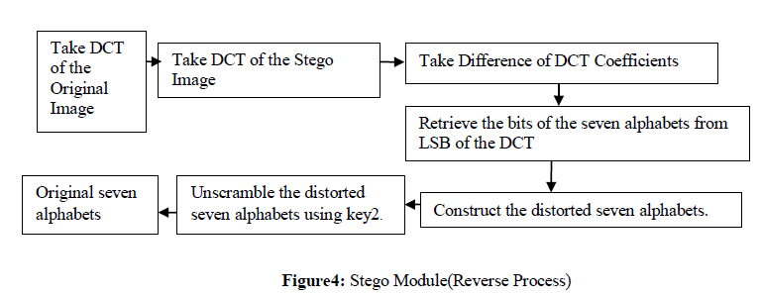

- Security Module (Reverse Process):
For Security Module the following steps are considered for retrieving the cipher text (refer Figure5):
- Club the seven characters with the alphabets of Key 4.
- Using Key 3 and Key 4 reconstruct the cipher text from alphabets and digits.

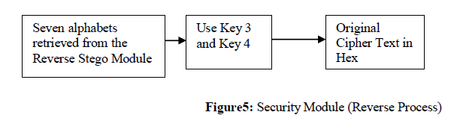

- Crypto Module(Reverse Process):
For Crypto Module the following steps are considered for retrieving the original text. For more details refer Figure6:
- Get the above retrieved cipher text.
- Reverse AES algorithm by using Key 1.
- Get the original message.

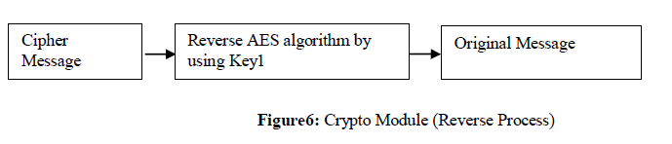

2.5.3 REPORTS
The output of the entire module was displays in the report window.

SYSTEM DESIGN AND DEVELOPEMENT

CHAPTER 3

3. SYSTEM DESIGN
3.1 LOGICAL DESIGN
3.1.1 DATA FLOW DIAGRAM
The Data Flow Diagram is a way of expressing the system requirements in a graphical form. Based upon the System Flow and the Table Design the Data Flow Diagram is generated. Diagram shows how data is transformed as it moves from one system component to another. This diagram can be used as an aid in checking for duplication and discrepancies and as an index for more detailed documentation.
- It can help as in identifying the flow of data in a system without specifying the media or hardware involved.
- It uses a few simple symbols connected by arrow represents among data, flows, external entities source and destinations stores.
- It is simple to draw and easily depict the basic components and flow of the system
- It can be drawn in a increasing level of details starting with the summary high-level view and proceeding to more detailed lower level views.
- This supports a modular structured, top-down view of the system component and flows.
- It can also be used to represent physical viewpoints.

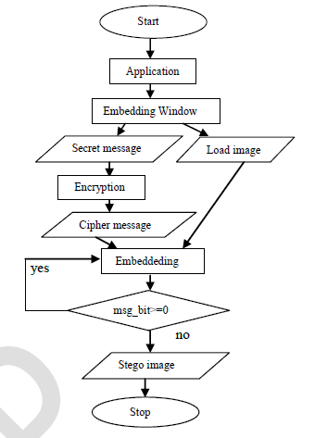

Data flow diagram

SYSTEM ARCHICTURE

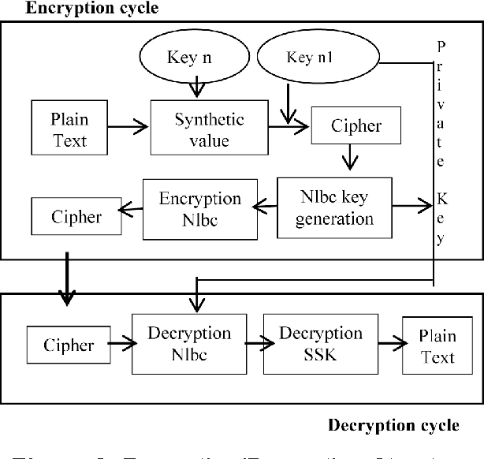

CASE DIAGRAM

UML DIAGRAM

3.2 PHYSICAL DESIGN
3.2.1 DATABASE DESIGN

CONCLUSION

CHAPTER 5
CONCLUSION AND FUTURE ENHANCEMENT
5.1 CONCLUSION
In this paper, the concepts of cryptography, steganography and their applications in the security of digital data communication across network are studied. A comprehensive technical survey of recent methods which combined steganography and cryptography is presented. Combining these two techniques is found to be more secure than applying each one of them separately. A detailed comparison of methods combining cryptography and steganography techniques is presented. A useful classification of these methods is proposed. Our study shows that Class-A Methods are more common than Class-B and provide better security with less exposing of the encrypted data. The only advantage of Class-B as claimed by the authors of the surveyed methods in this class is providing more capacity for the secret information.

5.1 FUTURE ENHANCEMENTS
As future work, we plan to study steganalytic techniques for hybrid steganography and cryptography approach and extend this approach to mobile video communication. We also plan to extend our system so that it can hide other digital files into image, for example hiding audio into image etc.

5.3 REFERENCE BOOKS
[1] A. Joseph Raphael,Dr.V Sundaram “Cryptography and Steganography – A Survey”, Int. J. Comp. ech. Appl., Vol 2 (3), 626-630.
[2] “Hiding the Text Messages of Variable Size using Encryption and Decryption Algorithm in Image Steganography” International Journal of Computer Applications (0975-8887) Volume 61-No.6, January 2013.
[3] Sumit Kushwaha, Amit kushwaha “Advanced Network Security using Cryptography and Steganography” Journal of Global Research in Electronics and Communication, Volume 1, No.1, November-December 2012.
[4] Adel Almohammad “Steganography-Based Secret and Reliable Communications: Improving Steganographic Capacity and Imperceptibility” A thesis submitted for the degree of Doctor of Philosophy, Department of Information Systems and Computing , Brunel University, August, 2010.
[5] Neil F Johnson, Sushil Jajodia, “Exploring Stenography: Seeing the Unseen”, IEEEComputer, Feb 1998, pp 26-34.
[6] Rajkumar Yadav “Analysis of Incremental Growth in Image Steganography Techniques for Various Parameters” Int. J. Comp. Tech. Appl., Vol 2 (6),1867-1870, NOV-DEC 2011
[7] Khan, Mohammed Minhajuddin “Steganography”
[8] S. Nithya Devi, P.Laura Juliet “SURVEY ON IMAGE STEGANOGRAPHY ALGORITHM “International Journal of Communications and Engineering Volume 04– No.4, Issue: 02 March2012.

