Unified and Automated Fault Management Platform for Optical Networks
ABSTRACT
A united and automated fault management platform for heterogeneous optical networks is quite important for telecom operators to monitor and respond to various levels of network events. In this demo, we are demonstrating the details of the design, implementation and evaluation of the proposed Optical router platform while targeting to manage the underlying optical network of a telecom operator in real time. The proposed system consists of three major building blocks i) a data collection layer that is integrated with the telecom operator infrastructure, (ii) data association and analysis layer that is used to measure the severity levels based on pre-deﬁned alarm severity levels and constraints, and (iii) user interface layer that is on top of management and infrastructure layer which is used to demonstrate the faulty optical lines and is also integrated with fault management systems. Through the dashboard interface of the proposed Optical router platform, telecommunication operator’s network optimization experts can easily detect the problems related to either or DWDM link and can take appropriate actions.

INTRODUCTION

CHAPTER 1
INTRODUCTION
Due to the special characteristics of WSNs, routing algorithms designed for traditional wireless networks may not be directly applicable to WSNs. Efficient Data Transfer Between Router consumption has the highest priority in WSNs, while due to the unreliable nature of WSNs, reliability of data dissemination is an important QoS parameter in designing efficient routing algorithms for WSNs. Clustering is considered as one of the techniques prolonging the lifetime of a WSN especially in case of data dissemination. The research efforts currently underway for devising an efficient cluster based routing algorithms mostly deal with the selection of CHs, optimizing the distance between CHs and the size of the cluster, and inter/intra cluster communication. Most of existing and well-known LEACH based approaches assume that each node in a sensor network has the ability to transmit data to all other nodes or directly to the base station (BS). However, these strong assumptions limit the cluster size and make those approaches unsuitable for some applications or network topologies. In other words, these approaches become useless when the distance between the nodes and destination is longer that nodes’ transmission range. Therefore, considering a multi-hop communication is more realistic because nodes may not be able to communicate directly with the CH or the BS. In the multi-hop communication, the data of each node farther away from CH is relayed through nodes closer to the CH in case of intra cluster communication. In case of inter-cluster communication the CHs closer to the BS act as routers uring delivering data to the BS. The main concern addressed in almost all existing clustering approaches for data dissemination is mainly Data Transfer Between Router conservation. Therefore, less attention has been paid so far to the QoS support within these algorithms. As link quality can be easily affected, among others, by weather, obstacles, and mobility, transmission reliability is one of important quality of service parameters for WSN applications. Different applications require different degree of reliability. Decision making applications such as event detection need high degree of transmission reliability, as events detected locally in the network or critical data should certainly be received by the destination. Periodic monitoring applications can better tolerate lost data and therefore need lower degree of reliability. The larger the number of hops between source and destination, the lower the probability of packet delivery at the destination. Reliable data dissemination is traditionally guaranteed by applying error control protocols. The main shortcoming of these approaches is that they very often introduce Data Transfer Between Router or/and delay overheads as they add redundancy to the packets (Forward Error Correction) or to the transmission (retransmission based approaches) [1]. In this paper, we aim to reach the maximum transmission reliability in a given cluster only by finding the best place for the CH and without the use of error controlling approach. The main issue addressed in this paper is the design of an aggregation-aware chain-clustering protocol for WSNs, which satisfies transmission reliability, Data Transfer Between Router efficiency and intracluster delay QoS requirements. Unlike existing clustering techniques, our proposed protocol considers multi-hop communication for both inside and outside the clusters to conserve more Data Transfer Between Router and support scalability. To the best of our knowledge, the approach presented in this paper is the first clustering algorithm that well incorporates Data Transfer Between Router efficiency and transmission reliability together to construct clusters and select proper CHs in WSNs. Most importantly, our proposed approach relaxes some strong assumptions that others rely on such as the ability of nodes to communicate directly with other nodes or with the BS, having nodes with the same Data Transfer Between Router level, and having a fixed transmission range for intra-cluster communication. Moreover, our algorithm uses a d-hop clustering scheme, which is more Data Transfer Between Router efficient than 1-hop. The rest of this paper is organized as follows. Firstly, we briefly discuss state of the art and preliminaries of this study. Then a detailed description of our approach will be provided, which will be followed by the performance evaluation. Finally we draw some conclusions and highlight the future work.LEACH [2] is one of the well-known distributed clustering algorithms for WSNs. The operation of LEACH is organized into rounds, each of which starts with a set-up phase followed by a steady-state phase. Each node has a certain probability of becoming a CH per round and the task of being CH is rotated among nodes. The CH then creates a TDMA schedule to avoid intra-cluster collisions and asks subordinated nodes to send their data within their assigned time slots. In the steady state, each CH sends its one hop neighbor BS an aggregated packet including the related sensor nodes’ data. Data collection in LEACH is centralized and periodically. The drawback of LEACH is that the dynamic cluster construction results in a huge overhead that increases the network Data Transfer Between Router consumption. Moreover, it is based on 1-hop communication and assumes each node can communicate directly with the BS. LEACH offers no guarantee about the placement and number of CH nodes due to lack of global coordination among nodes. However, using a central control algorithm to form the clusters may produce better clusters through well distribution of the CHs throughout the network. This is the key idea of LEACH-C [3], which uses a centralized clustering algorithm and has the same steady-state phase as LEACH. In the set-up phase, each node sends information about its current location and Data Transfer Between Router level to the BS. BS utilizes this information to produce better clusters that require less Data Transfer Between Router for data transmission per round and then broadcasts the clustering information to the network. By doing so, it will allow each node to know its related CH. Then each node determines its TDMA slot for data transmission and goes to sleep until it is its time to transmit data. Compared with LEACH, LEACH-C is more robust since it selects clusters and CHs based on location information and residual Data Transfer Between Router of the nodes. However, it still has high communication cost because of frequent communication between BS and the nodes to exchange data. Multi-hop-LEACH protocol [8] is a cluster based protocol similar to LEACH. In order to transmit the data from one CH to BS, it selects the optimal path between the CH and the BS through other CHs. PEGASIS [4] protocol improves LEACH in terms of Data Transfer Between Router consumption by allowing each node to receive from and transmit only to the closest neighboring nodes. At each round only one node sends the aggregated data to the BS. Due to the fact that only one leader exists in the entire network, PEGASIS can introduce a long and intolerable delay that causes collected data to be out of date in case of having long chain. The single cluster-head may also become a bottleneck.
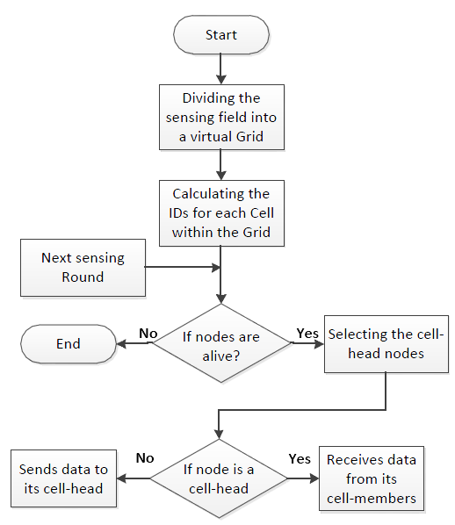
CCM [5] is mainly a hybrid of LEACH and PEGASIS. CCM divides the networks into several chains and selects one node in each chain as the leader and then forms a cluster from all chain leaders and the most powerful leader is selected as the CH to transmit data directly to the BS. The consumed Data Transfer Between Router of CCM increases as network size grows. CCBRP [6] is a two tiers chain-based protocol, which divided a WSN into a number of chains exploiting greedy algorithm of PEGASIS and selects a random leader for each chain. Then, it makes a chain of all leaders and selects one of them randomly as the global leader being responsible to transmit the aggregated data to the BS. CCBRP outperforms LEACH, PEGASIS and CCM with respect to the product of the Data Transfer between Router consumption and the experienced delay. CCRP [7] is another LEACH based protocol that adopts a more balanced CH selection algorithm and an improved data transmission mechanism from the CH to the BS. The CH selection of CCRP is done similar to LEACH but the residual Data Transfer Between Router of the node and the number of neighbors are also considered for calculating threshold of a given node. CCRP also forms a chain of CHs, which is constructed in such a way that each CH receives from and transmits to an adjacent CH and the leader of this chain is the closest CH to the BS. The aggregated data of each CH is transmitted along this chain until it is received by the BS. CCRP supports reliability by dynamically adjusting transmission power according to the receiver noise condition and the distance between transmitter and receiver to ensure the required packet delivery rate.

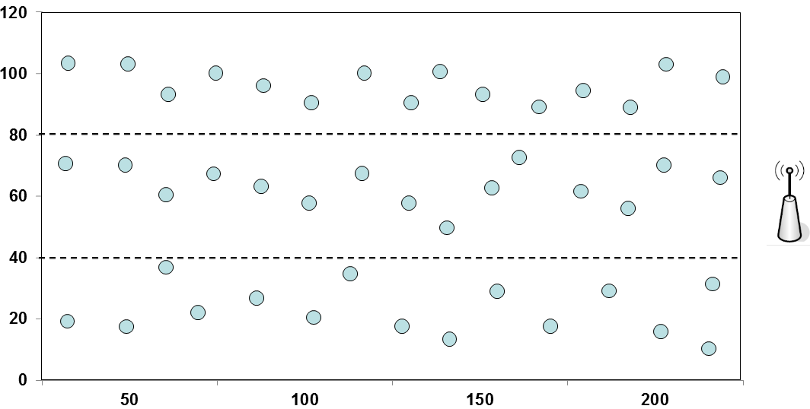

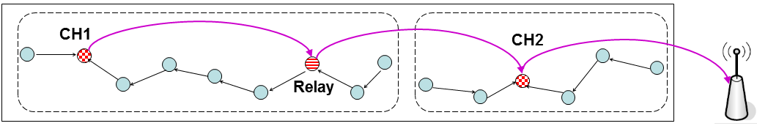

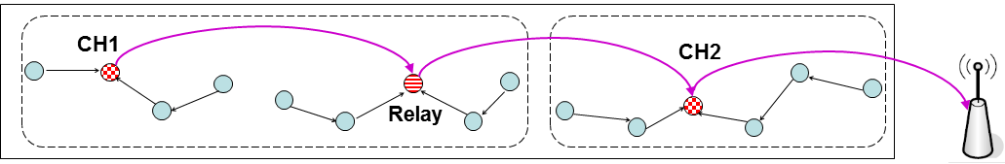
REC takes Data Transfer Between Router and transmission reliability into account while making clusters but it has no assumption about the distance between two CHs, which most of other approaches have. Relaxing the mentioned assumption does not come free and REC pays for it with the increasing delay. As it can be seen from Fig.1.b, data of the nodes located between RN and CH1 is transmitted and aggregated along the path till it reaches the CH1. Then CH1 has to send the aggregated value to the RN. This imposes an extra delay which could have been smaller if nodes closer to RNs send their data towards RN and the nodes closer to the CH1 send their data towards CH1 (Fig.1.c). In this case, delay can be decreased to half of the previous delay as two separated chain can send their data in parallel. Also, one intra-cluster communication related to the middle link (bridge link) is omitted. Doing so is similar to having three individual clusters while every RN acts as a new CH. Therefore to achieve a satisfactory performance, the BS can create a cluster around each RN while fairly (in terms of delay) assigns nodes between the given CH and RNs to the proper cluster. We introduce this modification to REC and make a new protocol called REC+.

We evaluate performance of REC, REC+, QoS-ACA, PEGASIS, C-LEACH in terms of Data Transfer Between Router efficiency, imposed delay and lifetime. The PL of the node’s radio has direct impact on the node’s transmission range. The higher the PL, the farther the transmissions range of CH and RN, and the smaller the inter-cluster delay. As the transmission range indicated by the PL is the main parameter for clusters’ shape, we perform simulation for different PL which each CH or RN can employ to send the aggregated data.
Description of scenarios:
We use Java JDK6 to perform simulations and repeat simulations 100 times. We consider 150 sensor nodes randomly deployed in a 500*100 area. The BS is located at (550, 60). The packet loss probability on the links changes randomly between 0 and 0.2 in some random times. We consider TICC2420 radio, whose output power is programmable in eight levels (from approximately –25 to 0 dBm). When a sensor node is elected to be a leader, it utilizes the highest available PL to reach the longest transmission range, otherwise the minimum PL which is required to reach the closest neighbor is employed. 8  Data Transfer Between Router  1.0 delay EER  , 8.0  , initialEg, initialEg=0.4J. e choose IEEE802.15.4 for the MAC layer and TI CC2420 radio model. For the simulation, transmit bit rate is 250 kbps and packet size is 128B.
Discussion of results:
Compares number of alive nodes in these five approaches as the simulation progresses. It can be seen that REC+ prolongs network lifetime much more effectively than other approaches. The number of alive nodes in PEGASIS
Suddenly falls from 120 in round 729 to 0 in round 730. This is due to the fact that when a CH (or leader) node dies in PEGASIS, the network will become disconnected even though other nodes are still alive but none of them can be a CH. The network lifetime is indicted by the death of the last node which can directly communicate with the BS and hence can become a CH. Since PEGASIS does not consider residual Data Transfer Between Router as a criterion to select CH, it cannot well balance the Data Transfer Between Router and hence the difference between the death of the first node and the last node is quite large.

Literature Survey:
The architecture of wireless sensor network can be described as a set ‘S’ of nodes. We assume that each sensor node is aware of its location using a GPS unit. The goal of using hierarchical schemes; chain, cluster, and hybrid, is to create a virtual structure that facilitates and ease managing data routing in wireless sensor networks. One of the goals of hierarchical routing algorithms is load balancing among sensor nodes.
Majority of Grid-based routing algorithms is directly or indirectly rely on clustering technique. The goal of clustering is to select a set of sensor nodes to be cluster heads that cover the whole network. The cluster head would be responsible for receiving and aggregating the sensed data from all cluster members and then forward the aggregated data either to the base station or to the next cluster head based on the routing mechanism. Therefore, the cluster head consumes more Data Transfer Between Router compared to the Data Transfer Between Router consumed by a normal cluster member. The problem of load balancing happens when a group of sensor nodes is repeatedly selected to operate as cluster heads. As a result, those nodes will die very fast and the death of nodes will cause empty gaps within the entire network. Those gaps not only can affect the validity of the sensed data but also can affect the communication of the WSNs which are mainly built upon multi-hop communication. Thus, the proposed algorithm aims to keep the load evenly distributed among sensor nodes which lead to retain all sensor nodes alive and functioning as long as possible.

In order to collect, aggregate, and send the sensed data to the base station, nodes called cell-heads and chain heads act as an intermediary between the non-head nodes and the base station. At the first sensing round, all nodes have the same Data Transfer between Router hence cell-head nodes will be randomly selected. Then, during the next sensing rounds, the node that has the maximum residual Data Transfer Between Router will be functioning as the cell-head. After the data get collected in the cell-head nodes, a chain head is selected depending on the same basis of selecting the cell-head, which will be responsible for gathering the data vertically. The job of the head nodes is to collect the sensed data from its nodes, aggregate with its own data and then forward it either to the next head node using multi-hop communication or send it directly to the base station. The process of selecting cell-head nodes, forming a chain that consists of a set of cell-head nodes, and finally select a chain head for each individual chain is accomplished by the base station. In VGRP algorithm, data transmission is done in steps; within the individual cells (intra-cell data transmission) based on clustering technique and between the cell-heads (inter-cell data transmission) based on chain technique. Therefore, here will be two types of head nodes which are cell-head and chain head nodes. Fig.2 shows the flowchart of virtual-grid setup process as well as the intra-cell communications.

System Architecture:

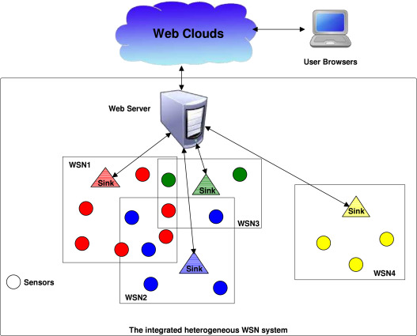

the proposed protocol is illustrated in detail. The proposed approach is called Multiple Chain Based Routing Protocol (MCRP) that belongs to chain-based routing techniques. MCRP algorithm includes two phases: initialization phase, and data transmission phase. The contribution of this research is to reduce data transmission distance by using multichip communications and minimize the excessive Data Transfer Between Router consumption in CHs nodes by adopting a simple and effective method for selecting the CHs nodes. Selecting CHs nodes process combines the remaining Data Transfer between Router of each sensor node and the distance from each node to the base station.

The MCRP algorithm fits perfectly with grid-based network topology of WSNs in which the base station is located outside the region of interest and is aware of sensor nodes locations. Sensor nodes distribution is done using the deterministic method since it requires fewer sensor nodes compared to random distribution in order to get the same level of data accuracy [15]. Due to the predetermined distribution of sensor nodes and grid based network topology, the MCRP algorithm can be typically utilized in agriculture monitoring systems (e.g. greenhouse conditions) [16], and smart home monitoring systems.
It is one of the major concerns in the operation of WSNs. Many applications of WSNs require guaranteed connectivity, sensing, and coverage during its operative time. When the nodes start to die, this might lead to instability in the network operation [2]. Thus, to obtain the best performance from WSNs, all nodes in the network are needed to still alive as long as possible. In other words, the network is considered optimally stable when all nodes are alive. As a result, the network instability period is considered from the moment when the first node dies until all sensor nodes die. Table II presents the stability period during the network lifetime using different algorithms. Moreover, in the table, we can see the length of the stability period in MCRP algorithm is the highest one compared to CCBRP and TSCP algorithms. The improvement of the MCRP algorithm is almost 4% and 35% over TSCP and CCBRP algorithms respectively in term of stability period. Equation (4) is implemented to calculate the stability period improvement.
In this metric, we will compare the amount of Data Transfer Between Router consumption in all algorithms used in this research during their lifetime. During data routing, there are three factors that consume Data Transfer Between Router, which is sending, receiving, and aggregating data packets. We use Equations (2) and (3) are used to calculate the dissipation of Data Transfer Between Router during transmitting and receiving data packets respectively. In addition, an equation for data aggregation used in [9] is implemented to calculate the consumption of Data Transfer Between Router due to data aggregation. The scale that we will use for comparison is the number of sensing rounds [7]. Therefore, the comparison will be the amount of Data Transfer between Router consumption versus the number of sensing rounds. The improvement achieved in MCRP algorithm over other algorithms in term of Data Transfer Between Router consumption.
1.1DESCRIPTION OF THE PROJECT
All sensor node groups will form an independent chain and the head node of the group will represent the chain head. In this stage, selecting the head node is done periodically using the y-coordinate of each node. In other words, since the chains are horizontally formed in this stage, the nodes within the same group (chain) have the same y-coordinate, but they have different, sequenced x-coordinate. Therefore, for the same chain, the node with the lowest x coordinate will be the head of the first sensing round and this is applicable for all horizontal chains. The reason for using this periodic way for selecting the head is to keep all heads on the same column and we can assure that the distance between head nodes is as small as possible. Every sensor node will transmit its data packet to the nearest neighbor on the way to its chain head using multi-hop communication. The moment that a node gets its neighbor data packet, it aggregates this packet with its own data packet and forwards it to the next neighbor and so on until all data are gathered in the chain head. The chain head gets data packet from its closest neighbor and combines it with its sensed data. When aggregated data packets become available in the chain head nodes, a new chain (vertical chain) will be formed and includes all chain head nodes. After that, one of the sensor nodes will be selected to operate as the head of the vertical chain (network head). The selection strategy combines two factors: The distance length from the node to the base station, and the current amount of Data Transfer between Router available in the sensor node. So that, (1) is implemented to determine the main head of the network. After selecting the network head, data transmission will follow the same style as in step (1). When the main head gets the data, it will aggregate the received data packets with its own packet and forward the produced packet to the base station. A complete sensing round is done When the last packet reaches the base station.

