AI-POWERED RESUME OPTIMIZER AND JOB RECOMMENDATION SYSTEM
ABSTRACT
The Resume Optimizer and Job Recommendation System project aims to simplify the job application and recruitment process by leveraging an advanced digital platform with AI-driven functionalities. This system enables job seekers to search for relevant jobs, create and upload resumes, and apply for positions seamlessly through an intuitive interface, while employers can post jobs, filter applicants, and manage recruitment more efficiently. AI integration plays a key role in the system, offering resume analysis and job matching functionalities. The resume builder allows candidates to create ATS (Applicant Tracking System)-friendly resumes, while the AI module analyzes these resumes to match job seekers with suitable job openings based on their skills, qualifications, and preferences. Recruiters benefit from automated resume screening and ranking of applicants, optimizing the hiring process. The platform caters to various user roles, including job seekers, who can build resumes, search, and apply for jobs; employers, who post job openings and manage candidates; and administrators, who oversee the system’s operations, user accounts, and generate detailed reports. Additionally, the system includes tools for skill assessments, quiz modules, and LinkedIn integration, providing a comprehensive profile for both applicants and employers. Overall this career portal enhances the job application and recruitment experience by automating key processes, providing data-driven insights, and utilizing AI for personalized job matching and resume analysis. This leads to greater operational efficiency, improved user satisfaction, and optimized hiring outcomes.

CHAPTER - 1
  - INTRODUCTION
Here in today’s competitive job market, finding the right job that aligns with one’s skills and aspirations can be a daunting task. Simultaneously, recruiters struggle with sifting through countless resumes to identify the ideal candidates for open positions. The rise of automated recruitment systems and applicant tracking systems (ATS) has further complicated the process for candidates who may lack optimized resumes or professional profiles. Addressing these challenges requires an intelligent, data-driven approach that bridges the gap between job seekers and employers. This project, titled "Resume Optimizer and Job Recommendation System" is designed to tackle these issues by providing a comprehensive platform for candidates to build optimized resumes, assess their skills, and match their profiles with relevant job opportunities. The system integrates modules such as a resume builder, profile scanner, and skill assessment tool, each powered by AI and machine learning algorithms. By leveraging these technologies, the platform not only suggests the best job matches but also provides real-time feedback on resumes and online profiles like LinkedIn and GitHub.
The core functionalities of this system include ATS-compliant resume building, LinkedIn and GitHub analysis, skill-based assessments, and job-matching algorithms. These modules work in tandem to deliver a seamless user experience where job seekers can easily enhance their profiles and identify job openings that best suit their qualifications. The inclusion of AI and NLP (Natural Language Processing) ensures that candidates receive accurate, relevant recommendations while recruiters benefit from a more refined talent pool. By integrating the latest advancements in technology with the recruitment process, this project aims to transform the way individuals approach job hunting. It not only simplifies the profile enhancement process but also increases the chances of candidates securing jobs that match their skillsets. With a focus on efficiency, accuracy, and user experience, the Intelligent Job Matching and Profile Enhancement System stands as a game-changer in the recruitment landscape, offering benefits for both job seekers and employers alike.
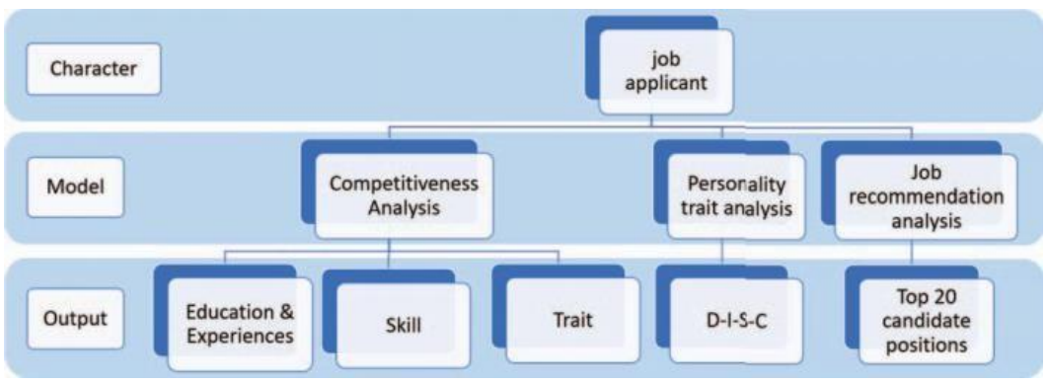
JOB RECOMMENDATION SYSTEM FRAMEWORK
Job matching, traditionally a complex and time-consuming process, has become increasingly challenging due to the influx of diverse job opportunities and a competitive global workforce. To address these challenges, we present a comprehensive system that leverages cutting-edge technologies in the realms of Natural Language Processing (NLP), Machine Learning, and Recommender Systems. This system empowers job seekers with a personalized, data-driven approach to career placement while simultaneously assisting employers in identifying the most suitable candidates. The core philosophy of the "AI Resume Analyzer" revolves around the seamless integration of technology into the career placement journey.
It starts with user registration, ensuring a secure and user-friendly experience. Job seekers are provided the option to categorize themselves as either "freshers" or "experienced" professionals, enabling a tailored user experience. Subsequently, advanced NLP techniques are employed to parse uploaded resumes, extracting key information, including skills and experience, to facilitate a more accurate categorization of job seekers. Machine learning models then take center stage to categorize candidates with exceptional precision, ensuring they are appropriately designated. The heart of the "AI Resume Analyzer" is its job recommendation engine, which harnesses a combination of collaborative filtering, content-based filtering, and hybrid recommender systems to provide job recommendations that align with a candidate's skills and experience.
What sets this system apart is its dynamic nature, continuously adapting to the ever-shifting job market to ensure recommendations remain relevant over time. The paramount importance of data security and privacy in this digital age is not overlooked. Stringent measures have been implemented to safeguard sensitive user information, ensuring compliance with data protection regulations. It introduces a revolutionary approach to career placement and hiring efficiency. By leveraging the power of AI, NLP, and sophisticated recommendation systems, it aims to bridge the gap between job seekers and employment opportunities, offering a smoother, more efficient, and secure transition into the workforce. AI resume analyzer revolves around the challenges and shortcomings in the traditional recruitment process. Human resources depart- ments are often inundated with a high volume of job applications, making it an arduous and time-consuming task to review each resume comprehensively.
This process can result in inefficiencies, overlooked qualified candidates, and potentially perpet-uate unconscious biases in hiring decisions. The objectives of an AI resume analyzer encompass a range of critical goals within the realm of talent acquisition and recruitment. These tools are engineered to effi- ciently sift through a substantial volume of resumes, expediting the initial screening process and conserving valuable time and resources. Their primary aim is to match the qualifications, skills, and experience listed in resumes with the prerequisites out-lined in job descriptions, ensuring that the most suitable candidates are identified.
Unlock the full potential of your resume with our cutting-edge AI-powered analyser! In today's competitive job market, a well-crafted resume is crucial for standing out to hiring managers and applicant tracking systems (ATS). Our AI Resume Analyzer utilizes advanced natural language processing (NLP) and machine learning algorithms to provide personalized feedback and suggestions for improvement. An AI Resume Analyzer is a tool that leverages artificial intelligence to streamline and enhance the resume screening process. By employing advanced techniques like natural language processing (NLP) and machine learning, these tools can rapidly analyse large volumes of resumes, extract key information, and identify the most qualified candidates.
It uses artificial intelligence and machine learning to analyse resumes and provide insights to help with hiring decisions. It can provide a comprehensive overview of a resume, highlighting qualifications, skills, and achievements. They can also pinpoint weaknesses and offer tailored solutions to improve them. Some AI resume analysers can even provide personalized job title recommendations. In today's fast-paced and competitive job market, recruiters are constantly seeking efficient ways to identify and shortlist the most qualified candidates. Traditional resume screening methods can be time-consuming and prone to human error. To address these challenges, artificial intelligence (AI) has emerged as a powerful tool, revolutionizing the recruitment process. AI Resume Analysers are cutting-edge applications that leverage advanced AI techniques to automate and streamline the resume screening process. During graduation season or the traditional job transition amount between the tip of the year and therefore the starting ofanother year, job candidates who want to advance to followingstage of their career are gung ho in seeking opportunities.
In giant job fairs or job-matching events, varied businesses are usually invited, and every tends to produce numerous jobvacancies to recruit ideal job applicants. within the method of job seeking, job applicants could encounter dissimilar situations: 1. they're unable to comprehensively review the content and necessities of every job vacancy attributable to the excessive amount of job vacancies provided in aforementioned occasions; 2. they do not understand their own conditions and competencies; and 3.whether or not they're admitted to the next-stage interview once undergoing the initial interview on website depends on their compatibility (based on varied indicators resembling experience, skills, .and personal characteristics) with the requirements and nature of the job vacancy they apply for. According to a survey report conducted by Glassdoor in 2015, approximately 80% of millennial job applicants check whether or not the culture of the company they intend to apply to suits them before even evaluating the event potential of the corporate [1]. This more accentuates the importance of understanding the aforesaid job needs and company culture. The aforementioned situation is also reflected in companies’ talent recruitment process.
Glassdoor’s 2015 survey report indicated that during the peak time of talent recruitment, a job vacancy in a large company generally receives 250 applications [1], and a job vacancy in a small-to-medium size company receives dozens of the resumes per day. the height time for job seeking is that the moment for job candidates to demonstrate their skills and distinguish themselves from varied competitors. within the meantime, it conjointly poses a challenge to job recruiters who ought to establish appropriate skills from a ocean of applicants. Several problematic situations might occur incompanies during that process. When receiving a {considerable} variety of resumes, human resources (HR) personnel generally conduct a primary spherical of filter supported education associate degreed work experience, victimisation their subjective opinion to pick the abilities they consider slot in an pseudoscientific manner.
In addition, a study discovered that hour personnel spends on the average half dozen seconds solely reading a resume [2].In the peak stage of resume submission, HR personnel has to spend considerable time and effort reading resumes and is therefore likely to make hasty judgements.. In sum, a way to effectively determine appropriate candidates from a ocean of applicants and invite them to interview is often a challenge for companies. Along with the prevalence of computing (AI) technology, repetitive tasks became attention of development for the technology. The international research and consulting agency Gartner indicated that by 2020, 1.8 million jobs will be filled by AI, but another 2.3 million job opportunities will be created, leading to a positive growth of overall job opportunities [3].
Applications of AI technology- based HR matching have gradually attracted public attention and are becoming trendy. Similar to previous trends of state and task transformation brought by key innovations within the past, AI is making a lot of hi-tech and social control positions whereas commutation variant low-to-middle rank positions and even creating entrance level and low-tech positions of a unique nature [4]. Considering the disadvantages observed by both the talent- recruiting and job-seeking parties, the relatively insufficient research on talent recommendation and Chinese resume analysis, and the maturation of AI technologies, this study designed a resume analysis and position recommendation system, that includes a resume designation function. The designation operate performs machine learning and text mining on the electronic resume uploaded by the user to produce a personalised resume analysis on themes such fight in 3 indicators and personality traits.
It allows job candidates to know their own aggressiveness on the market and eventually produces a listing of counseled job vacancies on the premise of the content within the job applicant’s resume. This study also designed a system for the talent- recruiting service in companies. Information technology presently is the first focus among trade types.. The system generates a talent recommendation list from the electronic resumes submitted by job applicants and analyzes each job applicant’s resume. The analysis results of the job- seeking parties and companies are immediately summarized in reports and presented as charts to provide both parties a reference in job fairs. Through the designed recommendation system, this study expects to effectively save time and effort to both the job- seeking and talent-recruiting parties as well as to overcome time and space constraints by using the Internet. In addition, this irrational filtering of resumes is probably going to be avoided. The systemis predicted to function a reference for position matching to reinforce its success rate, which might be dependent for each parties.

  - OBJECTIVE
The purpose of this study is to introduce SkillSync, a revolutionary job recommendation system powered by cutting-edge machine learning algorithms. SkillSync leverages AI and data-driven methodologies to provide highly accurate and personalized job recommendations, tapping into diverse data sources such as APIs and social media data to enrich its insights. Its innovative skill-based matching approach goes beyond traditional keyword-based methods, ensuring precise alignment between candidate skills and job requirements. Despite challenges such as data quality and privacy concerns, SkillSync presents immense opportunities to optimize talent acquisition, empower both job seekers and employers, and contribute to a more efficient labor market. As we continue to advance in research and collaboration, SkillSync stands as a beacon of innovation, unlocking the future of work where finding the perfect job is not just a possibility but a reality.
  - OVERVIEW OF THE PROJECT
The AI-Powered Resume Optimizer and Job Recommendation System is a smart career assistance tool designed to enhance job seekers' chances of landing their ideal roles. It uses artificial intelligence to analyze resumes and provide personalized feedback for optimization based on current industry trends and job requirements. The system highlights key skills, experience gaps, and formatting improvements to boost visibility with applicant tracking systems (ATS). In addition to resume refinement, the platform offers intelligent job recommendations tailored to the user’s skills, qualifications, and preferences. It continuously learns from user interactions to improve suggestions over time. The system also incorporates natural language processing (NLP) to match user profiles with job descriptions more accurately. Users can track their job applications, receive interview tips, and access career resources. This project aims to simplify and enhance the job search process with minimal effort from users. By integrating AI, the system empowers individuals to present themselves more competitively in the job market.

CHAPTER -2
SYSTEM ANALYSIS
  - EXISTING SYSTEM
It allows job candidates to know their own aggressiveness on the market and eventually produces a listing of counseled job vacancies on the premise of the content within the job applicant’s resume. This study also designed a system for the talent- recruiting service in companies. Information technology presently is the first focus among trade types.. The system generates a talent recommendation list from the electronic resumes submitted by job applicants and analyzes each job applicant’s resume. The analysis results of the job- seeking parties and companies are immediately summarized in reports and presented as charts to provide both parties a reference in job fairs. Through the designed recommendation system, this study expects to effectively save time and effort to both the job- seeking and talent-recruiting parties as well as to overcome time and space constraints by using the Internet. In addition, this irrational filtering of resumes is probably going to be avoided. The systemis predicted to function a reference for position matching to reinforce its success rate, which might be dependent for each parties.
DISADVANTAGES:
- May overlook unique human qualities not captured in data
- Can introduce or amplify bias in hiring recommendations
- Relies heavily on quality and accuracy of input resumes
- Might recommend irrelevant jobs due to algorithm limitations
- Lacks contextual understanding of career transitions
- Vulnerable to manipulation through keyword stuffing
- Data privacy and security concerns for user information

  - PROPOSED SYSTEM
AI resume analyzer revolves around the challenges and shortcomings in the traditional recruitment process. Human resources depart- ments are often inundated with a high volume of job applications, making it an arduous and time-consuming task to review each resume comprehensively. This process can result in inefficiencies, overlooked qualified candidates, and potentially perpet-uate unconscious biases in hiring decisions. The objectives of an AI resume analyzer encompass a range of critical goals within the realm of talent acquisition and recruitment. These tools are engineered to effi- ciently sift through a substantial volume of resumes, expediting the initial screening process and conserving valuable time and resources. Their primary aim is to match the qualifications, skills, and experience listed in resumes with the prerequisites out-lined in job descriptions, ensuring that the most suitable candidates are identified.
ADVANTAGES:
- Time-saving: Quickly processes and analyses large volumes of resumes, saving recruiters and hiring managers time and effort.
- Objectivity: Reduces bias by focusing on relevant skills and qualifications, promoting a fairer selection process.
- Accuracy: Identifies keywords, phrases, and qualifications with high precision, minimizing errors.
- Improved candidate matching: Uses algorithms to match candidates with job requirements, increasing the likelihood of finding the best fit.
- Enhanced screening process: Automates initial screening, allowing recruiters to focus on in-depth evaluations and interviews.

2.3 SYSTEM REQUIREMENTS
HARDWARE REQUIREMENTS

- System : Pentium IV 2.4 GHz.
- Hard Disk : 500 GB.
- Monitor : 15 VGA Colour.
- Mouse : Logitech.
- RAM : 4 GB.

SOFTWARE REQUIREMENTS

- Operating System : Windows-10/11 (64-bit).
- Language : Python 3.10
- IDE Tools : Visual Studio Code 1.7

CHAPTER - 3
LITERATURE SURVEY
[1] INTRODUCED THE SKILL SCANNER
Authors: Bothmer and Schlippe
An AI-based job recommendation system aimed at fostering connections between employers, job seekers, and educational institutions within the job market landscape [2]. The system employs artificial intelligence to facilitate recommendations tailored to the needs of various stakeholders.
[2] PROPOSED A JOB RECOMMENDATION SYSTEM VIA SOCIAL MEDIA
Authors: Bhosale et al
leveraging social media data to enhance job recommendations [7]. While these systems demonstrate promising approaches to leveraging AI for job matching, the specifics of the AI-based algorithms and recommendation techniques employed are not extensively elaborated upon in the literature.
[3] PROPOSED A JOB RECOMMENDATION SYSTEM EMPHASIZING SKILL-BASED MATCHING BETWEEN CANDIDATES AND JOB OPPORTUNITIES
Authors: Mahalakshmi, Kumar, and Senthilnayaki
By prioritizing the assessment and alignment of candidate skill sets with job requirements, the system aims to enhance the accuracy and relevance of job recommendations. This approach resonates with the growing recognition of the significance of skills in modern recruitment practices.
[4] DEVISED A RESUME RANKING SYSTEM CENTERED ON THE APPLICATION OF MACHINE LEARNING (ML) TECHNIQUES
Authors: Tejaswini Kadiwal, and Revanna
The system aims to streamline the process of evaluating resumes by automatically ranking them based on their relevance to job requirements. Such an approach aligns with the broader trend of leveraging ML algorithms for talent acquisition and recruitment tasks.
[5] RESUME PARSING USING NATURAL LANGUAGE PROCESSING
Authors: P. A. Srivastava etal.
The system focuses on identifying and categorizing personal details, education, work experience, and skills. Various NLP tools and methods such as tokenization, POS tagging, and named entity recognition are employed. These help the model to understand the context and meaning of text. The parsed data is then organized in a standard format, making it easier for recruiters to search and match candidates. The authors also discuss challenges like inconsistent formatting and unstructured data. Overall, the paper presents a practical approach to streamline hiring through intelligent text processing.
[6] NATURAL LANGUAGE PROCESSING FOR RESUME PARSING
Authors: K. Singh and M. Desa
Focuses on the application of NLP in parsing unstructured resume data, enabling better compatibility with Applicant Tracking Systems (ATS) by extracting relevant keywords and details
[7] JOB MATCHING WITH DEEP LEARNING TECHNIQUES
Authors: A. Singh, G. Kumar, V. Kumar, and T. Mahesh
The authors explore various architectures, including convolutional neural networks (CNNs) and recurrent neural networks (RNNs), to process and analyze textual data from job descriptions and candidate resumes. By leveraging these models, the system aims to understand the semantic relationships between job requirements and candidate qualifications. The study emphasizes the importance of feature extraction, data preprocessing, and model training in developing effective matching algorithms. Additionally, the paper discusses challenges such as handling unstructured data and ensuring scalability in real-world applications. The proposed deep learning-based approach demonstrates improved performance over traditional keyword-based methods, offering a more nuanced understanding of job-candidate compatibility. Overall, the research contributes to the advancement of intelligent recruitment systems by integrating deep learning techniques for more accurate job matching.​

CHAPTER- 4
SYSTEM IMPLEMENTATION
4.1 IMPLEMENTATION
The implementation mechanism is expressed using Flowcharts that provide a visual representation of the system’s workflow, making it easier to understand the process of job and skill recommendation. The system flowchart will include: a system for depicting how users input their skills and upload resumes. It will also have flowchart to illustrate the steps involved in extracting skills and job roles using NLP. Figure 2 shows a flowchart for extracting job-related information from an HTML file. It begins with the user providing the file path. If the file cannot be opened, an error is displayed. Otherwise, the HTML content is parsed to extract specific information, including the job title, company name, location, job description, job type, and the posted date. Once all relevant data is extracted, it is compiled into a structured format, and the final results are displayed to the user. This process ensures that key job details are efficiently retrieved from the provided HTML document.
4.2 MODULE
MODULES:
- User Authentication Module
- Resume Upload and Parsing Module
- Resume Optimization Module
- Job Recommendation Module
USER AUTHENTICATION MODULE:
This module manages the login, registration, and secure access of users to the platform. It supports different user roles such as job seekers and administrators. Features include email verification, password encryption, and optional two-factor authentication. The interface is simple and secure to enhance the user experience. It validates inputs in real-time to avoid incorrect data entries. Forgotten password recovery and session timeout features are also integrated. It ensures that each user’s data and activity are kept private and secure. Role-based access helps differentiate feature access and privileges. The module acts as the gateway to the system’s services.
RESUME UPLOAD AND PARSING MODULE:
This module allows users to upload their resumes in various formats such as PDF, DOCX, or TXT. It extracts structured information like name, education, skills, and work experience using Natural Language Processing (NLP). The parsing engine converts unstructured text into machine-readable data. It also highlights any missing or ambiguous details. The system ensures a high parsing accuracy rate for better optimization. This module supports drag-and-drop functionality for ease of use. It instantly displays parsed content for user confirmation. Errors or inconsistencies can be manually corrected by the user. It sets the foundation for the optimization and recommendation processes.
RESUME OPTIMIZATION MODULE:
This module analyzes the parsed resume and identifies gaps or areas for improvement. It compares the resume against industry standards and job-specific keywords. The system suggests optimized phrasing, formatting changes, and missing skills. A score is generated to reflect the resume's strength and compatibility with target jobs. Suggestions are interactive and can be accepted or ignored by the user. Real-time previews of the optimized resume are available. The module uses AI algorithms trained on hiring patterns and job descriptions. It also detects and flags potential ATS (Applicant Tracking System) issues. The goal is to enhance resume visibility and impact.
JOB RECOMMENDATION MODULE:
This module recommends relevant job openings based on the user’s profile, skills, and preferences. It leverages AI and machine learning to match resumes with job descriptions from integrated job portals. Recommendations are ranked by relevance and compatibility score. The module considers factors like location, industry, and desired job role. Users can apply filters to customize the recommendations. Each listing includes job title, company, location, and application link. The engine continuously learns and improves suggestions based on user behavior. Users can save or bookmark preferred jobs. This module bridges the gap between a strong resume and job opportunities.

CHAPTER - 5
SOFTWARE DEVELOPMENT
5.1 SOFTWARE ENVIRONMENT
PYTHON:
Python is a very popular general-purpose interpreted, interactive, object-oriented, and high-level programming language. Python is dynamically-typed and garbage-collected programming language. It was created by Guido van Rossum during 1985- 1990. Like Perl, Python source code is also available under the GNU General Public License (GPL). Python supports multiple programming paradigms, including Procedural, Object Oriented and Functional programming language. Python design philosophy emphasizes code readability with the use of significant indentation.
WHY TO LEARN PYTHON?
Python is consistently rated as one of the world's most popular programming languages. Python is fairly easy to learn, so if you are starting to learn any programming language then Python could be your great choice. Today various Schools, Colleges and Universities are teaching Python as their primary programming language. There are many other good reasons which makes Python as the top choice of any programmer:
- Python is Open Source which means its available free of cost.
- Python is simple and so easy to learn
- Python is versatile and can be used to create many different things.
- Python has powerful development libraries include AI, ML etc.
- Python is much in demand and ensures high salary

Python is a MUST for students and working professionals to become a great Software Engineer specially when they are working in Web Development Domain. I will list down some of the key advantages of learning Python:
- Python is Interpreted − Python is processed at runtime by the interpreter. You do not need to compile your program before executing it. This is similar to PERL and PHP.
- Python is Interactive − You can actually sit at a Python prompt and interact with the interpreter directly to write your programs.
- Python is Object-Oriented − Python supports Object-Oriented style or technique of programming that encapsulates code within objects.
- Python is a Beginner's Language − Python is a great language for the beginner-level programmers and supports the development of a wide range of applications from simple text processing to WWW browsers to games.
CHARACTERISTICS OF PYTHON:
Following are important characteristics of Python Programming:-
- It supports functional and structured programming methods as well as OOP.
- It can be used as a scripting language or can be compiled to byte-code for building large applications.
- It provides very high-level dynamic data types and supports dynamic type checking.
- It supports automatic garbage collection.
- It can be easily integrated with C, C++, COM, ActiveX, CORBA, and Java.

APPLICATIONS OF PYTHON:
The latest release of Python is 3.x. As mentioned before, Python is one of the most widely used language over the web. I'm going to list few of them here:
- Easy-to-learn − Python has few keywords, simple structure, and a clearly defined syntax. This allows the student to pick up the language quickly.
- Easy-to-read − Python code is more clearly defined and visible to the eyes.
- Easy-to-maintain − Python's source code is fairly easy-to-maintain.
- A broad standard library − Python's bulk of the library is very portable and cross-platform compatible on UNIX, Windows, and Macintosh.
- Interactive Mode − Python has support for an interactive mode which allows interactive testing and debugging of snippets of code.
- Portable − Python can run on a wide variety of hardware platforms and has the same interface on all platforms.
- Extendable − You can add low-level modules to the Python interpreter. These modules enable programmers to add to or customize their tools to be more efficient.
- Databases − Python provides interfaces to all major commercial databases.
- GUI Programming − Python supports GUI applications that can be created and ported to many system calls, libraries and windows systems, such as Windows MFC, Macintosh, and the X Window system of Unix.
- Scalable − Python provides a better structure and support for large programs than shell scripting.
PYTHON – OVERVIEW:
Python is a high-level, interpreted, interactive and object-oriented scripting language. Python is designed to be highly readable. It uses English keywords frequently where as other languages use punctuation, and it has fewer syntactical constructions than other languages.
- Python is Interpreted − Python is processed at runtime by the interpreter. You do not need to compile your program before executing it. This is similar to PERL and PHP.
- Python is Interactive − You can actually sit at a Python prompt and interact with the interpreter directly to write your programs.
- Python is Object-Oriented − Python supports Object-Oriented style or technique of programming that encapsulates code within objects.
- Python is a Beginner's Language − Python is a great language for the beginner-level programmers and supports the development of a wide range of applications from simple text processing to WWW browsers to games.
HISTORY OF PYTHON:
Python was developed by Guido van Rossum in the late eighties and early nineties at the National Research Institute for Mathematics and Computer Science in the Netherlands.
Python is derived from many other languages, including ABC, Modula-3, C, C++, Algol-68, SmallTalk, and Unix shell and other scripting languages.
Python is copyrighted. Like Perl, Python source code is now available under the GNU General Public License (GPL).
PYTHON FEATURES:
Apart from the above-mentioned features, Python has a big list of good features, few are listed below:
- It supports functional and structured programming methods as well as OOP.
- It can be used as a scripting language or can be compiled to byte-code for building large applications.
- It provides very high-level dynamic data types and supports dynamic type checking.
- It supports automatic garbage collection.
- It can be easily integrated with C, C++, COM, ActiveX, CORBA, and Java.

PYTHON - ENVIRONMENT SETUP:
As we learned in the previous Python Introduction article, python is a free, open-source, and cross-platform language. So, the python can run on multiple OS platforms like Windows, Linux, Mac, etc.
We will now learn how to install python or set up a Python development environment on different OS platforms like Windows, Mac, and Linux machines.
DOWNLOAD AND INSTALL PYTHON:
Before you start python installation, first verify whether the python has already installed on your machine or not. Nowadays, most of the devices are coming with preinstalled python.
To verify python installation, open the command prompt (cmd.exe) or Terminal and type the command like python --version. If you found that python has not installed on your machine, follow the below steps based on your OS version.
WINDOWS INSTALLATION:
Here are the steps to install Python on Windows machine.
- Open a Web browser and go to https://www.python.org/downloads/.
- Follow the link for the Windows installer python-XYZ.msi file where XYZ is the version you need to install.
- To use this installer python-XYZ.msi, the Windows system must support Microsoft Installer 2.0. Save the installer file to your local machine and then run it to find out if your machine supports MSI.
- Run the downloaded file. This brings up the Python install wizard, which is really easy to use. Just accept the default settings, wait until the install is finished, and you are done.
SETTING UP PATH:
Programs and other executable files can be in many directories, so operating systems provide a search path that lists the directories that the OS searches for executables.
The path is stored in an environment variable, which is a named string maintained by the operating system. This variable contains information available to the command shell and other programs.
The path variable is named as PATH in Unix or Path in Windows (Unix is case sensitive; Windows is not).
To install Python on a Windows machine, visit download python Url to download and install the latest python version. When you open the URL, it will automatically detect your OS and display the download link as per your operating system like as shown below.
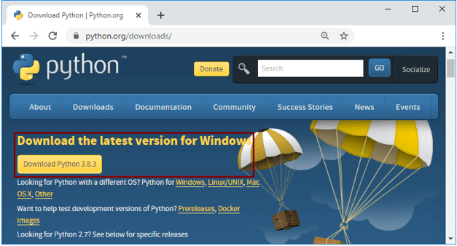
Fig.1 Python-Website
When you click on the Download Python 3.8.3 button, it will download the python-3.8.3.exe file for a 32-bit version. If you want to download the 64-bit version, visit the python for windows page and download the appropriate 64-bit installer.
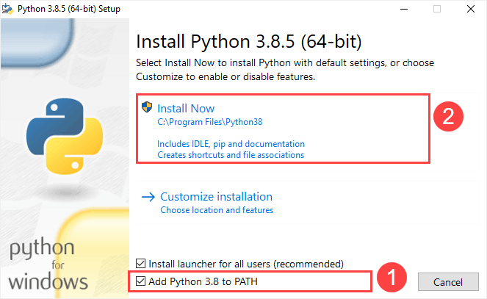
Fig.2 Install Python
If you choose the Install Now option, it will install Python in the default installation folder (C:\Users\{UserName}\AppData\Local\Programs\Python\Python38) with default settings. If you want to customize the python installation folder location & features, you can choose the Customize installation option. Select Add Python 3.8 to path option so that you can execute the python from any path.
After completing the python installation, you will see the success message window like as shown below, and click on the Close button to close the setup wizard.
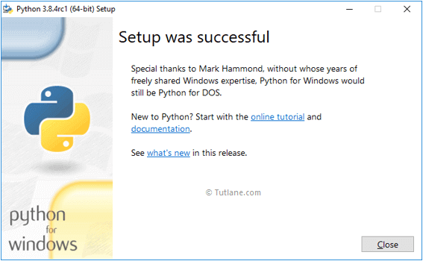
Fig3. Complete Install
VERIFY THE INSTALLATION:
After completing python installation on your machine, you can verify it by opening the command prompt and typing python --version command. If python is installed successfully, it will display the version of python installed on your machine as shown below. To verify the installation, you open the Run window and type cmd and press Enter:
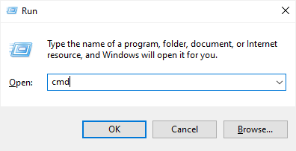
Fig.4. Run CMD
In the Command Prompt, type python command as follows:
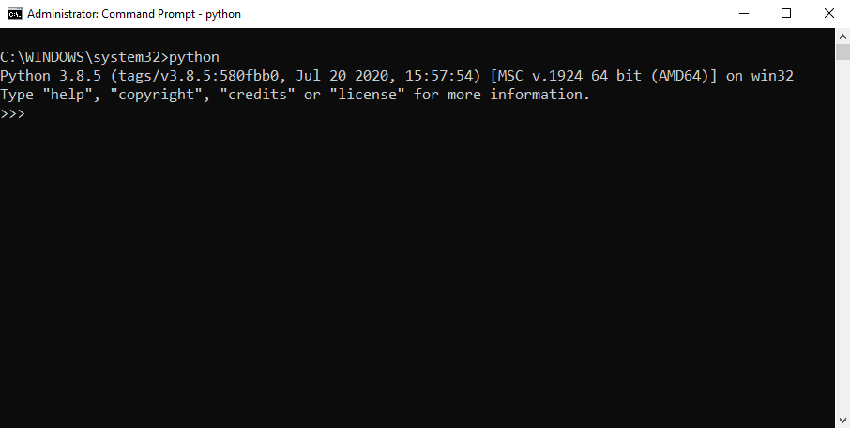
Fig.5. Command Prompt
SETTING PATH AT WINDOWS:
To add the Python directory to the path for a particular session in Windows
At the command prompt − type path %path%;C:\Python and press Enter.
Note − C:\Python is the path of the Python directory.
PYTHON ENVIRONMENT VARIABLES:
Here are important environment variables, which can be recognized by Python:
Sr.No. | Variable & Description
1 | PYTHONPATH  It has a role similar to PATH. This variable tells the Python interpreter where to locate the module files imported into a program. It should include the Python source library directory and the directories containing Python source code. PYTHONPATH is sometimes preset by the Python installer.
2 | PYTHONSTARTUP  It contains the path of an initialization file containing Python source code. It is executed every time you start the interpreter. It is named as .pythonrc.py in Unix and it contains commands that load utilities or modify PYTHONPATH.
3 | PYTHONCASEOK  It is used in Windows to instruct Python to find the first case-insensitive match in an import statement. Set this variable to any value to activate it.
4 | PYTHONHOME  It is an alternative module search path. It is usually embedded in the PYTHONSTARTUP or PYTHONPATH directories to make switching module libraries easy.

INTEGRATED DEVELOPMENT ENVIRONMENT:
You can run Python from a Graphical User Interface (GUI) environment as well, if you have a GUI application on your system that supports Python.
- Windows − PythonWin is the first Windows interface for Python and is an IDE with a GUI.
If you are not able to set up the environment properly, then you can take help from your system admin. Make sure the Python environment is properly set up and working perfectly fine.
PYTHON - BASIC SYNTAX:
The Python syntax defines a set of rules that are used to create Python statements while writing a Python Program. The Python Programming Language Syntax has many similarities to Perl, C, and Java Programming Languages. However, there are some definite differences between the languages.
FIRST PYTHON PROGRAM:
Let us execute a Python "Hello, World!" Programs in different modes of programming.
Python - Interactive Mode Programming
Python interpreter from command line by typing python at the command prompt as following-
>>> print ("Hello, World!")
If you are running older version of Python, like Python 2.4.x, then you would need to use print statement without parenthesis as in print "Hello, World!". However in Python version 3.x, this produces the following result.
Hello, World!
SETUP VISUAL STUDIO CODE FOR PYTHON:
Visual Studio Code is a lightweight source code editor. The Visual Studio Code is often called VS Code. The VS Code runs on your desktop. It’s available for Windows, macOS, and Linux. VS Code comes with many features such as IntelliSense, code editing, and extensions that allow you to edit Python source code effectively. The best part is that the VS Code is open-source and free. Be sides the desktop version, VS Code also has a browser version that you can use directly in your web browser without installing it.
SETTING UP VISUAL STUDIO CODE:
To set up the VS Code, you follow these steps:
- First, navigate to the VS Code official website and download the VS code based on your platform (Windows, macOS, or Linux).
- Second, launch the setup wizard and follow the steps.
Once the installation completes, you can launch the VS code application:

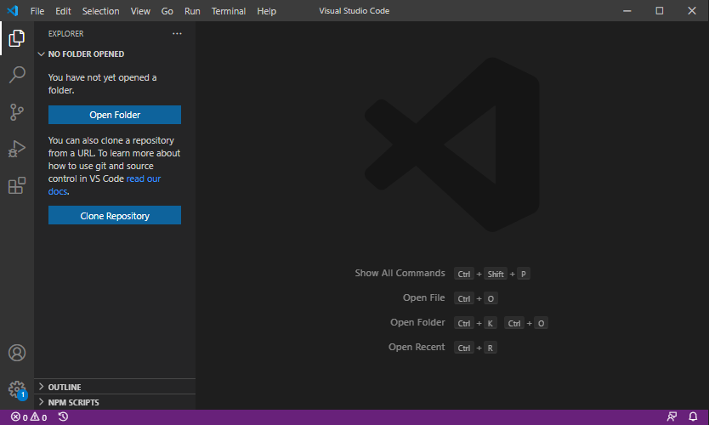

Fig.6. Visual Studio Code
Visual Studio Code is a lightweight but powerful source code editor which runs on your desktop and is available for Windows, macOS and Linux. It comes with built-in support for JavaScript, TypeScript and Node.js and has a rich ecosystem of extensions for other languages and runtimes (such as C++, C#, Java, Python, PHP, Go, .NET). Begin your journey with VS Code with these introductory videos.
EXTENSIONS:
VS Code extensions let third parties add support for additional:
- Languages - C++, C#, Go, Java, Python
- Tools - ESLint, JSHint , PowerShell
- Debuggers - PHP XDebug.
- Keymaps - Vim, Sublime Text, IntelliJ, Emacs, Atom, Brackets, Visual Studio, Eclipse
INSTALL PYTHON EXTENSION:
To make the VS Code works with Python, you need to install the Python extension from the Visual Studio Marketplace.
The following picture illustrates the steps:
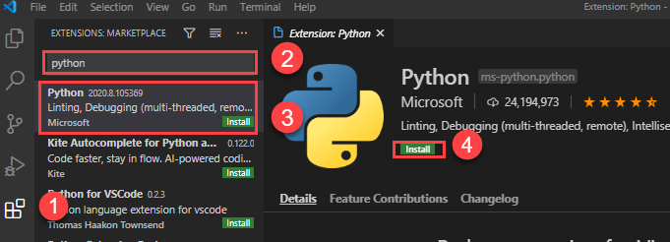
Fig.7. Visual Studio Code to Python Extension
- First, click the Extensions tab and second, type the python keyword on the search input.
- Third, click the Python extension. It’ll show detailed information on the right pane.
- Finally, click the Install button to install the Python extension.

INTRODUCTION TO TKINTER:

Graphical User Interface (GUI) is a form of user interface which allows users to interact with computers through visual indicators using items such as icons, menus, windows, etc. It has advantages over the Command Line Interface (CLI) where users interact with computers by writing commands using keyboard only and whose usage is more difficult than GUI.

Modern computer applications are user-friendly. User interaction is not restricted to console-based I/O. They have a more ergonomic graphical user interface (GUI) thanks to high speed processors and powerful graphics hardware. These applications can receive inputs through mouse clicks and can enable the user to choose from alternatives with the help of radio buttons, dropdown lists, and other GUI elements (or widgets).

Such applications are developed using one of various graphics libraries available. A graphics library is a software toolkit having a collection of classes that define a functionality of various GUI elements. These graphics libraries are generally written in C/C++. Many of them have been ported to Python in the form of importable modules.

What is Tkinter?

Tkinter is the inbuilt python module that is used to create GUI applications. It is one of the most commonly used modules for creating GUI applications in Python as it is simple and easy to work with. You don’t need to worry about the installation of the Tkinter module separately as it comes with Python already. It gives an object-oriented interface to the Tk GUI toolkit.
Some other Python Libraries available for creating our own GUI applications are,
- Kivy
- Python Qt
- wxPython

Among all Tkinter is most widely used
Here are some common use cases for Tkinter:
- Creating windows and dialog boxes: Tkinter can be used to create windows and dialog boxes that allow users to interact with your program. These can be used to display information, gather input, or present options to the user.
- Building a GUI for a desktop application: Tkinter can be used to create the interface for a desktop application, including buttons, menus, and other interactive elements.
- Adding a GUI to a command-line program: Tkinter can be used to add a GUI to a command-line program, making it easier for users to interact with the program and input arguments.
- Creating custom widgets: Tkinter includes a variety of built-in widgets, such as buttons, labels, and text boxes, but it also allows you to create your own custom widgets.
- Prototyping a GUI: Tkinter can be used to quickly prototype a GUI, allowing you to test and iterate on different design ideas before committing to a final implementation.

What are Widgets?
Widgets in Tkinter are the elements of GUI application which provides various controls (such as Labels, Buttons, ComboBoxes, CheckBoxes, MenuBars, RadioButtons and many more) to users to interact with the application.
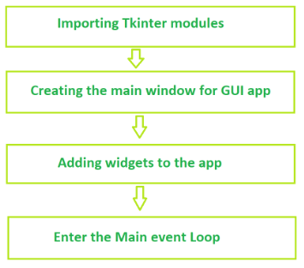
Fig.8. Fundamental structure of tkinter program
BASIC TKINTER WIDGETS:
SNo. | Operator & Description
1 | Button  The Button widget is used to display buttons in your application.
2 | Canvas  The Canvas widget is used to draw shapes, such as lines, ovals, polygons and rectangles, in your application.
3 | Checkbutton  The Checkbutton widget is used to display a number of options as checkboxes. The user can select multiple options at a time.
4 | Entry  The Entry widget is used to display a single-line text field for accepting values from a user.
5 | Frame  The Frame widget is used as a container widget to organize other widgets.
6 | Label  The Label widget is used to provide a single-line caption for other widgets. It can also contain images.
7 | Listbox  The Listbox widget is used to provide a list of options to a user.
8 | Menubutton  The Menubutton widget is used to display menus in your application.
9 | Menu  The Menu widget is used to provide various commands to a user. These commands are contained inside Menubutton.
10 | Message  The Message widget is used to display multiline text fields for accepting values from a user.
11 | Radiobutton  The Radiobutton widget is used to display a number of options as radio buttons. The user can select only one option at a time.
12 | Scale  The Scale widget is used to provide a slider widget.
13 | Scrollbar  The Scrollbar widget is used to add scrolling capability to various widgets, such as list boxes.
14 | Text  The Text widget is used to display text in multiple lines.
15 | Toplevel  The Toplevel widget is used to provide a separate window container.
16 | Spinbox  The Spinbox widget is a variant of the standard Tkinter Entry widget, which can be used to select from a fixed number of values.
17 | PanedWindow  A PanedWindow is a container widget that may contain any number of panes, arranged horizontally or vertically.
18 | LabelFrame  A labelframe is a simple container widget. Its primary purpose is to act as a spacer or container for complex window layouts.
Tkinter PROGRAMMING:
Tkinter is the standard GUI library for Python. Python when combined with Tkinter provides a fast and easy way to create GUI applications. Tkinter provides a powerful object-oriented interface to the Tk GUI toolkit.
Creating a GUI application using Tkinter is an easy task. All you need to do is perform the following steps-
- Import the Tkinter module.
- Create the GUI application main window.
- Add one or more of the above-mentioned widgets to the GUI application.
- Enter the main event loop to take action against each event triggered by the user.
EXAMPLE:
import Tkinter
top = Tkinter.Tk()
# Code to add widgets will go here...
top.mainloop()
This would create a following window-

