ABSTRACT

Breast cancer is one of the leading causes of death in women. Early detection through breast ultrasound images is important and can be improved using machine learning models, which are more accurate and faster than manual methods. Previous research has shown that the use of the logistic regression, svm and random forest algorithms in breast cancer detection still does not achieve high accuracy. This study aims to improve the accuracy of breast cancer detection using the Inception ResNet v2 transfer learning method and data augmentation. The data is divided into training, validation and testing data consisting of 3 classes, namely Benign, Malignant and Normal. The augmentation process includes rotation, zoom, and rescale. The model trained using CNN and Inception ResNet v2 showed good performance by producing the highest accuracy of 89.72% in the training data evaluation data and getting 90% accuracy in the prediction test stage with data testing. This study shows that the combination of data augmentation and the Inception ResNet v2 architecture can improve the accuracy of breast cancer detection in CNN models.

TABLE OF CONTENTS

CHAPTER NO |  | TITLES | PAGE NO
 |  | ABSTRACT | vi
1 | 1.1 | INTRODUCTION | 1
 | 1.2 | OBJECTIVE | 3
 | 1.3 | PROBLEM STATEMENT | 3
 | 1.4 | DEFINING DROWSINESS | 3
 | 1.5 | METHOD | 5
 |  | 1.5.1 Drowsiness Detection System | 8
 |  | 1.5.2 Accelerometer angle calculation Detection System | 8
 |  | 1.5.3 Seat Belt Remainder System | 9
 |  | 1.5.4 Ultrasonic Sensor | 9
 |  | 1.5.5 Server creation | 9
 |  | 1.5.6 Web server | 10
 | 1.6 | METHODS FOR MEASURING DROWSINESS | 10
 |  | 1.6.1 Subjective Measures | 10
 |  | 1.6.2 Vehicle-Based Measures | 11
 |  | 1.6.3 Behavioral Measures | 12
 |  | 1.6.4 Physiological Measures | 13
 | 1.7 | INTERNET OF THINGS | 15
2 |  | LITERATURE SURVEY | 16
 | 2.1 | EXISTING SYSTEM | 23
 |  | 2.1.1 Disadvantage of existing system | 23
 | 2.2 | PROPOSED SYSTEM | 23
 |  | 2.2.1 Advantage of proposed system | 23
 | 2.3 | FEASIBILITY STUDY | 24
 |  | 2.3.1 Economical feasibility | 24
 |  | 2.3.2 Technical feasibility | 24
 |  | 2.3.3 Operational feasibility | 25
3 |  | SYSTEM SPECIFICATIONS | 26
 | 3.1 | HARDWARE REQUIREMENT | 26
 | 3.2 | SOFTWARE REQUIREMENT | 31
4 |  | SYSTEM DESIGN AND DEVELOPMENT | 32
5 |  | TESTING AND IMPLEMENTATION | 34
 | 5.1 | TESTING | 34
 |  | 5.1.1 Unit testing | 34
 |  | 5.1.2 Block box testing | 34
 | 5.2 | SYSTEM IMPLEMENTATION | 34
6 |  | RESULT AND DISCUSSION | 35
7 |  | CONCLUSION | 37
 |  | REFERENCES | 38

CHAPTER 1

  - INTRODUCTION
Breast cancer is one of the highest causes of death in women. According to the World Health Organization, the death rate from breast cancer in Indonesia is 15.9 per 100,000 women, which means 15.9 out of every 100,000 women die from breast cancer each year [1]. About half of all breast cancers occur in women who have no specific risk factors other than gender and age [2]. Most people will not experience any symptoms when cancer is early, which is why it is important to do early detection. Early detection of breast cancer is carried out to predict the presence of cancer through the images of breast x-ray images provided. Early detection of breast cancer uses advanced machine learning models that can facilitate the detection process. Early detection using machine learning models is considered more effective than manual methods. Machine learning models are trained on very large
amounts of data, allowing them to identify patterns and anomalies that humans might miss [3]. This results in a higher level of accuracy in detecting cancer at an early stage. In addition, machine learning models can process data very quickly, allowing cancer detection to be carried out faster. This is very important to increase the chances of treatment success. Early detection of breast cancer using machine learning models has been widely carried out in previous studies. Many studies use deep learning algorithms, especially the Convolutional Neural Network (CNN) [4], [5]. Deep learning models are able to extract features that are more accurate from images than traditional machine learning models [6]. CNN models are perfect for capturing complex patterns in imagery. In a study conducted by Zeimarani et al. [7] using Breast Lesion Ultrasound Images images, the accuracy was 87.07%. Meanwhile, in another research dataset, Ahmed et al. [8] obtained an accuracy of 88.1% after using the deep convolutional neural network (DCNN) method. The use of the CNN algorithm alone is considered to lack high accuracy. Therefore, the study aims to improve the accuracy of CNN in the detection of Breast Cancer images using the Inception Resnet v2 transfer learning method. The transfer learning method takes a pretrained model that has been trained in advance to be combined with CNNs. The Inception ResNet-v2 architecture can handle scale variations in imagery data well [9]. With the combination of Inception and ResNet, Inception ResNet-v2 is capable of improving object recognition performance [10]. The Inception module helps in better and more detailed feature extraction, while the residue block deepens the network and prevents gradient vanishing issues, thereby improving the accuracy of object recognition [11]. In a study conducted by Badawy et al. [12] who compared the application of various types of transfer learning on CNN produced the best accuracy in the Inception Resnet v2 transfer learning model with an accuracy of 82.93%. However, this accuracy is still considered too low. Therefore, in this study, data augmentation will be carried out first to process the image so that it is better when processed by the model. This research contributes to improving the accuracy of the CNN algorithm using the Inception Resnet v2 method, image augmentation to improve the accuracy of the Inception Resnet v2 model. The steps of this research include, data augmentation, data splitting, modelling and evaluation. Model evaluation will use accuracy metrics to measure how accurately the model classifies imagery.
In breast cancer cases, cancer can develop in the breast tissue. Symptoms of breast cancer include a lump, a change in the shape of the breast, swelling in the skin, discharge from the nipple, an inverted nipple, or a red or scaly area of skin. Affected individuals may experience bone pain, enlarged lymph nodes, shortness of breath, or yellowing of the skin. Female gender, adiposity, idleness, consumption of alcohol, HRT during menarche, ionizing radiation, early first reproductive age, late or no childbearing, advanced age, prior breast cancer diagnosis, and family history are risk factors for the development of breast cancer. In between 10 and 15% of cases, a person inherits the BRCA1 and BRCA2 genes from their parents. Cancers that appear in the tubes are known as ductal lymphomas, and cancers that appear in the lobules are known as lobular lymphomas. Preinvasive lesions, including ductal carcinomas, are precursors to many types of cancer. A biopsy of a suspicious mass is done to confirm a diagnosis of breast cancer. Several diagnostic tests are done to find the spread Ness of cancer outside the breast to select the effective treatment. Breast cancer type, severity condition, and aged woman affect outcome. Life expectancy in developed countries is more in UK and US population living to at least 5 years. Life expectancy is lesser in developing countries. It is more common in developed countries and is over 100 times more common in women.
The benefits and harms of screening are controversial. A Cochrane review (2013) concluded that it is not clear whether mammography screening is more beneficial or more dangerous. The US Preventive Services Task Force found that screening for women aged 50 to 74 years was beneficial for women aged 40 to 70 years. The preventive strategy is the surgical removal of both breasts in selected high-risk women. Cancer patients may receive a variety of treatments such as surgery, radiation therapy, chemotherapy, hormone therapy, and targeted therapies. Breast conserving surgery and mastectomy are two different types of surgery. Breast reconstruction is possible during or after surgery. Treatment for people whose cancer has spread to other parts of the body is primarily aimed at improving comfort and quality of life.
The type of breast cancer, the severity of the condition, and the age of the patient influences the outcome. Men are much less likely than women to develop breast cancer. Breast cancer often begins in the milkproducing lobules or the lining of the milk• ducts. A cancerous tumor may metastasize, or• spread to other organs. Breast cancer is the most common• invasive tumor in women. It is the root cause of 22.9% of all invasive cancers in women and 16.3% of all female malignancies. 18.2% of all cancer-related deaths worldwide, in both males and females, are caused by breast cancer With this proposed approach, we're• attempting to foretell whether or not the sample observation is cancerous. A breast lump or an abnormal mammography is frequently the first indication of breast cancer. With a range of breast cancer treatments, stages range from early, curable breast cancer to metastatic breast cancer. Male breast cancer is a prevalent condition that requires significant consideration
Interactive segmentation can generate effective segmentation results, but skilled experts still need to put in a lot of work before they get results, they are happy with. This thesis blends deep convolutional neural networks with graph cut regularisation to automatically obtain tumour segmentations. The project's objective is to study automatic brain tumour segmentation. Although it doesn't require human input, this thesis uses an interactive brain segmentation system that has previously been successful. The tumour for the entire slice is automatically segmented.In this investigation, MRI image data was utilised. Magnetic resonance imaging (MRI) is a medical technique that uses magnetism, radio waves, and computers to create images of the architecture and physiological processes of the body in both healthy and unhealthy tissues. MRI provides a very accurate picture of the organs and may identify even the smallest structural changes in the human body. With a thorough MRI, doctors can examine various body parts and look for the existence of specific illnessesDigital image processing can be used on a computer to modify digital images. With an emphasis on visuals, it divides signals and systems. The creation of an image-processing computer system is DIP's principal goal. The system takes a digital image as input, processes it with effective algorithms, and outputs an image. Adobe Photoshop is used for illustration the most frequently. One of the most used programmes for editing digital images is this one. An image is used as the input data in imaging science, which is a branch of signal processing. Image processing involves turning a physical image into a digital one and applying various techniques to improve the image or eliminate important details. For instance, the output or reaction of a photographic or video outline will be an image, an arrangement of characteristics, an arrangement of qualities, or parameters associated with the image. Standard signal processing algorithms are often applied to images in image processing frameworks, which treat them as two-dimensional signals. The distinction between image processing and fields like image analysis and computer vision is up for discussion. On the continuum from image processing to computer vision, the processes at the low, mid, and high levels can be categorised. An essential component of image processing is the input image. After reviewing the fundamentals of image quality, performance measures for tumour and nontumor images are analysed to assess the image's quality.
A bi cluster is referred to as a pattern repeat is made up of instances and features in the rows and columns of matrix M, respectively. From the perspectives of physicians, a bichromate should exhibit some sort of diagnostic rule since it is a local coherent pattern. When determining the type of tumor mass, those tumor in a sample that contains with a comparable score under the same feature set seem to be more likely to make the same contribution. A pattern that regularly occurs indicates that it is one of the typical clinical symptoms of malignancies and can be used as a crucial diagnostic guideline. Each feature in a sample that contains in this situation should have the same or comparable values across a subset of features. The MSRS is defined as follows
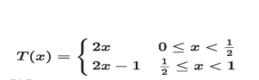
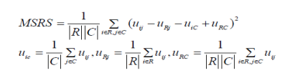
The following three steps make up the majority of the bi clustering algorithm: Step 1 :In order to separate each column into multiple clusters, apply the hierarchical clustering algorithm with a distance threshold Thcon in and refer to them as bicluster seeds (BS).
Step 2: Using these bicluster seeds as a starting point, a) To create an initial submatrix N, expand one column to all other columns for each BS. b) Go through all of N's rows and columns. c) Continue with the previous procedures till resultant predetermined values. Discard certain biclusters that are repetitive or redundant are completely engulfed by bigger ones. After biclustering mining, the following step entails converting the discovered biclusters (i.e., diagnostic patterns) into diagnostic rules. A self-belief measure is suggested to identify the category and dependability of a rule when converting a bicluster into a descriptive rule. In our study, each descriptive rule is categorised as benign (B) or malignant (M) (M). There are two numbers given: the number of rows in a bicluster, Rbic, and the number of rows with the labels "benign" and "malignant," Rbenign and Rmalignant, respectively. The confidence for the benign category (B) and that for the malignant category (M) can be calculated based on the instance labels (i.e., the final diagnostic result)

1.2 Problem Statement
Breast cancer is one of the most common forms of cancer among women worldwide, with early detection playing a critical role in successful treatment and prognosis. Machine learning algorithms have shown promise in assisting medical professionals in the early detection and diagnosis of breast cancer using medical imaging data, such as mammograms.

The problem statement revolves around developing a breast cancer detection system using an InceptionresnetV2 and Resnet50 classifier, a powerful machine learning algorithm known for its ability to improve the accuracy of weak classifiers. The goal is to build a model that can effectively classify mammogram images as either benign (non-cancerous) or malignant (cancerous), thereby aiding healthcare providers in making timely and accurate diagnoses.

Key Components of the Problem Statement:

Dataset Acquisition and Preprocessing:
Obtain a dataset of mammogram images, ideally from reputable sources such as medical research databases or healthcare institutions.
Preprocess the images to enhance quality, remove noise, and normalize features, ensuring that they are suitable for input to the machine learning algorithm.

Feature Extraction:
Extract relevant features from the mammogram images that are indicative of breast cancer, such as texture, shape, and density characteristics.
Use techniques such as image segmentation, edge detection, and feature extraction algorithms to derive meaningful features from the images.

Model Development:
Implement an InceptionresnetV2 and Resnet50 classifier algorithm for binary classification of mammogram images into benign and malignant classes.
Train the model using a portion of the dataset, validating its performance using techniques such as cross-validation or a separate validation dataset.
Model Evaluation:
Evaluate the performance of the InceptionresnetV2 and Resnet50 classifier model using appropriate metrics such as accuracy, precision, recall, F1-score, and area under the receiver operating characteristic (ROC) curve.
Compare the performance of the InceptionresnetV2 and Resnet50 classifier with other machine learning algorithms commonly used for breast cancer detection, such as support vector machines (SVM) or convolutional neural networks (CNNs).

Deployment and Validation:
Deploy the trained InceptionresnetV2 and Resnet50 classifier model in a real-world setting, such as a healthcare facility or diagnostic center.
Validate the model's performance on new, unseen mammogram images to assess its generalization ability and real-world applicability.
Ethical Considerations:
Ensure that the breast cancer detection system complies with ethical guidelines and regulations related to patient privacy, data security, and medical device usage.
Provide transparency regarding the limitations and potential biases of the machine learning model, particularly in the context of healthcare decision-making.

1.3 Implementation

The Breast Cancer Wisconsin (diagnostic) dataset was obtained via Kaggle. Ten independent variables—”Sample code number,” “Clump Thickness,” “Uniformity of Cell Size,” “Uniformity of Cell Shape,” “Marginal Adhesion,” “Single Epithelial Cell Size,” “Bare Nuclei,” “Bland Chromatin,” “Normal Nucleoli,” and “Mitoses”—are considered to be “X,” and one dependent variable—”Y”—consists of class labels. The dataset has roughly 137 samples. The data is separated into two groups: X contains all of the input variables, while Y contains the class label, which serves as the output variable
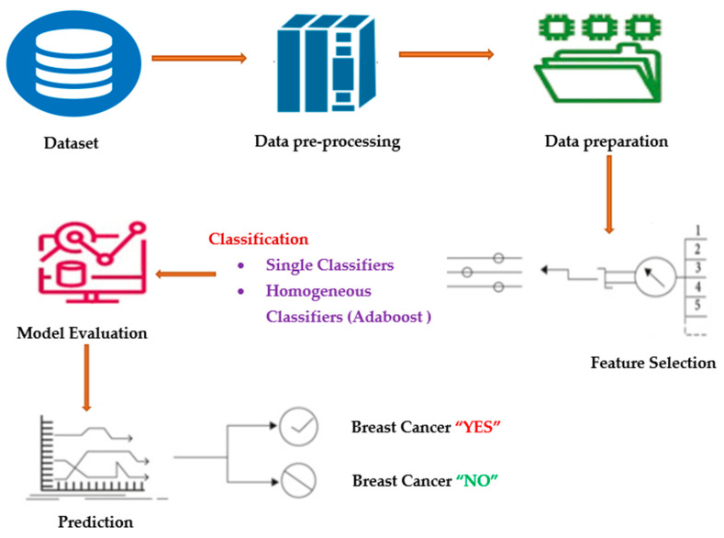

1.4 Data Preprocessing
A class imbalance occurs when there is an unbalanced distribution of classes in a dataset, meaning that there are many more data points in the negative class (majority class) than in the positive class (minority class). The classifier model’s performance will suffer if the skewed data are not corrected beforehand. The majority of the predictions will match the majority class, while the minority class features will be treated as data noise and ignored. The model will have a significant bias as a result. As mentioned, to achieve more accurate classification model results, the data are separated into training and test portions, with the training data comprising 70% of the total dataset, and the test portions comprising 30%.
Many classification algorithms strive to collect only pure examples for learning and make the boundary between each class as clear as possible to improve the prediction. Most classifiers find it significantly more difficult to learn how to classify synthetic cases close to the boundary than those far from it. Based on these results, the authors present an enhanced pre-processing method (A-SMOTE) for imbalanced training sets [25]. SMOTE uses a k-nearest neighbor method to generate synthetic data. SMOTE begins by randomly selecting data from the minority class, after which the data’s k-nearest neighbors are determined [26]. The k-nearest neighbor selected at random and the random data would then be combined to create synthetic data. The SMOTE method is explained in the section below.
Step A: Using Equation (1), a synthetic instance is created:
N=2∗(r−z)+z,
(1)
where r is the majority class samples, z is the minority class samples and N is the newly created synthetic instance.
Step B: The below mentioned steps are carried out to remove the outlier; that is, noise.
If, Sˆ = {Sˆ1, Sˆ2, Sˆ3, …. Sˆn} is a new instance received by Step A, then we will calculate the distance among Sˆi with the original minority Sm,MinRap(Sˆi, Sˆm) defined using Equation (2).
MinRap(Sˆi, Sˆm)=∑zk=1∑Mj=1(Sˆi(j)−Smk(j))2−−−−−−−−−−−−−−√,
(2)
where:
MinRap(Sˆi, Sˆm) are samples of rapprochement and, as per Equation (2), L is calculated using Equation (3).
L=∑ni=1(MinRap (Sˆi, Sm)),
(3)
Step C: Calculate the distance between Sˆi and every original majority Sa,MajRap(Sˆi,Sa), described using Equation (4).
MajRap(Sˆi,Sa)=∑ri=1∑Mj=1(Sˆi(j)−Sal(j))2−−−−−−−−−−−−−√,
(4)
MajRap(Sˆi,Sa) are samples of rapprochement and, as per Equation (4), H is computed using Equation (5).
H=∑ni=1(MajRap (Sˆi, Sa))
(5)
Entropy is nothing but the measure of disorder. Claude E. Shannon used the following Equations (6) and (7) to put this link between probability and heterogeneity or impurity into mathematical form:
H(X)=−∑(pi∗log2pi)
(6)
Entropy (p)=−∑Ni=1pi∗log2piEntropy (p)=−∑Ni=1pi∗log2pi

1.5 ADA Boost Classifier Work
InceptionresnetV2 and Resnet50 enables the fusion of many “weak classifiers” into a single, so-called “strong classifier”. These trees are often referred to as “Decision Stumps.” By giving each data point the same weight, this method builds a model. The improperly categorized points are subsequently given more weight. All points with higher weights are given more significance in the following model. The models will keep being trained until a reduced error is obtained. The pseudo code of the InceptionresnetV2 and Resnet50 classifier is depicted in Algorithm 1. InceptionresnetV2 and Resnet50 and LogitBoost, as depicted in Algorithms 1 and 2, are the two boosting algorithms that are utilized to prompt the ADTree variations discussed in the following section.
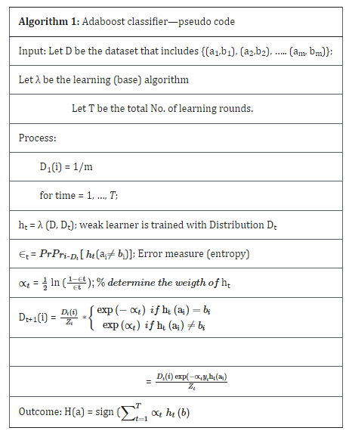

1.6 Alternative Decision tress(AdTree)
A ML approach for classification is ADTree. It generalizes decision trees (DTs) and is linked to boosting. A set of DT nodes representing a predicate condition and prediction nodes that will store a single integer make up an ADTree [27]. The Real InceptionresnetV2 and Resnet50 is implemented in Algorithm 3 to learn an ADTree model. The precondition P and base conditions C remain constant during the induction as two significant variables. The division of the input space greatly affects any decision tree’s quality.
In step 1.1 of Algorithm 3, all the training samples are given an equal weight by setting Wi,t = 0 = 1/n. The training sample as well as the boosting step are represented by the symbols I and t, respectively. Additionally, the precondition true, which is going to define the complete input space, is initialized as part of the precondition set P. With the root decision rule, a prior classifier is created by deriving a second prediction value, α0 from the ratio of positive to negative training data. W+(c) stands for the total weight of the positive samples that meet condition c, and W− (c) for the negative samples. Before starting a fresh boosting procedure, the training data set is reweighted in accordance with this root decision rule
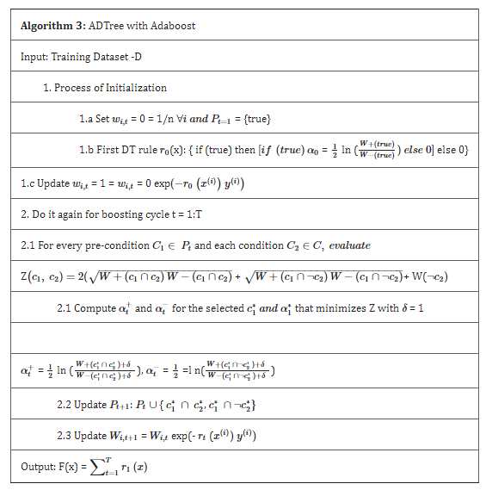

CHAPTER 2

LITERATURE SURVEY

- D. O’Loughlin, M. J. O’Halloran (2018) [1] have applied the Clinical developments in microwave breast imaging and enduring difficulties. A thorough analysis of these recent clinical advancements is provided in this paper, comparing patient groups and trial results. First, a review of existing knowledge regarding the dielectric characteristics of human breast tissues is done using data from both measurement studies and operational microwave imaging equipment. Second, the pros and cons of operational microwave imaging system design aspects are examined for use in clinical settings.
- A. H. Golnabi, P. M. Meaney (2019) [2] had carried out 3-dmicrowave tomography adopting the smooth earlier regularisation technique. Evaluation in numerical breast phantoms created from anatomically accurate MRI scans. This study proved that the smooth earlier algorithm is reliable in three dimensions and can work well with a variety of intricate geometries and tissue property distributions. It reveals that when spatial information from MRI is included using soft prior normalization, microwave tomography is capable of reconstructing accurate tissue property distributions.
- M. Omer, P. Mojabi, D. Kurrant (2018) [3] presented a demonstration of the concept for the use of anatomical data generated from ultrasound in microwave radar imaging. A technique for collecting the breast's information about the structure from ultrasound waves and combining radar-based image was established. In enhancing the image, these techniques work in concert to take advantage of the dielectric difference between glandular tissue at microwave frequencies and limited to a particular of ultrasound signals. The capability of this method to identify minute structural elements on the interior and exterior of the breast, which may offer context for the results' interpretation is one of its important features.
- N. Abdollahi, D. J. Kurrant, P. Mojabi (2019) [4] have improved quantitative microwave imaging of the breast by including ultrasonic historical data. This novel approach is evaluated based on the algorithm's capacity to identify malignancies; imaging findings are quantitatively assessed. Four alternative versions of the previous knowledge are used to test performance, two of them are based on structural information and two are of based on ass permittivity values. The imaging algorithm's sensitivity to malignant tissue is observed to be increasing.
2.1 EXISTING SYSTEM

- Eigen non-iterative function-based algorithm is a multistage approach that is now in use for quantitative MWI of the breast and uses the quantitative previous information. The FEMCSI algorithm uses this past knowledge as an inhomogeneous numerical foundation. In FEM-CSI, this effectively affects the contrast and the causes of the inverted contrast. The multistage method reduces the inversion process' instability and makes it simpler to precisely rebuild the inner details. Despite being equivalent to the previously mentioned MWI algorithms that use prior knowledge, the multistage technique has the special ability to capture scattered-field data using the same microwave data-acquisition device. The creation of a cheap single-modality breast imaging system is significantly aided by this

2.2 PROPOSED SYSTEM
The proposed system of the InceptionResNet-v2 architecture method is its ability to recognize objects with high accuracy and handle unstructured data by extracting relevant features from images using convolution. Where Convolution is the act of image extraction to obtain a model in the form of a kernel matrix. In this process, filtering is carried out that shifts with a certain "step value" on an image input. Or a process to look at the value of a parameter that determines how much the filter shifts in the input image. Furthermore, the results of the convolution become inputs for the fully connected parts for the classification process.
2.2.1 Inception-ResNet-V2
It can be coupled with other learning algorithms to enhance their performance. The outputs of the other learning algorithms, or "weak learners," are combined to generate a weighted total that represents the boosted classifier's final results. InceptionresnetV2 and Resnet50 is adaptive in that it corrects weak learners who were misclassified by earlier classifiers for future scenarios. InceptionresnetV2 and Resnet50 can be broken down by anomalies and noisy data. It may occasionally be less prone to the over fitting issue than other learning algorithms. Despite the fact that the final model might not converge to a powerful learner.

InceptionresnetV2 and Resnet50 (using decision trees as the weak learners) is frequently referred to as the best out-of-the-box classifier, even though every learning algorithm will tend to suit some problem types better than others and will typically have many different parameters and configurations to be adjusted before achieving optimal performance on a dataset. The InceptionresnetV2 and Resnet50 algorithm's data on the relative "hardness" of each training sample is supplied into the procedure for creating the tree-growing algorithm when employed with decision tree learning.

By minimising the loss function L, that is, by maximising, an InceptionresnetV2 and Resnet50 classifier of the aforementioned form can be trained. Each data sample xi is given a non-negative weight wi prior to training

2.2.2 Training and Weighting
The classifier enhancement accepts an object x as input and produces a value denoting the item's class. It is a weak learner-based classifier. For instance, in the two-class problem, the predicted object class is denoted by the sign of the weak learner output, and The degree of confidence in that classification is indicated by the absolute value.
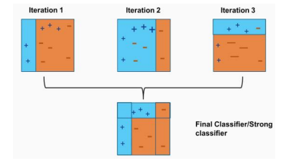
The InceptionresnetV2 and Resnet50 algorithm significantly outperforms the boosting model. It is frequently utilised in machine learning. The algorithm's goal is to create a strong learning classifier by combining multiple weak learning classifiers

2.3 FEASIBILITY STUDY

The feasibility of the project is analyzed in this phase and business proposal is put forth with a very general plan for the project and some cost estimates. During system analysis the feasibility study of the proposed system is to be carried out. This is to ensure that the proposed system is not a burden to the company. For feasibility analysis, some understanding of the major requirements for the system is essential.

Three key considerations involved in the feasibility analysis are:

- Economical feasibility

- Technical feasibility

- Operational feasibility

2.3.1 Economical Feasibility

This study is carried out to check the economic impact that the system will have on the organization. The amount of fund that the company can pour into the research and development of the system is limited. The expenditures must be justified. Thus the developed system as well within the budget and this was achieved because most of the technologies used are freely available. Only the customized products had to be purchased.

The economic feasibility based on the terms of:

- Time

- Cost

- Man power

2.3.2 Technical Feasibility

This study is carried out to check the technical feasibility, that is, the technical requirements of the system. Any system developed must not have a high demand on the available technical resources. This will lead to high demands on the available technical resources. This will lead to high demands being placed on the client. The developed system must have a modest requirement, as only minimal or null changes are required for implementing this system.

2.3.3 Operational Feasibility

The aspect of study is to check the level of acceptance of the system by the user. This includes the process of training the user to use the system efficiently. The user must not feel threatened by the system, instead must accept it as a necessity. The level of acceptance by the users solely depends on the methods that are employed to educate the user about the system and to make him familiar with it. His level of confidence must be raised so that he is also able to make some constructive criticism, which is welcomed, as he is the final user of the system.

CHAPTER 3

SYSTEM SPCIFICATION

3.1 HARDWARE REQUIREMENTS:

Keyboard

Mouse

8gb Ram

500 GB Harddisk

3.2 SOFTWARE REQUIREMENTS:

- Operating System : Windows 10
- Language : Python
CHAPTER 5

TESTING AND IMPLEMENTATION
  - TESTING
Implementation is the stage of the project when the theoretical design is turned into a working system. This is the final and important phase in the system life cycle It is actually the process of converting the new system into a operational one.
5.1.1Unit Testing
Unit testing comprises the set of tests performed by an individual programmer prior to integration of the unit into a larger system. The module interface is tested to ensure that information properly flows into and out of the program unit. The local data structure is examined to ensure that data stored temporarily maintains its integrity during all steps in an algorithm’s execution. Boundary conditions are tested to ensure that the module operates properly at boundaries established to limit or restrict processing. All independent paths through the control structure are tested. All error-handling paths are tested.
5.1.2 Block Box Testing
Black-box testing is a method of software testing that examines the functionality of an application without peering into its internal structures or workings. This method of test can be applied virtually to every level of software testing: unit, integration, system and acceptance. It is sometimes referred to as specification-based testing.
5.2 SYSTEM IMPLEMENTATION
Implementation is the stage of the project when the theoretical design is turned into a working system. This is the final and important phase in the system life cycle It is actually the process of converting the new system into a operational one.

CHAPTER 6

CONCLUSION
This study discusses the process of developing and evaluating a logistic regression, svm and random forest algorithms that uses the Inception ResNet v2 architecture to classify medical images. The data augmentation process is carried out to produce data variations to help the model recognize patterns better. The model is trained using CNN algorithms and Inception ResNet v2 which provides a solid foundation for complex pattern recognition. The highest accuracy value was recorded in the 5th epoch with a score of 89.72%, indicating that the model was able to learn and generalize patterns from the training data effectively. After training, the model was tested using test data and the results showed 90% accuracy. Overall, this study shows that the use of data augmentation and the Inception ResNet v2 architecture provide good performance. The use of other pre-trained models can be done to obtain higher accuracy in future studies.

REFERENCES

- [1] K.Srijayathi and M.Vedachary, “Implementation of the Driver Drowsiness Detection System,” International Journal of science,Engineering and Technology Research(IJSETR), vol. 2, pp. 1751-1754, September 2013.

- [2] Elie Nasr, Elie Kfoury and David Khoury, “An IoT Approach to Vehicle Accident Detection, Reporting and Navigation,” IEEE International Multidisciplinary Conference on Engineering Technology (IMCET), 978-1- 5090-0996-1, 2016.

- [3] Pragyaditya Das and S.Pragadeesh, “A Microcontroller based Car-Safety System: Implementing Drowsiness Detection And Vehicle-Vehicle Distance Detection In Parallel,” International journal of Scientific & Technology Research , vol. 4, issue 12 , pp. 161-163, December 2015.

- [4] Swaleh Owais, “Eye Blink Detection Algorithms”, https://hackaday.io/project/27552- blinktotext/log/68360-eye-blink-detection-algorithms.

- [5] Dr. Pradip Ashok Saymote,Mr.Abhijeet Patil, “Application Of Google API with Java Script for Web mapping of Shivaji University Campus(MS),” International Journal of Current Trands in Engineering & Research(IJCTER), vol. 2, issue 9, pp. 18-26, September 2016.

- [6] Patole Gitanjali, Shinde Jyoti, Dalve Satish, Prof. Vipul Ranjan, Prof. Suri S.B, “IOT based Vehical Tracking & Vehicular Emergy System – A case Study and Review,”International Journal of Advanced Research in Electrical,Electronics and Instrumentation Engineering, vol. 6, issue 10 pp. 8001–8012, October 2017.

