IOT-based Fall Detection for Elderly Care

ABSTRACT
- This paper presents an IoT based fall detection monitoring and alarm system for the elderly using 3-axis Accelerometer. In elderly, injuries induced by fall, becomes fatal sometimes, if timely medical interventions do not take place.
- Therefore, we aim to design a system to detect the fall and alert the medical experts about the incidents of distress. In the proposed system for detection of falling, the elderly patient's acceleration data are continuously acquired by using a wearable sensor and stored on a cloud server, using an IoT board.
- To access the stored data, an android application is designed for the medical expert to examine the fall in the elderly patient and provide the desired assistance, if needed. A threshold-based approach for the fall detection has been used to get the sensor data and set the threshold on accelerometer readings. A complete algorithm has been designed for the detection of genuine fall.

CHAPTER-1
INTRODUCTION
- In order to reduce the risk of elderly people getting harm from fall, medical attention needs to be provided immediately. Therefore, a reliable fall detection system can help to detect fall in elderly people and contact the nearest healthcare service for help and support. The fall detection system need to be user friendly which means it is easier to be used by the elderly people. The system also must not interfere and disturb activities of daily living of elderly people. The system needs to be cost-effective and durable. The MPU6050 sensor module has built-in a gyroscope and an accelerometer sensor. The gyroscope is used to determine the orientation and the accelerometer provides information about the angular parameter such as the X, Y, and Z-axis data. We interface this sensor with arguing microcontroller and keep different acceleration thresholds to check whether any false triggering is happening or the user has really fallen. If values exceed thresholds then we via Blink app we get notification in our android device.

CHAPTER 2
2. SYSTEM ANALYSIS
2.1 EXISTING SYSTEM

- The sensors of the last method are attached to the subject of interest. The wearable sensor-based method usually depends on accelerometer sensors, which are connected to the body and provide an extraordinary level of obtrusiveness. Accelerometers are popular wearable sensors embedded in FDSs to detect the position and movement of the subject. The advantages of wearable accelerometer sensors are their small size, lower cost than external sensors, ability to be easily carried by the body , and ability to measure acceleration in three coordinates or angles of incidence. Thus, among the above three methods, the wearable sensor-based method using accelerometer sensors is considered in this study.
.

2.1.1 DRAWBACKS OF EXISTING SYSTEM ARE
- Fall detection of elderly people is accurately detected based on FDS carried by the patient
- The location of the fall is determined with minimum localization error based on GSM technique in indoor environments for LOS and NLOS scenarios.
- The power consumption of the FDS carried by the subject is minimized based on DDA.
- Fall detection accuracy achieved using sensor-based fall detection algorithm (S-BFDA), localization error based on ANN technique, and FDS power consumption based on DDA are compared with those of state-of-the-art systems.

2.2. PROPOSED SYSTEM
- Smart IoT Gateway is the key component for fall detection and consists of four modules: interoperability, data transformation, big data analyzer, emergency alerts handler.
- This project proposed a fall detection system which is cost effective and reliable to detect fall and alert relatives for help and support. For fall detection, accelerometer and gyroscope was used to detect acceleration and body tilt angle of the faller respectively.
- By coupling accelerometer with gyroscope, the accuracy of the system was improved due to reducing in false positives and true negatives... Alert system in form of Short IOT was transmitted to the concerned authorities.

2.2.1. ADVANTAGES OF PROPOSED SYSTEM

- The system can detect falls instantly and notify caregivers or emergency services, ensuring timely assistance.
- Quick detection of falls reduces the risk of serious injuries and complications from delayed help.
- Continuous monitoring allows for analysis of movement patterns, helping identify risks and improve overall health management.
- Compact and portable designs (e.g., wristbands or pendants) make it easy for seniors to wear without feeling cumbersome.

2.3 FEASIBILITY STUDY
The feasibility Analysis is an analytical program through project manager determines the project success ratio and through feasibility study project manager able to see either project. The key considerations involved in the feasibility analysis are:
- Economic Feasibility
- Technical Feasibility
- Operational Feasibility
- Environmental Feasibility
2.3.1 ECONOMICAL FEASIBILITY
Hence this project is economically feasible there is no need to involve any cost for this project.
2.3.2 TECHNICAL FEASIBILITY
Software Technologies used are PHP and MySql. In the educational institutions, it is possible to update the system in future. No special hardware is required for the purpose of using this system. Hence it is declared that this project is technically feasible.
2.3.3 OPERATIONAL FEASIBILITY
As the admin work mainly to maintain the Patient and Doctor .Doctor will predict patient cancer disease. Hence it is easy to operate with training. Therefore it is operationally feasible for implementation.

2.3.4 ENVIRONMENTAL FEASIBILITY
This project environment is correct as a admin has developed this system and no expenditure is involved under any head and this process is part of admin document management, this project environment is accessible.

2.4 SYSTEM REQUIREMENTS
- System : Pentium IV 2.4 GHz.
- Hard Disk : 40 GB.
- Monitor : 15 inch VGA Color.
- Mouse : Logitech Mouse.
- Ram : 512 MB
- Keyboard : Standard Keyboard

2.4.1 HARDWARE REQUIREMENTS
The Hardware of the computer consists of physical component such as Input Devices, Storage Devices, Processing & Control units and Output Devices. Computer includes external storage unit to store data in programs.
The Hardware Configuration involved in this project
- System : Pentium IV 2.4 GHz.
- Hard Disk : 40 GB.
- Monitor : 15 inch VGA Color.
- Mouse : Logitech Mouse.
- Ram : 512 MB
- Keyboard : Standard Keyboard

2.4.2 SOFTWARE REQUIREMENTS
Software is a group of programs that computers need to do a particular task. It is an essential requirement of Computer System. The Software used to develop the project is
- Operating System : Windows XP.
- Platform : DOT NET TECHNOLOGY
- Front End : ASP.Net 3.5
- Back End : SQL SERVER 2005

CHAPTER 3

CHAPTER 4
TESTING AND IMPLEMENTATION

  - TESTING
Implementation is the stage of the project when the theoretical design is turned into a working system. This is the final and important phase in the system life cycle It is actually the process of converting the new system into a operational one.

4.1.1Unit Testing
Unit testing comprises the set of tests performed by an individual programmer prior to integration of the unit into a larger system. The module interface is tested to ensure that information properly flows into and out of the program unit. The local data structure is examined to ensure that data stored temporarily maintains its integrity during all steps in an algorithm’s execution. Boundary conditions are tested to ensure that the module operates properly at boundaries established to limit or restrict processing. All independent paths through the control structure are tested. All error-handling paths are tested.

4.1.2 Block Box Testing
Black-box testing is a method of software testing that examines the functionality of an application without peering into its internal structures or workings. This method of test can be applied virtually to every level of software testing: unit, integration, system and acceptance. It is sometimes referred to as specification-based testing.

4.2 SYSTEM IMPLEMENTATION
Implementation is the stage of the project when the theoretical design is turned into a working system. This is the final and important phase in the system life cycle It is actually the process of converting the new system into a operational one.

Block Diagram
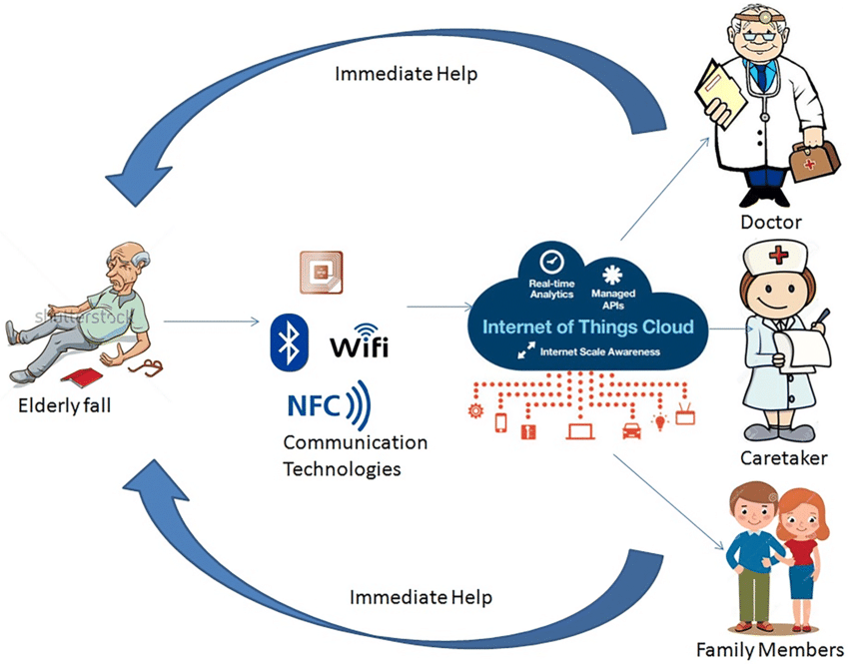

CHAPTER 5
CONCLUSION
CONCLUSION

- There is various fall detection systems detect effectively, but not Suitable for real time application. The proposed system will be a portable device mounted on the waist of user, having sensors consisting of accelerometer. The propose fall detection system can be regarded as alternative device to the existing detection approaches, since the device provides the comfortable wearing, is less complex as compared to other devices, fast fall response and will be more accurate and economical. These systems overcome the limitation of limited range of object tracking.
REFERENCE
- 1. Amin, M.G.; Zhang, Y.D.; Ahmad, F.; Ho, K.D. Radar signal processing for elderly fall detection: The future for in-home monitoring. IEEE Signal Process. Mag. 2016, 33, 71–80. [CrossRef]
- 2. Shinmoto Torres, R.L.; Visvanathan, R.; Hoskins, S.; van den Hengel, A.; Ranasinghe, D.C. Effectiveness of a batteryless and wireless wearable sensor system for identifying bed and chair exits in healthy older people. Sensors 2016, 16, 546. [CrossRef] [PubMed]
- 3. Chen, M.-C.; Chiu, Y.-W.; Chen, C.-H.; Chen, E.-J. Implementation of fall detection and localized caring system. Math. Probl. Eng. 2013, 2013, 217286. [CrossRef]
- 4. Naranjo, P.G.V.; Shojafar, M.; Mostafaei, H.; Pooranian, Z.; Baccarelli, E. P-sep: A prolong stable election routing algorithm for energy-limited heterogeneous fog-supported wireless sensor networks. J. Supercomput. 2017, 73, 733–755. [CrossRef]
- 5. Saleh, N.; Kassem, A.; Haidar, A.M. Energy-efficient architecture for wireless sensor networks in healthcare applications. IEEE Access 2018

