TOWARDS A SMART SUSTAINABLE CITY AIR POLLUTION DETECTION AND CONTROL USING INTERNET OF THINGS

ABSTRACT
The air quality in cities is degrading as a result of a complex interaction between natural and artificial environmental conditions. With the increase in urbanization and industrialization and lack of control on emissions and use of catalytic converters, a great amount of particulate and toxic gases are produced. The objective of this project is to monitor air pollution on roads and track vehicles which cause pollution over a specified limit. Increased use of automobiles is a serious problem that has been around for a very long time. This paper gives survey of different systems used to monitor vehicular pollution and proposes use IOT to address this problem.Air purf

CHAPTER-1
INTRODUCTION
Smart cities have become an essential and global need; they enhance the infrastructure to mitigate the problems caused by the rapid pace of the urbanization. The main goal is not only achieving a smart city but to realize a smart sustainable city, to achieve the balance of the environment alongside the balance of the city's technology evolution. The Internet of Things (IoT) technology is the most popular technology used in smart cities due to its efficiency in wide varieties of applications. Although the IoT is yet to fully emerge, the energy demand has proven to be significantly increased and will keep on increasing over the upcoming years, that's why it's crucial to investigate the Green IoT. One of the most challenging issues in cities is pollution especially air pollution. Air pollution will become a catastrophe with technological advancement if cities turned a blind eye to it. It has a direct effect on people's health as well as the ecosystem. From this point, this paper suggests a green IoT based efficient system that detects and monitor the outdoor air pollution level; the system is powered by renewable energy. The system monitors the pollution level; if the pollution level exceeds the acceptable pollution level, it takes a decision to notify the authorities who can use this data in planning preventive actions and take measures to stop the continuous harmful air pollution effects and prevent the evolution of this phenomenon.
CHAPTER 2
2. SYSTEM ANALYSIS
2.1 EXISTING SYSTEM
- Our air pollution monitoring System is an automated version of monitoring the quality of air and sending the information to a distant database wirelessly.
- Our system has got almost all things automated so that we get an advantage of this concept ie the real time direct measurement of the parameters (here air quality) through GSM/PC.
- Maintaining backup of sent data is easy and can be done within a few seconds.
- .
Pic
16f877a
co2
LCD
GSM
Power
Supply

.

2.1.1 DRAWBACKS OF EXISTING SYSTEM ARE

- The existing system has DC-DC boost converter method it required mppt , so not reliable.
- converter circuits has delay the process performance.
- Maintenance is poor compared to proposed system.

2.2. PROPOSED SYSTEM
- In this project we are going to design the new ECU (Engine Control Unit) device which consist of CO2 sensor, micro controller, LCD display, IOT and accelerometer.
- All the things will be monitored through IOT. We are going fix this ECU device, all upcoming vehicles. Where co2 sensor continuously measures the co2 level exhausted from the vehicles.
- Along with the polluted information about vehicle will be transmitted to RTO via IOT.
- Whenever that level crossed the threshold limit, it will intimate the person to rectify the problem like by doing Service maintenance.
- If the person ignores the process RTO will gives the warning message to the particular person.
- Ari pollution control in public place this method using water
- Again he doesn’t take care means, they will deactivate you vehicle ECU wirelessly.
- Once they locked ECU unit we can’t run our vehicles whatever situation may appear, if we did any malfunction means our system will helps the RTO to find out the vehicle.
- After correcting the pollution level we need to get the certificate from RTO.
- Then only they will unlock your vehicles without their permission we can’t access our vehicles.

- 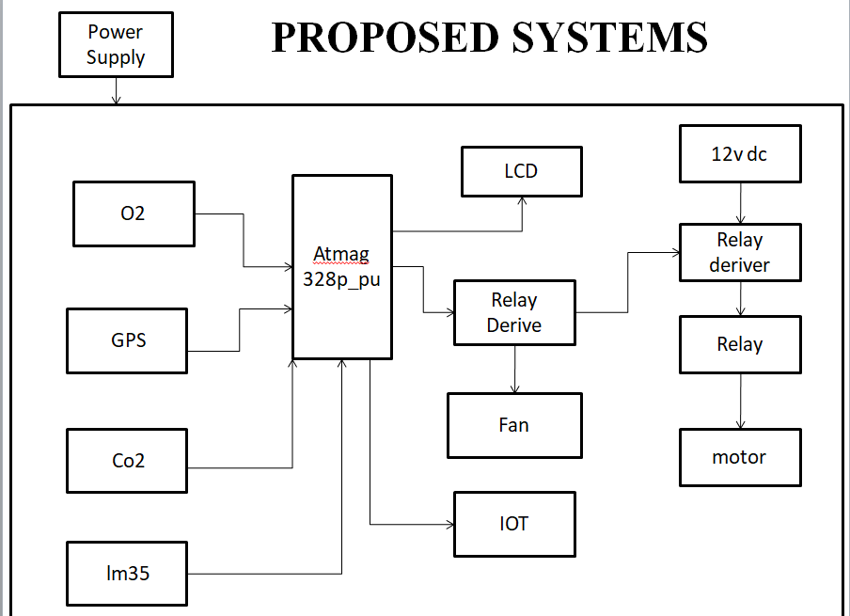
2.2.1. ADVANTAGES OF PROPOSED SYSTEM

- Artificial automation based on scheduling.
- Easily monitoring and reporting air pollution and drunk and drive.
- Avoid the crime activities for license check up.
- Check the weather condition.
- Speed control for vehicles in traffic places such as schools, hospitals and industries.
- Highly secure and safe.

2.3 FEASIBILITY STUDY
The feasibility Analysis is an analytical program through project manager determines the project success ratio and through feasibility study project manager able to see either project. The key considerations involved in the feasibility analysis are:
- Economic Feasibility
- Technical Feasibility
- Operational Feasibility
- Environmental Feasibility
2.3.1 ECONOMICAL FEASIBILITY
Hence this project is economically feasible there is no need to involve any cost for this project.
2.3.2 TECHNICAL FEASIBILITY
Software Technologies used are PHP and MySql. In the educational institutions, it is possible to update the system in future. No special hardware is required for the purpose of using this system. Hence it is declared that this project is technically feasible.
2.3.3 OPERATIONAL FEASIBILITY
As the admin work mainly to maintain the Patient and Doctor .Doctor will predict patient cancer disease. Hence it is easy to operate with training. Therefore it is operationally feasible for implementation.

2.3.4 ENVIRONMENTAL FEASIBILITY
This project environment is correct as a admin has developed this system and no expenditure is involved under any head and this process is part of admin document management, this project environment is accessible.

2.4 SYSTEM REQUIREMENTS
- System : Pentium IV 2.4 GHz.
- Hard Disk : 40 GB.
- Monitor : 15 inch VGA Color.
- Mouse : Logitech Mouse.
- Ram : 512 MB
- Keyboard : Standard Keyboard

2.4.1 HARDWARE REQUIREMENTS
The Hardware of the computer consists of physical component such as Input Devices, Storage Devices, Processing & Control units and Output Devices. Computer includes external storage unit to store data in programs.
The Hardware Configuration involved in this project
- System : Pentium IV 2.4 GHz.
- Hard Disk : 40 GB.
- Monitor : 15 inch VGA Color.
- Mouse : Logitech Mouse.
- Ram : 512 MB
- Keyboard : Standard Keyboard

2.4.2 SOFTWARE REQUIREMENTS
Software is a group of programs that computers need to do a particular task. It is an essential requirement of Computer System. The Software used to develop the project is
- Operating System : Windows XP.
- Platform : DOT NET TECHNOLOGY
- Front End : ASP.Net 3.5
- Back End : SQL SERVER 2005

CHAPTER 3
SYSTEM DESIGN AND DEVELOPEMENT

3.1 DATA FLOW DIAGRAM

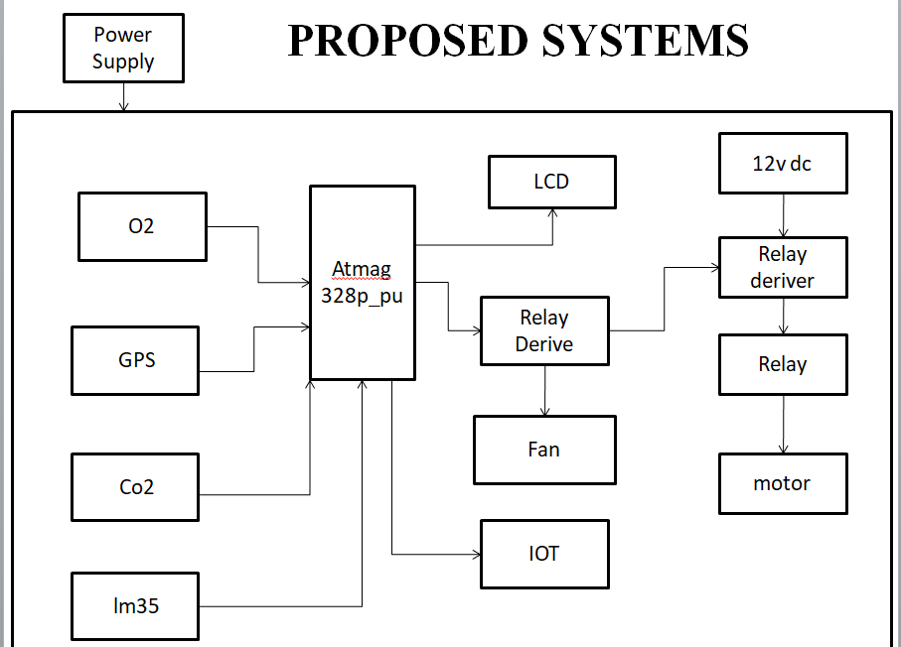

CHAPTER 4
TESTING AND IMPLEMENTATION

  - TESTING
Implementation is the stage of the project when the theoretical design is turned into a working system. This is the final and important phase in the system life cycle It is actually the process of converting the new system into a operational one.

4.1.1Unit Testing
Unit testing comprises the set of tests performed by an individual programmer prior to integration of the unit into a larger system. The module interface is tested to ensure that information properly flows into and out of the program unit. The local data structure is examined to ensure that data stored temporarily maintains its integrity during all steps in an algorithm’s execution. Boundary conditions are tested to ensure that the module operates properly at boundaries established to limit or restrict processing. All independent paths through the control structure are tested. All error-handling paths are tested.

4.1.2 Block Box Testing
Black-box testing is a method of software testing that examines the functionality of an application without peering into its internal structures or workings. This method of test can be applied virtually to every level of software testing: unit, integration, system and acceptance. It is sometimes referred to as specification-based testing.

4.2 SYSTEM IMPLEMENTATION
Implementation is the stage of the project when the theoretical design is turned into a working system. This is the final and important phase in the system life cycle It is actually the process of converting the new system into a operational one.

CHAPTER 5
CONCLUSION
CONCLUSION

- The project deals with designing a simple and low cost air pollution monitoring system using gas sensors, LCD ,CO2 ,GPS,IOT and Atmag328p-pu microcontroller unit to monitor the quality of air of the desired location and transmit it to a distant location wirelessly.
- The designed product module is at prelim stage and designed only for air quality monitoring but can be enhanced for monitoring other different type of environmental and climatic behavior of a location, which also can be cost effective.

CHAPTER-6
REFERENCES
- [1] Shital Y. Gaikwad and Maheshwari “V. C, Security System for Car using RFID, Thumb Impression, Steering wheel Lock Based on ARM 7” International Journal of Current Engineering and Technology Vol.4, No.3 (June 2014)
- [2] PriyaDarshini and Prasannabalaje S.M , “Multilevel Security System for Automotives using RFID and Biometric Techniques in Lab view” International Journal of Advanced Research in Electrical, Electronics and Instrumentation Engineering Vol. 2, Issue 4, April 2013
- [3]Amol S. Dhotre, Abhishek S. Chandurkar& S. S. Jadhav, “Design of a GSM Cell – Phone based Vehicle Monitoring & Theft Security System “International Journal of Electrical and Electronics Engineering (IJEEE) ISSN (PRINT): 2231 – 5284, Vol-1, Iss-3, 2012

