AN ARTIFICIAL LOGIC CONTROLLER IMPLEMENTATION OF HIGH PERFORMANCE VARIABLE FREQUENCY DRIVER WITH INTERLEAVED CONVERTER

ABSTRACT
- Variable frequency drive uses power electronics vary the frequency of input power to motor, thereby controlling motor speed.
- AC motor drives are widely used to control the speed of ACs,pumps, blower speeds, machine tool speeds, conveyor systems speeds and others applications that require variable speed with variable torque.
- This paper proposes a compact VFD circuit design using advanced ALU(artificial logic controller).
- The system completely designed with interleaved converter and reduced components.
- The controlling can be done by fuzzy logic control system.

CHAPTER-1
INTRODUCTION
- A Variable Frequency Drive (VFD) is a type of motor controller that drives an electric motor by varying the frequency and voltage supplied to the electric motor.
- A variable frequency drive is an adjustable speed drive.
- VFDs are available in a number of different low and medium voltage AC-AC and DC-AC topologies.
- Other names for a VFD are variable speed drive, adjustable speed drive, adjustable frequency drive, AC drive, micro drive, and inverter.

CHAPTER 2
2. SYSTEM ANALYSIS
2.1 EXISTING SYSTEM
- Before semiconductor devices were introduced (<1950):
- AC motors for fixed speed applications
- DC motors for variable speed applications
- After semiconductor devices were introduced (1950s)
- Variable frequency sources available – AC motors in variable speed applications
- Coupling between flux and torque control
- Application limited to medium performance applications – fans, blowers, compressors – scalar control
- High performance applications dominated by DC motors – tractions, elevators, servos, etc
- In 1980s vector controlled semiconductor drives were introduced

CONVENTIONAL BLOCK DIAGRAM
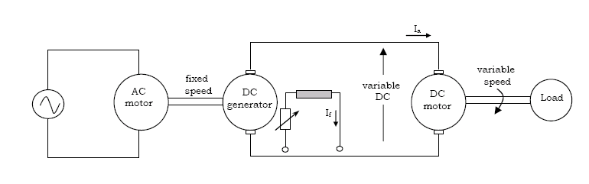

.

2.1.1 DRAWBACKS OF EXISTING SYSTEM ARE

- Bulky, Inefficient, inflexible.
- Switching stress is high.
- System efficiency is low.

2.2. PROPOSED SYSTEM
- The operation of the drive is as follows :
- Power first goes into the rectifier, where the 3-phase AC is converted into a rippling DC voltage.
- The intermediate circuits (interleaved converter) then smoothes and holds the DC Voltage at a constant level or energy source for the inverter.
- The last section, the inverter, uses the DC voltage to pulse the motor with varying levels of voltage and current depending upon the external temperature conditions.
- The control section uses the frequency, voltage and phase angle to control the inverter.
- And also fuzzy logic based control system is implemented for better performance and also reducing components.
- the system under wind speed variations. The wind farm's reactive power capability and the system's reactive power demand are also investigated, as are the controllable circumstances of access point voltage. Active voltage control solutions are proposed, including active reactive power reference modification, active speed control, and active pitch angle intervention based on wind speed ranges. The approach also efficiently reduces the change in grid voltage caused by variations in wind speed
- 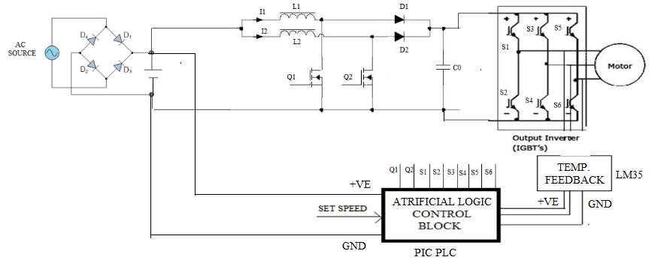
2.2.1. ADVANTAGES OF PROPOSED SYSTEM

ADVANTAGE
- Reducing I2R losses and inductor AC losses.
- Higher efficiency
- Switching loss is less.
- Advanced controller is used.
- Good modulation technique.
PURPOSE OF VFD
- Energy savings on most pump and fan applications.
- Better process control and regulation.
- Speeding up or slowing down a machine or process.
- Inherent power-factor correction
- Emergency bypass capability
- Protection from overload currents
- Safe Acceleration

APPLICATIONS
- Buildings:
  - Primarily commercial
  - Applications:
  - Air handling
  - District Heating
  - Room & Zone
  - Coal handling
  - Operation:
  - AC exhaust fan speed control, Control fans, pumps, compressors to reduce energy consumption
FUZZY LOGIC
- Fuzzy logic has rapidly become one of the most successful of today's technologies for developing sophisticated control systems. The reason for which is very simple.
- Fuzzy logic addresses such applications perfectly as it resembles human Adecision making with an ability to generate precise solutions from certain or approximate information.
- It fills an important gap in engineering design methods left vacant by purely mathematical approaches (e.g. linear control design), and purely logic-based approaches (e.g. expert systems) in system design.

2.3 FEASIBILITY STUDY
The feasibility Analysis is an analytical program through project manager determines the project success ratio and through feasibility study project manager able to see either project. The key considerations involved in the feasibility analysis are:
- Economic Feasibility
- Technical Feasibility
- Operational Feasibility
- Environmental Feasibility
2.3.1 ECONOMICAL FEASIBILITY
Hence this project is economically feasible there is no need to involve any cost for this project.
2.3.2 TECHNICAL FEASIBILITY
Software Technologies used are PHP and MySql. In the educational institutions, it is possible to update the system in future. No special hardware is required for the purpose of using this system. Hence it is declared that this project is technically feasible.
2.3.3 OPERATIONAL FEASIBILITY
As the admin work mainly to maintain the Patient and Doctor .Doctor will predict patient cancer disease. Hence it is easy to operate with training. Therefore it is operationally feasible for implementation.

2.3.4 ENVIRONMENTAL FEASIBILITY
This project environment is correct as a admin has developed this system and no expenditure is involved under any head and this process is part of admin document management, this project environment is accessible.

2.4 SYSTEM REQUIREMENTS
- System : Pentium IV 2.4 GHz.
- Hard Disk : 40 GB.
- Monitor : 15 inch VGA Color.
- Mouse : Logitech Mouse.
- Ram : 512 MB
- Keyboard : Standard Keyboard

2.4.1 HARDWARE REQUIREMENTS
The Hardware of the computer consists of physical component such as Input Devices, Storage Devices, Processing & Control units and Output Devices. Computer includes external storage unit to store data in programs.
The Hardware Configuration involved in this project
- System : Pentium IV 2.4 GHz.
- Hard Disk : 40 GB.
- Monitor : 15 inch VGA Color.
- Mouse : Logitech Mouse.
- Ram : 512 MB
- Keyboard : Standard Keyboard

2.4.2 SOFTWARE REQUIREMENTS
Software is a group of programs that computers need to do a particular task. It is an essential requirement of Computer System. The Software used to develop the project is
- Operating System : Windows XP.
- Platform : DOT NET TECHNOLOGY
- Front End : ASP.Net 3.5
- Back End : SQL SERVER 2005

CHAPTER 3
SYSTEM DESIGN AND DEVELOPEMENT

3.1 DATA FLOW DIAGRAM

An epic delicate exchanging interleaved coupled-inductor help converter is proposed in this paper. The least difficult helper resounding circuit is exhibited to understand the ZVT turn-on and littler current mood killer properties of the two fundamental switches. The swell voltage in the yield of two-arrange ILBC is 0.017 V. The swell voltage in the yield of three-arrange ILBC is 0.001V. The power yield in two phase ILBC is 15 W. The power yield in three phase ILBC is 30 W. Hence the exhibition of Three phase ILBC is superior to that of two phase ILBC

CHAPTER 4
TESTING AND IMPLEMENTATION

  - TESTING
Implementation is the stage of the project when the theoretical design is turned into a working system. This is the final and important phase in the system life cycle It is actually the process of converting the new system into a operational one.

4.1.1Unit Testing
Unit testing comprises the set of tests performed by an individual programmer prior to integration of the unit into a larger system. The module interface is tested to ensure that information properly flows into and out of the program unit. The local data structure is examined to ensure that data stored temporarily maintains its integrity during all steps in an algorithm’s execution. Boundary conditions are tested to ensure that the module operates properly at boundaries established to limit or restrict processing. All independent paths through the control structure are tested. All error-handling paths are tested.

4.1.2 Block Box Testing
Black-box testing is a method of software testing that examines the functionality of an application without peering into its internal structures or workings. This method of test can be applied virtually to every level of software testing: unit, integration, system and acceptance. It is sometimes referred to as specification-based testing.

4.2 SYSTEM IMPLEMENTATION
Implementation is the stage of the project when the theoretical design is turned into a working system. This is the final and important phase in the system life cycle It is actually the process of converting the new system into a operational one.

CHAPTER 5
CONCLUSION
CONCLUSION

- A solar PV array and to regulate the output DC voltage, a DC-DC boost converter is controlled using perturbation and observation technique. The control and implementation in wind and solar-PV energy has been presented. A three-phase and a capacitor energy storage system at its DC bus are used for regulating voltage and frequency at load terminals. A boost converter has been used in between solar PV array and DC bus of VSC to achieve maximum power point tracking. These has also been controlled for load leveling, load balancing and load current. Here inverter has controlled by the PIC16F877A micro controller with PWM pulse generation. Current transformer to measure load on three phases of our company which is provided to us from Grid. So here will pass AC wires from CT to measure load on every phase. PWM signal is generated by feeding a reference and a carrier signal through a comparator which creates the output signal based on the difference between the two inputs. The reference is a sinusoidal wave at the frequency of the desired output signal.

CHAPTER-6
REFERENCES
- [1] Sharma, R.K., Irusapparajan, G. & Periyaazhagar, D. 2019, "Three-phase symmetric cascading Z-source seven levels multilevel inverter excited by multi carrier sinusoidal pulse width modulation scheme", International Journal of Innovative Technology and Exploring Engineering, vol. 8, no. 10, pp. 4269-4274.
- [2] Velavan, R., Bharanidharan, S. & Sheeba, B. 2019, "EMF pollution - Causes, effects and protection", International Journal of Innovative Technology and Exploring Engineering, vol. 8, no. 9 Special Issue 3, pp. 1166-1168.
- [3] Saravana, S., Balaji, S., Arulselvi, S. & John Paul Praveen, A. 2019, "Reliable power quality monitoring and protection system", International Journal of Innovative Technology and Exploring Engineering, vol. 8, no. 9 Special Issue 3, pp. 644-645.
- [4] Tamil Selvan, S. & Sundararajan, M. 2019, "Performance Parameters of 3 Value 8t Cntfet Based Sram Cell Design Using H-Spice", International Journal of Recent Technology and Engineering, vol. 8, no. 2 Special issue 5, pp. 22-27.
- [5] Jac Fredo, A.R., Abilash, R.S., Femi, R., Mythili, A. & Kumar, C.S. 2019, "Classification of damages in composite images using Zernike moments and support vector machines", Composites Part B: Engineering, vol. 168, pp. 77-86.
- [6] Kathiravan, P. & Govindaraju, C. 2019, "Design and evaluation of ultra gain isolated DC-DC converter for photovoltaic system", International Journal of Engineering and Advanced Technology, vol. 8, no. 5, pp. 2646-2651.
- [7] Kripa, N., Vasuki, R. & Kishore Kanna, R. 2019, "Realtime neural interface controlled au-pair BIMA bot", International Journal of Recent Technology and Engineering, vol. 8, no. 1, pp. 992-994.
- [8] Mohanraj, Meenaa Kumari, M., Philomina, S. & Jasmin, M. 2019, "In-situ humidity measurement of hydrogen fuel cell car using MEMS sensor", International Journal of Recent Technology and Engineering, vol. 8, no. 1, pp. 41-43.
- [9] Velmurugan, T. & Prakash, S. 2019, "Artificial intelligent based distribution automation of swift fault detection isolation and power restoration for HT network", International Journal of Innovative Technology and Exploring Engineering, vol. 8, no. 6, pp. 1-6.
- [10] Dwarakesh, K. & Prem Kumar, G. 2019, "Five-level inverter based sequential boost system using fuzzy logic controller", International Journal of Innovative Technology and Exploring Engineering, vol. 8, no. 6, pp. 12-19.

