ACTIVE VOLTAGE CONTROL FOR DFIG-BASED WIND FARM INTEGRATED POWER SYSTEM BY COORDINATING ACTIVE AND REACTIVE POWERS

ABSTRACT
Large-scale wind farms are generally integrated by long-distance transmissions, but power grids cannot sufficiently support the access point voltage of these wind farms. The access point voltage undergoes a stability problem under wind speed variations. However, the reactive power compensation device cannot reconcile the requirements of response speed and compensation capacity. Despite their fast power decoupling control, the reactive power capability of doubly fed induction generators is restricted by active power output. To satisfy the reactive power demand of system under wind speed variations, coordinating the reactive power capability and active power output of wind farm is the key solution, based on which a novel active control idea is proposed. The reactive power capability of wind farm and the reactive power demand of system are both studied, and the controllable conditions of access point voltage are analyzed. Active voltage control strategies, including active adjustment of reactive power reference, active speed control, and active pitch angle intervention according to wind speed ranges, are proposed. In the simulation, the method is verified to adequately consider the reactive power demand, and excavate the wind farm reactive power capability. The method also effectively suppresses the change of grid voltage under wind speed variations.

CHAPTER-1
INTRODUCTION
- Alternatively, where a suitable head of water is not available, pumped-storage hydroelectricity other forms of grid energy storage such as compressed air energy storage and thermal energy storage can store energy developed by high-wind periods and release it when needed.
- Stored energy increases the economic value of wind energy since it can be shifted to displace higher cost generation during peak demand periods.
- requires low quantities of voltage and current sensors. Additionally, quantities of PI controllers are therefore low, which makes the framework relatively basic and financially savvy.
- To wind energy block of fed induction generator (DFIG) is equipped with maximum power point tracking (MPPT) algorithm.
- Autonomous applications as it requires lower numbers of switches, filtering element and current sensors.

CHAPTER 2
2. SYSTEM ANALYSIS
2.1 EXISTING SYSTEM
- Long-distance transmissions are commonly used to connect large-scale wind farms, however power networks cannot handle the access point voltage of these wind farms. Under wind speed fluctuations, the access point voltage has a difficulty with stability. The reactive power compensation device, on the other hand, is unable to meet both the response speed and the compensation capacity criteria. The reactive power capabilities of doubly fed induction generators are limited by active power output, notwithstanding their quick power decoupling control. This review is based on a variety of unique active control ideas.

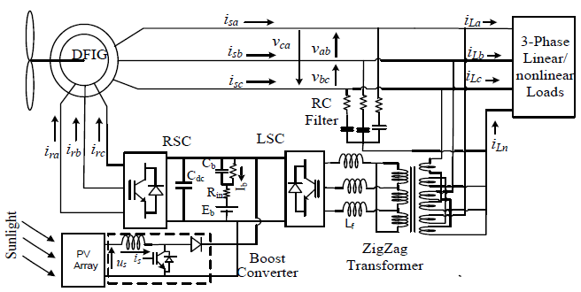.

2.1.1 DRAWBACKS OF EXISTING SYSTEM ARE

- The existing system has DC-DC boost converter method it required mppt , so not reliable.
- converter circuits has delay the process performance.
- Maintenance is poor compared to proposed system.

2.2. PROPOSED SYSTEM
- The reactive power compensation device, on the other hand, is unable to meet both the response speed and the compensation capacity criteria. The reactive power capabilities of doubly fed induction generators are limited by active power output, notwithstanding their quick power decoupling control. This review is based on a variety of unique active control ideas. Coordinating the reactive power capability and active power output of the wind farm is the main solution for satisfying the reactive power demand of the system under wind speed variations. The wind farm's reactive power capability and the system's reactive power demand are also investigated, as are the controllable circumstances of access point voltage. Active voltage control solutions are proposed, including active reactive power reference modification, active speed control, and active pitch angle intervention based on wind speed ranges. The approach also efficiently reduces the change in grid voltage caused by variations in wind speed
- 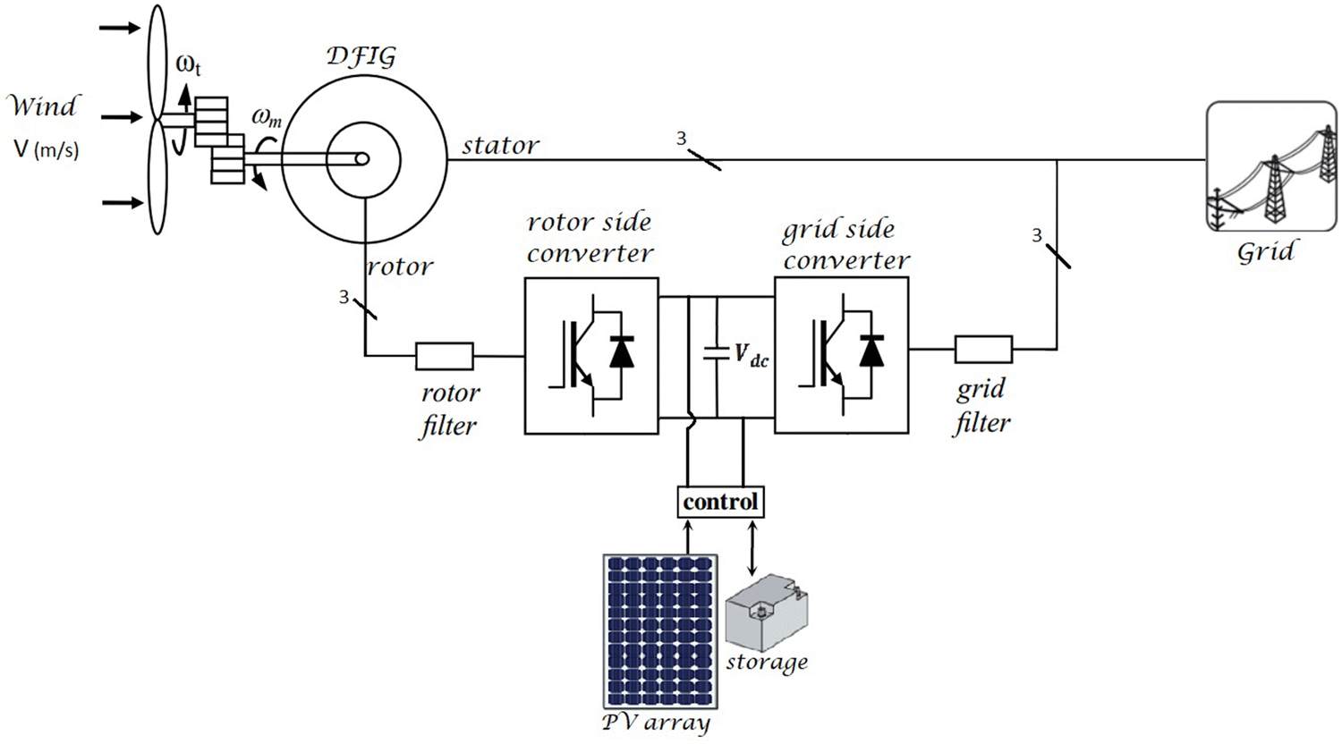
2.2.1. ADVANTAGES OF PROPOSED SYSTEM

- Over all efficiency increased and system cost get decreased.
- Micro controller is that it can allow for easy feedback to control the power flowing through the load.
- PWM is used extensively as a means of powering AC devices with a DC power source. A DC voltage source can be made to look like an AC signal across a load by altering the duty cycle of the PWM signal.
- These system can achieve inverter and produce more power with high efficiency than the DFIG feeding.

2.3 FEASIBILITY STUDY
The feasibility Analysis is an analytical program through project manager determines the project success ratio and through feasibility study project manager able to see either project. The key considerations involved in the feasibility analysis are:
- Economic Feasibility
- Technical Feasibility
- Operational Feasibility
- Environmental Feasibility
2.3.1 ECONOMICAL FEASIBILITY
Hence this project is economically feasible there is no need to involve any cost for this project.
2.3.2 TECHNICAL FEASIBILITY
Software Technologies used are PHP and MySql. In the educational institutions, it is possible to update the system in future. No special hardware is required for the purpose of using this system. Hence it is declared that this project is technically feasible.
2.3.3 OPERATIONAL FEASIBILITY
As the admin work mainly to maintain the Patient and Doctor .Doctor will predict patient cancer disease. Hence it is easy to operate with training. Therefore it is operationally feasible for implementation.

2.3.4 ENVIRONMENTAL FEASIBILITY
This project environment is correct as a admin has developed this system and no expenditure is involved under any head and this process is part of admin document management, this project environment is accessible.

2.4 SYSTEM REQUIREMENTS
- System : Pentium IV 2.4 GHz.
- Hard Disk : 40 GB.
- Monitor : 15 inch VGA Color.
- Mouse : Logitech Mouse.
- Ram : 512 MB
- Keyboard : Standard Keyboard

2.4.1 HARDWARE REQUIREMENTS
The Hardware of the computer consists of physical component such as Input Devices, Storage Devices, Processing & Control units and Output Devices. Computer includes external storage unit to store data in programs.
The Hardware Configuration involved in this project
- System : Pentium IV 2.4 GHz.
- Hard Disk : 40 GB.
- Monitor : 15 inch VGA Color.
- Mouse : Logitech Mouse.
- Ram : 512 MB
- Keyboard : Standard Keyboard

2.4.2 SOFTWARE REQUIREMENTS
Software is a group of programs that computers need to do a particular task. It is an essential requirement of Computer System. The Software used to develop the project is
- Operating System : Windows XP.
- Platform : DOT NET TECHNOLOGY
- Front End : ASP.Net 3.5
- Back End : SQL SERVER 2005

CHAPTER 3
SYSTEM DESIGN AND DEVELOPEMENT

3.1 DATA FLOW DIAGRAM

CHAPTER 4
TESTING AND IMPLEMENTATION

  - TESTING
Implementation is the stage of the project when the theoretical design is turned into a working system. This is the final and important phase in the system life cycle It is actually the process of converting the new system into a operational one.

4.1.1Unit Testing
Unit testing comprises the set of tests performed by an individual programmer prior to integration of the unit into a larger system. The module interface is tested to ensure that information properly flows into and out of the program unit. The local data structure is examined to ensure that data stored temporarily maintains its integrity during all steps in an algorithm’s execution. Boundary conditions are tested to ensure that the module operates properly at boundaries established to limit or restrict processing. All independent paths through the control structure are tested. All error-handling paths are tested.

4.1.2 Block Box Testing
Black-box testing is a method of software testing that examines the functionality of an application without peering into its internal structures or workings. This method of test can be applied virtually to every level of software testing: unit, integration, system and acceptance. It is sometimes referred to as specification-based testing.

4.2 SYSTEM IMPLEMENTATION
Implementation is the stage of the project when the theoretical design is turned into a working system. This is the final and important phase in the system life cycle It is actually the process of converting the new system into a operational one.

CHAPTER 5
CONCLUSION
CONCLUSION

- A solar PV array and to regulate the output DC voltage, a DC-DC boost converter is controlled using perturbation and observation technique. The control and implementation in wind and solar-PV energy has been presented. A three-phase and a capacitor energy storage system at its DC bus are used for regulating voltage and frequency at load terminals. A boost converter has been used in between solar PV array and DC bus of VSC to achieve maximum power point tracking. These has also been controlled for load leveling, load balancing and load current. Here inverter has controlled by the PIC16F877A micro controller with PWM pulse generation. Current transformer to measure load on three phases of our company which is provided to us from Grid. So here will pass AC wires from CT to measure load on every phase. PWM signal is generated by feeding a reference and a carrier signal through a comparator which creates the output signal based on the difference between the two inputs. The reference is a sinusoidal wave at the frequency of the desired output signal.

CHAPTER-6
REFERENCES
- [[1] IEEE Recommended Practice and Requirements for Harmonic Control in Electric Power Systems - Redline," IEEE Std 519-2014 (Revision of IEEE Std 519-1992), pp.1-213, June 11 2014.
- [2] M. Pattnaik and D. Kastha,“Comparison of MRAS based speed estimation methods for a stand alone Doubly Fed Induction Generator”, Inter. Conf. on Energy, Automation, and Signal (ICEAS), Dec. 2011.
- [3] M. R. A. Hamadi, A. Chandra and B. Singh, "Hybrid AC-DC standalone system based on PV array and wind turbine," IECON 2014 - 40th Annual Conf. of IEEE Industrial Elect. Society, Dallas, TX, 2014, pp. 5533-5539.
- [4] A. Hamadi, S. Rahmani, K. Addoweesh and K. Al-Haddad, “A modeling and control of DFIG wind and PV solar energy source generation feeding four wire isolated load” 39th Annual Conference of the IEEE Industrial Electronics Society, IECON 2013, 10-13 Nov, 2013 pp. 7778 – 7783
- [5] S.K. Tiwari, Bhim Singh and P.K. Goel, "Design and control of wind-solar energy system with DFIG feeding a 3-phase 4-wire network", 2016 IEEE 1st International Conference on Power Electronics, Intelligent Control and Energy Systems (PEICES), 4-6 July 2016.

