The Quantum Path Kernel A Generalized Neural Tangent Kernel for Deep Quantum Machine Learning

ABSTRACT
- Building a quantum analog of classical deep neural networks represents a fundamental challenge in quantum computing.
- A key issue is how to address the inherent non-linearity of classical deep learning, a problem in the quantum domain due to the fact that the composition of an arbitrary number of quantum gates, consisting of a series of sequential unitary transformations, is intrinsically linear.
- This problem has been variously approached in the literature, principally via the introduction of measurements between layers of unitary transformations.
- We introduce the Quantum Path Kernel, a formulation of quantum machine learning capable of replicating those aspects of deep machine learning typically associated with superior generalization performance in the classical domain, specifically, hierarchical feature learning.

CHAPTER-1
INTRODUCTION

Neural Tangent Kernels are a recent development in the theory of neural networks. They describe the behavior of infinitely wide neural networks during training.NTK helps in understanding the dynamics of gradient descent and the generalization properties of neural networks. QML is an interdisciplinary area combining quantum physics and machine learning, aiming to leverage quantum computing to enhance ML algorithms. A second problematic aspect of QNNs, and the one thatconstitutes our principal focus here, is the linearity of thedynamics of quantum systems. Concatenations of linearunitary transformations remain unitary and thus ‘stacked’quantum transformations, in effect, collapse to a single lineartransformation, appearing to rule out de facto the hierarchicalfeature learning of classical deep neural networks, whichrelies on non-linearities to separate feature layers. This prop-erty makes the QNN essentially a kernel machine [10]. Interms of the predictor function, however, the QNN is com-posed of multiplications of rotation operators parameterizedby both the feature and model weights. The nonlinearity ofprojections of rotation operators can be exploited to replicatea very constrained form of non-linearity for feature learning[11], [12]. Another strategy is to introduce nonlinearity viathe measurement operation, i.e. adissipative QNN[13]. Bothapproaches involve the projection the quantum state into asubspace of the original Hilbert space.Much of the recent study of the dynamics of deep neuralnetworks in the classical realm has focused on the NeuralTangent Kernel (NTK) [14] which represents the network interms of the corresponding training gradients in the modelparameter space. The NTK hence approximates the behaviorof predictors via a linear model. It is often therefore appliedto study neural networks in their asymptotic, infinite-width,limit. In this regime, the network exhibitslazy training[15],i.e. parameter gradients remain at their initial values duringthe entirety of the training. The NTK thus accurately charac-terizes the dynamics of such infinite-width neural networks,but is otherwise only an approximation [16]. The differencein test error between the predictor and its linearized versiondepends on the problem structure [17], with hierarchicalfeature learning capability being crucial to obtaining superiorperformance [18]. However, the kernel nature of the NTKmeans that it shares with quantum computing a ready inter-pretation within a Hilbert space, and is thus of considerableinterest within quantum machine learning. The first explicitapplication of NTK to quantum neural networks, thequantumneural tangent kernel(QNTK) was given in [19].In this paper, we propose a method for overcoming thede facto lack of hierarchical feature learning capability inQNNs. We propose the application of Path Kernels [20]to QNNs, which we call theQuantum Path Kernel(QPK).Such an approach generalizes the QNTK so that the resultingkernel is representative of the ensemble of NTKs calculatedover the full parameter path trajectory, i.e. the functiondescribing the evolution of model parameters over time,including implicitly any parametric evolutions correspondingto hierarchical feature learning. We show experimentally anincreased expressivity of the resulting model relative to lin-earized equivalents, evaluating our method on the GaussianXOR mixture classification problem. For this problem, finite-width neural networks have both theoretically and empir-ically shown to be close-to-optimal performance whereaslinear NTK models fail [21], suggesting that it cannot be effectively resolved without implicating multilevel learning behavior. Furthermore, we discuss possible improvements for the proposed approach, which can be obtained by considering only the contribution of the parameter gradient path that give srise to the most decorrelated feature representation. Theses pecifically corresponds to the contributions associated withthe maximally nonlinear point of the parameter path, cor-responding to the largest (positive or negative) eigenvaluesof the Hessian of the predictor function [22]. We furtherenhance the decorrelation between feature representationsvia a stochastic, noisy, or non-gradient-descent-based train-ing algorithm in which the averaging operation betweendecorrelated representations allows us to interpret the modelas an ensemble technique.The paper is structured as follows. In Section II we brieflyreview the necessary conceptual background. In Section IIIwe present the Quantum Path Kernel and discuss the hierar-chical feature learning of the induced model. In Section IVwe demonstrate how this leads to superior performance insolving the Gaussian XOR mixture classification problem. InSection V we draw our conclusions and present directions forfurther work.A. CONTRIBUTIONS•We propose theQuantum Path Kernelas a mechanismfor building hybrid classical/quantum machine learningmodels which are able to emulate the hierarchical fea-ture learning structure of deep neural networks with-out violating the underlying linearity of the quantumdynamics. We conjecture such a kernel can lead toimproved performance of the kernel machine on tasksinvolving feature learning.•We provide numerical evidence of the superior perfor-mance of the Quantum Path Kernel compared to theQNTK on the Gaussian XOR Mixture problem, whichis Bayes optimally soluble only through implicatinglayerwise nonlinear separability.•We consider the importance of the extraction ofnon-correlated feature representations corresponding tomaximally varying portions of the parameter gradientpath.B. RELATED WORKSThe introduction of the NTK by [14] has marked a significantstep in the theory of machine learning, sheding new light ondiscussions regarding the relative performance of linear andnonlinear models. For example, [17] suggests that tasks inwhich kernel methods (including NTK) perform worse thanneural networks are those in which the kernel suffers from thecurse of dimensionality whereas neural networks, in learningsome useful lower dimensional representation, do not. Oneexample of such a problem is the Gaussian XOR Mixtureclassification task [21]. Furthermore, linearized models havebeen shown to perform slightly worse than wide (i.e. large,but non-infinite) neural networks on CIFAR-10

Literature Review
- P. Wittek Quantum machine learning: what quantum computing means to data mining. Quantum Machine Learning bridges the gap between abstract developments in quant- um computing and the applied research on machine learning.

- M. Schuld, I. Sinayskiy, F. Petruccione An introduction to quantum machine learning. Uses algorithms run on quantum devices, such as quantum computers, to supplement, expedite, or support the work performed by a classical machine learning program.
- H.-Y. Huang, M. Broughton, M. Mohseni. Power of data in quantum machine learning. In the classical case the data is the n-dimensional input vector, and the quantum case uses a given circuit to embed the n-dimensional vector into the space of n qubits.
- A. Abbas, D. Sutter, C. Zoufal. The power of quantum neural networks. Quantum neural networks can possess a desirable Fisher infor- mation spectrum that enables them to train faster and express more functions than comparable classical and quantum models.

CHAPTER 2
2. SYSTEM ANALYSIS
2.1 EXISTING SYSTEM

- Neural Tangent Kernels are a recent development in the theory of neural networks. They describe the behavior of infinitely wide neural networks during training.
- NTK helps in understanding the dynamics of gradient descent and the generalization properties of neural networks.
- QML is an interdisciplinary area combining quantum physics and machine learning, aiming to leverage quantum computing to enhance ML algorithms.

.

2.1.1 DRAWBACKS OF EXISTING SYSTEM ARE

- Quantum algorithms and systems are inherently more complex to design, implement, and maintain compared to classical algorithms.
- Requires expertise in both quantum computing and machine learning, which can be a barrier for many researchers and practitioners.
- Current quantum hardware is still in the early stages of development, with limitations in terms of qubit count, coherence time, and error rates.
- Noise and errors in quantum computations can affect the reliability and accuracy of QPK-based models.

2.2. PROPOSED SYSTEM
- The proposed Quantum Path Kernel (QPK) aims to address these limitations by extending the concept of neural tangent kernels into the quantum domain, creating a more generalized framework for deep quantum machine learning.
- By leveraging quantum computing, QPK can provide more efficient training dynamics and improved generalization.
- QPK might be better suited for handling larger and more complex neural network architectures.
- Improved robustness to noise and errors in quantum computations, making it more practical for real-world applications.

2.2.1. ADVANTAGES OF PROPOSED SYSTEM

- By leveraging the principles of quantum computing, QPK can potentially offer exponential speedups for certain machine learning tasks compared to classical approaches.
- Improved training dynamics and generalization capabilities, particularly for complex datasets and deep learning models.
- QPK is designed to handle larger and more complex neural network architectures more efficiently than classical Neural Tangent Kernels (NTKs).
- Better suited for high-dimensional data and large-scale problems that are computationally prohibitive for classical methods.

2.3 FEASIBILITY STUDY
The feasibility Analysis is an analytical program through project manager determines the project success ratio and through feasibility study project manager able to see either project. The key considerations involved in the feasibility analysis are:
- Economic Feasibility
- Technical Feasibility
- Operational Feasibility
- Environmental Feasibility
2.3.1 ECONOMICAL FEASIBILITY
Hence this project is economically feasible there is no need to involve any cost for this project.
2.3.2 TECHNICAL FEASIBILITY
Software Technologies used are PHP and MySql. In the educational institutions, it is possible to update the system in future. No special hardware is required for the purpose of using this system. Hence it is declared that this project is technically feasible.
2.3.3 OPERATIONAL FEASIBILITY
As the admin work mainly to maintain the Patient and Doctor .Doctor will predict patient cancer disease. Hence it is easy to operate with training. Therefore it is operationally feasible for implementation.

2.3.4 ENVIRONMENTAL FEASIBILITY
This project environment is correct as a admin has developed this system and no expenditure is involved under any head and this process is part of admin document management, this project environment is accessible.

2.4 SYSTEM REQUIREMENTS
- System : Pentium IV 2.4 GHz.
- Hard Disk : 40 GB.
- Monitor : 15 inch VGA Color.
- Mouse : Logitech Mouse.
- Ram : 512 MB
- Keyboard : Standard Keyboard

2.4.1 HARDWARE REQUIREMENTS
The Hardware of the computer consists of physical component such as Input Devices, Storage Devices, Processing & Control units and Output Devices. Computer includes external storage unit to store data in programs.
The Hardware Configuration involved in this project
- System : Pentium IV 2.4 GHz.
- Hard Disk : 40 GB.
- Monitor : 15 inch VGA Color.
- Mouse : Logitech Mouse.
- Ram : 512 MB
- Keyboard : Standard Keyboard

2.4.2 SOFTWARE REQUIREMENTS
Software is a group of programs that computers need to do a particular task. It is an essential requirement of Computer System. The Software used to develop the project is
- Operating System : Windows 10.
- Platform : PYTHON

2.5 MODULE DESCRIPTION
• Neural Tangent Kernel (NTK):
- The Neural Tangent Kernel is a concept from classical deep learning theory. It describes the behavior of infinitely wide neural networks during training. In this limit, the network's behavior can be captured by a kernel function that simplifies the analysis of gradient-based optimization and learning dynamics.
• Deep Quantum Machine Learning:
- Deep quantum machine learning integrates principles from quantum computing and machine learning. It explores the use of quantum computers or quantum-inspired algorithms to enhance learning tasks that involve large-scale data processing, complex modeling, or optimization problems that are computationally intensive.
Quantum Path Kernel:
- This appears to be an extension or a generalization of the Neural Tangent Kernel concept within the domain of quantum machine learning. Instead of describing the behavior of classical neural networks, it likely pertains to quantum neural networks or quantum-inspired models.

CHAPTER 3
SYSTEM DESIGN AND DEVELOPEMENT

3.1 DATA FLOW DIAGRAM

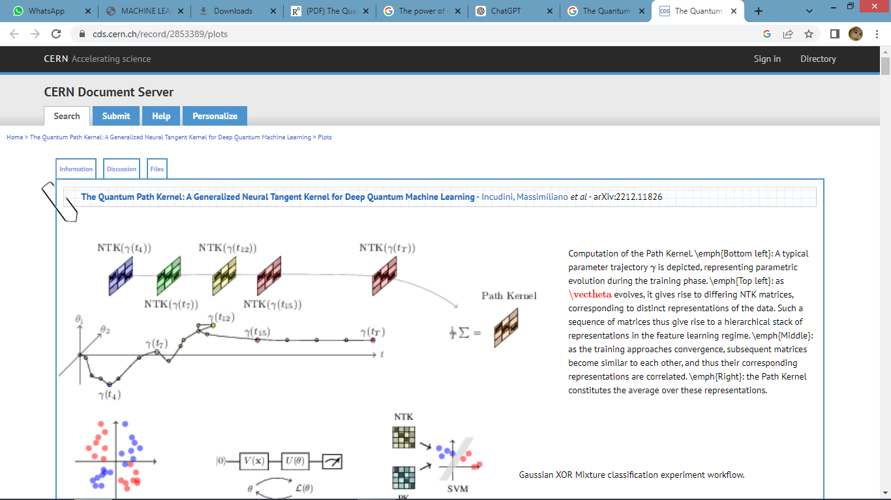

CHAPTER 4
TESTING AND IMPLEMENTATION

  - TESTING
Implementation is the stage of the project when the theoretical design is turned into a working system. This is the final and important phase in the system life cycle It is actually the process of converting the new system into a operational one.

4.1.1Unit Testing
Unit testing comprises the set of tests performed by an individual programmer prior to integration of the unit into a larger system. The module interface is tested to ensure that information properly flows into and out of the program unit. The local data structure is examined to ensure that data stored temporarily maintains its integrity during all steps in an algorithm’s execution. Boundary conditions are tested to ensure that the module operates properly at boundaries established to limit or restrict processing. All independent paths through the control structure are tested. All error-handling paths are tested.

4.1.2 Block Box Testing
Black-box testing is a method of software testing that examines the functionality of an application without peering into its internal structures or workings. This method of test can be applied virtually to every level of software testing: unit, integration, system and acceptance. It is sometimes referred to as specification-based testing.

4.2 SYSTEM IMPLEMENTATION
Implementation is the stage of the project when the theoretical design is turned into a working system. This is the final and important phase in the system life cycle It is actually the process of converting the new system into a operational one.

CHAPTER 5
CONCLUSION
CONCLUSION

- We have introduced the Quantum Path Kernel as a mechanism for incorporating key complex classical multi-layer network learning behaviors, in particular hierarchical feature learning, within quantum neural networks via an appropriately expressive kernelization of the training process.
- We evaluate our approach on the Gaussian XOR mixture classiﬁcation problem, a straightforward benchmark of multilayer learning capacity that requires a minimum two-layer solution in order to approach Bayes optimally.
- Experimental results indicate superior generalization performance relative to the Quantum NTK, an advantage which is especially pronounced in high-depth, low signal-to-noise settings.
- We have shown theoretically that the Quantum Path Kernel converges to the Quantum NTK only in the lazy training regime, i.e.
- When the training loss decreases to zero exponentially fast whilst model parameters stay close to their initializations across training.
- Such behaviour is classically seen in inﬁnite-wide neural networks, whose behaviour is then close to that of a linear model.
- Our experiments, by contrast, indicate that QNNs do not operate in the linear regime.
- We have discussed, though do not evaluate in the current paper, the potential for using stochastic, noisy or non-gradient descent based optimization techniques to artiﬁcially perturb parameter paths within the QPK in order to implicate more decorrelated feature representations.

CHAPTER-6
REFERENCE

- P. Wittek, Quantum Machine Learning: What Quantum Computing Means to Data Mining. Cambridge, MA, USA: Academic, 2014.
- M. Schuld, I. Sinayskiy, and F. Petruccione, “An introduction to quantum machine learning,” Contemporary Phys., vol. 56, no. 2, pp. 172–185, 2015.
- H.-Y. Huang et al., “Power of data in quantum machine learning,” Nature Commun., vol. 12, no. 1, 2021.
- A. Abbas, D. Sutter, C. Zoufal, A. Lucchi, A. Figalli, and S. Woerner, “The power of quantum neural networks,” Nature Comput. Sci., vol. 1, no. 6, pp. 403–409, 2021.
- Y. Liu, S. Arunachalam, and K. Temme, “A rigorous and robust quantum speed-up in supervised machine learning,” Nature Phys., vol. 17, no. 9, pp. 1013–1017, 2021.
- H.-Y. Huang et al., “Quantum advantage in learning from experiments,” Science, vol. 376, no. 6598, pp. 1182–1186, 2022.
- J. R. McClean, S. Boixo, V. N. Smelyanskiy, R. Babbush, and H. Neven, “Barren plateaus in quantum neural network training landscapes,” Nature Commun., vol. 9, no. 1, 2018.
- Z. Holmes, K. Sharma, M. Cerezo, and P. J. Coles, “Connecting ansatz expressibility to gradient magnitudes and barren plateaus,” PRX Quantum, vol. 3, no. 1, 2022.
- A. Skolik, J. R. McClean, M. Mohseni, P. van der Smagt, and M. Leib, “Layerwise learning for quantum neural networks,” Quantum Mach. Intell., vol. 3, no. 1, Jan. 2021.
- J. Liu, F. Tacchino, J. R. Glick, L. Jiang, and A. Mezzacapo, “Representation learning via quantum neural tangent kernels,” PRX Quantum, vol. 3, no. 3, 2022.

