Self-Supervised Learning for Electroencephalography

ABSTRACT

- Decades of research have shown machine learning superiority in discovering highly nonlinear patterns embedded in electroencephalography (EEG) records compared with conventional statistical techniques.
- However, even the most advanced machine learning techniques require relatively large, labeled EEG repositories.
- EEG data collection and labeling are costly.
- Moreover, combining available datasets to achieve a large data volume is usually infeasible due to inconsistent experimental paradigms across trials.

CHAPTER-1
INTRODUCTION
- We aim to learn robust vector representations from massive unlabeled EEG signals, such that the learned vectorized features are expressive enough to replace the raw signals in the sleep staging task.
- Provide better predictive performance than supervised models in scenarios of fewer labels and noisy samples.
- Deep learning models have shown great success in automating tasks in sleep medicine by learning from carefully annotated Electroencephalogram (EEG) data.

CHAPTER 2
2. SYSTEM ANALYSIS
2.1 EXISTING SYSTEM

- Techniques like SimCLR (Simple Framework for Contrastive Learning of Visual Representations) and MoCo (Momentum Contrast) have been adapted for EEG data.
- These methods involve creating positive and negative pairs of EEG segments and training a model to distinguish between them, thus learning useful representations.
- This method utilizes the temporal structure of EEG data by shuffling temporal segments and learning to re-order them or ensure consistency in temporal correlation, thereby capturing temporal dependencies in the data.

2.1.1 DRAWBACKS OF EXISTING SYSTEM
- Designing the right model architecture for SSL in EEG is complex and may require significant experimentation and expertise in both deep learning and EEG signal processing.
- SSL methods often involve numerous hyperparameters, such as learning rates, batch sizes, and the specifics of data augmentation, which can be difficult and time-consuming to optimize.
- SSL methods, especially those involving deep neural networks, can be computationally intensive, requiring powerful hardware (e.g., GPUs) and significant computational resources.

2.2. PROPOSED SYSTEM
- Gather a diverse and extensive dataset of raw EEG signals from various sources (e.g., different subjects, tasks, conditions).
- Apply standard EEG preprocessing techniques, including filtering (e.g., band-pass filtering to remove noise), artifact removal (e.g., independent component analysis), normalization, and segmentation into epochs.
- The proposed SSL framework can be designed using a combination of contrastive learning, generative models, and predictive coding techniques.
- Generate positive pairs by applying transformations to the same EEG segment Negative pairs are created by sampling different EEG segments.

2.2.1. ADVANTAGES OF PROPOSED SYSTEM

- While SSL methods can leverage large datasets, they also require significant computational resources. Optimizing these methods for efficiency remains a challenge.
- Ensuring that the learned representations generalize well across different subjects and experimental conditions is crucial.
- SSL models, particularly deep learning models, can be complex and difficult to interpret. Developing methods to make these models more transparent is an important area of research.
- Combining SSL with domain-specific knowledge about EEG signals and brain function can enhance the effectiveness of these methods.

Literature Survey
- Biswal S, Sun HQ, Goparaju B Expert-level sleep scoring with deep neural networks. Scoring laboratory polysomnography (PSG) data remains a manual task of visually annotating 3 primary categories.
- He K, Fan H, Wu Y, Momentum contrast for unsupervised visual representation learning. Trains a visual represen- tation encoder by matching an encoded query q to a dictionary of encoded keys using a contrastive loss.
- Arora S, Khandeparkar H, Khodak M. A theoretical analysis of contrastive unsupervised representation learning. Using unlabeled data to learn a representation function f such that replacing data point x by feature vector f(x) in new classification tasks reduces the requirement for labeled data.

2.3 FEASIBILITY STUDY
The feasibility Analysis is an analytical program through project manager determines the project success ratio and through feasibility study project manager able to see either project. The key considerations involved in the feasibility analysis are:
- Economic Feasibility
- Technical Feasibility
- Operational Feasibility
- Environmental Feasibility
2.3.1 ECONOMICAL FEASIBILITY
Hence this project is economically feasible there is no need to involve any cost for this project.
2.3.2 TECHNICAL FEASIBILITY
Software Technologies used are PHP and MySql. In the educational institutions, it is possible to update the system in future. No special hardware is required for the purpose of using this system. Hence it is declared that this project is technically feasible.
2.3.3 OPERATIONAL FEASIBILITY
As the admin work mainly to maintain the Patient and Doctor .Doctor will predict patient cancer disease. Hence it is easy to operate with training. Therefore it is operationally feasible for implementation.

2.3.4 ENVIRONMENTAL FEASIBILITY
This project environment is correct as a admin has developed this system and no expenditure is involved under any head and this process is part of admin document management, this project environment is accessible.
2.4 SYSTEM REQUIREMENTS
- System : Pentium IV 2.4 GHz.
- Hard Disk : 40 GB.
- Monitor : 15 inch VGA Color.
- Mouse : Logitech Mouse.
- Ram : 512 MB
- Keyboard : Standard Keyboard
2.4.1 HARDWARE REQUIREMENTS
The Hardware of the computer consists of physical component such as Input Devices, Storage Devices, Processing & Control units and Output Devices. Computer includes external storage unit to store data in programs.
The Hardware Configuration involved in this project
- System : Pentium IV 2.4 GHz.
- Hard Disk : 40 GB.
- Monitor : 15 inch VGA Color.
- Mouse : Logitech Mouse.
- Ram : 512 MB
- Keyboard : Standard Keyboard

2.4.2 SOFTWARE REQUIREMENTS
Software is a group of programs that computers need to do a particular task. It is an essential requirement of Computer System. The Software used to develop the project is
- Operating System : Windows XP.
- Platform : DOT NET TECHNOLOGY
- Front End : ASP.Net 3.5
- Back End : SQL SERVER 2005

2.5 Block Diagram
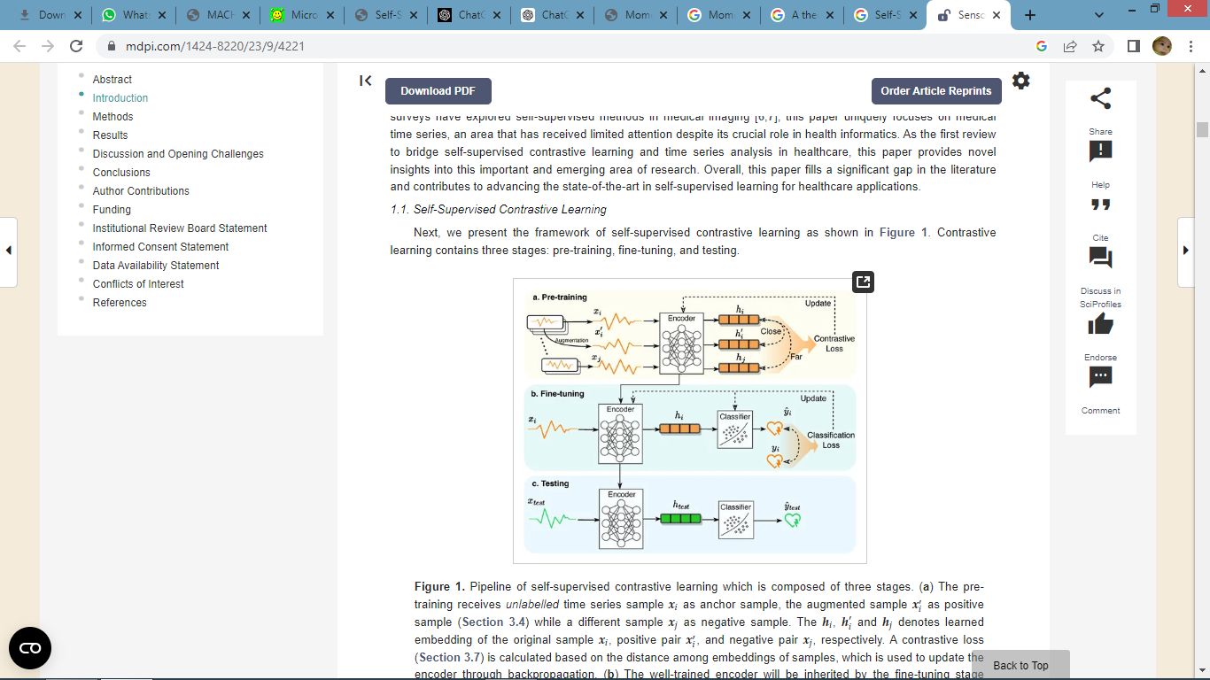

CHAPTER 3
CHAPTER 4
TESTING AND IMPLEMENTATION

  - TESTING
Implementation is the stage of the project when the theoretical design is turned into a working system. This is the final and important phase in the system life cycle It is actually the process of converting the new system into a operational one.

4.1.1Unit Testing
Unit testing comprises the set of tests performed by an individual programmer prior to integration of the unit into a larger system. The module interface is tested to ensure that information properly flows into and out of the program unit. The local data structure is examined to ensure that data stored temporarily maintains its integrity during all steps in an algorithm’s execution. Boundary conditions are tested to ensure that the module operates properly at boundaries established to limit or restrict processing. All independent paths through the control structure are tested. All error-handling paths are tested.
4.1.2 Block Box Testing
Black-box testing is a method of software testing that examines the functionality of an application without peering into its internal structures or workings. This method of test can be applied virtually to every level of software testing: unit, integration, system and acceptance. It is sometimes referred to as specification-based testing.
4.2 SYSTEM IMPLEMENTATION
Implementation is the stage of the project when the theoretical design is turned into a working system. This is the final and important phase in the system life cycle It is actually the process of converting the new system into a operational one.

CHAPTER 5
CONCLUSION
CONCLUSION

- This work provides a systematic review of the literature in the interdisciplinary research area of self-supervised contrastive learning and medical time series.
- Although this field only emerged a few years ago, dozens of studies have been published indicating the great potential of contrastive learning in addressing the limitations of sample annotation.
- We note that the most crucial components in contrastive learning are the design of time series augmentations, the formation of positive and negative pairs, and the choice of contrastive loss functions.
- In this review, we provide the most effective solutions for the above key components, which are expected to greatly benefit both computer scientists and healthcare providers in the development of contrastive learning methods.
- The widespread adoption of contrastive learning can largely reduce the burden of physicians by reducing the need for manual data annotation, and help enhance the efficiency and effectiveness of health systems (e.g., digital health and passive health).
- However, there are still some gaps in the field between the vision and current studies.

CHAPTER-6
REFERENCE
- H. Adeli and S. Ghosh-Dastidar, Automated EEG-Based Diagnosis of Neurological Disorders—Inventing the Future of Neurology in Corroboration With Nahid Dadmehr, Boca Raton, FL, USA:Taylor & Francis, 2010.
- F. J. Martinez-Murcia et al., "EEG connectivity analysis using denoising autoencoders for the detection of dyslexia", Int. J. Neural Syst., vol. 30, no. 7, Jul. 2020.
- A. Ortiz, F. J. Martinez-Murcia, J. L. Luque, A. Giménez, R. Morales-Ortega and J. Ortega, "Dyslexia diagnosis by EEG temporal and spectral descriptors: An anomaly detection approach", Int. J. Neural Syst., vol. 30, no. 7, Jul. 2020.
- A. Naro, M. G. Maggio, A. Leo and R. S. Calabrò, "Multiplex and multilayer network EEG analyses: A novel strategy in the differential diagnosis of patients with chronic disorders of consciousness", Int. J. Neural Syst., vol. 31, no. 2, Feb. 2021.
- D. López-García, A. Sobrado, J. M. G. Peñalver, J. M. Górriz and M. Ruz, "Multivariate pattern analysis techniques for electroencephalography data to study flanker interference effects", Int. J. Neural Syst., vol. 30, no. 7, Jul. 2020.
- K. D. Tzimourta et al., "Machine learning algorithms and statistical approaches for Alzheimer’s disease analysis based on resting-state EEG recordings: A systematic review", Int. J. Neural Syst., vol. 31, May 2021.
- A. Burns, H. Adeli and J. A. Buford, "Upper limb movement classification via electromyographic signals and an enhanced probabilistic network", J. Med. Syst., vol. 44, no. 10, pp. 176, Aug. 2020.
- U. R. Acharya, S. L. Oh, Y. Hagiwara, J. H. Tan and H. Adeli, "Deep convolutional neural network for the automated detection and diagnosis of seizure using EEG signals", Comput. Biol. Med., vol. 100, pp. 270-278, Sep. 2018.
- A. Burns, H. Adeli and J. A. Buford, "Brain–computer interface after nervous system injury", Neuroscientist, vol. 20, no. 6, pp. 639-651, Dec. 2014.
- A. Ortiz-Rosario and H. Adeli, "Brain-computer interface technologies: From signal to action", Rev. Neurosci., vol. 24, no. 5, pp. 537-552, Oct. 2013.

