machine learning in innovations in stroke identification

ABSTRACT

- Cerebrovascular diseases such as stroke are among the most common causes of death and disability worldwide and are preventable and treatable.
- Early detection of strokes and their rapid intervention play an important role in reducing the burden of disease and improving clinical outcomes.
- In recent years, machine learning methods have attracted a lot of attention as they can be used to detect strokes.
- The aim of this study is to identify reliable methods, algorithms, and features that help medical professionals make informed decisions about stroke treatment and preventionions for future directions in this arena.

CHAPTER-1
INTRODUCTION
- A stroke occurs when the blood supply to the brain is blocked or a blood vessel in the brain bursts. It is the most common cause of death worldwide, causing over 6.2 million deaths annually.
- Survivors often suffer from disabilities that severely impair their quality of life. Preventive measures and timely intervention can help to reduce the severity of stroke and its impact on the individual.
- Early identification of people at risk is crucial for stroke prevention .
- There are two types of stroke: ischemic stroke and hemorrhage-related stroke. About 87% of strokes are ischemic strokes, the most common type

CHAPTER 2
2. SYSTEM ANALYSIS
2.1 EXISTING SYSTEM

- This involves evaluating the patient’s symptoms, medical history (including risk factors like hypertension, diabetes, etc.), and conducting a physical examination.
- Symptoms commonly associated with stroke include sudden numbness or weakness in the face, arm, or leg, especially on one side of the body, sudden confusion, trouble speaking or understanding speech, sudden trouble seeing in one or both eyes, sudden trouble walking, dizziness, loss of balance, or coordination.
- This is often the first-line imaging technique used in the emergency setting due to its speed and accessibility. It can detect hemorrhagic strokes (bleeding in the brain) quickly.

2.1.1 DRAWBACKS OF EXISTING SYSTEM
- Machine learning models require large, high-quality datasets for training. Neuroimaging data, especially from diverse populations and different imaging modalities (e.g., CT, MRI)
- Deep learning models, which are often used in neuroimaging analysis, are known for their "black box" nature, making it difficult to understand how they arrive at their conclusions.
- This lack of interpretability can be a barrier in clinical settings where transparency and justification of decisions are crucial.
- Models trained on specific datasets may not generalize well to new populations, different hospitals, or varied imaging protocols.

2.2. PROPOSED SYSTEM
- Gather large and diverse datasets of neuroimaging data, including CT and MRI scans, annotated with stroke outcomes.
- Ensure data quality through standardized protocols for image acquisition and preprocessing techniques to enhance the reliability and consistency of input data.
- Utilize deep learning techniques to automatically extract relevant features from neuroimages, such as lesion location, size, and intensity patterns.
- Incorporate clinical data (e.g., patient demographics, medical history, symptom onset time) to improve model performance and diagnostic accuracy.

2.2.1. ADVANTAGES OF PROPOSED SYSTEM

- Allows remote neurologists to evaluate patients quickly via video conferencing, enabling prompt administration of clot-busting medications like tissue plasminogen activator (tPA).
- Algorithms can analyze brain imaging (such as CT scans) to quickly detect signs of stroke, helping clinicians prioritize urgent cases.
- Devices like mobile stroke units equipped with CT scanners can diagnose strokes on-site (e.g., at a patient's home), reducing treatment delays.
- Emerging biomarkers in blood tests can indicate stroke risk or confirm a stroke has occurred, aiding in rapid diagnosis.

Literature Survey
- K. Khosravi, F. Rezaie, J. R. Cooper ‘‘Soil water erosion susceptibility assessment using deep learning algorithms’’ Soil water erosion (SWE) is predicted though three kinds of deep learning algorithms.
- J. Donnelly, S. Abolfathi, ‘‘Gaussian process emulation of spatio-temporal outputs of a 2D inland flood model’’ The developed GPs produce real-time predictions based on the simulation output from LISFLOOD-FP numerical model.
- E. Rasool, M. J. Anwar, B. Shaker ‘‘Breast microcalcification detection in digital mammograms using deep transfer learning approaches’’ To increase the neural network's performance and reduce the false positive rate.

2.3 FEASIBILITY STUDY
The feasibility Analysis is an analytical program through project manager determines the project success ratio and through feasibility study project manager able to see either project. The key considerations involved in the feasibility analysis are:
- Economic Feasibility
- Technical Feasibility
- Operational Feasibility
- Environmental Feasibility
2.3.1 ECONOMICAL FEASIBILITY
Hence this project is economically feasible there is no need to involve any cost for this project.
2.3.2 TECHNICAL FEASIBILITY
Software Technologies used are PHP and MySql. In the educational institutions, it is possible to update the system in future. No special hardware is required for the purpose of using this system. Hence it is declared that this project is technically feasible.
2.3.3 OPERATIONAL FEASIBILITY
As the admin work mainly to maintain the Patient and Doctor .Doctor will predict patient cancer disease. Hence it is easy to operate with training. Therefore it is operationally feasible for implementation.

2.3.4 ENVIRONMENTAL FEASIBILITY
This project environment is correct as a admin has developed this system and no expenditure is involved under any head and this process is part of admin document management, this project environment is accessible.
2.4 SYSTEM REQUIREMENTS
- System : Pentium IV 2.4 GHz.
- Hard Disk : 40 GB.
- Monitor : 15 inch VGA Color.
- Mouse : Logitech Mouse.
- Ram : 512 MB
- Keyboard : Standard Keyboard
2.4.1 HARDWARE REQUIREMENTS
The Hardware of the computer consists of physical component such as Input Devices, Storage Devices, Processing & Control units and Output Devices. Computer includes external storage unit to store data in programs.
The Hardware Configuration involved in this project
- System : Pentium IV 2.4 GHz.
- Hard Disk : 40 GB.
- Monitor : 15 inch VGA Color.
- Mouse : Logitech Mouse.
- Ram : 512 MB
- Keyboard : Standard Keyboard

2.4.2 SOFTWARE REQUIREMENTS
Software is a group of programs that computers need to do a particular task. It is an essential requirement of Computer System. The Software used to develop the project is
- Operating System : Windows XP.
- Platform : DOT NET TECHNOLOGY
- Front End : ASP.Net 3.5
- Back End : SQL SERVER 2005

2.5 Block Diagram
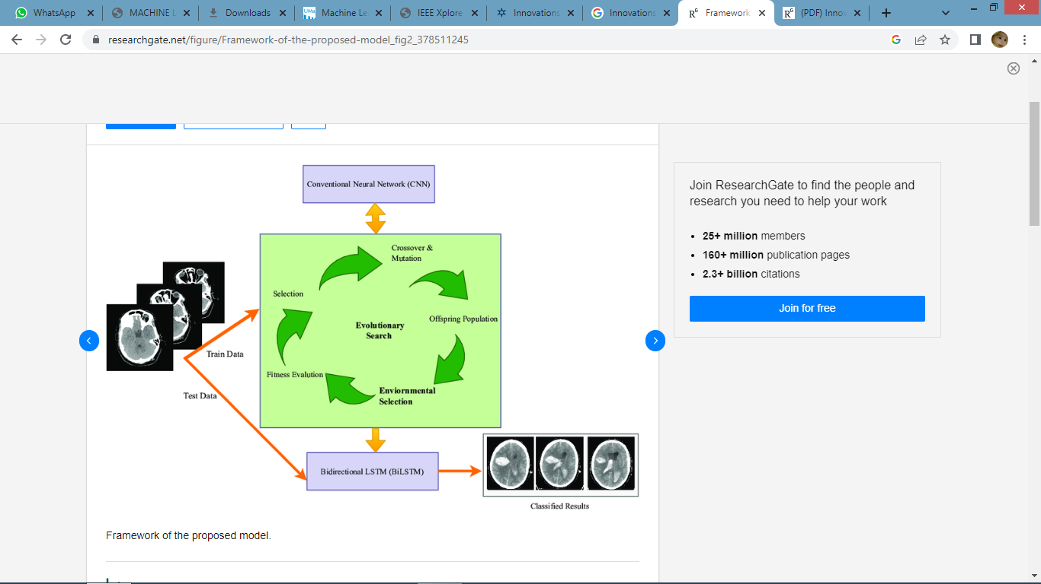

CHAPTER 3
CHAPTER 4
TESTING AND IMPLEMENTATION

  - TESTING
Implementation is the stage of the project when the theoretical design is turned into a working system. This is the final and important phase in the system life cycle It is actually the process of converting the new system into a operational one.

4.1.1Unit Testing
Unit testing comprises the set of tests performed by an individual programmer prior to integration of the unit into a larger system. The module interface is tested to ensure that information properly flows into and out of the program unit. The local data structure is examined to ensure that data stored temporarily maintains its integrity during all steps in an algorithm’s execution. Boundary conditions are tested to ensure that the module operates properly at boundaries established to limit or restrict processing. All independent paths through the control structure are tested. All error-handling paths are tested.
4.1.2 Block Box Testing
Black-box testing is a method of software testing that examines the functionality of an application without peering into its internal structures or workings. This method of test can be applied virtually to every level of software testing: unit, integration, system and acceptance. It is sometimes referred to as specification-based testing.
4.2 SYSTEM IMPLEMENTATION
Implementation is the stage of the project when the theoretical design is turned into a working system. This is the final and important phase in the system life cycle It is actually the process of converting the new system into a operational one.

CHAPTER 5
CONCLUSION
CONCLUSION
- This study proposes a method for stroke detection using machine learning techniques.
- An image-based dataset is used to validate the performance of the newly developed model.
- The proposed model is based on a genetic algorithm and BiLSTM.
- A genetic algorithm based on a neural network is applied to recognize the key features of CT brain images.
- These features are input into the LSTM and BiLSTM models for stroke prediction.
- The performance of different K-folds was evaluated to determine which is the most effective classification.
- We also tested different machine-learning algorithms for stroke prediction.
- The results of the experiment show that the proposed machine-learning model is more efficient than other models.
- To improve stroke detection in the future, we aim to use more complex models that can predict strokes automatically.

CHAPTER-6
REFERENCE
- Vision Impairment and Blindness, Feb. 2023, [online] Available: https://www.world-stroke.org/world-stroke-day-campaign/why-stroke-matters/learn-about-stroke.
- A. Khosla, Y. Cao, C. C.-Y. Lin, H.-K. Chiu, J. Hu and H. Lee, "An integrated machine learning approach to stroke prediction", Proc. 16th ACM SIGKDD Int. Conf. Knowl. Discovery Data Mining, pp. 183-192, Jul. 2010.
- Y. Xu, K. Li, Y. Zhao, L. Zhou, Y. Liu and J. Zhao, "Role of ferroptosis in stroke", Cellular Mol. Neurobiol., vol. 43, no. 1, pp. 205-222, Jan. 2023.
- Y. Yang, J. Zheng, Z. Du, Y. Li and Y. Cai, "Accurate prediction of stroke for hypertensive patients based on medical big data and machine learning algorithms: Retrospective study", JMIR Med. Informat., vol. 9, no. 11, Nov. 2021.
- M. Chun, R. Clarke, B. J. Cairns, D. Clifton, D. Bennett, Y. Chen, et al., "Stroke risk prediction using machine learning: A prospective cohort study of 0.5 million Chinese adults", J. Amer. Med. Inform. Assoc., vol. 28, no. 8, pp. 1719-1727, Jul. 2021.
- G. Ntaios, D. Sagris, A. Kallipolitis, E. Karagkiozi, E. Korompoki, E. Manios, et al., "Machine-learning-derived model for the stratification of cardiovascular risk in patients with ischemic stroke", J. Stroke Cerebrovascular Diseases, vol. 30, no. 10, Oct. 2021.
- H. Z. U. Rehman, H. Hwang and S. Lee, "Conventional and deep learning methods for skull stripping in brain MRI", Appl. Sci., vol. 10, no. 5, pp. 1773, Mar. 2020.
- M. Lim, A. Abdullah, N. Z. Jhanjhi, M. K. Khan and M. Supramaniam, "Link prediction in time-evolving criminal network with deep reinforcement learning technique", IEEE Access, vol. 7, pp. 184797-184807, 2019.
- M. Lim, A. Abdullah, N. Jhanjhi and M. Supramaniam, "Hidden link prediction in criminal networks using the deep reinforcement learning technique", Computers, vol. 8, no. 1, pp. 8, Jan. 2019.

