Active Reinforcement Learning for Target Classification in Wargame

ABSTRACT

- To meet the requirements of high accuracy and low cost of target classification in modern warfare, and lay the foundation for target threat assessment, the article proposes a human-machine agent for target classification based on active reinforcement learning (TCARL_H-M), inferring when to introduce human experience guidance for model and how to autonomously classify detected targets into predefined categories with equipment information.
- To simulate different levels of human guidance, we set up two modes.
- The easier-to-obtain but low-value-type cues simulated by Mode 1 and the labor-intensive but high-value class labels simulated by Mode 2.

CHAPTER-1
INTRODUCTION
- In the intricate field of contemporary joint warfare, the deployment of cutting-edge technologies such as unmanned and intelligent combat equipment has sparked an unprecedented escalation in the ferocity of the battlefield.
- In this context, the strain on mental resources for military leaders soars. In light of this, the implementation of auxiliary decision-making systems plays a critical role in relieving commanders of the burden of laborious manual tasks and cognitive overload.
- The capacity of these systems to process information in a refined manner and to present it in an intuitive form provides invaluable decision support for effective facilitation and scientifically grounded resource planning, program adjustment, and battlefield analysis

CHAPTER 2
2. SYSTEM ANALYSIS
2.1 EXISTING SYSTEM

- This technique involves an agent (in this case, the machine agent) learning to make decisions (such as target classification) by interacting with its environment (the wargame scenario).
- The agent receives feedback in the form of rewards or penalties based on its actions, which helps it improve its decision-making abilities over time.
- This implies that human operators and machine agents work together synergistically.
- The human might provide high-level strategic guidance or domain expertise, while the machine agent handles tasks like target classification autonomously.

2.1.1 DRAWBACKS OF EXISTING SYSTEM
- Developing and maintaining a reinforcement learning (RL) system can be complex and resource-intensive.
- It requires expertise in both machine learning and the specific domain (wargaming in this case).
- RL algorithms often require large amounts of training data and computational resources to achieve optimal performance.
- In the context of wargames, obtaining sufficient and diverse training data can be challenging due to the sensitivity and complexity of real-world scenarios.

2.2. PROPOSED SYSTEM
- This aspect emphasizes the involvement of human decision-makers in the loop.
- While the agent learns from data and feedback, human expertise and judgment are crucial in guiding the learning process, setting objectives, and interpreting results.
- In wargames, identifying and classifying targets accurately and quickly is critical for making informed decisions.
- The system aims to improve this capability by leveraging both machine learning algorithms and human input.

2.2.1. ADVANTAGES OF PROPOSED SYSTEM

- The agent can continuously learn and adapt its classification strategies based on feedback received during gameplay or simulations.
- This adaptive learning capability improves its effectiveness over time.
- Active reinforcement learning allows the agent to prioritize and select which targets to classify, optimizing the use of computational resources and human attention.
- Once trained, the system can potentially scale to handle large volumes of data and complex scenarios, providing consistent and reliable performance in various wargaming environments.

Literature Survey
- Yuksek, B.; Guner, G.; Karali, H. Intelligent Wargaming Approach to Increase Course of Action Effectiveness in Military Operations. The armies' doctrinal approach to create operation plans, to predict counter-actions of the opposite forces and to evaluate the effectiveness of the proposed operation plan,
- Kase, S.E.; Hung, C.P.; Krayzman, T. The Future of Collaborative Human-Artificial Intelligence Decision-Making for Mission Planning. In an increasingly complex military operating environment, next generation wargaming platforms can reduce risk, decrease operating costs, and improve overall outcomes.
- Bell, A.; Bollfrass, A. To Hell with the Cell: The Case for Immersive Statecraft Education Current wargaming techniques are effective training and research instruments for military scenarios with fixed tools and boundaries on the problem.
- Davis, P.K.; Bracken, P. Artificial intelligence for wargaming and modeling We discuss implications for the design and development of families of models, simulations, and wargames using several types of AI functionality.

2.3 FEASIBILITY STUDY
The feasibility Analysis is an analytical program through project manager determines the project success ratio and through feasibility study project manager able to see either project. The key considerations involved in the feasibility analysis are:
- Economic Feasibility
- Technical Feasibility
- Operational Feasibility
- Environmental Feasibility
2.3.1 ECONOMICAL FEASIBILITY
Hence this project is economically feasible there is no need to involve any cost for this project.
2.3.2 TECHNICAL FEASIBILITY
Software Technologies used are PHP and MySql. In the educational institutions, it is possible to update the system in future. No special hardware is required for the purpose of using this system. Hence it is declared that this project is technically feasible.
2.3.3 OPERATIONAL FEASIBILITY
As the admin work mainly to maintain the Patient and Doctor .Doctor will predict patient cancer disease. Hence it is easy to operate with training. Therefore it is operationally feasible for implementation.

2.3.4 ENVIRONMENTAL FEASIBILITY
This project environment is correct as a admin has developed this system and no expenditure is involved under any head and this process is part of admin document management, this project environment is accessible.
2.4 SYSTEM REQUIREMENTS
- System : Pentium IV 2.4 GHz.
- Hard Disk : 40 GB.
- Monitor : 15 inch VGA Color.
- Mouse : Logitech Mouse.
- Ram : 512 MB
- Keyboard : Standard Keyboard
2.4.1 HARDWARE REQUIREMENTS
The Hardware of the computer consists of physical component such as Input Devices, Storage Devices, Processing & Control units and Output Devices. Computer includes external storage unit to store data in programs.
The Hardware Configuration involved in this project
- System : Pentium IV 2.4 GHz.
- Hard Disk : 40 GB.
- Monitor : 15 inch VGA Color.
- Mouse : Logitech Mouse.
- Ram : 512 MB
- Keyboard : Standard Keyboard

2.4.2 SOFTWARE REQUIREMENTS
Software is a group of programs that computers need to do a particular task. It is an essential requirement of Computer System. The Software used to develop the project is
- Operating System : Windows XP.
- Platform : DOT NET TECHNOLOGY
- Front End : ASP.Net 3.5
- Back End : SQL SERVER 2005

2.5 Block Diagram
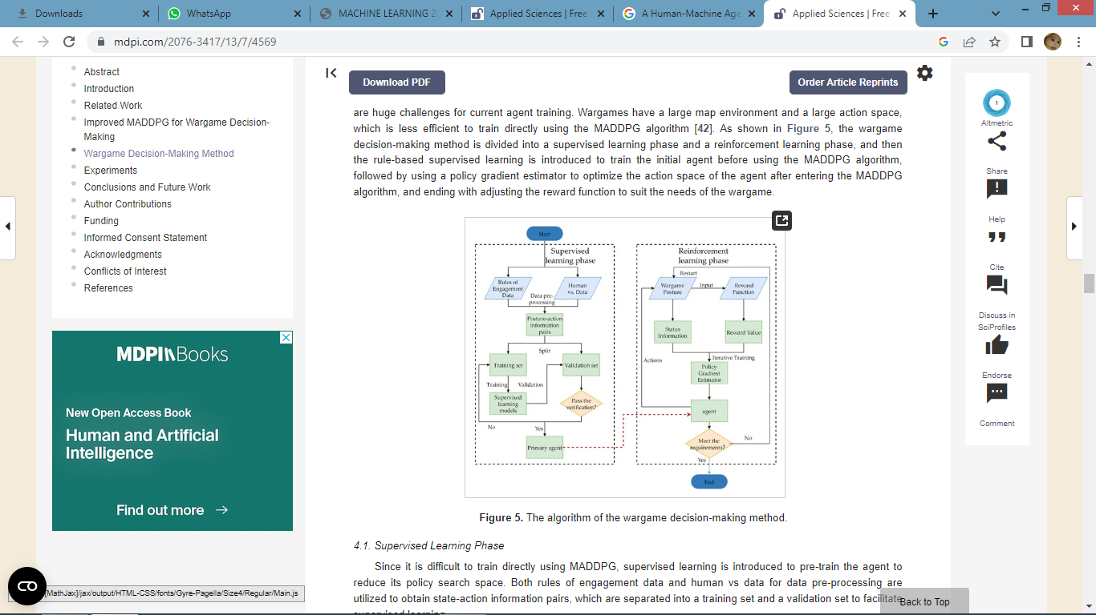

CHAPTER 3
CHAPTER 4
TESTING AND IMPLEMENTATION

  - TESTING
Implementation is the stage of the project when the theoretical design is turned into a working system. This is the final and important phase in the system life cycle It is actually the process of converting the new system into a operational one.

4.1.1Unit Testing
Unit testing comprises the set of tests performed by an individual programmer prior to integration of the unit into a larger system. The module interface is tested to ensure that information properly flows into and out of the program unit. The local data structure is examined to ensure that data stored temporarily maintains its integrity during all steps in an algorithm’s execution. Boundary conditions are tested to ensure that the module operates properly at boundaries established to limit or restrict processing. All independent paths through the control structure are tested. All error-handling paths are tested.
4.1.2 Block Box Testing
Black-box testing is a method of software testing that examines the functionality of an application without peering into its internal structures or workings. This method of test can be applied virtually to every level of software testing: unit, integration, system and acceptance. It is sometimes referred to as specification-based testing.
4.2 SYSTEM IMPLEMENTATION
Implementation is the stage of the project when the theoretical design is turned into a working system. This is the final and important phase in the system life cycle It is actually the process of converting the new system into a operational one.

CHAPTER 5
CONCLUSION
CONCLUSION

- A novel wargame decision-making approach that utilizes MADDPG is proposed in this paper.
- The proposed method surpasses traditional reinforcement learning methods applied to wargame-assisted decision-making scenarios.
- The POMDP model is leveraged to encapsulate the decision-making process within wargames. In addition, the joint action-value functions tailored to wargame environments are introduced in the MADDPG algorithm.
- With the purpose of overcoming the challenge of discrete policies, the Gumbel-Softmax estimator was integrated into MADDPG.
- Our approach includes a supervised learning phase and a reinforcement learning phase to tackle the problems of the large action space and sparse rewards.
- The experimental results demonstrate that the proposed wargame decision-making method improves the wargame win rate by 31.5% compared to pure MADDPG
- Furthermore, our method outperforms the DOP with COMA based on the AC framework by 69.9% and 34.9%. The results indicate that the proposed approach holds great potential for decision-making in wargame scenarios given its superior performance and ability to overcome the challenges of the current wargame environment.

CHAPTER-6
REFERENCE
- B. Feng, B. Chen and H. Liu, "Radar HRRP target recognition with deep networks", Pattern Recognit., vol. 61, pp. 379-393, Jan. 2017.
- H. Yin and Z. Guo, "Radar HRRP target recognition with one-dimensional CNN", Telecommun. Eng., vol. 58, no. 10, pp. 1121-1126, 2018.
- C. Du, B. Chen, B. Xu, D. Guo and H. Liu, "Factorized discriminative conditional variational auto-encoder for radar HRRP target recognition", Signal Process., vol. 158, pp. 176-189, May 2019.
- A. Santoro et al., "Meta-learning with memory-augmented neural networks", Proc. Int. Conf. Mach. Learn., pp. 1842-1850, 2016.
- B. Xu, B. Chen, J. Wan, H. Liu and L. Jin, "Target-aware recurrent attentional network for radar HRRP target recognition", Signal Process., vol. 155, pp. 268-280, Feb. 2019.
- D. Guo, B. Chen, W. Chen, C. Wang, H. Liu and M. Zhou, "Variational temporal deep generative model for radar HRRP target recognition", IEEE Trans. Signal Process., vol. 68, pp. 5795-5809, 2020.
- X. Wang, R. Li, J. Wang, L. Lei and Y. Song, "One-dimension hierarchical local receptive fields based extreme learning machine for radar target HRRP recognition", Neurocomputing, vol. 418, pp. 314-325, Dec. 2020
- F. Gao, F. Ma, J. Wang, J. Sun, E. Yang and H. Zhou, "Visual saliency modeling for river detection in high-resolution SAR imagery", IEEE Access, vol. 6, pp. 1000-1014, 2017.
- Z. Yue et al., "A novel semi-supervised convolutional neural network method for synthetic aperture radar image recognition", Cogn. Comput., vol. 13, no. 4, pp. 795-806, 2019.
- S. Hudson and D. Psaltis, "Correlation filters for aircraft identification from radar range profiles", IEEE Trans. Aerosp. Electron. Syst., vol. 29, no. 3, pp. 741-748, Jul. 1993.

