ABSTRACT

Brain Computer Interface (BCI) sometimes called Brain-Machine Interface (BMI). It is a direct communication pathway between the Brain’s Electrical Activity and external device. Computer based system that acquires brainsignals,analyzesthemandtranslatesthemintocommandsthatarerelayed to an output device to carry out into desired action. We can measurethebrain waves using technique known as ELECTROENCEPHALOGRAPHY (EEG). SuccessfullyuseofP300BCIhasalsobeenreportedforpeoplewithdisabilities resulting fromstroke, spinalcord injury, cerebralpalsy, multiple sclerosis and otherdisorders. Therefore, theBCIsystemmaybe usedtoimprovethequality of life of such patients. Hence the development and Implementation of BCI system is complex and Time consuming. Brain ComputerInterface(BCI) offersasolutionto independent mobility for peoplewithmovingdifficulties. This paper proposes a BCI to smart control of a wheelchair. The paper describes the experience of developing a complete BCIsystem consistingofhardware andsoftware parts to instructawheelchairbyhuman intention to move to different directions, left, right, backward, and forward usingnon-invasiveEEGbrainwaves.Thehighestaccuracyachievedis79.2% forsupportvector machine algorithm. Brain Computer Interface technology hastakenupthechallengeofdevelopingsolutionsthatallowdeliveringabetter qualityoflifetothosepeople,andoneofthemostimportantareashasbeenthe mobilitysolutions,whichincludesthebraincomputerinterfaceenabledelectric wheelchairs as one of the most helpful solutions. The results prove that the systemcan be used for medical purposes successfullyand the concept can be extended for other applications.

TABLEOFCONTENTS

CHAPTER  NO | TITLE | PAGE  NO
 | ABSTRACT | v
 | LISTOF FIGURES | viii
 | LISTOF ABBREVATION | ix
1 | INTRODUCTION | 1
2 | LITERATURESURVEY | 10
3 | METHODOLOGY | 16
 | 3.1.SOFTWARE | 16
 | 3.1.1.INTRODUCTION | 16
 | 3.1.2.BACKGROUND | 17
 | 3.1.3.PROCEDURE | 18
 | 3.1.4.NEEDFORNEUROIMAGING | 21
 | 3.2.EEGANALYSISANDCLASSIFICATION | 21
 | 3.2.1.EEG ANALYSIS | 22
 | 3.2.2.EEG CLASSIFICATION | 22
 | 3.3.CHANNELSELECTION | 23
 | 3.3.1.BCITHEORY | 23
 | 3.3.2.SIGNALACQUISITION | 23
 | 3.3.3. PREPROCESSING | 24
 | 3.3.4.FEATUREEXTRACTION | 25
 | 3.3.5.MACHINELEARNINGALGORITHM | 26
 | 3.4.EEG WAVEFORMS | 30
 | 3.4.1.SAMPLEOFDIFFERENTBRAINWAVES | 30
 | 3.4.2.EEGORIGINALSIGNAL | 33
 | 3.4.3.EEGFILTERSIGNAL | 34

 | 3.5.SOFTWAREREQUIRED | 34
 | 3.5.1.AURDINOIDE | 34
 | 3.5.2.EMDEDDEDC | 35
 | 3.5.3. HYPERTERMINAL | 35
4 | HARDWARE DESCRIPTION | 37
 | 4.1.HARDWAREREQUIRED | 37
 | 4.1.1.MICROCONTROLLER(ATMEGA328PU) | 37
 | 4.1.2.BATTERY(12V,7.5AH-LEADACID) | 38
 | 4.1.3.BUCKCONVERTOR(LM2596) | 38
 | 4.1.4.MOTORDRIVE(L298D) | 38
 | 4.1.5.DCMOTOR (JOHNSON MOTOR) | 39
 | 4.1.6. SERVO MOTOR(MG900) | 39
 | 4.1.7.GYROSCOPESENSOR(ADXL350) | 40
 | 4.1.8. RF TRANSMITTER | 40
5 | CONCLUSION | 43
6 | WORK TOBEDONEIN PHASEII | 44
7 | REFERENCE | 45

LISTOF FIGURES

FIGURENO | TITLE | PAGENO
2.1 | SYSTEMSTRUCTURE | 10
2.2 | BCISYSTEM | 12
2.3 | FRAMEWORKOFTHEWHEELCHAIR | 13
2.4 | EYEBLINKARTIFACTSINEEG WAVEFORM | 14
3.1 | METHODOLOGYFORSEAT ADJUSTMENT | 17
3.2 | BCIKNOWLEDGE | 20
3.3 | EEGANALYSISANDCLASSIFICATION | 21
3.4 | EEGSIGNALACQUISITIONANDITSPATTERN | 24
3.5 | FEATUREEXTRACTIONREGARDINGTHEEEG SIGNAL | 26
3.6 | DIFFERENTTYPESOFWAVEFORMS | 31
3.7. | EEGBRAINWAVEPATTERNSDURINGSLEEP | 33
3.8. | EEGORIGINALSIGNAL | 33
3.9. | EEGFILTERSIGNAL | 34
4,1. | PINCONFIGURATIONOFATMEGA328PU | 37
4.2 | MOTOR DRIVEL298D | 39
4.3 | BLOCKDIAGRAMOFEEG | 41
4.4. | BLOCKDIAGRAMOF WHEELCHAIR | 42
4.5. | METHODOLOGYFORWHEELCHAIRMOVEMENT | 42
6.1 | PROTOTYPEMODELOFWHEELCHAIR | 44

LISTOFABBREVATION

ALS | AmyotrophicLateralSclerosis
ANN | ArtificialNeuralNetwork
BCI | BrainComputerInterface
CNV | ContingentNegativeVariation
COM | CommunicationPort
CSP | CommonSpace PatternAlgorithm
EEG | Electroencephalogram
EPIC | EmbeddedPlatformforIndustrialComputing
ERD | Event RelatedDesynchronization
ERP | Event RelatedPotential
FIRDA | FrontalIntermittentRhythmicDeltaActivity
FNIR | FrontalNearInfrared
FMRI | FunctionMagneticResonanceImaging
HFO | HighFrequencyOscillation
ISM | IndustrialScientific Medical
ISO | InfraSlow Oscillation
LDA | LinearDiscriminantAnalysis

LIS | LockedInSyndrome
KNN | K-Nearest Neighbor
MI | MotorImagery
MIPS | MillionInstructionPerSecond
MND | MotorNeuronDiseases
OEM | OriginalEquipmentManufacturer
OIRDA | OccipitalIntermittent RhythmicDelta Activity
PBP | ProgressiveBulbar Palsy
PIO | ProgrammedInput Output
PSD | PowerSpectralDensity
RPM | RevolutionPerMinute
RISC | ReducedInstructionSetComputer
SAT | SpontaneousActivityTransistor
SMA | SpinalMuscleAtrophy
SMR | Sensorimotor Rhythms
SSP | SerialPortProtocol
SVM | SupportVectorMachine
TTL | TransistorLogic
TIRDA | TemporalIntermittentRhythmicDeltaActivity
UART | UniversalAsynchronousReceiverTransmitter
WPT | WaveletPacketTransform

CHAPTER1

INTRODUCTION

Brain computer interface (BCI) is a technology in which the brain waves of a personare usedto controlanexternalobject. It acts as a mediator betweenthe brainand a device. BCI based systems record the electrical activity ofa human brain via different technologies, such aselectroencephalography (EEG), functional magnetic resonance imaging(fMRI), and functionalnear infrared (fNIR).Among thesealternatives, EEGis the most popular solution because of its low cost, hightemporal resolution, and non- invasivenessfeatures.Thistechnologycanbeappliedindifferentfields, beingoneofthe most important the health area. BCI brings a capable and efficient way of aiding users with Motor Neuron Diseases (MND) such as Amyotrophic Lateral Sclerosis (ALS), Progressive Bulbar Palsy (PBP), Primary lateral sclerosis (PLS), among others.

According to the United Nations, the number of individuals in the world above the age of 60 is expected to increase rapidly, and this is especially significant in developing countries where the proportionofolder individuals will increase from9% in 2015 to 16% by 2040. Additionally, according to the ALS association, most people develop ALS betweenthe ages of40and 70, withanaverage ageof55 atthe time of its diagnosis.Inmanycases,thedisabilityissoseverethatthepatientscannothaveanykind of movements.

Facedwiththissituation,BCItechnologyhastakenupthechallengeofdeveloping solutionsthatallow deliveringabetterqualityoflifetothosepeople, andoneofthemost important areas has been the mobility technologies, which includes the BCI enabled electricwheelchairsasoneofthemosthelpfulsolutions.Inthissituation,thepresentwork hasproposedanddevelopedasystemforcontrollingBrainComputerInterfacetechnology has taken up the challenge of developing solutions that allow delivering a better quality of life to those people, and one of the most important areas has been themobility solutions,whichincludesthebraincomputerinterfaceenabledelectricwheelchairsasone of the electric wheelchairs utilizing the brain signals generated by the user when blinks his/hereyes.Thedevelopedprototypewillallowpeoplewithseveremovementdisabilities

tohaveahigher levelofindependence intermsofmobility. Insummary,theobjectiveof the present work is to design, develop and test a BCI systemprototype which willallow peoplewithmovementdisabilitiestocontrolanelectricwheelchairusingthebrainsignals generated when they blink their eyes.

The rest ofthis work is organized as follows. First, the previous works related to BCI wheelchair systems are studied. Then, the proposed solution and the used methodology are described with details. Once, explained the architecture and implementation ofthe proposed solution, the results ofthe experiments performed using the implemented prototype are analyzed. Finally, the conclusions reached in the present work are presented. Human brain control of wheelchairs for physically disabled people has attracted great attention due to their convenience and relatively low cost, high mobility,andquicksetup.The measurementofhumanbrainsignalsandconvertingthem into control signals enquire the development of an interface between the brain and the computer. A brain-computer interface (BCI) system provides communication between computer and mind of pupils. This interface can be based on brain activity during muscularmovementsorthechangesoftherhythmsofbrainsignals.Thesebrainactivities can be detected using electroencephalographic (EEG) signals.

BCI transforms the EEG signals produced by brain activity into control signals whichcanbelaterusedforcontrollingthewheelchairwithoutusinganyphysicalcontrols. Since the brain signals are very weak, we need to apply amplifiers and some spatial and spectral filters to the EEG signals in order to extract the features of these signals. The detected EEG signals are based on the change of frequencies and change of amplitudes. For example, during voluntary thoughts, the frequencies of signals change, and during movement, Synchronization / desynchronization of brain activity which involves µ rhythmamplitudechangehappens. Thisrelevant characteristic makesrhythm basedBCI suitable to be used Recently, some research works have been done to develop many applications of BCI for wheelchairs.

The main function of BCI is to convert and transmit human intentions into appropriate motion commands for the wheelchairs, robots, devices, and so forth. BCI is designed for control of wheelchair using three possible commands: turn left, turn right,

andmove forward. In, BCI is designed using EEG signal captured by eight electrodes. Wavelettransformwasusedforfeatureextractionandtheradialbasisnetworkswereused to classifythepredefined movements.In,controllerforhumanoidrobot navigationusing anEEG.ConsidersanoninvasiveEEG-basedbrain-computerinterfacesystemtoachieve stable control of a low speed unmanned aerial vehicle for indoor target searching. Consider the design of brain-controlled wheelchair.

The construction of viable brain-actuated wheelchair that combines BCI with a commercialwheelchair,viaacontrollayer,isconsidered.CombiningtheBCIwithshared control architecture allows for dynamically producing intuitive and smooth trajectories. The processes of feature extraction and classification arevery important in BCI design and they great effect on the performance.

Set of research works has been done for improvement of the feature extraction andclassificationalgorithms. ReferencesconsiderfeatureextractionalgorithmsforBCI. Reference uses adaptive common spatial patterns for feature extraction. Different clusteringalgorithmsbasedonsupportvectormachines,lineardiscriminant analysis,and neural networks are applied for classification of brain signals. Reference uses features, optimized in the sense of statistically significant and potentially discriminative coherences at a specific frequency, and applies linear discriminant analysis (LDA) for classificationpurpose.SVMandLDAareusedforclassificationpurposeofbrainsignals. Recently, several soft computing techniques are used for recognition of brain activity. Reference uses fuzzy logic and uses neural networks with fuzzy particle swarm optimization for BCI design. In, continuous wavelet transform is used to extract highly representative features and then an Adaptive Neuron-Fuzzy Inference System (ANFIS) is applied for classification. The systems based on fuzzy logic can make classifications using vague, imprecise, noisy, or missing input information. On given problem, human perception process can be efficiently modelled using fuzzy logic.
Asshown,featureextractionandclassificationplayanimportantroleinthedesign ofbrain-based controlforobtaining highclassificationaccuracy. Inthe BCI design, high classificationrateisveryimportant.Otherwise,thepresenceoferrorscancauseinitiation of a wrong command that can lead to dangerous situations.

Therefore, achieving low error rates keeps the users safe. Different clustering algorithms based on support vector machines, linear discriminant analysis, and neural networks are applied for classification of brain signals.Fuzzy classification represents knowledge more naturallyto the wayof human thinking and is more robust intolerating imprecision, conflict, and missing information. In this paper, the fuzzy neural network structureisproposedforthedesignofBCIinordertoachieveefficientbrain-basedcontrol of wheelchair. In the literature, different neural and fuzzynetworksareproposedfor solvingvariousproblems.In,FNNstructureisdesignedforcontrolofdynamic plants. In, neuro fuzzy inference systems are designed for classification and control purposes.

Thesystemsdesignedinthesepapersareusedforspecialpurposes.Inthe neuro fuzzy structures, therulesareconstructedusingallpossiblecombinationsofinputs and cluster center. The problems that are characterized by multiple inputs and multiple outputswillhaveahugenumberoffuzzyrules.Theconstructionsofsuchsystemsarenot efficient andthesesystemshaveahugenumber ofparameters. In this paper, the number of rules is selected using the clustering results which is equal to the number ofcluster center.Inthispaper,inordertoimprovetheperformanceofclassificationsystem,amulti- input and multioutput fuzzy neural system (FNS) based on TSK rules are proposed for classificationoftheECGsignals.Thepaperisorganizedasfollows.Section2presentsthe architectureofBCIsystembasedonFNN.Signalprocessingandfeatureextractionstages havebeendescribed.Section3presentsclassificationalgorithmbasedonFNN.Section4 presents parameter updates rule used for FNN.

The fuzzy means classification and gradient descent algorithms are applied for updatingparametersofFNN.Section5givesexperimentalresultsobtainedforFNNbased BCI system. Section 6 presents conclusions ofthe paper. Amyotrophic LateralSclerosis (ALS),brainstemstroke,brainorspinalcordinjurycerebralpalsy, musculardystrophies, multiple sclerosis, and numerous other diseases impair the neural pathways that control muscles or impair the muscles themselves.

Theyaffect nearlytwo millionpeople in the United States alone 1,2. Those most severelyaffected mayloseall voluntarymusclecontrolandmaybecompletely lockedin

to their bodies. Although there are no statistics available on the number of patients with locked-in syndrome, the locked-in population is growing due to advances in artificial respiration. One estimation based on NationalInstitute ofHealth statistics on brain-stem strokesandsurvivalinformation,putsthenumberatasmanyas50,000individualsinthe United States alone. In order to help physically challenged people control a computer, a communicationdeviceorawheelchair,variousinputdevicesareavailable.Thisincludes a simple stick held between the teeth, buttons and joysticks of various sizes that can be activated by various parts of the body, gaze tracking systems or head movement based systemsto enablecontrolofacursor onascreen. However, allthose input devicesareof no use to locked-in people. The only alternative for locked-in people is to establish communicationandcontrolchannelsdirectlyfromthebrain,bypassingthedisfunctioning brain's normal output channels of peripheral nerves and muscles. In a Brain Computer Interface (BCI), signals from the brain are acquired and processed to extract specific features that reflect the user's intent. These features are then translated into commands.

BCI technology has taken up challenge of developing solutions that allow deliveringabetterqualityoflifetothosepeople,andoneofthemost importantareashas been the mobility technologies, which includes the BCI enabled electric wheelchairs as one of the most helpful solutions. In this situation, the present work has proposed and developed a system for controlling an electric wheelchair utilizing the brain signals generated by the user when blinks his/her eyes. The developed prototype will allow peoplewithseveremovementdisabilitiestohaveahigherlevelofindependenceinterms of mobility.

BCI system prototype which will allow people with movement disabilities to control an electric wheelchair using the brain signals generated. operate the wheelchair thesubjecthastoplacethecaponhis/herheadThemovementofmusclesaroundtheface due to facial expressions can be observed from the EEG signals being recorded. Each expressionislinkedtomovementofthewheelchair.Signalispreprocessedtoremovethe artifacts and then features are extracted using Fast Fourier Transform. Among different input signals for BCI control, electroencephalography (EEG) appears viable for wheelchair control due to its high temporal resolution and portability.

Most studiesonwheelchaircontrolbymeansofa BCI investigatedsensorimotor rhythms(SMR)asinputsignalthatcanbemodulatedvoluntarilybymotorimagery(MI;). Itispossibletodiscriminatebetweendifferentimageriesorforexamplebetweenimagery andrest.Eachcommandisreferredtoasoneclass,e.g.,lefthandvs.righthandMIwould be referred to as a two-class SMR-BCI paradigm. Different protocols have been suggested for wheelchair (or robot) navigation tasks that either analyze ongoing EEG activity(asynchronouscontrol, i.e.,acommandcanbedeliveredatanytime;)oranalyze EEG activity at a given time window (synchronous control, i.e., a command can be delivered only at a certain time;). The latter require cues that trigger the time windows and display themto the user. Such cues can be presented visually. However, to achieve SMR modulations without occupying the visual channel (i.e., visual cue on a screen), auditory-cued paradigms have been validated (auditory+ visual:).

Furthermore, feedback can be presented throughtactile stimulation units As any error made while controlling a wheelchair may immediately cause damage (or even danger for the patient), wheelchairs may be equipped with shared control systems, i.e. sensors that for example prevent collisions or regulate speed while approaching an object).Suchsharedcontrolsystemsusuallyalso dedicatepartsofthemovement control tothewheelchairasBCIsarenotyet capabletooperateonafullcontrollevelaspossible with motor control. One reason is, that the number of classes in SMR based BCIs is limited, as discrimination between different MI patterns becomes more difficult with increasing class number, and intensive training may be required. Thus, researchers introduced paradigms that extrapolate different navigation commands from few MI classesonly,e.g.,translatethreeMIclassesintosixdifferentcommandsortwoMIclasses intothreedifferentcommands.Suchtranslation,however,mayrequiretasksthataremore complex and entail slower rates for communicating commands. Furthermore, a general issue with motor imagery based BCIs is that for many participants SMR-BCIs are inefficacious or display large performance variations across runs.

However, reliability of BCI commands is particularly necessary for accurate wheelchaircontrol.Inarecentevaluationstudy,severelymotorimpairedend-usersrated reliability of BCI applications controlled by event-related potentials (ERP) high. ERP- based systems maythusconstituteamorereliable alternativeto SMRasinput signalfor

wheelchair control, although users cannot actively modulate ERPs for control command generation but need external stimulation. ERP-BCIs make use of a so-called oddball-paradigm, i.e., rare but relevant stimuli are presented within frequent, but irrelevant stimuli. Users focus their attention by counting the rare target stimuli whilst ignoring all other (non-target) stimuli. Target stimuli will evoke more pronounced negative and positive potential fluctuations in the event-related EEG than non-target stimuli(forreviewontheparadigm,).ThemostprominentpotentialinERP-BCIsystems usually is the P300, a positive deflection around 300 milliseconds post-stimulus, its amplitude, shape and latency strongly vary with paradigms and subject-specific conditions; for review,), which is why ERP-BCIs were often referred to as P300-BCIs (originallyby;forcomparisonofERPscontributingtoERP-BCIperformance;forrecent review). By detecting the elicited ERPs, classification algorithms can identify the intendedtargetselectionandtranslateit intoacontrolcommand.SeveralERP-basedBCI systems for wheelchair (or robot) control have been proposed that differ strongly concerning the amount of control that is left to the user. Reb same and colleagues proposed a system, which allowed users to select the targeted destination in a building (e.g., the kitchen) from a visually displayed ERP-BCI matrix.

The wheelchair willthen autonomouslydrive to the selected location. This fully transfers navigationcontroltothe smart wheelchair and users canonlyinterfere through selecting a stop mechanism that will terminate the movement. Asimilar levelofcontrol wasproposedforcontrolofahumanoidrobot.Usersselectedtargetedobjectsorlocations from a series of camera screenshots used as stimuli in an oddball-paradigm. The robot thenautonomouslyapproachedandpickeduptheobject. Theadvantageofsuchsystems with which users select high-level goals (e.g., a location) while the system performs all low-leveloperations(steeringtowardthelocation)usuallyliesinitsspeedandaccuracy. However, its performance fully depends on which and how many environmental conditionsthedevicecanhandle.Inaddition,usersmaywellprefertohavemoreprocess controlontheirside,assituationalgoalsmaychangeandthegoalselectionoptionsofthe smart wheelchair may not cover all goals

BCI for actual navigation control can easily be implemented by displaying direction arrows in a visual ERP-BCI matrix, i.e., the wheelchair is steered step bystep

by selecting the upcoming movement direction from a separately displayed matrix colleagues proposed a more advanced ERP-BCI for navigation control. The authors equipped a wheelchair with a screen that displayed a reconstruction of the real environmentalscenarioinrealtime.Targetlocationsweredisplayedinthereconstruction model and could be selected using an ERP-BCI. Consequently, the system leaves more decisionstotheuser,yettheactualtargetlocationsarecomputedbythesmartwheelchair, i.e., users canonlyselect those target locations that are recognized as possible locations by the detection sensors. This system was recently developed further for control of a telepresence mobile robot. Furthermore, different input signals can be combined for wheelchaircontrolinahybridapproach.Longandcolleaguesimplementedasystemthat controlled direction by means of SMR modulation and speed with a visual ERP-BCI.

AlthoughvisuallyelicitedERPsusuallyprovidebestclassificationaccuraciesand thus highest information transfer rates compared to other modalities, there are several issueswithregardtowheelchaircontrol.ThesameissuesapplytoBCIsbasedonsteady- statevisualevokedpotentials(SSVEP) Visualstimulationrequiresadisplaymountedin the visualfield ofthe user,which iscriticalforthose withsevere impairment not able to move the neck for looking past the screen to observe their environment they navigate through.

Userscannotobservetheirenvironment intheprocessoftarget selection, asthey need to pay attention to the visual stimulation. Changing light settings may negatively influencetheefficacyofBCIsthatrelyonvisualstimulationSuchtactileBCIsusetactile vibrationunits(calledtactors)placedonparticipants’body, e.g.,onhandsandwrists,on different positions around the waist or on the back of participants. Similar to the visual oddball-paradigm,tactorsarestimulatedrandomly(i.e.,theyvibrateforashorttime)and participants focus their attention on one of the tactors (target) whilst ignoring all others (non-targets).

Stimuli will elicit distinct ERPs among which the most prominent is the above described P300 component; for a thorough investigation of tactually-evoked ERPs in a BCIsetting).Brouwerandvaninvestigatedhowstimulusuncertainty(i.e.,thenumberof stimuli used) and stimulus timing affect classification accuracy and found equal accuracies for two, four and six tactors. For stimulus timing, they found similar

parameters feasible as used for visual ERP-BCIs. The lings and colleagues found, that Placement of tactors significantly affected offline BCI performance in a paradigm that appliedtactorsforcontrol-displaymapping(i.e., mapping betweennavigationdirections and tactor location).
A placement that was congruent with the navigation environment provided best results. Recently, a case studyreportedtactile stimulation feasible for reliable elicitation of ERPs in a patient with classic locked-in syndrome. Results were more robust in the tactilethanintheauditoryorthevisualdomain.Ourcurrentstudyisbasedontheseresults that established a basis for tactile ERP-BCI based navigation. Participants steered a virtual wheelchair in real time by selecting one of four tactor locations. This approach allowed us to investigate how more complex (and realistic) scenarios affect user performance.

Navigation tasks can be regarded as more complex, as users individually decide on the path they take and as processing of their environment may distract them the proposed algorithms stop the stimulation cycle when classification reached sufficient probability for identification of the intended target from the event-related EEG. Thus, theydynamicallyadjustthenumberofstimulationcyclesbasedonusers’individualbrain signal.

CHAPTER 2 LITERATURESURVEY
[1]. YingdaLi,JianpingYang. [2018]

INTELLIGENTWHEELCHAIRBASEDONBRAINWAVE.

With the acceleration of the aging population and the increase of accidents, the number of people with disabilities, especially those with hands and feet, continues to increase. The disabled are a specialcomponent ofthe humansociety, and theyare faced withmanydifficulties intheir lives. Inordertoimprovetheir qualityoflife, thedisabled wheelchair based on brain wave detection was studied. Based on the key technology of brain wave module identification, multiple sensors, GPS module, wireless transmission module, single-chip microcomputer and Android, the intelligent wearable device is designed and equipped with the functions of brain wave control, automatic obstacle avoidance, navigation and positioning, mobile phone terminal control, etc. With many kindsoftechnologyintegration,multi-intelligencenetworktorealizethemulti-functional disability tools, the main goal is to solve the problem of disabled people's travel and mobility.

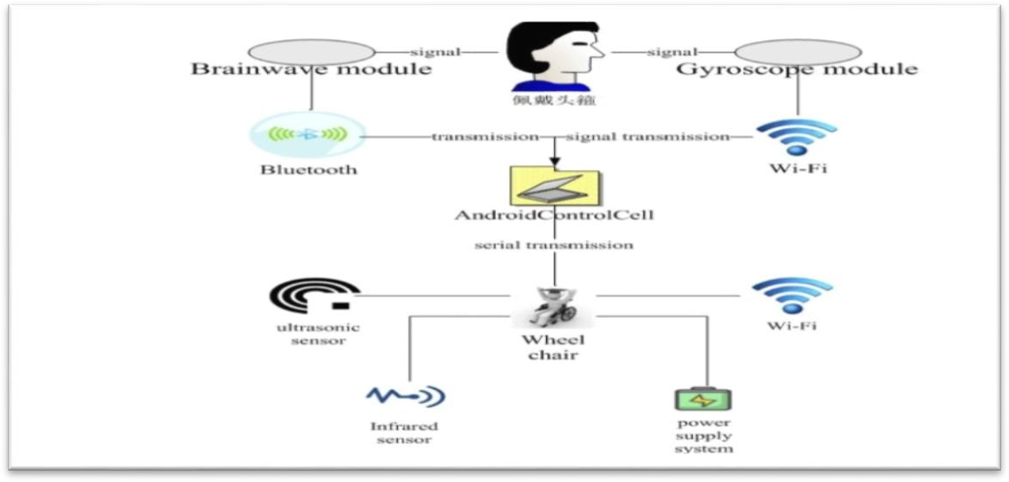

Figure2.1 SystemStructure

RESULT:

Thesystemdesignsanintelligentwheelchaircontrolledbybrainwavetechnology UsingtheGAMmoduleNeuroSkyneuroskyLimitedlaunched,throughsmart wearable devices to extract the EEG signal and the angle signal of gyroscope. The intelligent wheelchairisprocessedbybrainwavecontrolbasedonARMprocessorwhichrealizethe real-timecontrolofwheelchairbehavioranddirection.Experimentsshowthatthesystem is fast and stable, simple structure, low cost, easy operation, strong human-computer interaction, high practical value.

[2].MandeepKaur.[2012]

TECHNOLOGYDEVELOPMENTFORUNBLESSEDPEOPLEUSINGBCI

Abrain computer interface systemhat interpretsthe steadystate visuallyevoked response into a control signal for operating a physical device or computer program Prosthetic Controlled System Based on Signal Pattern Recognition of Electroencephalogram A prosthetic controlled system. It uses EEG signals. 200810 Automatic Sleep Stage Classification Using Two Facial Electrodes

A system for determining the sleep disorders (light sleep and deep sleep) from brain signals.200811 Multiclass Voluntary Facial Expression Classification based on Filter Bank Common Spatial Pattern. An EEG and EMG signal-based system for classifyingmultiplefacialexpressions.200812EmotionClassificationBasedonGamma- band EEG. An EEG signal-based system for classifying the happiness and sadness of a person.200913 Study on

EEG-Based Mouse System by Using Brain-Computer Interface. An EEG-based mouse designed for Brain Computer Interface (BCI) system to move a cursor on a computerdisplay.200914 Classification of Single Trial EEG during Imagined Hand Movement by Rhythmic Component Extraction an EEG signal based Rhythmic Component Extraction(RCE) systemto extract afeaturecorresponding to(left/right) hand movement.

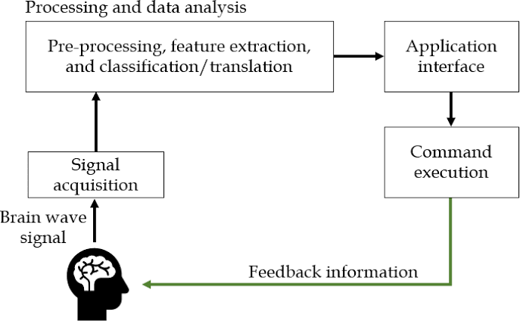

Figure2.2.BCI System

RESULT:

AnEEGbasedBCIsysteminvolvessignalacquisition,signalprocessing,feature extraction, Classification, application. The signal acquisition can be done in two ways: invasiveandnon-invasivemethod.Also,therearevariousmethodsforsignalprocessing, feature extraction, Classification. This survey paper presents work done in BCI for Unblessed people. The feature and classifier performance have been summarized for variousapplications.ThefutureworkistostudythespontaneousbehaviorofEEGsignal.

- Paul,Dabosmita;Mukherjee,Moumita.[2019]

AUTOMATION OF WHEELCHAIR USING BRAIN COMPUTER INTERFACE (BCI) TECHNIQUE

Low-cost brain-computer interfacing g technology has been proposed for the automationofwheelchair. The authors have incorporatedthis interfacing technologyby extracting brain -signal by placing A electrodes properly on skull. 110-190 million physically challenged people, worldwide, need help to move. Researchers all over the world are suggesting and developing various methodologies in order to address this situation. The most common mode of movement is the use of wheelchair. In this paper the authors have focused on making a cost-effective wheelchair supported with BCI to help disabled people to lead an independent life through their brain signals using non- invasive techniques

[4].AnuraagManvi,AmaanMasood,KusumaMohanchandra.[2020]

BRAINOPERATEDWHEELCHAIRUSINGASINGLEELECTRODEEEG DEVICE AND BCI

This paper predominantlyexplains the use ofa simplistic unipolar device toobtain EEG for thedevelopment of a Brain-Computer Interface (BCI). In contrast, BCI's eye- blinking stimuli can also be obtained. Focus and eye-blinking stimuli can be captured as controlpulsesinelectricwheelchairsviaacomputerinterfaceandelectricalinterface.This survey paper aims to provide a feasible solution to integrate a Brain-Computer Interface (BCI) with automated identification and avoidance of obstacles. The automated obstacle detectionand avoidancesystemaimsto providea wayto easilydetect obstaclesand easily correct the course.
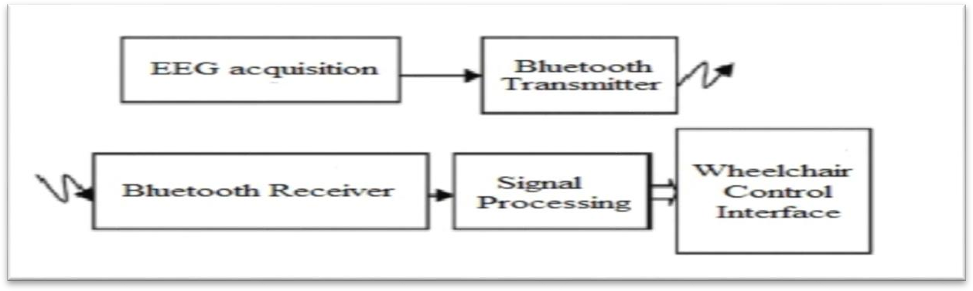

Figure2.3.Frameworkworkofthewheelchairsystem

RESULT:

BC Interface is built that can read EEG signals for driving a wheelchair without anykindofphysicalinputs.TheseEEGsignalsarereadusingasingleUni-polarelectrode and fed into the computer system using a Bluetooth interface.

The computer distinct the signals into 3 categories which are single eye blink pulse,twoeyeblinkpulseandaconstantattentionsignal.Thesesignalsareevaluatedand then transmitted to the motor processor that drives the wheelchair and gives an easy control to patient.

[5].WilliamCFrancis,CUmayal,GKanimozhi.[2021]

BRAIN-COMPUTERINTERFACINGFORWHEELCHAIRCONTROLBY DETECTING VOLUNTARY EYE BLINKS

The human brain is considered as one of the most powerful quantum computers and combining the human brain with technology can even outperform artificial intelligence. Using a Brain-Computer Interface (BCI) system, the brain signals can be analyzedandprogrammedforspecifictasks.ThisresearchworkemploysBCItechnology for a medical application that gives the unfortunate paralyzed individuals the capability to interact with their surroundings solely using voluntary eye blinks.

This research contributes to the existing technology to be more feasible by introducinga modulardesignwiththreephysicallyseparatedcomponents:aheadwear,a computer, and a wheelchair The work presented here gives a basic understanding ofthe functionality of a BCI system, and provides eye blink-controlled navigation of a wheelchair for patients suffering from severe paralysis.

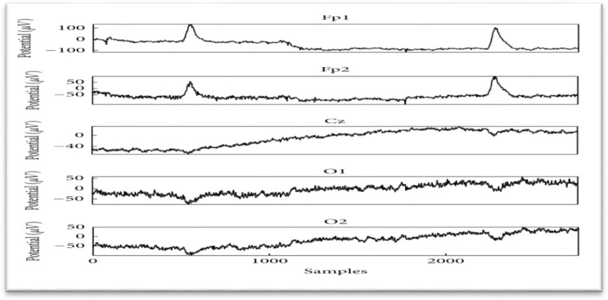

Figure2.4.Eyeblink artifactsinEEGwaveform

RESULT:

This work commenced as a research-based work to understand human brain waves and how various artifacts could be captured from EEG signals for medical applications. Recognizing the struggle of severely paralyzed patients having to depend onothersfortheirdailyneeds,thegoalwassettoprovideasolutionfortheirplight.Thus, asuitablewheelchairfortheparalyzedpatientsthatcanbecontrolledsolelybyeyeblinks is designed. The idea of choosing eye blink artifacts as the control element concluded from the variations in EEG patterns associated with various human stimuli. Since this researchadapts eye blinks as the command, a wheelchair developed fromthis prototype can provide a helping hand to a wide spectrum of paralyzed patients across the world. Even the most paralyzed patients are capable of making eye blinks despite their disabilities signal acquisition with better signal filtering hardware revealed how these signals can control a device wirelessly without any physical gestures except for eye blinks.

CHAPTER3

METHODOLOGY
  - SOFTWARE:
    - INTRODUCTION

Designing smart environment is an active area of research where data is sensed and used to improve life for people. One source ofdata is the human brain where using BrainComputerInterface (BCI),informationisgatheredtoaidincontrollingdevices insmartandnewway. Theidea behindusing EEG signals for human computer interface was first proposed by Jacques Vidal in 1973. Thereare different methods to record brain activity, for example: Electroencephalographic (EEG), Magneto encephalography(MEG),PositionEmissionTomography(PET)andfunctionalMagnetic Resonance Imaging (FMRI). EEG is a non-invasive technique of recording electrical activityfromthescalpandismeasuredbymicro-voltageoveraspecifictime.EEGsignal isgeneratedduetoneuronsfiringanditvariesaccordingtothebrainactivityandranges between 0 to 100 µV.

Thehumancerebralcortexdividedintofourlobes:frontal,temporal,parietal,and occipitallobes,andthestartedlettersoftheelectrodesensorsF,T,PandOstandforthat lobe. Electrodes located inthe frontallobescoveredthesensorymotor cortex, which is relatedtohumanmotormovements.Therearefivetypesofbrainwavesandisclassified accordingtothementalactivity:Deltawaves(0.4-4Hz)relatedto sleeping,Thetawaves (4-7Hz)occurduringemotionalstress,Alphawaves(8-12Hz)reduceamplitudeduring mentalimagery, Mu waves (9-11 Hz)reduceamplitudeswith intentionof movement, and Beta waves (12-36 Hz) increase amplitudes during intense mental activity. Methodology was applied for the development of the proposed solution.

This approach is useful when you want to create a quick prototype that is thoroughly and easily tested. In our case, we worked with two smaller increments, the firstwasthemaincontroller,whichmanagestheuserinterfaceandtheprocessingofbrain waves. The second increment (module of the prototype) was the wheelchair controller, which handles the movement of the wheelchair. The implementation of both modules

createsaBCIsystemthatcanhandlethemovementsofthewheelchairEEGwasrecorded with a sampling rate of 512 Hz with 12 passive Ag/AgCl electrodes and amplified. Electrode positions were Fz, FC1, FC2, C3, Cz, C4, P3, Pz, P4, O1, Oz, and O2 with ground and reference electrodes at the right and left mastoids, respectively. Impedances were kept below 5kΩ.Online filtering included a bandpass filter between0.1 and 60 Hz and a notch filter between 48 and 52 Hz.

For offline analysis, EEG data was bandpass filtered between0.1 and 30 Hz and divided into segments of 800 ms post-stimulus, plus 100 ms pre-stimulus for baseline- correction.Segmentscontainingvaluesexceedingathresholdof±150μvwereexcluded. Target and non-target epochs were averaged separately. Data were analyzed using adaptedscriptsprovidedbyBCI2000.Classifierweightsweredefinedusingthestepwise linear discriminant analysis (SWLDA) as implemented in the BCI2000 package.

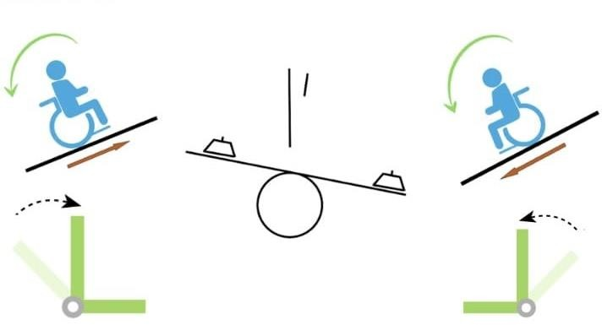

Figure3.1. Methodologyseatadjustment

BACKGROUND

Brain-computer interfaces (BCI) allow for direct communication between a person’s brainand technicaldevices without the need for motor control(for review, [1– 4]). BCIsthus constitute a promising assistive technologydevice for people withsevere motor impairment, e.g., due to neurodegenerative disease (e.g., [5–10]). Among many different applications, researchers suggested their use for wheelchair control thus renderingBCIsofhighvalueforpeoplewithsevereparalysiswhoarenotableto control

awheelchairbymeansofajoystick.Inthelastdecade,avarietyofBCItechnologieshas been developed to help people with MND. Some of these technologies have allowed to upgradethemovementofpeopleimprovingtheir lifestylesandbringingbacktheirsense ofindependencewhichareconsideredasnavigationassistivetechnologies.Tocontrola BCI,usershavetoacquireconsciouscontrolovertheirbrainactivity.Twofundamentally different approachesexist to achievethis.Inthefirst approach,subjectsperceiveasetof stimulidis-playedbytheBCIsystemandcancontroltheirbrainactivitybyfocusingonto onespecificstimulus.Thechangesinneuro-physiologicsignalsresultingfromperception and processing of stimuli are termed event-related potentials (ERPs)

In the second approach, users control their brain activity by concentrating on a specificmentaltask.Forexample, imaginationofhandmovementcanbeusedto modify activityinthemotorcortex.Inthisapproachfeedbacksignalsareoftenusedtoletsubjects learn the production ofeasily detectable patterns of neurophysiologic signals. The types ofsignals resulting fromconcentrationon mentaltasks together withthe corresponding.

PROCEDURE

Participantsweresitting inachair in front ofadesk,onwhicha monitor showed the virtual environment for wheelchair navigation from the perspective of a wheelchair user (the backrest of the wheelchair was shown to better allow for an estimation of its dimensions). They were instructed to keep their eyes open and to avoid blinking, unnecessary movements and to keep facial muscles relaxed during recording Initially Bluetooth connection is established between the headset and the signal processing unit (PC/Laptop). Oncetheheadset isturnedon, dependingontherequirementsofthe motor movements, actions are performed.

The brainsignalsare now extracted using Brainwave kit and convertedto digital values and transmitted to signal processing unit via Bluetooth. These values are then processed in MATLAB and mapped into control signals of required amplitude using Arduino (ATMega8) and are then used to activate the motor THE Among the different assistive technologies, one of the solutions that could help to people with movement disabilities is the wheelchairs controlled by BCI systems. In this aspect, several

alternatives for controlling wheelchairs have been proposed so far. Turnip et al. have proposed an electric wheelchair control system utilizing Steady state visually evoked potential (SSVEP) responses.

This is done byclassifying 6-9Hz frequencies whichare usedto execute theturn left, turn right, go back, and go forward commands. These signals are processed and classified using a sixth order Bandpass Filter (BPF) and an Adaptive Neuro-Fuzzy Inference System (ANFIS).In another similar work, Liet al. developed a hybrid system for controlling a wheelchair combining P300 and SSVEP. The control is done by positioning4groupsofflickeringbuttons;eachgroupcontainsalargebuttoninthecenter and8smallersurroundingitwhichflashesatafixedfrequencywiththeobjectivetoevoke SSVEPresponses.Atthesametime,thebuttonswereintensifiedthroughshapeandcolor change in a random order to produce P300. Based on these two classifications, anoutputisreached.Toclassifybothsignalsatthesametime,theyuseddifferentmethods; intheP300case,theyusedSupportVectorMachine(SVM)andfortheSSVEP,theyused power ratios. Additionally, Kim et al prototyped a BCI based system that allows the control of a wheelchair using motor imagery. They utilized five commands (left, left- diagonal, right, right-diagonal and forward) which are detected using a classifier that detectsthe imagination of left- or right-hand movements whilst the user simultaneously performs foot movement imagination.

Thesignalsarefirstspatiallyfiltered usingacommonaveragereferenceandthen band-pass filtered between 8 and 32. As shown in the previous works, there are a large number of BCI enabled wheelchair solutions. However, most of them uses dense techniques suchas SSVEP and Motor Imagerywhich brings several limitations. First of all, in solutions basedonSSVEPresponses, theuserhasto lookat severalvisual stimuli commonly implemented on blinking LEDs which could cause severe fatigue when the wheelchair has to be used by the user for a considerable period of time Thirty-one physicians(26%)reportedthat >50%oftheirpatientshadasevereneurologicaldisorder (SND) (Fig. 4a), while 21 (17%) reported that >50% of their patients had a severe neurological disorder with preserved cognition (SNDwPC) (Fig. 4b). Most physicians (64%)reportedthat patientswithSNDwPCrepresented<10%oftheir practice(Fig. 4b). Notably, nearlyhalfofphysiatrists had practices where>50% ofpatients had SNDwPC

. In the last decade, a variety of BCI technologies has been developed to help people. Some of these technologies have allowed to upgrade the movement of people improving their lifestyles and bringing back their sense of independence which are considered as navigation assistive technologies. Among the different assistive technologies,oneofthesolutionsthatcouldhelptopeoplewithmovement disabilitiesis the wheelchairs controlled by BCI systems.

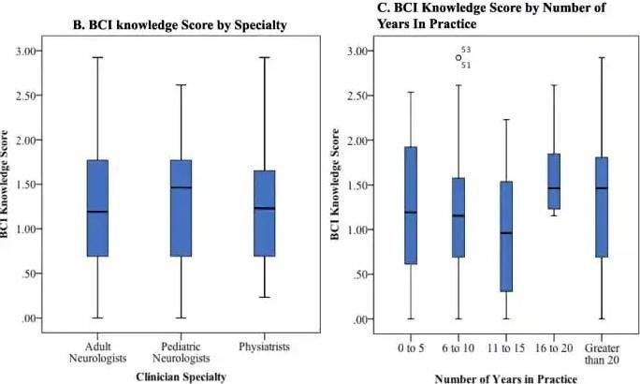

Figure3.2 BCIknowledge

Conversely, most pediatric neurologists (73%) had practices where <10% of their patients had (Fig. 4d). Physicians’ BCI knowledge scores were not associated with the proportion of patients in their practice with SND alone (p=0.266) or with (p=0.173).
.
In the last decade, a varietyofBCI technologies has been developed to help people Some of these technologies have allowed to upgrade the movement of people improving their lifestyles and bringing back their sense of independence which are considered as navigation assistive technologies. Among the different assistive technologies, one of the solutionsthat couldhelptopeoplewithmovement disabilities isthewheelchairscontrolled by BCI systems.

3.1.4NEEDFORNEUROIMAGING

Todaythere is a demand for ambulatory/wireless EEG systems to address wide variety of research and clinical needs, in particular in ecologically valid real-world environments. Most of the EEG systems commercially available are relatively expensive,requireproprietarysoftwareto function,have limited numbersand locations of electrodes, and require trained researchers or clinicians to apply the system and to record, analyze, and interpret the data. Further, many of the currently available ambulatory/wirelesssystemshavebeendesignedforaspecificpurposeorusergroupand do not conform to established recording guidelines or standards(e.g., some systems designed to be used during video game play). One such issue is the positioning of electrodes in the sensor “headset” and their exact scalp locationonce placed on a participant’s head. Manyoftheseambulatory/wirelessEEG systemsdo not conform, or only loosely conform, to the standard International 10- 20 system for positioning electrodesonthescalp,whichmakesitdifficultorimpossibletorelatethedatarecorded from such systems to that recorded from conventional EEG based on the International 10-20system.Thus,thechallenge istodevelopproductsthatarelessexpensive,easyto prepare and record data, use open-source software, and allow for modular or flexible configuration of electrodesconsistent with the standardized electrode mapping on the skull (i.e., 10-20 montage). Thedevelopmentof EEG systems, mightdesign alow- cost, dry, wireless, lightweight, comfortable,noninvasive, and flexible EEG recording system that can be implemented in real-world environments while still conforming to established EEG recording guidelines and standards.

EEGANALYSISANDCLASSIFICATION
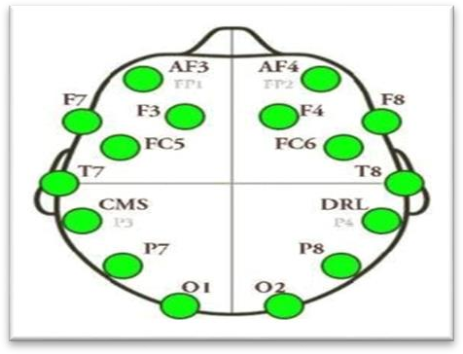
Figure3.3.EEGANALYSISAND CLASSIFICATION

EEGAnalysisandClassificationThissectiondiscussesthetheoryand concepts behind the BCIsystem.

EEG ANALYSIS
Thecentralelement ineachBCIistheclassificationmodulewhichisalsoreferred to as translation algorithm. It simply converts electrophysiological input fromthe user into output that controls externaldevices. The translation algorithm is an important stage in the signalprocessingmoduleoftheBCIsystemanditisresponsiblefortranslatingtheextracted signalfeaturesintodevicecommandsthatperformstheuser’sintent.Whateverthenatureis, atranslationalgorithmchangessignalfeatures intodevicecontrolcommands. The first part of signal processing simply extracts specific signal features. The extracted signal features maybeclassifiedonbothfrequencyandshapefeaturesbasedonlinearmethodsornonlinear methods like the neural networks. BCI operations have been said to depend mainly on effective interaction between two adaptive controllers the user who encodes his or her commands in the electrophysiological input provided to the BCI, and the computer which recognizes the command

3.2.2.EEGCLASSIFICATION

The centralelement ineachBCI is the classificationmodule which is also referred to astranslationalgorithm. It simplyconvertselectrophysiologicalinput fromtheuser into output that controlsexternaldevices. Thetranslationalgorithm isan important stageinthe signalprocessingmoduleoftheBCIsystemanditisresponsiblefortranslatingtheextracted signal features into device commands that performsthe user’s intent. Whatever the nature is, a translationalgorithmchanges signal features into device controlcommands. The first part of signal processing simply extracts specific signal features. The extracted signal featuresmaybeclassifiedonbothfrequencyandshapefeaturesbasedonlinearmethodsor nonlinear methods like the Model

CHANNELSELECTION

C3 and C4 electrodes are related to the neural activity for hand movements, however,theEMOTIVEPOCheadsetdoesnothaveC3andC4electrodes,asshownin Figure5.Therefore,selectingallthechannelsperformedbyEMOTIVEPOCheadset isthesolutionas reportedintosolvethelimitation and conduct the experiment.

BCITHEORY

BCITheoryBCIconsistsoffourmainstepsandconcepts:
      - signalacquisition
      - pre-processing
      - featureextraction
      - MachinelearningAlgorithm

3.3.2SIGNALACQUISTION

EEGsignalsacquisition is mainlydone byplacing electrodesonthescalp. 10-20 systemisthe most commonstandardusedto place electrode.Someusesfivechannelbi- polarelectrodeswhilesomeuses12Ag/Clelectrodes.SimplercommercialBCIwithone electrode and a reference electrode onear are also used. Signal are acquired by placing the electrode in particular location of the brain mostly using10-20placementsystem. Normally for ERD system it is done by imagining certain body partwhich is active response and for ERP or SSVEP it is done by presenting a stimulus which is reactive response. Sometimes both are used. Electrode is placed using 10-10 system which is much denserelectrode placement strategy. Here subject is presented with an arrow pointing to left,right ordown which isdisplayed for3secondsduring whichsubject are askedtoimaginelefthand,righthandorfeetmovementfor8seconds.64channeldevices to capture EEG signal the device is sample at 512 Hz with ahigh pass filter at 1z and subject were ask to execute three mentaltask left hand imagination movement, rest and wordsassociation.14electrodestocaptureEEGsignal,andsampleat256Hz.Numberof electrodes used varies from one research to another usually multiple electrode

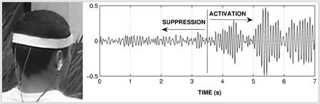

Figure3.4.EEGacquisitionand thepattern.

3.3.3. PRE-PROCESSING

Pre-processingEEGsignalisto removetheartifacts.Thereare manysources for artifacts duringthe experimentation, for example:eyemovement,musclemovement, and cardiogenicartifacts. In thiswork, two types of filters are applied.

- MedianFilter

Median filter is non-liner filter and the conceptbehind itis toremovethe backgroundnoiseby finding the median value for each channel and then subtract the data from the median value as medianfilter will remove the EMG which is related to muscle artifacts.

- HighpassFilter

High pass filter with 0.16Hz cutoff frequency is used to remove the DC offset. Sometimes EEG signals works as batteries due to the interference between sensors and thebrainscalp, therefore, removingtheDC offset is needed. Moreover, EEGsignalsare converted fromtime to frequencydomainusing periodogramcommand in MATLAB to calculate the Fast Fourier Transform (FFT) and normalize the output to find the power spectrum density (PCD)is used Converting the signal to frequency domain. K is the number of nearest neighbors.

It estimates the output through the average of the outputs and calculates the distancesofalltrainingdatatothetest argument given. IfKisasmall number, thenit is ahighaccuracyandviceversa.preprocessingstepstartswithsamplingoftheinputsignal. As the data being collected is a continuous EEG signal, it needs to be discretized for computationpurpose.Hence,theinputsignalwasbeingsampledandsamplingfrequency was set to 256 Hz. In our work, after sampling we carried out noise reduction using a bandpass filter.

A band-pass filter allows only a specific range of frequencies. In our work, we had set the frequency from0.3 Hz to 30 Hz. Signal below 0.3 Hz was feeble signaland was neglected. Signal above30 Hz constituted noise or gamma signals hence were neglected.

4.4FEATUREEXTRACTION

Tocomputea featurevectorfromeachoftheEEGsignalsrecordedbyelectrodes located at C3, C4and CZ the following strategies are used. It is worth to note that the features for eachelectrodeareconcatenated into asingle vector, for eachtrial, leading to a feature matrix of dimension 140 ×p, where pic the corresponding feature dimension.
Statistics:Fromeachwaveletdecompositionlevel,thethreefirstmomentsarecalculated, i.e., mean, variance and kurtosis.
Phase Locking Value: To relate the information and extract shared features between adjacent electrodes we used phase locking value (PLV) measure. PLV method measures the synchronization between the EEG signals from a pair of sensors at a frequency of interest. Windowing of 1 second is used to relate each pair of electrodes. There are only three electrode pair combination, since there are only three electrodes.
PowerSpectralDensityoverrawdata:PSDfeaturesarecomputedovertheentire EEG recording for each electrode, i.e., without decomposition, as usually done in the state-of-the-art methods.

Power Spectral Density: Finally, PSD features are calculated from each band previously computed by means of the DWT, we aim to demonstrate that such

