ABSTRACT

One of the main causes of death for women in developed countries is now recognized to be breast cancer. The best method for reducing mortality rates is early breast cancer identification. The capacity to detect breast cancer early, however, is necessary for faster therapy. In this method, feature acquisition is carried out during the pre-processing stage by applying Dyadic Transformation. The training data's column consistency patterns are then discovered using the useful technology of biclustering mining. The recurring patterns in tumors with the same label could serve as a possible diagnostic guide. Then, using a novel way for combining rules, the classification problem in various feature spaces is resolved by constructing component classifiers of the AdaBoost algorithm utilizing the diagnostic rules (PCDFS).

TABLE OF CONTENTS

CHAPTER NO |  | TITLES | PAGE NO
 |  | ABSTRACT | vi
1 | 1.1 | INTRODUCTION | 1
 | 1.2 | OBJECTIVE | 3
 | 1.3 | PROBLEM STATEMENT | 3
 | 1.4 | DEFINING DROWSINESS | 3
 | 1.5 | METHOD | 5
 |  | 1.5.1 Drowsiness Detection System | 8
 |  | 1.5.2 Accelerometer angle calculation Detection System | 8
 |  | 1.5.3 Seat Belt Remainder System | 9
 |  | 1.5.4 Ultrasonic Sensor | 9
 |  | 1.5.5 Server creation | 9
 |  | 1.5.6 Web server | 10
 | 1.6 | METHODS FOR MEASURING DROWSINESS | 10
 |  | 1.6.1 Subjective Measures | 10
 |  | 1.6.2 Vehicle-Based Measures | 11
 |  | 1.6.3 Behavioral Measures | 12
 |  | 1.6.4 Physiological Measures | 13
 | 1.7 | INTERNET OF THINGS | 15
2 |  | LITERATURE SURVEY | 16
 | 2.1 | EXISTING SYSTEM | 23
 |  | 2.1.1 Disadvantage of existing system | 23
 | 2.2 | PROPOSED SYSTEM | 23
 |  | 2.2.1 Advantage of proposed system | 23
 | 2.3 | FEASIBILITY STUDY | 24
 |  | 2.3.1 Economical feasibility | 24
 |  | 2.3.2 Technical feasibility | 24
 |  | 2.3.3 Operational feasibility | 25
3 |  | SYSTEM SPECIFICATIONS | 26
 | 3.1 | HARDWARE REQUIREMENT | 26
 | 3.2 | SOFTWARE REQUIREMENT | 31
4 |  | SYSTEM DESIGN AND DEVELOPMENT | 32
5 |  | TESTING AND IMPLEMENTATION | 34
 | 5.1 | TESTING | 34
 |  | 5.1.1 Unit testing | 34
 |  | 5.1.2 Block box testing | 34
 | 5.2 | SYSTEM IMPLEMENTATION | 34
6 |  | RESULT AND DISCUSSION | 35
7 |  | CONCLUSION | 37
 |  | REFERENCES | 38

CHAPTER 1

  - INTRODUCTION
In breast cancer cases, cancer can develop in the breast tissue. Symptoms of breast cancer include a lump, a change in the shape of the breast, swelling in the skin, discharge from the nipple, an inverted nipple, or a red or scaly area of skin. Affected individuals may experience bone pain, enlarged lymph nodes, shortness of breath, or yellowing of the skin. Female gender, adiposity, idleness, consumption of alcohol, HRT during menarche, ionizing radiation, early first reproductive age, late or no childbearing, advanced age, prior breast cancer diagnosis, and family history are risk factors for the development of breast cancer. In between 10 and 15% of cases, a person inherits the BRCA1 and BRCA2 genes from their parents. Cancers that appear in the tubes are known as ductal lymphomas, and cancers that appear in the lobules are known as lobular lymphomas. Preinvasive lesions, including ductal carcinomas, are precursors to many types of cancer. A biopsy of a suspicious mass is done to confirm a diagnosis of breast cancer. Several diagnostic tests are done to find the spread Ness of cancer outside the breast to select the effective treatment. Breast cancer type, severity condition, and aged woman affect outcome. Life expectancy in developed countries is more in UK and US population living to at least 5 years. Life expectancy is lesser in developing countries. It is more common in developed countries and is over 100 times more common in women.
The benefits and harms of screening are controversial. A Cochrane review (2013) concluded that it is not clear whether mammography screening is more beneficial or more dangerous. The US Preventive Services Task Force found that screening for women aged 50 to 74 years was beneficial for women aged 40 to 70 years. The preventive strategy is the surgical removal of both breasts in selected high-risk women. Cancer patients may receive a variety of treatments such as surgery, radiation therapy, chemotherapy, hormone therapy, and targeted therapies. Breast conserving surgery and mastectomy are two different types of surgery. Breast reconstruction is possible during or after surgery. Treatment for people whose cancer has spread to other parts of the body is primarily aimed at improving comfort and quality of life.
The type of breast cancer, the severity of the condition, and the age of the patient influences the outcome. Men are much less likely than women to develop breast cancer. Breast cancer often begins in the milkproducing lobules or the lining of the milk• ducts. A cancerous tumor may metastasize, or• spread to other organs. Breast cancer is the most common• invasive tumor in women. It is the root cause of 22.9% of all invasive cancers in women and 16.3% of all female malignancies. 18.2% of all cancer-related deaths worldwide, in both males and females, are caused by breast cancer With this proposed approach, we're• attempting to foretell whether or not the sample observation is cancerous. A breast lump or an abnormal mammography is frequently the first indication of breast cancer. With a range of breast cancer treatments, stages range from early, curable breast cancer to metastatic breast cancer. Male breast cancer is a prevalent condition that requires significant consideration
Interactive segmentation can generate effective segmentation results, but skilled experts still need to put in a lot of work before they get results, they are happy with. This thesis blends deep convolutional neural networks with graph cut regularisation to automatically obtain tumour segmentations. The project's objective is to study automatic brain tumour segmentation. Although it doesn't require human input, this thesis uses an interactive brain segmentation system that has previously been successful. The tumour for the entire slice is automatically segmented.In this investigation, MRI image data was utilised. Magnetic resonance imaging (MRI) is a medical technique that uses magnetism, radio waves, and computers to create images of the architecture and physiological processes of the body in both healthy and unhealthy tissues. MRI provides a very accurate picture of the organs and may identify even the smallest structural changes in the human body. With a thorough MRI, doctors can examine various body parts and look for the existence of specific illnessesDigital image processing can be used on a computer to modify digital images. With an emphasis on visuals, it divides signals and systems. The creation of an image-processing computer system is DIP's principal goal. The system takes a digital image as input, processes it with effective algorithms, and outputs an image. Adobe Photoshop is used for illustration the most frequently. One of the most used programmes for editing digital images is this one. An image is used as the input data in imaging science, which is a branch of signal processing. Image processing involves turning a physical image into a digital one and applying various techniques to improve the image or eliminate important details. For instance, the output or reaction of a photographic or video outline will be an image, an arrangement of characteristics, an arrangement of qualities, or parameters associated with the image. Standard signal processing algorithms are often applied to images in image processing frameworks, which treat them as two-dimensional signals. The distinction between image processing and fields like image analysis and computer vision is up for discussion. On the continuum from image processing to computer vision, the processes at the low, mid, and high levels can be categorised. An essential component of image processing is the input image. After reviewing the fundamentals of image quality, performance measures for tumour and nontumor images are analysed to assess the image's quality.
A bi cluster is referred to as a pattern repeat is made up of instances and features in the rows and columns of matrix M, respectively. From the perspectives of physicians, a bichromate should exhibit some sort of diagnostic rule since it is a local coherent pattern. When determining the type of tumor mass, those tumor in a sample that contains with a comparable score under the same feature set seem to be more likely to make the same contribution. A pattern that regularly occurs indicates that it is one of the typical clinical symptoms of malignancies and can be used as a crucial diagnostic guideline. Each feature in a sample that contains in this situation should have the same or comparable values across a subset of features. The MSRS is defined as follows
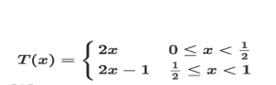
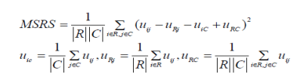
The following three steps make up the majority of the bi clustering algorithm: Step 1 :In order to separate each column into multiple clusters, apply the hierarchical clustering algorithm with a distance threshold Thcon in and refer to them as bicluster seeds (BS).
Step 2: Using these bicluster seeds as a starting point, a) To create an initial submatrix N, expand one column to all other columns for each BS. b) Go through all of N's rows and columns. c) Continue with the previous procedures till resultant predetermined values. Discard certain biclusters that are repetitive or redundant are completely engulfed by bigger ones. After biclustering mining, the following step entails converting the discovered biclusters (i.e., diagnostic patterns) into diagnostic rules. A self-belief measure is suggested to identify the category and dependability of a rule when converting a bicluster into a descriptive rule. In our study, each descriptive rule is categorised as benign (B) or malignant (M) (M). There are two numbers given: the number of rows in a bicluster, Rbic, and the number of rows with the labels "benign" and "malignant," Rbenign and Rmalignant, respectively. The confidence for the benign category (B) and that for the malignant category (M) can be calculated based on the instance labels (i.e., the final diagnostic result)

1.2 Problem Statement
Breast cancer is one of the most common forms of cancer among women worldwide, with early detection playing a critical role in successful treatment and prognosis. Machine learning algorithms have shown promise in assisting medical professionals in the early detection and diagnosis of breast cancer using medical imaging data, such as mammograms.

The problem statement revolves around developing a breast cancer detection system using an AdaBoost classifier, a powerful machine learning algorithm known for its ability to improve the accuracy of weak classifiers. The goal is to build a model that can effectively classify mammogram images as either benign (non-cancerous) or malignant (cancerous), thereby aiding healthcare providers in making timely and accurate diagnoses.

Key Components of the Problem Statement:

Dataset Acquisition and Preprocessing:
Obtain a dataset of mammogram images, ideally from reputable sources such as medical research databases or healthcare institutions.
Preprocess the images to enhance quality, remove noise, and normalize features, ensuring that they are suitable for input to the machine learning algorithm.

Feature Extraction:
Extract relevant features from the mammogram images that are indicative of breast cancer, such as texture, shape, and density characteristics.
Use techniques such as image segmentation, edge detection, and feature extraction algorithms to derive meaningful features from the images.

Model Development:
Implement an AdaBoost classifier algorithm for binary classification of mammogram images into benign and malignant classes.
Train the model using a portion of the dataset, validating its performance using techniques such as cross-validation or a separate validation dataset.
Model Evaluation:
Evaluate the performance of the AdaBoost classifier model using appropriate metrics such as accuracy, precision, recall, F1-score, and area under the receiver operating characteristic (ROC) curve.
Compare the performance of the AdaBoost classifier with other machine learning algorithms commonly used for breast cancer detection, such as support vector machines (SVM) or convolutional neural networks (CNNs).

Deployment and Validation:
Deploy the trained AdaBoost classifier model in a real-world setting, such as a healthcare facility or diagnostic center.
Validate the model's performance on new, unseen mammogram images to assess its generalization ability and real-world applicability.
Ethical Considerations:
Ensure that the breast cancer detection system complies with ethical guidelines and regulations related to patient privacy, data security, and medical device usage.
Provide transparency regarding the limitations and potential biases of the machine learning model, particularly in the context of healthcare decision-making.

1.3 Implementation

The Breast Cancer Wisconsin (diagnostic) dataset was obtained via Kaggle. Ten independent variables—”Sample code number,” “Clump Thickness,” “Uniformity of Cell Size,” “Uniformity of Cell Shape,” “Marginal Adhesion,” “Single Epithelial Cell Size,” “Bare Nuclei,” “Bland Chromatin,” “Normal Nucleoli,” and “Mitoses”—are considered to be “X,” and one dependent variable—”Y”—consists of class labels. The dataset has roughly 137 samples. The data is separated into two groups: X contains all of the input variables, while Y contains the class label, which serves as the output variable
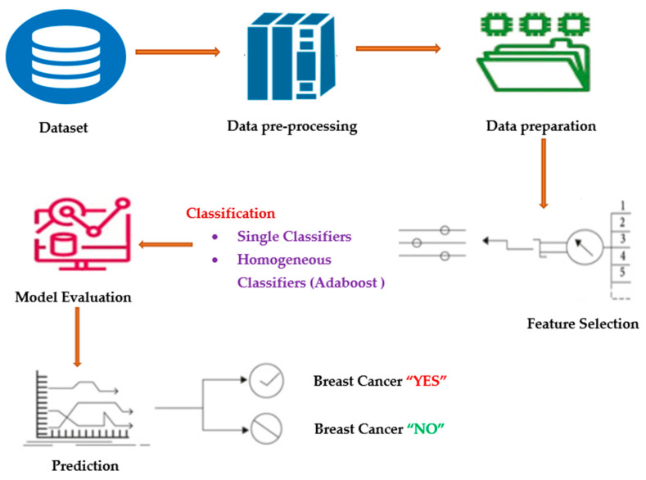

1.4 Data Preprocessing
A class imbalance occurs when there is an unbalanced distribution of classes in a dataset, meaning that there are many more data points in the negative class (majority class) than in the positive class (minority class). The classifier model’s performance will suffer if the skewed data are not corrected beforehand. The majority of the predictions will match the majority class, while the minority class features will be treated as data noise and ignored. The model will have a significant bias as a result. As mentioned, to achieve more accurate classification model results, the data are separated into training and test portions, with the training data comprising 70% of the total dataset, and the test portions comprising 30%.
Many classification algorithms strive to collect only pure examples for learning and make the boundary between each class as clear as possible to improve the prediction. Most classifiers find it significantly more difficult to learn how to classify synthetic cases close to the boundary than those far from it. Based on these results, the authors present an enhanced pre-processing method (A-SMOTE) for imbalanced training sets [25]. SMOTE uses a k-nearest neighbor method to generate synthetic data. SMOTE begins by randomly selecting data from the minority class, after which the data’s k-nearest neighbors are determined [26]. The k-nearest neighbor selected at random and the random data would then be combined to create synthetic data. The SMOTE method is explained in the section below.
Step A: Using Equation (1), a synthetic instance is created:
N=2∗(r−z)+z,
(1)
where r is the majority class samples, z is the minority class samples and N is the newly created synthetic instance.
Step B: The below mentioned steps are carried out to remove the outlier; that is, noise.
If, Sˆ = {Sˆ1, Sˆ2, Sˆ3, …. Sˆn} is a new instance received by Step A, then we will calculate the distance among Sˆi with the original minority Sm,MinRap(Sˆi, Sˆm) defined using Equation (2).
MinRap(Sˆi, Sˆm)=∑zk=1∑Mj=1(Sˆi(j)−Smk(j))2−−−−−−−−−−−−−−√,
(2)
where:
MinRap(Sˆi, Sˆm) are samples of rapprochement and, as per Equation (2), L is calculated using Equation (3).
L=∑ni=1(MinRap (Sˆi, Sm)),
(3)
Step C: Calculate the distance between Sˆi and every original majority Sa,MajRap(Sˆi,Sa), described using Equation (4).
MajRap(Sˆi,Sa)=∑ri=1∑Mj=1(Sˆi(j)−Sal(j))2−−−−−−−−−−−−−√,
(4)
MajRap(Sˆi,Sa) are samples of rapprochement and, as per Equation (4), H is computed using Equation (5).
H=∑ni=1(MajRap (Sˆi, Sa))
(5)
Entropy is nothing but the measure of disorder. Claude E. Shannon used the following Equations (6) and (7) to put this link between probability and heterogeneity or impurity into mathematical form:
H(X)=−∑(pi∗log2pi)
(6)
Entropy (p)=−∑Ni=1pi∗log2piEntropy (p)=−∑Ni=1pi∗log2pi

1.5 ADA Boost Classifier Work
Adaboost enables the fusion of many “weak classifiers” into a single, so-called “strong classifier”. These trees are often referred to as “Decision Stumps.” By giving each data point the same weight, this method builds a model. The improperly categorized points are subsequently given more weight. All points with higher weights are given more significance in the following model. The models will keep being trained until a reduced error is obtained. The pseudo code of the Adaboost classifier is depicted in Algorithm 1. Adaboost and LogitBoost, as depicted in Algorithms 1 and 2, are the two boosting algorithms that are utilized to prompt the ADTree variations discussed in the following section.
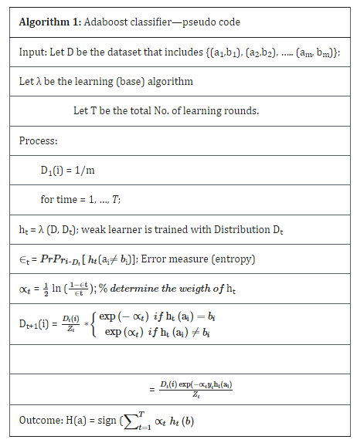

1.6 Alternative Decision tress(AdTree)
A ML approach for classification is ADTree. It generalizes decision trees (DTs) and is linked to boosting. A set of DT nodes representing a predicate condition and prediction nodes that will store a single integer make up an ADTree [27]. The Real Adaboost is implemented in Algorithm 3 to learn an ADTree model. The precondition P and base conditions C remain constant during the induction as two significant variables. The division of the input space greatly affects any decision tree’s quality.
In step 1.1 of Algorithm 3, all the training samples are given an equal weight by setting Wi,t = 0 = 1/n. The training sample as well as the boosting step are represented by the symbols I and t, respectively. Additionally, the precondition true, which is going to define the complete input space, is initialized as part of the precondition set P. With the root decision rule, a prior classifier is created by deriving a second prediction value, α0 from the ratio of positive to negative training data. W+(c) stands for the total weight of the positive samples that meet condition c, and W− (c) for the negative samples. Before starting a fresh boosting procedure, the training data set is reweighted in accordance with this root decision rule
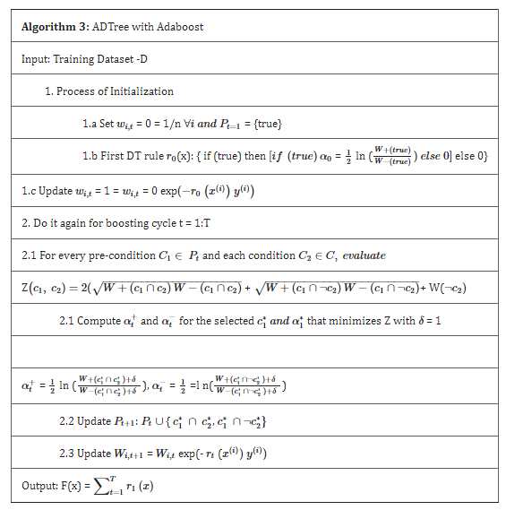

CHAPTER 2

LITERATURE SURVEY

- D. O’Loughlin, M. J. O’Halloran (2018) [1] have applied the Clinical developments in microwave breast imaging and enduring difficulties. A thorough analysis of these recent clinical advancements is provided in this paper, comparing patient groups and trial results. First, a review of existing knowledge regarding the dielectric characteristics of human breast tissues is done using data

