ABSTRACT

An high non-linear diode bridge rectifier has been used in the electric vehicle charger for the use of DC voltage at only the DC-DC converter input but also to implement significant power quality problems only at existing AC input. By eliminating their input bridges, such problems developed a tremendous a need boost the Performance of power quality of developed battery chargers. Also in proposed method, these are accomplished by a inclusion of even a advanced Power Quality bridgeless LUO converter. This current PFC converter indeed a addition made by two LUO converters with such a standard inductor, operating independently and over corresponding half-cycles. A converter offers a high power density and low cost based EV charging strategy with higher precision operating in only a single switching cycle because of the absence of an input diode bridge from conventional PFC converters. The input current in a charger becomes rendered and it makes its source voltage, accurately on step, but it reaches the high input power factor.

TABLE OF CONTENTS

CHAPTER NO |  | TITLES | PAGE NO
 |  | ABSTRACT | vi
1 | 1.1 | INTRODUCTION | 1
 | 1.2 | OBJECTIVE | 3
 | 1.3 | PROBLEM STATEMENT | 3
 | 1.4 | DEFINING DROWSINESS | 3
 | 1.5 | METHOD | 5
 |  | 1.5.1 Drowsiness Detection System | 8
 |  | 1.5.2 Accelerometer angle calculation Detection System | 8
 |  | 1.5.3 Seat Belt Remainder System | 9
 |  | 1.5.4 Ultrasonic Sensor | 9
 |  | 1.5.5 Server creation | 9
 |  | 1.5.6 Web server | 10
 | 1.6 | METHODS FOR MEASURING DROWSINESS | 10
 |  | 1.6.1 Subjective Measures | 10
 |  | 1.6.2 Vehicle-Based Measures | 11
 |  | 1.6.3 Behavioral Measures | 12
 |  | 1.6.4 Physiological Measures | 13
 | 1.7 | INTERNET OF THINGS | 15
2 |  | LITERATURE SURVEY | 16
 | 2.1 | EXISTING SYSTEM | 23
 |  | 2.1.1 Disadvantage of existing system | 23
 | 2.2 | PROPOSED SYSTEM | 23
 |  | 2.2.1 Advantage of proposed system | 23
 | 2.3 | FEASIBILITY STUDY | 24
 |  | 2.3.1 Economical feasibility | 24
 |  | 2.3.2 Technical feasibility | 24
 |  | 2.3.3 Operational feasibility | 25
3 |  | SYSTEM SPECIFICATIONS | 26
 | 3.1 | HARDWARE REQUIREMENT | 26
 | 3.2 | SOFTWARE REQUIREMENT | 31
4 |  | SYSTEM DESIGN AND DEVELOPMENT | 32
5 |  | TESTING AND IMPLEMENTATION | 34
 | 5.1 | TESTING | 34
 |  | 5.1.1 Unit testing | 34
 |  | 5.1.2 Block box testing | 34
 | 5.2 | SYSTEM IMPLEMENTATION | 34
6 |  | RESULT AND DISCUSSION | 35
7 |  | CONCLUSION | 37
 |  | REFERENCES | 38

CHAPTER 1

  - INTRODUCTION
WITH the significant development in battery technologies and power electronics, the automotive industries such as electric vehicles (EVs) have provided a wider platform for modern researchers to grab an opportunity for achieving the cleaner propelling power sources [1]. The high energy and fuel efficiency have become a great concern for both manufacturers and EV consumers, which has accelerated the need for efficient battery chargers for EVs. To obtain high efficiency and reliability during charging, the power factor correction (PFC) converters have become a vital part of the modern EV chargers. The circuit for the existing traditional EV charger with input full bridge diode rectifier (DBR) and dc–dc converter is shown in Fig. 1(a)
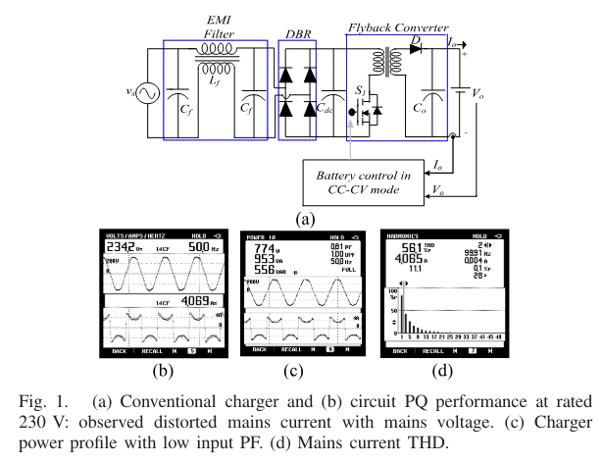
The performance of a conventional EV charger is measured as shown in Fig. 1(b)–(d), which shows that the conventional charger without PF correction causes rich harmonic content in mains current and deteriorates the input power quality (PQ) indices such as input power factor (PF), displacement PF (DPF), and crest factor (CF). The value of true PF lies in the range 0 to 1. When the power demanded by the load is reactive (usually inductive load), true PF is 0. However, the DPF represents the PF due to the phase difference between input voltage and input current at the fundamental frequency (line). True PF is considered with harmonic content; however, DPF is taken into account at the fundamental frequency. However, the value of DPF and PF is the same for sinusoidal current with low distortion, which is unity. Therefore, the performance of a conventional battery charger for EV is not found as per the IEC 61000-3-2 standard [2].
To overcome the above PQ issues, the conventional boost and buck-boost PFC converters are incorporated at the front end, between DBR and dc-link capacitor as shown in Fig. 2. However, the addition of an extra converter in charger, adds to the number of total components. This affects the cost and size of the charger, which restricts the efficiency and reliability of the charger with increased weight. Therefore, single stage isolated ac–dc converters with input DBR are more widely used in PFC applications at high-power rating [3]. Several single-phase single stage EV chargers based on integrated unidirectional and bidirectional configurations are
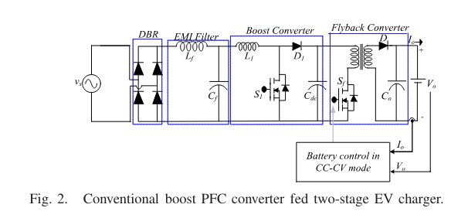

reported in the literature, which provide high efficiency along with reduced size and weight [4]. A comprehensive analytical review of different EV charger topologies for the charging infrastructure and power levels is proposed in [5]. A new single stage full bridge converter with pulse width modulation (PWM) control is discussed in [6] for PFC over universal ac mains voltage, but the use of four switches and additional gate drive circuitry make it less attractive for a low cost EV charger. Wang et al. [7] have proposed a half bridge converter for LED driver with single stage configuration, which reduces the gate drive complexity. A CLCL converter used for soft switching of the half bridge converter makes the converter bulky, and the switch stresses are observed to be higher than the maximum input voltage. However, single-phase single stage PFC-based EV chargers have the limitations of high switch voltage stress, higher component stress, and high ripple. A bridgeless interleaved (IL) boost PFC converter with reduced input current ripple and low current stress through components is proposed for plug-in electric vehicle (PHEV) chargers [8]. A detailed discussion and classification on several single phase improved PQ converters (IPQCs) have been proposed by Singh et al. [9] to facilitate easy selection of the PFC converter suitable for specific application. Various single-phase buck-boost high frequency isolated PF correction converters such as Zeta, Cuk, single-ended primary inductance (SEPIC), and Luo converters have been presented previously to provide improved PQ charging at varying line voltage and loads. Zeta converters have increased input current ripple, and SEPIC converter shows increased ripple at output, which have adverse impact on the battery life. Cuk converter is considered to be a better solution for intrinsic PFC in EV chargers as it overcomes the disadvantage with continuous currents at input and output. However, all these configurations of single-stage single switch solutions seem to be unattractive for high power applications of ac–dc converters, typically, due to increased voltage stress in PFC semiconductor devices, which, in turn, results into lower efficiency [10]. A novel technique based on coupled winding structure is proposed in [11]–[14], which reduces the switch voltage and current stress, but the arrangement of coupled winding makes the design of isolation transformer complex and bulky. Dylan et al. have proposed an integrated boost-forward PFC converter to reduce the main switch current stress with two independent conduction period of mains current. However, the switch voltage stress is clamped at bus voltage using a dual peak-current controller [15]. Therefore, in the proposed work, a two switch technology is applied for significant switch voltage and current stress reduction in isolated Luo converter-based EV charger.
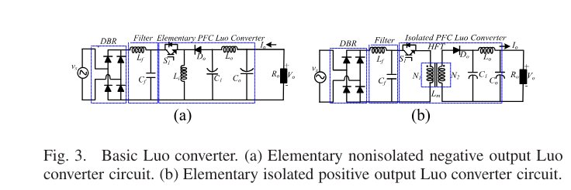

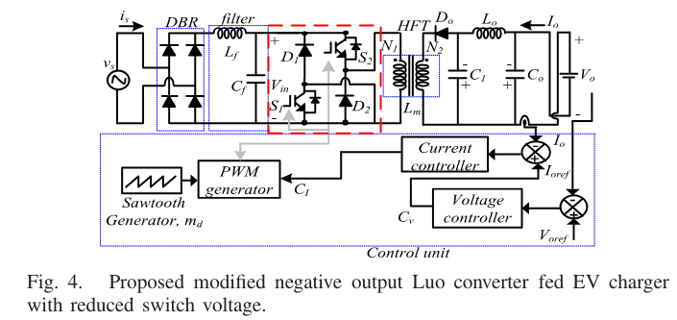
A Luo converter is popularly used as dc–dc converter on account of having improved voltage regulation under sudden varying line voltages and better light load efficiency [16]–[22]. The elementary nonisolated positive [16] and negative output Luo converters [19] are reported in the literature, which have proved their potential for increased voltage conversion ratio and low output ripple and input ripple. The basic topologies for nonisolated as well as isolated Luo converter are represented in Fig. 3(a) and (b). The contribution of the proposed work is seen in terms of use of Luo converter for an improved PFbased EV charger, which has found less exploration in the literature earlier. However, it is noticed that Luo converters are widely used for voltage super-lift, relift, and ultralift applications in the literature [20], [21]. A nonisolated bridgeless Luo converter has shown an excellent PF preregulation capability for brushless dc (BLDC) motor drive as given in [22]. The bridgeless technology facilitates the advantage of comparatively low conduction loss since the line diodes conducting in each switching cycle are halved. However, the problem of high switch voltage stress remains in these converters, which, in turn, lowers the converter efficiency.
Therefore, a modified isolated Luo converter fed single stage EV charger in DCM is designed and implemented in this work, to charge a 48 V, 100-Ah EV battery in constant current and constant voltage (CC–CV) mode. The other significant contribution of the proposed work is seen with remarkably reduced voltage stress across the PFC switches, which is obtained with certain modification made in the base-isolated Luo structure [23]. The proposed Luo converter is a modified version of basic isolated Luo converter with one additional switch and two clamping diodes. The significant modifications to base-isolated Luo converter topology are done at the primary side of the isolation transformer by adding one switch S2 and two clamping diodes D1 and D2 as shown in Fig. 4. It is worth to note that the advantage of this modification comes with reduced semiconductor switch voltage stress as the voltage stress across the two switches is clamped at input voltage unlike the isolated base converter, which incurs peak voltage stress of Vin + nVo across the switch S1, where
n is the transformation ratio of the HFT. This reduces the conduction loss and increases the efficiency of the proposed charger. The operation of the converter in discontinuous mode considerably reduces the control complexity due to reduced sensors, and the output of PFC Luo converter is maintained constant. The proposed converter has a significant benefit of low ripple-based EV charging during CC–CV phases [24] and fast response to the source voltage variations. The performance of the proposed converter is found robust enough to validate the efficacy of charging under rated as well as at varying line voltages. The input PQ indices such as input PF, DPF, mains current total harmonic distortion (THD) are observed as per the PQ norms such as the international standard of IEC 61000-3-2.

  - MODIFIED LUO CONVERTER-BASED CHARGER
The configuration of the EV charger with modified Luo converter is shown in Fig. 4. The design of this isolated converter is selected to provide a discontinuous conduction mode (DCM)-based operation. This ensures the intrinsic PFC characteristics of the charger over the entire variation of input voltage. The converter consists of two PFC switches S1 and S2 and clamping diodes D1 and D2 at the primary side of the high frequency transformer (HFT). The secondary of the transformer is connected to output diode Do, intermediate capacitor C1 and output inductor Lo. The charging of the battery in CC–CV phases is achieved using a dual loop PI controller. A 760 W prototype for this charger with new Luo converter is designed and discussed to prove the efficacy of the charger with improved PQ as per the IEC 61000-3-2 standard. The analysis and key switching operations are illustrated in Sections II-A and II-B.

1.3 Operation of Modified Luo Converter
The design of modified Luo converter is selected to operate in DCM as the current through the HFT magnetizing inductance Lm becomes discontinuous over a complete switching cycle. Different modes of operation associated with proposed converter corresponding to the three switching durations are discussed as follows. Mode-I: During this mode, both switches S1 and S2 are made on. The magnetizing inductor starts storing the energy from supply as the current through this rises linearly. The inductor Lo starts charging through the intermediate capacitor C1 as the capacitor voltage starts decreasing through Lo, during this instance as shown in Fig. 5(a). The diode Do remains in reverse bias at the secondary side. Under steady state, considering magnetizing inductor current as iLm, output inductor current as iLo, the intermediate capacitor voltage as vc1, and dc link capacitor voltage as vo = vco, the inductor voltage and capacitor currents are written as follows:
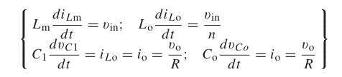
where n is the transformation ratio of the HFT and io is the rated charging current.
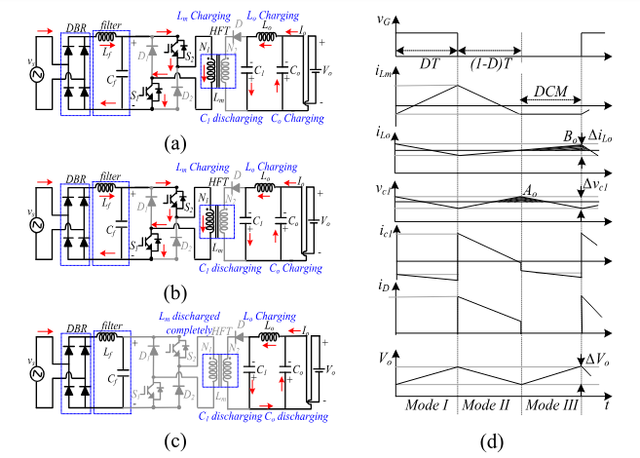
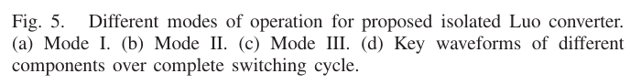
Mode-II: Fig. 5(b) represents Mode-II, when both the PFC switches S1 and S2 are turned off. During this interval, the diodes D1 and D2 come into conduction. The magnetizing inductance Lm provides the stored energy to the output diode Do, and it starts conducting. The intermediate capacitor voltage vC1 starts increasing through the energy of the magnetizing inductance at the HFT secondary winding. The energy is transferred to the output capacitor through the output inductor Lo, and the required charging current is supplied to the battery.

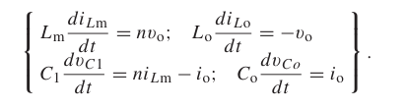
During this instant, the voltage across the magnetizing inductor and output inductor as well as the capacitor currents is expressed as follows: Mode-III: In this period, both the diodes (D1, D2) are reverse biased and pulses to the PFC switches (S1, S2) are made off. The converter enters DCM operation as the energy stored in Lm is depleted completely. The diode Do becomes reverse biased. The required energy for the battery is provided by the dc-link capacitance through the inductor Lo and the energy transfer capacitor, C1, as shown in Fig. 5(c). The key switching phenomena over the complete switching cycle associated with the circuit components are depicted in Fig. 5(d). During DCM operation, the inductor voltage and capacitor current are expressed as follows:
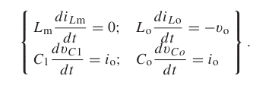

1.4 Voltage Conversion Ratio
Considering ILm, ILo, Io, Vin, VC1, and Vo as the corresponding dc values of iLm, iLo, io, vin, vC1, and vo at steady state and D is the required duty cycle, the volt-sec balance across the inductors Lm and Lo is applied as
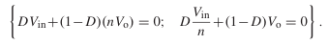

This results in the dc voltage gain of the proposed Luo converter, the expression of which is given as


1.5 Voltage Stress on PFC Devices (S1,2Do, and D1,2)
From mode-I, the voltage stress on clamping diodes D1 and D2 as well as diode Do are obtained as follows:
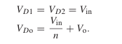
During mode II, the peak voltage across the primary switches S1,2 are obtained as follows:
Note that the voltage stress across the primary switches S1,2 is clamped to input voltage due to the use of clamping diodes at the primary. This stress is lower than the conventional isolated Luo converter case which incurs a maximum voltage stress of Vin+ nVo as shown in Fig. 3(b).

1.5.1 Current Stresses on PFC Devices (S1,2, Do, and D1,2)
Considering the charge second balance equation for the capacitor C1 and Co under steady state, the following relation for the inductor currents ILm and ILo with respect to the output current are obtained as follows:
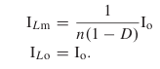
As discussed in mode I, the instantaneous current through the primary switches S1 and S2 is given as
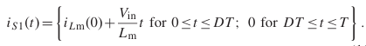
Consequently, the calculation for the dc value of current stress through the switches is made as follows:
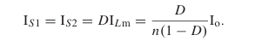
Again, considering mode-II operation, the instantaneous currents through the diodes D1 and D2 is given as
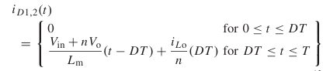

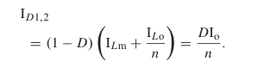
Conventional vehicles help amplify already existing issues like global warming, high carbon footprint, and pollution. Along with this, they’re also responsible for the depletion of fossil fuels. The burning of fossil fuels, vehicle exhaust smoke, industrial outflow, and power stations have been major reasons for air pollution. Depending on exhaustible resources such as petroleum, natural gas, and coal, severe climate change and increasing energy cost are a few of the major problems across the globe. In the automobile industry, electric vehicles have become popular recently. Electric vehicles help in controlling pollution majorly as the fuel used is electric power. This
reduces the use of fossil fuels, which in turn reduces pollution coming from power generation stations. The popularity of electric vehicles has increased amongst the automobile industry, buyers, and environmentalists. The hour of need is to significantly cut pollution and use of non-renewable resources. Both these agendas are achieved by replacing conventional vehicles with electric automobiles. In the new decade, electric vehicles have acquired prominence among producers, preservationists just as purchasers. Rising worries related to climate has increased the need for cleaner energy. This has added to the interest in electric vehicles. These days, numerous nations on the planet are adding to accomplish a specific objective to promote non-polluting energy. To deal with increased fuel costs and to execute the natural arrangements with better expectations, EV is a choice that curbs the craving of a green wellspring of transportation with low emanations and plausible fuel economy. As of late, many explorations contemplate have shown that because of green climate, energy-saving highlight, and simpler method of execution, the innovation of EVs holds extra benefits over traditional energy advances. In metropolitan spaces across the globe, electric vehicles will increment significantly and will accomplish bigger acknowledgment in the vehicle market because of their higher productivity
Electric vehicles rely on lead acid batteries for their power, thus they need a reliable charger to keep the vehicle and its accessories running [1-2]. A good battery charger it should have better input power quality, high efficiency, reliability and high power density,. Thus, the basic PQ indices used today should fulfil IEC 61000-3-2 standards [3]. The input power factor and total harmonic distortion (THD) must be below the required values. Onboard, off-board, and bidirectional electric car charging stations exist. EVs store power in batteries, flywheels, or super capacitors. Customers should be able to charge their EVs anytime they have a charging connection since the battery is in the car. Many single-stage AC/DC converters with built-in PFC have been designed to solve battery charger PQ concerns [4]. Two-stage and single-stage EV battery chargers employ bridged, bridgeless, and interleaved AC-DC PFC converter topologies [5]. Single-stage EV chargers use soft switches, step down-fly back, and step up fly back PFC converters [6-9]. Single-stage PFC isolated topologies increase switch stress, output ripple, and DC link capacitor values. LCbased soft-switched PFC converters may minimize electronic component stress
Bridgeless fly back converter-based circuits [13–15] are too complicated for low-power PFC applications. Step down or step up PFC converters are popular utility interface frontend converters for high-power applications due to their superior input wave shaping. The wide input voltage control range of the buck-boost PFC converter [18] optimizes EV battery charging. The SEPIC, Cuk, Zeta, and Luo converters are among the single-phase buck-boost PFC converters examined in [19-22]. The Cuk converter is ideal for EV charger PQ improvement because it overcomes these limits and decreases input and output current ripples. Luo converters [21-22] are the most common DC-DC power converters because to their superior voltage control over a broad supply voltage range and better efficiency under low loads. Series Luo DC-DC converters include re-lift, ultra-lift, and super-lift mechanisms [23-26]. This BL Luo topology outperforms DBR-based Luo converters, BL converters [27], and integrated boost-fly back converters in conduction loss and efficiency at high power levels. The battery current is managed via a fly back converter in DCM when charging in CC-CV mode. An electric vehicle, popularly known as an EV, gets its power from collector systems which are in turn powered by electricity. The source of power could differ, battery, fuel cells, solar panels, electric generator, etc. The benefits of EV can be boosted when it’s connected to a power grid. A few would constitute sustaining renewable energy resources, balancing load, support of reactive power. The main problem with EVs is the life cycle and efficiency of batteries, problems pertaining to battery chargers, and the charging infrastructure of batteries. This issue can be tackled using active rectifiers in the circuit. One such fixture is the ultra-lift Luo converter which can be incorporated with DC-DC converters to yield better results in the field of onboard battery charging for EVs. This system increases voltage transfer gain; hence, improving efficiency. This paper majorly covers efficient battery charging- discharging and motor efficiency of traction motors and load analysis.

1.6 BACKROUND OF THE WORK
The crucial link between electric vehicles (EV) with a depleted battery that provides the infrastructure element to electrical source that will recharge those batteries is the Electric Vehicle standards related to current and emerging for EVSE technologies. The assessment codes review the standards related to current and emerging for EVSE technologies. The network of EV charging stations recommendations of infrastructure required to support the accelerating deployment of EVs to expanded their challenges. The network establishment of requirements and needs is the primary barriers which is easy accessible of PEV recharging network communication is the significant barriers are expansion of EVSE infrastructure.
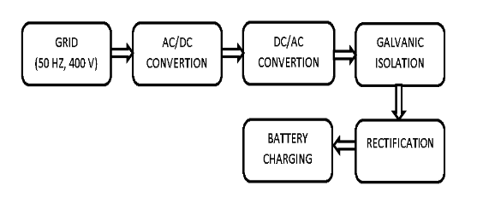
PEV and infrastructure environment focused and consistent public awareness campaigns supporting the continued adoption of PEVs and a public officials and private enterprise want to better understand of PEV and EVSE infrastructure are needed. The manufacture of PEV have near terms expectations for advanced battery technology that will provide a travel range equal to significant advancements are made in PEV technologies for advanced battery technology. The evaluation of performance of electric vehicle charging system is the efficient of key parameters. The shorter charging time for EVs has promising future especially those bidirectional fast chargers among many charging circuit topologies of the concept “vehicle-to-grid (V2G)”. In commercial EV fast chargers, the downstream DC/DC converter is usually designed to be an isolated converter where a high frequency transformer is necessary for isolation the traditional fast an AC/DC converter and a downstream DC/DC
converter is a usual consists of charging system. The adjustable wide battery range for output voltage for various EVs (280V- 400V). For the designed to be an isolated converter where a high frequency transformer is necessary for isolation in commercial EV fast chargers, the downstream DC/DC converter. The comparison of the power conversion efficiency is limited to DC/DC converter. Once the non-isolated DC/DC converter is adopted, there must be an influence frequency transformer at the grid side to make sure electrical safety as shown in Figure.1.No matter which type of two-stage converters; it seems difficult to enhance the system efficiency further with lower cost. In this paper, a single-stage AC/DC structure shown in Figure.2 is considered to replace two-stage structure with lower cost but higher efficiency. To accommodate the battery voltage range, the turn ratio of power frequency transformer is designed to make the input voltage of the AC/DC converter lower than the grid voltage
1.7 EFFICIENCY COMPARISION
A system efficiency comparison is carried out between the proposed structure and the traditional two-stage structure. And the efficiency calculation results are validated by the SEMISEL simulation tool. Through the analysis and calculation, the proposed single-stage structure has nearly more than 2% higher power conversion efficiency compared to traditional two-stage structure with no additional cost. Furthermore based on the proposed structure, there is another problem that the harmonic power from the grid can be directly transmitted to the battery packs to be solved. Hence, a small capacity bidirectional half bridge DC/DC converter shown in Figure.3 is applied in this paper to work as an DC active power filter (DCAPF) to compensate the harmonic current as shown in Figure.4. Both the simulation and experimental results indicate that the DCAPF method is effective in battery harmonic current compensation

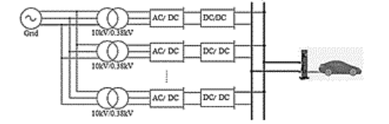
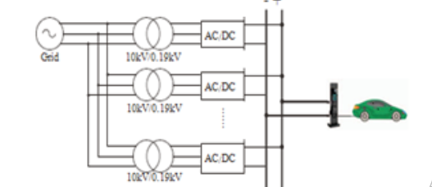
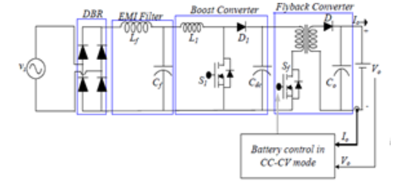

However, all these configurations of single-stage single switch solutions seem to be unattractive for high power applications of AC-DC converters, typically, due to increased voltage stress in PFC semiconductor devices, which, in turn, results into lower efficiency. A novel technique based on coupled winding structure is proposed, which reduces the switch voltage and current stress, but the arrangement of coupled winding makes the design of isolation transformer complex and bulky. Lu et al have proposed an integrated boost-forward PFC converter to reduce the main switch current stress with two independent conduction period of mains current. However, the switch voltage stress is clamped at bus voltage using a dual peak-current controller. Therefore, in the proposed work, a two switch technology is applied for significant switch voltage and current stress reduction in isolated Luo converter based EV charger.

1.8 PROBLEM STATEMENT
A LUO converter is popularly used as DC-DC converter on account of having improved voltage regulation under sudden varying line voltages and better light load efficiency. The elementary non-isolated positive and negative output LUO converters, are reported in the literature, which have proved their potential for increased voltage conversion ratio, low output ripple and input ripple. The contribution of proposed work is seen in terms of use of LUO converter for improved power factor based EV charger, which has found less exploration in the literature earlier. However, it is noticed that LUO converters are widely used for voltage super-lift, re-lift and ultra-lift applications in literature. A non-isolated bridgeless LUO converter has shown an excellent power factor pre-regulation capability for BLDC motor drive as given. The bridgeless technology facilitates the advantage of comparatively low conduction loss since the line diodes conducting in each switching cycle, are halved. However, the problem of high switch voltage stress remains in these converters, which, in turn, lowers the converter efficiency. Therefore, a modified isolated LUO converter fed single stage EV charger in DCM, is designed and implemented in this work, to charge a 48V, 100Ah EV battery in constant current and constant voltage (CC-CV) mode. The significant contribution of proposed work is seen with remarkably reduced voltage stress across the PFC switches, which is obtained with certain modification made in the base isolated LUO structure. The proposed LUO converter is modified version of basic isolated LUO converter with one additional switch and two clamping diodes.

CHAPTER 2

LITERATURE SURVEY

1. “IMPLEMENTATION OF THE DRIVEER DROWSINESS DETECTION SYSTEM” K.SRIJAYATHI AND M.VEDACHARY,
It combines off-the-shelf software components for face detection, human skin color detection, and eye state (open vs. closed) classification in a novel way. Drowsiness (also referred to as sleepiness) can be defined as “the need to fall asleep”. This process is a result of normal human biological rhythm and its sleep-wake cycles. The longer the period of wakefulness, the more pressure builds for sleep and the more difficult it is to resist it. If the sequence of captured images and measured parameters (e.g., pattern of nodding or time lapsed in “closed eye state”) suggest that the driver is drowsy, an action – such as sounding an audible alarm – might be warranted. Easily portable to different platforms. The application must run on a mobile device (e.g., Android-based smartphone) mounted on the vehicle’s dashboard. Ideally, it should be easily portable to other (e.g., iOS-based) mobile devices of comparable size and computational capabilities. Computationally non-intensive. Since (near) realtime performance is required, algorithms must be optimized to ensure continuous monitoring of driver’s state without excessive burdening of the device’s main processor. As a side benefit, battery consumption is reduced as well. Accuracy. One of the main challenges of designing such a system is related to the fact that both type I and type II errors are highly undesirable, for different reasons: type I errors (false positives) will annoy the driver and reduce their willingness to use the system (due to excessive false alarms), whereas type II errors (false negatives) can have literally catastrophic consequences and defeat the purpose of the entire system. Robustness. The system must be tolerant to modest amounts of lighting variations, relative camera motion (e.g. due to poor road conditions), changes to the driver’s visual appearance (even in the course of a session, e.g., by wearing/removing a hat or sunglasses), camera resolution and frame rates, and different computational capabilities of the device’s processors. Driver cooperation. Last, but certainly not least, all driver drowsiness detection systems assume a cooperative driver, who is willing to assist in the setup steps, keep the monitoring system on at all times, and take proper action when warned by the system of potential risks due to detected drowsiness.
DRAWBACKS
- A special video containing 571 frames of a driver sitting in a drivers position is used. Driver is moving minimally.
- Every frame is manually marked as containing open or closed eyes.
- Open and closed eye samples are roughly the same in number, 304 containing open eyes and 267 containing closed eyes.

2. “AN IOT APPROACH TO VEHICLE ACCIDENT DETECTION, REPORTING AND NAVIGATION” ELIE NASR, ELIE KFOURY AND DAVID KHOURY
One particular concern that Public Safety Organizations (PSO) must account for whilst engaging in many activities is decreasing the effect of vehicle accidents, aiding as many injured people as possible and providing 24/7 on the spot rescue. The Red Cross humanitarian organization is one of the most known PSOs to be present on-site whenever an accident or a disaster takes place. However, some of the rescue teams face difficulty in reaching the injured people to due late alerts and insufficient information of the specific accident location. The advent of the mobile phone and Internet of Things (IoT) industries reshaped the way people communicate and brought a paradigm shift to public and private services. This everevolving technology marked the beginning of new era affecting the lives of people and various businesses. This paper conveys a smart and reliable IoT system solution which instantly notifies the PSO headquarter whenever an accident takes place and pinpoints its geographic coordinates on the map. When an accident takes place, a shock sensor detects it. The challenges imposed to local PSOs in saving human lives resulting from vehicles accidents have become a crucial concern due to the huge aforementioned number of departed people. As far as many injured could lose their lives, and since no on-site medical assistance has been provided promptly as a result of: (1) late accident reporting, (2) inaccurate geographic location, and (3) lack of injured medical information, the need for automated and intelligent mobile solution tackling this burden becomes a must. Our proposed solution is a smart IoT system consisting of architecture, design, and implementation. This system requires no user interaction during or after the accident; consequently, it provides instant automated vehicle accident detection and reporting. This method is applicable for any vehicle used in transportation and mainly for cars accidents. After installing the device, the owner gives the Vehicle ID to the operator responsible for vehicles registration in the headquarter’s database. This would lead the PSO to recognize that the registered vehicle satisfies the pre-conditions to be integrated in the system.
DRAWBACKS
- The main disadvantage is that it serves only as a form of manual reporting about the accident after it is being taken place.
- The main disadvantage of this app is that it focuses on reporting and doesn’t provide any sense of rescue.
- It features time saving forms that allow users to clearly collect accident information. Not being automated is considered a drawback of this application.

3.“A MICROCONTROLLER BASED CAR-SAFETY SYSTEM: IMPLEMENTING DROWSINESS DETECTION AND VEHICLE-VEHICLE DISTANCE DETECTION IN PARALLEL”PRAGYADITYA DAS AND S.PRAGADEESH
Accidents due to drowsiness can be controlled and prevented with the help of eye blink sensor using IR rays. It consists of IR transmitter and an IR receiver. The transmitter transmits IR rays into the eye. If the eye is shut, then the output is high. If the eye is open, then the output is low. This output is interfaced with an alarm inside and outside the vehicle. This module can be connected to the braking system of the vehicle and can be used to reduce the speed of the vehicle. The alarm inside the vehicle will go on for a period of time until the driver is back to his senses. Accidents are caused yearlong due to various factors such as drunk driving, texting while driving, speeding, distractions, sleeping on the wheel, etc. It is a reflective sensor that includes infrared emitter and phototransistor in a lead package which blocks visible light. One main condition is that the IR transmitter and receiver should be in a straight line for optimum performance. The transmitter transmits IR rays into the eye of the driver. Depending on whether the eye is closed or open, there will be high output for closed eye and low output for open eye. The transmitted signal is captured by the IR receiver. This receiver is connected to the comparator. The comparator is an op amp where the reference voltage is given to inverting input terminal and the output of receiver is given to non-inverting terminal. When the IR transmitter passes the rays to the receiver, the receiver is conducting due to the fact that non inverting input voltage is less than inverting input voltage. Now the output of comparator is GND, so output is given to microcontroller. It can also be connected to the braking system to stop the vehicle. The sensors are evenly distributed on the left and right side. The IR transmitter transmits infrared rays into the eyes. The ray reflected from the eye is picked up by the receiver which is in a straight line to the transmitter. Depending on the output of receiver, we get to know whether the eye is in an open or closed position. Another extra feature is the alarm system. There are two alarms. One inside the vehicle to alert the driver and another outside to alert the people in the vicinity of the vehicle. If the eye is in a closed position, then the output is high. This output activates the corresponding pin in the microcontroller and sets off an alarm. The alarm continues to ring until the driver takes necessary steps to take control of the vehicle.
DRAWBACKS
- One main condition is that the IR transmitter and receiver should be in a straight line for optimum performance. The transmitter transmits IR rays into the eye of the driver.
- The alarm continues to ring until the driver takes necessary steps to take control of the vehicle.

4. “EYE BLINK DETECTION ALGORITHMS” SWALEH OWAIS,
Eyeblink characteristics are frequently used as physiological indicators for this purpose. In this paper, we describe an efficient and robust eyeblink detection algorithm based on nonlinear analysis ofthe electrooculogram (EOG) signal. Theperformance ofthe algorithm was evaluated via data analysis results ofseveral benchmark test sets in comparison with another eyeblink detection algorithm. Eyeblinks are periodic closings and reopenings of the eyelid. The duration of the eyelid closure is used as the criterion to discriminate an eyeblink from an eye closure, An eyeblink closure duration is usually 300 msec and is more typically 200 msec or less. The electrooculogram (EGG) records changes in the electrical potentials between the cornea and retina as the eyelid movement occurs. The lid closing over the eye causes a difference in the corneal/retinal potential that is evident in the EGG (Stern & Dunham, 1990). Therefore, the EGG can be used to detect eyeblinks. In this paper, a new algorithm is described that automatically detects eyeblinks in the EGG. The proposed eyeblink detection algorithm first enhances relevant features in the EGG and then determines whether an EOG complex is an eyeblink or not via a composite matching score. First a nonlinear erosion filter is used to enhance troughs in the EGG signal that may be possible eyeblinks. Then a differentiation filter is used to reduce baseline drift. Finally, median and threshold filters are utilized to suppress noise in the EGG signal. To determine whether an EGG complex corresponds to an eyeblink, features extracted from the preprocessed EGG are checked against reference values. The results of the evaluations of individual features are combined to form a composite score upon which a decision is made as to whether the EGG complex is an eyeblink or not. In the training mode, the algorithm uses default parameter settings (e.g., predetermined averaged blink duration, slope sizes, interblink duration) to perform eyeblink detection. The algorithm then does a simple statistical analysis (mean and variance) of the eyeblink detection results. The algorithm automatically adjusts the detection parameters to provide a better fit ofthe eyeblink characteristics of the subject under study. The algorithm then repeats the eyeblink detection (with the new parameters) and continues the parameter updating process until the parameters converge or the number of iterations exceeds a predetermined value. Our experience suggests that the learning process converges in fewer than five iterations, and the entire training process is completed without any operator intervention.
DRAWBACKS
- This is in general agreement with the commonly used half-amplitude definition with respect to the original EOG complex. The algorithm then searches for a sequence ofa negative slope followed by a positive slope.
- However, the shape of the blinks may change during an experiment, thus decreasing detection accuracy and requiring the establishment of new parameters for these data sets.

5. “APPLICATION OF GOOGLE API WITH JAVA SCRIPT FOR WEB MAPPING OF SHIVAJI UNVERSITY CAMPUS(MS)” DR.PRADIP ASHOK SAYMOTE, MR. ABJIJEET PATIL,
By Geoinformatics perspective there are different kinds of well-known APIs in the market i.e. Google Maps, Open Layers. The present study is an attempt to apply the Google API with Java script for web mapping of Shivaji University. The data used in this study is vectorized spatial features of university campus (i.e. department, buildings, roads, water bodies, Hostels, etc.). The essential attribute information of spatial features is attached to shape file. In initial phase the base map of study and spatial features available at university campus are mapped. The development of web applications is often supported by Application Programming Interfaces (APIs) which is having good capability to development several kinds of applications. An API is typically used by programmers, but it can also be used by domain experts who occasionally may play the role of programmers in the development process. While selecting among competing APIs, user is interested for an API that improves the productivity of programmers, through usability. There are three well-known APIs available in market i.e. Google Maps, Open Layers and Arc GIS by Geoinformatics perspective. These APIs are concern with commercial, academic and GIS aspects with map. It aims to empower the grassroots through providing more accessible public information and opening available channel for response. Public Participation GIS (PPGIS), in some literature, is also referred to as Community GIS, bottom up GIS with the similar objectives of extending GIS capabilities to benefit much broader social groups. Google Maps was introduced in a blog post on Google in February 2005. It revolutionized the way of utilizing maps on web pages. Intially the map solutions were expensive and required special map servers. Google Maps was originally developed by two Danish brothers i.e. Lars and Jens Rasmussen. They cofounded 2 technologies and start a company dedicated to creating mapping solutions. The company was acquired by Google in October 2004, and the two brothers then created Google Maps.
DRAWBACKS
- The API is basically consists of JavaScript files that contain classes with several methods and properties that can use to tell the map how to behave and how to use.
- The Google API application is having various supporting material. The tutorial, manuals are assisting the programmer in proper direction.
- There are several supporting material on internet which is having instructions, raw scripts as well as video libraries

  - EXISTING SYSTEM

The problem of high switch voltage stress remains in these converters, which, in turn, lowers the converter efficiency. Therefore, a modified isolated LUO converter fed single stage EV charger in DCM, is designed and implemented in this work, to charge a 48V, 100Ah EV battery in constant current and constant voltage (CC-CV) mode. The significant contribution of proposed work is seen with remarkably reduced voltage stress across the PFC switches, which is obtained with certain modification made in the base isolated LUO structure. The proposed LUO converter is modified version of basic isolated LUO converter with one additional switch and two clamping diodes.

2.1.1 Disadvantages of existing system

- Assuming that both transformers of the two structures have the same cost, namely the total transmitted power, copper amount and iron core specifications are the same. Usually a transformer’s power loss consists of load loss and no-load loss.

- the power losses are identical in the two transformers due to their same settings. As for the secondary side, it is difficult to compare their power losses directly. Thus, it is necessary to analyze their load losses and no load losses in detail.

2.2 PROPOSED SYSTEM
- The proposed method is implemented to overcome the power quality issues by selective harmonic distortionsof 3rd and 5th order.
- The converter design is based on LUO power factor correction controller.
- PID control logic is applied through the PIC controller.
- To compare the efficiency of the two kinds of structure fairly, the power losses in both transformers and power
- converters are considered in the following evaluation model.

2.2.1 Advantages of proposed system
- The main objective of this project is to design bridgeless AC-DC converter for electric vehicle charger.

- To improve the power quality & THD a closed loop control system is implemented.

2.3 FEASIBILITY STUDY

The feasibility of the project is analyzed in this phase and business proposal is put forth with a very general plan for the project and some cost estimates. During system analysis the feasibility study of the proposed system is to be carried out. This is to ensure that the proposed system is not a burden to the company. For feasibility analysis, some understanding of the major requirements for the system is essential.

Three key considerations involved in the feasibility analysis are:

- Economical feasibility

- Technical feasibility

- Operational feasibility

2.3.1 Economical Feasibility

This study is carried out to check the economic impact that the system will have on the organization. The amount of fund that the company can pour into the research and development of the system is limited. The expenditures must be justified. Thus the developed system as well within the budget and this was achieved because most of the technologies used are freely available. Only the customized products had to be purchased.

The economic feasibility based on the terms of:

- Time

- Cost

- Man power

2.3.2 Technical Feasibility

This study is carried out to check the technical feasibility, that is, the technical requirements of the system. Any system developed must not have a high demand on the available technical resources. This will lead to high demands on the available technical resources. This will lead to high demands being placed on the client. The developed system must have a modest requirement, as only minimal or null changes are required for implementing this system.

2.3.3 Operational Feasibility

The aspect of study is to check the level of acceptance of the system by the user. This includes the process of training the user to use the system efficiently. The user must not feel threatened by the system, instead must accept it as a necessity. The level of acceptance by the users solely depends on the methods that are employed to educate the user about the system and to make him familiar with it. His level of confidence must be raised so that he is also able to make some constructive criticism, which is welcomed, as he is the final user of the system.

CHAPTER 3

