Agriculture Soil moisture and ph detection using IOT

Abstract:
In India economy is mainly based on agriculture still we are not able to make it profitable and make sustainable use of our land resources. Main reason is lack of knowledge regarding soil. There are many types of soil present and each type of soil has different characteristics. So it is necessary to test soil characteristics. There are different tools present for soil analysis, but these tools do not give accurate and desired result every time and also farmer needs to take pain of visiting laboratory for soil analysis. But it is very difficult to test all soil types in time from laboratory. Also tools which are present for soil analysis are not in regional language. Hence there is a need of tool to do soil analysis which can be made available to the farmer. The main objective of our work is to develop a soil based fertilizer recommendations system which can be used for regional soil analysis which in turn helps the farmers to cultivate and produce the proper crop. This tool will be in regional language so farmer can understand it easily.

Objective :
Soil analysis is a valuable tool for farmers, it determines the inputs required for efficient and economical production. A proper soil test will help to ensure the application of enough fertilizer to meet the requirements of the crop while taking advantage of the nutrients already present in the soil. It will also allow you to determine lime requirements and can be used to diagnose problem areas.
Existing System :
Soil fertility changes with every harvest and changing weather condition and also affects the nutrient content of soil. Also fertility of soil varies at different part of field and it requires to be monitored for healthy crop production.
For Testing Soil Every farmer should take the soil and travel to agriculture office and need to test there. so it will take more time to test soil in lab.
Proposed System :
The objective of proposed system is to replace the traditional farming technique of testing soil fertility by the automated remotely monitored fertility monitoring technique. In this system the farmer gets current status of soil fertility in his land at real time. The soil quality is determined by using the sensors to calculate the soil nutrient contents i.e. nitrogen, phosphorus and potassium (NPK). The farmer tests multiple sample of soil in his land using a portable device. Result of each test is averaged to determine the approximate fertility of total land. Result of all the tests will be displayed on display screen. The farmer physically enters the displayed value in his mobile application to get a digitally generated soil fertility e-report. A digital report generated on the basis of all the tests, which will include the averaged result of all the tests, reflecting the ratio in which various nutrients i.e. Nitrogen, Phosphorous, Potassium are present in the soil. And will also contain the list of suitable crop and the required fertilizer for the land.

BLOCK DIGRAM :
Transformer
Power Supply

LCD DIsplay
PIC CONTROLLER

Soil For
Test
PH Sensor

Introduction :
India is a land of versatile soils. In India economy is mainly based on agriculture and agricultural productivity is depends upon soil type. But the major problem pertaining to the Indian farmers is lack of sufficient knowledge about their soil. Each soil type has different characteristics i.e. there are various nutrients present in the soil. Deficiency of the nutrients to decrease in productivity. So, there is need of soil analysis. The alarming situation of farmer’s suicide and the silent on the same; to lead the idea to put the efforts in the design and development of a sophisticated soil testing and fertilizer recommendation system. Our system will be used for soil analysis in order to increase crop yield.
Soil analysis is done through the sensors. Based on soil analysis report fertilizer will be recommended to the user. Fertilizer will be recommended using nutrient status table stored in the database. By comparing values of nutrients with table classification will be done. And accordingly fertilizer will be recommended to the user. Our system will help farmers for better crop yield which in turn maximizes profit. This increase the financial status of farmers. Our system also trying to fulfill the vision of our honorable prime minister that every farmer should have soil health report.
Soil analysis is a valuable tool for farmers, it determines the inputs required for efficient and economical production. A proper soil test will help to ensure the application of enough fertilizer to meet the requirements of the crop while taking advantage of the nutrients already present in the soil. It will also allow you to determine lime requirements and can be used to diagnose problem areas. Sampling technique is correct as the results are only as good as the sample you take. Soil testing is also a requirement for farms that must complete a nutrient management plan. Tests often check for plant nutrients in three categories
• Major nutrients: Nitrogen (N), Phosphorus (P) and Potassium (K)

• Secondary nutrients: Sulphur (S), Calcium (C), Magnesium (Mg)

• Minor nutrients: Iron (Fe), Manganese (Mn), Copper (Cu), Zinc (Zn), Boron (B).

Soil pH is the most commonly measured soil properties. It is also one of the most useful and informative soil parameters because of its relationship to many aspects of soil fertility and plant growth. Despite its importance, the implications of inadequate soil pH on forage response, particularly nutrient use efficiency, is often overlooked.

Soil pH and Nutrient Availability :
The optimum uptake of most nutrients occurs at a soil pH near neutral. The availability of most micronutrients (nitrogen, phosphorus, potassium, sulfur, calcium, and magnesium) decreases as soil acidity increases. the nutrient availability for a corresponding pH range [6].Therefore, application of lime to moderately acid soil tends to increase the availability of these nutrients. On the other hand, most micronutrients decrease their availability as soil pH increases. Under these conditions, nutrient deficiencies may occur in response to excessive lime application. This “lime induced” deficiency is particularly important in Florida, where the majority of the inorganic soils present low buffering capacity and, therefore, can change the pH easily in response to liming. The most important implication of the relationship between soil pH and nutrient uptake efficiency is that fertilizer use and crop response are expected to change as a function of soil pH.In acid soils, liming improves soil pH and thus, increases nutrient availability and use efficiency.

pH Value :

The soil pH is a measure of the acidity or basicity in soils. pH is defined as the negative logarithm (base 10) of the activity of hydronium ions (H+or, more precisely, H3O+aq) in a solution. It ranges from 0 to 14, with 7 being neutral. A pH below 7 is acidic and above 7 is basic. Soil pH is considered a master variable in soils as it controls many chemical processes that take place. It specifically affects plant nutrient availability by controlling the chemical forms of the nutrient. The optimum pH range for most plants is between 5.5 and 7.0.

Electrical Conductivity (EC) :

Electrical Conductivity is a very quick, simple and inexpensive method that farmers and home gardeners can
use to check the health of their soils. The Electrical Conductivity (EC) reading shows the level of ability the soil water has to carry an electrical current. The EC level of the soil water is a good indication of the amount of nutrients available for your crops to absorb.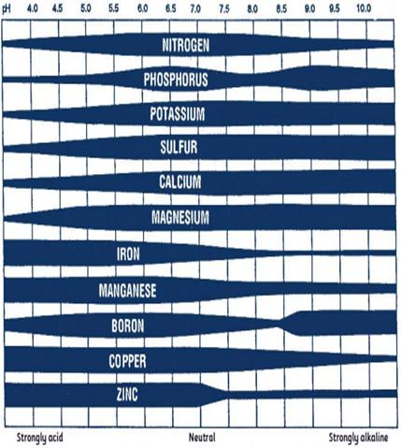

Motivation of Project :
The alarming situation of farmer’s suicide and the silent on the same; lead the idea to put the efforts in the design and development of a sophisticated soil testing and fertilizer recommendation system. As the agricultural productivity is mainly depends upon the soil condition which is mainly depends upon nutrients present in the soil. So, there is need of soil testing system. Based on soil analysis fertilizer should be recommended to the farmers in order to increase crop productivity and in turn increase the financial status of the farmers.

METHODOLOGIES :
Real time embedded based soil analyzer (RTEBSA) measures the pH value of soil and electrical conductivity (EC. .Soil pH value is used to identify the solutions or mixture acidity or basicity. Soil pH values start from the 0 to 14.The range of pH value below7 becomes acidity, above 7 becomes basicity and pH value7 is the neutral value. In the soil pH measurement, soil sample is mixed with the distilled water. After mixing, soil pH value calculated with help of the pH sensor. Soil’s most common pH value range is from 4 to 10. RTEBSA’s another calculating parameter is EC, measurement of the electrical conductivity shows the level of ability in the soil water has to carry an electrical current. The EC levels of the soil water are a good indication of the amount of nutrients available for the crops to absorb. In this system an EC sensor is used for Electric Conductivity measurement.
Measurement of Soil pH Value :
Soil pH is measured from soil solution using pH electrode. pH electrode has an output in mill-volts depending upon the pH value. pH electrode basically measures the hydrogen ion [H+] activity. Measurement of pH with pH electrode is based on the principle that potential is developed when twosolutions of different pH comes in contact through a thin glass membrane. Figure.3.2 shows the main parts of the pH electrode. PH electrode consists of glass electrode, a reference electrode and a metallic electrode [6]. pH is determined by measuring the potential between the two electrodes. At the tip of the sensor there is a thin membrane capable of ion exchange. The pH sensitive glass membrane of electrodes has an extremely low alkaline error and low electrical resistance thus ensuring fast and accurate response. We can supply these electrodes for pH range of 014.The Electrode is available KCL (Potassium Chloride Solution) filled versions and is supplied with one meter long cable and BNC plug. This electrode can be supplied with almost all makes of international and domestic meters. pH electrode model CA-11 provide by Toshniwal Company. For neutral solutions, i.e. at pH of 7 the output of pH electrodes is 0mV when ideally.
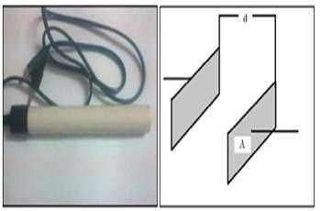

The output pH electrode is connected to the microcontroller. The signals generated by the sensors are sent to the ADC of inbuilt PIC18F microcontroller. The PIC18F accepts the signal and computes the soil pH. Microcontroller displays the three parameters of the soil on the LCD. These parameters are used to interpret the properties or quality of soil, treatment to be given to soil to make it suitable for plant growth.
Salinity/Conductivity of Soil:
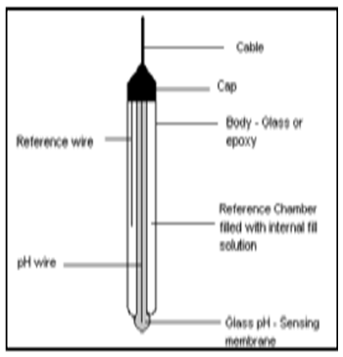
Ions are transported in soil through decomposition of minerals present in the soil, irrigation water, fertilizers or they may migrate upward in the soil from underground water. But when the rainfall is insufficient leach away the salts from soil or drainage system is poor, the salts accumulate in the soil. If this condition prevails over a long period, the result is excessive concentration of salts in soil and this excessive concentration/accumulation of salts in soil is termed as soil salinity. High soil salinity has a negative effect on plant growth. The main effect of soil salinity is osmotic effect. Different plants have different response to soil salinity.
When soil salinity exceeds the plant’s limit to handle salinity level, the growth of plants is reduced. Excessive accumulation of salts on the surface of the soil also results in the loss of soil permeability to air and water. Different plants have different response to soil salinity. Some plants are highly tolerant to soil salt concentration; some are moderately tolerant while some of the plants are very sensitive to soil salinity. They are able to absorb the water from soil with higher salt concentration in soil while salt sensitive plants have limited ability to adjust to soil salinity. The effect of salinity is less at emergence of plant as compared to mature plant. Soil salinity can be calculated with the help of electric conductivity sensors which is given.

Soil Moisture Sensor
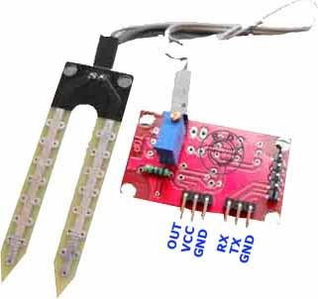
This sensor can be used to test the moisture of soil, when the soil is having water shortage, the module output is at high level, else the output is at low level. By using this sensor one can automatically water the flower plant, or any other plants requiring automatic watering technique. Module triple output mode, digital output is simple, analog output more accurate, serial output with exact readings.

Features
- Sensitivity adjustable.
- Has fixed bolt hole, convenient installation.
- Threshold level can be configured.
- Module triple output mode, digital output is simple, analog output more accurate, serial output with exact readings.

Applications
- Agriculture
- Landscape irrigation

Specifications

Parameter | Value
Operating Voltage | +5v dc regulated
Soil moisture | Digital value is indicated by out pin

Pin Details
Pin | Name | Details
1 | out | Active high output
2 | +5v | Power supply
3 | gnd | Power supply gnd
4 | rx | receiver
5 | tx | transmitter
6 | gnd | Power supply gnd

Using The Sensor
- Connect +5v to pin 2 and ground to pin 5 and 6.
- Pin 4 and 5 should be connected to particular transmitter and receiver pin of controller.
- Output pin may be connected to any port pins and can be used to any application.

Working
Soil moisture sensors measure the water content in soil. A soil moisture probe is made up of multiple soil moisture sensors. One common type of soil moisture sensors in commercial use is a Frequency domain sensor such as a capacitance sensor. Another sensor, the neutron moisture gauge, utilize the moderator properties of water for neutrons.
Soil moisture content may be determined via its effect on dielectric constant by measuring the capacitance between two electrodes implanted in the soil. Where soil moisture is predominantly in the form of free water (e.g., in sandy soils), the

dielectric constant is directly proportional to the moisture content. The probe is normally given a frequency excitation to permit measurement of the dielectric constant. The readout from the probe is not linear with water content and is influenced by soil type and soil temperature. Therefore, careful calibration is required and long-term stability of the calibration is questionable.

- In This sensor We are using 2 Probes to be dipped into the Soil
- As per Moisture We will get Analoug Output variations from 0.60volts - 5volts
- Input Voltage 5V DC

RELAY DRIVER:

How to Build a Relay Driver Circuit
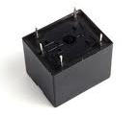
A relay driver circuit is a circuit which can drive, or operate, a relay so that it can function appropriately in a circuit.
The driven relay can then operate as a switch in the circuit which can open or close, according to the needs of the circuit and its operation.
In this project, we will build a relay driver for both DC and AC relays. Since DC and AC voltages operate differently, to build relay drivers for them requires slightly different setup. We will also go over a generic relay driver which can operate from either AC or DC voltage and operate both AC and DC relays.
All the circuits are relatively simple to understand.

DC Relay Driver Circuit
We will first go over how to build a relay driver circuit for relays which operate from DC power.
To drive a DC relay, all we need is sufficient DC voltage which the relay is rated for and a zener diode.
All relays come with a voltage rating. This is called on a relay's datasheet its rated coil voltage. This is the voltage needed in order for the relay to be able to operate and be able to open or close its switch in a circuit. In order for a relay to function, it must receive this voltage at its coil terminals. Thus, if a relay has a rated voltage of 9VDC, it must receive 9 volts of DC voltage to operate. So the most important thing a DC relay needs is its rated DC voltage. If you don't know this, look up what relay you have and look up its datasheet and check for this specification.
And the reason why a diode is needed is usually because it functions to eliminate voltage spikes from a relay circuit as the relay opens and closes. The coil of a relay acts an inductor. Remember that inductors are basically coils of wires wrapped around a conductive core. This is what relay coils are as well. Therefore, they act as inductors. Inductors are electronic components that resist changes in current. Inductors do not like sudden changes in current. If the flow of current through a coil is suddenly interrupted, for example, a switch opening, the coil will respond by producing a sudden, very large voltage across its leads, causing a large surge of current through it. From a physics or physical perspective, this phenomen is a result of a collapsing magnetic field within the coil as the current is terminated abruptly. Mathematically, this can be understood by noticing how a large change in current (dI/dt) affects the voltage across a coil (V=LdI/dt). Since we are opening the switch, in this case, the current literally goes from full mode to 0 instantaneously. This creates a large voltage spike. Surges in current that result from inductive effects can create very high voltage spikes (as high as 1000V) that can have nasty effects on neighboring devices with in the circuits, such as switches and transistors getting zapped. Not only are these voltage spikes damaging to other electronic components in a circuit but thye are also damaging to the relay's switch contacts. The contacts will suffer from these spikes as well.
So how do we prevent these voltage spikes? How can we suppress them so that they don't cause this damage? The answer for DC relay circuits is to use a diode. A diode is placed reverse biased in parallel with the relay. The diode acts as a transient suppressor. A transient is a spike. A transient suppressor suppresses these spikes. Placing a diode in reverse bias across a relay's coil eliminates voltage spikes by going into conduction before a large voltage can form across the coil. In other words, a diode will conduct current in reverse bias once the voltage reaches a certain threshold and shunt the current to ground. Once the diode begins conducting, it no longer holds voltage. So that the relay in parallel will not receive the excess voltage. So the diode functions to shunt excess power to ground once it reaches a certain threshold. Diodes are devices that do not conduct in reverse. However, if the voltage reaches a certain level, called the breakdown voltage, it will conduct. This is a good thing, when we need the diode to act as a transient suppressor, because it forces all excess power to ground, as to not affect any other parts of the circuit.
The diode must be rated to handle currents equivalent to the maximum current that woudl have been flowing through the coil before the supply current was interrupted. Therefore, if the relay normally passes a certain amount of current through it during normal operation, the diode must be rated for a current rating above this value, as to not stop normal operation.

Components Needed
- DC Relay
- Zener Diode
- DC Voltage Source

Again, the DC relay must receive its rated voltage value in order to operate.
The DC power source can be either batteries, wall wart power, or a DC power supply- any DC power source.
The zener diode is placed reverse biased in parallel to the relay.

DC Relay Driver Circuit Schematic
Below is the DC relay driver circuit which we will build:
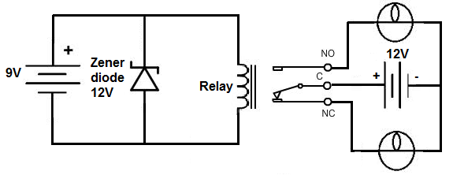
The relay which we use in this case is rated for 9V. Therefore, a 9-volt DC voltage source feeds the resistor. To suppress transients that may be caused by the relay opening and closing, we place a zener diode reverse biased in parallel with the relay. This will shunt all excess power to ground once it reaches a certain threshold. This is all that is needed to operate the relay. With sufficient power, the relay will now closed, driving the loads that are connected to its output.

How to Build an AC Relay Driver Circuit
Now we will show how to build an AC relay driver circuit.
This is a relay which is run, not off of DC power, but AC power.
To drive an AC relay, all we need is sufficient AC voltage which the relay is rated for and again a transient suppressor.
Unlike DC relays, however, you cannot use a diode to to eliminate voltage spikes. With AC power, the diode will conduct on alternate half-cycles. Using 2 diodes in reverse parallel will also not work because the current will not make it to the coil of the relay. The current will just go through the diodes. Instead, to create a working transient voltage suppressor with an AC circuit, we use an RC series newtwork placed across the coil in parallel. The capacitor absorbs excessive charge and the resistor helps to control the discharge.

Components Needed
- AC relay
- 0.05µF capacitor
- 100Ω Resistor
- AC Voltage Source

The AC voltage source will likely come from a plug plugged into a US wall outlet.
Warning: Be very careful with AC power coming directly from a wall outlet because it is lethal enough to cause shock. Please consult a professional before taking power directly from a plug in a wall outlet.

AC Relay Driver Circuit
The AC relay driver circuit we will build is shown below:
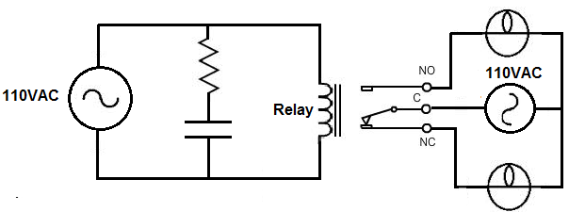
We, again, feed the AC relay the AC voltage it is rated for. If we use a relay with a rated voltage of 110VAC, we must feed it 110V from an AC power source. The capacitor and resistor in series acts as the transient voltage suppressor to suppress voltage spikes. This first half of the circuit serves as the relay driver. With the relay now having sufficient power, it will turn on and power the loads it is connected to.

Generic Relay Driver Circuit
The last relay driver circuit we will show is one which can be driven by an arbitrary control voltage.
This is a relay driver circuit which can be driven by either AC or DC input voltage. And unlike the other circuits, a specific voltage, such as the rated voltage values we used to drive the others, does not need to be used. Because this circuit contains a transistor, much less power needs to used on the input side to drive it.

Components Needed
- 6-9V Relay
- 2N2222 Transistor
- Zener diode
- 1KΩ Resistor
- 9V Battery or DC Power Supply
- Another input voltage source

Relay Driver Circuit
The circuit we will build is shown below:
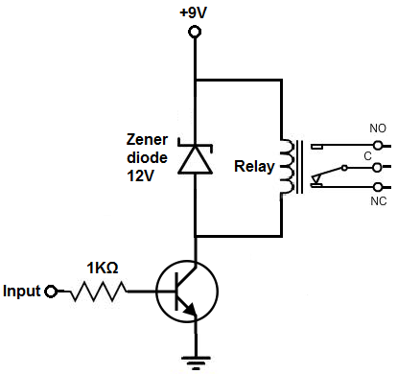
Now that we're using a transistor to drive the relay, we can use considerably less power to get the relay driven. Because a transistor is an amplifier, we just have to make sure that the base lead gets enough current to cause a larger current to flow from the emitter of the transistor to the collector. Once the base receives sufficient power, the transistor will conduct from emitter to collector and power the relay.
With no voltage or input current applied to the transistor's base lead, the transistor's emitter-to-collector channel is open, hence blocking current flow through the relay's coil. However, if sufficient voltage and input current are applied to the base lead, the transistor's emitter-to-collector channel will open, allowing current to flow through the relay's coil.

Relay Driver Circuit
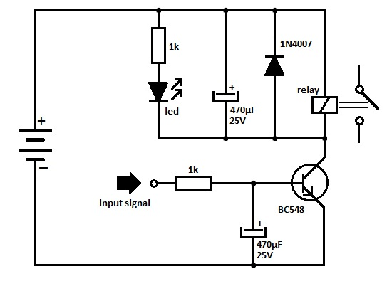
transistor relay driver circuit schematic
Another 470uF capacitor is added parallel to the relay coil which maintains steady current through the relay coil so that relay clicking can be avoided if the power supply varies momentarily.
IN 4007 diode eliminates back e.m.f when the relay switches off and protects the transistor. LED indicates the on status of the relay
What is a relay? How can we connect relay to a circuit? What is relay driver? These are some of the common doubts of an electronics beginner. Don’t worry, here CG will guide you with the basic concepts and working of relays..!Relays were invented in 1835 by an American scientist Joseph Henry. You can turn on larger electrical machines and electrical appliances by sensor currents with the help of relays. When the relay coil is energized by a small current, the coil will attract a common contact to another contact making the circuit closed.

Relay Driver IC Circuit
Relays are components that permit a low-power circuit to control signals or to switch high current ON and OFF which should be electrically isolated from controlling circuit.
The Required Components
- Zener Diode
- 6-9V Relay
- 9V Battery or DC Power Supply
- 2N2222 Transistor
- 1K Ohm Resistor
- Second Input Voltage Source
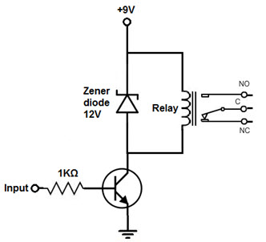
Relay Driver IC Circuit
In order to drive the relay, we use transistor and only less power can be possibly used to get the relay driven. Since, transistor is an amplifier so the base lead receives sufficient current to make more current flow from Emitter of Transistor to Collector. If the base once gets power that is sufficient, then the transistor conduct from Emitter to Collector and power the relay.
The Transistor’s emitter-to-collector channel will be opened even though no input current or voltage is applied to Base lead of Transistor. Therefore, blocking current flows through relay coil.
The emitter-to-collector channel will be opened and allows current to flow through relay’s coil if enough current or voltage is applied as input to the base lead. AC or DC Current can be used to power the relay and circuit.Relays are electromagnetic devices which allow low-power circuit to switch a high current ON and OFF switching devices with the help of an armature that is moved by an electromagnet.
Driver Circuit is used to boost or amplify signals from micro-controllers to control power switches in semi-conductor devices. Driver circuits take functions that include isolating the control circuit and the power circuit, detecting malfunctions, storing and reporting failures to the control system, serving as a precaution against failure, analyzing sensor signals and creating auxiliary voltages.

Driver Circuits
A typical digital logic output pin supplies only tens of MA of current. External devices such as high-power LEDs, motors, speakers, light bulbs, buzzers, solenoids and relays can require hundreds of MA and they need same voltages. In order to control small devices which use DC, a transistor-based driver circuit is used to amplify current to the required levels. If the voltage and current levels are in perfect range, the transistor acts like a high-current switch controlled by the lower current digital logic signal. A discrete BJT is used at times in place of MOSFET transistor especially on older or low voltage circuits as shown below.
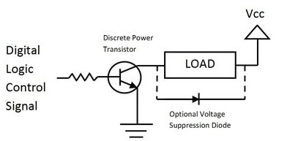
Driver Circuit

Basic Driver Circuit using a BJT Transistor
PNP, NPN, or MOS transistors are also be used. Transistor provides current gain. The resistor used on the base of the transistor is 1K ohm. On inductive loads (i.e., motors, solenoids, relays), a diode is often connected backwards across the load to suppress the voltage spikes (back EMF) generated when turning devices OFF.
Inductor V = L* di/dt
A negative voltage spike is produced when turning the device OFF. A diode is also connected across the transistor instead of the load sometimes in order to protect the transistor. The 2N3904 shown below is a small discrete BJT transistor is used for a driver circuit that required less than 200MA. In this circuit with BJTs, Vcc – higher voltage supply than the logic power supply and 6 or 12V DC is required for motors or relays.
The load is directly connected to battery power and cannot passed through the voltage regulator in battery operated devices. Many devices such as motors have more inflow current spike when they are first turned ON. Be cautious on maximum current ratings.
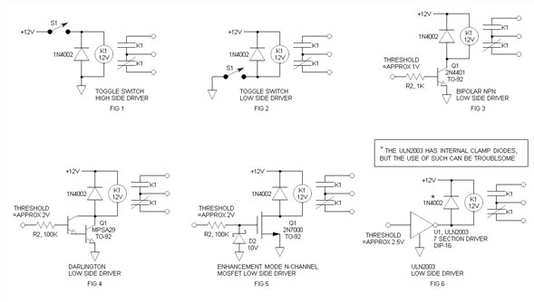
Relay Driver Circuits

Advantages of Low Side Driver
More interface options are available which includes popular ULN2003 driver.
- Easy to interface to low voltage logic circuitry.
- Fewer components are used.
- Less expensive NPN drive transistors.
- Relay power reduces load on voltage regulator.
- It uses more commonly obtained NPN drive transistors.
- It is easier to interface relay.
- It is economic.
- Uses Industry standard technique.
The ULN2003 has internal clamp diodes. While these work OK in non-critical applications and it leads to rise of glitches.

Clamp Diode
The clamp, free-wheeling or commutation diode provides a path for the inductive discharge current to flow when the driver switch is opened. If not provided, it will generate an arc in the switch—while the arc will not generally damage a switch contact, it will cause contact degradation over time—and yes, it will destroy transistors—been there, done that. The diode requirements are non-critical and a 1N4148 signal diode will generally work OK in low power applications.
Avoid emitter follower drivers. If the relay is switched to OFF in 4007 diode eliminates back e.m.f and safe guards the transistor. ON status of the relay is indicated by LED.

DC Relay Driver IC Circuit
Let us see construction of relay driver circuit for relays that are operated from DC power. In order to drive a DC relay, DC voltage is needed in required quantity to rate a relay and a zener diode.Voltage is required for the relay to operate and to open or close its switch in a circuit. Relays exist with a voltage rating. This is known as relay’s datasheet to rate its coil voltage. For the function of relay, it must receive this voltage at its coil terminals. Thus, if a relay has a rated voltage of 9VDC, it should get 9 volts of DC voltage for its working. In order to eliminate voltage spikes from a relay circuit, a diode is required for its proper functioning. The coil of a relay acts an Inductor.
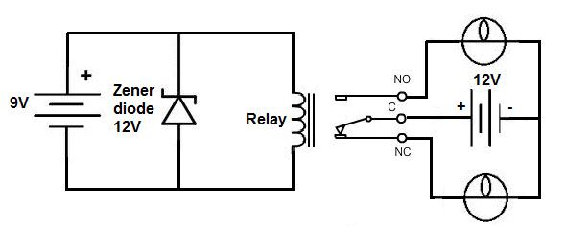
DC Relay Driver Circuit
The inductors are electronic components which withstand changes in current and also the inductors are coils of wires wrapped around a conductive core. Voltage spikes damages all components in a circuit and also damages relay’s switch contacts. To prevent these voltage spikes, a diode is kept reverse biased in parallel with the relay which acts as a transient (spike) suppressor eliminates voltage spikes by going into conduction before voltage is formed across the coil. A transient suppressor suppresses these spikes. A diode conducts reverse bias current if voltage reaches a certain threshold. The diode functions to shunt excess power to ground, and the diodes conduct if the voltage reaches breakdown voltage.

The Required Components
- DC Relay
- Zener Diode
- DC Voltage Source or a DC power supply.
The zener diode is placed reverse biased in parallel to the relay.
The Relay used in the above is rated for 9Volts. In this a 9V DC Voltage source feeds the resistor. A Zener diode reverse biased is placed in order to suppress the transients caused by opening and closing the relay. This shunts all excess power to ground if it reaches a particular threshold. This is the process to operate a relay. Driving the loads which were connected to the output taking required power the relay will be closed.

AC Relay Driver IC Circuit
This AC Relay driver IC circuit is a relay that runs with AC power and cannot be run with DC power. In order to run an AC relay, enough AC voltage is required tp rate the relay and transient suppressor. In AC relay circuit we cannot use a diode to remove voltage spikes. This diode conducts an alternate half-cycle with AC power. We use an RC series network by placing across coil in parallel to form a working transient voltage suppressor with an AC circuit. Capacitor absorbs charge which comes excessively and resistor helps to control overflow.Components required to form the circuit is as follows
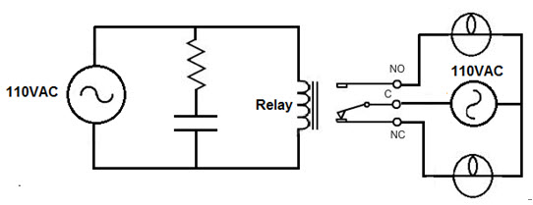
AC Relay Driver Circuit
- AC Relay
- 100 Ohm Resistor
- 0.05 Micro Farad Capacitor
- AC Voltage Source
NOTE: AC voltage source may come out from plug that is inserted into US wall outlet.
Be careful with AC Power that comes out directly from wall outlet as it causes Shock. Consult a Professional before taking power from plug into wall outlet.
When we use a relay with rated voltage 110VAC, we should feed it with 110V from an AC power source. To suppress voltage spikes, resistor and capacitor connected in series acts as transient voltage suppressor.

Relay Driver IC ULN2003
The relay driver uln2003 ic is a high voltage and current darlington array ic, it comprises of 7-open collector darlington pairs with common emitters. A pair of darlington is an arrangement of two bipolar transistors. This IC belongs to the family of ULN200x ICs and various types of this family interface to various logic families. This ULN2003 IC is for 5V TTL and CMOS logic devices. These ICs are used as relay drivers as well as to drive a wide range of loads, line drivers, display drivers etc. This IC is also normally used while driving Stepper Motors. The pairs of darlington in ULN2003 is esteemed at 500mA and can withstand peak current of 600mA.In the pin layout, the i/ps & o/ps are provided reverse to each other. Each driver also has a suppression diode to dissipate voltage spikes while driving inductive loads
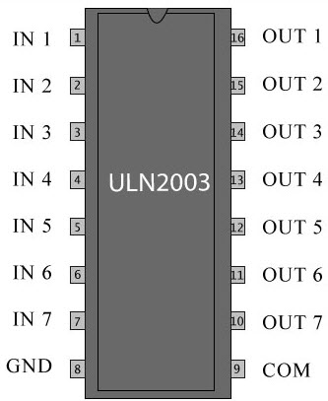
Relay Driver IC ULN2003
This project is designed for a three-phase-solid-state relay system. It incorporates three single-phase units wherein each phase is controlled individually by power TRIAC with RC snubber network for a zero-voltage switching (ZVS).
Opto-isolators are used in each phase to receive switching signals from a microcontroller of the 8051 family, loads are connected in series with a set of TRIACS driven by an opto-isolator. The microcontroller is designed to generate output pulses after zero voltage pulse to ensure that the load gets switched on at zero cross of the supply waveform.
The zero crossing feature of the TRIAC driver, (an opto-isolator) ensures low noise generation thus avoiding sudden inrush of current on resistive and inductive loads. In this project, two push buttons are used for generating the output pulses from the microcontroller randomly, away from the ZVS ie not coinciding with zero voltage supply voltage of the waveform.
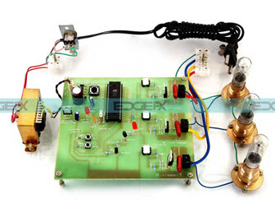
Semiconductor Relay with ZVS Project Kit by Edgefxkits.com
Thus the lamp which is used as a load is forced to switch on and off at non ZVS points but the final switch happens at the next ZVS only. Using CRO or DSO we can see the waveform of voltage supplied to load for verifying the switching ON/ OFF the load at zero voltage point.
Furthermore, this project can be enhanced by using 2 back-to-back SCRs, in each phase for heavy load switching as used in industries. Over load and short circuit protection can also be incorporated for higher reliability.

Circuit Options Explore Issues, Solutions For Relay Drivers
Relays usually are driven using optocouplers, which offer isolation between analog and digital grounds to ensure that switching currents in the relay coils do not affect the noise margin of the digital circuit. For driving a large number of relays through a bus-based backplane, the on-board complex programmable logic device (CPLD)/FPGA provides the interfacing and diagnostics to the I/O board.
A ULN2803 Darlington transistor with base current controlled by the optocoupler drives the relay. To minimize power for CPLDs, their outputs are connected to the cathode of the optocoupler, while the anode is connected to either +5 V through a current-limiting resistor.
In a typical backplane bus-based system, +5 V and +24 V are used for powering the digital logic and relay coil, respectively. The problem begins when we independently switch off the digital-circuitry power supply before the relay-coil supply. In the circuit of Figure 1, the CPLD has to output a logic “1” (+5 V) to ensure that the relay is switched off. When the digital power supply is switched off, the power supply begins to decay, with the time constant depending on the load.
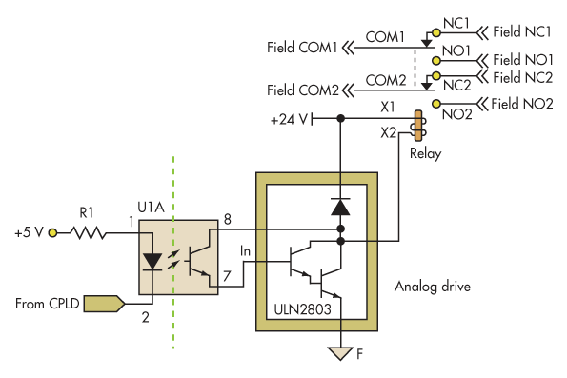
As +5 V reaches 2.5 V, the CPLD output goes to logic zero, causing the optocoupler to switch the Darlington transistor ON. This, in turn, energizes the relay. As the power supply decays to +1.2 V, it turns the optocoupler off, which in turn de-energizes the relay. This intermittent energizing of relays can cause problems in critical applications due to improper power sequencing.
For example, the relay may be driving a safety valve and a power switch-off would cause the safety valve to actuate or de-actuate, resulting in a critical process disturbance. A similar event takes place during power-on, when +5 V ramps up slower than +24 V.
The blue and pink lines in Figure 2 represent the +5 V and relay’s normally open (NO) contact, respectively. The duration of the energization is directly related to the time between the +2.5-V to +1.2-V transition, after which the relay gets permanently de-energized.
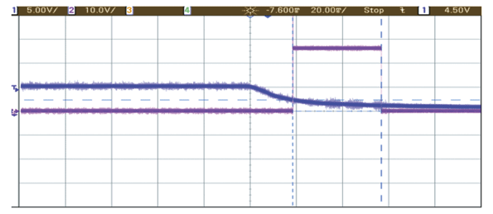

PIC CONTROLLER
PIC is a family of modified Harvard architecture microcontrollers made by Microchip Technology, derived from the PIC1650 originally developed by General Instrument's Microelectronics Division. The name PIC initially referred to "Peripheral Interface Controller" now it is "PIC" only.
PICs are popular with both industrial developers and hobbyists alike due to their low cost, wide availability, large user base, extensive collection of application notes, availability of low cost or free development tools, and serial programming (and re-programming with flash memory) capability.
INTRODUCTION
The original PIC was built to be used with General Instrument's new CP1600 16-bit CPU. While generally a good CPU, the CP1600 had poor I/O performance, and the 8-bit PIC was developed in 1975 to improve performance of the overall system by offloading I/O tasks from the CPU. The PIC used simple microcode stored in ROM to perform its tasks, and although the term was not used at the time, it shares some common features with RISC designs.
In 1985, General Instrument spun off their microelectronics division and the new ownership cancelled almost everything which by this time was mostly out-of-date. The PIC, however, was upgraded with an internal EPROM to produce a programmable channel controller. Today a huge variety of PICs are available with various on-board peripherals (serial communication modules, UARTs, motor control kernels, etc.) and program memory from 256 words to 64k words and more (a "word" is one assembly language instruction, varying from 8, 12, 14 or 16 bits depending on the specific PIC micro family).
PIC and PIC micro are registered trademarks of Microchip Technology. It is generally thought that PIC stands for Peripheral Interface Controller, although General Instruments' original acronym for the initial PIC1640 and PIC1650 devices was "Programmable Interface Controller". The acronym was quickly replaced with "Programmable Intelligent Computer".
The Microchip 16C84 (PIC16x84), introduced in 1993, was the first[citation needed] Microchip CPU with on-chip EEPROM memory. This electrically erasable memory made it cost less than CPUs that required a quartz "erase window" for erasing EPROM. By 2013, Microchip was shipping over one billion PIC microcontrollers every year.
Core architecture
The PIC architecture is characterized by its multiple attributes:
- Separate code and data spaces (Harvard architecture).
- A small number of fixed length instructions
- Most instructions are single cycle execution (2 clock cycles, or 4 clock cycles in 8-bit models), with one delay cycle on branches and skips
- One accumulator (W0), the use of which (as source operand) is implied (i.e. is not encoded in the opcode)
- All RAM locations function as registers as both source and/or destination of math and other functions.
- A hardware stack for storing return addresses
- A small amount of addressable data space (32, 128, or 256 bytes, depending on the family), extended through banking
- Data space mapped CPU, port, and peripheral registers
- ALU status flags are mapped into the data space
- The program counter is also mapped into the data space and writable (this is used to implement indirect jumps).
There is no distinction between memory space and register space because the RAM serves the job of both memory and registers, and the RAM is usually just referred to as the register file or simply as the registers.
Data space (RAM)
PICs have a set of registers that function as general purpose RAM. Special purpose control registers for on-chip hardware resources are also mapped into the data space. The addressability of memory varies depending on device series, and all PIC devices have some banking mechanism to extend addressing to additional memory. Later series of devices feature move instructions which can cover the whole addressable space, independent of the selected bank. In earlier devices, any register move had to be achieved via the accumulator.
To implement indirect addressing, a "file select register" (FSR) and "indirect register" (INDF) are used. A register number is written to the FSR, after which reads from or writes to INDF will actually be to or from the register pointed to by FSR. Later devices extended this concept with post- and pre- increment/decrement for greater efficiency in accessing sequentially stored data. This also allows FSR to be treated almost like a stack pointer (SP).
External data memory is not directly addressable except in some high pin count PIC18 devices.
Code space
The code space is generally implemented as ROM, EPROM or flash ROM. In general, external code memory is not directly addressable due to the lack of an external memory interface. The exceptions are PIC17 and select high pin count PIC18 devices.
Word size
All PICs handle (and address) data in 8-bit chunks. However, the unit of addressability of the code space is not generally the same as the data space. For example, PICs in the baseline (PIC12) and mid-range (PIC16) families have program memory addressable in the same word size as the instruction width, i.e. 12 or 14 bits respectively. In contrast, in the PIC18 series, the program memory is addressed in 8-bit increments (bytes), which differs from the instruction width of 16 bits.
In order to be clear, the program memory capacity is usually stated in number of (single word) instructions, rather than in bytes.
Stacks
PICs have a hardware call stack, which is used to save return addresses. The hardware stack is not software accessible on earlier devices, but this changed with the 18 series devices.
Hardware support for a general purpose parameter stack was lacking in early series, but this greatly improved in the 18 series, making the 18 series architecture more friendly to high level language compilers.
Instruction set
A PIC's instructions vary from about 35 instructions for the low-end PICs to over 80 instructions for the high-end PICs. The instruction set includes instructions to perform a variety of operations on registers directly, the accumulator and a literal constant or the accumulator and a register, as well as for conditional execution, and program branching.
Some operations, such as bit setting and testing, can be performed on any numbered register, but bi-operand arithmetic operations always involve W (the accumulator), writing the result back to either W or the other operand register. To load a constant, it is necessary to load it into W before it can be moved into another register. On the older cores, all register moves needed to pass through W, but this changed on the "high end" cores.
PIC cores have skip instructions which are used for conditional execution and branching. The skip instructions are 'skip if bit set' and 'skip if bit not set'. Because cores before PIC18 had only unconditional branch instructions, conditional jumps are implemented by a conditional skip (with the opposite condition) followed by an unconditional branch. Skips are also of utility for conditional execution of any immediate single following instruction. It is possible to skip skip instructions. For example, the instruction sequence "skip if A; skip if B; C" will execute C if A is true or if B is false.
The 18 series implemented shadow registers which save several important registers during an interrupt, providing hardware support for automatically saving processor state when servicing interrupts.
In general, PIC instructions fall into 5 classes:
Operation on working register (WREG) with 8-bit immediate ("literal") operand. E.g. movlw (move literal to WREG), andlw (AND literal with WREG). One instruction peculiar to the PIC is retlw, load immediate into WREG and return, which is used with computed branches to produce lookup tables.
Operation with WREG and indexed register. The result can be written to either the Working register (e.g. addwf reg,w). or the selected register (e.g. addwf reg,f).
Bit operations.
These take a register number and a bit number, and perform one of 4 actions: set or clear a bit, and test and skip on set/clear. The latter are used to perform conditional branches. The usual ALU status flags are available in a numbered register so operations such as "branch on carry clear" are possible.
Control transfers.
Other than the skip instructions previously mentioned, there are only two: goto and call. A few miscellaneous zero-operand instructions, such as return from subroutine, and sleep to enter low-power mode.
Performance
The architectural decisions are directed at the maximization of speed-to-cost ratio. The PIC architecture was among the first scalar CPU designs, and is still among the simplest and cheapest. The Harvard architecture—in which instructions and data come from separate sources—simplifies timing and microcircuit design greatly, and this benefits clock speed, price, and power consumption.
The PIC instruction set is suited to implementation of fast lookup tables in the program space. Such lookups take one instruction and two instruction cycles. Many functions can be modeled in this way. Optimization is facilitated by the relatively large program space of the PIC (e.g. 4096 × 14-bit words on the 16F690) and by the design of the instruction set, which allows for embedded constants. For example, a branch instruction's target may be indexed by W, and execute a "RETLW" which does as it is named - return with literal in W.
Interrupt latency is constant at three instruction cycles. External interrupts have to be synchronized with the four clock instruction cycle, otherwise there can be a one instruction cycle jitter. Internal interrupts are already synchronized. The constant interrupt latency allows PICs to achieve interrupt driven low jitter timing sequences. An example of this is a video sync pulse generator. This is no longer true in the newest PIC models, because they have a synchronous interrupt latency of three or four cycles.
Advantages
- Small instruction set to learn
- RISC architecture
- Built in oscillator with selectable speeds
- Easy entry level, in-circuit programming plus in-circuit debugging PICKit units available for less than $50
- Inexpensive microcontrollers
- Wide range of interfaces including I²C, SPI, USB, USART, A/D, programmable comparators, PWM, LIN, CAN, PSP, and Ethernet[9]
- Availability of processors in DIL package make them easy to handle for hobby use.
Limitations
- One accumulator
- Register-bank switching is required to access the entire RAM of many devices
- Operations and registers are not orthogonal; some instructions can address RAM and/or immediate constants, while others can use the accumulator only.
- The following stack limitations have been addressed in the PIC18 series, but still apply to earlier cores:
- The hardware call stack is not addressable, so preemptive task switching cannot be implemented
- Software-implemented stacks are not efficient, so it is difficult to generate reentrant code and support local variables
- With paged program memory, there are two page sizes to worry about: one for CALL and GOTO and another for computed GOTO (typically used for table lookups). For example, on PIC16, CALL and GOTO have 11 bits of addressing, so the page size is 2048 instruction words. For computed GOTOs, where you add to PCL, the page size is 256 instruction words. In both cases, the upper address bits are provided by the PCLATH register. This register must be changed every time control transfers between pages. PCLATH must also be preserved by any interrupt handler.
DIFFERENT ARCHITECTURE
PICmicro chips have a Harvard architecture, and instruction words are unusual sizes. Originally, 12-bit instructions included 5 address bits to specify the memory operand, and 9-bit branch destinations. Later revisions added opcode bits, allowing additional address bits.
Baseline core devices (12 bit)
These devices feature a 12-bit wide code memory, a 32-byte register file, and a tiny two level deep call stack. They are represented by the PIC10 series, as well as by some PIC12 and PIC16 devices. Baseline devices are available in 6-pin to 40-pin packages.
Generally the first 7 to 9 bytes of the register file are special-purpose registers, and the remaining bytes are general purpose RAM. Pointers are implemented using a register pair: after writing an address to the FSR (file select register), the INDF (indirect f) register becomes an alias for the addressed register. If banked RAM is implemented, the bank number is selected by the high 3 bits of the FSR. This affects register numbers 16–31; registers 0–15 are global and not affected by the bank select bits.
Because of the very limited register space (5 bits), 4 rarely read registers were not assigned addresses, but written by special instructions (OPTION and TRIS).
The ROM address space is 512 words (12 bits each), which may be extended to 2048 words by banking. CALL and GOTO instructions specify the low 9 bits of the new code location; additional high-order bits are taken from the status register. Note that a CALL instruction only includes 8 bits of address, and may only specify addresses in the first half of each 512-word page.
The instruction set is as follows. Register numbers are referred to as "f", while constants are referred to as "k". Bit numbers (0–7) are selected by "b". The "d" bit selects the destination: 0 indicates W, while 1 indicates that the result is written back to source register f. The C and Z status flags may be set based on the result; otherwise they are unmodified. Add and subtract (but not rotate) instructions that set C also set the DC (digit carry) flag, the carry from bit 3 to bit 4, which is useful for BCD arithmetic.
ELAN Microelectronics clones (13 bit)
ELAN Microelectronics Corp. make a series of PIC micro-like microcontrollers with a 13-bit instruction word. The instructions are mostly compatible with the mid-range 14-bit instruction set, but limited to a 6-bit register address (16 special-purpose registers and 48 bytes of RAM) and a 10-bit (1024 word) program space.
The 10-bit program counter is accessible as R2. Reads access only the low bits, and writes clear the high bits. An exception is the TBL instruction, which modifies the low byte while preserving bits 8 and 9.
The 7 accumulator-immediate instructions are renumbered relative to the 14-bit PIC micro, to fit into 3 op code bits rather than 4, but they are all there, as well as an additional software interrupt instruction.
There are a few additional miscellaneous instructions, and there are some changes to the terminology (the PICmicro OPTION register is called the CONTrol register; the PICmicro TRIS registers 1–3 are called I/O control registers 5–7), but the equivalents are obvious.
Mid-range core devices (14 bit)
These devices feature a 14-bit wide code memory, and an improved 8 level deep call stack. The instruction set differs very little from the baseline devices, but the 2 additional opcode bits allow 128 registers and 2048 words of code to be directly addressed. There are a few additional miscellaneous instructions, and two additional 8-bit literal instructions, add and subtract. The mid-range core is available in the majority of devices labeled PIC12 and PIC16.
The first 32 bytes of the register space are allocated to special-purpose registers; the remaining 96 bytes are used for general-purpose RAM. If banked RAM is used, the high 16 registers (0x70–0x7F) are global, as are a few of the most important special-purpose registers, including the STATUS register which holds the RAM bank select bits. (The other global registers are FSR and INDF, the low 8 bits of the program counter PCL, the PC high preload register PCLATH, and the master interrupt control register INTCON.)
The PCLATH register supplies high-order instruction address bits when the 8 bits supplied by a write to the PCL register, or the 11 bits supplied by a GOTO or CALL instruction, is not sufficient to address the available ROM space.

PIC17 high end core devices (16 bit)
The 17 series never became popular and has been superseded by the PIC18 architecture. It is not recommended for new designs, and availability may be limited.
Improvements over earlier cores are 16-bit wide opcodes (allowing many new instructions), and a 16 level deep call stack. PIC17 devices were produced in packages from 40 to 68 pins.
The 17 series introduced a number of important new features:
- a memory mapped accumulator
- read access to code memory (table reads)
- direct register to register moves (prior cores needed to move registers through the accumulator)
- an external program memory interface to expand the code space
- an 8-bit × 8-bit hardware multiplier
- a second indirect register pair
- auto-increment/decrement addressing controlled by control bits in a status register (ALUSTA)

PIC18 high end core devices (8 bit)
In 2000, Microchip introduced the PIC18 architecture. Unlike the 17 series, it has proven to be very popular, with a large number of device variants presently in manufacture. In contrast to earlier devices, which were more often than not programmed in assembly, C has become the predominant development language.
The 18 series inherits most of the features and instructions of the 17 series, while adding a number of important new features:
- call stack is 21 bits wide and much deeper (31 levels deep)
- the call stack may be read and written (TOSU:TOSH:TOSL registers)
- conditional branch instructions
- indexed addressing mode (PLUSW)
- extending the FSR registers to 12 bits, allowing them to linearly address the entire data address space
- the addition of another FSR register (bringing the number up to 3)
The RAM space is 12 bits, addressed using a 4-bit bank select register and an 8-bit offset in each instruction. An additional "access" bit in each instruction selects between bank 0 (a=0) and the bank selected by the BSR (a=1).
A 1-level stack is also available for the STATUS, WREG and BSR registers. They are saved on every interrupt, and may be restored on return. If interrupts are disabled, they may also be used on subroutine call/return by setting the s bit (appending ", FAST" to the instruction).
The auto increment/decrement feature was improved by removing the control bits and adding four new indirect registers per FSR. Depending on which indirect file register is being accessed it is possible to postdecrement, postincrement, or preincrement FSR; or form the effective address by adding W to FSR.
In more advanced PIC18 devices, an "extended mode" is available which makes the addressing even more favorable to compiled code:
- a new offset addressing mode; some addresses which were relative to the access bank are now interpreted relative to the FSR2 register
- the addition of several new instructions, notable for manipulating the FSR registers.
These changes were primarily aimed at improving the efficiency of a data stack implementation. If FSR2 is used either as the stack pointer or frame pointer, stack items may be easily indexed—allowing more efficient re-entrant code. Microchip's MPLAB C18 C compiler chooses to use FSR2 as a frame pointer.

PIC32 32-bit microcontrollers
In November 2007, Microchip introduced the new PIC32MX family of 32-bit microcontrollers. The initial device line-up is based on the industry standard MIPS32 M4K Core. The device can be programmed using the Microchip MPLAB C Compiler for PIC32 MCUs, a variant of the GCC compiler. The first 18 models currently in production (PIC32MX3xx and PIC32MX4xx) are pin to pin compatible and share the same peripherals set with the PIC24FxxGA0xx family of (16-bit) devices allowing the use of common libraries, software and hardware tools. Today starting at 28 pin in small QFN packages up to high performance devices with Ethernet, CAN and USB OTG, full family range of mid-range 32-bit microcontrollers are available.
The PIC32 architecture brings a number of new features to Microchip portfolio, including:
- The highest execution speed 80 MIPS (120+[21] Dhrystone MIPS @ 80 MHz)
- The largest flash memory: 512 KB
- One instruction per clock cycle execution
- The first cached processor
- Allows execution from RAM
- Full Speed Host/Dual Role and OTG USB capabilities
- Full JTAG and 2 wire programming and debugging
- Real-time trace
- 5.1. POWER SUPPLY
- Definition:
- A power supply (sometimes known as a power supply unit or PSU) is a device or system that supplies electrical or other types of energy to an output load or group of loads. The term is most commonly applied to electrical energy supplies, less often to mechanical ones, and rarely to others.
- 5.1.1. POWER SUPPLY UNIT BLOCK
- All digital circuits work only with low DC voltage. A power supply unit is required to provide the appropriate voltage supply. This unit consists of transformer, rectifier, filter and a regulator. AC voltage typically of 230Vrms is connected to a transformer which steps that AC voltage down to the desired AC voltage level. A diode rectifier then provides a full wave rectified voltage that is initially filtered by a simple capacitor filter to produce a DC voltage. This resulting DC voltage usually has some ripple or AC voltage variations. Regulator circuit can use this DC input to provide DC voltage that not only has much less ripple voltage but also remains in the same DC value, even when the DC voltage varies, or the load connected to the output DC voltage changes. The required DC supply is obtained from the available AC supply after rectification, filtration and regulation. Block diagram of power supply unit is shown in Figure 2.1
AC SUPPLY
TRANSFORMER
RECTIFIER
FILTER
VOLTAGE
REGULATOR
DC SUPPLY

- Figure 5.1 Power Supply Block Diagram
- The main components used in the power supply unit are Transformer, Rectifier, Filter and Regulator. The 230V AC supply is converted into 9V AC supply through the transformer. The output of the transformer has the same frequency as in the input AC power. This AC power is converted into DC power through diodes. Here the bridge diode is used to convert AC supply to the DC power supply. This converted DC power supply has the ripple content and for normal operation of the circuit, the ripple content of the DC power supply should be as low as possible. Because the ripple content of the power supply will reduce the life of the circuit. So to reduce the ripple content of the DC power supply, the large value of capacitance filter is used.
- This filtered output will not be the regulated voltage. For this purpose IC7805 regulator IC is used in the circuit.
- TRANSFORMER
- Transformer is a device used either for stepping-up or stepping-down the AC supply voltage with a corresponding decreases or increases in the current. Here, a transformer is used for stepping-down the voltage so as to get a voltage that can be regulated to get a constant 5V.
- RECTIFIER
- A rectifier is a device like semiconductor, capable of converting sinusoidal input waveform units into a unidirectional waveform, with a nonzero average component.
- FILTERS
- Capacitors are used as filters in the power supply unit. The action of the system depends upon the fact, that the capacitors stores energy during the conduction period and delivers this energy to the load during the inverse or non-conducting period. In this way, time during which the current passes through the load is prolonged and ripple is considerably reduced.
- VOLTAGE REGULATOR
- The LM78XX is three terminal regulator available with several fixed output voltages making them useful in a wide range of applications. IC7805 is a fixed voltage regulators used in this circuit.
- Circuit diagram of such power supply is as shown in Figure 3.2
- 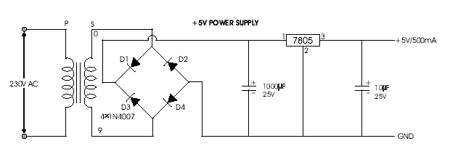
- Figure 5.1.1 Five Volts Power Supply

TRANSFORMER
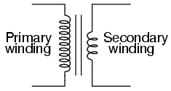
A transformer is a static device that transfers electrical energy from one circuit to another through inductively coupled conductors—the transformer's coils. A varying current in the first or primary winding creates a varying magnetic flux in the transformer's core and thus a varying magnetic field through the secondary winding. This varying magnetic field induces a varying electromotive force (EMF) or "voltage" in the secondary winding. This effect is called mutual induction

Fig 5.1.1 Transformer

This is a very useful device, indeed. With it, we can easily multiply or divide voltage and current in AC circuits. Indeed, the transformer has made long-distance transmission of electric power a practical reality, as AC voltage can be “stepped up” and current “stepped down” for reduced wire resistance power losses along power lines connecting generating stations with loads. At either end (both the generator and at the loads), voltage levels are reduced by transformers for safer operation and less expensive equipment. A transformer that increases voltage from primary to secondary (more secondary winding turns than primary winding turns) is called a step-up transformer. Conversely, a transformer designed to do just the opposite is called a step-down transformer.
This is a step-down transformer, as evidenced by the high turn count of the primary winding and the low turn count of the secondary. As a step-down unit, this transformer converts high-voltage, low-current power into low-voltage, high-current power. The larger-gauge wire used in the secondary winding is necessary due to the increase in current. The primary winding, which doesn't have to conduct as much current, may be made of smaller-gauge wire.

POTENTIAL TRANSFORMER THEORY
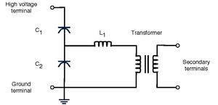
Figure 3.4. Potential Ttransformer
A voltage transformer theory or potential transformer theory is just like a theory of general purpose step down transformer. Primary of this transformer is connected across the phase and ground. Just like the transformer used for stepping down purpose, potential transformer i.e. PT has lower turns winding at its secondary. The system voltage is applied across the terminals of primary winding of that transformer, and then proportionate secondary voltage appears across the secondary terminals of the PT.
The secondary voltage of the PT is generally 110 V. In an ideal potential transformer or voltage transformer, when rated burden gets connected across the secondary; the ratio of primary and secondary voltages of transformer is equal to the turns ratio and furthermore, the two terminal voltages are in precise phase opposite to each other. But in actual transformer, there must be an error in the voltage ratio as well as in the phase angle between primary and secondary voltages.
Potential transformers (PT) (also called voltage transformers (VT)) are a parallel connected type of instrument transformer. They are designed to present negligible load to the supply being measured and have an accurate voltage ratio and phase relationship to enable accurate secondary connected metering.
CURRENT TRANSFORMER
A current transformer (CT) is used for measurement of alternating electric currents. Current transformers, together with voltage (or potential) transformers (VT or PT), are known as instrument transformers. When current in a circuit is too high to apply directly to measuring instruments, a current transformer produces a reduced current accurately proportional to the current in the circuit, which can be conveniently connected to measuring and recording instruments. A current transformer isolates the measuring instruments from what may be very high voltage in the monitored circuit. Current transformers are commonly used in metering and protective relays in the electrical power industry.

3.2.1. CT DESIGN
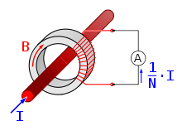
Figure 3.3.Current Transformer
Like any other transformer, a current transformer has a primary winding, a magnetic core and a secondary winding. The alternating current in the primary produces an alternating magnetic field in the core, which then induces an alternating current in the secondary winding circuit. An essential objective of current transformer design is to ensure the primary and secondary circuits are efficiently coupled, so the secondary current is linearly proportional to the primary current.
The most common design of CT consists of a length of wire wrapped many times around a silicon steel ring passed 'around' the circuit being measured. The CT's primary circuit therefore consists of a single 'turn' of conductor, with a secondary of many tens or hundreds of turns. The primary winding may be a permanent part of the current transformer, with a heavy copper bar to carry current through the magnetic core. Window-type current transformers (aka zero sequence current transformers, or ZSCT) are also common, which can have circuit cables run through the middle of an opening in the core to provide a single-turn primary winding. When conductors passing through a CT are not centered in the circular (or oval) opening, slight inaccuracies may occur.
Shapes and sizes can vary depending on the end user or switchgear manufacturer. Typical examples of low-voltage single ratio metering current transformers are either ring type or plastic molded case. High-voltage current transformers are mounted on porcelain insulators to isolate them from ground. Some CT configurations slip around the bushing of a high-voltage transformer or circuit breaker, which automatically centers the conductor inside the CT window.
Current transformers can be mounted on the low voltage or high voltage leads of a power transformer; sometimes a section of bus bar is arranged to be easily removed for exchange of current transformers.

3.2.2. CT USES

Many digital clamp meters utilize a current transformer for measuring alternating current (AC).Current transformers are used extensively for measuring current and monitoring the operation of the power grid. Along with voltage leads, revenue-grade CTs drive the electrical utility's watt-hour meter on virtually every building with three-phase service and single-phase services greater than 200 amperes.
The CT is typically described by its current ratio from primary to secondary. Often, multiple CTs are installed as a "stack" for various uses. For example, protection devices and revenue metering may use separate CTs to provide isolation between metering and protection circuits, and allows current transformers with different characteristics (accuracy, overload performance) to be used for the devices.
The primary circuit is largely unaffected by the insertion of the CT. The rated secondary current is commonly standardized at 1 or 5 amperes. For example, a 4000:5 CT secondary winding will supply an output current of 5 amperes when the primary winding current is 4000 amperes. The secondary winding can be single or multi-ratio, with five taps being common for multi-ratio CTs.
The load, or burden, of the CT should be a low resistance. If the voltage time integral area is higher than the core's design rating, the core goes into saturation toward the end of each cycle, distorting the waveform and affecting accuracy.

3.2.3.Accuracy of CT
The accuracy of a CT is directly related to a number of factors including:
- Burden
- Burden class/saturation class
- Rating factor
- Load
- External electromagnetic fields
- Temperature and
- Physical configuration.
- The selected tap, for multi-ratio CTs
- Phase change
For the IEC standard, accuracy classes for various types of measurement are set out in IEC 61869-1, Classes 0.1, 0.2s, 0.2, 0.5, 0.5s, 1 and 3. The class designation is an approximate measure of the CT's accuracy. The ratio (primary to secondary current) error of a Class 1 CT is 1% at rated current; the ratio error of a Class 0.5 CT is 0.5% or less. Errors in phase are also important especially in power measuring circuits, and each class has an allowable maximum phase error for a specified load impedance.
Current transformers used for protective relaying also have accuracy requirements at overload currents in excess of the normal rating to ensure accurate performance of relays during system faults. A CT with a rating of 2.5L400 specifies with an output from its secondary winding of 20 times its rated secondary current (usually 5 A × 20 = 100 A) and 400 V (IZ drop) its output accuracy will be within 2.5 percent.
3.2.4. APPLICATIONS
Current transformers are used for protection, measurement and control in high-voltage electrical substations and the electrical grid. Current transformers may be installed inside switchgear or in apparatus bushings, but very often free-standing outdoor current transformers are used. In a switchyard, live tank current transformers have a substantial part of their enclosure energized at the line voltage and must be mounted on insulators. Dead tank current transformers isolate the measured circuit from the enclosure. Live tank CTs are useful because the primary conductor is short, which gives better stability and a higher short-circuit current rating. The primary of the winding can be evenly distributed around the magnetic core, which gives better performance for overloads and transients. Since the major insulation of a live-tank current transformer is not exposed to the heat of the primary conductors, insulation life and thermal stability is improved.
A high-voltage current transformer may contain several cores, each with a secondary winding, for different purposes (such as metering circuits, control, or protection).A neutral current transformer is used as earth fault protection to measure any fault current flowing through the neutral line from the wye neutral point of a transformer.

CONCLUTION:
In this project, Real time embedded based soil analyzer (RTEBSA) is used to do analysis of various soil nutrients parameters with the help of the pH value and the, soils Electrical Conductivity (EC). Depends on the pH value, The availability of various nutrients is calculated. Based on the nutrient availability, recommendation for cultivating particular crop is also done. Expansion of Hardware implementation of Real Time Embedded Based Soil Analyzer (RTEBSA) will be done in hard copy of report generation and also fertilizer recommendation for the particular crop will be given.

