UNDERSTANDING DEPTH OF REFLECTIVE WRITING IN WORKPLACE LEARNINGASSESSMENTS USING MACHINE LEARNING CLASSIFICATION
ABSTRACT:
The collapse of Dam I, owned by Vale S.A, in Brumadinho-MG (Brazil), among other serious socioenvironmental consequences, contaminated the waters of the Paraopeba River in a stretch of hundreds of kilometers. Considering the relevance of monitoring water quality, and knowing that field evaluation is a time-consuming and costly procedure, the use of satellite images, widely available at low cost, emerges as a relevant alternative.This work proposes a systematic experimental evaluation of five machine learning methods - Extra Trees, Multilayer Perceptron, Naïve Bayes, Random Forest and Support Vector Machine, under different configurations and input data treatments, to classify the turbidity of the Paraopeba River waters from Sentinel-2 mission images.

EXISTING SYSTEM:
- Building upon the existing coding scheme by Kember et al. and extending the analytical approach by Kovanović et al. this study designed an automated machine learning system to classify learners.
- Considering some of these research gaps, our work goes beyond the existing approaches of understanding reflective practices within MOOCs, trying to detect the reflective depth exhibited by professionals within workplace learning, which is currently underexplored.

Disadvantage of Existing System
- In contrast, process reflection involves deliberating on the methods of problem-solving and their associated effectiveness and merit. Finally, when engaging in premise reflection, learners criticallyevaluate their fundamental beliefs and the presuppositions underlying their knowledge and reasons for attending to the problem.
- Additionally, the descriptive accounts allow proble-reframing and transverse through different hierarchical levels of reflection
PROPOSED SYSTEM :
- The proposed approach can effectively support the deployment at scale of the labor-intensive evaluation of reflective writing by highly trained professionals.
- The proposed approach can effectively support the deployment at scale of the labor-intensive evaluation of reflective writing by highly trained professionals
- This study focused on developing an automated classification system to categorize learners' reflections into four levels, according to the proposed coding scheme and explore the features that contribute towards this classification of professional development through leadership learning.

ADVANTAGE:
- Considering the relevance of monitoring water quality, and knowing that field evaluation is a time-consuming and costly procedure, the use of satellite images, widely available at low cost, emerges as a relevant alternative.
- This work proposes a systematic experimental evaluation of five machine learning methods - Extra Trees, Multilayer Perceptron, Naïve Bayes, Random Forest and Support Vector Machine, under different configurations and input data treatments, to classify the turbidity of the Paraopeba River waters from Sentinel-2 mission images.

LITRATURE REVIEW:
TITTLE | AUTHOR | DESCRIPTION
Understand students’ self-  reflections through learning analytics, | V. Kovanović et al. | The analysis of students’ resective writings has been the focus  of many research studies.  .
‘‘Towards Reflective Writing  Analytics: Rationale, Methodology and Preliminary  ,. | S. Buckingham Shum, Á. Sándor, R. Goldsmith, R.  Bass, and M. McWilliams | While these conditions set a challenging context for automated solutions, natural language processing may also help address the challenge of providing real time, formative feedback on draft writing.
“How and how well do  students reflect? multi-dimensional automated reflection  assessment in health professions education, | Y. Jung and A. F. Wise, Z, | Tis study addressed this issue by developing a multi-dimensional automated assessment that uses linguistic models to classify reflections by overall quality (depth) and the presence of six constituent elements denoting quality (description, analysis, feeling, perspective, evaluation, and outcome).
““Promoting  reflection in learning: A model,” | D. Boud, R. Keogh, and D. Walker | We were convinced that it is important to draw upon learners' prior experience and to provide opportunities for them to be engaged actively in what they are learning

INTRODUCTION :
- As a form of personal reflection on past experiences, events, or situations, self-reflection is a well-acknowledged intrinsic element of learning Considerable research has focused on understanding what constitutes reflective processes. For example, earlier research efforts conceptualized and studied the reflective process in terms of phases.
- Boud, Keogh, and Walker described reflective practice through three phases: returning to the experience, attending to the feelings, and re-evaluating the experience.
- This model introduced by Boud et al. model emphasized the importance of both cognitive and affective activities. In their view, the outcomes of engaging in these reflective phases included gaining new perspectives on the experience, changes in behavior, readiness to apply new knowledge, and commitment to actio
BLOCK DIAGRAM:
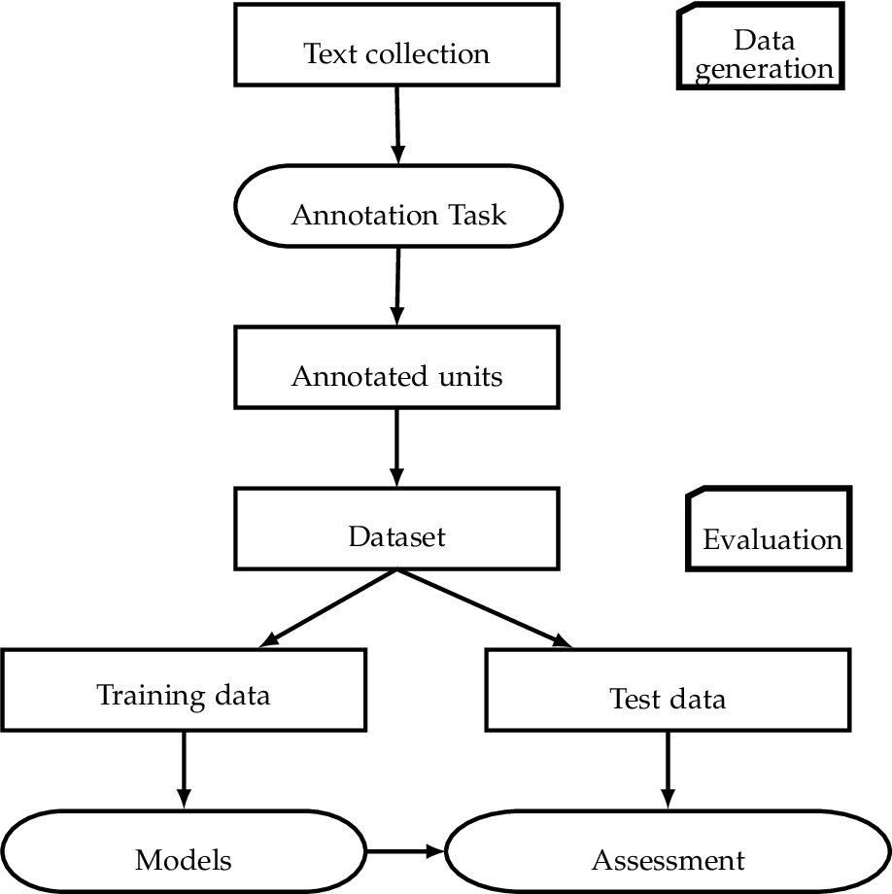
ARCHITECTURE DIAGRAM :
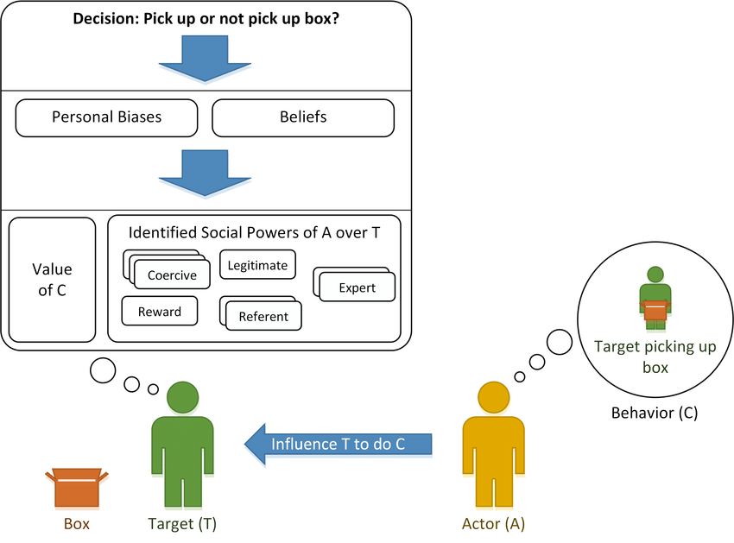

SOFTWARE REQUIREMENTS:
- Operating System : Windows 10
- Platform : python
HARDWARE REQUIREMENTS:
- Keyboard
- Mouse
- Hard disk 500GB
- Ram 4 G

CONCLUTION
- Evaluating self-reflection and classifying professionals into different categories based on their reflective writing is essential for assessing learning processes in 21st-century workplaces.
- Confirming some of the earlier propositions, this study has shown that "professionals reflect, albeit in different ways, and to different degrees.
- However, the contribution of this study is the automation of evaluation of professionals’ reflective writing within workplace learning settings, using a vertical reflection model to assess the depth of reflection that can replace the labor-intensive manual coding process.
- The automated grades generated within the courses, evaluating the reflective writing, do not necessarily consider the content matter. Based on a well-accepted reflective framework and use of automated-machine learning techniques, the methodology reported in this study has strong potentials to address this problem.

REFERENCE :
- [1] V. Kovanović et al., “Understand students’ self-reflections through learning analytics,” in Proceedings of the 8th International Conference on Learning Analytics and Knowledge, Sydney New South Wales Australia, Mar. 2018, pp. 389–398. doi: 10.1145/3170358.3170374.
- [2] S. Buckingham Shum, Á. Sándor, R. Goldsmith, R. Bass, and M. McWilliams, “Towards Reflective Writing Analytics: Rationale, Methodology and Preliminary Results,” J. Learn. Anal., vol. 4, no. 1, Mar2017, doi: 10.18608/jla.2017.41.5.
- [3] Y. Jung and A. F. Wise, “How and how well do students reflect? multi-dimensional automated reflection assessment in health professions education,” in Proceedings of the Tenth International Conference on Learning Analytics & Knowledge, New York, NY, USA, Mar. 2020, pp. 595–604. doi: 10.1145/3375462.3375528.
- [4] D. Boud, R. Keogh, and D. Walker, “Promoting reflection in learning: A model,” in Boundaries of adult learning, In R. Edwards, A. Hanson, P. Raggatt., vol. 1, Taylor & Francis, 2013, pp. 32–57. Accessed: May 10, 2021. [Online]. Available: https://books.google.co.uk/books?id=MVvdAAAAQBAJ
- [5] D. Kember, J. McKay, K. Sinclair, and F. K. Y. Wong, “A four‐category scheme for coding and assessing level of reflection in written work,” Assess. Eval. High. Educ., vol. 33, no. 4, pp. 369–379, Aug. 2008, doi: 10.1080/02602930701293355.
- [6] Donald. Schön, The Reflective Practitioner: How Professionals Think In Action, vol. 5126. Basic Books
- [7] J. A. Moon, Learning Journals: A Handbook for Academics, Students and Professional Development. Kogan Page, 1999.
- [8] J. Mezirow, Transformative Dimensions of Adult Learning. Jossey-Bass, 350 Sansome Street, San Francisco, CA 94104-1310 ($27, 1991.
- [9] D. Boud, R. Keogh, and D. Walker, Reflection: Turning Experience into Learning. Routledge, 1985.
- [10] G. Lai and B. Calandra, “Examining the effects of computer-based scaffolds on novice teachers’ reflective journal writing,” Educ. Technol. Res. Dev., vol. 58, no. 4, pp. 421–437, Aug. 2010, doi: 10.1007/s11423-009-9112-2.
- [11] S. Joksimović, N. Dowell, D. Gašević, N. Mirriahi, S. Dawson, and A. C. Graesser, “Linguistic characteristics of reflective states in video annotations under different instructional conditions,Comput. Hum. Behav., vol. 96, pp. 211–222, Jul. 2019, doi: 10.1016/j.chb.2018.03.003.
- [12] T. D. Ullmann, “Automated Analysis of Reflection in Writing: Validating Machine Learning Approaches,” Int. J. Artif. Intell. Educ., vol. 29, no. 2, pp. 217–257, May 2019, doi: 10.1007/s40593-019-00174-2
- [13] Ullmann, Thomas Daniel, “Automated detection of reflection in texts. A machine learning based approach - Open Research Online,” The Open University, 2015. Accessed: Dec. 01, 2020. [Online]. Available: http://oro.open.ac.uk/45402/
- [14] A. Gibson, A. Aitken, Á. Sándor, S. Buckingham Shum, C. Tsingos-Lucas, and S. Knight, “Reflective writing analytics for actionable feedback,” in Proceedings of the Seventh International Learning Analytics & Knowledge Conference, Vancouver British Columbia Canada, Mar. 2017, pp. 153–162. doi: 10.1145/3027385.3027436.
- [15] A. Gibson, K. Kitto, and P. Bruza, “Towards the Discovery of Learner Metacognition From Reflective

