3-D DECONVOLUTIONAL NETWORKS FOR THE UNSUPERVISED REPRESENTATION LEARNING OF HUMAN MOTIONS
ABSTRACT:
The major obstacle for learning-based RF sensing is to obtain a high-quality large-scale annotated dataset. However, unlike visual datasets that can be easily annotated by human workers, RF signal is non-intuitive and non-interpretable, which causes the annotation of RF signals time-consuming and laborious. To resolve the rapacious appetite of annotated data, we propose a novel unsupervised representation learning (URL) framework for RF sensing, RF-URL, to learn a pre-training model on large-scale unannotated RF datasets that can be easily collected. RF-URL utilizes a contrastive framework to mind the gap between signal-processing-based RF sensing and learning-based RF sensing

EXISTING SYSTEM:
- To this end, we have noted that the core of contrastive framework lies in building positive and negative pairs to learn their inherent consistencies and discrepancies, while existing methods generally utilize data augmentation to construct the positive and negative pairs, which is designed for visual images but are not able to avoid shortcuts for RF signals.
- Network Structure. For fair comparison with the existing methods, we do not adopt the same backbone in Section 5. Instead, our human silhouette generation network, named as RFSG, follows the design of RF-Pose, which uses two RF encoding networks to extract features from vertical and horizontal RF signals.
Disadvantage of Existing System
- A translator is utilized as a mediator to embed different signal representations of RF signals into a unified metric space to avoid convergence problem, and a predictor with stop-gradient operation is proposed to improve the performance of RF-URL.
- Translator is utilized as a mediator to embed different signal representations of RF signals into a unified metric space to avoid convergence problem.
- We solve this problem by shuffling BN that trains with multiple GPUs and performs BN on the samples independently for each GPU

PROPOSED SYSTEM :
- By learning a general semantic information for various sensing tasks from different signal representations, the proposed RF-URL could enhance the sensing performance in an unsupervised manner
- It is noted that the proposed PEN model works only for single-user case since only single-user dataset has been accessible.
- These existing works mainly rely on supervised learning which requires large-scale annotated RF datasets, while the proposed framework exploits unannotated data for model training
ADVANTAGE:
- Since almost all RF sensing tasks can be seen as a combination of above three tasks, and two most widely used RF signals are WiFi and radar signals, with the above three RF sensing tasks, it is sufficient to demonstrate the universality of the RF-URL framework.
- The first dataset (non number dataset) collects the widely used hand gestures for human-computer interaction, which contains 38687 samples
- The commonly used contrastive learning frameworks include memory bank method InsDis MoCo and contrastive multiview coding (CMC) ), big batchsize, clustering SwAV transformer MoCov3and DINO and negative-pairs-free methods.

LITRATURE REVIEW:
TITTLE | AUTHOR | DESCRIPTION
“3D Tracking via Body Radio Reflections. | Fadel Adib, Zachary Kabelac, Dina Katabi, and Robert C | This paper introduces WiTrack, a system that tracks the 3D motion of a user from the radio signals reflected off her body.
"Smart Homes That Monitor Breathing and Heart Rate. | "Fadel Adib, Hongzi Mao, Zachary Kabelac, Dina Katabi, and Robert C,". | The evolution of ubiquitous sensing technologies has led to intelligent environments that can monitor and react to our daily activities, such as adapting our heating and cooling systems, responding to our gestures, and monitoring our elderly
“"Representation Learning: A Review and New Perspectives. | Yoshua Bengio, Aaron Courville, and Pascal Vincent | The success of machine learning algorithms generally depends on data representation, and we hypothesize that this is because different representations can entangle and hide more or less the different explanatory factors of variation behind the data.
“Language Models are Few | Tom Brown, Benjamin Mann, Nick Ryder, and et | By contrast, humans can generally perform a new language task from only a few examples or from simple instructions - something which current NLP systems still largely struggle to do.

INTRODUCTION :
- RF-URL is a URL framework for RF-based sensing based on contrastive learning. It utilizes different signal representations to construct positive and negative pairs for contrastive learning, which allows us to seamlessly integrate the well-developed RF signal processing techniques with URL framework.
- As shown in, the architecture of RF-URL mainly contains four components: signal representation, feature extraction with translation, predictor and memory bank sampling.
Specifically, RF signal 𝑥 𝑖 is firstly processed by different signal processing techniques to obtain different representations
BLOCK DIAGRAM:
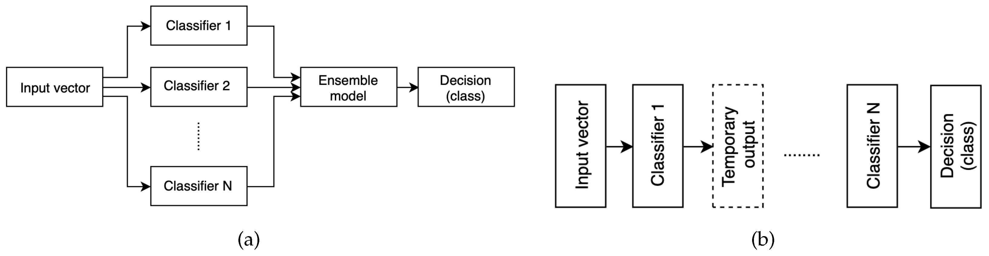
ARCHITECTURE DIAGRAM :
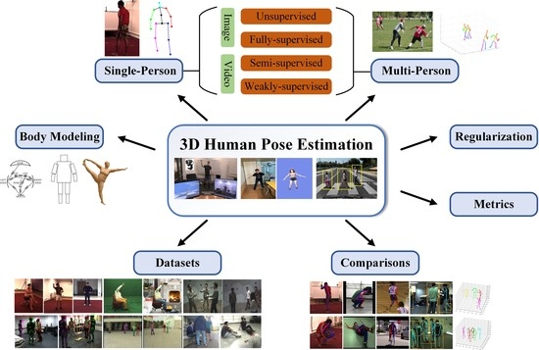

SOFTWARE REQUIREMENTS:
- Operating System : Windows 10
- Platform : python
HARDWARE REQUIREMENTS:
- Keyboard
- Mouse
- Hard disk 500GB
- Ram 4 G
CONCLUTION :
- This paper presented a novel URL framework, RF-URL, for RF-based sensing through contrastive learning.
- The positive and negative pairs were constructed with different signal processing technologies, which achieved effective contrastive learning in an unsupervised manner by minding the gap between signal processing and neural network.
- All experimental results strongly demonstrated that RF-URL took an important step towards deploying learningbased solutions for large-scale RF-based sensing applications

REFERENCE :
- [1] Fadel Adib, Zachary Kabelac, Dina Katabi, and Robert C. Miller. 2014. 3D Tracking via Body Radio Reflections. In Proc. of the 11th USENIX (NSDI’14). 317–329
- [2] Fadel Adib, Hongzi Mao, Zachary Kabelac, Dina Katabi, and Robert C. Miller. 2015. Smart Homes That Monitor Breathing and Heart Rate. In Proc. of the 33rd ACM CHI (CHI ’15). 837–846.
- [3] Yoshua Bengio, Aaron Courville, and Pascal Vincent. 2013. Representation Learning: A Review and New Perspectives. IEEE Transactions on Pattern Analysis and Machine Intelligence 35, 8 (2013), 1798–1828
- [4] Tom Brown, Benjamin Mann, Nick Ryder, and et. al. 2020. Language Models are Few-Shot Learners. In Proc. of the 34th NeurIPS (NIPS’20, Vol. 33). 1877–1901.
- [5] Mathilde Caron, Ishan Misra, Julien Mairal, Priya Goyal, Piotr Bojanowski, and Armand Joulin. 2020. Unsupervised Learning of Visual Features by Contrasting Cluster Assignments. In Proc. of the 34th NeurIPS (NIPS’20). Article 831, 13 pages.
- [6] Mathilde Caron, Hugo Touvron, Ishan Misra, Hervé Jegou, Julien Mairal, Piotr Bojanowski, and Armand Joulin. 2021. Emerging Properties in Self-Supervised Vision Transformers. In Proc. of the IEEE/CVF ICCV. 9630–9640.
- [7] Ting Chen, Simon Kornblith, Mohammad Norouzi, and Geoffrey Hinton. 2020. A Simple Framework for Contrastive Learning of Visual Representations. In Proc. of the 37th ICML (ICML’20). Article 149, 11 pages.
- [8] Xinlei Chen, Haoqi Fan, Ross Girshick, and Kaiming He. 2020. Improved baselines with momentum contrastive learning. arXiv preprint arXiv:2003.04297 (2020).
- [9] Xinlei Chen and Kaiming He. 2021. Exploring Simple Siamese Representation Learning. In Proc. of the IEEE/CVF CVPR. 15745–15753.
- [10] Xinlei Chen, Saining Xie, and Kaiming He. 2021. An Empirical Study of Training Self-Supervised Vision Transformers. In Proc. of the IEEE/CVF ICCV. 9620–9629.
- [11] Yan Chen, Hongyu Deng, Dongheng Zhang, and Yang Hu. 2021. SpeedNet: Indoor Speed Estimation With Radio Signals. IEEE Internet of Things Journal 8, 4 (2021), 2762–2774.
- [12] Yan Chen, Xiang Su, Yang Hu, and Bing Zeng. 2020. Residual Carrier Frequency Offset Estimation and Compensation for Commodity WiFi. IEEE Transactions on Mobile Computing 19, 12 (2020), 2891–2902 [13] Zhe Chen, Tianyue Zheng, Chao Cai, and Jun Luo. 2021. MoVi-Fi: Motion-Robust Vital Signs Waveform Recovery via Deep Interpreted RF Sensing. In Proc. of the 27th ACM MobiCom (MobiCom ’21). 392–405.
- [14] Jacob Devlin, Ming-Wei Chang, Kenton Lee, and Kristina Toutanova. 2019. BERT: Pre-training of Deep Bidirectional Transformers for Language Understanding. In Proc. of the ACL. 4171–4186.
- [15] Shuya Ding, Zhe Chen, Tianyue Zheng, and Jun Luo. 2020. RF-Net: A Unified Meta-Learning Framework for RF-Enabled One-Shot Human Activity Recognition. In Proc. of the 18th ACM SenSys. 517–530.

