MACHINE LEARNING FOR INTER-TURN SHORT-CIRCUIT FAULT DIAGNOSIS IN PERMANENT MAGNET SYNCHRONOUS MOTORS
ABSTRACT:
Permanent Magnet Synchronous Motor (PMSM) is widely used due to its advantages of high power density, high efficiency and so on. In order to ensure the reliability of a PMSM system, it is extremely vital to accurately diagnose the incipient faults. In this paper, a variety of optimization algorithms are utilized to realize the diagnosis of the faulty position and severity of the inter-turn short-circuit (ITSC) fault, which is one of the most destructive and frequent faults in PMSMCompared with the existing research results gained by particle swarm optimization algorithms, in this paper, the methods using other optimization algorithms incorporating genetic algorithm, whale optimization algorithm and stochastic parallel gradient descent algorithm (SPGD) can acquire more stable and precise results

EXISTING SYSTEM:
- ITSC fault of PMSM, which has several advantages over the existing mainstream fault diagnosis methods.
- In the simulation, the genetic algorithm, whale optimization algorithm and stochastic parallel gradient descent are compared with the existing fault diagnosis method based on particle swarm optimization under ideal circumstances, respectively.
Disadvantage of Existing System
With the development of research, the algorithm has been successfully applied in wind speed prediction, feature selection, optimal reactive power scheduling, secondary allocation problem, clustering, scheduling optimization, image classification and other fields.
PROPOSED SYSTEM :
- Therefore, some fault diagnosis methods using the signal of PMSM are proposed. With the development of machine learning and artificial intelligence, many data classification and recognition methods have been proposed, such as neural network (NN), support vector machine (SVM), and fuzzy logic system (FLS).
- Moreover, compared with the method based on the particle swarm optimization algorithm, which has been proposed by other scholars, it is proved that the performance of proposed methods based on heuristic optimization algorithms in this research have been improved a lot, whereas, due to the randomness of the heuristic algorithms, it is difficult to obtain satisfactory results stably
ADVANTAGE:
- Machine learning (ML) has become an increasingly used technology in every aspect of our lives.
- Then offers a broad overview of the most widely used and efficient methodologies for dealing with adversary attacks in AI fields.
- The perturbations performed by the adversarial machine learning attacks aim to be minimal to fool the model without an obvious change in the data used.
- We chose the mentioned algorithms as they are among the most used ones for binary classification problems in recent machine learning literature
LITRATURE REVIEW:
TITTLE | AUTHOR | DESCRIPTION
Recent Advances in Modeling and Online Detection of Stator Interturn Faults in Electrical Motors. | Gandhi, A.; Corrigan, T.; Parsa, L | This paper deals with the consequences of some manufacturing imprecision related to the use of a fractional-slot concentrated winding (FSCW) in recent permanent-magnet synchronous machine (PMSM) designs.
‘‘Real-Time Detection of Interturn Faults in PM Drives Using Back-EMF Estimation and Residual Analysis. | Leboeuf, N.; Boileau, T.; Nahid-Mobarakeh, B.; Clerc, G.; Meibody-Tabar, F. | Interturn stator winding fault is one of the most frequent faults in permanent-magnet synchronous machines (PMSMs).
Inter-Turn Fault Detection in PM Synchronous Machines by Physics-Based Back Electromotive Force Estimation | Sarikhani, A.; Mohammed, O.A. | One of the most common faults experienced by the permanent magnet synchronous motor (PMSM) is stator interturn fault which account for 35-40% of the machine failure.
MBack-EMF Based Detection of Stator Winding Inter-turn Fault for PM Synchronous Motor Drives. | Boileau, T.; Nahid-Mobarakeh, B.; Meibody-Tabar, F | It consists of extracting the mechanical power second harmonic component which appears when the machine is faulty.

INTRODUCTION :
- As a power device with features such as low pollution, high efficiency and strong practicality, motors have been widely used in industrial production and daily life.
- Among all kinds of motors, currently, PMSM possesses desired merits such as compact structure, high power and torque density and so on, which have been paid more and more attention.
- However, PMSM is quite prone to diverse faults in its working process because of the narrow working environment, high temperature and humidity and poor heat dissipation conditions, particularly in the emerging new energy industries involving electric vehicle and wind power generation.
- Common faults of PMSM include mechanical faults, permanent magnet faults and electrical faults. If these breakdowns cannot be detected and solved in a timely manner, it will lead to huge economic losses and security risks.
- Accordingly, the fault diagnosis of PMSM becomes more and more prevalent and significant in recent years.
BLOCK DIAGRAM:
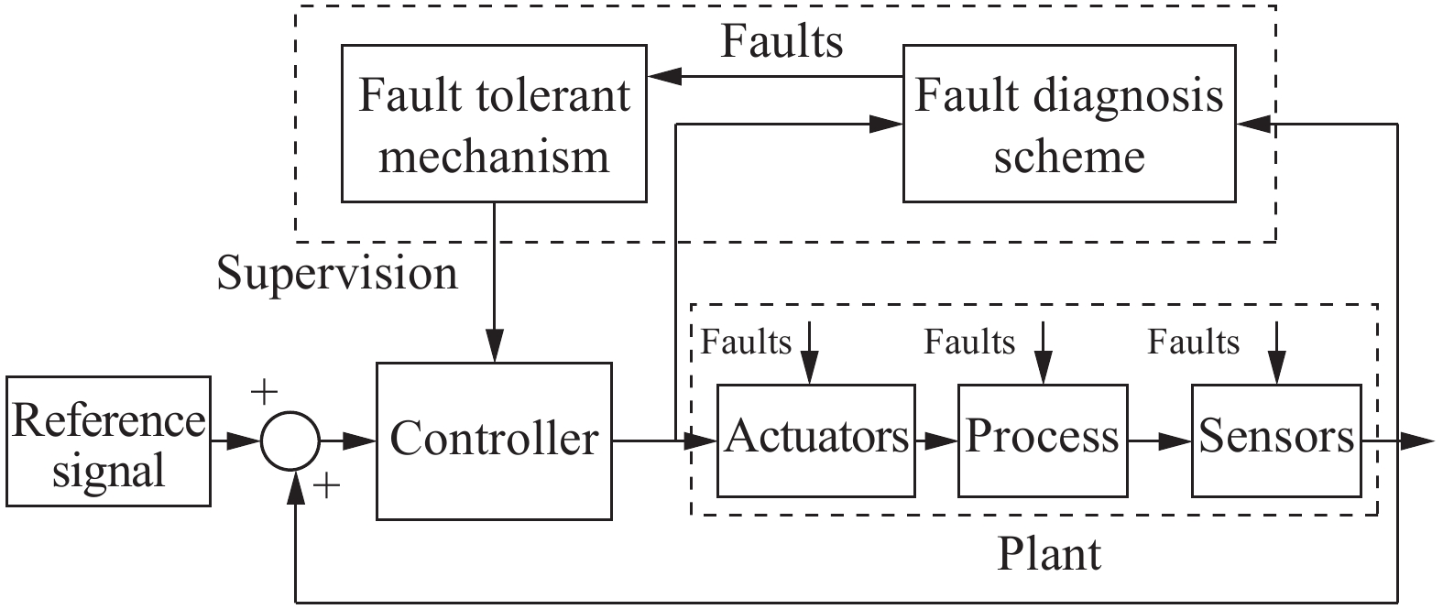
ARCHITECTURE DIAGRAM :
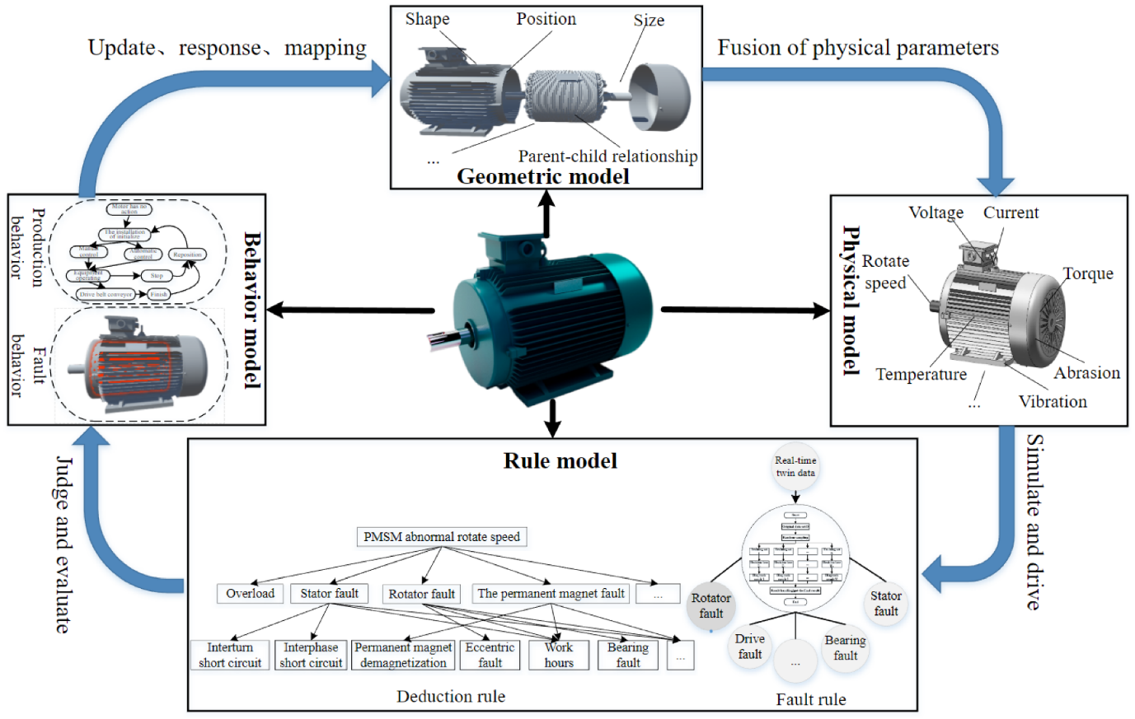
SOFTWARE REQUIREMENTS:
- Operating System : Windows 10
- Platform : python
HARDWARE REQUIREMENTS:
- Keyboard
- Mouse
- Hard disk 500GB
- Ram 4 G

CONCLUTION :
- In this paper, aiming at the ITSC fault of PMSM, certain fault diagnosis methods based on heuristic optimization algorithms—that is, the particle swarm optimization algorithm, genetic algorithm and whale optimization algorithm—are proposed. In addition, due to the great random influence of the heuristic algorithm, the stochastic parallel gradient descent algorithm is utilized.
- This algorithm, i.e., the stochastic parallel gradient descent algorithm, regards the model as a black box and uses random interference to obtain the approximate gradient.
- In the simulation, the genetic algorithm, whale optimization algorithm and stochastic parallel gradient descent are compared with the existing fault diagnosis method based on particle swarm optimization under ideal circumstances, respectively
REFERENCE :
- 1. Gandhi, A.; Corrigan, T.; Parsa, L. Recent Advances in Modeling and Online Detection of Stator Interturn Faults in Electrical Motors. IEEE Trans. Ind. Electron. 2011, 58, 1564–1575. [CrossRef]
- 2. Leboeuf, N.; Boileau, T.; Nahid-Mobarakeh, B.; Clerc, G.; Meibody-Tabar, F. Real-Time Detection of Interturn Faults in PM Drives Using Back-EMF Estimation and Residual Analysis. IEEE Trans. Ind. Appl. 2011, 47, 2402–2412. [CrossRef]
- 3. Sarikhani, A.; Mohammed, O.A. Inter-Turn Fault Detection in PM Synchronous Machines by Physics-Based Back Electromotive Force Estimation. IEEE Trans. Ind. Electron. 2013, 60, 3472–3484. [CrossRef]]
- 4.Boileau, T.; Nahid-Mobarakeh, B.; Meibody-Tabar, F. Back-EMF Based Detection of Stator Winding Inter-turn Fault for PM Synchronous Motor Drives. In Proceedings of the Vehicle Power & Propulsion Conference, Arlington, TX, USA, 9–12 September 2007; pp. 95–100.
- 5. Krolczyk, G.M.; Krolczyk, J.B.; Legutko, S.; Hunjet, A. Effect of the disc processing technology on the vibration level of the chipper during operations. Teh. Vjesn. 2014, 447–450.
- 6. Capolino, G.A.; Henao, H.; Demian, C. A frequency-domain detection of stator winding faults in induction machines using an external flux sensor. In Proceedings of the Industry Applications Conference, Salt Lake City, CA, USA, 12–16 October 2003.
- 7. Cira, F.; Arkan, M.; Gumus, B.; Goktas, T. Analysis of stator inter-turn short-circuit fault signatures for inverter-fed permanent magnet synchronous motors. In Proceedings of the IECON 2016-42nd Annual Conference of the IEEE Industrial Electronics Society, Florence, Italy, 24–27 October 2016.
- 8. Ping, Z.A.; Yang, J.; Ling, W. Fault Detection of Stator Winding Interturn Short Circuit in PMSM Based on Wavelet Packet Analysis. In Proceedings of the Fifth International Conference on Measuring Technology & Mechatronics Automation, Hong Kong, China, 16–17 January 2013.
- 9. Moosavi, S.S.; Esmaili, Q.; Djerdir, A.; Amirat, Y.A. Inter-Turn Fault Detection in Stator Winding of PMSM Using Wavelet Transform. In Proceedings of the 2017 IEEE Vehicle Power and Propulsion Conference (VPPC), Belfort, France, 14–17 December 2017.
- 10. Obeid, N.H.; Boileau, T.; Nahid-Mobarakeh, B. Modeling and diagnostic of incipient inter-turn faults for a three phase permanent magnet synchronous motor using wavelet transform. In Proceedings of the 2014 IEEE Industry Applications Society Annual Meeting, Las Vegas, NV, USA, 7–11 October 2015.
- 11. Gao, Z.; Cecati, C.; Ding, S.X. A Survey of Fault Diagnosis and Fault-Tolerant Techniques—Part II: Fault Diagnosis With Knowledge-Based and Hybrid/Active Approaches. IEEE Trans. Ind. Electron. 2015, 62, 3768–3774. [CrossRef]
- 12. Quiroga, J.; Liu, L.; Cartes, D.A. Fuzzy logic based fault detection of PMSM stator winding short under load fluctuation using negative sequence analysis. In Proceedings of the American Control Conference, Seattle, WA, USA, 11–13 June 2008; pp. 4262–4267
- 13. Liang, S.; Chen, Y.; Liang, H.; Li, X. Sparse Representation and SVM Diagnosis Method for Inter-Turn Short-Circuit Fault in PMSM. Appl. Sci. 2019, 9, 224. [CrossRef]
- 14. Das, S.; Koley, C.; Purkait, P.; Chakravorti, S. Wavelet aided SVM classifier for stator inter-turn fault monitoring in induction motors. In Proceedings of the Power & Energy Society General Meeting IEEE 2010, Minneapolis, MN, USA, 25–29 July 2010.
- 15. Nyanteh, Y.; Edrington, C.; Srivastava, S.; Cartes, D. Application of Artificial Intelligence to Real-Time Fault Detection in Permanent-Magnet Synchronous Machines. IEEE Trans. Ind. Appl. 2013, 49, 1205–1214. [CrossRef]

