I LET DEPRESSION AND ANXIETY DROWN ME…” IDENTIFYING FACTORS ASSOCIATEDWITH RESILIENCE BASED ON JOURNALING USING MACHINE LEARNING AND THEMATIC
ABSTRACT:
- Over the years, there has been a global increase in the use of technology to deliver interventions for health and wellness, such as improving people’s mental health and resilience.
- An example of such technology is the Q-Life app which aims to improve people’s resilience to stress and adverse life events through various coping mechanisms, including journaling.
- Using a combination of sentiment analysis and thematic analysis methods, this paper presents the results of analyzing 6023 journal entries from 755 users.
- We uncover both positive and negative factors that are associated with resilience.

EXISTING SYSTEM:
- This approach has been adopted by only a few existing research in mental health domain to the best of our knowledge.
- In our dataset, a total of 68247 reviews have user ratings (representing 77.4% of total reviews). Similar to the approach used by existing research we applied the criteria in to automatically annotate reviews. presents the number of reviews per sentiment polarity after annotation.
- Our approach aligns with existing research which defines sentiment classification as a ‘‘two-class classification problem, positive and negative’’ and also as a technique that ‘‘determines whether a document or sentence is opinionated, and if so whether it carries a positive or negative opinion’’
Disadvantage of Existing System
- Complement NB addresses skewed training data problem by estimating model weights from the complement of each class thereby making it well suited for imbalanced datasets.
- Logist Reg is a linear model for obtaining probabilities describing possible outcomes (binary, multinomial, or ordinal) using a logistic function that minimizes the loss on a dataset
- Research also shows that a high level of mindfulness and relaxation will significantly increase resilience and reduce the risk of developing mental health problems
- Future work will extend this study by applying machine learning techniques to automatically detect thematic problems of individuals based on their journal entries and then propose appropriate interventions.
PROPOSED SYSTEM :
- To address the negative factors discussed above, we propose the following design recommendations based on the positive themes in (see Appendix section) which are factors that contribute to the effectiveness of mental health apps.
- HACP, while very welcome, is in ways reminiscent of the early days of the Web, when many “similar” quality benchmarking tools and codes of conduct for information publishers were proposed to appraise and rate online medical and health information.

ADVANTAGE:
- The health sector has used this approach to provide real-time health services and early intervention through web and mobile applications
- Journaling in healthcare has been used primarily for counseling and psychotherapy to provide self-help interventions and promote personal reflection
- Sentiment analysis is used to analyze people’s opinions, sentiments, evaluations, attitudes, and emotions from written language
- we utilized and compared multiple classifiers using lexicon-based and machine learning techniques to determine the best performing classifier overall, which is then used in predicting the sentiment polarity of unclassified journal entries.
LITRATURE REVIEW:
TITTLE | AUTHOR | DESCRIPTION
“Adoption of digital health technologies in the practice of behavioral health: Qualitative case study of glucose monitoring technology,” | S. G. May et al., “ | Background Evaluation of patients with serious mental illness (SMI) relies largely on patient or caregiver self-reported symptoms. New digital technologies are being developed to better quantify the longitudinal symptomology of patients with SMI and facilitate disease management.
“Technological innovations in mental healthcare: Harnessing the digital revolution,” | C. Hollis | Digital technology has the potential to transform mental healthcare by connecting patients, services and health data in new ways.
“Mobile medical and health apps: state of the art, concerns, regulatory control and certification,” | M. N. Kamel Boulos, A. C. Brewer, C. Karimkhani, D. B. Buller, and R. P. Dellavalle, , | A estimate puts the number of health-related apps at no fewer than as healthcare professionals and consumers continue to express concerns about the quality of many apps, calling for some form of app regulatory control or certification to be put in place
“Health and Mental Health,” , | C. Green | Mental health disorders are among the most important problems of recent decade as they have various individual and social effects

INTRODUCTION :
- Journaling has been shown to have a positive impact on both physical and mental health and can be used as a tool to reduce post-traumatic stress and facilitate positive growth from a stressful event .
- Several studies have uncovered the beneficial effects of journaling.
- For example, Baikie et al. highlighted how expressive writing can be used for therapeutic reasons that have positive impact on physical and psychological health.
- Similarly, Koschwanez et al. found that journaling could improve wound healing in older adults and women.
- Sentiment analysis is used to analyze people’s opinions, sentiments, evaluations, attitudes, and emotions from written language .

BLOCK DIAGRAM:
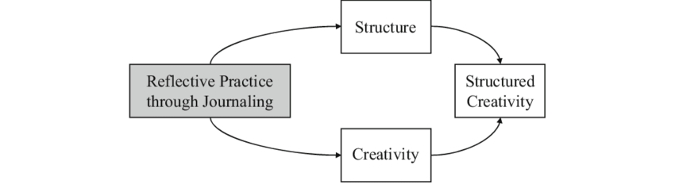
ARCHITECTURE DIAGRAM :
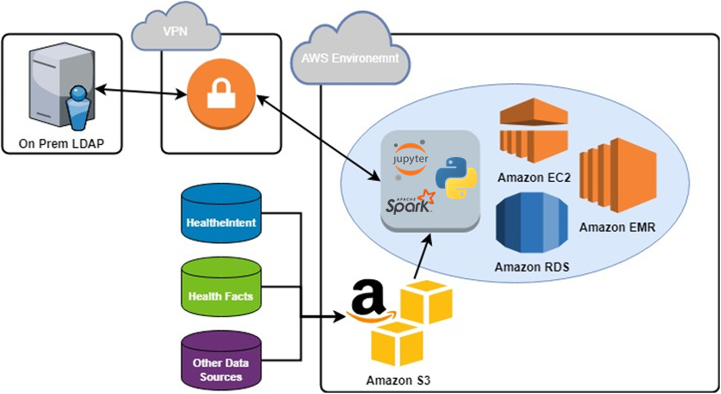

SOFTWARE REQUIREMENTS:
- Operating System : Windows 10
- Platform : python
HARDWARE REQUIREMENTS:
- Keyboard
- Mouse
- Hard disk 500GB
- Ram 4 G

CONCLUTION :
- Journaling is a key feature in many technological mental health interventions due to its ability to promote health and wellness via self-reflection, self-awareness, and consciousness raising.
- This paper compared the performance of eight machine learning classifiers and two lexicon-based classifiers to determine the overall best performing classifier for sentiment analysis of journal entries.
- We also compared two vectorization techniques (TF-IDF and Word2Vec) as part of the experiments and selected the technique that yield better classification performance.

REFERENCE :
[1] S. G. May et al., “Adoption of digital health technologies in the practice of behavioral health: Qualitative case study of glucose monitoring technology,” J. Med. Internet Res., vol. 23, no. 2, p. e18119, Feb. 2021, doi: 10.2196/18119.
[2] C. Hollis et al., “Technological innovations in mental healthcare: Harnessing the digital revolution,” British Journal of Psychiatry, vol. 206, no. 4. Royal College of Psychiatrists, pp. 263–265, Apr. 2015.
[3] M. N. Kamel Boulos, A. C. Brewer, C. Karimkhani, D. B. Buller, and R. P. Dellavalle, “Mobile medical and health apps: state of the art, concerns, regulatory control and certification,” Online J. Public Health Inform., vol. 5, no. 3, p. 229, Feb. 2014, doi: 10.5210/ojphi.v5i3.4814.
[4] C. Green, “Health and Mental Health,” in Research Anthology on Mental Health Stigma, Education, and Treatment, IGI Global, 2021, pp. 1235–1256.
[5] D. Meichenbaum, “Important facts about resilience: A consideration of research findings about resilience and implications for assessment and treatment,” Miami, FL, USA, 2007. [Online]. Available: https://www.melissainstitute.org/documents/facts_resilience.pdf.
[6] “Q-LIFE.” https://www.vendurawellness.ca/q-life (accessed May 11, 2021)
[7] S. M. Southwick, G. A. Bonanno, A. S. Masten, C. Panter-Brick, and R. Yehuda, “Resilience definitions, theory, and challenges: Interdisciplinary perspectives,” Eur. J. Psychotraumatol., vol. 5, no. 1, Oct. 2014, doi: 10.3402/ejpt.v5.25338.
[8] V. Vakili, W. P. Brinkman, N. Morina, and M. A. Neerincx, “Characteristics of successful technological interventions in mental resilience training,” Journal of Medical Systems, vol. 38, no. 9. Springer New York LLC, 2014, doi: 10.1007/s10916-014-0113-2.
[9] M. Pusey, K. W. Wong, and N. A. Rappa, “Resilience interventions using interactive technology: a scoping review,” Interactive Learning Environments. Routledge, 2020, doi: 10.1080/10494820.2020.1772837 [10] R. R. Pai and S. Alathur, “Assessing mobile health applications with twitter analytics,” Int. J. Med. Inform., vol. 113, no. September 2017, pp. 72–84, 2018, doi: 10.1016/j.ijmedinf.2018.02.016.
[11] W. Miller, “Interactive Journaling as a Clinical Tool,” J. Ment. Heal. Couns., vol. 36, no. 1, pp. 31–42, Jan. 2014.
[12] J. Lent, “Journaling enters the 21st century: The use of therapeutic blogs in counseling,” J. Creat. Ment. Heal., vol. 4, no. 1, pp. 67–73, 2009.
[13] J. Wright and M. C. Chung, “Mastery or mystery? Therapeutic writing: A review of the literature,” British Journal of Guidance and Counselling, vol. 29, no. 3. Routledge, pp. 277–291, 2001.
[14] A. Rivera, A. de Rooij, and S. Jones, “Reflective Journaling: A Theoretical Model and Digital Prototype for Developing Resilience and Creativity,” in International Conference on Human-Computer Interaction, Jul. 2020, pp. 144–158.
[15] University of Rochester Medical Center, “Journaling for Mental Health,” Health Encyclopedia. https://www.urmc.rochester.edu/encyclopedia/content.aspx?ContentID= 4552&ContentTypeID=1 (accessed May 11, 2021)

