FUSING SELL-SIDE ANALYST BIDIRECTIONAL FORECASTS USING MACHINE LEARNING

ABSTRACT:
Sell-side analysts’ recommendations are primarily targeted at institutional investors mandated to invest across many companies within client-mandated equity benchmarks, such as the FTSE/JSE All-Share index. Given the numerous sell-side recommendations for a single stock, making unbiased investment decisions is not often straightforward for portfolio managers. This study explores the use of historical sell-side recommendations to create an unbiased fusion of analyst forecasts such that bidirectional accuracy is optimised using random forest, extreme gradient boosting, deep neural networks, and logistic regression.

EXISTING SYSTEM:
- During the learning process, decision trees are added at each stage, and the existing trees in the ensemble are not replaced
- The contribution of the weak learner to the ensemble is based on the gradient descent optimisation process performed on each weak learner.
- The calculated contribution of each tree is then based on minimising the overall error of the composite learner

Disadvantage of Existing System
- Our research focused on a binary classification problem, that is upward or downward classes.
- Let true positives (TP) refer to the number of positive classes correctly predicted by the classifier.
- Gradient boosting is an optimisation problem, where the goal is to locate the minimum or minimise the model’s loss function by adding weak learners using gradient descent.
PROPOSED SYSTEM :
- In recent years, many fairness metrics have been proposed to define what is fairness in machine learning.
- we conduct extensive experiments to validate the effectiveness of our proposed methods.
- The rest of this paper is organized as follows. The preliminaries is given in Section The first proposed method FSMC is given in Sect.
- Many fairness constraints have been proposed to enforce various fairness metrics, such as disparate impact and disparate mistreatment, and these fairness constraints can be used in our framework.
ADVANTAGE:
- Machine learning algorithms, as useful decision-making tools, are widely used in the society
- In real-world machine learning tasks, a large amount of data used for training is necessary, and is often a combination of labeled and unlabeled data
- Unlabeled data is abundant in era of big data and, if it could be used as training data, we may be able to make a better compromise between fairness and accuracy
- This step can be solved by a convex problem and convex-concave programming when disparate impact and disparate mistreatment are used as fairness metrics respectively.
LITRATURE REVIEW:
TITTLE | AUTHOR | DESCRIPTION
‘‘The financial analyst forecasting literature: A taxonomy with suggestions for further research,’’ | ‘‘S. Ramnath, S. Rock, and P. Shane, ‘ | This paper develops a taxonomy of research examining the role of financial analysts in capital markets.
‘‘What is the value of sell-side analysts? Evidence from coverage initiations and terminations | K. K. Li and H. You, | We investigate whether and how sell-side analysts create value for companies by examining what drives the market reaction to analyst coverage initiation.
‘‘Do analysts matter for governance? Evidence from natural experiments,, | T. Chen, J. Harford, and C. Lin, | We find that as a firm experiences an exogenous decrease in analyst coverage, shareholders value internal cash holdings less, its CEO receives higher excess compensation, its management is more likely to make value-destroying acquisitions, and its managers are more likely to engage in earnings management activities.
‘The impact of sell-side analyst research coverage on an affiliated broker’s market share of trading volume, | G. Niehaus and D. Zhang, ‘ | Using NASDAQ reported individual stock level trading volume, we find that analyst research coverage on a stock increases the level of an affiliated broker’s market share of trading volume in that stock by 0.8 percent, on average, which corresponds to an additional annual volume of about one million shares in an average stock.

INTRODUCTION :
- Institutional investors are primarily mandated to invest in an equity benchmark representing the most prominent companies listed on an exchange .
- Among these companies within the equity benchmark, brokerage firms hire analysts to produce investment reports called sell-side equity analyst reports.
- Sell-side analyst reports are highly valued in the investment industry, and generally include three standard quantitative outputs: earnings forecasts, target prices, and buy/sell recommendations.
- The importance of sell-side reports has been demonstrated in several ways.
- Sell-side analysts play an essential role in interrogating company results and executive management of their strategies, while ensuring the reduction of any mismanagement or unethical behaviour.

BLOCK DIAGRAM:
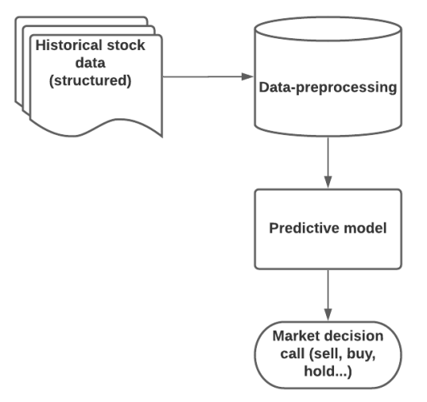
ARCHITECTURE DIAGRAM :
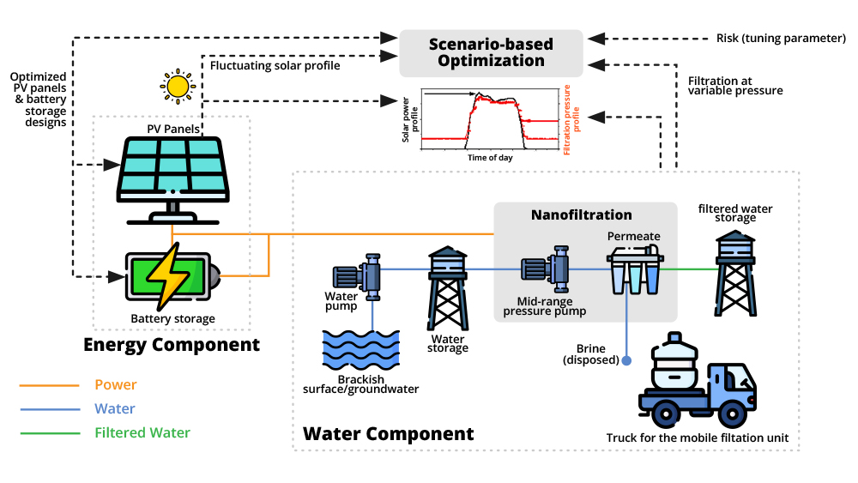

SOFTWARE REQUIREMENTS:
- Operating System : Windows 10
- Platform : python
HARDWARE REQUIREMENTS:
- Keyboard
- Mouse
- Hard disk 500GB
- Ram 4 G

CONCLUTION :
- There is increasing evidence that analysts’ reports are used in different investment processes because of their market influence.
- We conducted a study to build a generic fused AI analyst to generate directional predictions of stock price movements based on sell-side report outputs.
- The results show that a generic AI analyst performs better than an individual analyst directional prediction, with accuracy for generic fused AI analyst between 75%-79% and individual analyst accuracy between 54%-57%, similar to the findings of Ahmed et al.
- The precision score showed a similar performance
REFERENCE :
- [1] S. Ramnath, S. Rock, and P. Shane, ‘‘The financial analyst forecasting literature: A taxonomy with suggestions for further research,’’ Int. J. Forecasting, vol. 24, no. 1, pp. 34–75, Jan. 2008.
- [2] K. K. Li and H. You, ‘‘What is the value of sell-side analysts? Evidence from coverage initiations and terminations,’’ J. Accounting Econ., vol. 60, nos. 2–3, pp. 141–160, Nov. 2015.
- [3] T. Chen, J. Harford, and C. Lin, ‘‘Do analysts matter for governance? Evidence from natural experiments,’’ J. Financial Econ., vol. 115, no. 2, pp. 383–410, Feb. 2015
- [4] G. Niehaus and D. Zhang, ‘‘The impact of sell-side analyst research coverage on an affiliated broker’s market share of trading volume,’’ J. Banking Finance, vol. 34, no. 4, pp. 776–787, 2010.
- [5] M.-T. Chiang and M.-C. Lin, ‘‘Market sentiment and herding in analysts’ stock recommendations,’’ North Amer. J. Econ. Finance, vol. 48, pp. 48–64, Apr. 2019.
- [6] T. Sidogi, R. Mbuvha, and T. Marwala, ‘‘Stock price prediction using sentiment analysis,’’ in Proc. IEEE Int. Conf. Syst., Man, Cybern. (SMC), Oct. 2021, pp. 46–51.
- [7] C. Spence, M. Aleksanyan, Y. Millo, S. Imam, and S. Abhayawansa, ‘‘Earning the ‘write to speak’: Sell-side analysts and their struggle to be heard,’’ Contemp. Accounting Res., vol. 36, no. 4, pp. 2635–2662, Dec. 2019.
- [8] E. F. Fama, ‘‘Efficient capital markets: A review of theory and empirical work,’’ J. Finance, vol. 25, no. 2, pp. 383–417, May 1970.
- [9] B. Barber, R. Lehavy, M. McNichols, and B. Trueman, ‘‘Can investors profit from the prophets? Security analyst recommendations and stock returns,’’ J. Finance, vol. 56, no. 2, pp. 531–563, Apr. 2001.
- [10] K. L. Womack, ‘‘Do brokerage analysts’ recommendations have investment value?’’ J. Finance, vol. 51, no. 1, pp. 137–167, Mar. 1996.
- [11] S. Ahmed and E. Flint, ‘‘Evaluating equity analyst forecasts in South Africa,’’ Investment Anal. J., vol. 49, no. 3, pp. 199–214, Jul. 2020.
- [12] K. Kua and A. Ignjatovic, ‘‘Iterative filtering algorithms for computing consensus analyst estimates,’’ in Proc. IEEE Symp. Comput. Intell. Financial Eng. Econ. (CIFEr), May 2022, pp. 1–8 [
- 13] J. Singh and M. Khushi, ‘‘Feature learning for stock price prediction shows a significant role of analyst rating,’’ Appl. Syst. Innov., vol. 4, no. 1, p. 17, Mar. 2021.
- [14] A. Zaremba and P. Konieczka, ‘‘The profitability of following analyst recommendations on the Polish stock market,’’ Financial Internet Quart., e-Finanse, vol. 11, no. 1, pp. 22–31, Mar. 2015.
- [15] S. J. Park and K. Y. Park, ‘‘Can investors profit from security analyst recommendations? New evidence on the value of consensus recommendations,’’ Finance Res. Lett., vol. 30, pp. 403–413, Sep. 2019.

