FAIRNESS IN SEMI-SUPERVISED LEARNING: UNLABELED DATA HELP TO REDUCE DISCRIMINATION

ABSTRACT:
Machine learning is widely deployed in society, unleashing its power in a wide rangeof applications owing to the advent of big data.One emerging problem faced by machine learning is the discrimination from data, and such discrimination is reflected in the eventual decisions made by the algorithms. Recent study has proved that increasing the size of training (labeled) data will promote the fairness criteria with model performance being maintained. Taking the popularity of graph-based approaches in semi-supervised learning, we study this problem both on conventional label propagation method and graph neural networks, where various fairness criteria can be flexibly integrated.

EXISTING SYSTEM:
- Our developed algorithms are proved to be non-trivial extensions to the existing supervised models with fairness constraints
- Existing fair learning methods mainly focus on supervised and unsupervised learning, and cannot be directly applied to SSL. As far as we know, only has explored fairness in SSL. Chzhen et al. studied Bayes classifier under the fairness metric of equal opportunity, where labeled data is used to learn the output conditional probability, and unlabeled data is used for to calibrate threshold in the post-processing phase.

Disadvantage of Existing System
- Our first approach, fair semi-supervised margin classifiers (FSMC), is formulated as an optimization problem, where the objective function includes a loss for both the classifier and label propagation, and fairness constraints over labeled and unlabeled data.
- This step can be solved by a convex problem and convex-concave programming when disparate impact and disparate mistreatment are used as fairness metrics respectively
- we propose algorithms to solve optimization problems when disparate impact and disparate mistreatment are integrated as fairness metrics in the graph-based regularization
PROPOSED SYSTEM :
- In recent years, many fairness metrics have been proposed to define what is fairness in machine learning.
- we conduct extensive experiments to validate the effectiveness of our proposed methods.
- The rest of this paper is organized as follows. The preliminaries is given in Section The first proposed method FSMC is given in Sect.
- Many fairness constraints have been proposed to enforce various fairness metrics, such as disparate impact and disparate mistreatment, and these fairness constraints can be used in our framework.
ADVANTAGE:
- Machine learning algorithms, as useful decision-making tools, are widely used in the society
- In real-world machine learning tasks, a large amount of data used for training is necessary, and is often a combination of labeled and unlabeled data
- Unlabeled data is abundant in era of big data and, if it could be used as training data, we may be able to make a better compromise between fairness and accuracy
- This step can be solved by a convex problem and convex-concave programming when disparate impact and disparate mistreatment are used as fairness metrics respectively.
LITRATURE REVIEW:
TITTLE | AUTHOR | DESCRIPTION
Persistent anti-muslim bias in large language models | Abid A, Farooqi M, Zou J | It has been observed that large-scale language models capture undesirable societal biases, e.g. relating to race and gender; yet religious bias has been relatively unexplored.
‘‘Apple card investigated after gender discrimination complaints. | Vigdor N | Something curious happened when a husband and wife recently compared their Apple Card spending limits.
S.KA framework for understanding unintended consequences of machine learning. arXiv preprint | Suresh H, Guttag JV | As machine learning (ML) increasingly affects people and society, awareness of its potential unwanted consequences has also grown
A survey on bias and fairness in machine learning | . Mehrabi N, Morstatter F, Saxena N, Lerman K, Galstyan A | AI systems can be used in many sensitive environments to make important and life-changing decisions; t.

INTRODUCTION :
- GNNs have been widely used in supervised learning or semi-supervised learning tasks, such as convolutional GNNs and recurrent GNNs .
- In SSL, GNNs aim to classify the data in a graph using a small subset of labeled data and all the data features.
- A large number of unlabeled data added to model training is able to help the utilization of structural and feature information of all data, and thus improves the classification accuracy.
- Our second approach, fair graph neural networks (FGNN), is built with GNNs, where the loss function includes classification loss and fairness loss.
- Classification loss optimizes the classification accuracy over all labeled data, and fairness loss enforces fairness over labeled data and unlabeled data

BLOCK DIAGRAM:
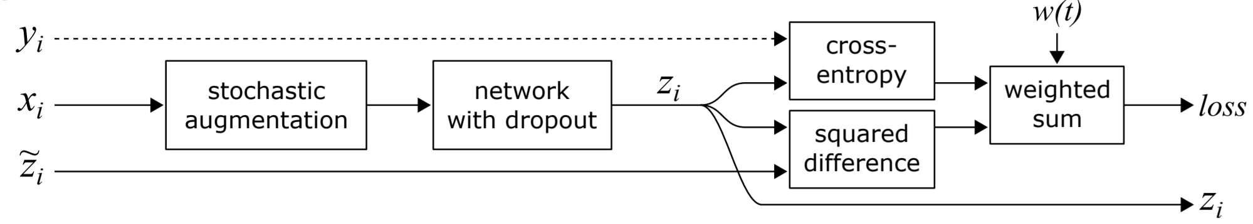
ARCHITECTURE DIAGRAM :
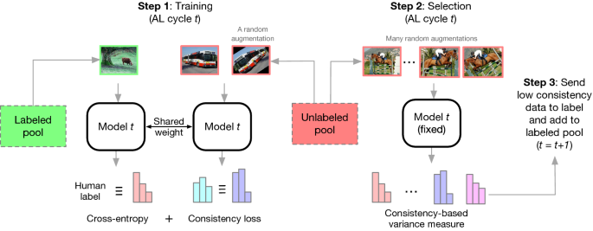

SOFTWARE REQUIREMENTS:
- Operating System : Windows 10
- Platform : python
HARDWARE REQUIREMENTS:
- Keyboard
- Mouse
- Hard disk 500GB
- Ram 4 G
CONCLUTION :
- In this paper, we study how to improve the trade-off between fairness and accuracy with unlabeled data.
- We propose two methods of fair graph-based SSL that operates during inprocessing phase. Our first method is formulated as an optimization problem with the goal of finding weights and labeling unlabeled data by minimizing the loss function subject to fairnessconstraints.
- We analyze several different cases of fairness constraints for their effects on the optimization problem plus the accuracy and discrimination level in the results.
- The second method is built on GNN models with fairness regularizers that ensures fair representations of nodes with labeled and unlabeled data can be learned.
- Our experiments confirm this analysis, showing that the proposed framework provides accuracy and fairness at high levels in semisupervised settings.
REFERENCE :
- 1. Abid A, Farooqi M, Zou J (2021) Persistent anti-muslim bias in large language models. arXiv preprint arXiv:2101.05783
- 2. Vigdor N (2019) Apple card investigated after gender discrimination complaints. The New York Times
- 3. Suresh H, Guttag JV (2019) A framework for understanding unintended consequences of machine learning. arXiv preprint arXiv:1901.10002
- 4. Mehrabi N, Morstatter F, Saxena N, Lerman K, Galstyan A (2021) A survey on bias and fairness in machine learning. ACM Comput Surv (CSUR) 54(6):1–35
- 5. Chouldechova A (2017) Fair prediction with disparate impact: a study of bias in recidivism prediction instruments. Big Data 5(2):153–163
- 6. Zafar MB, Valera I, Rodriguez MG, Gummadi KP (2017) Fairness constraints: mechanisms for fair classification. In: Proceedings of the 20th international conference on artificial intelligence and statistics, vol 54, pp 962–970
- 7. Dwork C, Hardt M, Pitassi T, Reingold O, Zemel R (2012) Fairness through awareness. In: Proceedings of the 3rd innovations in theoretical computer science conference, pp 214–226. ACM
- 8. Jung C, Kearns M, Neel S, Roth A, Stapleton L,Wu ZS (2019) Eliciting and enforcing subjective individual fairness. arXiv preprint arXiv:1905.10660
- 9. Zhu T, Yu PS (2019) Applying differential privacy mechanism in artificial intelligence. In: 2019 IEEE 39th international conference on distributed computing systems (ICDCS), pp 1601–1609
- 10. Dwork C, Ilvento C, Jagadeesan M (2020) Individual fairness in pipelines. arXiv preprint arXiv:2004.05167
- 11. Kusner MJ, Loftus J, Russell C, Silva R (2017) Counterfactual fairness. Adv Neural Inf Process Syst 30:4066–4076
- 12. Wu Y, Zhang L, Wu X, Tong H (2019) Pc-fairness: a unified framework for measuring causality-based fairness. Adv Neural Inf Process Syst 32:3404–3414
- 13. Hardt M, Price E, Srebro N et al (2016) Equality of opportunity in supervised learning. Adv Neural Inf Process Syst 29:3315–3323
- 14. Song J, Kalluri P, Grover A, Zhao S, Ermon S (2019) Learning controllable fair representations. In: Proceedings of the 22nd international conference on artificial intelligence and statistics (AISTATS) 2019, vol 89, pp 2164–2173
- 15. Chierichetti F, Kumar R, Lattanzi S, Vassilvitskii S (2017) Fair clustering through fairlets. Adv Neural Inf Process Syst 30:5029–5037

