ENRICHING THE TRANSFER LEARNING WITH PRE-TRAINED LEXICON EMBEDDINGFOR LOW-RESOURCE NEURAL MACHINE TRANSLATION
ABSTRACT:
Most State-Of-The-Art (SOTA) Neural Machine Translation (NMT) systems today achieve outstanding results based only on large parallel corpora. The large-scale parallel corpora for high-resource languages is easily obtainable. However, the translation quality of NMT for morphologically rich languages is still unsatisfactory, mainly because of the data sparsity problem encountered in Low-Resource Languages (LRLs). In the low-resource NMT paradigm, Transfer Learning (TL) has been developed into one of the most efficient methods. It is difficult to train the model on high-resource languages to include the information in both parent and child models, as well as the initially trained model that only contains the lexicon features and word embeddings of the parent model instead of the child languages feature. In this work, we aim to address this issue by proposing the language-independent Hybrid Transfer Learning (HTL) method for LRLs by sharing lexicon embedding between parent and child languages without leveraging back translation or manually injecting noises.

EXISTING SYSTEM:
- However, many existing approaches which take advantages of TL suffer from a core disadvantage: they are incapable of containing lexicon information as well as lexicon embeddings of low-resource child languages.
- TL exploits knowledge from the existing model to improve the performance of related work. TL varies from ML in that it learns from learned-models, while ML learns from data.
- The main differences from existing literature are we train the parent model on training dataset with its vocabularies; we compare the parent and child language pairs, and we made the child language training corpus the same size as those of the parent language pairs using the oversampling method;

Disadvantage of Existing System
- The TL is one of the essential elements for coping with the data sparsity problem in low-resource NMT
- In this paper, in contrast with the aforementioned approaches we focus on addressing the problem of lexicon embedding and vocabulary information of MRLs (child) in the training step
- We were motivated by the domain adaptation problem in the computer vision field. As shown in Algorithm 1, we do not directly fine-tune the child model using a pre-trained parent model.
PROPOSED SYSTEM :
- Therefore, we consider this problem and aim to enrich the performance of NMT for LRLs in our proposed model.
- The proposed model is one of the revised versions of the original TL. We were motivated by the domain adaptation problem in the computer vision field.
- The reason we used the TRANSFORMER is that the proposed HTL method is model transparent and it is the SOTA architecture in NMT, and we can also use any other NMT model architecture, even newer architectures.
- It stands to reason to compare our proposed method with highly similar approaches.
- The proposed method incorporates the discriminative distribution matching which enhances intraclass compactness and interclass separability to reduce the discrepancy in distributions.

ADVANTAGE:
- TL has been widely used in Computer Vision (CV). The main point of the TL is to pre-train the NN or to pre-initialize the weights of the NN.
- based SMT system MOSES for word tokenization. The results from all experiment have not used any UNK-replacement techniques .
- The reason we used the TRANSFORMER is that the proposed HTL method is model transparent and it is the SOTA architecture in NMT, and we can also use any other NMT model architecture, even newer architectures.
LITRATURE REVIEW:
TITTLE | AUTHOR | DESCRIPTION
Neural Information Processing Systems, | I. Sutskever, O. Vinyals, and V. Le Quoc | Markov networks are widely used in a wide variety of applications, in problems  ranging from computer vision, to natural language, to computational biology.
‘‘Neural machine translation by jointly learning to align and translate, | D. Bahdanau, K. Cho, and Y. Bengio,. | The models proposed recently for neural machine translation often belong to a family of encoder-decoders and consists of an encoder that encodes a source sentence into a fixed-length vector from which a decoder generates a translation.
“Attention is all you need | A. Vaswani, N. Shazeer, N. Parmar, J. Uszkoreit, L. Jones, A. N. Gomez, Ł Kaiser, and I. Polosukhin, | The dominant sequence transduction models are based on complex recurrent or convolutional neural networks that include an encoder and a decoder
“Bridging the gap between human and machine translation, | Y. H. Wu, M. Schuster, Z. F. Chen, V. Le Quoc, M. Norouzi, W. Macherey, M. Krikun, Y. Cao, Q. Gao, K. Macherey, | Neural Machine Translation (NMT) is an end-to-end learning approach for automated translation, with the potential to overcome many of the weaknesses of conventional phrase-based translation systems.

INTRODUCTION :
- The end-to-end framework is a common Neural Network (NN) architecture.
- Neural Machine Translation (NMT), which uses neural networks to model the translation process of natural languages in an end-toend manner, has attracted intense attention from the community.
- Excelling in learning representations and capturing long-distance dependencies by exploiting gating attention mechanisms, and pre-training method, NMT has shown significant superiority over conventional Statistical Machine Translation (SMT)[8–10] for a number of natural languages

BLOCK DIAGRAM:
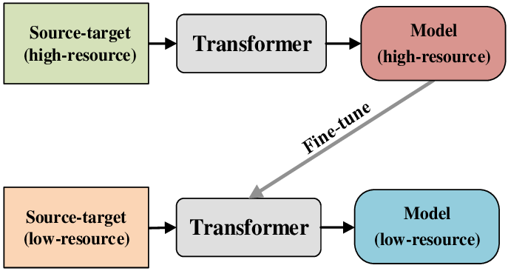

ARCHITECTURE DIAGRAM :
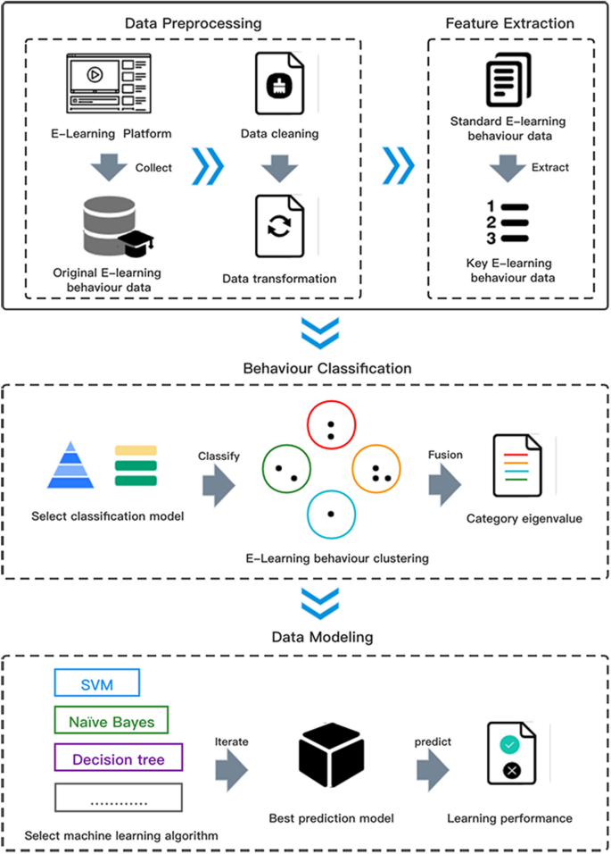

SOFTWARE REQUIREMENTS:
- Operating System : Windows 10
- Platform : python
HARDWARE REQUIREMENTS:
- Keyboard
- Mouse
- Hard disk 500GB
- Ram 4 G

CONCLUTION :
- In this paper, we introduce a rather straightforward and effective method that can feed certain lexicon features into the TL via shared vocabulary. First, We propose the HTL method for low-resource languages.
- Then, with the intent to make the child model obtain more lexicon features from the parent model, we design the hybrid transfer mode to be used before fine-tuning the child model.
- It should be noted that we leveraged the oversampling method, and made the child corpus size equal to parent corpus size, then shuffled them and created the bigger mixed corpus, rather than directly mixed the parent and child language pairs.
REFERENCE :
- [1] I. Sutskever, O. Vinyals, and V. Le Quoc, Sequence to sequence learning with neural networks, in Proc. 27th Int. Conf. Neural Information Processing Systems, Cambridge, MA, USA, 2014, pp. 3104–3112.
- [2] D. Bahdanau, K. Cho, and Y. Bengio, Neural machine translation by jointly learning to align and translate, in Proc. 3 rd Int. Conf. Learning Representations, San Diego, CA, USA, 2015.
- [3] A. Vaswani, N. Shazeer, N. Parmar, J. Uszkoreit, L. Jones, A. N. Gomez, Ł Kaiser, and I. Polosukhin, Attention is all you need, in Proc. 31st Int. Conf. Neural Information Processing Systems, Red Hook, NY, USA, 2017, pp. 6000– 6010.
- [4] Y. H. Wu, M. Schuster, Z. F. Chen, V. Le Quoc, M. Norouzi, W. Macherey, M. Krikun, Y. Cao, Q. Gao, K. Macherey, et al., Google’s neural machine translation system: Bridging the gap between human and machine translation, arXiv preprint arXiv: 1609.08144, 2016.
- [5] S. Hochreiter and J. Schmidhuber, Long short-term memory, Neural Computation, vol. 9, no. 8, pp. 1735–1780, 1997.
- [6] K. Cho, B. van Merrienboer, C. Gulcehre, D. Bahdanau, ¨ F. Bougares, H. Schwenk, and Y. Bengio, Learning phrase representations using RNN encoder-decoder for statistical machine translation, in Proc. 2014 Conf. Empirical Methods in Natural Language Processing, Doha, Qatar, 2014, pp. 1724–1734.
- [7] J. Devlin, M. W. Chang, K. Lee, and K. Toutanova, BERT: Pre-training of deep bidirectional transformers for language understanding, arXiv preprint arXiv: 1810.04805, 2018.
- [8] P. F. Brown, V. J. Della Pietra, S. A. Della Pietra, and R. L. Mercer, The mathematics of statistical machine translation: Parameter estimation, Computational Linguistics, vol. 19, no. 2, pp. 263–311, 1993.
- [9] P. Koehn, F. J. Och, and D. Marcu, Statistical phrase-based translation, in Proc. 2003 Conf. North American Chapter of the Association for Computational Linguistics on Human Language Technology, Stroudsburg, PA, USA, 2003, pp. 48–54.
- [10] D. Chiang, A hierarchical phrase-based model for statistical machine translation, in Proc. 43rd Annu. Meeting on Association for Computational Linguistics, Stroudsburg, PA, USA, 2005, pp. 263–270.
- [11] M. Junczys-Dowmunt, T. Dwojak, and H. Hoang, Is neural machine translation ready for deployment? A case study on 30 translation directions, arXiv preprint arXiv: 1610.01108, 2016.
- [12] B. Zoph, D. Yuret, J. May, and K. Knight, Transfer learning for low-resource neural machine translation, in Proc. 2016 Conf. Empirical Methods in Natural Language Processing, Austin, Texas, 2016, pp. 1568–1575
- [13] C. Vania and A. Lopez, From characters to words to in between: Do we capture morphology? in Proc. 55th Annu. Meeting of the Association for Computational Linguistics, Vancouver, Canada, 2017, pp. 2016–2027.
- [14] Y. Chen, Y. Liu, and V. O. K. Li, Zero-resource neural machine translation with multi-agent communication game, arXiv preprint arXiv: 1802.03116, 2018.
- [15] A. Karakanta, J. Dehdari, and J. van Genabith, Neural machine translation for low-resource languages without parallel corpora, Machine Translation, vol. 32, nos. 1&2, pp. 167–189, 2018.

