AUTOMATED SCREENING SYSTEM FOR ACUTE MYELOGENOUS LEUKEMIA DETECTION
ABSTRACT:
Acute myelogenous leukemia (AML) is a subtype of acute leukemia, which is prevalent among adults.The average age of a person with AML is 65 years. The need for automation of leukemia detection arises since current methods involve manual examination of the blood smear as the first step toward diagnosis. This is time-consuming, and its accuracy depends on the operator’s ability. In this paper, a simple technique that automatically detects and segments AML in blood smears is presented.
EXISTING SYSTEM:
- Two new features, such as cell energy and Hausdorff dimension (HD), have been used. The result is then compared with the results of the existing models
- The LBP method has proved to outperform many existing methods, including the linear discriminant analysis and the principal component analysis.
- The system presented not only enables classification of whole images but also presents a better performance for subimages when compared with some of the existing systems
- A set of four existing systems that employ the same color correlation, segmentation, and classification techniques as the proposed system were taken into consideration
Disadvantage of Existing System
- This speaks to the difficulty in designing a general-purpose clustering algorithm and the ill-posed problem of clustering
- The selection of a classification technique for classification is a challenging problem because an appropriate choice given the available data can significantly help improving the accuracy in credit scoring practice.
PROPOSED SYSTEM :
- The proposed system attempts to present an effective tool that acts as an ancillary to the physicians in decision-making.
- A watershed segmentation algorithm to segment nucleus from the surrounding cytoplasm of cervical cancer images was proposed by Nallaperumal and Krishnaveni
- This paper is structured as follows. Section II focuses in detail on the process overview of the proposed model. Sections III and IV show the image processing methods being used to perform enhancement and segmentation. Section V builds the database of future vectors, which are used by the classification component of the system.

ADVANTAGE:
- The constructed system is applied to complete blood smear images containing multiple nuclei. Two new features, such as cell energy and Hausdorff dimension (HD), have been used.
- Third, it has only two color components (a and b), and it is designed to approximate human vision (the L component closely matches human perception of lightness or it can be used to adjust the lightness contrast using the L component.
- It was noted that certain features were widely used as they gave a good classification.
LITRATURE REVIEW:
TITTLE |  | AUTHOR |  | DESCRIPTION
“Automatic morphological analysis for acute leukemia identification in peripheral blood microscope images,” |  | F. Scotti, |  | The early identification of acute lymphoblastic leukemia symptoms in patients can greatly increase the probability of recovery. .
‘‘Morphological classification of blood leucocytes by microscope images, |  | V. Piuri and F. Scotti |  | The classification and the count of white blood cells in microscopy images allows the in vivo assessment of a wide range of important hematic pathologies (i.e., from presence of infections to leukemia).
““Automated leukemia detection in blood microscopic images using statistical texture analysis,” |  | M. Subrajeet, D. Patra, and S. Satpathy |  | In this paper we present a texture based approach for automated leukemia detection. Acute lymphocytic leukemia (ALL) is a malignant disease characterized by the accumulation of lymphoblast in the bone marrow.
“Leukocyte segmentation and classification in blood-smear images,” |  | H. Ramoser, V. Laurain, H. Bischof, and R. Ecker, |  | In this paper we present a fully automated approach to leukocyte segmentation that is robust with respect to cell appearance and image quality.

INTRODUCTION :
- WHITE blood cells (WBCs) or leukocytes play a major role in the diagnosis of different diseases; as a result, extracting information about them is valuable for hematologists .
- The term leukemia comes from the Greek word “leukos” meaning “white” and “aim” meaning “blood.” It refers to the cancer of the blood or the bone marrow (where blood cells are produced).
- Diagnosing leukemia is based on the fact that white cell count is increased with immature blast cells (lymphoid or myeloid), and neutrophils and platelets are decreased
BLOCK DIAGRAM:
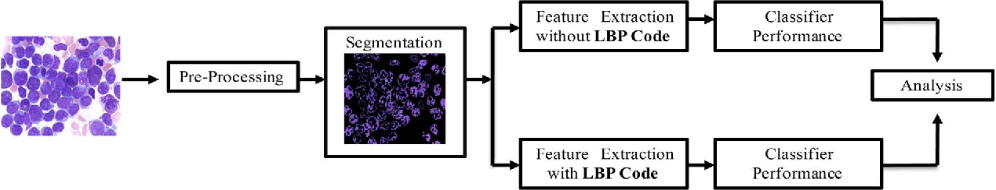

ARCHITECTURE DIAGRAM :
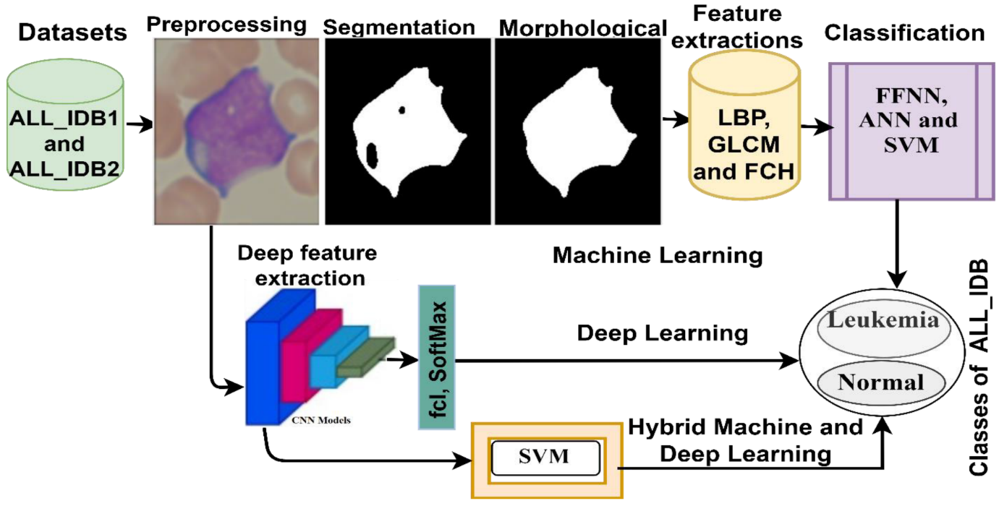

SOFTWARE REQUIREMENTS:
- Operating System : Windows 10
- Platform : python
HARDWARE REQUIREMENTS:
- Keyboard
- Mouse
- Hard disk 500GB
- Ram 4 G

CONCLUTION :
- This paper has reported the design, development, and evaluation of an automated screening system for AML in blood microscopic images.
- It uses 80 high-quality 184 × 138 size images obtained from the American Society of Haematology .
- The presented system performs automated processing, including color correlation, segmentation of the nucleated cells, and effective validation and classification.
- A feature set exploiting the shape, color, and texture parameters of a cell is constructed to obtain all the information required to perform efficient classification.
REFERENCE :
- [1] F. Scotti, “Automatic morphological analysis for acute leukemia identification in peripheral blood microscope images,” in Proc. CIMSA, 2005, pp. 96–101.
- [2] V. Piuri and F. Scotti, “Morphological classification of blood leucocytes by microscope images,” in Proc. CIMSA, 2004, pp. 103–108.
- [3] M. Subrajeet, D. Patra, and S. Satpathy, “Automated leukemia detection in blood microscopic images using statistical texture analysis,” in Proc. Int. Conf. Commun., Comput. Security, 2011, pp. 184–187[4] H. Ramoser, V. Laurain, H. Bischof, and R. Ecker, “Leukocyte segmentation and classification in blood-smear images,” in Proc. IEEE EMBS, 2006, pp. 3371–3374.
- [5] C. Reta, L. Altamirano, J. A. Gonzalez, R. Diaz, and J. S. Guichard, “Segmentation of bone marrow cell images for morphological classification of acute leukemia,” in Proc. 23rd FLAIRS, 2010, pp. 86–91.
- [6] G. Ongun, U. Halici, K. Leblebicioglu, V. Atalay, M. Beksac, and S. Beksac, “Feature extraction and classification of blood cells for an automated differential blood count system,” in Proc. IJCNN, 2001, vol. 4, pp. 2461–2466.
- [7] S. Mohapatra and D. Patra, “Automated leukemia detection using hausdorff dimension in blood microscopic images,” in Proc. Int. Conf. Emerg. Trends Robot Commun. Technol., 2010, pp. 64–68.
- [8] S. Mohapatra, S. Samanta, D. Patra, and S. Satpathi, “Fuzzy based blood image segmentation for automated leukemia detection,” in Proc. ICDeCom, 2011, pp. 1–5.
- [9] S. Mohapatra, D. Patra, and S. Satpathi, “Image analysis of blood microscopic images for acute leukemia detection,” in Proc. IECR, 2010, pp. 215–219.
- [10] S. Mohapatra, D. Patra, and S. Satpathi, “Automated cell nucleus segmentation and acute leukemia detection in blood microscopic images,” in Proc. ICSMB, 2010, pp. 49–54.
- [11] MedlinePlus: Leukemia.National Institutes of Health. [Online]. Available: http://www.nlm.nih.gov/medlineplus/ency/article/001299.htm
- [12] J. N. Jameson, L. K. Dennis, T. R. Harrison, E. Braunwald, A. S. Fauci, S. L. Hauser, and D. L. Longo, “Harrison’s principles of internal medicine,” JAMA, vol. 308, no. 17, pp. 1813–1814, Nov. 2012[13] S. Serbouti, A. Duhamel, H. Harms, U. Gunzer, J. Mary, and R. Beuscart, “Image segmentation and classification methods to detect leukemias,” in Proc. Int. Conf. IEEE Eng. Med. Biol. Soc., 1991, pp. 260–261.
- [14] D. Foran, D. Comaniciu, P. Meer, and L. A. Goodell, “Computer-assisted discrimination among malignant lymphomas and leukemia using immunophenotyping, intelligent image repositories, and telemicroscopy,” IEEE Trans. Inf. Technol. Biomed., vol. 4, no. 4, pp. 265–273, Dec. 2000.
- [15] K. S. Kim, P. K. Kim, J. J. Song, and Y. C. Park, “Analyzing blood cell image do distinguish its abnormalities,” in Proc. ACM Int. Conf. Multim., 2002, pp. 395–397

