AN ONLINE TRANSFER LEARNING FRAMEWORK WITH EXTREME LEARNING MACHINFOR AUTOMATED CREDIT SCORINGE
ABSTRACT:
Automated Credit Scoring (ACS) is the process of predicting user credit based on historical data. It involves analyzing and predicting the association between the data and particular credit values based on similar data. Recently, ACS has been handled as a machine learning problem, and numerous models were developed to address it. In this paper, we address ACS issues concerning credit scoring in a batch of machine learning problems, namely, feature irregularities due to empty features in many records, class imbalance due to non-uniform statistical distributions of the records between classes, and concept drift due to changing statistical characteristics concerning certain classes and features with time.
EXISTING SYSTEM:
- Future work should incorporate feature selection to handle dynamic changes concerning relevant features and high dimensional data.
- In addition, the developed framework should be evaluated on other machine learning fields that share the same issues concerning the credit scoring problem.
- Future work is to extend the developed algorithm to include optimization of the random weights between the input-hidden layer algorithm and to incorporate dynamic feature selection.

Disadvantage of Existing System
- ACS has been handled as a machine learning problem, and numerous models were developed to address it.
- Automated credit scoring performance has been assessed using various approaches specified in the literature. Some studies used the binary classification problem
- The problem of credit scoring is discussed in the literature from various aspects: the first one is the handling of the missing features, the second one is the concept drift awareness and handling, the third one is approaches based on single classifier and the last one is the ensemble learning based approaches.
PROPOSED SYSTEM :
- A multiple time scale ensemble classifiers and a novel sample-based online class imbalance learning procedure are proposed to handle the potential concept drift and class imbalance in the client credit assessment data streams
- Lastly, a weighted formula was proposed that comprehensively considers the class imbalance ratio of the sample’s category and the prediction difficulty
- The optimization has been proposed based on multi-population of genetic with enhancement of crossover, mutation, and adding niche points and migrations
ADVANTAGE:
- In the work of the support vector machine SVM wa used with the incorporation of incorporates a group penalty function in the SVM formulation in order to penalize the variables simultaneously that belong to the same group, assuming that companies often acquire groups of related variables for a given cost rather than acquiring them individually.
- Note that the STL method only utilizes the credit data variables; that is, the training data label information is not used; therefore, the STL model is basically an unsupervised learning method.

LITRATURE REVIEW:
TITTLE | AUTHOR | DESCRIPTION
‘A smart e-form for effective business communication in the financial industry,’ | H. Chang and M. Park | In the era of the Fourth Industrial Revolution, industries are  moving forward to prepare countermeasures in response to  changes in the digital environment, and the nancial industry,
‘‘Regulatory learning: How to supervise machine learning models? An application to credit scoring,’’ | D. Guégan and B. Hassani, ‘ | The arrival of Big Data strategies is threatening the latest trends in financial regulation related to the simplification of models and the enhancement of the comparability of approaches chosen by financial institutions.
‘Credit risk assessment: A comparison of the performances of the linear discriminant analysis and the logistic regression,’’ | A. Levy and R. Baha, | Various methods are used to build prediction models and can be adapted according to the country, the sector of activity and the nature of the data used. .
‘‘Predicting credit risk in peerto-peer lending: A neural network approach,’’, | A. Byanjankar, M. Heikkila, and J. Mezei, | Emergence of peer-to-peer lending has opened an appealing option for micro-financing and is growing rapidly as an option in the financial industry.

INTRODUCTION :
- Managing credit risk and supporting credit application decision-making has become a demanding artificial intelligence and machine learning application.
- It comprises providing the probability of default for lending institutions’ clients and satisfying the minimum loss principle for business sustainability.
- Transitioning from manual borrowing application processing based on officers or expert-based credit scoring to establishing automated credit scoring helps create a more promising system to avoid credit and opportunity loss. Limiting user intervention is the general direction targeted using automated systems.

BLOCK DIAGRAM:
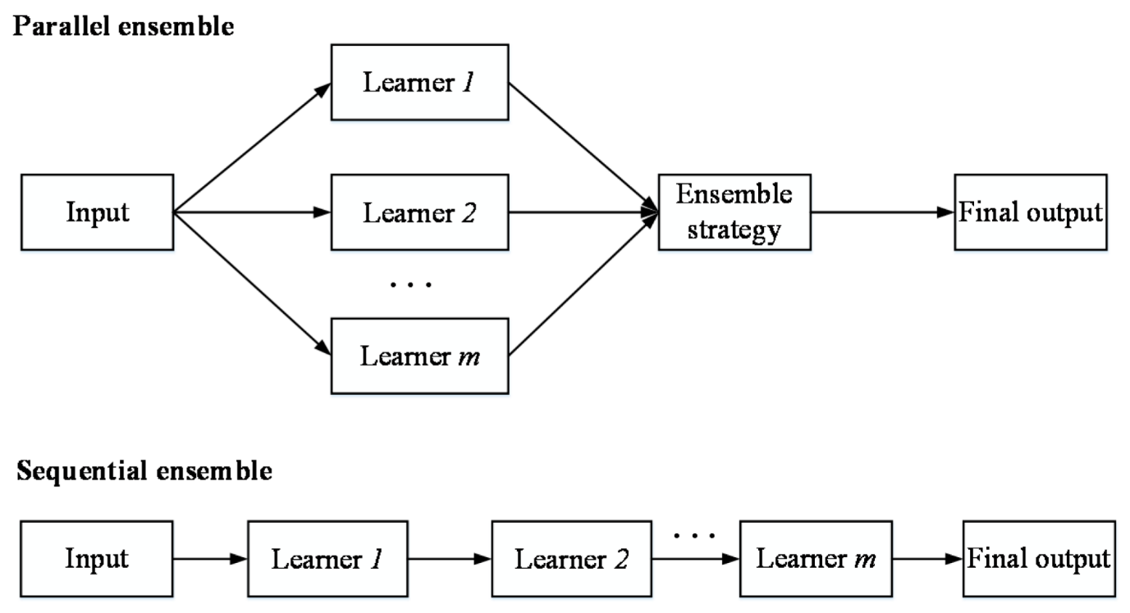
ARCHITECTURE DIAGRAM :
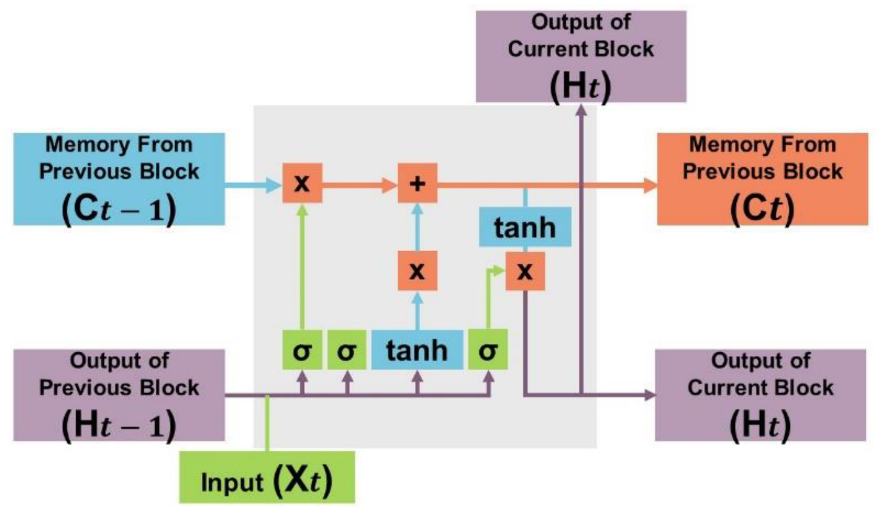
SOFTWARE REQUIREMENTS:
- Operating System : Windows 10
- Platform : python
HARDWARE REQUIREMENTS:
- Keyboard
- Mouse
- Hard disk 500GB
- Ram 4 G
CONCLUTION :
- This article handles the credit scoring problem as a batch learning problem.
- We considered three specific problems: feature irregularities due to empty features in many records, class imbalance due to non-uniform statistical distributionsof records among classes, and concept drift due to varying statistical characteristics for specific classes based on certain features with respect to time.
- The article proposed transfer learning to handle evolving features and changes concerning active/disabled features across batches.
REFERENCE :
- [1] H. Chang and M. Park, ‘‘A smart e-form for effective business communication in the financial industry,’’ Bus. Commun. Res. Pract., vol. 1, no. 2, pp. 95–101, Jul. 2018.
- [2] D. Guégan and B. Hassani, ‘‘Regulatory learning: How to supervise machine learning models? An application to credit scoring,’’ J. Finance Data Sci., vol. 4, no. 3, pp. 157–171, Sep. 2018.
- [3] A. Levy and R. Baha, ‘‘Credit risk assessment: A comparison of the performances of the linear discriminant analysis and the logistic regression,’’ Int. J. Entrepreneurship Small Bus., vol. 42, nos. 1–2, pp. 169–186, 2021
- [4] A. Byanjankar, M. Heikkila, and J. Mezei, ‘‘Predicting credit risk in peerto-peer lending: A neural network approach,’’ in Proc. IEEE Symp. Ser. Comput. Intell., Dec. 2015, pp. 719–725.
- [5] S. Maldonado, C. Bravo, J. López, and J. Pérez, ‘‘Integrated framework for profit-based feature selection and SVM classification in credit scoring,’’ Decision Support Syst., vol. 104, pp. 113–121, Dec. 2017.
- [6] Y. Xia, C. Liu, Y. Li, and N. Liu, ‘‘A boosted decision tree approach using Bayesian hyper-parameter optimization for credit scoring,’’ Expert Syst. Appl., vol. 78, pp. 225–241, Jul. 2017
- [7] J. Nalić, G. Martinović, and D. Žagar, ‘‘New hybrid data mining model for credit scoring based on feature selection algorithm and ensemble classifiers,’’ Adv. Eng. Informat., vol. 45, Aug. 2020, Art. no. 101130.
- [8] H. Sutrisno and S. Halim, ‘‘Credit scoring refinement using optimized logistic regression,’’ in Proc. Int. Conf. Soft Comput., Intell. Syst. Inf. Technol. (ICSIIT), Sep. 2017, pp. 26–31.
- [9] G. Bennouna and M. Tkiouat, ‘‘Fuzzy logic approach applied to credit scoring for microfinance in Morocco,’’ Proc. Comput. Sci., vol. 127, pp. 274–283, Jan. 2018.
- [10] C.-S. Ong, J.-J. Huang, and G.-H. Tzeng, ‘‘Building credit scoring models using genetic programming,’’ Expert Syst. Appl., vol. 29, pp. 41–47, Jul. 2005.
- [11] K. Tran, T. Duong, and Q. Ho, ‘‘Credit scoring model: A combination of genetic programming and deep learning,’’ in Proc. Future Technol. Conf. (FTC), Dec. 2016, pp. 145–149.
- [12] G. Teles, J. J. P. C. Rodrigues, R. A. L. Rabê, and S. A. Kozlov, ‘‘Artificial neural network and Bayesian network models for credit risk prediction,’’ J. Artif. Intell. Syst., vol. 2, no. 1, pp. 118–132, 2020.
- [13] B. Zhu, W. Yang, H. Wang, and Y. Yuan, ‘‘A hybrid deep learning model for consumer credit scoring,’’ in Proc. Int. Conf. Artif. Intell. Big Data (ICAIBD), May 2018, pp. 205–208.
- [14] W. Zhang, H. He, and S. Zhang, ‘‘A novel multi-stage hybrid model with enhanced multi-population niche genetic algorithm: An application in credit scoring,’’ Expert Syst. Appl., vol. 121, pp. 221–232, May 2019.
- [15] M. Ala’raj and M. F. Abbod, ‘‘A new hybrid ensemble credit scoring model based on classifiers consensus system approach,’’ Expert Syst. Appl., vol. 64, pp. 36–55, Dec. 2016.

