THE HIDDEN SEXUAL MINORITIES MACHINE LEARNING APPROACHES TO ESTIMATE
ABSTRACT:
The availability of digital technology in the hands of every citizenry worldwide makes an availableunprecedented massive amount of data. The capability to process these gigantic amounts of data in real-time with Big Data Analytics (BDA) tools and Machine Learning (ML) algorithms carries many paybacks. However, the highnumber of free BDA tools, platforms, and data mining tools makes it challenging to select the appropriate one for theright task. This paper presents a comprehensive mini-literature review of ML in BDA, using a keyword search; a totalof 1512 published articles was identiﬁed.

EXISTING SYSTEM:
- None of the existing demonstrated clear statistical information on the BDA platforms and modelling tools
- Thus, big data are high-dimensional, diverse, gigantic,complex, incomplete, amorphous, noisy, and erroneous,making data pre-processing difﬁcult in BDA. However, itis essential to make machine learning models effectivelyperform well with high accuracy. Nevertheless, thispaper can afﬁrm that this challenge still exist in BDAtoday.
Disadvantage of Existing System
- This outcome can be attributed to LSTM’s storing memory and solving the gradient vanishing problem
- CNN canautomatically notice and extract the appropriate internalstructure from a time series dataset to create in-depthinput features, using convolution and pooling operations.
- Also, CNN and LSTM algorithms are resilient to noisetolerance and accuracy for time-series classiﬁcation.
PROPOSED SYSTEM :
- The articles were screened to 140 based on the study proposed novel taxonomy.
- We further screened the remaining basedon its title abstract, publishers and publication type, andpapers that were not connected with the proposed studywere discarded.
- However, the tools and platforms employed for the empirical analysis also count. Detailed study results based on the proposed taxonomy are presented in the following sections of this paper

ADVANTAGE:
- The aim was to measure the correlation between keywords used in big data analytics.
- As seen in big data, machine learning, analytics, network, and Spark are frequently used by research papers in BDA.
- several evaluation metrics can be used to measure a machine learning model’s performance, depending on the ML task.
- Appendix summarises the papers reviewed in this study; it presents the application area, the papers’ objective, and the data size used.

LITRATURE REVIEW:
TITTLE | AUTHOR | DESCRIPTION
Computer Vision and Machine Intelligence in Medical Image Analysis. London, U.K.: Springer, | J. F. Qiu, Q. H. Wu, G. R. Ding, Y. H. Xu, and S. Feng | The recent development in the areas of deep learning and deep convolutional neural networks has significantly progressed and advanced the field of computer vision (CV) and image analysis and understanding.
‘‘Big data in policy making | B. Aragona and R. De Rosa, | Data analytics inspired by the expanded possibilities of big data can help organisations in both public and private sectors to make better, quicker, and more efficient decisions based on evidence and insights.
Design of cloud-based  green IoT architecture for smart cities, | AG. Kaur, P. Tomar, and P. Singh, | It will make smart cities a greener place by detecting pollution through IoT and environmental sensors.
Big data analytics  services for enhancing business intelligence, | Big data analytics  services for enhancing business intelligence, | This paper examines how to use big data analytics services to enhance business intelligence.
INTRODUCTION :
- According to Sujitparapitaya et al., BD is the gathering of data in huge volume enabled by the recent advances made in technologies tools and platformsthat support high-velocity data capture, storage, and analysis.
- Huge volumes of data are being generated every day in a variety of ﬁelds, from social networks to engineering and commerce to biomolecular research and phycology
- Digital data generated from various digital platforms and devices are growing at astounding rates worldwide
- It is anticipated to reach 149 zettabytes in 2024 as we go into an even more data-driven future
BLOCK DIAGRAM:
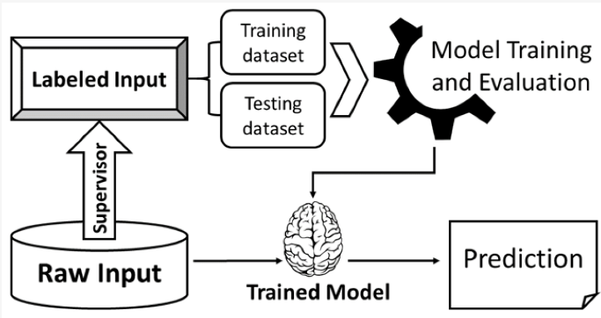
ARCHITECTURE DIAGRAM :
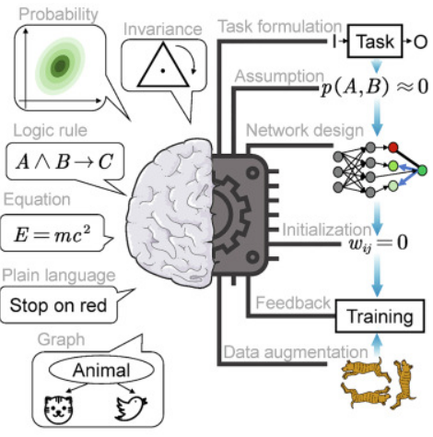

SOFTWARE REQUIREMENTS:
- Operating System : Windows 10
- Platform : python
HARDWARE REQUIREMENTS:
- Keyboard
- Mouse
- Hard disk 500GB
- Ram 4 G

CONCLUTION :
- The current studies reviewed past studies on big data analytics with machine learning applications in different economic areas.
- A total of 1512 papers published in journals and conferences were downloaded using keywords search in Google scholar.
- The downloaded papers were screened through several stages, and the ﬁnal selected papers were reviewed based on a proposed taxonomy.
- Based on the analysis we have presented in previous subsections and the summarized information in Tables 2 and A1 and it is obvious to envision the most used tools for this review, the trend of research work over the years, besides mentioning several openings for future works
- survey will be valuable for researchers entering this field, as well as for experts.

REFERENCE :
- [1]J. F. Qiu, Q. H. Wu, G. R. Ding, Y. H. Xu, and S. Feng, A survey of machine learning for big data processing, EURASIP .Adv.Signal Process., vol. 2016, no. 1, pp.67, 2016.
- [2] B. Aragona and R. De Rosa, Big data in policy making, Math.Popul.Stud., vol. 26, no. 2, pp. 107–113, 2019.
- [3] G. Kaur, P. Tomar, and P. Singh, Design of cloud-based green IoT architecture for smart cities, in Internet ofThings and Big Data Analytics Toward Next-GenerationIntelligence, N. Dey, A. E. HassanienC. Bhatt, A.S. Ashour, and S. C. Satapathy, eds. Cham, Germany: Springer, 2018, pp. 315–333
- [4]A. Holst, Amount of information globally 2010–2024,https://www.statista.com/statistics/871513/worldwide-data-created/, 2020.
- [5]Z. H. Sun, L. Z. Sun, and K. Strang, Big data analyticsservices for enhancing business intelligence,J.Comput.Inf.Syst., vol. 58, no. 2, pp. 162–169, 2018
- [6]S. Debortoli, O. M uller, and J. vom Brocke, Comparingbusiness intelligence and big data skills, Bus.Inf.Syst.Eng., vol. 6, no. 5, pp. 289–300, 2014
- [7]B. K. Sarkar, Big data for secure healthcare system: Aconceptual design, Complex Intell.Syst., vol. 3, no. 2, pp.133–151, 2017.
- [8] J. Zakir, T. Seymour, and K. Berg, Big data analytics,Issues Inf.Syst., vol. 16, no. 2, pp. 81–90, 2015
- [9] I. K. Nti, A. F. Adekoya, and B. A. Weyori, A systematicreview of fundamental and technical analysis of stockmarket predictions, Artif.Intell.Rev., vol. 53, no. 4, pp.3007–3057, 2020
- [10] I. K. Nti, A. F. Adekoya, and B. A. Weyori, Acomprehensive evaluation of ensemble learning forstock-market prediction,J.Big Data, vol. 7, no. 1, p. 20, 2020.
- [11]R. Raja, I. Mukherjee, and B. K. Sarkar, A systematicreview of healthcare big data, Sci.Program.vol. 2020, p.5471849, 2020.
- [12]C. W. Tsai, C. F. Lai, H. C. Chao, and A. V. Vasilakos,Big data analytics: A survey,J.Big Data, vol. 2, no. 1, p.21, 2015
- [13]P. Russom, Introduction to big data analyticshttps://vivomente.com/wp-content/uploads/2016/04/big-data-analytics-white-paper.pdf, 2011.
- [14]M. G. Kibria, K. Nguyen, G. P. Villardi, O. Zhao,K. Ishizu, and F. Kojima, Big data analytics, machinelearning, and artiﬁcial intelligence in next-generationwireless networks, IEEE Access, vol. 6, pp. 32328–32338,2018.
- [15]C. Choi, J. Kim, J. Kim, D. Kim, Y. Bae, and H. S.Kim, Development of heavy rain damage prediction modelusing machine learning based on big data, Adv.Meteorol.,vol. 2018, p. 5024930, 2018.

