ON THE SYNERGIES BETWEEN MACHINE LEARNING AND BINOCULAR STEREO FO DEPTH ESTIMATION FROM IMAGES A SURVEY
ABSTRACT:
Stereo matching is one of the longest-standing problems in computer vision with close to 40 years of studies and research. Throughout the years the paradigm has shifted from local, pixel-level decision to various forms of discrete and continuous optimization to data-driven, learning-based methods.Recently, the rise of machine learning and the rapid proliferation of deep learning enhanced stereo matching with new exciting trends and applications unthinkable until a few years ago. Interestingly, the relationship between these two worlds is two-way. While machine, and especially deep, learning advanced the state-of-the-art in stereo matching, stereo itself enabled new ground-breaking methodologies such as self-supervised monocular depth estimation based on deep networks. In this paper, we review recent research in the field of learning-based depth estimation from single and binocular images highlighting the synergies, the successes achieved so far and the open challenges the community is going to face in the immediate future. Index Terms—Stereo matching, machine learning, deep learning, monocular depth estimation

EXISTING SYSTEM:
- While machine, and especially deep, learning advanced the state-of-the-art in stereo matching, stereo itself enabled new ground-breaking methodologies such as self-supervised monocular depth estimation based on deep networks.
- In this paper, we review recent research in the field of learning-based depth estimation from single and binocular images highlighting the synergies, the successes achieved so far and the open challenges the community is going to face in the immediate future.
- Index Terms—Stereo matching, machine learning, deep learning, monocular depth estimation
Disadvantage of Existing System
- Then, we consider two aspects concerning respectively the conventional pipelines and the end-to-end models, that are confidence estimation, covered in the domain-shift problem, introduced in together with techniques aimed at mitigating it.
- In most computer vision problems, the availability of large and diverse datasets is of paramount importance for successfully developing new algorithms and for being able to measure their effectiveness.
PROPOSED SYSTEM :
- A few years later, an improved dataset and benchmark for scene flow estimation was proposed. In this case, the dataset consists of color stereo pairs, evenly split into training and test sets
- Three main versions have been proposed between 2002 [1] and with varying resolution and image content. We will focus on this latter version, namely Middlebury 2014, since it provides an online benchmark for evaluation and still represents one of the most challenging datasets for stereo matching.
- As evidence, we underline that most of the proposed end-to-end networks for stereo matching are trained from scratch on this large dataset, before being fine-tuned on real data.

ADVANTAGE:
- The same procedure used for KITTI 2012 is followed here to obtain ground truth labels, except for moving objects whose 3D points cannot be properly accumulated over time.
- Some of the data are used multiple times under different exposure and illumination conditions.
- This dataset has rarely been used in the evaluationof stereo approaches .it is much more popular in optical flow.
- Although rarely used to train stereo networks [19], the aforementioned modelling power makes it a promising tool for future research

LITRATURE REVIEW:
TITTLE | AUTHOR | DESCRIPTION
The same procedure used for KITTI 2012 is followed here to obtain ground truth labels, except for moving objects whose 3D points cannot be properly accumulated over time. | The same procedure used for KITTI 2012 is followed here to obtain ground truth labels, except for moving objects whose 3D points cannot be properly accumulated over time. | The same procedure used for KITTI 2012 is followed here to obtain ground truth labels, except for moving objects whose 3D points cannot be properly accumulated over time.
Some of the data are used multiple times under different exposure and illumination conditions. | Some of the data are used multiple times under different exposure and illumination conditions. | Some of the data are used multiple times under different exposure and illumination conditions.
"“Unsupervised CNN for single view depth estimation: Geometry to the rescue,” | R. Garg, V. K. BG, G. Carneiro, and I. Reid | A significant weakness of most current deep Convolutional Neural Networks is the need to train them using vast amounts of manu- ally labelled data.
“Advances in computational stereo,” | M. Brown, D. Burschka, and G. Hager, | Extraction of three-dimensional structure of a scene from stereo images is a problem that has been studied by the computer vision community for decades.
INTRODUCTION :
- Since the early stages of computer vision, estimating depth from images has been one of the iconic challenges for researchers.
- Obtaining dense and accurate depth maps is crucial for effectively addressing higher-level tasks such as 3D reconstruction, mapping and localization, autonomous driving, and many more.
- The focus of this paper is on stereo matching, which is classified as a passive sensing technique, and related topics.
BLOCK DIAGRAM:
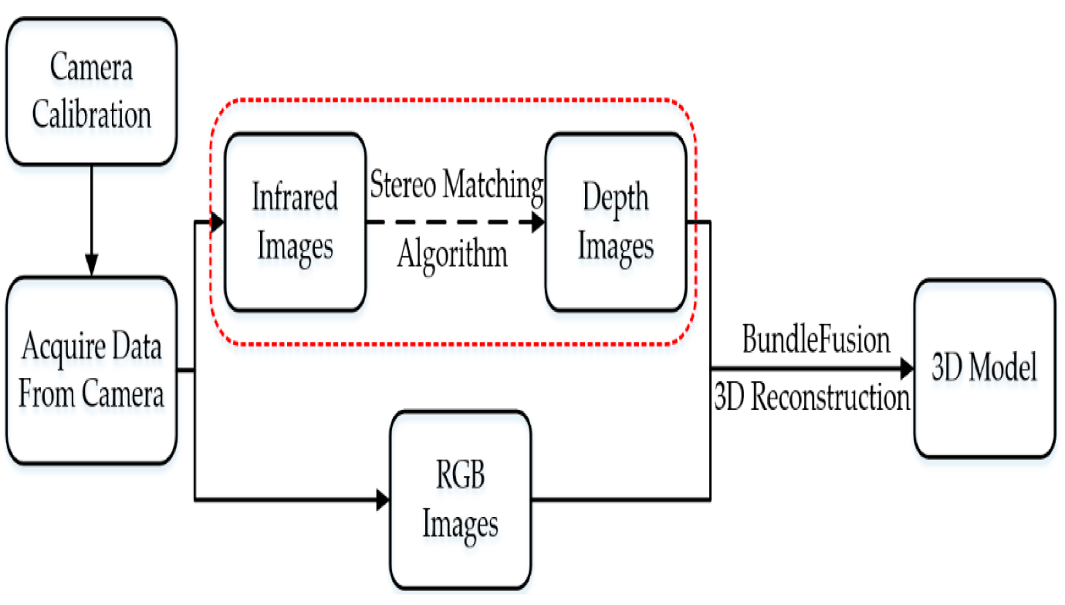
ARCHITECTURE DIAGRAM :
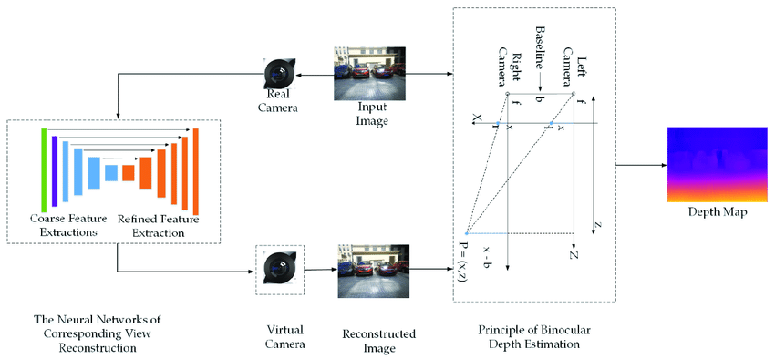

SOFTWARE REQUIREMENTS:
- Operating System : Windows 10
- Platform : python
HARDWARE REQUIREMENTS:
- Keyboard
- Mouse
- Hard disk 500GB
- Ram 4 G

CONCLUTION :
- We have presented a comprehensive survey of recent advances in depth estimation from images leveraging the synergies between binocular stereo and data-driven, learningbased methods.
- Reviewing the literature reveals that the relationship is bidirectional and new machine learning approaches had to be developed to address depth estimation.
- While research is ongoing and voluminous, we believe that this survey will be valuable for researchers entering this field, as well as for experts.
REFERENCE :
- [1] D. Scharstein and R. Szeliski, “A taxonomy and evaluation of dense two-frame stereo correspondence algorithms,” IJCV, vol. 47, no. 1-3, pp. 7–42, 2002.
- [2] Y. LeCun, Y. Bengio, and G. Hinton, “Deep learning,” Nature, vol. 521, no. 7553, p. 436, 2015.
- [3] R. Garg, V. K. BG, G. Carneiro, and I. Reid, “Unsupervised CNN for single view depth estimation: Geometry to the rescue,” in ECCV. Springer, 2016, pp. 740–756.
- [4] M. Brown, D. Burschka, and G. Hager, “Advances in computational stereo,” PAMI, vol. 25, no. 8, pp. 993–1008, 2003
- [5] D. Scharstein and R. Szeliski, “High-accuracy stereo depth maps using structured light,” in CVPR, 2003.
- [6] H. Hirschmuller and D. Scharstein, “Evaluation of cost functions ¨ for stereo matching,” in CVPR, 2007.
- [7] A. Geiger, P. Lenz, and R. Urtasun, “Are we ready for autonomous driving? The KITTI vision benchmark suite,” in CVPR, 2012.
- [8] D. Scharstein, H. Hirschmuller, Y. Kitajima, G. Krathwohl, ¨ N. Nesiˇ c, X. Wang, and P. Westling, “High-resolution stereo ´ datasets with subpixel-accurate ground truth,” in German Conference on Pattern Recognition, 2014, pp. 31–42.
- [9] M. Menze and A. Geiger, “Object scene flow for autonomous vehicles,” in CVPR, 2015, pp. 3061–3070.
- [10] T. Schops, J. L. Sch ¨ onberger, S. Galliani, T. Sattler, K. Schindler, ¨ M. Pollefeys, and A. Geiger, “A multi-view stereo benchmark with high-resolution images and multi-camera videos,” in CVPR, 2017, pp. 3260–3269.
- [11] N. Mayer, E. Ilg, P. Hausser, P. Fischer, D. Cremers, A. Dosovitskiy, and T. Brox, “A large dataset to train convolutional networks for disparity, optical flow, and scene flow estimation,” in CVPR, 2016, pp. 4040–4048. [12] A. Geiger, P. Lenz, C. Stiller, and R. Urtasun, “Vision meets robotics: The kitti dataset,” IJRR, vol. 32, no. 11, pp. 1231–1237, 2013
- [12] A. Geiger, P. Lenz, C. Stiller, and R. Urtasun, “Vision meets robotics: The kitti dataset,” IJRR, vol. 32, no. 11, pp. 1231–1237, 2013.
- [13] N. Mayer, E. Ilg, P. Fischer, C. Hazirbas, D. Cremers, A. Dosovitskiy, and T. Brox, “What makes good synthetic training data for learning disparity and optical flow estimation?” IJCV, vol. 126, no. 9, pp. 942–960, 2018.
- [14] A. X. Chang, T. Funkhouser, L. Guibas, P. Hanrahan, Q. Huang, Z. Li, S. Savarese, M. Savva, S. Song, H. Su et al., “ShapeNet: An information-rich 3d model repository,” arXiv preprint arXiv:1512.03012, 2015.
- [15] D. J. Butler, J. Wulff, G. B. Stanley, and M. J. Black, “A naturalistic open source movie for optical flow evaluation,” in European Conf. on Computer Vision (ECCV), ser. Part IV, LNCS 7577, A. Fitzgibbon et al. (Eds.), Ed. Springer-Verlag, Oct. 2012, pp. 611–625.

