MACHINE LEARNING AND MARKETING A SYSTEMATIC LITERATURE REVIEW
ABSTRACT:
Even though machine learning (ML) applications are not novel, they have gained popularity partly due to the advance in computing processing.This study explores the adoption of ML methods in marketing applications through a bibliographic review of the period 2008–2022. In this period, the adoption of ML in marketing has grown significantly. This growth has been quite heterogeneous, varying from the use of classical methods such as artificial neural networks to hybrid methods that combine different techniques to improve results.

EXISTING SYSTEM:
- Based on this, we aim to present and discuss the main results of the relevant existing works in this field using a strictly scientific method, systematic literature review (SLR), consisting of various critical steps.
- This review seeks to treat and study existing solutions explored in this area and give the gist and suggestions from the previous works.
- This investigation represents a reference that guides and helps the researchers to discover the existing studies and provides them with plan for future direction.
- we don't treat all existing works because of the unavailability of some papers

Disadvantage of Existing System
- ML models are applied to data due to their ability to resolve different problems, from those that could be solved through conventional statistics and management of scientific techniques to complex problems that require a bigger analysis; in this regard, ML allows solving problems faster and better than conventional tech- niques.
- Thus, after a thorough review, a total of 320 scientific articles were obtained, allow81 ing us to observe what marketing problems are solved and the techniques used for this purpose.
In this article, we presented the advantages and disadvantages of the methods and which marketing problems are more feasible to solve with specificalgorithms
PROPOSED SYSTEM :
- The methodology used in this paper adopts the guidelines proposed by Kitchenham and Brereton to perform a systematic literature review (SLR), which reposed on various well-defined stages to establish a rigorous process.
- We divided our proposed quality assessment questions into two classes.
- The first represents the questions that we have affected a high coefficient which is QA1 and QA2, that address the machine learning technique used, architecture of the proposed solution and comparison of the findings with others as shown in Table
- Therefore, 26 papers selected as final set that responds to our proposed criteria.

ADVANTAGE:
- In this regard, machine learning (ML) allows for generating useful results for com23 panies with less effort and time and it is increasingly being used in marketing research
- Therefore, ML-based techniques are used to predict the results of new data, predictions, and classifications or to help people in the process of decision-making
- As we will see, ML has been widely used to discover the most relevant needs of consumers and the relationship they have with products and their attributes segment satisfaction, recognition or recommendation, the selection of a new product or reaction to advertising
LITRATURE REVIEW:
TITTLE | AUTHOR | DESCRIPTION
‘‘Big data consumer analyt- ics and the transformation of marketing,’, | S. Erevelles, N. Fukawa, and L. Swayne, | Consumer analytics is at the epicenter of a Big Data revolution. Technology helps capture rich and plentiful data on consumer phenomena in real time.
‘‘‘‘An analytic approach to select data mining for business decision,’ | J.-L. Seng and T. C. Chen | Due to the information technology improvement and the growth of internet, enterprises are able to collect and to store huge amount of data. .
Impact of big data and machine learning on digital transformation in marketing: | A. Miklosik and N. Evans | This paper describes the impact of big data and machine learning (ML) on digital transformation of the marketing industry and the challenges it faces from a data and information management perspective.
‘An efficient CRM-data mining frame work for the prediction of customer behaviour | T. F. Bahari and M. S. Elayidom | CRM-data mining framework establishes close customer relationships and manages relationship between organizations and customers in today's advanced world of businesses

INTRODUCTION :
- Due to improvements in information technology and the fast growth of the Internet, the revolution of data in the last decades has made businesses generate a substantial amount of useful data; however, we still don’t know how to use it.
- The data must be transformed into information and knowledge that can be turned into tools to help organizations improve their decision-making .
- In this regard, machine learning (ML) allows for generating useful results for com panies with less effort and time and it is increa ingly being used in marketing research.
- For example, ML is employed in market segmentation, tourism, customer lifetime value, loyalty and client segment, direct market, marketing campaigns, and other applications
BLOCK DIAGRAM:
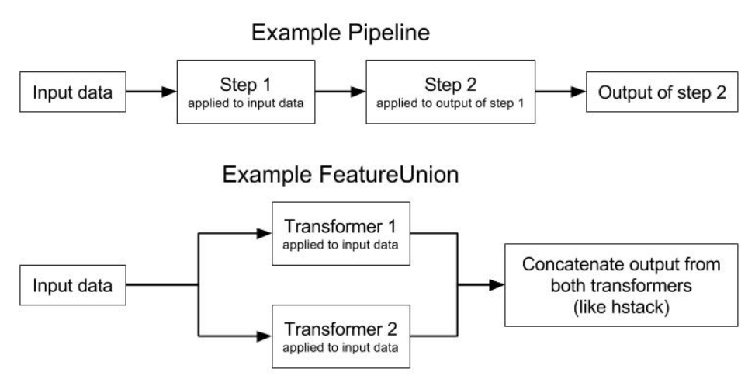
ARCHITECTURE DIAGRAM :
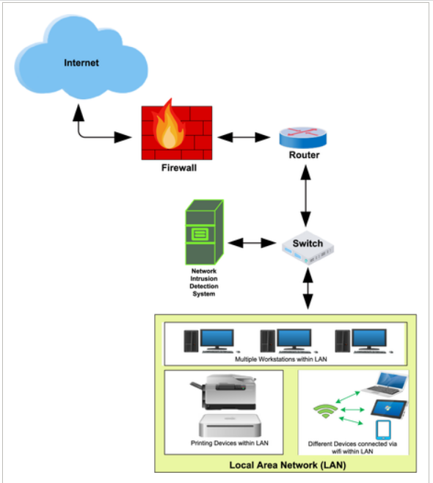

SOFTWARE REQUIREMENTS:
- Operating System : Windows 10
- Platform : python
HARDWARE REQUIREMENTS:
- Keyboard
- Mouse
- Hard disk 500GB
- Ram 4 G

CONCLUTION :
- In this systematic literature review, we have explored the trend of machine learning techniques applications in precision marketing.
- We have selected a set of papers published between 2016 and 2021 and responded to the criteria and research questions that we have defined in the planning stage.
- In addition, it provides an overview of the practical implications and improvement of using machine learning in the precision marketing field.
- This review reposed on accurate method and well-defined stages associated.
- It begins by reviewing protocol identification, review conduct and presentation of the results
REFERENCE :
- [1] S. Erevelles, N. Fukawa, and L. Swayne, ‘‘Big data consumer analyt- 894 ics and the transformation of marketing,’’ J. Bus. Res., vol. 69, no. 2, 895 pp. 897–904, Feb. 2016, doi: 10.1016/j.jbusres.2015.07.001. 896
- [2] J.-L. Seng and T. C. Chen, ‘‘An analytic approach to select data mining 897 for business decision,’’ Expert Syst. Appl., vol. 37, no. 12, pp. 8042–8057, 898 Dec. 2010, doi: 10.1016/j.eswa.2010.05.083. 899
- [3] A. Miklosik and N. Evans, ‘‘Impact of big data and machine learning on 900 digital transformation in marketing: A literature review,’’ IEEE Access, 901 vol. 8, pp. 101284–101292, 2020, doi: 10.1109/ACCESS.2020.2998754.
- [4] T. F. Bahari and M. S. Elayidom, ‘‘An efficient CRM-data mining frame904 work for the prediction of customer behaviour,’’ Proc. Comput. Sci., 905 vol. 46, no. 1, pp. 725–731, 2015, doi: 10.1016/j.procs.2015.02.136. 906
- [5] H. C. Jessen and G. Paliouras, ‘‘Data mining in economics, finance, 907 and marketing,’’ in Machine Learning and its Applications, vol. 2049, 908 G. Paliouras, V. Karkaletsis and C. D. Spyropoulos, Eds. Berlin, Ger909 many: Springer, 2001, pp. 295–299, doi: 10.1007/3-540-44673-7_18. 910
- [6] M. Tkáč and R. Verner, ‘‘Artificial neural networks in business: Two 911 decades of research,’’ Appl. Soft Comput., vol. 38, pp. 788–804, Jan. 2016, 912 doi: 10.1016/j.asoc.2015.09.040
- [7] Ö. Çelik, ‘‘A research on machine learning methods and its applications,’’ J. Educ. Technol. Online Learn., vol. 1, no. 3, pp. 25–40, Sep. 2018, doi: 915 10.31681/jetol.457046. 916
- [8] A. Miklosik, M. Kuchta, N. Evans, and S. Zak, ‘‘Towards the adop917 tion of machine learning-based analytical tools in digital marketing,’’ IEEE Access, vol. 7, pp. 85705–85718, 2019, doi: 10.1109/ACCESS. 919 2019.2924425. 920
- [9] J. R. Hauser, ‘‘Consideration-set heuristics,’’ J. Bus. Res., vol. 67, no.pp. 1688–1699, Aug. 2014, doi: 10.1016/j.jbusres.2014.02.015
- [10] D. Dzyabura and J. R. Hauser, ‘‘Active machine learning for consideration 923 heuristics active machine learning for consideration heuristics,’’ Market924 ing Sci., vol. 30, no. 5, pp. 801–819, Sep. 2011. [Online]. Available: 925 https://www.jstor.org/stable/23011979 926
- [11] R. Briesch and P. Rajagopal, ‘‘Neural network applications in consumer 927 behavior,’’ J. Consum. Psychol., vol. 20, no. 3, pp. 381–389, Jul. 2010, 928 doi: 10.1016/j.jcps.2010.06.001. 929
- [12] X. Wang, J. He, D. J. Curry, and J. H. Ryoo, ‘‘Attribute embedding: 930 Learning hierarchical representations of product attributes from con931 sumer reviews,’’ J. Marketing, vol. 1, no. 21, pp. 1–21, Nov. 2021, doi: 932 10.1177/00222429211047822
- [13] M.-H. Huang and R. T. Rust, ‘‘A strategic framework for artificial intel934 ligence in marketing,’’ J. Acad. Marketing Sci., vol. 49, no. 1, pp. 30–50, 935 Jan. 2021, doi: 10.1007/s11747-020-00749-9. 936
- [14] S.-H. Chen, ‘‘The gamma CUSUM chart method for online customer 937 churn prediction,’’ Electron. Commerce Res. Appl., vol. 17, pp. 99–111, 938 May 2016, doi: 10.1016/j.elerap.2016.04.003. 939
- [15] B. Balducci and D. Marinova, ‘‘Unstructured data in marketing,’’ 940 J. Acad. Marketing Sci., vol. 46, no. 4, pp. 557–590, Jul. 2018, doi: 941 10.1007/s11747-018-0581-x.

