ICS: TOTAL FREEDOM IN MANUAL TEXT CLASSIFICATION SUPPORTED BY UNOBTRUSIVE MACHINE LEARNING
ABSTRACT:
We present the Interactive Classification System (ICS), a web-based application that supports the activity of manual text classification.The application uses machine learning to continuously fit automatic classification models that are in turn used to actively support its users with classification suggestions. The key requirement we have established for the development of ICS is to give its users total freedom of action: they can at any time modify any classification schema and any label assignment, possibly reusing any relevant information from previous activities.

EXISTING SYSTEM:
- The rest of the paper is organized as follows. Section II presents the related work, framing the context of our work and comparing ICS with similar existing systems.
- Each column identifies a functionality: fitting a machine learning model from a training set (batch learning); updating an existing model using novel examples (online learning); the possibility of implementing an active learning process; creating a model starting from an existing one; modifying a schema, i.e., adding/renaming/removing a label

Disadvantage of Existing System
- As detailed in the rest of the paper, this approach is a challenge that asks for original machine learning methods to effectively and efficiently solve the problems it poses.
- we present experiments that evaluate the machine learning component of ICS, on four relevant classification problems
- Research on automatic text classification addresses several machine learning problems and scenarios, each defined by a specific set of boundary conditions on the task.
- Relevant to our work is the problem of considering the human as an oracle that acts on-demand, waiting for interrogations by the system.
PROPOSED SYSTEM :
- We show with experiments that the proposed solution is efficient, effective, and competitive against traditional approaches that are not constrained to the requirements of ICS.
- The availability of this classification enables to perform various tasks on the data, e.g. to measure the variation of the engagement of the public over time and topics in order to identify which are the most relevant ones; to profile users’ interests, possibly targeting each different profile with different messages; to select the content that is relevant to one specific topic in order to perform further analysis, e.g., sentiment analysis
ADVANTAGE:
- The application uses machine learning to continuously fit automatic classification models that are in turn used to actively support its users with classification suggestions
- Such automatic classifications can be used as suggestions presented to the users during their manual classification activity, thus implementing an active learning process, or to produce, once its accuracy is deemed to be adequate, the automatic classification of an entire dataset
- This paper follows the terminology currently used in machine learning research.
LITRATURE REVIEW:
TITTLE | AUTHOR | DESCRIPTION
‘Automatic indexing: An experimental inquiry,’’ | M. E. Maron | Opinion mining (OM) is a recent subdiscipline at the crossroads of information retrieval and computational linguistics .
‘‘‘‘Machine learning in automated text categorization,’’ | F. Sebastiani | he automated categorization (or classification) of texts into predefined categories has witnessed a booming interest in the last 10 years, due to the increased availability of documents in digital form and the ensuing need to organize them.
Active learning literature survey,’ | B. Settles | The key idea behind active learning is that a machine learning algorithm can achieve greater accuracy with fewer training labels if it is allowed to choose the data from which it learns.
‘Interactive classification system,’’ | A. Esuli | Interactive data mining focuses on efficient and effective human-computer interactions for data analysis purposes.

INTRODUCTION :
- The task of text classification consists of selecting labels that are relevant to the content of a document. This label assignment process gives an explicit and structured form to the information that is latent and represented in an unstructured way in the text.
- The classification of documents is an intellectual task that requires giving a semantic to the concepts represented by the labels and recognizing such concepts in the content of documents.
- Some concepts may be simple to define and recognize, e.g., the mention of a brand name, others may be much harder to give a clear and shared definition, e.g., the expression of sarcasm
BLOCK DIAGRAM:
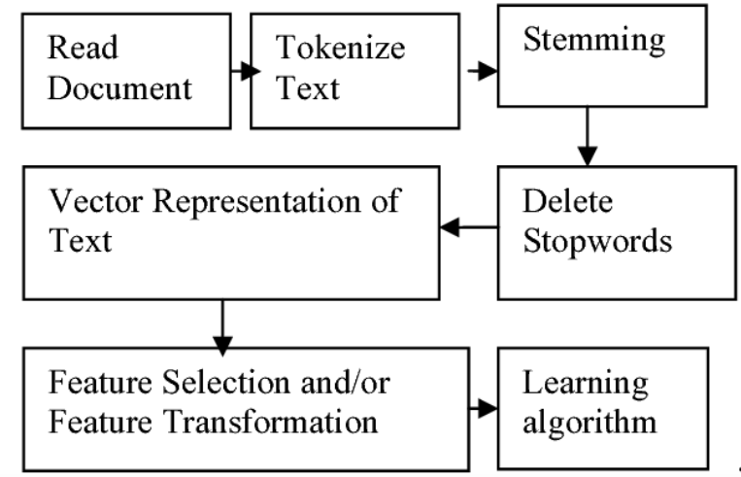
ARCHITECTURE DIAGRAM :
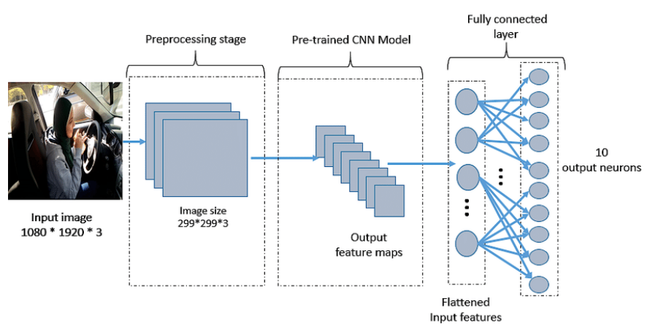
SOFTWARE REQUIREMENTS:
- Operating System : Windows 10
- Platform : python
HARDWARE REQUIREMENTS:
- Keyboard
- Mouse
- Hard disk 500GB
- Ram 4 G

CONCLUTION :
- We presented ICS, a web-based application that supports the activity of manual text classification. ICS has been designed and implemented to give its users total freedom of action.
- This is an innovation with respect to the typical approach of machine learning research applied to text, which focuses on the algorithms, and assigns the human actors to constrained roles within the workflow of the algorithm
- They also bring in the advantage of having usable models for prediction since the early steps of training set construction.
- A typical barrier to access to machine learning is the need for training data.
REFERENCE :
- [1] M. E. Maron, ‘‘Automatic indexing: An experimental inquiry,’’ J. ACM, vol. 8, no. 3, pp. 404–417, Jul. 1961, doi: 10.1145/321075.321084.
- [2] C. C. Aggarwal and C. Zhai, A Survey of Text Classification Algorithms. Heidelberg, Germany: Springer, 2012, pp. 163–222, doi: 10.1007/ 978-1-4614-3223-4_6.
- [3] F. Sebastiani, ‘‘Machine learning in automated text categorization,’’ ACM Comput. Surv., vol. 34, no. 1, pp. 1–47, 2002, doi: 10.1145/505282.505283.
- [4] B. Settles, ‘‘Active learning literature survey,’’ Dept. Comput. Sci., Univ. Wisconsin-Madison, Wisconsin, WI, USA, Tech. Rep. TR1648, 2009. [Online]. Available: http://digital.library.wisc.edu/1793/60660
- [5] A. Esuli, ‘‘Interactive classification system,’’ Zenodo, 2022, doi: 10.5281/zenodo.6586244.
- [6] D. W. Oard, ‘‘The state of the art in text filtering,’’ User Model. UserAdapted Interact., vol. 7, no. 3, pp. 141–178, Jun. 1997.
- [7] R. E. Schapire, Y. Singer, and A. Singhal, ‘‘Boosting and Rocchio applied to text filtering,’’ in Proc. 21st Annu. Int. ACM SIGIR Conf. Res. Develop. Inf. Retr., vol. 98, Aug. 1998, pp. 215–223, doi: 10.1145/290941.290996.
- [8] I. Soboroff and C. K. Nicholas, ‘‘Combining content and collaboration in text filtering,’’ in Proc. Workshop Mach. Learn. Inf. Filtering (IJCAI), 1999, pp. 86–91. [Online]. Available: http://citeseerx.ist.psu.edu/viewdoc/summary?doi=10.1.1.39.8019 [9] S. Wermter, ‘‘Neural network agents for learning semantic text classification,’’ Inf. Retr., vol. 3, no. 2, pp. 87–103, 2000, doi: 10.1023/A:1009942513170
- [10] T. Joachims, ‘‘Text categorization with support vector machines: Learning with many relevant features,’’ in Proc. Eur. Conf. Mach. Learn., 1998, pp. 137–142, doi: 10.1007/BFb0026683.
- [11] Y. Yang and X. Liu, ‘‘A re-examination of text categorization methods,’’ in Proc. 22nd Annu. Int. ACM Conf. Res. Develop. Inf. Retr. (SIGIR), 1999, pp. 42–49, doi: 10.1145/312624.312647.
- [12] R. Johnson and T. Zhang, ‘‘Semi-supervised convolutional neural networks for text categorization via region embedding,’’ in Proc. Adv. Neural Inf. Process. Syst., vol. 28, C. Cortes, N. Lawrence, D. Lee, M. Sugiyama, and R. Garnett, Eds. Red Hook, NY, USA: Curran Associates, 2015, pp. 919–927. [Online]. Available: https://proceedings.neurips.cc/paper/2015/hash/ acc3e0404646c57502b480dc052c4fe1-Abstract.html .
- [13] A. McCallum and K. Nigam, ‘‘A comparison of event models for naive Bayes text classification,’’ in Proc. AAAI Workshop Learn. Text Categorization, vol. 752, no. 1, 1998, pp. 41–48.
- [14] K. Nigam, A. K. McCallum, S. Thrun, and T. Mitchell, ‘‘Text classification from labeled and unlabeled documents using EM,’’ Mach. Learn., vol. 39, nos. 2–3, pp. 103–134, 2000, doi: 10.1023/A:1007692713085.
- [15] A. Joulin, E. Grave, P. Bojanowski, and T. Mikolov, ‘‘Bag of tricks for efficient text classification,’’ in Proc. 15th Conf. Eur. Chapter Assoc. Comput. Linguistics, vol. 2, 2017, pp. 427–431. [Online]. Available: https://aclanthology.org/E17-2068

