MACHINE LEARNING FOR STRUCTURE DETERMINATION IN SINGLE-PARTICLE CRYO ELECTRON MICROSCOPY: A SYSTEMATIC REVIEW
ABSTRACT:
Traditionally, X-ray crystallography and NMR spectroscopy represent major workhorses of structural biologists, with the lion share of protein structures reported in protein data bank (PDB) being generated by these powerful techniques.Despite their wide utilization in protein structure determination, these two techniques have logical limitations, with X-ray crystallography being unsuitable for the analysis of highly dynamic structures and with NMR spectroscopy being restricted to the analysis of relatively small proteins In recent years, we have witnessed an explosive development of the techniques based on Cryo-electron microscopy (Cryo-EM) for structural characterization of biological molecules In fact, single-particle Cryo-EM is a special niche as it is a technique of choice for the structural analysis of large, structurally heterogeneous, and dynamic complexes. Here, sub-nanometer atomic resolution can be achieved (i.e., resolution below 10 Å) via single-particle imaging of non-crystalline specimens, with accurate 3D reconstruction being generated based on the computational averaging of multiple 2D projection images of the same particle that was frozen rapidly in solution.

EXISTING SYSTEM:
- Sample heterogeneity and biomolecular flexibility remains a great challenge in crystal formation, hence predisposing the need for the development of novel techniques and multi-disciplinary approaches that are able to surmount existing limitations of the technique.
- High contrast is observed due to existing relative electron density between the sample and the surrounding stain.
- The emergence of single particle cryo-EM was a ray of hope for structural determination of biologically relevant macromolecules considered unamenable to existing methods.

Disadvantage of Existing System
- When faced with a problem, a reduction to its component parts is generally a common practice in science. Oftentimes, fundamental insights are readily obtained by piecing the individual parts back together.
- A deep understanding of the overall structure of a problem informs potential strategies that could be undertaken in solving the underlying constraint. This rationale particularly applies to the growing field of structural biology, recognized approximately 70 years ago following structural elucidation of the atomic structure of DNA and other globular proteins
PROPOSED SYSTEM :
- Therefore, new phase plates, based on high-intensity laser technology, are currently under development.
- This new technology is likely to replace VPP as it proposes no loss in image information and a constant phase shif
- Built on the collective efforts of researchers in this field, it is now possible to determine the structural architecture of biologically relevant macromolecules and assemblies (proteins and nucleic acids) that play very important roles in the overall coordination of human physiology.

ADVANTAGE:
- cryo-EM as a powerful tool for the reduction of sample heterogeneity
- So far in cryo-EM, various cryogenic substances, such as liquid helium, liquid ethane, and liquid nitrogen, have been used at some point.
- Thin-section electron microscopy was the first method used to have a glance at the structural organization of the RyR channel.
- Negative stain Cryo-EM was first used to model the 3D structure of the RyR channel at 40 Å resolution, giving insight into its mushroom-shaped morphology

LITRATURE REVIEW:
TITTLE | AUTHOR | DESCRIPTION
‘The current revolution in cryo-em | Egelman, E.H | Structural biology is the study of the molecular architecture of proteins and nucleic acids, which are the basis for all life forms.
‘The contribution of intrinsically disordered regions to protein function,,” . | Babu, M.M., , | Consequently, protein disorder can play an especially important role in plants, providing them with a fast mechanism to obtain complex, interconnected and versatile molecular networks
An illustration of the protein structure-function continuum concept. | Uversky, V.N. | his protein has numerous biological functions, possesses intrinsically disordered regions crucial for its functionality, can form both homo-tetramers and isoform-based hetero-tetramers, and is able to interact with many binding partners.
Order, disorder, and everything in between | DeForte, S.; Uversky, V.N | There are also subtler categories of disorder, such as conditional (or dormant) disorder and partial disorder.

INTRODUCTION :
- In recent years, we have witnessed an explosive development of the techniques based on Cryo-electron microscopy (Cryo-EM) for structural characterization of biological molecules.
- In fact, single-particle Cryo-EM is a special niche as it is a technique of choice for the structural analysis of large, structurally heterogeneous, and dynamic complexes.
Here, sub-nanometer atomic resolution can be achieved (i.e., resolution below 10 Å) via single-particle imaging of non-crystalline specimens, with accurate 3D reconstruction being generated based on the computational averaging of multiple 2D projection images of the same particle that was frozen rapidly in solution

BLOCK DIAGRAM:
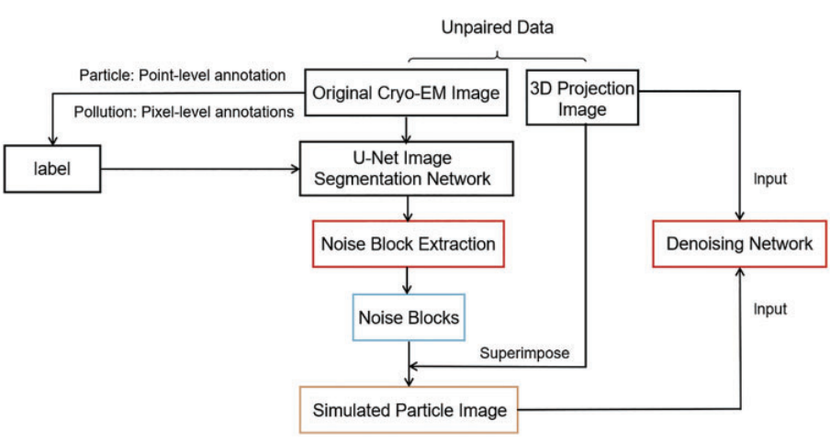
ARCHITECTURE DIAGRAM :
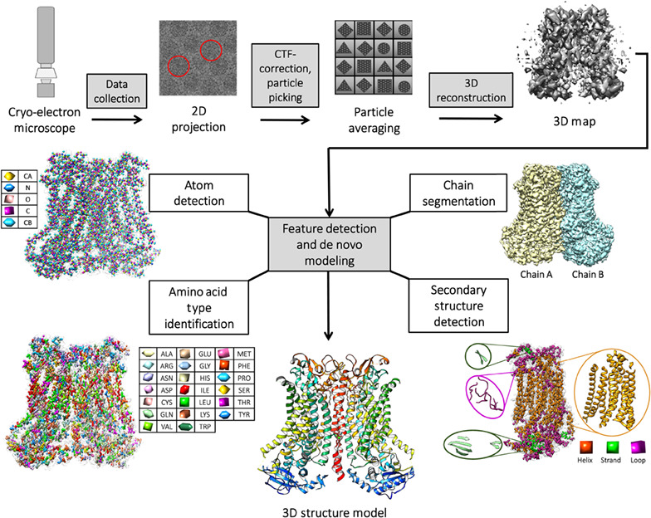
SOFTWARE REQUIREMENTS:
- Operating System : Windows 10
- Platform : python
HARDWARE REQUIREMENTS:
- Keyboard
- Mouse
- Hard disk 500GB
- Ram 4 G

CONCLUTION :
- The extensive impact of X-ray crystallography since its inception cannot be overstated, however like many other technologies, it is not without its limitations.
- In an effort to surmount the challenges associated with the technique, alternative biophysical tools for structure determination were successfully developed based on the foundation laid by a pioneering X-ray crystallography.
- NMR spectroscopy was developed to handle molecular interactions and analyze dynamic systems.
Its reign was short-lived, however, due to the daunting task of resolving copious amounts of data
REFERENCE :
- 1. Egelman, E.H. The current revolution in cryo-em. Biophys. J. 2016, 110, 1008–1012. [CrossRef] [PubMed]
- 2. Babu, M.M. The contribution of intrinsically disordered regions to protein function, cellular complexity, and human disease. Biochem. Soc. Trans. 2016, 44, 1185–1200. [CrossRef] [PubMed]
- 3. Uversky, V.N. P53 proteoforms and intrinsic disorder: An illustration of the protein structure-function continuum concept. Int. J. Mol. Sci. 2016, 17, 1874. [CrossRef] [PubMed]
- 4. DeForte, S.; Uversky, V.N. Order, disorder, and everything in between. Molecules 2016, 21, 1090. [CrossRef] [PubMed]

- 5. Uversky, V.N. Dancing protein clouds: The strange biology and chaotic physics of intrinsically disordered proteins. J. Biol. Chem. 2016, 291, 6681–6688. [CrossRef] [PubMed]
- 6. Uversky, V.N. Unusual biophysics of intrinsically disordered proteins. Biochim. Biophys. Acta 2013, 1834, 932–951. [CrossRef] [PubMed]
- 7. van der Lee, R.; Buljan, M.; Lang, B.; Weatheritt, R.J.; Daughdrill, G.W.; Dunker, A.K.; Fuxreiter, M.; Gough, J.; Gsponer, J.; Jones, D.T.; et al. Classification of intrinsically disordered regions and proteins. Chem. Rev. 2014, 114, 6589–6631. [CrossRef]
- 8. Oldfield, C.J.; Dunker, A.K. Intrinsically disordered proteins and intrinsically disordered protein regions. Annu. Rev. Biochem. 2014, 83, 553–584. [CrossRef]
- 9. Heather, J.M.; Chain, B. The sequence of sequencers: The history of sequencing DNA. Genomics 2016, 107, 1–8. [CrossRef]
- 10. Marion, D. An introduction to biological nmr spectroscopy. Mol. Cell. Proteom. 2013, 12, 3006–3025. [CrossRef
- 11. Sugiki, T.; Kobayashi, N.; Fujiwara, T. Modern technologies of solution nuclear magnetic resonance spectroscopy for three-dimensional structure determination of proteins open avenues for life scientists. Comput. Struct. Biotechnol. J. 2017, 15, 328–339. [CrossRef]
- 12. Schneider, R.; Blackledge, M.; Jensen, M.R. Elucidating binding mechanisms and dynamics of intrinsically disordered protein complexes using nmr spectroscopy. Curr. Opin. Struct. Biol. 2019, 54, 10–18. [CrossRef
- 13. Salvi, N.; Abyzov, A.; Blackledge, M. Atomic resolution conformational dynamics of intrinsically disordered proteins from nmr spin relaxation. Prog. Nucl. Magn. Reson. Spectrosc. 2017, 102–103, 43–60. [CrossRef]
- 14. Gibbs, E.B.; Cook, E.C.; Showalter, S.A. Application of nmr to studies of intrinsically disordered proteins. Arch. Biochem. Biophys. 2017, 628, 57–70. [CrossRef]
- 15. Kurzbach, D.; Kontaxis, G.; Coudevylle, N.; Konrat, R. Nmr spectroscopic studies of the conformational ensembles of intrinsically disordered proteins. Adv. Exp. Med. Biol. 2015, 870, 149–185.

