Data Privacy and key based security using SH256
ABSTRACT:
Information security means protecting data, such as a database, from destructive forces and from the unwanted actions of unauthorized users. Information Security can be achieved by using cryptographic techniques. It is now very much demanding to develop a system to ensure better long lasting security services for message transaction over the Internet. Thus in this research paper RSA is used as Two key based cryptographic technique with a hash function SHA-2. At first, the key pairs have been generated for the users to perform the encryption and decryption.

EXISTING SYSTEM:
- I tried to design and develop such a system based on existing technique that will help any organization for secured information sharing with message confidentiality, user authentication and data integrity
- Cryptography is the most ancient and fascinating mechanism to handle data communication over an insecure channel. Among various types of cryptography, RSA is most popular asymmetric-key cryptography and a hash function SHA-2

Disadvantage of Existing System
- The Internet as an open forum has created some security problems like confidentiality, integrity, and authentication.
- It may be used to provide both secrecy and digital signatures and its security is based on the intractability of the integer factorization problem.
- RSA uses exponentiation modulo a product of two large primes to encrypt and decrypt, performing both public key encryption and public key digital signature, and its security is connected to the presumed difficulty of factoring large integers, a problem for which there is no known efficient general technique
PROPOSED SYSTEM :
- The proposed information security system is composed of two parts: one is data encryption and another is data decryption. Hence assume two users namely A and B wish to communicate.
- Let A is the sender who wish to send a secured message to a specific user B. Both the transaction parties have their own key pair provided by KDC (Key Distribution Centre).
- Here RSA is used to generate this keys. Their private key should remain private but their public key is distributed by means of some method like Public key Distribution Centre (KDC), Public key Authority etc.

ADVANTAGE:
- Public key pair (e, n) is used for encryption and for decryption corresponding private key pair (d, n) is used.
- For key generation, first select two large primes: p, q, and compute the modulo factor, n = p x q and, calculate the totient factor, Ω (n) = (p-1) x (q-1)
- RSA is widely used in electronic commerce protocols, and is believedto be secure given sufficiently long keys and the use of up-todate implementations

LITRATURE REVIEW:
TITTLE | AUTHOR | DESCRIPTION
“Cryptography and Network SecurityPrinciples and Practices”,. | William Stallings. | This paper shows that if a large neural network is used for a pattern classification problem, and the learning algorithm finds a network with small weights that has small squared error on the training patterns, then the generalization performance depends on the size of the weights rather than the number of weights.
“Standard Specifications for Public Key Cryptography”, | William Stallings. | This standard specifies common public-key cryptographic techniques, including mathematical primitives for secret value (key) derivation, public-key encryption, and digital signatures, and cryptographic schemes based on those primitives.
"A Method for Obtaining Digital Signatures and Public-Key Cryptosystems". | Rivest, R.; A. Shamir; L. Adleman (1978).. | Couriers or other secure means are not needed to transmit keys, since a message can be enciphered using an encryption key publicly revealed by the intended recipient
“Cryptography and Network Security” | Behrouz A. Forouzan, Special | Computer data often travels from one computer to another, leaving the safety of its protected physical surroundings. Once the data is out of hand, people with bad intention could modify or forge your data, either for amusement or for their own benefit.

INTRODUCTION :
- Information security refers to protective digital privacy measures that are applied to prevent unauthorized access to computers, databases and websites. Information security also protects data from corruption. Information security is the main priority for organizations of every size and genre. There two ways to ensure information security.
- One is by using software and the other one is by the use of hardware. With the introduction of the computer, the need for automated tools for protecting files and other information stored on the computer became evident.
- This is especially the case for a shared system, such as a time-sharing system, and the need is even more acute for systems that can be accessed over a public telephone network, data network, or the Internet.

BLOCK DIAGRAM:
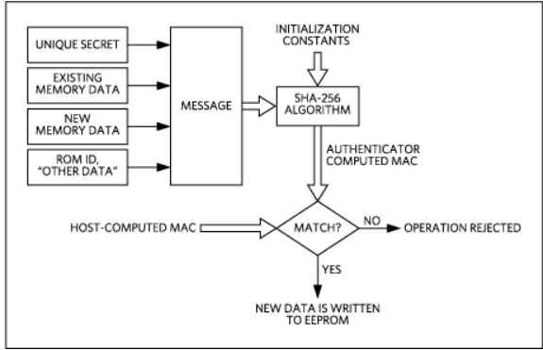
ARCHITECTURE DIAGRAM :
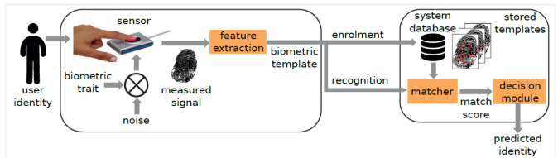
SOFTWARE REQUIREMENTS:
- Operating System : Windows 10
- Platform : python
HARDWARE REQUIREMENTS:
- Keyboard
- Mouse
- Hard disk 500GB
- Ram 4 G

CONCLUTION :
- We introduced the SHA-256 scheme for fine-grained access control in cloud computing and to ensure scalability and flexibility in it.
- The SHA scheme seamlessly enforces a secured structure of system users by applying a delegation algorithm which redefines the methodologies ASBE.
- Finally, I implemented the proposed scheme and performed comprehensive performance analysis and evaluation, which showed its advantages and efficiency over existing schemes.
REFERENCE :
- [1] William Stallings, “Cryptography and Network SecurityPrinciples and Practices”, Fourth Edition, 2006, ISBN: 978-81- 203-3018-4

- [2] “Standard Specifications for Public Key Cryptography”, IEEEP1363/D10 (Draft Version 10), New York USA, 199

- [3] Rivest, R.; A. Shamir; L. Adleman (1978). "A Method for Obtaining Digital Signatures and Public-Key Cryptosystems". Communications of the ACM 21 (2): 120– 126.doi:10.1145/359340.359342.

- [4] http://theory.lcs.mit.edu/~rivest/rsapaper.pdf

- [5] Thomas H. Cormen, Charles E. Leiserson, Ronald L. Rivest, and Clifford Stein. Introduction to Algorithms, Second Edition. MIT Press and McGraw-Hill, 2001. ISBN 0-262- 03293-7. Section 31.3: Modular Arithmetic, pp.862–868.
- [6] “Cryptography and Network Security” , Behrouz A. Forouzan, Special Edition 2011, McGraw-Hill, ISBN-13: 978- 0-07-066046-5 and ISBN-10: 0-07-066046-8

- [7] RSA Laboratories. RSA Laboratories frequently asked questions about today’s cryptography, version 4.1.2000. Accessed on-http://www.rsasecurity.com.

- [8] Ronald L. Rivest. Abelian square-free dithering for iterated hash functions. Accessed onhttp://theory.lcs.mit.edu/~rivest/RivestAbelianSquareFreeDithe ring ForIteratedHashFunctions.pdf. Last accessed on 15th of December 2006.

- [9] Ralph Merkle. “One way hash functions and DES”. In Gilles Brassard, editor, Advances in cryptology: CRYPTO 89, volume 435 of Lecture Notes in Computer Science, pages 428- 446. Springer-Verlag, 1989.
- [10] Wikipedia, the free encyclopaedia https://en.wikipedia.org/wiki/SHA-2

- [11] Wikipedia, the free encyclopaedia http://en.wikipedia.org/wiki/Cryptography, Accessed on November 15, 2014.

- [12] Wikipediahttp://en.wikipedia.org/wiki/Cryptographic_ha sh_function, Accessed on January 7, 2015.
s
- [13] S. Bakhtiari, R. Safavi-Naini and J. Pieprzyk. “Cryptographic hash functions: A Survey”. Technical Report 95-09, Department of Computer Science, University of Wollongong, July 1995.

