A MULTIPLE GRADIENT DESCENT DESIGN FOR MULTI-TASK LEARNING ON EDGE .COMPUTING MULTI-OBJECTIVE MACHINE LEARNING APPROACH
ABSTRACT:
In multi-task learning, multiple tasks are solved jointly, sharing inductive bias between them. Multi-task learning is inherently a multi-objective problem because different tasks may conflict, necessitating a trade-off. A common compromise is to optimize a proxy objective that minimizes a weighted linear combination of pertask losses. However, this workaround is only valid when the tasks do not compete, which is rarely the case.In this paper, we explicitly cast multi-task learning as multi-objective optimization, with the overall objective of finding a Pareto optimal solution. To this end, we use algorithms developed in the gradient-based multiobjective optimization literature.

EXISTING SYSTEM:
- A variety of algorithms for multi-objective optimization exist. One such approach is the multiple-gradient descent algorithm (MGDA), which uses gradient-based optimization and provably converges to a point on the Pareto set (Désidéri, 2012). MGDA is well-suited for multi-task learning with deep networks.
- It can use the gradients of each task and solve an optimization problem to decide on an update over the shared parameters. However, there are two technical problems that hinder the applicability of MGDA on a large scale

Disadvantage of Existing System

- The problem of finding Pareto optimal solutions given multiple criteria is called multi-objective optimization.
- It can use the gradients of each task and solve an optimization problem to decide on an update over the shared parameters
- In this paper, we develop a Frank-Wolfe-based optimizer that scales to high-dimensional problems
- We empirically evaluate the presented method on three different problems

PROPOSED SYSTEM :
- In order to understand the role of the approximation proposed in Section 3.3, we compare the final performance and training time of our algorithm with and without the presented approximation in Table 2 (runtime measured on a single Titan Xp GPU).
- For a small number of tasks (3 for scene understanding), training time is reduced by 40%. For the multi-label classification experiment (40 tasks), the presented approximation accelerates learningAlthough many hypothesis classes and loss functions have been proposed in the MTL literature
ADVANTAGE:
- Stein’s paradox was an early motivation for multi-task learning (MTL) (Caruana, 1997), a learning paradigm in which data from multiple tasks is used with the hope to obtain superior performance over learning each task independently.
- Potential advantages of MTL go beyond the direct implications of Stein’s paradox, since even seemingly unrelated real world tasks have strong dependencies due to the shared processes that give rise to the data
LITRATURE REVIEW:
TITTLE | AUTHOR | DESCRIPTION
T. Evgeniou, and M. Pontil. Multi-task feature learning | A. Argyriou, | We present a method for learning a low-dimensional representation which is shared across  a set of multiple related tasks.
‘‘Content-based image retrieval through a multi-agent meta-learning framework | A. Bagherjeiran, R. Vilalta, and C. F. Eick. | The objective of a general-purpose content-based image retrieval system is to find images in a database that match an external measure of relevance.
Task clustering and gating for Bayesian multitask learning | B. Bakker and T. Heskes | Modeling a collection of similar regression or classification tasks can be improved by making the tasks 'learn from each other'
A model of inductive bias learning. , | J. Baxter | major problem in machine learning is that of inductive bias: how to choose a learner's hypothesis space so that it is large enough to contain a solution to the problem being learnt, yet small enough to ensure reliable generalization from reasonably-sized training sets. .

INTRODUCTION :
- One of the most surprising results in statistics is Stein’s paradox.
- Stein (1956) showed that it is better to estimate the means of three or more Gaussian random variables using samples from all of them rather than estimating them separately, even when the Gaussians are independent.
- Stein’s paradox was an early motivation for multi-task learning (MTL) (Caruana, 1997), a learning paradigm in which data from multiple tasks is used with the hope to obtain superior performance over learning each task independently.
- Potential advantages of MTL go beyond the direct implications of Stein’s paradox, since even seemingly unrelated real world tasks have strong dependencies due to the shared processes that give rise to the data.
BLOCK DIAGRAM:
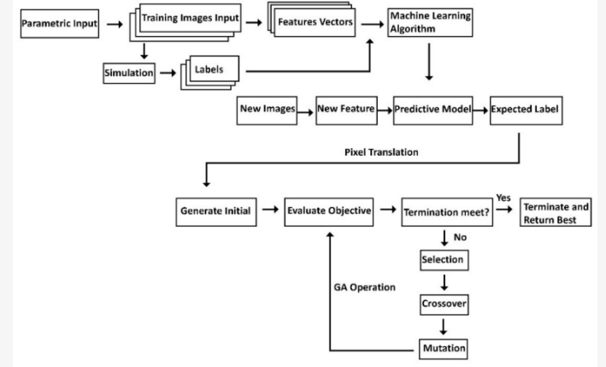
ARCHITECTURE DIAGRAM :
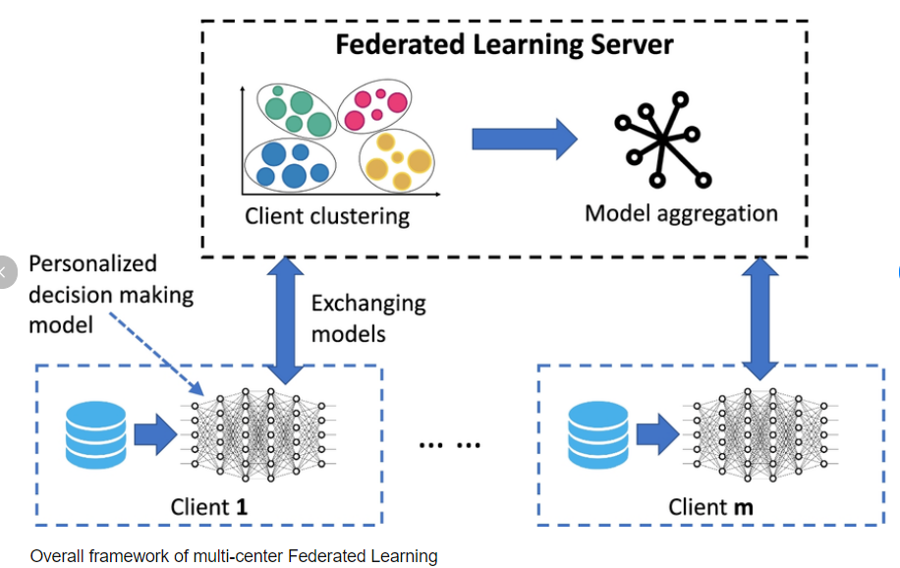

SOFTWARE REQUIREMENTS:
- Operating System : Windows 10
- Platform : python
HARDWARE REQUIREMENTS:
- Keyboard
- Mouse
- Hard disk 500GB
- Ram 4 G
CONCLUTION :
- We described an approach to multi-task learning. Our approach is based on multi-objective optimization.
- In order to apply multi-objective optimization to MTL, we described an efficient algorithm as well as specific approximations that yielded a deep MTL algorithm with almost no computational overhead.
Our experiments indicate that the resulting algorithm is effective for a wide range of multi-task scenarios.

REFERENCE :
- [1]A. Argyriou, T. Evgeniou, and M. Pontil. Multi-task feature learning. In NIPS, 2007.
- [2]A. Bagherjeiran, R. Vilalta, and C. F. Eick. Content-based image retrieval through a multi-agent meta-learning framework. In International Conference on Tools with Artificial Intelligence, 2005
- [3]B. Bakker and T. Heskes. Task clustering and gating for Bayesian multitask learning. JMLR, 4:83–99, 2003.
- [4] J. Baxter. A model of inductive bias learning. Journal of Artificial Intelligence Research, 12:149–198, 2000.
- [5]H. Bilen and A. Vedaldi. Integrated perception with recurrent multi-task neural networks. In NIPS, 2016. R. Caruana. Multitask learning. Machine Learning, 28(1):41–75, 1997
- [6]Z. Chen, V. Badrinarayanan, C. Lee, and A. Rabinovich. GradNorm: Gradient normalization for adaptive loss balancing in deep multitask networks. In ICML, 2018.

- [7]R. Collobert and J. Weston. A unified architecture for natural language processing: Deep neural networks with multitask learning. In ICML, 2008.
- 8]M. Cordts, M. Omran, S. Ramos, T. Rehfeld, M. Enzweiler, R. Benenson, U. Franke, S. Roth, and B. Schiele. The Cityscapes dataset for semantic urban scene understanding. In CVPR, 2016.
- [9]P. B. C. de Miranda, R. B. C. Prudêncio, A. C. P. L. F. de Carvalho, and C. Soares. Combining a multi-objective optimization approach with meta-learning for SVM parameter selection. In International Conference on Systems, Man, and Cybernetics, 2012.
- [10]J. Deng, W. Dong, R. Socher, L.-J. Li, K. Li, and L. Fei-Fei. ImageNet: A large-scale hierarchical image database. In CVPR, 2009.
- [11] J.-A. Désidéri. Multiple-gradient descent algorithm (MGDA) for multiobjective optimization. Comptes Rendus Mathematique, 350(5):313–318, 2012.
- [12]D. Dong, H. Wu, W. He, D. Yu, and H. Wang. Multi-task learning for multiple language translation. In ACL, 2015.
- [13]M. Ehrgott. Multicriteria Optimization (2. ed.). Springer, 2005.
- [14]J. Fliege and B. F. Svaiter. Steepest descent methods for multicriteria optimization. Mathematical Methods of Operations Research, 51(3):479–494, 2000.
- [15] S. Ghosh, C. Lovell, and S. R. Gunn. Towards Pareto descent directions in sampling experts for multiple tasks in an on-line learning paradigm. In AAAI Spring Symposium: Lifelong Machine Learning, 2013

