INTEGRATING MACHINE LEARNING ALGORITHMS WITH QUANTUM ANNEALING SOLVERS FOR ONLINE FRAUD DETECTION
ABSTRACT:
Machine learning has been increasingly applied in identification of fraudulent transactions. However, most application systems detect duplicitous activities after they have already occurred, not at or near real time. Since spurious transactions are far fewer than the normal ones, the highly imbalanced data makes fraud detection very challenging and calls for ways to address it beyond the traditional machine learning approach. This study has proposed a detection framework, and implemented it using quantum machine learning (QML) approach by applying Support Vector Machine (SVM) enhanced with quantum annealing solvers
EXISTING SYSTEM:
- Secondly, in spite of the need for real time or near real time fraud detection for online e-commerce transactions, the effectiveness of many existing systems is compromised since most detect only after the fraud activities have happenedwhen the loss has already occurred.
- Besides the models designed for directly analyzing non-stationary data with the ‘‘time’’ variable, there are existing approaches to transform non-stationary to stationary data by detrending methods such as power transform, square root, and log transform
- Because of quantum computing’s powerful modelling abilities to solve some complex problems that existing computing cannot, we consider QML a promising approach to tackle the huge volume of online fraud data

Disadvantage of Existing System
- Because of quantum computing’s powerful modelling abilities to solve some complex problems that existing computing cannot, we consider QML a promising approach to tackle the huge volume of online fraud data. Details on why QML are used in this study are discussed
- It is a supervised machine learning method for two-group classification problems.
- More complex kernel functions can be obtained by solving quadratic constrained binary optimization problem [27], and that require very high computing capability. One solution is to develop a general quadratic constrained model for SVM, and recast it explicitly as a quadratic unconstrained binary optimization problem (QUBO) using quadratic infeasibility penalties as constraints .
PROPOSED SYSTEM :
- This study has proposed a detection framework, and implemented it using quantum machine learning (QML) approach by applying Support Vector Machine (SVM) enhanced with quantum annealing solvers.
- shows the proposed fraud detection framework and its components.
- Although machine learning algorithms have been proposed, they are still under the assumption of stationary or non-time series data.

ADVANTAGE:
- Describes the characteristics of the datasets used and the algorithms evaluated in this study.
- Once the optimal hyperplane is constructed, it is then used to separate the transactions into normal and fraudulent groups.
- Augmented Dickey Fuller (ADF) and Kwiatkowski-Phillips-Schmidt-Shin (KPSS) are two of the most commonly used statistical test to analyze whether the series of data are the stationary, this study uses both tests to evaluate whether the time series data is stationary as shown in via the unit root test
LITRATURE REVIEW:
TITTLE | AUTHOR | DESCRIPTION
‘Data mining for credit card fraud: A comparative study, | S. Bhattacharyya, S. Jha, K. Tharakunnel, and J. C. Westlan | Over the years, along with the evolution of fraud detection methods, perpetrators of fraud have also been evolving their fraud practices to avoid detection
‘‘‘The application of data mining techniques in financial fraud detection: A classification framework and an academic review of literature,’’ | E. W. T. Ngai, Y. Hu, Y. H. Wong, Y. Chen, and X. Sun, | This paper presents a review of — and classification scheme for — the literature on the application of data mining techniques for the detection of financial fraud. .
‘‘Association rules for fraud detection,’’ | J. A. Tackett | The proposed methodology has been applied on data about credit card fraud in some of the most important retail companies in Chile.
‘‘The comparisons of data mining techniques for the predictive accuracy of probability of default of credit card clients,, | I.-C. Yeh and C.-H. Lien, | Because the real probability of default is unknown, this study presented the novel “Sorting Smoothing Method” to estimate the real probability of default..
INTRODUCTION :
- Fraudulent transactions are costly to businesses. According to, every year, businesses in the US lost 4 billion dollars on average because of fraudulent transactions, and insurance companies in the UK lost 1.6 billion pounds to the fraudulent transaction claims.
- In addition to expense write-offs to cover shipping, refund, and other managerial expenses, businesses also lose sale opportunities from trusted customers and reputational risk.
- Effective detection systems can assist businesses to cut down the loss due to fraudulent transactions.
- However, it is challenging to prevent and detect these incidents for three main reasons.
- First, the development and wide adoption of mobile technologies has brought a tremendous increase of online transactions. In early 2020, there has been a 110% increase in e-commerce transactions in the US alone than previous year
BLOCK DIAGRAM:
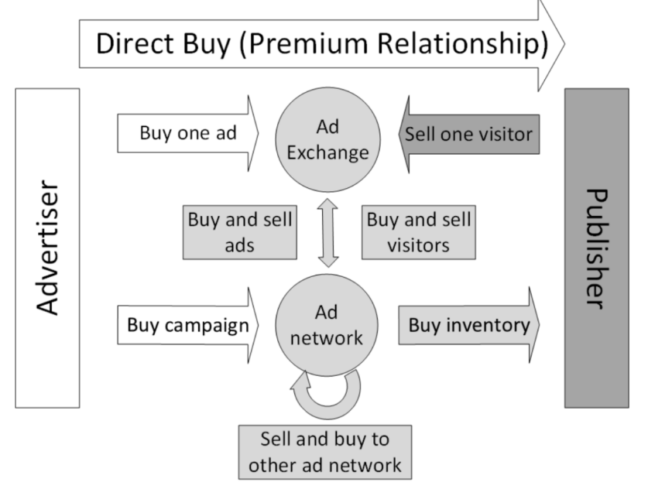
ARCHITECTURE DIAGRAM :
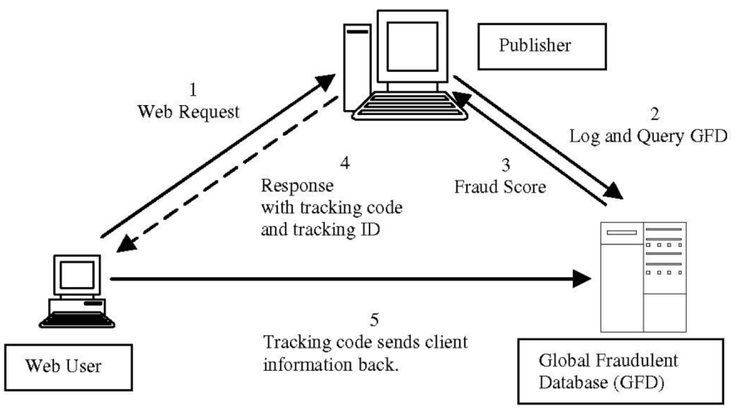

SOFTWARE REQUIREMENTS:
- Operating System : Windows 10
- Platform : python
HARDWARE REQUIREMENTS:
- Keyboard
- Mouse
- Hard disk 500GB
- Ram 4 G

CONCLUTION :
- QML has drawn an increasing interest for its potential of solving critical problems because of its computing capability .
- Due to the challenges of formulating problems into the QUBO format that quantum computing requires, and how costly such a process is, identification of the most critical areas for QML application is important to justify the expense for potential gain in performance.
- The prevalence of e-business, online transactions, and huge loss over spurious activities, make timely and accurate fraud detection a great choice for QML solution. We propose a fraud detection framework for this purpose.
REFERENCE :
- [1] S. Bhattacharyya, S. Jha, K. Tharakunnel, and J. C. Westland, ‘‘Data mining for credit card fraud: A comparative study,’’ Decis. Support Syst., vol. 50, no. 3, pp. 602–613, Feb. 2011.
- [2] E. W. T. Ngai, Y. Hu, Y. H. Wong, Y. Chen, and X. Sun, ‘‘The application of data mining techniques in financial fraud detection: A classification framework and an academic review of literature,’’ Decis. Support Syst., vol. 50, no. 3, pp. 559–569, Feb. 2011.
- [3] J. A. Tackett, ‘‘Association rules for fraud detection,’’ J. Corporate Accounting Finance, vol. 24, no. 4, pp. 15–22, May 2013.
- [4] L. Columbus. (2020). How E-Commerce’s Explosive Growth is Attracting Fraud. [Online]. Available: https://www.forbes.com/sites/ louiscolumbus/2020/05/18/how-e-commerces-explosive-growth-isattracting-fraud/?sh=5a1e8f586c4b
- [5] LexisNexis. (2020). Lexis/Nexis Solutions for 2020 True Cost of Fraud Study: E-Commerce/Retail Edition. [Online]. Available: https://risk. lexisnexis.com/about-us/press-room/press-release/20200721-tcof-retailstudy
- [6] I.-C. Yeh and C.-H. Lien, ‘‘The comparisons of data mining techniques for the predictive accuracy of probability of default of credit card clients,’’ Expert Syst. Appl., vol. 36, pp. 2473–2480, Mar. 2009
- [7] Kaggle.com. Credit Card Fraud Detection. Accessed: May 2022. [Online]. Available: https://www.kaggle.com/mlg-ulb/creditcardfraud
- [8] G. P. Nason, Statistics in Volcanology (Stationary and Non-Stationary Time Series). London, U.K.: Geological Society of London, 2006.
- [9] R. Salles, K. Belloze, F. Porto, P. H. Gonzalez, and E. Ogasawara, ‘‘Nonstationary time series transformation methods: An experimental review,’’ Knowl.-Based Syst., vol. 164, pp. 274–291, Jan. 2019.
- [10] P. Ravisankar, V. Ravi, G. R. Rao, and I. Bose, ‘‘Detection of financial statement fraud and feature selection using data mining techniques,’’ Decision Support Syst., vol. 50, no. 2, pp. 491–500, 2011.
- [11] F. Itoo, Meenakshi, and S. Singh, ‘‘Comparison and analysis of logistic regression, Naïve Bayes and KNN machine learning algorithms for credit card fraud detection,’’ Int. J. Inf. Technol., vol. 13, pp. 1503–1511, Feb. 2021.
- [12] N. Rtayli and N. Enneya, ‘‘Enhanced credit card fraud detection based on SVM-recursive feature elimination and hyper-parameters optimization,’’ J. Inf. Secur. Appl., vol. 55, Dec. 2020, Art. no. 102596
- [13] C. Lin, A. Chiu, S. Y. Huang, and D. C. Yen, ‘‘Detecting the financial statement fraud: The analysis of the differences between data mining techniques and experts’ judgments,’’ Knowl.-Based Syst., vol. 89, pp. 459–470, Nov. 2015.
- [14] E. Duman and M. H. Ozcelik, ‘‘Detecting credit card fraud by genetic algorithm and scatter search,’’ Expert Syst. Appl., vol. 38, no. 10, pp. 13057–13063, Sep. 2011.
- [15] P. Hájek and R. Henriques, ‘‘Mining corporate annual reports for intelligent detection of financial statement fraud—A comparative study of machine learning methods,’’ Knowl.-Based Syst., vol. 128, pp. 139–152, Jul. 2017.

